SUPPLEMENTARY MATERIAL

A ziphodont crocodylomorph from Villaggio del Pescatore lagerstätte (Campanian, Italy)
Marco Muscioni*, Alfio Alessandro Chiarenza, Cecily S. C. Nicholl, Tullio Perentin, Diego Dreossi, Federico Fanti

Symphyseal density comparison among notosuchians and neosuchians
Data for the comparative sample of Fig. 8 was obtained both by first hand inspection of fossil specimens and using pictures provided by third parties and/or available in the literature. The complete list of taxa, density values, relative specimen code and main references are reported in Table S1.
Density values were obtained by dividing foramen number by square millimetres of surface for each dentary, meaning that – where available – left and right sides of the same individual were counted as different data for the same taxon, in compliance with the high variability of the character between sides. Foramina were counted starting from the posteriormost ventral contact of the symphysis up to the distalmost end of the dentaries (Fig. S1). Surface values were measured on pictures using ImageJ. Pictures of the symphyseal region of each dentary were taken with a 90 degrees angle as to grant the most visible bone surface; more than one picture was used to integrate data for dentaries with complex three-dimensional morphologies involving both mediolateral and dorsoventral surfaces.
References
da Silva Marinho, T., Vidoi Iori, F., de Souza Carvalho, I., de Vasconcellos, F.M., 2013. Gondwanasuchus scabrosus gen. et sp. nov., a new terrestrial predatory crocodyliform (Mesoeucrocodylia: Baurusuchidae) from the Late Cretaceous Bauru Basin of Brazil. Cretaceous Research 44, 104-111, ISSN 0195-6671. https://doi.org/10.1016/j.cretres.2013.03.010.
Dal Sasso, C., Pasini, G., Fleury, G., Maganuco, S., 2017. Razanandrongobe sakalavae, a gigantic mesoeucrocodylian from the Middle Jurassic of Madagascar, is the oldest known notosuchian. PeerJ 5:e3481 https://doi.org/10.7717/peerj.3481
Darlim, G., Carvalho, I.S., Tavares, S.A.S., Langer, M.C., 2021. A new Pissarrachampsinae specimen from the Bauru Basin, Brazil, adds data to the understanding of the Baurusuchidae (Mesoeucrocodylia, Notosuchia) distribution in the Late Cretaceous of South America. Cretaceous Research 128, 104969. https://doi.org/10.1016/j.cretres.2021.104969
Ibrahim, N., Sereno, P.C., Varricchio, D.J., Martill, D.M., Dutheil, D.B., Unwin, D.M., Baidder, L., Larsson, H.C.E., Zouhri, S., Kaoukaya, A., 2020. Geology and paleontology of the Upper Cretaceous Kem Kem Group of eastern Morocco. ZooKeys 928: 1-216. https://doi.org/10.3897/zookeys.928.47517
Kellner, A., Figueiredo, R., Calvo, J., 2023. A new species of Comahuesuchus Bonaparte, 1991 (Crocodyliformes: Notosuchia) from the Upper Cretaceous of Neuquén, Lake Barreales, Patagonia, Argentina. Anais da Academia Brasileira de Ciências. 95. https://doi.org/10.1590/0001-3765202320230179
Kley, N.J., Sertich, J.W., Turner, A.H., Kause, D.W., O’Connor, P.M., Georgi, J.A., 2010. Craniofacialmorphology of Simosuchus clarki (Crocodyliformes: Notosuchia) from the Late Cretaceous of Madagascar. Journal of Vertebrate Paleontology 30:13–98. https://doi.org/10.1080/02724634.2010.532674
Narváez, I., Brochu, C.A., Escaso, F., Pérez-García, A., Ortega, F., 2015. New Crocodyliforms from Southwestern Europe and Definition of a Diverse Clade of European Late Cretaceous Basal Eusuchians. PLoS ONE 10(11): e0140679. https://doi.org/10.1371/journal.pone.0140679
Nicholl, C.S.C., Hunt, E.S.E., Ouarhache, D., Mannion, P.D., 2021 A second peirosaurid crocodyliform from the Mid Cretaceous Kem Kem Group of Morocco and the diversity of Gondwanan notosuchians outside South America. Royal Society Open Science 8: 211254. https://doi.org/10.1098/rsos.211254
Pochat-Cottilloux, Y., Rinder, N., Perrichon, G., Adrien, J., Amiot, R., Hua, S., Martin, J.A., 2023. The neuroanatomy and pneumaticity of Hamadasuchus (Crocodylomorpha, Peirosauridae) from the cretaceous of Morocco and its paleoecological significance for altirostral forms. Journal of Anatomy, 243, 374–393. https://doi.org/10.1111/joa.13887
Sereno, P.C., Larsson, H.C.E., 2009. Cretaceous Crocodyliforms from the Sahara. ZooKeys 28: 1-143. https://doi.org/10.3897/zookeys.28.325
Turner, A.H., 2006. Osteology and phylogeny of a new species of Araripesuchus (Crocodyliformes: Mesoeucrocodylia) from the Late Cretaceous of Madagascar. Historical Biology, 2006; 18(3): 255–369. http://dx.doi.org/10.1080/08912960500516112

(Next page) Table S1 Taxa, density values, relative specimen code and main references. In the taxa list numbers indicate different specimens, letters (a, b) indicate right and left side of the same individual.
Taxon | Density | Specimen | Main data source
Araripesuchus tsangatsangana a | 0,1004 | UA 8720 | Photographs and CT imagery from Turner et al. 2006
Araripesuchus tsangatsangana b | 0,0964 | UA 8720 | Photographs and CT imagery from Turner et al. 2006
Araripesuchus rattoides | 0,2870 | CMN 41893 | Photographs, Sereno & Larsson 2009
Antaeusuchus taouzensis | 0,0071 | NHMUK PV R36829 | Photographs, Nicholl et al. 2021
Hamadasuchus rebouli | 0,0225 | NMC 41784 | Photographs, Ibrahim et al. 2020
Hamadasuchus | 0,0064 | MNHN-SAM 136 | Photographs, Pochat-Cotilloux et al. 2023
Simosuchus clarki | 0,0314 | UA 8679 | Photographs, illustrations and CT data from Kley et al. 2010
Razanandrongobe sakalavae | 0,0022 | MHNT.PAL.2012.6.1 | Photographs, Dal Sasso et al. 2017
Gondwanasuchus scabrosus | 0,1000 | UFRJ DG 408-R | Photographs, da Silva Marinho et al. 2013
Campinasuchus dinizi | 0,0100 | UFRJ DG 402-R | Photographs, Darlim et al. 2021
Aphaurosuchus escharafacies | 0,0238 | LPRP 0697 | Darlim et al. 2021
Sebecus icaeorhinus | 0,0149 | AMNH 316 | Kellner et al. 2023
Doratodon cf. carcharidens | 0,2045 | MCSNT 57035 | First hand inspection
Bernissartia fagesii a | 0,2598 | IRSNB R46 | Photographs and CT imagery from Martin et al. 2020
Bernissartia fagesii b | 0,3000 | IRSNB R46 | Photographs and CT imagery from Martin et al. 2020
Acynodon adriaticus | 0,1462 | MCSNT 57248 | First hand inspection
Lohuecosuchus megadontos | 0,0222 | HUE-04498 | Photographs, Narváez et al. 2015
Crocodylus acutus | 0,0335 | FMNH 13220 | Dr. Giacomo Gobbo Pers. comm. 2025
Crocodylus siamensis 1a | 0,1347 | Codeless comparative spec. | First hand inspection
Crocodylus siamensis 1b | 0,1467 | Codeless comparative spec. | First hand inspection
Crocodylus siamensis 2a | 0,2147 | Codeless comparative spec. | First hand inspection
Crocodylus siamensis 2b | 0,2251 | Codeless comparative spec. | First hand inspection
Crocodylus siamensis 3a | 0,1918 | Codeless comparative spec. | Dr. Riccardo Rocchi Pers. comm. 2025
Crocodylus siamensis 3b | 0,1795 | Codeless comparative spec. | Dr. Riccardo Rocchi Pers. comm. 2025
Crocodylus novaeguineae | 0,0493 | FMNH 14043 | Dr. Giacomo Gobbo Pers. comm. 2025
Alligator mississippiensis 1 | 0,0757 | Bologna Museum collection, no code | First hand inspection
Alligator mississippiensis 2 | 0,0855 | FMNH 284905 | Dr. Giacomo Gobbo Pers. comm. 2025
Caiman crocodylus a | 0,1662 | FMNH 13062 | Dr. Giacomo Gobbo Pers. comm. 2025
Caiman crocodylus b | 0,1490 | FMNH 13062 | Dr. Giacomo Gobbo Pers. comm. 2025
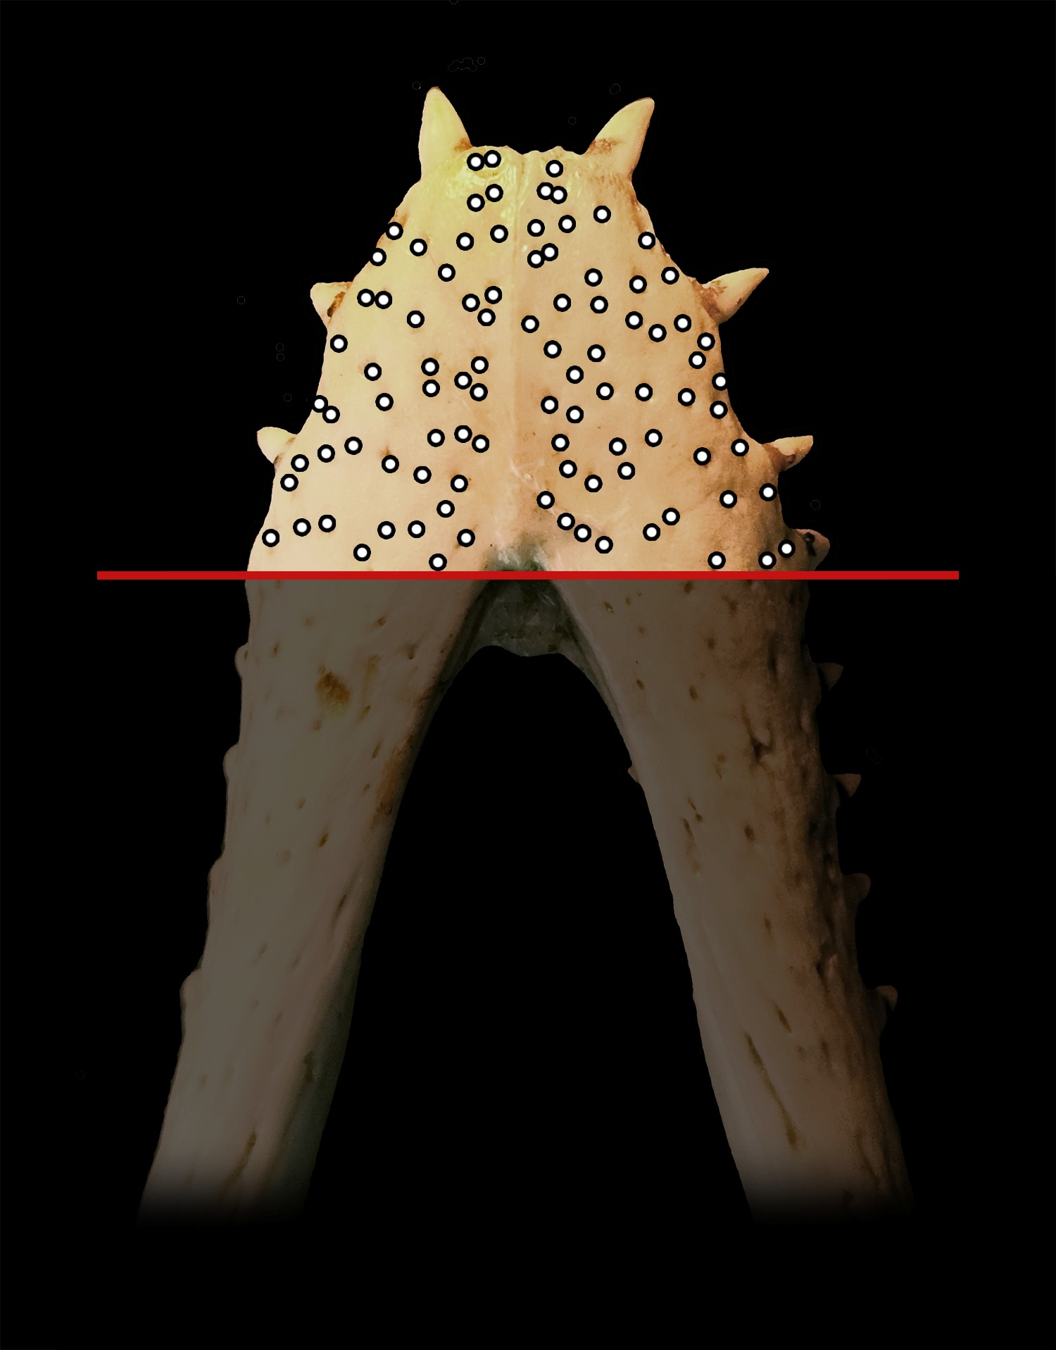
Fig. S1 Example of measured area on a Crocodylus siamensis mandible. Only the area over the red line was taken in consideration.

