Supplementary
CM-OB quality control
Obesogenic conditioned-medium (CM-OB) was collected from mature adipocytes isolated from VAT of obese patients (PT03, PT09, PT16, PT22). Leptin and adiponectin levels in CM-OB were measured by ELISA as an internal quality control to validate adipocyte differentiation and secretory activity. Concentrations were quantified using the Human Leptin Quantikine QuicKit ELISA (R&D Systems, Bio-Techne, QK398) and the Human Total Adiponectin/Acrp30 Quantikine ELISA (R&D Systems, Bio-Techne, DRP300), respectively, according to the manufacturer’s instructions. PDO medium was used as the negative control (NC). For each CM-OB, ELISA analysis showed elevated leptin levels (Figure S1A, 1B) and lower adiponectin concentrations (Figure S1C, 1D) in CM-OB, consistent with the secretory activity of mature obese adipocytes.
Figure S1.
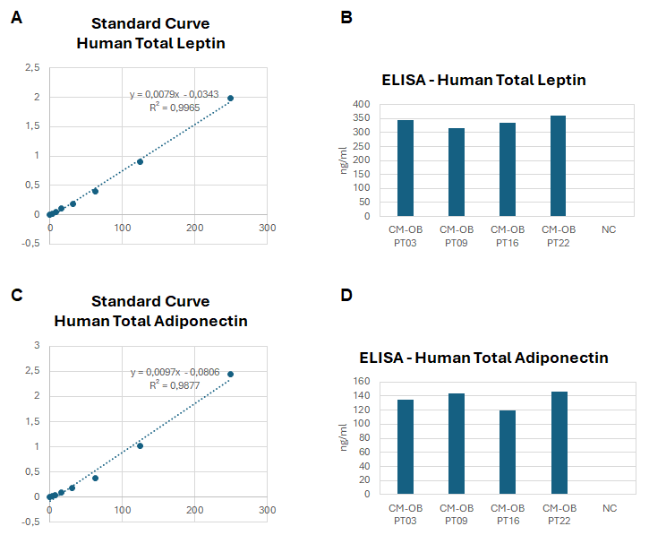

Figure S1. ELISA quantification of leptin and adiponectin in adipocyte-conditioned media.
Conditioned media (CM-OB) were collected from mature adipocytes isolated from visceral adipose tissue (VAT) of four obese patients and analysed by ELISA for total leptin and adiponectin levels.
A) Standard curve for human total leptin at known standard concentrations.
B) Leptin concentrations measured in CM-OB samples derived from four patients (PT03, PT09, PT16, PT22) compared with negative control (NC).
C) Standard curve for human total adiponectin at known standard concentrations.
D) Adiponectin concentrations measured in CM-OB samples compared with NC.
Values are expressed as ng/mL and calculated using the corresponding standard curves supplied with the kit.

Table S1. Detailed composition of PDO medium.
BASAL medium
Components | Final concentration | Company | Product number
Advanced DMEM-F12 | up to volume | Gibco | #12634-010
Hepes | 1X | Gibco | #15630080
Glutamax | 1X | Gibco | #35050061
Penicillin/Streptomycin (PS) | 1X | Gibco | #129211
N2 | 1X | Gibco | #17502-048
B27 | 1X | Gibco | #17504-044
N-Acetylcysteine | 1 nM | Sigma-Aldrich | #A7250
Gastrin | 10 nM | Sigma-Aldrich | #G9145
A83-01 | 500 nM | Tocris | #2939
SB202190 | 10 µM | Sigma-Aldrich | #S7067
Nicotinamide | 10 mM | Sigma-Aldrich | #N0636
mEGF | 50 ng/ml | Gibco | #PMG8041
Human-Noggin | 100 ng/ml | Peprotech | #120-10C
PDO medium
Components | Final concentration | Reference
BASAL | 50% | [1]
WNT3A-conditioned medium (CM) | 50% | [1]

DNA extraction and next-generation sequencing
Genomic DNA was extracted from snap frozen tissues using the Maxwell 16 instrument (Promega Corporation) as previously reported [2]. Next-generation sequencing (NGS) was performed on an Ion Chef and Ion Gene Studio S5 System (Ion Torrent, Thermo Fisher Scientific) using the Ion Ampliseq Cancer HotSpot Panel v2 and a custom Ion AmpliSeq On-Demand panel (Thermo Fisher Scientific), designed to detect SNV and small indel variants in 21 genes associated with cancer including the APC gene. Briefly, genomic DNA was quantified using a NanoDrop 1000 Spectrophotometer and 10–20 ng of DNA was used to manually prepare libraries with Ion AmpliSeq Library Kit Plus and IonXpress Barcode Adapter Kit. The barcoded and purified libraries were quantified using the Ion Library TaqMan Quantitation Kit (Thermo Fisher Scientific) and pooled in an equimolar manner (30 pM). A template was prepared with 510TM &520TM &530TM kit - Chef using the Ion Chef System. Up to 32 samples were loaded on Ion 530 chips (Thermo Fisher Scientific). The number of samples per chip was calculated to obtain an average cover of at least 450/500x. Data were analyzed with Ion Reporter Software v5.18 and the following stringent criteria were applied for final variant calling: (1) Class 4 or 5 variants, according to ACMG and ClinVar classifications; (2) allele frequency ≥ 5%; (3) P-value (QC) ≤ 0.01.

Table S2. NGS analysis of matched NM tissues used for PDO establishment and corresponding CRC specimens.
CRC Patients |  | Somatic genetic alterations
ID Patient  Tissue | MMR Protein Status | Gene | Function | Coding | Protein
CRC 10 | MSI; loss of MLH1 e PMS2 | BRAF  MSH3 PIK3CA | missense  frameshift  missense | c.1799T>A  c.1148delA c.3197C>T | p.Val600Glu  p.Lys383ArgfsTer32  p.Ala1066Val
NM 10 | NA | NEG
CRC 12 | MSS | APC º  TP53 TP53 | nonsense  missense missense | c.4182_4183insT  c.524G>A c.404G>T | p.Ser1395Ter  p.Arg175His p.Cys135Phe
NM 12 | NA | NEG
CRC 13 | MSS | APC TP53 | frameshift unknown | c.3911delT c.994-1G>A | p.Ile1304LysfsTer4 p.?
NM 13 | NA | NEG
CRC 15 | MSS | PIK3CA  APC TP53 | missense  nonsense  missense | c.1258T>C  c.847C>T c.524G>A | p.Cys420Arg  p.Arg283Ter p.Arg175His
NM 15 | NA | NEG
MSI: microsatellite instable; MSS: microsatellite stable; NEG: negative; NA: not available.
Variants were classified as pathogenic or likely pathogenic on ClinVar database, except for PIK3CA (c.3197C>T) which was described as VUS. The function of APC º variants is not yet available on ClinVar database, as they are common types of mutations in germline APC mutated settings, they can be considered likely pathogenic.

Table S3. Detailed composition of OB medium.
OB medium
Components | Final concentration | Reference
PDO medium | 50% | [1]
CM-OB | 50% | [3]

Bioactive substances intermediate dilutions
Three different types of bioactive substances were used to treat intestinal PDOs: i) Eicosapentaenoic acid (EPA); ii) Docosahexaenoic acid (DHA); iii) (-)-Epigallocatechin gallate (EGCG).
i) EPA-free fatty acid (FFA) capsules (500 mg Gastro-Resistant Capsules) were purchased from ALFA, S.L.A and were stored at room temperature, protected from light. The capsule’s content was transferred with a sterile syringe into a tube, aliquoted and stored at -80°C. According to the moles-molarity formulas (EPA molecular weight: 302.451 g/mol – mass: 0.5 g - total volume; 500 μL), EPA stock concentration was 3.3 M. Prior to PDOs treatments, the stock solution was diluted in ethanol (EtOH 96%) resulting in a final concentration of 121.76 mM (first intermediate), and, from that, ulteriorly diluted in PBS (1:4 ratio) to obtain a final concentration of 30.442 mM (second intermediate).
ii) DHA-FFA powder was purchased from Sigma-Aldrich (D2534 100 MG, powder, purity ≥ 98%) and stored at -80°C, protected from light. According to the moles-molarity formulas (DHA molecular weight: 328,488 g/mol– mass: 0.1 g - total volume; 2500 μL), DHA powder was dissolved in ethanol (EtOH 96%) obtaining a stock solution of 121.6 mM. Prior to PDO treatments, the stock solution was diluted in PBS (1:4 ratio) reaching a final concentration of 30.442 mM.
iii) (-)-Epigallocatechin gallate (EGCG; E4143 purity ≥ 95%; Sigma-Aldrich, Milan, Italy) was dissolved in dimethyl sulfoxide (DMSO) to obtain a stock concentration of 54.54 mM. Prior to PDOs treatments, the stock solution was diluted in PBS (1:10 ratio) reaching a final concentration of 5.454 mM.

PDO and CM-OB donor matching from VAT
For dose-response curve and viability experiments, PDOs were exposed to OB medium (CM-OB mixed 1:1 with PDO medium), with (OB+EDE) or without EDE(OB-EDE). Specifically, PDOs from PT10 were treated with CM-OB derived from VAT of PT03; PT12 with CM-OB from VAT of PT09; PT13 with CM-OB from VAT of PT16; and PT15 with CM-OB from VAT of PT22. Control (CTRL) samples received the corresponding pre-diluted vehicles in OB medium (PDO medium:CM-OB, 1:1).

Figure S2
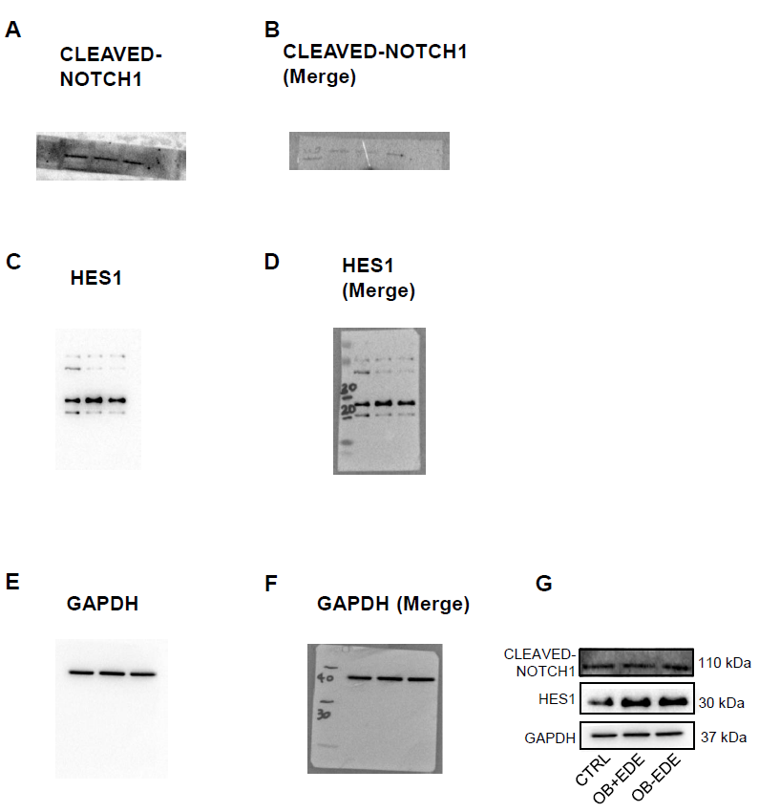
Figure S2. Uncropped blots relative to Main Figure 4.
Uncropped blots of CLEAVED-NOTCH1, HES1 and GAPDH (n=4) in PDOs treated for 48 h with the indicated conditions. For Notch1 signal acquisition, due to the high signal belonging to the higher/lower molecular weight proteins tested, we covered the upper/lower part of blot to acquire Notch1 protein signal with the optimized exposure time already selected in our lab for all the experiments. After transfer and Ponceau Red staining, the membrane was divided into two parts: the upper membrane portion was used to detect proteins between 260-60 kDa, while the lower portion was used to detect proteins between 50-3.5 kDa
A, B) Covered uncropped CLEAVED-NOTCH1 blots shown as the original image (A) and merged with the protein molecular weight marker (B).
C, D) Uncropped HES1 blots shown as the original image (C) and merged with the protein molecular weight marker (D).
E, F) Uncropped GAPDH blots shown as the original image (E) and merged with the protein molecular weight marker (F).
G) Cropped blots relative to Main Figure 4.

Figure S3
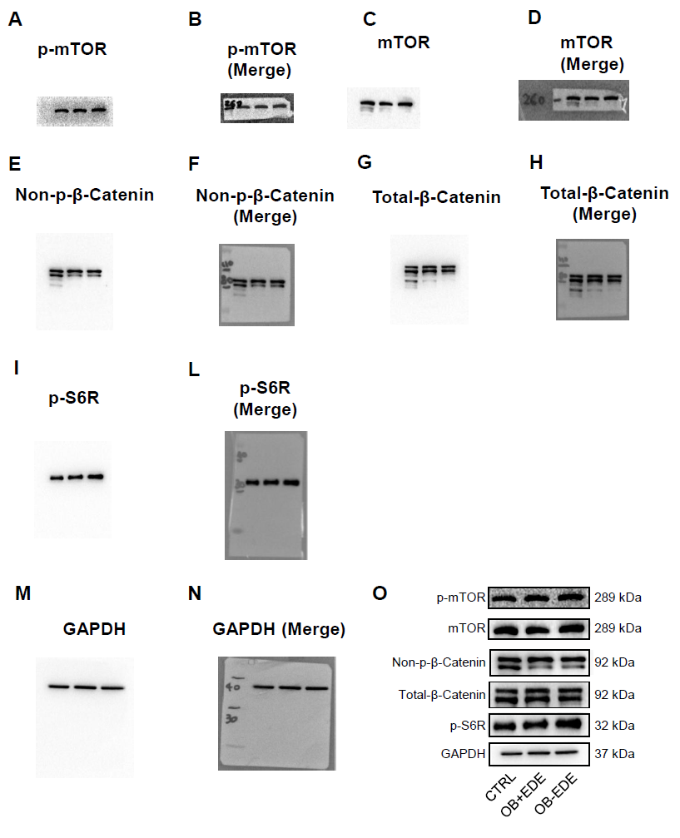
Figure S3. Uncropped blots relative to Main Figure 5.
Uncropped blots of p-mTOR, mTOR, non-p-β-Catenin, total-β-Catenin, p-S6R and GAPDH (n=4) in PDOs treated for 48 h with the indicated conditions. After transfer and Ponceau Red staining, the membrane was divided into three parts: the upper membrane portion was used to detect proteins between 260-160 kDa, the central membrane portion was used to detect proteins between 160-60 kDa while the lower portion was used to detect proteins between 50-3.5 kDa
A,B) Uncropped p-mTOR blots shown as the original image (A) and merged with the protein molecular weight marker (B).
C,D) Uncropped mTOR blots shown as the original image (C) and merged with the protein molecular weight marker (D).
E, F) Uncropped non-p-β-Catenin blots shown as the original image (E) and merged with the protein molecular weight marker (F).
G, H) Uncropped total-β-Catenin blots shown as the original image (G) and merged with the protein molecular weight marker (H).
I, L) Uncropped p-S6R blots shown as the original image (I) and merged with the protein molecular weight marker (L).
M, N) Uncropped p-S6R blots shown as the original image (M) and merged with the protein molecular weight marker (N).
O) Cropped blots relative to Main Figure 5.

Figure S4
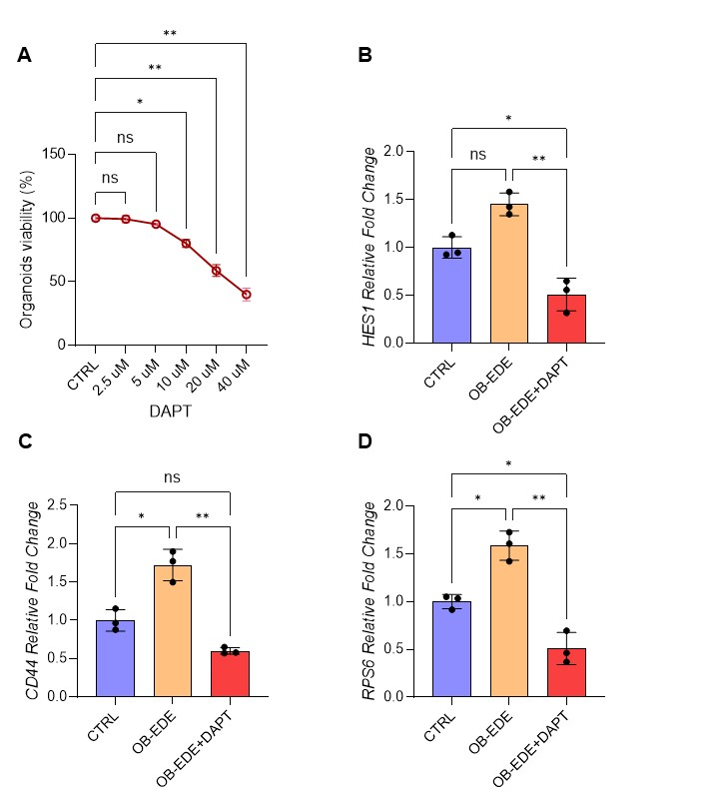

Figure S4: DAPT-mediated inhibition of Notch1 signaling in patient-derived organoids exposed to obesogenic-like stimuli.
A) Dose-response viability curves for DAPT. PDOs were treated for 48 h with DAPT in OB medium. CTRL consisted of vehicle-treated PDOs in OB medium. Repeated-measures one-way ANOVA with Dunn’s multiple comparison was performed.
B, C, D) RNA expression of HES1, CD44, and RPS6 in PDOs treated for 48 h with CTRL (vehicle-treated PDOs in standard PDO medium), OB-EDE (vehicle pre-diluted in OB medium) or OB-EDE+DAPT (DAPT = 5 μM). Repeated-measures one-way ANOVA with Tukey’s multiple comparison was performed. Data are reported as mean ± SD (n=3; PT12, PT13, PT15). Global p-values: (A) = .0012; (B) =.0057; (C) = .0034; (D) = .0026. * p < .05, ** p < .01, *** p < .001, **** p < .0001.

References
1. Pleguezuelos-Manzano C, Puschhof J, van den Brink S, Geurts V, Beumer J, Clevers H. Establishment and Culture of Human Intestinal Organoids Derived from Adult Stem Cells. Curr Protoc Immunol. 2020 Sep 1;130(1). doi:10.1002/CPIM.106 PubMed PMID: 32940424.
2. Di Paola FJ, Alquati C, Conti G, Calafato G, Turroni S, D’Amico F, Ceccarelli C, Buttitta F, Bernardi A, Cuicchi D, Poggioli G, Turchetti D, Ferrari S, Cannizzaro R, Realdon S, Brigidi P, Ricciardiello L. Interplay between WNT/PI3K-mTOR axis and the microbiota in APC-driven colorectal carcinogenesis: data from a pilot study and possible implications for CRC prevention. J Transl Med. 2024 Dec 1;22(1). doi:10.1186/S12967-024-05305-5 PubMed PMID: 38970018.
3. Carswell KA, Lee MJ, Fried SK. Culture of isolated human adipocytes and isolated adipose tissue. Methods Mol Biol. 2012;806:203–14. doi:10.1007/978-1-61779-367-7_14 PubMed PMID: 22057454.

