Food Safety Practices and Foodborne Illness in Italian Pediatric Oncology and Hematology Centers: a survey on behalf of the Infectious Disease Working Group of AIEOP

Davide Leardini¹, Gianluca Bossù¹, Francesco Venturelli^{1,*}, Francesco Baccelli¹, Edoardo Muratore¹, Antonio Grasso¹, Pietro Gasperini², Chiara Pilotto³, Letizia Pomponia Brescia⁴, Nagua Giurici⁵, Angelica Barone⁶, Mariacristina Menconi⁷, Elena Soncini⁸, Daniela Onofrillo⁹, Manuela Spadea^{10, 11}, Francesco Fabozzi¹², Pietro Casartelli¹³, Simona Rinieri¹⁴, Maria Grazia Petris¹⁵, Valeria Petroni¹⁶, Paola Muggeo¹⁷, Katia Perruccio¹⁸, Cristina Meazza¹⁹, Francesca Compagno²⁰, Francesco Paolo Tambaro²¹, Maura Faraci²², Angela Mastronuzzi¹², Riccardo Masetti¹, Simone Cesaro²³

SUPPORTING INFORMATION

Supplementary Text: Full questionnaire shared with the centers.
Supplementary Table 1: Rate of food permission among centers who recommend or not recommend neutropenic diet.

Supplementary Text: Full questionnaire shared with the centers.
1. General Information about the Center and Dietary Recommendations
Does the Center use specific dietary recommendations for pediatric oncohematologic patients?
- Yes
- No
If yes, please specify the type of document used:
- Official document of the Department/Operational Unit (e.g., Operational Instruction)
- Official document of the Institution/Hospital (e.g., Corporate Operational Instruction)
- Article or publications from relevant scientific societies
- Other (specify):……………………………..
Does the Center provide specific dietary guidelines for pediatric oncohematologic patients?
- Yes
- No
If yes, which professional provides these guidelines in daily practice? (multiple responses possible)
- Pediatrician (any, attending or resident)
- Structured Pediatric Oncohematologist (admitting or patient-responsible physician)
- Dietitian/nutritionist from the Operational Unit, Department, or Corporate level
- Nurse (any, on shift)
- Dedicated or trained nurse (case manager)
- Other (specify):……………………………………
2. Specific Dietary Guidelines
Does the Center recommend a restrictive hospital diet (neutropenic diet) for neutropenic inpatients?
- Yes
- No
What instructions are given to patients regarding the type of drinking water during hospitalization?
- Only bottled water
- No preference (bottled or tap water)
Does the Center recommend a restrictive home diet (neutropenic diet) for neutropenic patients or those at risk of becoming neutropenic?
- Yes
- No
At home, what instructions are given to patients regarding the type of drinking water?
- Only bottled water
- No preference (bottled or tap water)

What foods are permitted for the oncohematologic patient in relation to the clinical phases of treatment?
 | Home care after low-dose chemotherapy (non-neutropenic) | Home care after high-dose chemotherapy/ autologous HSCT | Home care during the first month after discharge following allogeneic HSCT | Hospitalized, non-neutropenic | Hospitalized, neutropenic after high-dose chemotherapy/ autologous HSCT | Hospitalized neutropenic after allogenic HSCT
UHT milk or fresh pasteurized milk
Unpasteurized milk and its derivatives
Parmesan/Grana
Other aged cheeses
Blue cheeses
Mozzarella, spreadable cheeses
Pastry/ice cream products (ice cream, filled cakes)
Fresh fruit with skin (bananas, oranges, etc.)
Fresh fruit without skin (e.g., strawberry)
Dried fruit
Fresh vegetables
Pre-washed and packaged vegetables
Honey
Raw egg
Cooked egg
Raw egg derivatives (e.g., mayonnaise, creams)
Well-cooked or canned meats
Raw meats
Cooked cured meats (cooked ham, mortadella)
Dry-cured meats/aged salted meats
Cooked fish
Raw/smoked fish
Mollusks and crustaceans
Leftover cooked food
Hamburger (fast food)
Takeaway pizza

- Are there any foods prohibited that are not included in this list?
Please specify:
- Are there any recommended foods that are not included in this list?
Please specify:
Does the Center recommend the use of supplements during any phase of treatment for oncohematologic patients?
- Yes
- No
If yes, which supplements are prescribed in relation to the different phases of treatment?
 | Home care after low-dose chemotherapy (non-neutropenic) | Home care after high-dose chemotherapy/ autologous HSCT | Home care during the first month after discharge following allogeneic HSCT | Hospitalized, non-neutropenic | Hospitalized, neutropenic after high-dose chemotherapy/ autologous HSCT | Hospitalized neutropenic after allogenic HSCT
Trace elements (e.g., magnesium, calcium, zinc, iron, selenium)
Multivitamins
Vitamin B12
Vitamin D
Caloric supplements
Prebiotics (e.g., inulin)
Probiotics

- Are there any supplements not included in this list that you recommend?
Please specify :
- Are there any supplements not included in this list that you discourage?
Please specify :
3. General Information on Diet Management and Food Preparation
Can parents or the hospitalized patient cook food directly in the ward?
- Yes
- No
Is the hospitalized patient allowed to consume food cooked at home?
- Yes
- Yes, only if not neutropenic
- No
Is the hospitalized patient allowed to order takeout food that is permitted according to dietary guidelines? (e.g., pizza, sandwiches, hamburgers, kebabs delivered to the ward)
- Yes
- Yes, only if not neutropenic
- No
Does the center provide specific instructions regarding food cleaning at home?
- Yes
- No
If you answered yes to the previous question, please specify:
Does the center provide specific instructions regarding food storage at home?
- Yes
- No
If you answered yes to the previous question, please specify:
4. Perception of the Role of Dietary Guidelines in the Overall Care of Pediatric Oncohematologic Patients (evaluation by the questionnaire respondent)
- How important do you think dietary recommendations are for pediatric oncohematologic patients?
☐ 1 ☐ 2 ☐ 3 ☐ 4 ☐ 5
Definitely not important Very important

- What importance do you perceive parents place on the dietary aspect?
☐ 1 ☐ 2 ☐ 3 ☐ 4 ☐ 5
Definitely not important Very important

- In your experience, how generally compliant is the family with your dietary recommendations?
☐ 1 ☐ 2 ☐ 3 ☐ 4 ☐ 5
Low High

- How often do patients deviate from the recommendations? Including antitumor diets/dietary consultations at another center/non-conventional food practices.
☐ 1 ☐ 2 ☐ 3 ☐ 4 ☐ 5
Infrequently Very frequently

5. Foodborne Infections
Have you had any experience with suspected or confirmed foodborne infections*?
*Defined as a microbiologically confirmed foodborne infection in a patient with a history of consuming potentially contaminated food or beverages within the preceding 24 hours OR a foodborne infection with a typical pathogen isolated as defined by the CDC (see attached image for the list of pathogens), even without a suspected food history.
- Yes
- No
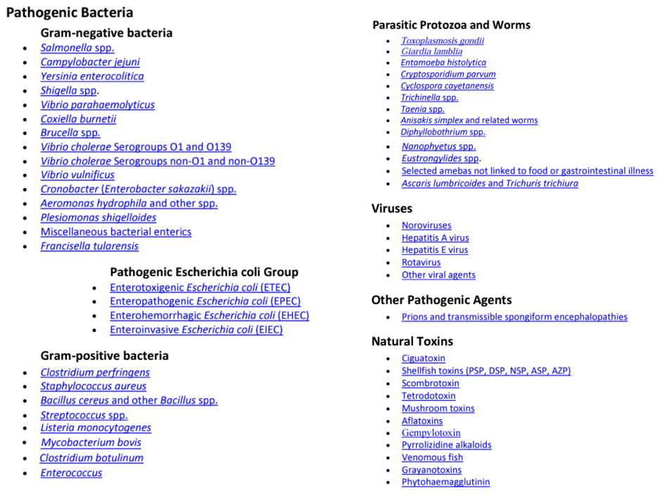

Case Report Form

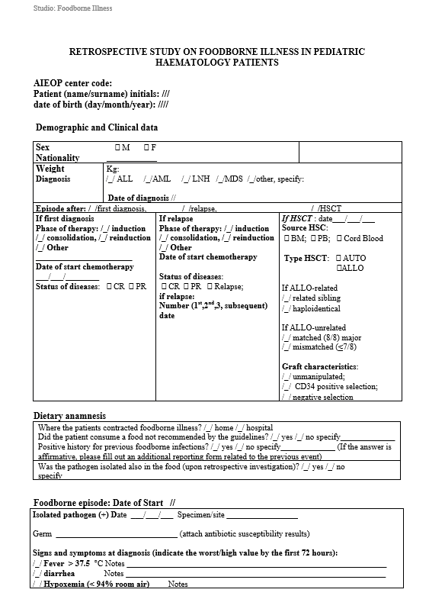
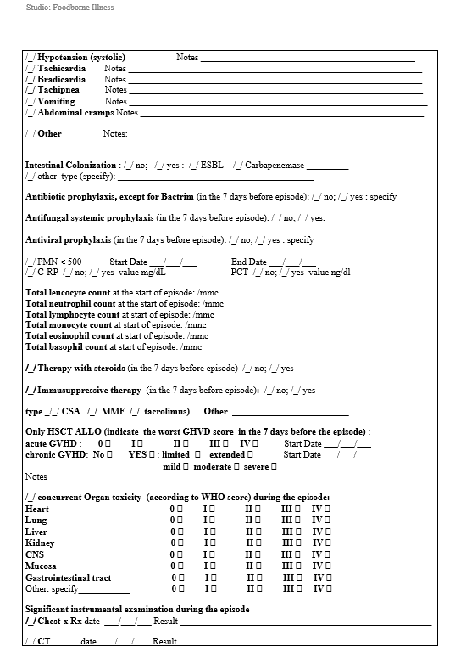
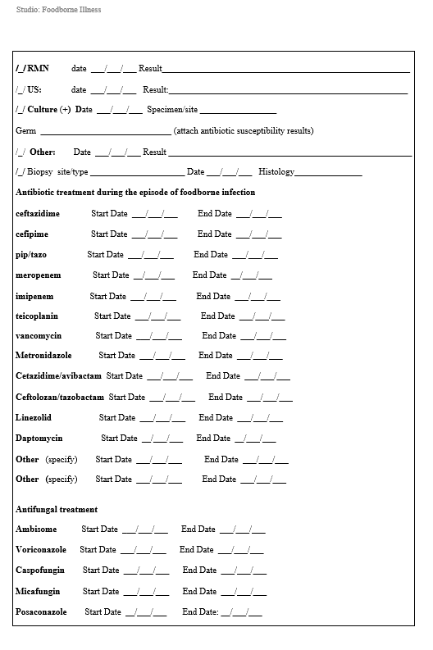
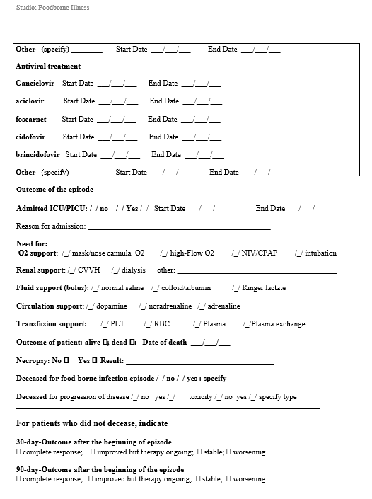
Supplementary Table 1: Rate of food permission among centers who recommend or not recommend neutropenic diet.

