Identification and management of gastrointestinal manifestations of hereditary transthyretin amyloidosis: recommendations from an Italian group of experts

SUPPLEMENTARY MATERIAL
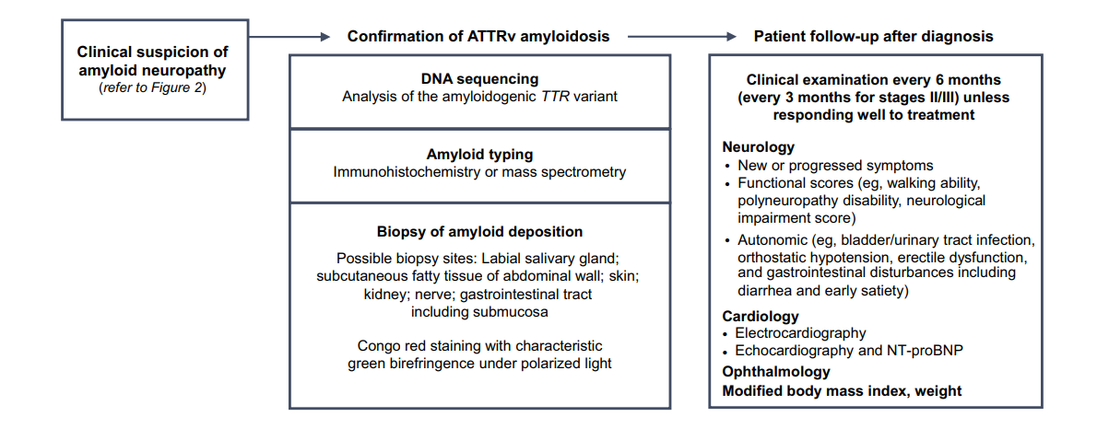

Supplementary Figure 1. Strategy for diagnosis of hereditary transthyretin amyloidosis. It is recommended to ask for genetic testing in parallel with the detection of amyloid in biopsy samples, particularly in non-endemic areas. Adapted from [4] under a Creative Commons Attribution 4.0 International License.

Supplementary Table 1. Diagnostic tools for ATTR-PN. Adapted from [4] under a Creative Commons Attribution 4.0 International License.
 |  | Amyloid detection
 | TTR gene analysis | Biopsy | DPD, PYP, HMDP scintigraphy
Advantages | Looking for 1 of the 130 amyloidogenic  variants;  possible to rule out ATTRv if gene analysis is negative for a variant;  fastest method to confrm ATTRv in case of neuropathy. | Formal proof of amyloidosis in carriers of TTR variants and sporadic amyloid neuropathy. | Non-invasive demonstration of cardiac amyloid with bone scintigraphy
Rules | TTR gene sequencing of the 4 exons | Congo red staining;  examination under polarized microscopy; many sections often needed to detect a single deposit
Limits | 13 nonamyloidogenic variants, including  Gly6Ser and Thr119Met; possible delay of genetic results | Sensitivity for amyloid detection 60–80%; dependent on experience and expertise of pathologist may be invasive and risky; time-consuming  Several biopsy sites sometimes needed to find a depositª | Radiolabeling if no light chain;  sensitivity <100%;  LV wall thickness >12 mm in combination with abnormal heart/whole-body  retention;  heart/whole-body >7.5 associated with the highest event rate
Remarks | Some correlation between mutation and  predominant organ involvement (e.g.,  heart, brain, eye) | False negative; amyloid light chain must be excluded | Complementarity of TTR gene analysis; may avoid cardiac biopsy
ATTR-PN: amyloid transthyretin polyneuropathy, DPD: diphosphono-1,2-propanodicarboxylic acid, HMDP: hydroxymethylene diphosphonate, LV: left ventricular, PYP: pyrophosphate
ª: at least one tissue biopsy should be performed to identify amyloid deposits and, if negative, another biopsy, preferentially mini-invasive (skin, labial salivary gland, abdominal fat), should be performed.

