Supplementary Information
This file contains additional information on Methods and Results.

Article title: A comparison of protocols for isolating and extracting host DNA from caribou (Rangifer tarandus) fecal pellets
Journal name: Conservation Genetics Resources
Authors and affiliation:
Samantha Barrette¹, Samuel Deakin^{1,2}, Agnès Pelletier³, Pauline Priadka⁴, Helen Schwantje⁵, Caeley Thacker⁶, Lalenia Neufeld⁷, Sean Rogers², Marco Musiani^{2,8}, and Jocelyn Poissant¹

¹ Faculty of Veterinary Medicine, University of Calgary, Calgary, AB, Canada
² Department of Biological Sciences, University of Calgary, Calgary, AB, Canada
³ Ministry of Water, Land and Resource Stewardship, Government of British Columbia, Prince George, BC, Canada
⁴ Ministry of Water, Land and Resource Stewardship, Government of British Columbia, Williams Lake, BC, Canada
⁵ Ministry of Water, Land and Resource Stewardship (Emeritus), Government of British Columbia, Nanaimo, BC, Canada
⁶ Ministry of Water, Land and Resource Stewardship, Government of British Columbia, Nanaimo, BC, Canada
⁷ Jasper National Park of Canada, Parks Canada, Jasper, AB, T0E 1E0, Canada
⁸ Dipartimento Scienze Biologiche Geologiche Ambientali, Università Di Bologna, Bologna, BO, 40126, Italia
Corresponding authors: samantha.barrette@ucalgary.ca, jocelyn.poissant@ucalgary.ca

Supplementary Table S1. Post-hoc observed power analysis results for all lmer mixed models. Observed power was estimated for each fixed predictor using the package simr with the function powerSim() (Green & MacLeod 2016). Each predictor tested used 500 simulations with the default alpha value of 0.05.
Model | Dataset | Predictor tested | Estimated power (%) | 95% confidence interval | Number of samples (n)
Total DNA | Initial comparison | Isolation method:Extraction kit | 100.0 | 99.26, 100.0 | 240
Target DNA | Initial comparison | Isolation method:Extraction kit | 100.0 | 99.26, 100.0 | 240
Percent DNA | Initial comparison | Isolation method: Extraction kit | 100.0 | 99.26, 100.0 | 240
Target DNA | Post-hoc validation | Population | 100.0 | 99.26, 100.0 | 140
Target DNA | Post-hoc validation | Isolation method: Extraction kit | 100.0 | 99.26, 100.0 | 140
Percent DNA | Post-hoc validation | Population | 97.80 | 96.10, 98.90 | 140
Percent DNA | Post-hoc validation | Isolation method:Extraction kit | 100.0 | 99.26, 100.0 | 140
Note: for the linear model of Total DNA for the Post-hoc validation, power was estimated to be 1 using the R package pwr (Champely 2023) and function pwr.f2.test() based on 9 predictor levels and 129 degrees of freedom (as the package simr can only be used with mixed models).
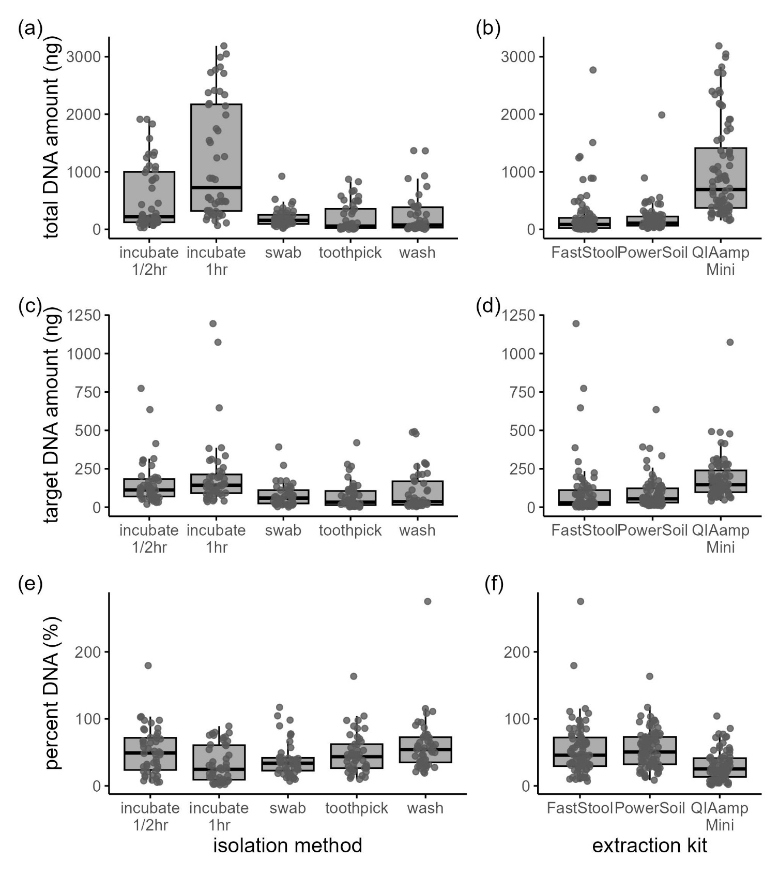
Supplementary Fig. S1 Total and target DNA yield (ng) eluted in 400ul of water, and percent of total DNA which was caribou DNA (target (ng) / total (ng); %), categorized by each of the 5 isolation protocols (a, c, e) and 3 extraction kits (b, d, f). Sample size was 240 fecal pellets (48 pellets per isolation treatment, 80 pellets per extraction kit).

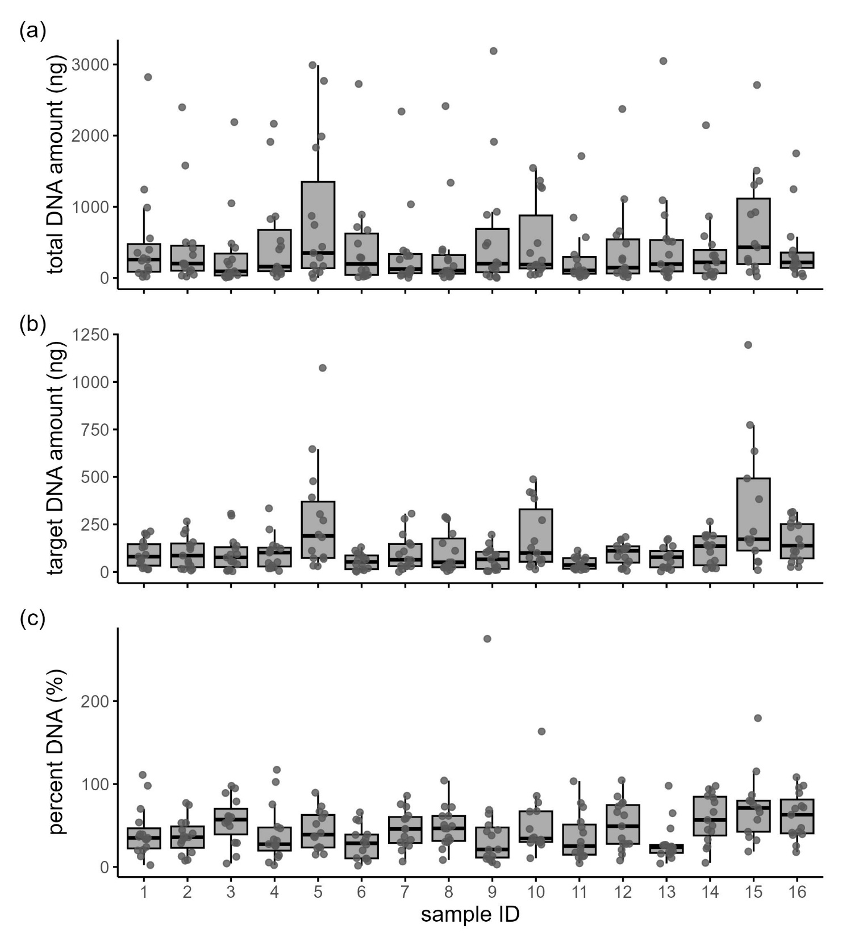

Supplementary Fig. S2 Total (a) and target (b) DNA yield (ng) eluted in 400ul of water, and percent of total DNA which was caribou DNA (target (ng) / total (ng); %) (c), categorized by sample ID. Sample size was 240 fecal pellets (15 pellets per sample ID).
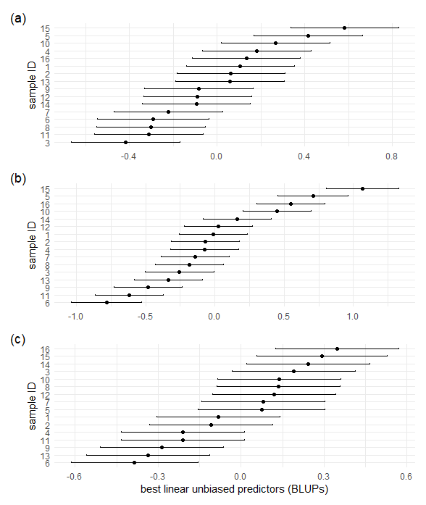
Supplementary Fig. S3 Best linear unbiased predictors (BLUPs) for the random effect sample ID from the linear mixed effect models of log transformed (a) total (ng), (b) target (ng), and (c) percent DNA (%) obtained by extracting DNA from boreal caribou fecal pellets using 15 combinations of isolation methods and QIAGEN extraction kits. Each point represents how much each sample ID deviates from the overall average log DNA yield, after accounting for the fixed effects (isolation method and extraction kit). Conditional modes (BLUPs) were extracted using the ranef function in the R package lme4 (Bates et al. 2015). Bars represent 95% confidence intervals.

Supplementary Table S2. Parameter coefficient estimates for the linear mixed effect model of (log transformed) total DNA (ng) obtained by extracting boreal caribou fecal pellets using 15 combinations of isolation methods and QIAGEN extraction kits. ½-hour incubation and Fast Stool were used as reference levels and therefore do not appear in the table.
Variable | Estimate | Std. Error | P-value
1-hour incubation  Swab  Toothpick  Wash  PowerSoil kit  QIAamp Mini kit  1-hour incubation:PowerSoil  Swab:PowerSoil  Toothpick:PowerSoil  Wash:PowerSoil  1-hour incubation:QIAamp Mini  Swab:QIAamp Mini  Toothpick:QIAamp Mini  Wash:QIAamp Mini | 1.367  -0.615  -2.425  -1.907  -0.058  2.037  -0.642  0.541  1.576  1.154  -0.697  -0.762  1.506  1.059 | 0.189  0.189  0.193  0.189  0.189  0.189  0.268  0.268  0.270  0.268  0.268  0.268  0.270  0.268 | < 0.001  0.001  < 0.001  < 0.001  0.760  < 0.001  0.017  0.044  < 0.001  < 0.001  0.010  0.005  < 0.001  < 0.001

Supplementary Table S3. Parameter coefficient estimates for the linear mixed effect model of (log transformed) target (caribou) DNA (ng) obtained by extracting boreal caribou fecal pellets using 15 combinations of isolation methods and QIAGEN extraction kits. ½-hour incubation and Fast Stool were used as reference levels and therefore do not appear in the table.
Variable | Estimate | Std. Error | P-value
1-hour incubation  Swab  Toothpick  Wash  PowerSoil kit  QIAamp Mini kit  1-hour incubation:PowerSoil  Swab:PowerSoil  Toothpick:PowerSoil  Wash:PowerSoil  1-hour incubation:QIAamp Mini  Swab:QIAamp Mini  Toothpick:QIAamp Mini  Wash:QIAamp Mini | 0.380  -1.788  -2.655  -1.962  -0.459  0.541  0.315  1.608  1.782  1.143  -0.732  1.148  2.304  2.043 | 0.177  0.177  0.184  0.177  0.177  0.181  0.251  0.251  0.256  0.251  0.255  0.253  0.258  0.253 | 0.033  < 0.001  < 0.001  < 0.001  0.010  0.003  0.211  < 0.001  < 0.001  < 0.001  0.005  < 0.001  < 0.001  < 0.001

Supplementary Table S4. Parameter coefficient estimates for the linear mixed effect model of (log transformed) percent caribou DNA (%) obtained by extracting boreal caribou fecal pellets using 15 combinations of isolation methods and QIAGEN extraction kits. ½-hour incubation and Fast Stool were used as reference levels and therefore do not appear in the table.
Variable | Estimate | Std. Error | P-value
1-hour incubation  Swab  Toothpick  Wash  PowerSoil kit  QIAamp Mini kit  1-hour incubation:PowerSoil  Swab:PowerSoil  Toothpick:PowerSoil  Wash:PowerSoil  1-hour incubation:QIAamp Mini  Swab:QIAamp Mini  Toothpick:QIAamp Mini  Wash:QIAamp Mini | -0.961  -1.207  -0.488  -0.052  -0.395  -1.486  0.934  1.097  0.448  -0.029  0.071  1.947  1.070  0.983 | 0.173  0.173  0.179  0.173  0.173  0.176  3.819  4.485  1.798  -0.118  0.286  7.890  4.258  3.982 | < 0.001  < 0.001  0.007  0.766  0.024  < 0.001  < 0.001  < 0.001  0.074  0.906  0.775  < 0.001  < 0.001  < 0.001

Supplementary Table S5. Summary of ANOVA results for the linear mixed effects models of (log transformed) total (ng), target (ng), and percent DNA (%) obtained by extracting DNA from boreal caribou fecal pellets using 15 combinations of isolation methods and QIAGEN extraction kits. ANOVA tables generated using the R package lmerTest (Kuznetsova et al. 2017).
Model, variable | Df | Sum sq | Mean sq | F-value | P-value
Total DNA  Isolation method  Extraction kit  Isolation method:Extraction kit  Target DNA  Isolation method  Extraction kit  Isolation method:Extraction kit  Percent DNA  Isolation method  Extraction kit  Isolation method:Extraction kit | 4  2  8  4  2  8  4  2  8 | 169.6  226.3  45.21  79.43  89.52  59.95  20.95  27.35  31.46 | 42.40  113.2  5.651  19.86  44.76  7.493  5.237  13.68  3.933 | 147.8  394.5  19.70  78.94  177.9  29.79  21.88  57.14  16.43 | < 0.001  < 0.001  < 0.001  < 0.001  < 0.001  < 0.001  < 0.001  < 0.001  < 0.001

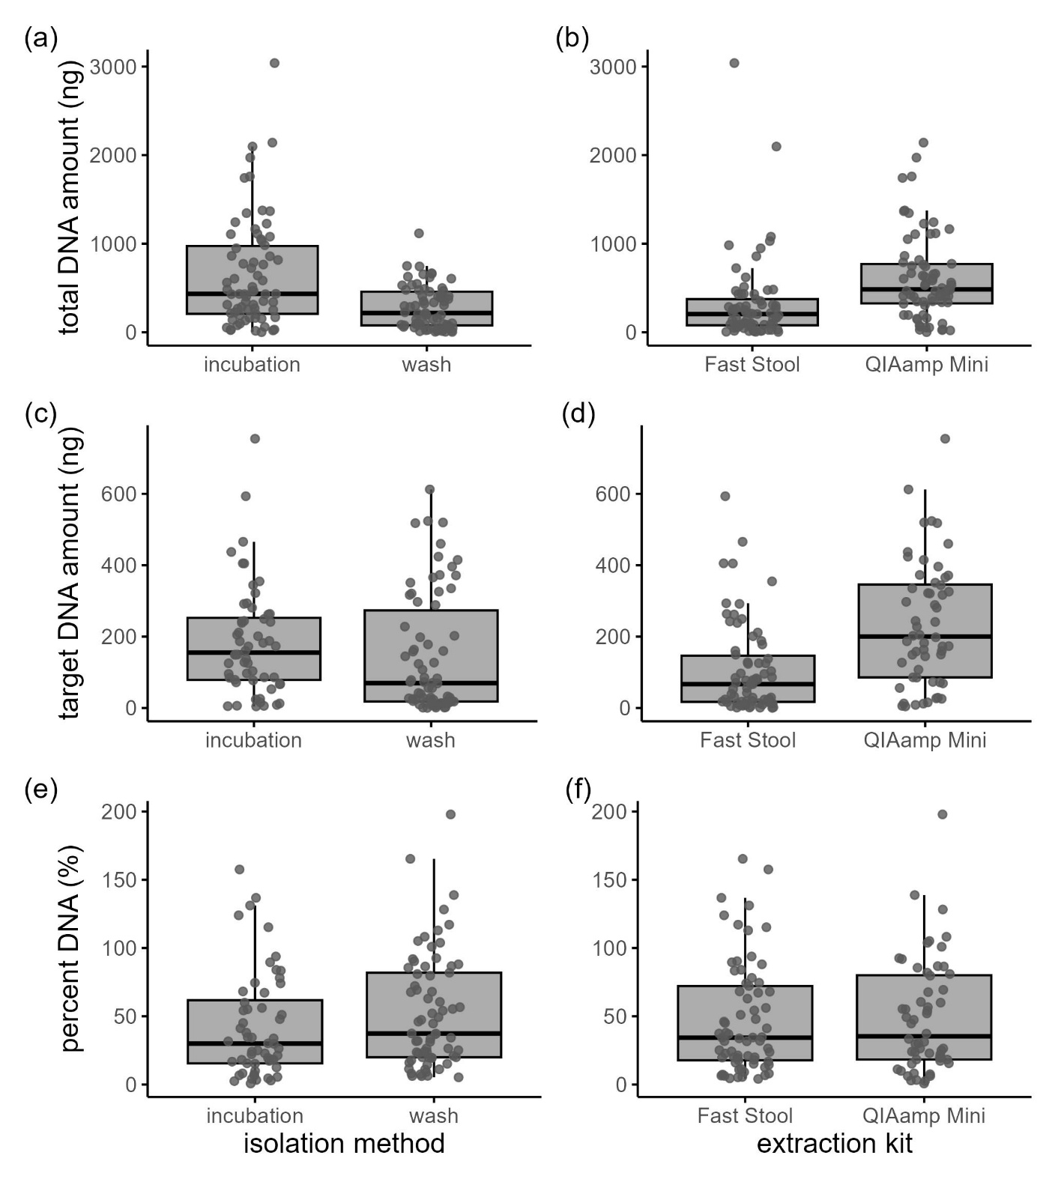
Supplementary Fig. S4 Total and target DNA yield (ng) eluted in 400ul of water, and percent of total DNA which was caribou DNA (target (ng) / total (ng); %), categorized by the two isolation protocols (a, c, e) and extraction kits (b, d, f) which were chosen for comparison with samples from multiple populations. Sample size was 140 fecal pellets (70 pellets per isolation treatment, 70 pellets per extraction kit).

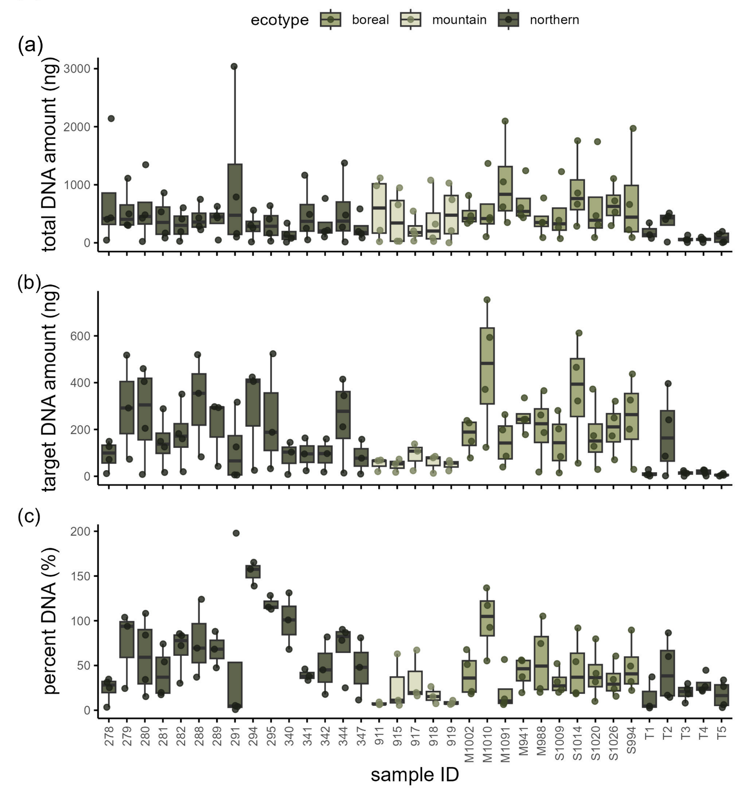

Supplementary Fig. S5 Total (a) and target (b) DNA yield (ng) eluted in 400ul of water, and percent of total DNA which was caribou DNA (target (ng) / total (ng); %) (c), categorized by sample ID and color coded by population ecotype. Sample size was 140 fecal pellets (4 pellets per sample ID).
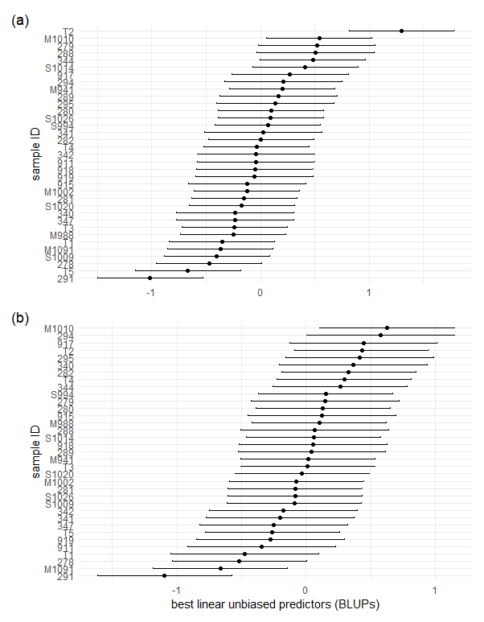
Supplementary Fig. S6 Best linear unbiased predictors (BLUPs) for the random effect sample ID from the linear mixed effect models of log transformed (a) target (ng) and (b) percent DNA (%) obtained by extracting DNA from woodland caribou fecal pellets using 4 combinations of isolation methods and QIAGEN extraction kits. Each point represents how much each sample ID deviates from the overall average log DNA yield, after accounting for the fixed effects (isolation method and extraction kit). Conditional modes (BLUPs) were extracted using the ranef function in the R package lme4 (Bates et al. 2015). Bars represent 95% confidence intervals.
Supplementary Table S6. Parameter coefficient estimates for the linear model of (log transformed) total DNA (ng) obtained by extracting woodland caribou fecal pellets using 4 combinations of isolation methods and QIAGEN extraction kits. ½-hour incubation, Fast Stool, and Barkerville were used as reference levels and therefore do not appear in the table.
Variable | Estimate | Std. Error | P-value
Wash  QIAamp Mini kit  Charlotte Alplands  Itcha-Ilgachuz  Tweedsmuir  Rainbows  Maxhamish  Snake-Sahtaneh  Wash:QIAamp Mini | -1.622  0.222  0.601  0.144  -0.963  0.479  1.081  1.017  1.490 | 0.248  0.246  0.325  0.325  0.330  0.325  0.325  0.325  0.349 | < 0.001  0.368  0.067  0.659  0.004  0.143  0.001  0.002  < 0.001

Supplementary Table S7. Parameter coefficient estimates for the linear mixed effect model of (log transformed) target (caribou) DNA (ng) obtained by extracting woodland caribou fecal pellets using 4 combinations of isolation methods and QIAGEN extraction kits. ½-hour incubation, Fast Stool, and Barkerville were used as reference levels and therefore do not appear in the table.
Variable | Estimate | Std. Error | P-value
Wash  QIAamp Mini kit  Charlotte Alplands  Itcha-Ilgachuz  Tweedsmuir  Rainbows  Maxhamish  Snake-Sahtaneh  Wash:QIAamp Mini | -1.877  -0.102  0.793  0.366  -1.424  0.922  1.245  1.068  2.375 | 0.135  0.161  0.381  0.384  0.381  0.384  0.381  0.381  0.210 | < 0.001  0.529  0.046  0.349  < 0.001  0.023  0.003  0.009  < 0.001

Supplementary Table S8. Parameter coefficient estimates for the linear mixed effect model of (log transformed) percent DNA (%) obtained by extracting woodland caribou fecal pellets using 4 combinations of isolation methods and QIAGEN extraction kits. ½-hour incubation, Fast Stool, and Barkerville were used as reference levels and therefore do not appear in the table.
Variable | Estimate | Std. Error | P-value
(Intercept)  Wash  QIAamp Mini kit  Charlotte Alplands  Itcha-Ilgachuz  Tweedsmuir  Rainbows  Maxhamish  Snake-Sahtaneh  Wash:QIAamp Mini | 2.669  -0.335  -0.924  1.260  1.348  0.503  1.478  1.241  1.122  1.555 | 0.284  0.153  0.182  0.377  0.381  0.378  0.381  0.376  0.376  0.237 | < 0.001  0.031  < 0.001  0.002  0.001  0.193  < 0.001  0.002  0.006  < 0.001

Supplementary Table S9. Summary of ANOVA results for the linear mixed effects models of (log transformed) total (ng), target (ng), and percent DNA (%) obtained by extracting DNA from woodland caribou fecal pellets using 4 combinations of isolation methods and QIAGEN extraction kits. Samples from 7 caribou populations were used. ANOVA tables generated using the R package lmerTest (Kuznetsova et al. 2017).
Model, variable | Df | Sum sq | Mean sq | F-value | P-value
Total DNA  Isolation method  Extraction kit  Population  Isolation method:Extraction kit  Target DNA  Isolation method  Extraction kit  Population  Isolation method:Extraction kit  Percent DNA  Isolation method  Extraction kit  Population  Isolation method:Extraction kit | 1  1  6  1  1  1  6  1  1  1  6  1 | 24.88  30.88  56.22  19.27  13.67  33.88  23.15  40.55  5.567  0.610  9.791  17.31 | 24.88  30.88  9.370  19.27  13.67  33.88  3.86  40.55  5.570  0.610  1.632  17.31 | 23.54  29.21  8.864  18.23  43.04  106.7  12.15  127.7  13.82  1.513  4.049  42.95 | < 0.001  < 0.001  < 0.001  < 0.001  < 0.001  < 0.001  < 0.001  < 0.001  < 0.001  0.222  0.005  < 0.001

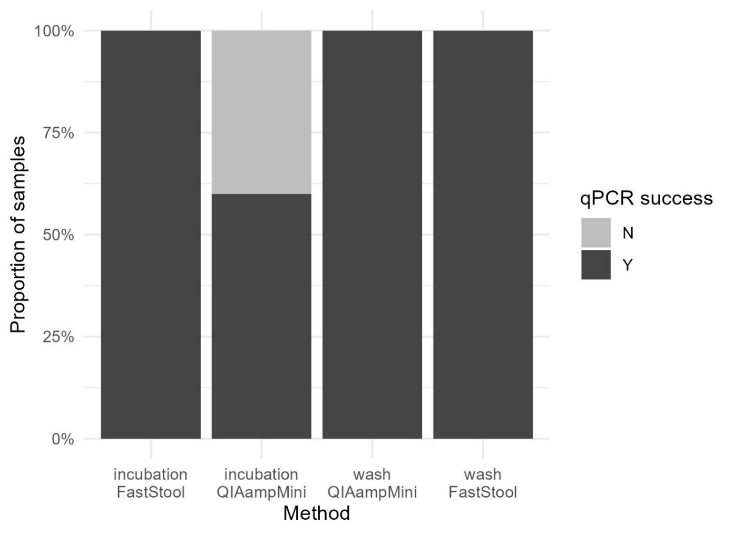
Supplementary Fig. S7 Bar plot showing proportion of fecal DNA extracts which successfully amplified in qPCR, categorized by method combination. Sample size was 140 fecal pellets (35 pellets per isolation-extraction combination).

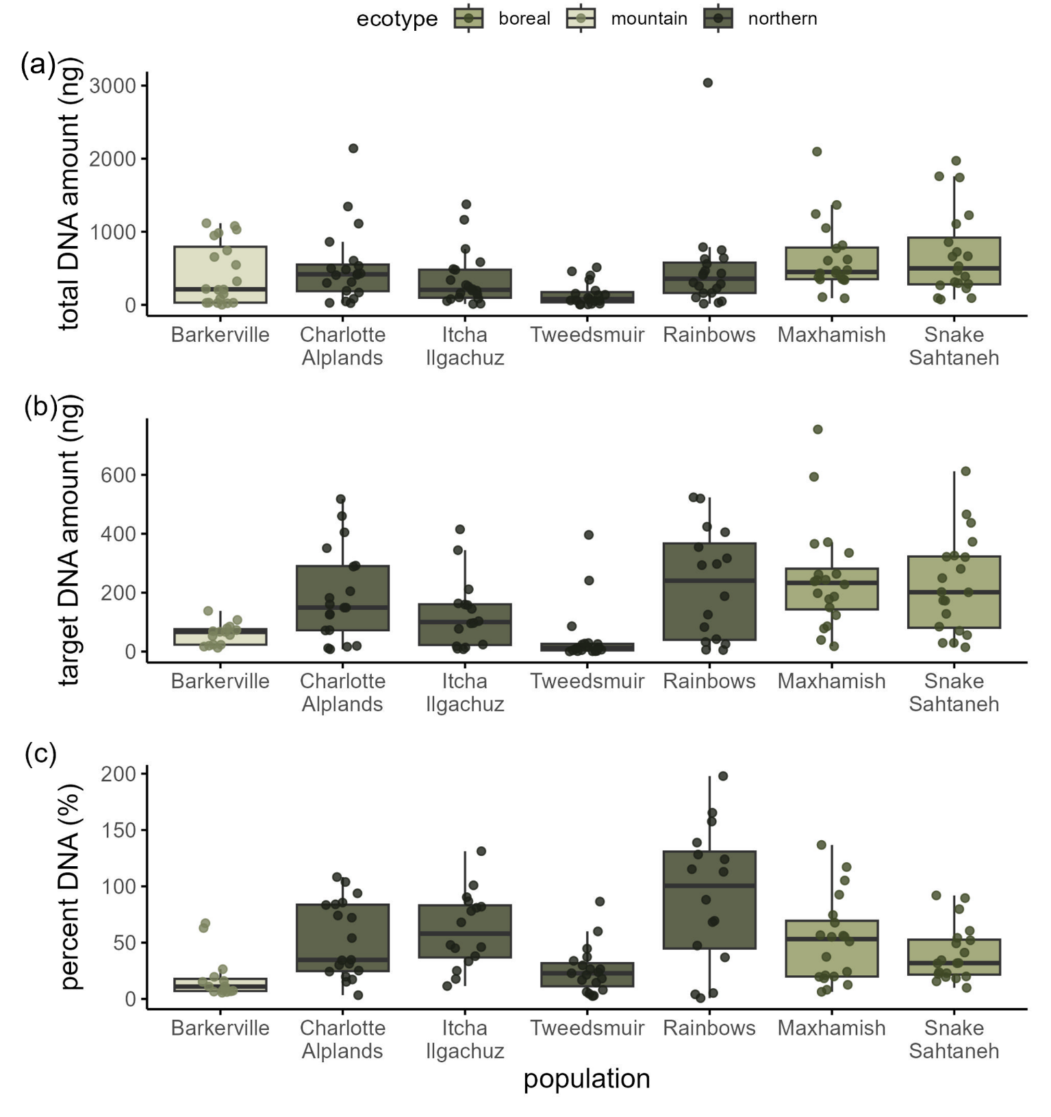
Supplementary Fig. S8 Total (a) and target (b) DNA yield (ng) eluted in 400ul of water, and percent of total DNA which was caribou DNA (target (ng) / total (ng); %) (c), categorized by each of the 7 populations sampled in this study. Color represents the BC caribou ecotype that each population has been classified as. Sample size was 140 fecal pellets (20 pellets from each population).

Experimental Protocols
Treatment 1. DNA Extraction with Washing and QIAamp DNA Mini Kit
Required Materials:
- QIAamp DNA Mini Kit contents
- Filtered pipette tips (1250uL, 200uL, 20uL)
- 15mL Falcon tubes
- Plastic weigh boats
- 2mL Eppendorf tubes/microcentrifuge tubes
- Ethanol (96%-100%)
- Molecular grade water heated to 56°C
Make sure to use new gloves for each sample to avoid cross-sample contamination.
Always use filtered tips to avoid cross-contamination.
The QIAamp DNA mini kit (cat. nos. 51304 and 51306) can be stored at room temperature (15–25°C) for up to 1 year if not otherwise stated on label.
- Buffer AL and Buffer ATL may form precipitate upon storage. If necessary, warm to 56C until the precipitates have fully dissolved.
- Vortexing should be performed by pulse-vortexing
- Buffer AW1 and Buffer AW2 are supplied as concentrates. When opening a new kit, add the appropriate amount of 96-100% ethanol as indicated on the bottle.

ISOLATION (Wash Isolation Protocol modified from Taylor et al 2021)
1. place 1 fecal pellet with as much ice removed as possible in a 15mL Falcon tube with 1mL lysis buffer (980ul ATL + 20ul Proteinase K) and gently rotate tube for 90 seconds.
2. pour the contents of the tube out into a plastic weigh boat. Transfer all buffer solution to a 2mL tube.
3. Vortex continuously for 1 min.
4. Centrifuge sample for 1 min to pellet stool particles.
5. Pipette 600ul of the buffer, avoiding fecal debris as much as possible, and put it in a new 2mL Eppendorf tube.
6. incubate the sample at 56°C for 1h.

EXTRACTION (The following steps are adapted from the QIAamp DNA mini kit Quick Start Protocol.)
1.Vortex 15s.
2. Add 600μl Buffer AL. Mix thoroughly by vortexing.
3. Add 600μl ethanol (96–100%). Mix thoroughly by vortexing.
4. Total volume of mixture will be 1800μL. Pipette 600μL of the mixture into a DNeasy Mini spin column placed in a 2 mL collection tube. Centrifuge at ≥6000 x g (8000 rpm) for 1 min. Discard the flow-through and collection tube. Repeat twice until all of the 1800uL has made it through the column. Discard the flow-through and collection tube.
5. Place the spin column in a new 2 mL collection tube. Add 500μL Buffer AW1. Centrifuge for 1 min at ≥6000 x g. Discard the flow-through and collection tube.
6. Place the spin column in a new 2 ml collection tube, add 500μL Buffer AW2 and centrifuge for 3 min at 20,000 x g (14,000 rpm). Discard the flow-through and collection tube. If ethanol carryover occurs, empty the collection tube, then reuse it into another centrifugation for 1 min.
7. Transfer the spin column to a new 2 mL microcentrifuge tube (not provided).
8. Elute the DNA by adding 200μL of molecular grade water warmed up to 56°C to the center of the spin column membrane. Incubate for 1 min at room temperature (15–25°C). Centrifuge for 1 min at ≥6000g (8000 rpm) to elute.
9. Repeat step 8 (this increases DNA yield) to end up with a volume of 400uL.
10. Store DNA samples at –80°C (not –20°C; this is important to prevent DNA degradation).

Treatment 2. DNA Extraction with Washing and QIAamp Fast DNA Stool Mini Kit
Required Materials
- QIAamp Fast DNA Stool Mini Kit contents
- Filtered pipette tips (1250uL, 200uL, 20uL)
- 15mL Falcon tubes
- Plastic weigh boats
- 2mL Eppendorf tubes/microcentrifuge
- Ethanol (96%-100%)
- Molecular grade water heated to 56°C
Notes before starting:
Make sure to use new gloves for each sample to avoid cross-sample contamination.
Always use filtered tips to avoid cross-contamination.
The QIAamp Fast DNA Stool Mini Kit (cat. no. 51604) can be stored at room temperature (15–25°C) for up to 12 months.
- Perform all centrifugation steps at room temperature (15–25°C) at 20,000 x g (~14,000 rpm).
- Redissolve any precipitates in Buffer AL and InhibitEX® Buffer by heating and mixing.
- Add ethanol to Buffer AW1 and Buffer AW2 concentrates.

ISOLATION (Wash Isolation Protocol modified from Taylor et al 2021)
1.place 1 fecal pellet in a 15mL Falcon tube tube with 1mL lysis buffer (980uL InhibitEX + 20ul Proteinase K) and gently rotate tube for 90 seconds.
2. pour the contents of the tube out into a plastic weigh boat. Transfer all buffer solution to 2mL tube.
3. Vortex continuously for 1 min.
4. Centrifuge sample for 1 min to pellet stool particles.
5. Pipette 600uL of the buffer, avoiding fecal debris as much as possible, and put it in a new 2mL Eppendorf tube.

EXTRACTION (the following steps are adapted from protocol for human DNA analysis in the QIAamp Fast DNA Stool Mini Kit quick start protocol).
1. Add 600µL Buffer AL and vortex for 15s. It is essential that the sample and Buffer AL are thoroughly mixed to form a homogeneous solution.
2. Incubate at 70°C for 10 min.
3. Add 600µL of ethanol (96–100%) to the lysate, and mix by vortexing.
4. Carefully apply 600µL lysate to the QIAamp spin column. Close the cap and centrifuge for 1 min. Place the QIAamp spin column in a new 2 mL collection tube, and discard the tube containing the filtrate. Repeat step 10 until all lysate is loaded.
5. Carefully open the QIAamp spin column and add 500µL Buffer AW1. Centrifuge for 1 min. Place the QIAamp spin column in a new 2 ml collection tube, and discard the collection tube containing the filtrate.
6. Carefully open the QIAamp spin column and add 500µL Buffer AW2. Centrifuge for 3 min. Discard the collection tube containing the filtrate.
7. Place the QIAamp spin column in a new 2 mL collection tube (not provided) and discard the old collection tube with the filtrate. Centrifuge for 3 min.
8. Transfer the QIAamp spin column into a new, labeled 1.5 mL microcentrifuge tube (not provided)
9. pipette 200µL molecular grade water warmed up to 56°C directly onto the QIAamp membrane. Incubate for 1 min at room temperature, then centrifuge for 1 min (at ≥6000g (8000 rpm)) to elute DNA.
10. Repeat step 9 (this increases DNA yield) to end up with a volume of 400uL.
11. Store DNA samples at –80°C (not –20°C; this is important to prevent DNA degradation).

Treatment 3. DNA Extraction with Washing and DNeasy PowerSoil Pro DNA Kit
Required Materials
- DNeasy PowerSoil Pro DNA Kit contents
- Filtered pipette tips (1250uL, 200uL, 20uL)
- 15mL Falcon tubes
- Plastic weigh boats
- 2mL Eppendorf tubes/microcentrifuge
- Ethanol (96%-100%)
- Molecular grade water heated to 56°C
Notes before starting:
Make sure to use new gloves for each sample to avoid cross-sample contamination.
Always use filtered tips to avoid cross-contamination.
Solution CD2 should be stored at 2–8°C. All other reagents and kit components should be stored at room temperature (15–25°C).
- If Solution CD3 has precipitated, heat at 60°C until precipitate dissolves.
- Perform all centrifugation steps at room temperature (15–25°C).

ISOLATION (Wash Isolation Protocol modified from Taylor et al 2021)
1.place 1 fecal pellet with as much ice removed as possible in a 15mL Falcon tube with 800uL CD1 (lysis) buffer.
2. Gently rotate tube for 90 seconds, as demonstrated in the video tutorial.
3. pour the contents of the tube out into a plastic weigh boat. Transfer all buffer solution to a 2mL tube.
4. Transfer as much of the buffer as possible to a 2mL Eppendorf tube.

EXTRACTION (The following steps are from the DNeasy PowerSoil Pro DNA Kit Protocol: Alternative lysis methods – reduction of shearing of DNA; no bead beating)
1. Vortex Eppendorf tube 3-4 sec to mix.
2. Heat to 70°C for 5 minutes. Vortex 3-4 sec. Heat to 70°C for another 5 minutes. Vortex 3-4 sec to mix.
3. Centrifuge the tube at 15,000 x g for 1 min.
4. Transfer the supernatant to a clean 2 mL Microcentrifuge Tube. Add 200µL of Solution CD2 and vortex for 5s.
5. Centrifuge at 15,000 x g for 1 min at room temperature. Avoiding the pellet, transfer up to 700µL of supernatant to a clean 2 mL Microcentrifuge Tube (provided).
6. Add 600µL of Solution CD3 and vortex for 5s.
7. Load 650µL of the lysate onto an MB Spin Column and centrifuge at 15,000 x g for 1 min.
8. Discard the flow-through and repeat step 8 to ensure that all lysate has passed through the MB Spin Column.
9. Carefully place the MB Spin Column into a clean 2 mL Collection Tube (provided). Avoid splashing any flow-through onto the MB Spin Column.
10. Add 500µL of Solution EA to the MB Spin Column. Centrifuge at 15,000 x g for 1 min.
11. Discard the flow-through and place the MB Spin Column back into the same 2 mL Collection Tube.
12. Add 500 µL of Solution C5 to the MB Spin Column. Centrifuge at 15,000 x g for 1 min.
13. Discard the flow-through and place the MB Spin Column into a new 2 mL Collection Tube (provided).
14. Centrifuge at up to 16,000 x g for 2 min. Carefully place the MB Spin Column into a new 1.5 mL Elution Tube.
15. Add 200µL of molecular grade water to the center of the white filter membrane. Centrifuge at 15,000 x g for 1 min. Discard the MB Spin Column.
16. Repeat step 16 (this increases DNA yield) to end up with a volume of 400uL.
17. Store DNA at –80°C (not –20°C; this is important to prevent DNA degradation).

Treatments 4 and 5. DNA Extraction with Incubation and QIAamp DNA Mini Kit
Required Materials
- QIAamp DNA Mini Kit contents
- Filtered pipette tips (1250uL, 200uL, 20uL)
- 50mL Falcon tubes
- Plastic weigh boats
- 2mL Eppendorf tubes/microcentrifuge
- Ethanol (96%-100%)
- Molecular grade water heated to 56°C
Notes before starting:
Make sure to use new gloves for each sample to avoid cross-sample contamination.
Always use filtered tips to avoid cross-contamination.
Label tubes using an ethanol-resistant lab marker, not a regular sharpie.
The QIAamp DNA mini kit (cat. nos. 51304 and 51306) can be stored at room temperature (15–25°C) for up to 1 year.
- Perform all centrifugation steps at room temperature (15–25°C).
- Buffer AL and Buffer ATL may form precipitate upon storage. If necessary, warm to 56C until the precipitates have fully dissolved.
- Vortexing should be performed by pulse-vortexing
- Buffer AW1 and Buffer AW2 are supplied as concentrates. When opening a new kit, add appropriate amount of 96-100% ethanol as indicated on the bottle.

ISOLATION
1. place 1 fecal pellet in a 50mL falcon tube with 1mL of lysis buffer (980ul ATL + 20ul Proteinase K).
2. Let the tube swirl gently on a rotating platform rotating platform at 200 rpm for 30min (Treatment 4) or 1h (Treatment 5) at 56°C.
3. pour the contents of the tube out into a plastic weigh boat. Transfer as much of the buffer solution as possible to a 2ml tube.

EXTRACTION (The following steps are adapted from the QIAamp DNA mini kit Quick Start Protocol.)
1.Vortex 15s.
2. Add 600μl Buffer AL. Mix thoroughly by vortexing.
3. Add 600μl ethanol (96–100%). Mix thoroughly by vortexing.
4. Total volume of mixture will be 1800 μl. Pipet 600 μl of the mixture into a DNeasy Mini spin column placed in a 2 ml collection tube. Centrifuge at ≥6000 x g (8000 rpm) for 1 min. Discard the flow-through and collection tube. Repeat twice until all of the 1800ul has made it through the column. Discard the flow-through and collection tube.
5. Place the spin column in a new 2 ml collection tube. Add 500 μl Buffer AW1. Centrifuge for 1 min at ≥6000 x g. Discard the flow-through and collection tube.
6. Place the spin column in a new 2 ml collection tube, add 500 μl Buffer AW2 and centrifuge for 3 min at 20,000 x g (14,000 rpm). Discard the flow-through and collection tube. If ethanol carryover occurs, empty the collection tube, then reuse it into another centrifugation for 1 min.
7. Transfer the spin column to a new 2 ml microcentrifuge tube (not provided).
8. Elute the DNA by adding 200 μl of molecular grade water warmed up to 56C to the center of the spin column membrane. Incubate for 1 min at room temperature (15–25°C). Centrifuge for 1 min at ≥6000g (8000 rpm) to elute.
9. Repeat step 8 (this increases DNA yield) to end up with a volume of 400ul.
10. Store DNA samples at –80C (not –20C; this is important to prevent DNA degradation).

Treatments 6 and 7. DNA Extraction with Incubation and QIAamp Fast DNA Stool Mini Kit
Required Materials
- QIAamp Fast DNA Stool Mini Kit contents
- Filtered pipette tips (1250uL, 200uL, 20uL)
- 50mL Falcon tubes
- Plastic weigh boats
- 2mL Eppendorf tubes/microcentrifuge
- Ethanol (96%-100%)
- Molecular grade water heated to 56°C
Notes before starting:
Make sure to use new gloves to avoid cross-sample contamination.
Always use filtered tips to avoid cross-contamination.
Label tubes using an ethanol-resistant lab marker, not a regular sharpie.
The QIAamp Fast DNA Stool Mini Kit (cat. no. 51604) can be stored at room temperature (15–25°C) for up to 12 months.
- Prepare a thermomixer with 2 ml inlays or a water bath at 70°C for use in steps 3 and 8.
- Perform all centrifugation steps at room temperature (15–25°C) at 20,000 x g (~14,000 rpm).
- Redissolve any precipitates in Buffer AL and InhibitEX® Buffer by heating and mixing.
- Add ethanol to Buffer AW1 and Buffer AW2 concentrates.

ISOLATION
1. place 1 fecal pellet in a 50mL falcon tube with 1mL of lysis buffer (980ul InhibitEX + 20ul Proteinase K)
2. Let the tube swirl gently on a rotating platform at 200 rpm for 30min (Treatment 6) or 1h (Treatment 7) at 56°C.
3. pour the contents of the tube out into a plastic weigh boat. Transfer as much of the buffer solution as possible to a 2ml tube.

EXTRACTION (The following steps are adapted from protocol for human DNA analysis in QIAamp Fast DNA Stool Mini Kit quick start protocol)
1. Vortex continuously for 1 min.
2. Centrifuge sample for 1 min to pellet stool particles.
3. Pipette 600ul of supernatant into a new 2ml microcentrifuge tube.
4. Add 600 µl Buffer AL and vortex for 15 s.
5. Incubate at 70°C for 10 min.
6. Add 600 µl of ethanol (96–100%) to the lysate and mix by vortexing.
7. Carefully apply 600 µl lysate to the QIAamp spin column. Centrifuge for 1 min. Place the QIAamp spin column in a new 2 ml collection tube and discard the tube containing the filtrate. Repeat until all lysate is loaded.
8. Carefully open the QIAamp spin column and add 500 µl Buffer AW1. Centrifuge for 1 min. Place the QIAamp spin column in a new 2 ml collection tube and discard the collection tube containing the filtrate.
9. Carefully open the QIAamp spin column and add 500 µl Buffer AW2. Centrifuge for 3 min. Discard the collection tube containing the filtrate.
10. Place the QIAamp spin column in a new 2 ml collection tube (not provided) and discard the old collection tube with the filtrate. Centrifuge for 3 min.
11. Transfer the QIAamp spin column into a new, labeled 1.5 ml microcentrifuge tube (not provided)
12. pipette 200 µl molecular grade water warmed up to 56°C directly onto the QIAamp membrane. Incubate for 1 min at room temperature, then centrifuge for 1 min (at ≥6000g (8000 rpm)) to elute DNA.
13. Repeat step 12 (this increases DNA yield) to end up with a volume of 400ul.
14. Store DNA samples at –80°C (not –20°C; this is important to prevent DNA degradation).

Treatments 8 and 9. DNA Extraction with Incubation and DNeasy PowerSoil Pro DNA Kit
Required Materials
- DNeasy PowerSoil Pro DNA Kit contents
- Filtered pipette tips (1250uL, 200uL, 20uL)
- 50mL Falcon tubes
- Plastic weigh boats
- 2mL Eppendorf tubes/microcentrifuge
- Ethanol (96%-100%)
- Molecular grade water heated to 56°C
Notes before starting:
Make sure to use new gloves for each sample to avoid cross-sample contamination.
Always use filtered tips to avoid cross-contamination.
Solution CD2 should be stored at 2–8°C. All other kit components should be stored at room temperature (15–25°C).
- If Solution CD3 has precipitated, heat at 60°C until precipitate dissolves.
- Perform all centrifugation steps at room temperature (15–25°C).

ISOLATION
1. place 1 fecal pellet in a 50mL falcon tube with 800uL of CD1 (lysis) buffer
2. Let the tube swirl gently on a rotating platform (at 200 rpm) for 30min or 1h at 56°.
3. pour the contents of the tube out into a plastic weigh boat. Transfer all buffer solution to a 2ml tube.

EXTRACTION (The following steps are adapted from the DNeasy PowerSoil Pro DNA Kit Protocol: Alternative lysis methods – reduction of shearing of DNA; no bead beating)
1. Vortex Eppendorf tube 3-4 sec to mix.
2. Heat to 70°C for 5 minutes. Vortex 3-4 sec. Heat to 70°C for another 5 minutes. Vortex 3-4 sec to mix.
3. Centrifuge the tube at 15,000 x g for 1 min.
4. Transfer the supernatant to a clean 2 ml Microcentrifuge Tube (provided).
5. Add 200 µl of Solution CD2 and vortex for 5s.
6. Centrifuge at 15,000 x g for 1 min at room temperature. Avoiding the pellet, transfer up to 700 µl of supernatant to a clean 2 ml Microcentrifuge Tube (provided).
7. Add 600 µl of Solution CD3 and vortex for 5s.
8. Load 650 µl of the lysate onto an MB Spin Column and centrifuge at 15,000 x g for 1 min.
9. Discard the flow-through and repeat step 8 to ensure that all lysate has passed through the MB Spin Column.
10. Carefully place the MB Spin Column into a clean 2 ml Collection Tube. Avoid splashing flow-through onto the MB Spin Column.
11. Add 500 µl of Solution EA to the MB Spin Column. Centrifuge at 15,000 x g for 1 min.
12. Discard the flow-through and place the MB Spin Column back into the same 2 ml Collection Tube.
13. Add 500 µl of Solution C5 to the MB Spin Column. Centrifuge at 15,000 x g for 1 min.
14. Discard the flow-through and place the MB Spin Column into a new 2 ml Collection Tube (provided).
15. Centrifuge at up to 16,000 x g for 2 min. Carefully place the MB Spin Column into a new 1.5 ml Elution Tube
16. Add 200 µl of molecular grade water to the center of the white filter membrane.
17. Centrifuge at 15,000 x g for 1 min. Discard the MB Spin Column.
18. Repeat steps 16-17 (this increases DNA yield) to end up with a volume of 400ul.
19. Store DNA at –80°C (not –20°C; this is important to prevent DNA degradation).

Treatment 10. DNA Extraction from Toothpicks with QIAamp DNA Mini Kit
Required Materials
- QIAamp DNA Mini Kit contents
- Filtered pipette tips (1250uL, 200uL, 20uL)
- Wooden toothpicks
- Scissors
- Plastic weigh boats
- 1.5ml microcentrifuge tubes
- Ethanol (96%-100%)
- Molecular grade water heated to 56°C
Notes before starting:
Use new gloves, a new weigh boat, as well as clean/sterile tweezers for each sample to avoid contamination.
Always use filtered tips to avoid cross-contamination.
The QIAamp DNA Mini Kit (cat. nos. 51304 and 51306) can be stored at room temp (15–25°C) for up to 1 year.
- Redissolve any precipitates in Buffer AL and ATL by heating and mixing.
- Vortexing should be performed by pulse-vortexing
- Buffer AW1 and Buffer AW2 are supplied as concentrates. When opening a new kit, add appropriate amount of 96-100% ethanol as indicated on the bottle.

ISOLATION (Toothpick Isolation Protocol based on info from Parks Canada)
1. Wearing a new pair of gloves for each sample if touching pellets, place a pellet in a clean plastic weigh boat and allow to partially thaw (until ice has melted).
2. Wearing a new pair of gloves for each sample and using tweezers to hold the pellet if needed, use the top quarter of a wooden toothpick to scrape the outer layer of the pellet, being careful not to remove too much fecal material. The mucosal layer will be most obvious at the ends of the pellet.
3. cut the toothpick above a 1.5ml microcentrifuge tube so that the end with mucus falls in the tube.
4. Clean scissors in 70% ethanol and put them over a flame to destroy traces of DNA.

EXTRACTION (The following steps are adapted from the QIAamp DNA Mini kit Quick Start Protocol)
1. Add 360 μl Buffer ATL and 40 μl proteinase K to each sample, mix by vortexing and incubate at 56°C for 1 hour. Place on rocking platform in incubator at 200rpm. Vortex 15 s before proceeding to step 2.
2. Add 400 μl Buffer AL. Mix thoroughly by vortexing for 15s. Incubate at 70C for 10min. Briefly centrifuge the tube to remove drops from the lid
3. Add 400 μl ethanol (96–100%). Mix thoroughly by vortexing for 15s.
4. Pipet 600 μl of the mixture into a DNeasy Mini spin column placed in a 2 ml collection tube. Centrifuge at ≥6000 x g (8000 rpm) for 1 min. Discard flow-through and collection tube. Repeat until all lysate is loaded.
5. Place the spin column in a new 2 ml collection tube. Add 500 μl Buffer AW1. Centrifuge for 1 min at ≥6000 x g. Discard the flow-through and collection tube.
6. Place the spin column in a new 2 ml collection tube, add 500 μl Buffer AW2 and centrifuge for 3 min at 20,000 x g (14,000 rpm). Discard the flow-through and collection tube. If ethanol carryover occurs, empty the collection tube, then reuse it into another centrifugation for 1 min.
7. Place the QIAamp Mini spin column in a new 2 ml collection tube and centrifuge at full speed for 1 min.
8. Transfer the spin column to a new 2 ml microcentrifuge tube.
9. Elute the DNA by adding 200 μl of molecular grade water warmed up to 56C to the center of the spin column membrane. Incubate for 1 min at room temperature (15–25°C). Centrifuge for 1 min at ≥6000g (8000 rpm) to elute.
10. Repeat step 10 (this increases DNA yield) to end up with a volume of 400ul.
11. Store DNA samples at –80C (not –20C; this is important to prevent DNA degradation).

Treatment 11. DNA Extraction from Toothpicks with QIAamp Fast DNA Stool Mini Kit
Required Materials
- QIAamp Fast DNA Stool Mini Kit contents
- Filtered pipette tips (1250uL, 200uL, 20uL)
- Wooden toothpicks
- Scissors
- Plastic weigh boats
- 1.5ml microcentrifuge tubes
- Ethanol (96%-100%)
- Molecular grade water heated to 56°C
Notes before starting:
Use new gloves, a new weigh boat, as well as clean/sterile tweezers for each sample to avoid contamination.
Always use filtered tips to avoid cross-contamination.
The QIAamp Fast DNA Stool Mini Kit (cat. no. 51604) can be stored at room temperature (15–25°C) for 1 year.
- Perform all centrifugation steps at room temperature (15–25°C) at 20,000 x g (~14,000 rpm).
- Redissolve any precipitates in Buffer AL and InhibitEX® Buffer by heating and mixing.
- Add ethanol to Buffer AW1 and Buffer AW2 concentrates.

ISOLATION (Toothpick Isolation Protocol based on info from Parks Canada)
1. Wearing a new pair of gloves for each sample if touching pellets, place a pellet in a clean plastic weigh boat and allow to partially thaw (until ice has melted).
2. Wearing a new pair of gloves for each sample and using tweezers to hold the pellet if needed, use the top quarter of a wooden toothpick to scrape the outer layer of the pellet, being careful not to remove too much fecal material. The mucosal layer will be most obvious at the ends of the pellet.
3. cut the toothpick above a 1.5ml microcentrifuge tube so that the end with mucus falls in the tube.
4. Clean scissors in 70% ethanol and put them over a flame to destroy traces of DNA.

EXTRACTION (The following steps are adapted from protocol for human DNA analysis in QIAamp Fast DNA Stool Mini Kit quick start protocol).
1. Add 1 ml InhibitEX Buffer to each stool sample. Vortex continuously for 1 min.
2. Centrifuge sample for 1 min to pellet stool particles.
3. Pipet 25 µl Proteinase K into a new 2 ml microcentrifuge tube (not provided).
4. Pipet 600 µl supernatant from step 3 into the 2 ml microcentrifuge tube containing Proteinase K.
5. Add 600 µl Buffer AL and vortex for 15 s. Incubate at 70°C for 10 min.
6. Add 600 µl of ethanol (96–100%) to the lysate and mix by vortexing.
7. Carefully apply 600 µl lysate from step 9 to the QIAamp spin column. Centrifuge for 1 min. Place the spin column in a new 2 ml collection tube and discard the tube containing the filtrate. Repeat until all lysate is loaded.
8. Carefully open the QIAamp spin column and add 500 µl Buffer AW1. Centrifuge for 1 min. Place the QIAamp spin column in a new 2 ml collection tube and discard the collection tube containing the filtrate.
9. Carefully open spin column and add 500 µl Buffer AW2. Centrifuge 3 min. Discard old collection tube/filtrate.
10. Place spin column in a new 2 ml collection tube and discard the old collection tube/filtrate. Centrifuge for 3 min.
11. Transfer the QIAamp spin column into a new, labeled 1.5 ml microcentrifuge tube (not provided)
12. pipet 200 µl molecular grade water warmed up to 56°C directly onto the QIAamp membrane. Incubate for 1 min at room temperature, then centrifuge for 1 min (at ≥6000g (8000 rpm)) to elute DNA.
13. Repeat step 14 (this increases DNA yield) to end up with a volume of 400ul.
14. Store DNA samples at –80°C (not –20°C; this is important to prevent DNA degradation).

Treatment 12. DNA Extraction from Toothpicks with DNeasy PowerSoil Pro DNA Kit
Required Materials
- DNeasy PowerSoil Pro DNA Kit contents
- Filtered pipette tips (1250uL, 200uL, 20uL)
- Wooden toothpicks
- Scissors
- Plastic weigh boats
- 1.5ml microcentrifuge tube
- Ethanol (96%-100%)
- Molecular grade water heated to 56°C
Notes before starting:
Use new gloves, a new weigh boat, as well as clean/sterile tweezers for each sample to avoid contamination.
Always use filtered tips to avoid cross-contamination.
Solution CD2 should be stored at 2–8°C. All other kit components should be stored at room temperature (15–25°C).
- If Solution CD3 has precipitated, heat at 60°C until precipitate dissolves.
- Perform all centrifugation steps at room temperature (15–25°C).

ISOLATION (Toothpick Isolation Protocol based on info from Parks Canada)
1. Wearing a new pair of gloves for each sample if touching pellets, place a pellet in a clean plastic weigh boat and allow to partially thaw (until ice has melted).
2. Wearing a new pair of gloves for each sample and using tweezers to hold the pellet if needed, use the top quarter of a wooden toothpick to scrape the outer layer of the pellet, being careful not to remove too much fecal material. The mucosal layer will be most obvious at the ends of the pellet.
3. cut the toothpick above a 1.5ml microcentrifuge tube so that the end with mucus falls in the tube.
4. Clean scissors in 70% ethanol and put them over a flame to destroy traces of DNA.

EXTRACTION (The following steps are adapted from the DNeasy PowerSoil Pro DNA Kit Protocol: Alternative lysis methods – reduction of shearing of DNA).
1. Add 800 µl of Solution CD1 to the tube containing toothpicks. Vortex 3-4 sec to mix.
2. Heat to 70°C for 5 minutes. Vortex 3-4 sec. Heat to 70°C for another 5 minutes. Vortex 3-4 sec to mix.
3. Centrifuge the tube at 15,000 x g for 1 min.
4. Transfer the supernatant to a clean 2 ml Microcentrifuge Tube. Add 200 µl of Solution CD2 and vortex for 5s.
5. Centrifuge at 15,000 x g for 1 min. Avoiding the pellet, transfer up to 700 µl of supernatant to a clean 2ml tube.
6. Add 600 µl of Solution CD3 and vortex for 5s.
7. Load 650 µl of the lysate onto an MB Spin Column and centrifuge at 15,000 x g for 1 min. Discard the flow-through and repeat until all the lysate has passed through the MB Spin Column.
8. Carefully place spin column into a clean 2ml collection tube. Avoid splashing flow-through onto the spin column.
9. Add 500 µl of Solution EA to the MB Spin Column. Centrifuge at 15,000 x g for 1 min.
10. Discard the flow-through and place the MB Spin Column back into the same 2 ml Collection Tube.
11. Add 500 µl of Solution C5 to the MB Spin Column. Centrifuge at 15,000 x g for 1 min. Discard the flow-through and place the MB Spin Column into a new 2 ml Collection Tube (provided).
12. Centrifuge at up to 16,000 x g for 2 min. Carefully place the MB Spin Column into a new 1.5 ml Elution Tube
13. Add 200 µl of molecular grade water to the center of the white filter membrane. Centrifuge at 15,000 x g for 1 min. Discard the MB Spin Column.
14. Repeat step 15 (this increases DNA yield) to end up with a volume of 400ul.
15. Store DNA at –80°C (not –20°C; this is important to prevent DNA degradation).

Treatment 13. DNA Extraction with Swabs and QIAamp DNA Mini Kit
Required Materials
- QIAamp DNA Mini Kit contents
- Filtered pipette tips (1250uL, 200uL, 20uL)
- Sterile cotton-tipped swabs
- Scissors
- Plastic weigh boats
- 1.5ml microcentrifuge tube
- Ethanol (96%-100%)
- Molecular grade water heated to 56°C
Notes before starting:
Use new gloves, a new weigh boat, as well as clean/sterile tweezers for each sample to avoid contamination.
Always use filtered tips to avoid cross-contamination.
The QIAamp DNA Mini Kit (cat. nos. 51304 and 51306) can be stored at room temperature (15–25°C) for up to 12 months.
- Perform all centrifugation steps at room temperature (15–25°C).
- Buffer AL and Buffer ATL may form precipitate; mix and heat until dissolved
- Vortexing should be performed by pulse-vortexing
- Buffer AW1 and Buffer AW2 are supplied as concentrates. When opening a new kit, add appropriate amount of 96-100% ethanol as indicated on the bottle.

ISOLATION (Swab Isolation Protocol adapted from Ball et al 2007)
1.Thaw 1 pellet in 2mL of 0.1 M Phosphate Buffered Saline (PBS) using a disposable weigh boat for 5 minutes.
2. Wearing a new pair of gloves for each sample and tweezers to hold the pellet, gently rub the surface of the pellet with a sterile cotton swab to remove the mucosal layer. Minimize the amount of fecal material that is removed.
3. cut the swab above a 1.5ml microcentrifuge tube so that the end with mucus falls in the tube.

EXTRACTION (The following steps are adapted from the QIAamp DNA Mini kit Quick Start Protocol.)
1. Add 360 μl Buffer ATL and 40 μl proteinase K to each sample, mix by vortexing and incubate at 56°C for 1 hour. Place on a rocking platform in the incubator at 200rpm. Vortex 15 s directly before proceeding to step 2.
2. Add 400 μl Buffer AL. Mix thoroughly by vortexing for 15s.
3. Incubate at 70C for 10min. Briefly centrifuge the tube to remove drops from the lid.
4. Add 400 μl ethanol (96–100%). Mix thoroughly by vortexing for 15s.
5. Total volume of mixture will be 1200 μl. Pipet 600 μl of the mixture into a DNeasy Mini spin column placed in a 2 ml collection tube. Centrifuge at ≥6000 x g (8000 rpm) for 1 min. Discard the collection tube/flow-through and repeat until all the lysate has passed through the DNeasy Spin Column.
6. Place the spin column in a new 2 ml collection tube. Add 500 μl Buffer AW1. Centrifuge for 1 min at ≥6000 x g. Discard the flow-through and collection tube.
7. Place the spin column in a new 2 ml collection tube, add 500 μl Buffer AW2 and centrifuge for 3 min at 20,000 x g (14,000 rpm). Discard the flow-through and collection tube. If ethanol carryover occurs, empty the collection tube, then reuse it into another centrifugation for 1 min.
8. Place the QIAamp Mini spin column in a new 2 ml collection tube and centrifuge at full speed for 1 min.
9. Transfer the spin column to a new 2 ml microcentrifuge tube (not provided).
10. Elute the DNA by adding 200 μl of molecular grade water warmed up to 56C to the center of the spin column membrane. Incubate for 1 min at room temperature (15–25°C). Centrifuge for 1 min at ≥6000g (8000 rpm) to elute.
11. Repeat step 10 (this increases DNA yield) to end up with a volume of 400ul.
12. Store DNA samples at –80°C (not –20°C; this is important to prevent DNA degradation).

Treatment 14. DNA Extraction with Swabs and QIAamp Fast DNA Stool Mini Kit
Required Materials
- QIAamp Fast DNA Stool Mini Kit contents
- Filtered pipette tips (1250uL, 200uL, 20uL)
- Sterile cotton-tipped swabs
- Scissors
- Plastic weigh boats
- 1.5ml microcentrifuge tube
- Ethanol (96%-100%)
- Molecular grade water heated to 56°C
Notes before starting:
Use new gloves, a new weigh boat, as well as clean/sterile tweezers for each sample to avoid contamination.
Always use filtered tips to avoid cross-contamination.
The QIAamp Fast DNA Stool Mini Kit (cat. no. 51604) can be stored at room temp (15–25°C) for up to 12 months.
- Perform all centrifugation steps at room temperature (15–25°C) at 20,000 x g (~14,000 rpm).
- Redissolve any precipitates in Buffer AL and InhibitEX® Buffer by heating and mixing.
- Add ethanol to Buffer AW1 and Buffer AW2 concentrates.

ISOLATION (Swab Isolation Protocol adapted from Ball et al 2007)
1.Thaw 1 pellet in 2mL of 0.1 M Phosphate Buffered Saline (PBS) using a disposable weigh boat for 5 minutes.
2. Wearing a new pair of gloves for each sample and tweezers to hold the pellet, gently rub the surface of the pellet with a sterile cotton applicator/swab to remove the mucosal layer. Be careful to minimize the amount of fecal material that is removed.
3. cut the swab above a 1.5ml microcentrifuge tube so that the end with mucus falls in the tube.

EXTRACTION (the following steps are adapted from protocol for human DNA analysis in QIAamp Fast DNA Stool Mini Kit quick start protocol).
1. Add 1 ml InhibitEX Buffer to each swab sample. Vortex continuously for 1 min.
2. Centrifuge sample for 1 min to pellet stool particles.
3. Pipet 25 µl Proteinase K into a new 2 ml microcentrifuge tube (not provided).
4. Pipet 600µl supernatant from step 4 into the 2 ml microcentrifuge tube containing Proteinase K.
5. Add 600µl Buffer AL and vortex 15s. Do not add Proteinase K directly to Buffer AL. Incubate at 70°C for 10min.
6. Add 600µl of ethanol (96–100%) to the lysate and mix by vortexing.
7. Carefully apply 600 µl lysate from step 9 to the QIAamp spin column. Centrifuge for 1 min. Place the QIAamp spin column in a new 2 ml collection tube and discard the old tube/filtrate. Repeat until all lysate is loaded.
8. Carefully open the QIAamp spin column and add 500 µl Buffer AW1. Centrifuge for 1 min. Place the QIAamp spin column in a new 2 ml collection tube and discard the collection tube containing the filtrate.
9. Carefully open the spin column and add 500 µl Buffer AW2. Centrifuge 3 min. Discard collection tube/filtrate.
10. Place the spin column in a new 2 ml collection tube and discard old collection tube/filtrate. Centrifuge for 3 min.
11. Transfer the QIAamp spin column into a new, labeled 1.5 ml microcentrifuge tube (not provided)
12. pipette 200 µl molecular grade water warmed up to 56°C directly onto the QIAamp membrane. Incubate for 1 min at room temperature, then centrifuge for 1 min (at ≥6000g (8000 rpm)) to elute DNA.
13. Repeat step 14 (this increases DNA yield) to end up with a volume of 400ul.
14. Store DNA samples at –80°C (not –20°C; this is important to prevent DNA degradation).

Treatment 15. DNA Extraction with Swabs and DNeasy PowerSoil Pro DNA Kit
Required Materials
- DNeasy PowerSoil Pro DNA Kit contents
- Filtered pipette tips (1250uL, 200uL, 20uL)
- Sterile cotton-tipped swabs
- Scissors
- Plastic weigh boats
- 1.5ml microcentrifuge tube
- Ethanol (96%-100%)
- Molecular grade water heated to 56°C
Notes before starting:
Use new gloves, a new weigh boat, as well as clean/sterile tweezers for each sample to avoid contamination.
Always use filtered tips to avoid cross-contamination.
Solution CD2 should be stored at 2–8°C. All other kit components should be stored at room temp (15–25°C).
- If Solution CD3 has precipitated, heat at 60°C until precipitate dissolves.
- Perform all centrifugation steps at room temperature (15–25°C).

ISOLATION (Swab Isolation Protocol adapted from Ball et al 2007)
1. Thaw 1 pellet in 2mL of 0.1 M Phosphate Buffered Saline (PBS) using a disposable weigh boat for 5 minutes.
2. Wearing a new pair of gloves for each sample and tweezers to hold the pellet, gently rub the surface of the pellet with a sterile cotton swab to remove the mucosal layer. Minimize the amount of fecal material that is removed.
3. cut the swab above a 1.5ml microcentrifuge tube so that the end with mucus falls in the tube.

EXTRACTION (The following steps are from the DNeasy PowerSoil Pro DNA Kit Protocol with Alternate Lysis Methods – Reduction of DNA Shearing; no bead beating):
1. Add 800 µl of Solution CD1 to the tube containing swab. Vortex 3-4 sec to mix.
2. Heat to 70°C for 5 minutes. Vortex 3-4 sec. Heat to 70°C for another 5 minutes. Vortex 3-4 sec to mix.
3. Centrifuge the microcentrifuge tube at 15,000 x g for 1 min.
4. Transfer the supernatant to a clean 2 ml Microcentrifuge Tube (provided).
5. Add 200 µl of Solution CD2 and vortex for 5 s.
6. Centrifuge at 15,000 x g for 1 min at room temperature. Avoiding the pellet, transfer up to 700 µl of supernatant to a clean 2 ml Microcentrifuge Tube (provided).
7. Add 600 µl of Solution CD3 and vortex for 5s.
8. Load 650 µl of the lysate onto an MB Spin Column and centrifuge at 15,000 x g for 1 min. Discard flow-through and repeat until all of the lysate has passed through the MB Spin Column.
9. Carefully place spin column into a clean 2ml collection tube. Avoid splashing flow-through onto the spin column.
10. Add 500 µl of Solution EA to the MB Spin Column. Centrifuge at 15,000 x g for 1 min.
11. Discard the flow-through and place the MB Spin Column back into the same 2 ml Collection Tube.
12. Add 500 µl of Solution C5 to the MB Spin Column. Centrifuge at 15,000 x g for 1 min.
13. Discard the flow-through and place the MB Spin Column into a new 2 ml Collection Tube (provided).
14. Centrifuge at up to 16,000 x g for 2 min. Carefully place the MB Spin Column into a new 1.5 ml Elution Tube
15. Add 200 µl of molecular grade water to the center of the white filter membrane. Centrifuge at 15,000 x g for 1 min. Discard the MB Spin Column.
16. Repeat step 15 (this increases DNA yield) to end up with a volume of 400ul.
17. Store DNA at –80°C (not –20°C; this is important to prevent DNA degradation).

