SUPPLEMENTARY MATERIALS

Appendix to the paper:

Effect of Femoral Component Design and Quadriceps Load on Patellofemoral Kinematics After Total Knee Arthroplasty: An In Vitro Cadaveric Study

SUPPLEMENTARY MATERIAL #3

Single specimen kinematic: before and after TKA with traditional femoral component
To provide an intuitive, detailed illustration of quadriceps-induced kinematic effects in native and implanted knees with traditional design implants, this section focuses on one representative specimen (Specimen #1 with traditional femoral component). For each quadriceps parameter (QV_{ML}, QV_{AP}, and QV_{load}), motion curves are shown for all six patellofemoral kinematic components before and after TKA.

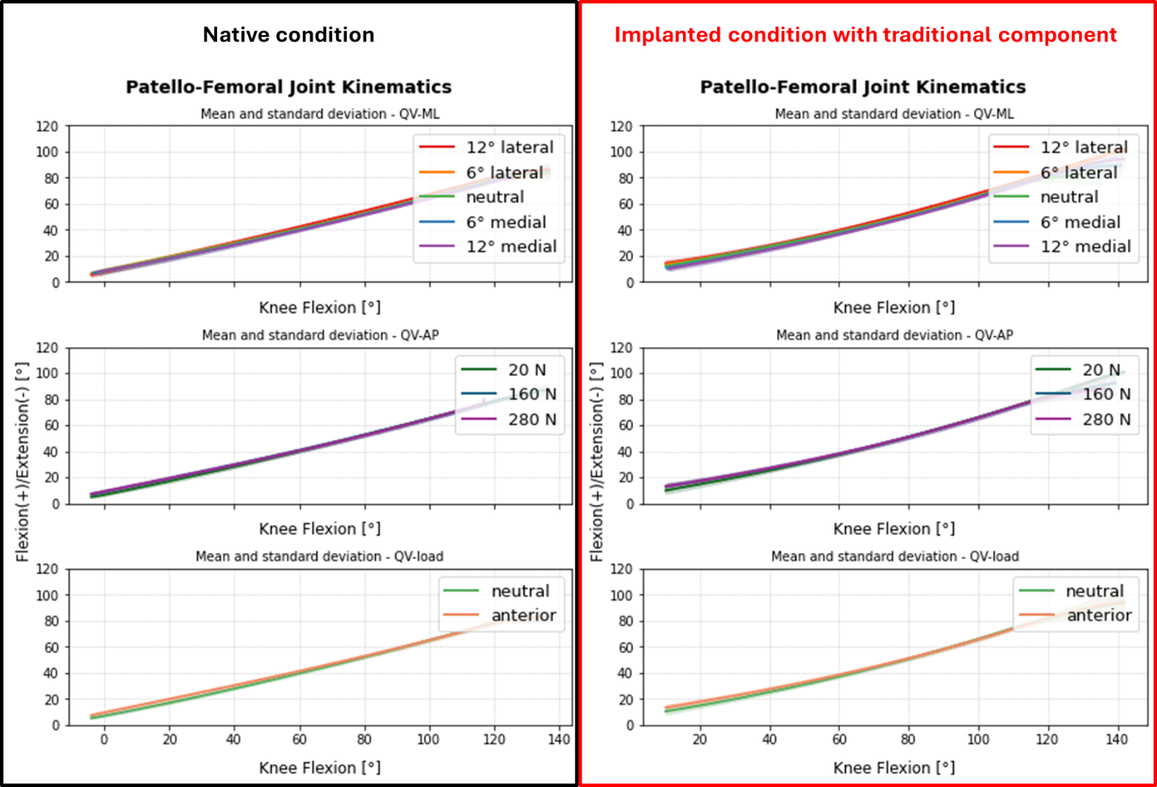
Figure S3_1 Flexion/Extension rotation of one specimen (#1) with respect to the knee flexion for all the tests, grouped by QV-ML in the top, QV-load in the middle and QV-AP in the bottom. On the left, in the black box, the native kinematics; on the right, in the red box, the implanted kinematics with traditional femoral component.
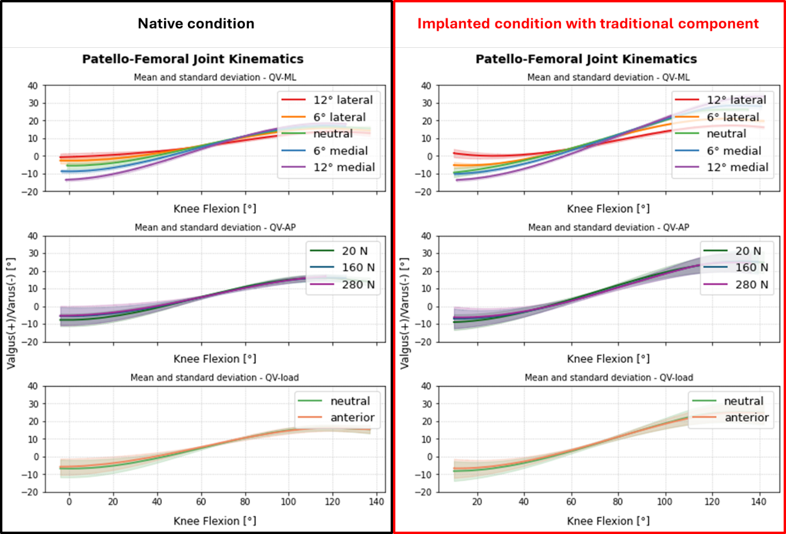
Figure S3_2 Valgus/varus rotation of one specimen (#1) with respect to the knee flexion for all the tests, grouped by QV-ML in the top, QV-load in the middle and QV-AP in the bottom. On the left, in the black box, the native kinematics; on the right, in the red box, the implanted kinematics with traditional femoral component.
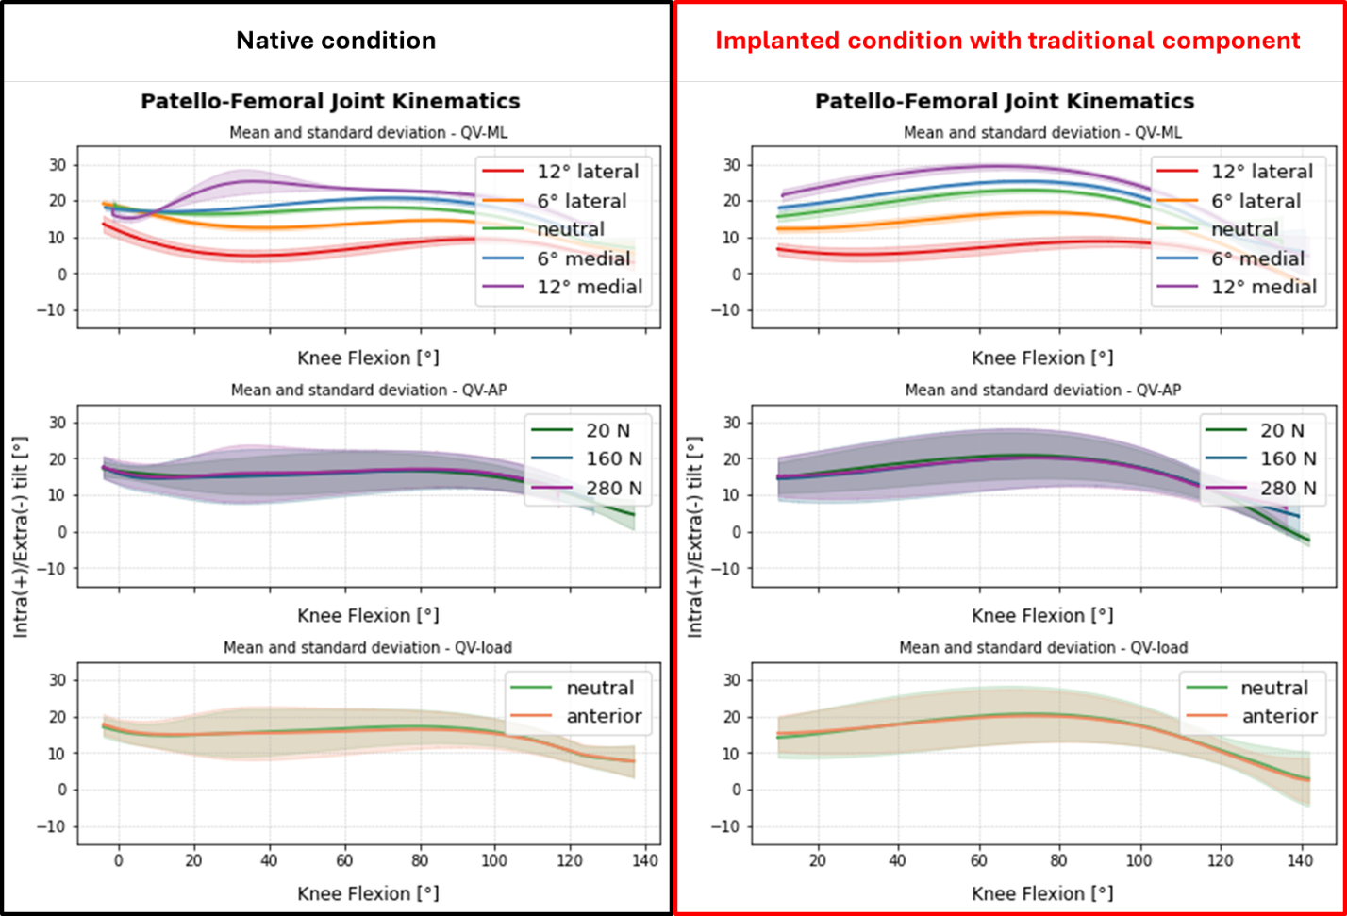
Figure S3_3 Internal/external tilt of one specimen (#1) with respect to the knee flexion for all the tests, grouped by QV-ML in the top, QV-load in the middle and QV-AP in the bottom. On the left, in the black box, the native kinematics; on the right, in the red box, the implanted kinematics with traditional femoral component.
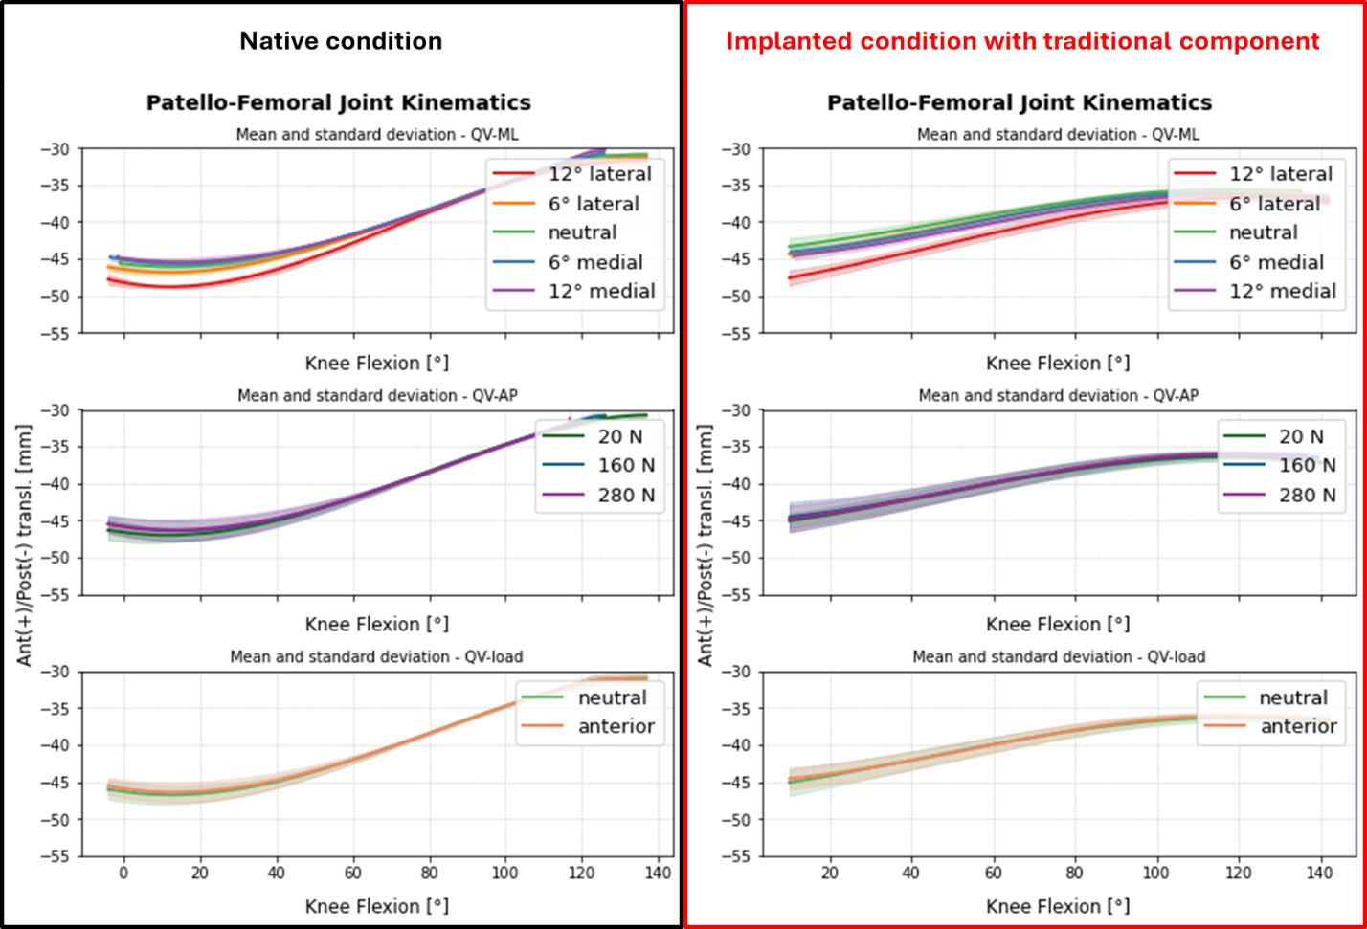
Figure S3_4 Anterior/posterior translation of one specimen (#1) with respect to the knee flexion for all the tests, grouped by QV-ML in the top, QV-load in the middle and QV-AP in the bottom. On the left, in the black box, the native kinematics; on the right, in the red box, the implanted kinematics with traditional femoral component.
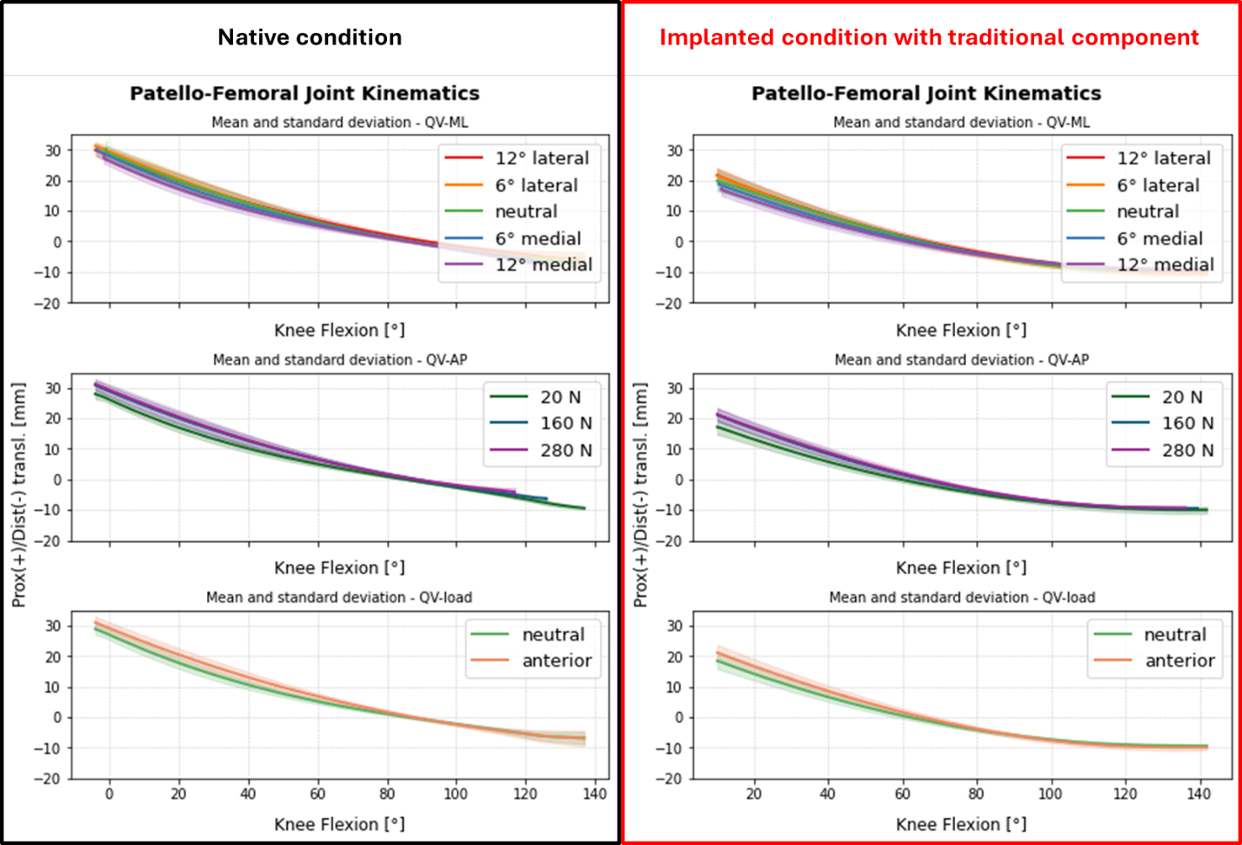
Figure S3_5 Proximal/distal translation of one specimen (#1) with respect to the knee flexion for all the tests, grouped by QV-ML in the top, QV-load in the middle and QV-AP in the bottom. On the left, in the black box, the native kinematics; on the right, in the red box, the implanted kinematics with traditional femoral component.
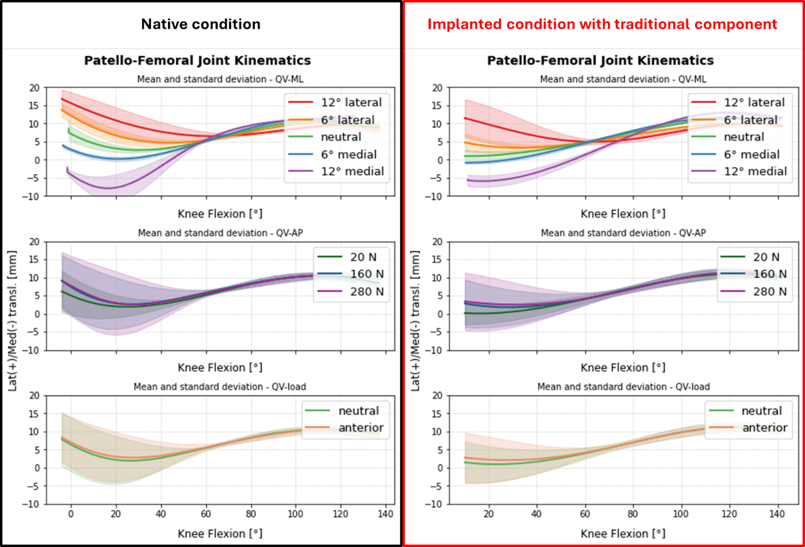
Figure S3_6 Lateral/medial translation of one specimen (#1) with respect to the knee flexion for all the tests, grouped by QV-ML in the top, QV-load in the middle and QV-AP in the bottom. On the left, in the black box, the native kinematics; on the right, in the red box, the implanted kinematics with traditional femoral component.

