APPENDIX
THE WORDING OF ALL QUESTIONS AND RESPONSES
Age
“When were you born?” Select month and year.
Gender
“Are you…?” “Man” / “Woman” / “Other”

Ethnicity
“What best describes you? Are you…”

- “Czech”
- “Moravian”
- “Silesian”
- “Slovak”
- “Ukrainian”
- “Russian”
- “Vietnamese”
- “Roma”
- “Other”

“In what country were you and your parents born?”
(“Czech Republic” / “Other”/ “Don’t know”)
- “You”
- “Your mother”
- “Your father”

Identity processing strategies
“Below you will find a number of statements about beliefs, attitudes or ways of dealing with issues. Read them carefully and indicate on a five-point scale how well they describe you.” (“1 Does not describe” me well at all – “5 Describes me well”)

Informational strategy
- “When facing a life decision, I take into account different points of view before making a choice.”
- “I spend a lot of time reading or talking to others trying to develop a set of values that makes sense to me.”
- “When facing a life decision, I try to analyse the situation in order to understand it.”
- “When making important decisions, I like to have as much information as possible.”
- “It is important for me to obtain and evaluate information from a variety of sources before I make important life decisions.”
Normative strategy
- “I automatically adopt and follow the values I was brought up with.”
- “I think it is better to adopt a firm set of beliefs than to be open-minded.”
- “I think it’s better to hold on to fixed values rather than to consider alternative value systems.”
- “I prefer to deal with situations in which I can rely on social norms and standards.”
- “When I make a decision about my future, I automatically follow what close friends or relatives expect from me.”
Diffuse/avoidant strategy
- “I’m not sure where I’m heading in my life; I guess things will work themselves out.”
- “It doesn’t pay to worry about values in advance; I decide things as they happen.”
- “I am not really thinking about my future now, it is still a long way off.”
- “I try to avoid personal situations that require me to think a lot and deal with them on my own.”
- “When personal problems arise, I try to delay acting as long as possible.”

Attitudes toward outgroups
“We would like to know your attitudes toward selected social groups. How do you feel about members of the following groups? Please indicate your answer on a 0-100 scale, where “0” indicates very negative attitude, “100” very positive attitude, and 50 stands for ambivalence.”
(“0 Negative” – “100 Positive”)
- “Czechs”
- “Slovaks”
- “Roma”
- “Ukrainians”
- “Vietnamese”
- “Russians”

FIGURES TO M3 AND M7
Figure 1A. Relationship between the diffuse/avoidant identity strategy and attitudes toward outgroups moderated by ethnic diversity in the classroom (majority members)
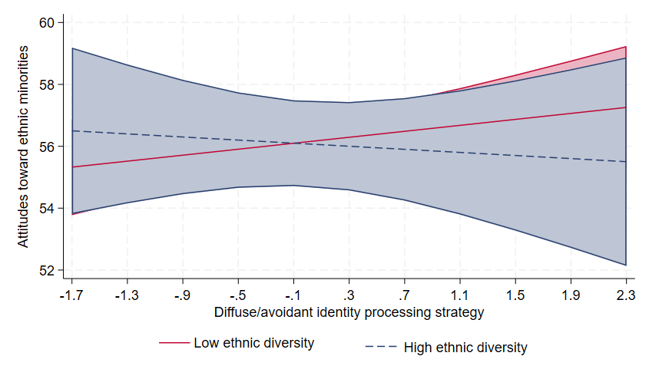
Note: Predicted values with 95% confidence intervals.
Figure 2A. Relationship between the normative identity strategy and attitudes toward outgroups moderated by ethnic diversity in the classroom (minority members)
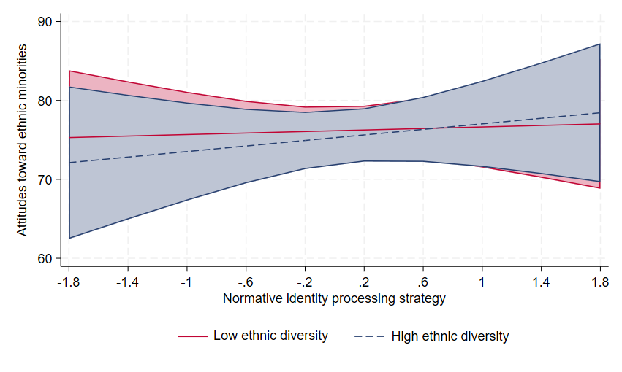
Note: Predicted values with 95% confidence intervals.
Figure 3A. Relationship between the diffuse/avoidant identity strategy and attitudes toward outgroups moderated by ethnic diversity in the classroom (minority members)
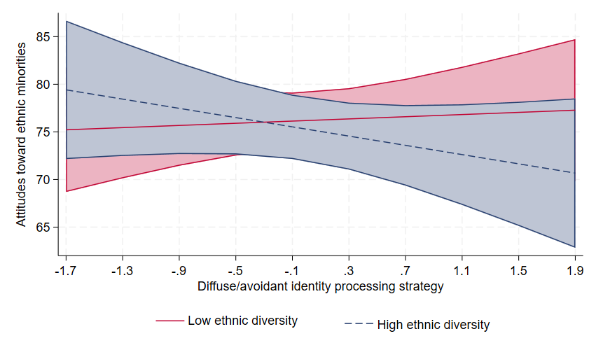
Note: Predicted values with 95% confidence intervals.

MODELS WITH PARENTAL EDUCATION
Table 1A. Attitudes toward ethnic minorities; models summary
 | M0 | M1 | M2 | M3
Informational identity strategy |  | 2.98*** (0.21) | 2:99*** (0.21) | 3.17*** (0.20)
Normative identity strategy |  | -1.23*** (0.24) | -1.24*** (0.24) | -1.11*** (0.24)
Diffuse/avoidant identity strategy |  | 0.32 (0.20) | 0.32 (0.20) | 0.23 (0.19)
School type (Academic track)
Vocational |  | -1.30*** (0.58) | -1.33** (0.59) | -1.91** (0.58)
Gender (Male)
Female |  | 5.08*** (0.34) | 5.09***(0.34) | 4.98*** (0.33)
Other |  | 3.22 (1.89) | 3.23 (1.89) | 2.99 (1.75)
Age |  | -0.50** (0.20) | -0.51** (0.20) | -0.51** (0.20)
Parents' education (Primary school)
High school |  | -0.09 (0.41) | -0.08 (0.41) | -0.08 (0.41)
University |  | 1.20** (0.45) | 1.22** (0.45) | 1.21** (0.45)
Simpson's diversity index |  |  | 0.30 (1.12) | 0.43 (1.12)
Interactions
Informational # Diversity |  |  |  | 3.59*** (1.08)
Normative # Diversity |  |  |  | 2.79* (1.31)
Diffuse/Avoidant # Diversity |  |  |  | -0.87 (1.06)
Constant | 56.22*** (0.29) | 54.33*** (0.68) | 54.34*** (0.68) | 54.42*** (0.68)
Random-effects parametres
Classroom | 17.39 (1.96) | 14.67 (1.87) | 14.64 (1.87) | 14.67 (1.87)
Log likelihood | -91,198.893 | -84,173.119 | -84,173.082 | -84,161.598
ICC | 0.06 | 0.04 | 0.04 | 0.04
N Observations | 20,539 | 19,019 | 19,019 | 19,019
N Classrooms | 1,028 | 1,028 | 1,028 | 1,028
*** p<0..001, ** p<0.01, * p<0.05

Table 2A. Attitudes toward Czech majority; models summary
 | M4 | M5 | M6 | M7
Informational identity strategy |  | 2.89*** (0.73) | 3.90*** (0.74) | 3.14*** (0.86)
Normative identity strategy |  | 1.12 (0.87) | 1.18 (0.87) | 0.94 (0.95)
Diffuse/avoidant identity strategy |  | 0.32 (0.20) | -0.79 (0.66) | 0.55 (1.02)
School type (Academic track)
Vocational trak |  | 0.37 (1.79) | -0.35 (1.82) | 0.28 (1.82)
Gender (Male)
Female |  | -0.46 (1.15) | -0.46 (1.15) | -0.31 (1.15)
Other |  | -15.15*** (4.45) | -15.15*** (4.45) | -15.48*** (4.46)
Age |  | -1.29* (0.60) | -1.30* (0.60) | -1.24* (0.60)
Simpson's diversity index |  |  | 0.25 (3.28) | -0.69 (3.31)
Parents' education (Primary school)
High school |  | 4.63** (1.47) | 4.64** (1.48) | 4.64** (1.48)
University |  | 4.65*** (1.41) | 4.66*** (1.42) | 4.66*** (1.42)
Interactions
Informational # Diversity |  |  |  | 5.94 (3.31)
Normative # Diversity |  |  |  | 3.44 (4.76)
Diffuse/Avoidant # Diversity |  |  |  | -2.46 (3.86)
Constant | 75.69*** (0.56) | 72.33*** (2.14) | 72.32*** (2.15) | 72.54***(2.15)
Random-effects parametres
Classroom | 39.22 (13.45) | 31.14 (14.68) | 31.13 (14.68) | 32.03 (14.72)
Log likelihood | -12,180.29 | -10,254.904 | -10,254.901 | -10,252.627
ICC | 0.06 (0.02) | 0.05 (0.02) | 0.05 (0.02) | 0.05 (0.02)
N Observations | 2,605 | 2,196 | 2,196 | 2,196
N Classrooms | 852 | 818 | 818 | 818
*** p<0.001, ** p<0.01, * p<0.05

CONFIRMATORY FACTOR ANALYSIS
Factor structure of the short version ISI was tested with a Confirmatory Factor Analysis (CFA). Parameters were estimated using the Robust Maximum likelihood Estimator (MLR) in Mplus 7.2. A three-factor structure was tested, and several measurement error correlations were added to the model based on theory and according to the wording of the items. The results showed that the model fits the data well (RMSEA = 0.052, CFI = 0.902, SRMR = 0.050, χ² (73) = 4716.014, p < .001), when the CFI (Comparative Fit Index), RMSEA (Root Mean Squared Error of Approximation) and SRMR (Standardized Root Mean Squared Residual) are above the desired threshold (West et al., 2012).

Figure 4A. Final Three-factor Structure of the model of ISI
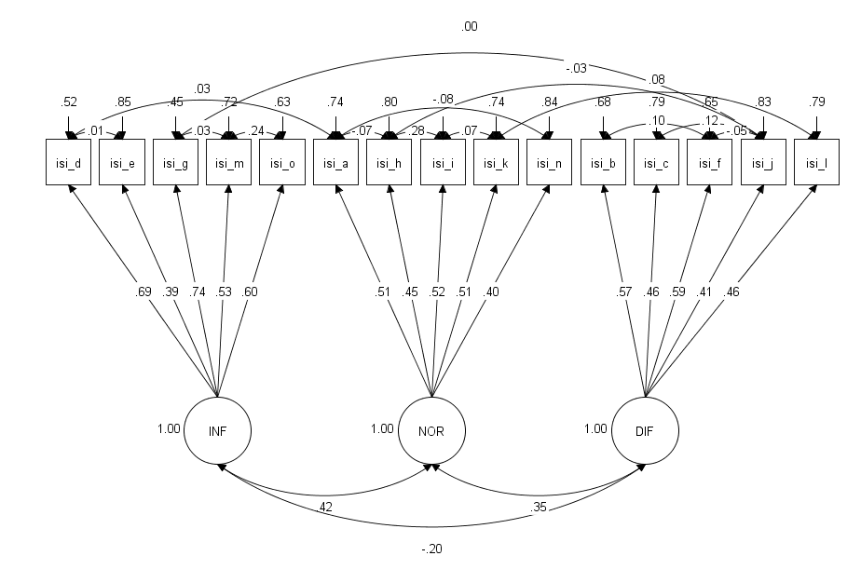
Note. Standardized coefficients, RMSEA = 0.052, CFI = 0.902, SRMR = 0.050, χ² (73) = 4716.014, p < .001, N = 23,359

Since we are focusing on differences between the majority (N = 20,701) and minority (N = 2,658) groups, it was first necessary to test for measurement invariance, i.e. whether members of both groups perceive and use the scale in the same way. Traditional multiple-group confirmatory factor analysis (MGCFA) was used for measurement invariance (Boer et al., 2018; Davidov et al., 2014). The results (see Table 3A) show that the differences between invariance levels are 0.003 or less for all three indices (CFI, RMSEA, SRMR) (Chen, 2007). The values for RMSEA and SRMR themselves attain desirable values; however, in the case of CFI, the value is borderline (West et al., 2012). In conclusion, full scalar invariance was achieved, thereby enabling a comparison of latent means and (co)variances of the identity styles between members of the majority and minority groups.

Table 3A. Results of measurement invariance of the ISI across majority and minority groups
 | Chi-square | CFI (ΔCFI) | RMSEA (ΔRMSEA) | SRMR (ΔSRMR)
Configural | 4804.359 | 0.901 | 0.052 | 0.050
Metric | 4809.116 | 0.901 (0.000) | 0.050 (0.002) | 0.050 (0.000)
Scalar | 4953.776 | 0.898 (0.003) | 0.049 (0.001) | 0.051 (0.001)
Note. Maximum Likelihood Robust (MLR) estimation method. CFI = Comparative Fit Index; RMSEA = Root Mean Square Error of Approximation, SRMR = Standardized Root Mean Squared Residual; Δ = change/difference; N = 23,359.

References:

Boer, D., Hanke, K., & He, J. (2018). On detecting systematic measurement error in cross-cultural research: A review and critical reflection on equivalence and invariance tests. Journal of Cross-Cultural Psychology, 49(5), 713–734. https://doi.org/10.1177/0022022117749042

Davidov, E., Meuleman, B., Cieciuch, J., Schmidt, P., & Billiet, J. (2014). Measurement equivalence in cross-national research. Annual Review of Sociology, 40(1), 55–75. https://doi.org/10.1146/annurev-soc-071913-043137

Chen, F. F. (2007). Sensitivity of goodness of fit indexes to lack of measurement invariance. Structural Equation Modeling: A Multidisciplinary Journal, 14(3), 464–504. https://doi.org/10.1080/10705510701301834

West, S. G., Taylor, A. B., & Wu, W. (2012). Model fit and model selection in structural equation modeling. In R. H. Hoyle (Ed.), Handbook of structural equation modeling (pp. 209–231). The Guilford Press.

