An evaluation of the potential sensitivity of pork production situations aiming at high quality products to the use of entire male pigs as an alternative to surgical castrates
M. Bonneau, M. Čandek-Potokar, M. Śkrlep, M. Font-i-Furnols, M. Aluwé, The Castrum network, L. Fontanesi

Supplementary Figure S1 Model used for the calculation of BT_Inc (Boar taint incidence score) from [Age score] and [Weight score].

Supplementary Figure S2 Model used for the calculation of BT_Per (Boar taint perception score) from [Fat score], [Consumption score] and [Smoke].

Supplementary Figure S3 Model used for the calculation of Manag (Management score) from [Age score], [Weight score] and [Outdoor].

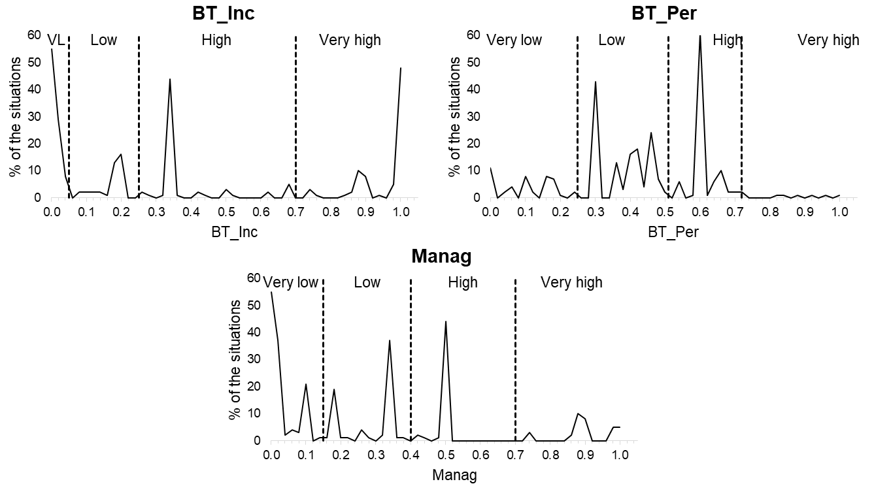
Supplementary Figure S4 Distributions (solid line) of the continuous dimensions of potential sensitivity to entire male pig production (BT_Inc: Boar taint incidence score; BT_Per: Boar taint perception score; Manag: Management score) with indication of the limits (broken lines) used to define the four classes: Very low (VL), Low, High and Very high.

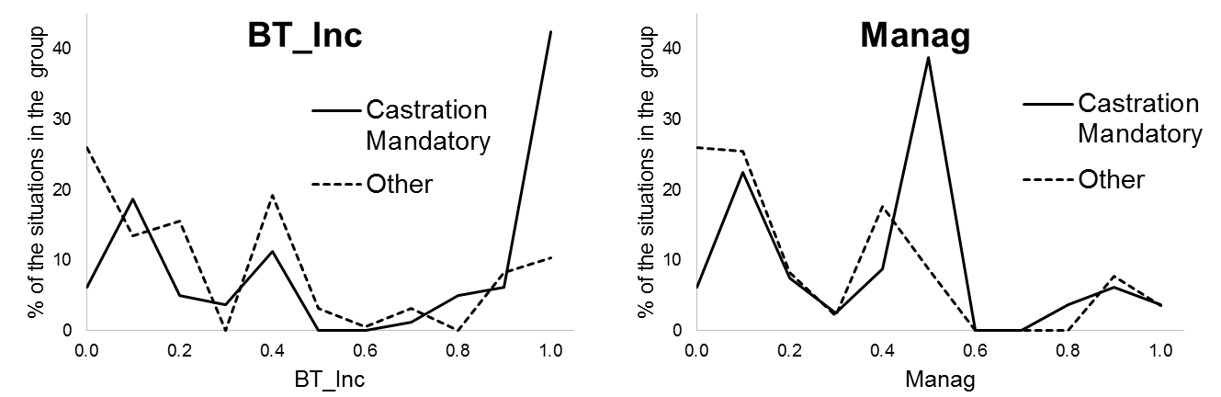
Supplementary Figure S5 Compared distributions of BT_Inc and Manag in situations where castration is mandatory (solid line) and in situations where it is not (broken line). BT_Inc: Boar taint incidence score; Manag: Management score.

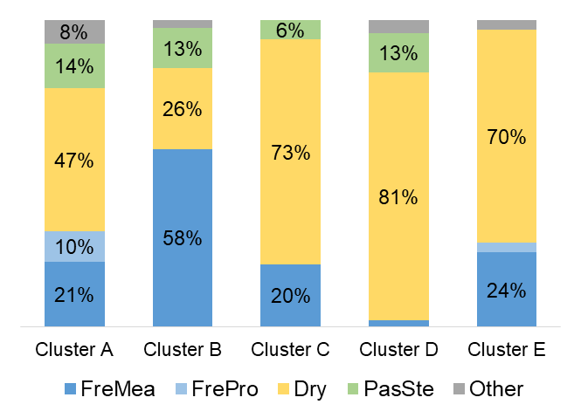
Supplementary Figure S6 Distribution of the categories of products for each of the five clusters of situations determined by Ascending Hierarchical Clustering following Multiple Correspondence Analysis. FreMea: Fresh meat; FrePro: Fresh processed; Dry: Dry cured and dry fermented; PasSte: Pasteurized sterilised. For better legibility, percentages lower than 5% are not shown.

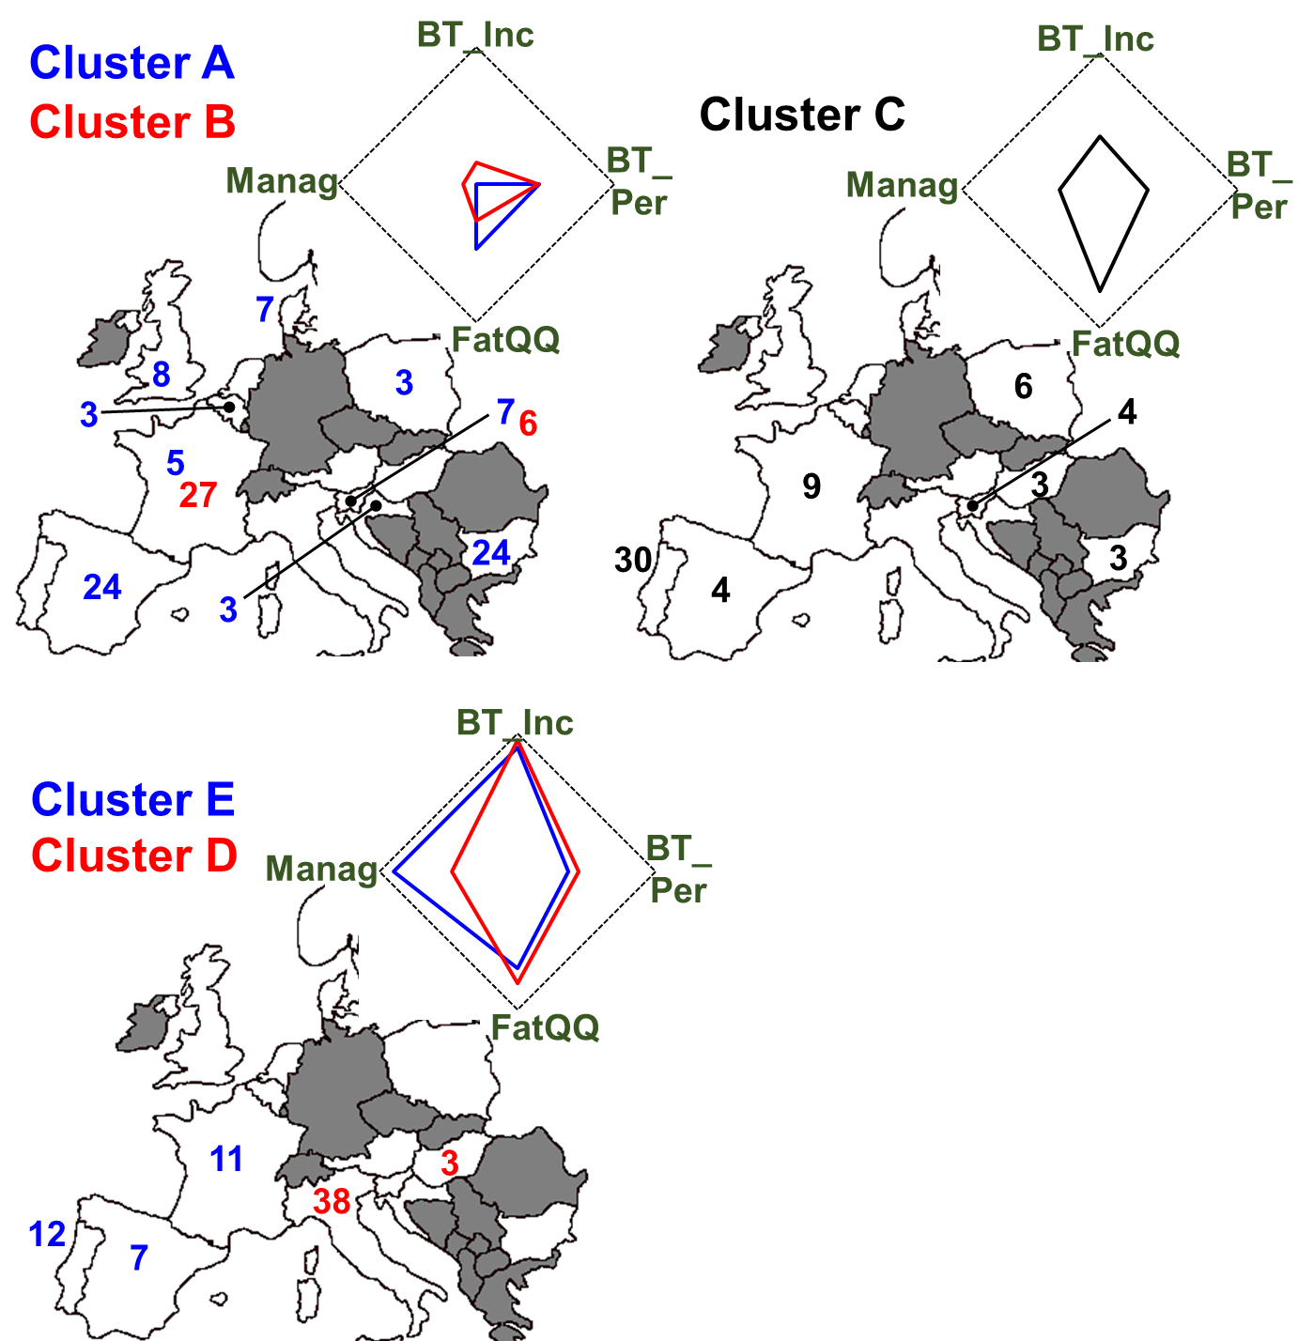

Supplementary Figure S7 Summary of the profiles of the five clusters and main localisation of the situations for each cluster. The five clusters of situations were determined by Ascending Hierarchical Clustering following Multiple Correspondence Analysis. BT_Inc: Boar taint incidence score; BT_Per: Boar taint perception score; FatQQ: Fat quantity and quality; Manag: Management score. For better legibility numbers lower than 3 are not shown (see Table 5 for complete list of numbers per country).

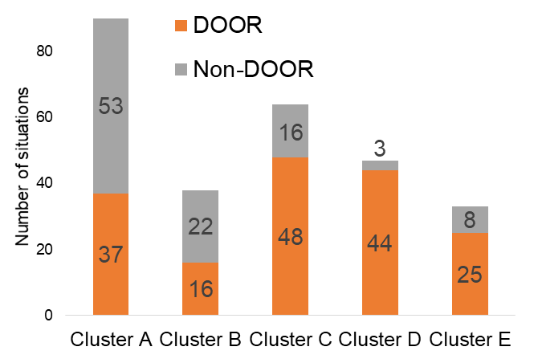

Supplementary Figure S8 Distribution of the DOOR and non-DOOR situations in the five clusters determined by Ascending Hierarchical Clustering following Multiple Correspondence Analysis.

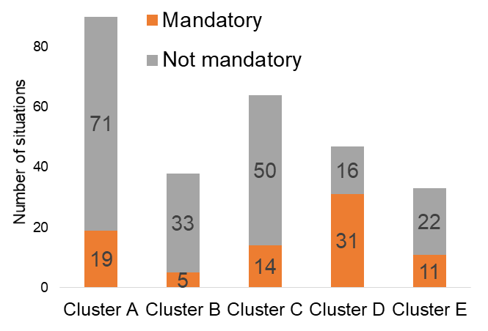

Supplementary Figure S9 Distribution of the situations where castration is mandatory and those where it is not in the five clusters determined by Ascending Hierarchical Clustering following Multiple Correspondence Analysis.

Supplementary Table S1 List of the 272 analysed situations

DOOR | Country | Designation of the situation
Yes | Austria | Gailtaler Speck
Yes | Austria | Tiroler Speck
Yes | Belgium | Jambon d'Ardenne
Yes | Belgium | Saucisson d’Ardenne / Collier d’Ardenne / Pipe d’Ardenne
Yes | Bulgaria | КАЙСЕРОВАН ВРАТ ТРАКИЯ (Kayserovan Vrat Trakiya)
Yes | Bulgaria | Луканка Панагюрска (Lukanka Panagyurska)
Yes | Bulgaria | РОЛЕ ТРАПЕЗИЦА (Role Trapezitsa)
Yes | Bulgaria | Филе Елена (File Elena)
Yes | Croatia | Baranjski kulen
Yes | Croatia | Dalmatinski pršut
Yes | Croatia | Drniški pršut
Yes | Croatia | Istarski pršut / Istrski pršut
Yes | Croatia | Krčki pršut
Yes | Croatia | Slavonski kulen / Slavonski kulin
Yes | France | Boudin blanc de Rethel
Yes | France | Coppa de Corse / Coppa de Corse - Coppa di Corsica
Yes | France | Jambon d'Auvergne
Yes | France | Jambon de Bayonne
Yes | France | Jambon de Lacaune
Yes | France | Jambon de l'Ardèche
Yes | France | Jambon de Vendée
Yes | France | Jambon noir de Bigorre
Yes | France | Jambon sec de Corse / Jambon sec de Corse - Prisuttu
Yes | France | Jambon sec des Ardennes / Noix de Jambon sec des Ardennes
Yes | France | Lonzo de Corse / Lonzo de Corse - Lonzu
Yes | France | Pâté de Campagne Breton
Yes | France | Porc d'Auvergne
Yes | France | Porc de Franche-Comté
Yes | France | Porc de la Sarthe
Yes | France | Porc de Normandie
Yes | France | Porc de Vendée
Yes | France | Porc du Limousin
Yes | France | Porc du Sud-Ouest
Yes | France | Porc noir de Bigorre
Yes | France | Rillettes de Tours
Yes | France | Saucisse de Montbéliard
Yes | France | Saucisse de Morteau / Jésus de Morteau
Yes | France | Saucisson de Lacaune / Saucisse de Lacaune
Yes | France | Saucisson de l'Ardèche
Yes | France | Saucisson sec d’Auvergne / Saucisse sèche d’Auvergne
Yes | Hungary | Budapesti téliszalámi
Yes | Hungary | Csabai kolbász/Csabai vastagkolbász
Yes | Hungary | Gyulai kolbász / Gyulai pároskolbász
Yes | Hungary | Szegedi szalámi ; Szegedi téliszalámi
Yes | Italy | Capocollo di Calabria
Yes | Italy | Ciauscolo
Yes | Italy | Cinta Senese
Yes | Italy | Coppa di Parma
Yes | Italy | Coppa Piacentina
Yes | Italy | Cotechino Modena
Yes | Italy | Crudo di Cuneo
Yes | Italy | Culatello di Zibello
Yes | Italy | Finocchiona
Yes | Italy | Lardo di Colonnata
Yes | Italy | Mortadella Bologna
Yes | Italy | Mortadella di Prato
Yes | Italy | Pancetta di Calabria
Yes | Italy | Pancetta Piacentina
Yes | Italy | Porchetta di Ariccia
Yes | Italy | Prosciutto Amatriciano
Yes | Italy | Prosciutto di Carpegna
Yes | Italy | Prosciutto di Modena
Yes | Italy | Prosciutto di Norcia
Yes | Italy | Prosciutto di Parma
Yes | Italy | Prosciutto di San Daniele
Yes | Italy | Prosciutto di Sauris
Yes | Italy | Prosciutto Toscano
Yes | Italy | Prosciutto Veneto Berico-Euganeo
Yes | Italy | Salama da sugo
Yes | Italy | Salame Brianza
Yes | Italy | Salame Cremona
Yes | Italy | Salame di Varzi
Yes | Italy | Salame d'oca di Mortara
Yes | Italy | Salame Felino
Yes | Italy | Salame Piacentino
Yes | Italy | Salame Piemonte
Yes | Italy | Salame S. Angelo
Yes | Italy | Salamini italiani alla cacciatora
Yes | Italy | Salsiccia di Calabria
Yes | Italy | Soppressata di Calabria
Yes | Italy | Soprèssa Vicentina
Yes | Italy | Speck Alto Adige / Südtiroler Markenspeck / Südtiroler Speck
Yes | Italy | Valle d’Aosta Lard d’Arnad/Vallée d’Aoste Lard d’Arnad
Yes | Italy | Valle d'Aosta Jambon de Bosses
Yes | Italy | Zampone Modena
Yes | Poland | Kabanosy
Yes | Poland | Kabanosy staropolskie
Yes | Poland | Kiełbasa biała parzona wielkopolska
Yes | Poland | Kiełbasa jałowcowa
Yes | Poland | Kiełbasa jałowcowa staropolska
Yes | Poland | Kiełbasa lisiecka
Yes | Poland | Kiełbasa myśliwska
Yes | Poland | Kiełbasa myśliwska staropolska
Yes | Poland | Krupnioki śląskie
Yes | Portugal | Alheira de Barroso-Montalegre
Yes | Portugal | Alheira de Mirandela
Yes | Portugal | Alheira de Vinhais
Yes | Portugal | Butelo de Vinhais ; Bucho de Vinhais ; Chouriço de Ossos de Vinhais
Yes | Portugal | Cacholeira Branca de Portalegre
Yes | Portugal | Carne de Bísaro Transmontano ; Carne de Porco Transmontano
Yes | Portugal | Carne de Porco Alentejano
Yes | Portugal | Chouriça de Carne de Barroso-Montalegre
Yes | Portugal | Chouriça de Carne de Melgaço
Yes | Portugal | Chouriça de Carne de Vinhais ; Linguiça de Vinhais
Yes | Portugal | Chouriça de sangue de Melgaço
Yes | Portugal | Chouriça Doce de Vinhais
Yes | Portugal | Chouriço Azedo de Vinhais ; Azedo de Vinhais ; Chouriço de Pão de Vinhais
Yes | Portugal | Chouriço de Abóbora de Barroso-Montalegre
Yes | Portugal | Chouriço de Carne de Estremoz e Borba
Yes | Portugal | Chouriço de Portalegre
Yes | Portugal | Chouriço grosso de Estremoz e Borba
Yes | Portugal | Chouriço Mouro de Portalegre
Yes | Portugal | Farinheira de Estremoz e Borba
Yes | Portugal | Farinheira de Portalegre
Yes | Portugal | Linguiça de Portalegre
Yes | Portugal | Linguíça do Baixo Alentejo ; Chouriço de carne do Baixo Alentejo
Yes | Portugal | Lombo Branco de Portalegre
Yes | Portugal | Lombo Enguitado de Portalegre
Yes | Portugal | Morcela de Assar de Portalegre
Yes | Portugal | Morcela de Cozer de Portalegre
Yes | Portugal | Morcela de Estremoz e Borba
Yes | Portugal | Paia de Estremoz e Borba
Yes | Portugal | Paia de Lombo de Estremoz e Borba
Yes | Portugal | Paia de Toucinho de Estremoz e Borba
Yes | Portugal | Painho de Portalegre
Yes | Portugal | Paio de Beja
Yes | Portugal | Presunto de Barrancos /Paleta de Barrancos
Yes | Portugal | Presunto de Barroso
Yes | Portugal | Presunto de Campo Maior e Elvas ; Paleta de Campo Maior e Elvas
Yes | Portugal | Presunto de Melgaço
Yes | Portugal | Presunto de Santana da Serra ; Paleta de Santana da Serra
Yes | Portugal | Presunto de Vinhais / Presunto Bísaro de Vinhais
Yes | Portugal | Presunto do Alentejo ; Paleta do Alentejo
Yes | Portugal | Salpicão de Barroso-Montalegre
Yes | Portugal | Salpicão de Melgaço
Yes | Portugal | Salpicão de Vinhais
Yes | Portugal | Sangueira de Barroso-Montalegre
Yes | Slovenia | Istrski pršut
Yes | Slovenia | Kranjska klobasa
Yes | Slovenia | Kraška panceta
Yes | Slovenia | Kraški pršut
Yes | Slovenia | Kraški zašink
Yes | Slovenia | Prekmurska Šunka
Yes | Slovenia | Prleška tünka
Yes | Slovenia | Šebreljski želodec
Yes | Slovenia | Zgornjesavinjski želodec
Yes | Spain | Botillo del Bierzo
Yes | Spain | Chorizo de Cantimpalos
Yes | Spain | Chorizo Riojano
Yes | Spain | Chosco de Tineo
Yes | Spain | Dehesa de Extremadura
Yes | Spain | Guijuelo
Yes | Spain | Jabugo
Yes | Spain | Jamón de Serón
Yes | Spain | Jamón de Teruel / Paleta de Teruel
Yes | Spain | Jamón de Trevélez
Yes | Spain | Jamón Serrano
Yes | Spain | Lacón Gallego
Yes | Spain | Los Pedroches
Yes | Spain | Morcilla de Burgos
Yes | Spain | Salchichón de Vic ; Llonganissa de Vic
Yes | Spain | Sobrasada de Mallorca
Yes | Sweden | Falukorv
Yes | UK | Carmarthen Ham
Yes | UK | Melton Mowbray Pork Pie
Yes | UK | Newmarket Sausage
Yes | UK | Traditional Cumberland Sausage
Yes | UK | Traditionally Farmed Gloucestershire Old Spots Pork
Yes | UK | Traditionally Reared Pedigree Welsh Pork
No | Belgium | Le Porc plein air / Het buiten gekweekte varken
No | Belgium | Organic wallonie
No | Belgium | Pâté Gaumais
No | Belgium | Porc fermier de Wallonie
No | Bulgaria | Бански старец (Banski starets)
No | Bulgaria | Бут по Еленски (But po Elenski)
No | Bulgaria | Карловски Бабек (Karlovski Babek)
No | Bulgaria | Кебапче (kebepche)
No | Bulgaria | Кърначе (karnache)
No | Bulgaria | Кюфте (kyufte)
No | Bulgaria | луканка Смядовска (lukanka Smyadovska)
No | Bulgaria | луканка Трапезица (lukanka Trapezitsa)
No | Bulgaria | луканка Троянска (likanka Troyanska)
No | Bulgaria | луканка Чумерна (lukanka Chumerna)
No | Bulgaria | месо от Източнобалканска свиня (meso ot Iztochnobalkanska svinya)
No | Bulgaria | наденица Стара Планина (nadenica Stara Planina)
No | Bulgaria | салам Амбарица (salam Ambaritsa)
No | Bulgaria | салам Дебоя (salam Deboya)
No | Bulgaria | салам Диавена (salam Diavena)
No | Bulgaria | салам Медвен (salam Medven)
No | Bulgaria | сланина от Източнобалканска свиня (slanina ot Iztochnobalkanska svinya)
No | Bulgaria | солена сланина (solena slanina)
No | Bulgaria | Странджански дядо (Strandzhanski dyado)
No | Bulgaria | субпродукти от Източнобалканска свиня (subproducti ot Iztochnobalkanska svinya)
No | Bulgaria | суджук Плевенски (sudzhuk Plevenski)
No | Bulgaria | суджук Чипровски (sudzhuk Chiprovski)
No | Bulgaria | суджук Шопски (sudzhuk Shopski)
No | Bulgaria | филе свинско двойно Арабанаси (file svinsko dvoino Arbanasi)
No | Croatia | Meat of Crna Slavonska pig
No | Croatia | Međimursko meso z' tiblice
No | Denmark | Antibiotic free production
No | Denmark | Antonius
No | Denmark | Bornholmergrisen (pig from Bornholm, a Danish island)
No | Denmark | Den goé gris
No | Denmark | Friland (Free range pigs)
No | Denmark | Grambogaard
No | Denmark | Organic pork
No | France | Abattoir des Crêts
No | France | Basque
No | France | Bayeux
No | France | Blanc de l'Ouest
No | France | Cocholin
No | France | Cochon du druide
No | France | Cochon paysan
No | France | Cul noir du Limousin
No | France | ERCA BIO
No | France | Fattening pigs to higher weight for home consumption/processing
No | France | Francochon
No | France | Jambon du Kintoa
No | France | Jean Rozé sélection
No | France | Kintoa
No | France | Nustrale
No | France | Organic pig production in France
No | France | Porc au grain du Sud-Ouest
No | France | Porc Bio Atlantique
No | France | Porc d'Argoat
No | France | Porc Délice
No | France | Porc Fermier d'Argoat
No | France | Porc Franc
No | France | Porc Maggiore
No | France | Tradival
No | France | UNEBIO
No | France | Vallégrain tradition
No | Hungary | Excellent Pork Quality (KMS)
No | Hungary | Fattening heavy pigs for own consumption/processing
No | Hungary | Rearing of Mangalica
No | Netherlands | Organic system
No | Netherlands | Outdoor housing system
No | Norway | Santa Kristina
No | Slovenia | Agricultural policy measure Welfare
No | Slovenia | Dobrote naših kmetij (En. Delicacies of our farms)
No | Slovenia | Dobrote slovenskih kmetij (En. Delecacies of Slovenian farms)
No | Slovenia | Fattening heavy pigs for direct sale of products to consumers
No | Slovenia | Fattening heavy pigs for known buyer (demanding higher weight)
No | Slovenia | Fattening heavy pigs for own consumption/processing
No | Slovenia | Izbrana kakovost (Selected quality)
No | Slovenia | Mesnine krškopoljskega praši (Meat and products of Krskopolje pig)
No | Slovenia | Organic/ecological farming
No | Spain | Androlla
No | Spain | Androlla Maragata
No | Spain | Bacon
No | Spain | Baiona curada
No | Spain | Bisbe, bull
No | Spain | Bolas
No | Spain | Borono
No | Spain | Butifarra
No | Spain | Cabeza de jabalí
No | Spain | Chistorra
No | Spain | Chorizo de Pamplona
No | Spain | Farinato
No | Spain | Fuet
No | Spain | Hamburguer
No | Spain | Lomo de ibérico
No | Spain | Longaniza
No | Spain | Magreta
No | Spain | Morcilla
No | Spain | Mortadela
No | Spain | Patatera
No | Spain | Salami
No | Spain | Salchicha
No | UK | Assured Food Standards Red Tractor Scheme
No | UK | Males castrated in Hobby farms

Supplementary Table S2 Characteristics of the 272 analysed situations. To preserve anonymity, the listing order is different from Supplementary Table S1. DOOR: DOOR situation; Cast Mand: Castration Mandatory; BT_Incid: Boar taint incidence score; Weight: Weight score; Age: Age score; Manag: Management score; Outdoor: outdoor production; BT_Per: Boar taint perception score. Consum: Consumption score; Home Cook: Cooked at home; Cons Warm: Consumed warm; Fat Score: Score for fat content of the associated product; Smoke: The associated product is smoked; FatQQ: Fat quantity and quality.

DOOR | Cast  Mand | BT_  Incid | Wei  ght | Age | Ma  nag | Out  door | BT_  Per | Con  sum | Home  Cook | Cons  Warm | Fat  Score | Smo  ke | Fat  QQ
Yes | Yes | 1.00 | 1.00 | 1 | 0.50 | No | 0.44 | 0 | no | No | 0.35 | No | Yes
Yes | Yes | 1.00 | 1.00 | 1 | 0.50 | No | 0.29 | 0 | No | No | 0.10 | No | Yes
Yes | No | 0.89 | 0.84 | 1 | 0.89 | Yes | 0.71 | 0 | No | No | 0.80 | No | No
Yes | Yes | 1.00 | 1.00 | 1 | 0.50 | No | 0.82 | 1 | yes | Yes | 0.50 | No | Yes
Yes | No | 0.00 | 0.00 | 0 | 0.00 | No | 0.35 | 1 | Yes | Yes | 0.20 | Yes | No
Yes | Yes | 1.00 | 1.00 | 1 | 0.50 | No | 0.29 | 0 | No | No | 0.10 | No | Yes
Yes | No | 0.01 | 0.01 | 0 | 0.00 | No | 0.19 | 0 | No | No | 0.43 | Yes | Yes
No | Yes | 0.01 | 0.02 | 0 | 0.01 | No | 0.44 | 0 | No | No | 0.35 | No | Yes
Yes | No | 0.88 | 0.82 | 1 | 0.88 | Yes | 0.38 | 1 | Yes | Yes | 0.25 | Yes | Yes
Yes | No | 0.00 | 0.00 | 0 | 0.00 | No | 0.65 | 1 | Yes | Yes | 0.20 | No | No
No | No | 0.50 | 0.25 | 1 | 0.50 | Yes | 0.29 | 1 | Yes | Yes | 0.10 | Yes | No
No | No | 0.00 | 0.00 | 0 | 0.00 | No | 0.61 | 1 | Yes | Yes | 0.14 | No | No
Yes | No | 0.11 | 0.16 | 0 | 0.05 | No | 0.29 | 0 | No | No | 0.10 | No | Yes
No | No | 0.18 | 0.02 | 0.5 | 0.09 | No | 0.59 | 1 | yes | Yes | 0.10 | No | No
Yes | No | 0.93 | 0.90 | 1 | 0.47 | No | 0.09 | 0 | No | No | 0.25 | Yes | Yes
Yes | Yes | 0.03 | 0.05 | 0 | 0.02 | No | 0.03 | 0 | No | No | 0.15 | Yes | Yes
No | No | 0.01 | 0.01 | 0 | 0.00 | No | 0.59 | 1 | Yes | Yes | 0.10 | No | No
Yes | Yes | 1.00 | 1.00 | 1 | 0.50 | No | 0.45 | 0 | no | No | 0.37 | No | Yes
Yes | No | 0.00 | 0.00 | 0 | 0.00 | No | 0.37 | 1 | Yes | Yes | 0.23 | Yes | No
No | No | 0.01 | 0.01 | 0 | 0.00 | No | 0.29 | 1 | Yes | Yes | 0.10 | Yes | No
Yes | No | 0.34 | 0.01 | 1 | 0.34 | Yes | 0.09 | 0 | No | No | 0.25 | Yes | Yes
Yes | Yes | 0.73 | 0.60 | 1 | 0.73 | Yes | 0.00 | 0 | no | No | 0.10 | Yes | Yes
Yes | No | 0.03 | 0.04 | 0 | 0.01 | No | 0.71 | 1 | Yes | Yes | 0.30 | No | No
Yes | No | 0.01 | 0.01 | 0 | 0.00 | No | 0.49 | 0 | No | No | 0.43 | No | No
No | No | 0.00 | 0.00 | 0 | 0.00 | No | 0.45 | 0 | No | No | 0.37 | No | Yes
Yes | No | 0.34 | 0.01 | 1 | 0.34 | Yes | 0.09 | 0 | No | No | 0.25 | Yes | Yes
Yes | No | 0.41 | 0.12 | 1 | 0.41 | Yes | 0.38 | 1 | Yes | Yes | 0.25 | Yes | Yes
No | No | 0.89 | 0.84 | 1 | 0.89 | Yes | 0.59 | 1 | yes | Yes | 0.10 | No | No
Yes | Yes | 0.33 | 0.00 | 1 | 0.33 | Yes | 0.38 | 1 | Yes | Yes | 0.25 | Yes | Yes
Yes | No | 1.00 | 1.00 | 1 | 0.50 | No | 0.45 | 0 | no | No | 0.37 | No | Yes
Yes | No | 0.34 | 0.01 | 1 | 0.34 | Yes | 0.06 | 0 | No | No | 0.20 | Yes | Yes
No | No | 0.00 | 0.00 | 0 | 0.00 | No | 0.59 | 1 | Yes | Yes | 0.10 | No | No
Yes | No | 0.34 | 0.01 | 1 | 0.34 | Yes | 0.38 | 1 | Yes | Yes | 0.25 | Yes | Yes
No | No | 0.00 | 0.00 | 0 | 0.00 | No | 1.00 | 1 | Yes | Yes | 0.80 | No | No
No | No | 0.00 | 0.00 | 0 | 0.00 | No | 0.65 | 1 | Yes | Yes | 0.20 | No | No
Yes | No | 0.34 | 0.01 | 1 | 0.34 | Yes | 0.53 | 0 | No | No | 0.50 | No | Yes
Yes | No | 0.67 | 1.00 | 0 | 0.33 | No | 0.35 | 0 | No | No | 0.20 | No | Yes
Yes | No | 0.44 | 0.16 | 1 | 0.44 | Yes | 0.29 | 0.67 | Yes | No | 0.25 | Yes | Yes
Yes | Yes | 0.00 | 0.00 | 0 | 0.00 | No | 0.47 | 0 | No | No | 0.40 | No | Yes
No | No | 0.17 | 0.25 | 0 | 0.08 | No | 0.59 | 0 | No | No | 0.60 | No | No
Yes | Yes | 1.00 | 1.00 | 1 | 0.50 | No | 0.41 | 0 | no | No | 0.30 | No | Yes
Yes | Yes | 1.00 | 1.00 | 1 | 0.50 | No | 0.29 | 0 | No | No | 0.10 | No | Yes
Yes | Yes | 1.00 | 1.00 | 1 | 0.50 | No | 0.38 | 0 | No | No | 0.25 | No | Yes
Yes | Yes | 1.00 | 1.00 | 1 | 1.00 | Yes | 0.18 | 0 | No | No | 0.40 | Yes | Yes
Yes | No | 0.88 | 0.82 | 1 | 0.88 | Yes | 0.29 | 0.67 | Yes | No | 0.25 | Yes | Yes
Yes | No | 1.00 | 1.00 | 1 | 0.50 | No | 0.35 | 0 | no | No | 0.20 | No | Yes
Yes | No | 0.97 | 0.96 | 1 | 0.97 | Yes | 0.29 | 0 | No | No | 0.10 | No | Yes
Yes | No | 0.88 | 0.82 | 1 | 0.88 | Yes | 0.38 | 1 | Yes | Yes | 0.25 | Yes | No
No | No | 0.00 | 0.00 | 0 | 0.00 | No | 0.36 | 0 | No | No | 0.22 | No | No
No | No | 0.67 | 1.00 | 0 | 0.33 | No | 0.47 | 0 | No | No | 0.40 | No | Yes
Yes | No | 0.34 | 0.01 | 1 | 0.34 | Yes | 0.38 | 1 | Yes | Yes | 0.25 | Yes | Yes
Yes | No | 0.01 | 0.01 | 0 | 0.00 | No | 0.00 | 0 | No | No | 0.10 | Yes | Yes
Yes | Yes | 0.33 | 0.00 | 1 | 0.33 | Yes | 0.38 | 1 | Yes | Yes | 0.25 | Yes | Yes
No | Yes | 0.01 | 0.02 | 0 | 0.01 | No | 0.45 | 0 | No | No | 0.37 | No | Yes
Yes | Yes | 1.00 | 1.00 | 1 | 0.50 | No | 0.29 | 0 | No | No | 0.10 | No | Yes
No | No | 0.17 | 0.01 | 0.5 | 0.17 | Yes | 0.59 | 1 | yes | Yes | 0.10 | No | No
Yes | No | 1.00 | 1.00 | 1 | 0.50 | No | 0.63 | 0.33 | no | Yes | 0.50 | No | Yes
No | No | 0.00 | 0.00 | 0 | 0.00 | No | 0.64 | 0 | No | No | 0.68 | No | Yes
Yes | No | 0.00 | 0.00 | 0 | 0.00 | No | 0.44 | 0 | No | No | 0.35 | No | Yes
Yes | Yes | 0.33 | 0.00 | 1 | 0.33 | Yes | 0.09 | 0 | No | No | 0.25 | Yes | Yes
No | Yes | 0.00 | 0.00 | 0 | 0.00 | No | 0.48 | 0 | No | No | 0.42 | No | Yes
Yes | No | 0.13 | 0.20 | 0 | 0.07 | No | 0.00 | 0 | no | No | 0.10 | Yes | Yes
Yes | Yes | 0.03 | 0.04 | 0 | 0.01 | No | 0.41 | 1 | yes | Yes | 0.30 | Yes | No
Yes | No | 0.34 | 0.01 | 1 | 0.34 | Yes | 0.06 | 0 | No | No | 0.20 | Yes | Yes
No | No | 0.00 | 0.00 | 0 | 0.00 | No | 0.64 | 1 | Yes | Yes | 0.18 | No | No
No | No | 0.50 | 0.25 | 1 | 0.25 | No | 0.29 | 1 | Yes | Yes | 0.10 | Yes | No
Yes | No | 0.17 | 0.01 | 0.5 | 0.09 | No | 0.59 | 1 | yes | Yes | 0.10 | No | No
Yes | Yes | 0.07 | 0.10 | 0 | 0.03 | No | 0.00 | 0 | no | No | 0.10 | Yes | Yes
Yes | No | 0.33 | 0.00 | 1 | 0.33 | Yes | 0.38 | 1 | Yes | Yes | 0.25 | Yes | Yes
Yes | No | 0.34 | 0.01 | 1 | 0.34 | Yes | 0.53 | 0 | No | No | 0.50 | No | Yes
Yes | Yes | 1.00 | 1.00 | 1 | 0.50 | No | 0.81 | 1 | yes | Yes | 0.47 | No | Yes
No | No | 0.50 | 0.75 | 0 | 0.25 | No | 0.29 | 1 | Yes | Yes | 0.10 | Yes | No
Yes | No | 1.00 | 1.00 | 1 | 0.50 | No | 0.40 | 0 | no | No | 0.28 | No | No
Yes | No | 0.00 | 0.00 | 0 | 0.00 | No | 0.45 | 0 | No | No | 0.37 | No | Yes
Yes | Yes | 0.19 | 0.04 | 0.5 | 0.10 | No | 0.47 | 0 | no | No | 0.40 | No | No
Yes | No | 0.00 | 0.00 | 0 | 0.00 | No | 0.41 | 0 | No | No | 0.30 | No | Yes
No | Yes | 0.01 | 0.02 | 0 | 0.01 | No | 0.44 | 0 | No | No | 0.35 | No | Yes
No | No | 0.17 | 0.25 | 0 | 0.08 | No | 0.29 | 1 | Yes | Yes | 0.10 | Yes | No
No | No | 0.01 | 0.02 | 0 | 0.01 | No | 0.45 | 0 | No | No | 0.37 | No | Yes
Yes | Yes | 1.00 | 1.00 | 1 | 0.50 | No | 0.41 | 0 | No | No | 0.30 | No | Yes
Yes | No | 0.34 | 0.01 | 1 | 0.34 | Yes | 0.41 | 1 | Yes | Yes | 0.30 | Yes | Yes
Yes | No | 0.62 | 0.93 | 0 | 0.31 | No | 0.18 | 0 | No | No | 0.40 | Yes | Yes
Yes | No | 0.34 | 0.01 | 1 | 0.34 | Yes | 0.41 | 1 | Yes | Yes | 0.30 | Yes | Yes
Yes | Yes | 0.33 | 0.50 | 0 | 0.17 | No | 0.03 | 0 | No | No | 0.15 | Yes | Yes
Yes | No | 0.88 | 0.82 | 1 | 0.88 | Yes | 0.38 | 1 | Yes | Yes | 0.25 | Yes | Yes
Yes | Yes | 0.01 | 0.02 | 0 | 0.01 | No | 0.29 | 0 | No | No | 0.10 | No | Yes
Yes | No | 0.34 | 0.01 | 1 | 0.34 | Yes | 0.41 | 1 | Yes | Yes | 0.30 | Yes | Yes
Yes | Yes | 0.86 | 0.79 | 1 | 0.86 | Yes | 0.59 | 1 | Yes | Yes | 0.10 | No | No
No | No | 0.18 | 0.02 | 0.5 | 0.09 | No | 0.59 | 1 | yes | Yes | 0.10 | No | No
No | No | 0.00 | 0.00 | 0 | 0.00 | No | 0.59 | 1 | Yes | Yes | 0.10 | No | No
Yes | No | 0.00 | 0.00 | 0 | 0.00 | No | 0.44 | 0 | No | No | 0.35 | No | Yes
No | No | 0.33 | 0.00 | 1 | 0.33 | Yes | 0.59 | 1 | Yes | Yes | 0.10 | No | No
Yes | No | 0.03 | 0.04 | 0 | 0.01 | No | 0.41 | 0 | no | No | 0.30 | No | No
Yes | No | 0.08 | 0.12 | 0 | 0.04 | No | 0.10 | 0 | No | No | 0.27 | Yes | Yes
No | No | 0.00 | 0.00 | 0 | 0.00 | No | 0.65 | 0 | No | No | 0.70 | No | No
Yes | No | 0.97 | 0.96 | 1 | 0.97 | Yes | 0.29 | 0 | No | No | 0.10 | No | Yes
No | Yes | 0.89 | 0.84 | 1 | 0.89 | Yes | 0.29 | 0 | no | No | 0.10 | No | Yes
Yes | Yes | 1.00 | 1.00 | 1 | 0.50 | No | 0.18 | 0 | No | No | 0.40 | Yes | Yes
Yes | No | 1.00 | 1.00 | 1 | 0.50 | No | 0.62 | 1 | yes | Yes | 0.16 | No | No
Yes | Yes | 0.67 | 0.50 | 1 | 0.33 | No | 0.15 | 0 | No | No | 0.35 | Yes | Yes
Yes | No | 0.88 | 0.82 | 1 | 0.88 | Yes | 0.34 | 1 | Yes | Yes | 0.18 | Yes | Yes
Yes | No | 0.33 | 0.00 | 1 | 0.33 | Yes | 0.68 | 1 | Yes | Yes | 0.25 | No | No
Yes | Yes | 0.33 | 0.25 | 0.5 | 0.17 | No | 0.59 | 1 | yes | Yes | 0.10 | No | No
Yes | No | 1.00 | 1.00 | 1 | 1.00 | Yes | 0.29 | 0 | No | No | 0.10 | No | Yes
No | No | 0.33 | 0.25 | 0.5 | 0.17 | No | 0.59 | 1 | yes | Yes | 0.10 | No | No
Yes | No | 0.01 | 0.01 | 0 | 0.00 | No | 0.00 | 0 | No | No | 0.10 | Yes | Yes
Yes | No | 0.01 | 0.02 | 0 | 0.01 | No | 0.29 | 0 | No | No | 0.10 | No | Yes
No | No | 0.00 | 0.00 | 0 | 0.00 | No | 0.59 | 1 | Yes | Yes | 0.10 | No | No
No | Yes | 0.01 | 0.02 | 0 | 0.01 | No | 0.45 | 0 | No | No | 0.37 | No | Yes
No | No | 0.00 | 0.00 | 0 | 0.00 | No | 0.35 | 1 | Yes | Yes | 0.20 | Yes | No
Yes | No | 0.83 | 1.00 | 0.5 | 0.42 | No | 0.12 | 0 | No | No | 0.30 | Yes | Yes
No | No | 0.01 | 0.01 | 0 | 0.00 | No | 0.59 | 1 | Yes | Yes | 0.10 | No | No
Yes | No | 0.03 | 0.05 | 0 | 0.02 | No | 0.29 | 0 | No | No | 0.10 | No | Yes
No | Yes | 0.17 | 0.25 | 0 | 0.17 | Yes | 0.29 | 1 | Yes | Yes | 0.10 | Yes | No
Yes | No | 1.00 | 1.00 | 1 | 0.50 | No | 0.41 | 0 | no | No | 0.30 | No | Yes
No | Yes | 0.33 | 0.25 | 0.5 | 0.33 | Yes | 0.59 | 1 | Yes | Yes | 0.10 | No | No
Yes | No | 0.00 | 0.00 | 0 | 0.00 | No | 0.06 | 0 | No | No | 0.20 | Yes | Yes
Yes | No | 1.00 | 1.00 | 1 | 1.00 | Yes | 0.59 | 1 | yes | Yes | 0.10 | No | No
No | No | 0.00 | 0.00 | 0 | 0.00 | No | 0.62 | 1 | Yes | Yes | 0.16 | No | No
No | No | 0.00 | 0.00 | 0 | 0.00 | No | 0.59 | 1 | Yes | Yes | 0.10 | No | No
Yes | No | 0.33 | 0.50 | 0 | 0.17 | No | 0.15 | 0 | No | No | 0.35 | Yes | Yes
No | No | 1.00 | 1.00 | 1 | 0.50 | No | 0.59 | 1 | Yes | Yes | 0.10 | No | No
Yes | No | 0.33 | 0.00 | 1 | 0.33 | Yes | 0.09 | 0 | No | No | 0.25 | Yes | Yes
Yes | No | 0.00 | 0.00 | 0 | 0.00 | No | 0.69 | 1 | Yes | Yes | 0.28 | No | No
Yes | No | 0.03 | 0.05 | 0 | 0.02 | No | 0.41 | 1 | Yes | Yes | 0.29 | Yes | No
Yes | No | 0.18 | 0.02 | 0.5 | 0.09 | No | 0.59 | 1 | yes | Yes | 0.10 | No | No
No | No | 0.00 | 0.00 | 0 | 0.00 | No | 0.35 | 0 | No | No | 0.20 | No | No
No | No | 0.18 | 0.02 | 0.5 | 0.09 | No | 0.59 | 1 | yes | Yes | 0.10 | No | No
No | No | 0.18 | 0.02 | 0.5 | 0.09 | No | 0.59 | 1 | yes | Yes | 0.10 | No | No
Yes | Yes | 0.01 | 0.01 | 0 | 0.00 | No | 0.36 | 1 | yes | Yes | 0.22 | Yes | No
Yes | Yes | 1.00 | 1.00 | 1 | 0.50 | No | 0.44 | 0 | No | No | 0.34 | No | Yes
No | No | 0.01 | 0.02 | 0 | 0.01 | Yes | 0.59 | 1 | Yes | Yes | 0.10 | No | No
Yes | Yes | 0.33 | 0.00 | 1 | 0.33 | Yes | 0.18 | 0 | No | No | 0.40 | Yes | Yes
Yes | No | 0.00 | 0.00 | 0 | 0.00 | No | 0.53 | 0.33 | no | Yes | 0.33 | No | No
Yes | No | 0.88 | 0.82 | 1 | 0.88 | Yes | 0.38 | 1 | Yes | Yes | 0.25 | Yes | Yes
Yes | Yes | 0.17 | 0.00 | 0.5 | 0.08 | No | 0.29 | 0 | No | No | 0.10 | No | Yes
Yes | Yes | 1.00 | 1.00 | 1 | 0.50 | No | 0.29 | 0 | No | No | 0.10 | No | Yes
Yes | No | 0.34 | 0.01 | 1 | 0.34 | Yes | 0.09 | 0 | No | No | 0.25 | Yes | Yes
No | Yes | 0.01 | 0.02 | 0 | 0.01 | No | 0.45 | 0 | No | No | 0.37 | No | Yes
No | No | 0.01 | 0.02 | 0 | 0.01 | Yes | 0.59 | 1 | Yes | Yes | 0.10 | No | No
No | Yes | 0.89 | 0.84 | 1 | 0.89 | Yes | 0.59 | 1 | Yes | Yes | 0.10 | No | No
No | No | 0.00 | 0.00 | 0 | 0.00 | No | 0.59 | 1 | Yes | Yes | 0.10 | No | No
No | Yes | 0.89 | 0.84 | 1 | 0.89 | Yes | 0.59 | 1 | Yes | Yes | 0.10 | No | No
Yes | No | 0.31 | 0.46 | 0 | 0.15 | No | 0.00 | 0 | no | No | 0.10 | Yes | Yes
Yes | Yes | 1.00 | 1.00 | 1 | 0.50 | No | 0.29 | 0 | No | No | 0.10 | No | Yes
No | No | 0.17 | 0.01 | 0.5 | 0.17 | Yes | 0.59 | 1 | yes | Yes | 0.10 | No | No
Yes | No | 0.01 | 0.01 | 0 | 0.00 | No | 0.29 | 0 | No | No | 0.10 | No | Yes
No | No | 0.18 | 0.02 | 0.5 | 0.09 | No | 0.59 | 1 | yes | Yes | 0.10 | No | No
Yes | No | 0.00 | 0.00 | 0 | 0.00 | No | 0.29 | 0 | No | No | 0.10 | No | Yes
No | No | 0.19 | 0.03 | 0.5 | 0.09 | No | 0.59 | 1 | yes | Yes | 0.10 | No | No
Yes | No | 1.00 | 1.00 | 1 | 0.50 | No | 0.38 | 0 | No | No | 0.25 | No | No
No | No | 0.00 | 0.00 | 0 | 0.00 | No | 0.65 | 0 | No | No | 0.70 | No | No
Yes | Yes | 1.00 | 1.00 | 1 | 0.50 | No | 0.87 | 0.33 | No | Yes | 0.91 | No | No
Yes | No | 0.88 | 0.82 | 1 | 0.88 | Yes | 0.41 | 1 | Yes | Yes | 0.30 | Yes | Yes
No | No | 0.00 | 0.00 | 0 | 0.00 | No | 0.65 | 0 | No | No | 0.70 | No | Yes
Yes | Yes | 0.75 | 0.63 | 1 | 0.38 | No | 0.47 | 0 | No | No | 0.40 | No | Yes
Yes | No | 0.16 | 0.24 | 0 | 0.08 | No | 0.29 | 0 | no | No | 0.10 | No | Yes
Yes | No | 0.34 | 0.01 | 1 | 0.34 | Yes | 0.41 | 1 | Yes | Yes | 0.30 | Yes | Yes
Yes | No | 0.00 | 0.00 | 0 | 0.00 | No | 0.65 | 1 | Yes | Yes | 0.20 | No | No
Yes | Yes | 1.00 | 1.00 | 1 | 0.50 | No | 0.29 | 0 | No | No | 0.10 | No | Yes
No | No | 0.00 | 0.00 | 0 | 0.00 | No | 0.59 | 1 | Yes | Yes | 0.10 | No | No
No | No | 0.00 | 0.00 | 0 | 0.00 | No | 0.65 | 0 | No | No | 0.70 | No | Yes
Yes | No | 0.34 | 0.01 | 1 | 0.34 | Yes | 0.24 | 0 | No | No | 0.50 | Yes | Yes
No | No | 0.00 | 0.00 | 0 | 0.00 | No | 0.45 | 0 | No | No | 0.37 | No | Yes
Yes | No | 0.00 | 0.00 | 0 | 0.00 | No | 0.00 | 0 | No | No | 0.10 | Yes | Yes
Yes | No | 1.00 | 1.00 | 1 | 0.50 | No | 0.64 | 1 | yes | Yes | 0.18 | No | No
No | No | 0.01 | 0.02 | 0 | 0.01 | No | 0.59 | 1 | Yes | Yes | 0.10 | No | No
No | No | 0.00 | 0.00 | 0 | 0.00 | No | 0.59 | 1 | Yes | Yes | 0.10 | No | No
Yes | No | 0.00 | 0.00 | 0 | 0.00 | No | 0.65 | 1 | Yes | Yes | 0.20 | No | No
Yes | Yes | 1.00 | 1.00 | 1 | 0.50 | No | 0.41 | 0 | no | No | 0.29 | No | Yes
Yes | No | 0.01 | 0.01 | 0 | 0.00 | No | 0.38 | 0 | No | No | 0.25 | No | No
Yes | No | 0.34 | 0.01 | 1 | 0.34 | Yes | 0.41 | 1 | Yes | Yes | 0.30 | Yes | Yes
Yes | Yes | 1.00 | 1.00 | 1 | 0.50 | No | 0.35 | 0 | No | No | 0.20 | No | Yes
Yes | Yes | 1.00 | 1.00 | 1 | 0.50 | No | 0.29 | 0 | no | No | 0.10 | No | Yes
Yes | No | 0.03 | 0.05 | 0 | 0.02 | No | 0.46 | 0 | No | No | 0.38 | No | Yes
Yes | Yes | 0.97 | 0.96 | 1 | 0.97 | Yes | 0.29 | 0 | No | No | 0.10 | No | Yes
Yes | No | 0.00 | 0.00 | 0 | 0.00 | No | 0.44 | 0 | No | No | 0.35 | No | Yes
Yes | No | 0.03 | 0.05 | 0 | 0.02 | No | 0.06 | 0 | No | No | 0.20 | Yes | Yes
No | No | 0.41 | 0.12 | 1 | 0.21 | No | 0.59 | 1 | yes | Yes | 0.10 | No | No
No | Yes | 0.01 | 0.02 | 0 | 0.01 | No | 0.45 | 0 | No | No | 0.37 | No | Yes
No | Yes | 0.00 | 0.00 | 0 | 0.00 | No | 0.45 | 0 | No | No | 0.37 | No | Yes
No | No | 0.00 | 0.00 | 0 | 0.00 | No | 0.35 | 1 | Yes | Yes | 0.20 | Yes | No
No | Yes | 0.01 | 0.02 | 0 | 0.01 | No | 0.45 | 0 | No | No | 0.37 | No | Yes
No | No | 0.00 | 0.00 | 0 | 0.00 | No | 0.65 | 0 | No | No | 0.70 | No | Yes
No | No | 0.00 | 0.00 | 0 | 0.00 | No | 0.47 | 0.33 | No | Yes | 0.24 | No | No
Yes | Yes | 0.26 | 0.14 | 0.5 | 0.26 | Yes | 0.59 | 1 | yes | Yes | 0.10 | No | No
No | No | 0.18 | 0.02 | 0.5 | 0.09 | No | 0.59 | 1 | yes | Yes | 0.10 | No | No
No | Yes | 0.26 | 0.14 | 0.5 | 0.13 | No | 0.59 | 1 | Yes | Yes | 0.10 | No | No
Yes | Yes | 1.00 | 1.00 | 1 | 0.50 | No | 0.29 | 0 | No | No | 0.10 | No | Yes
No | No | 0.67 | 1.00 | 0 | 0.33 | No | 0.29 | 0 | No | No | 0.10 | No | Yes
No | No | 0.97 | 0.96 | 1 | 0.97 | Yes | 0.29 | 0 | No | No | 0.10 | No | Yes
Yes | No | 0.34 | 0.01 | 1 | 0.34 | Yes | 0.38 | 1 | Yes | Yes | 0.25 | Yes | Yes
Yes | No | 0.33 | 0.50 | 0 | 0.17 | No | 0.15 | 0 | No | No | 0.35 | Yes | Yes
No | No | 0.17 | 0.01 | 0.5 | 0.17 | Yes | 0.59 | 1 | yes | Yes | 0.10 | No | No
No | No | 0.89 | 0.84 | 1 | 0.89 | Yes | 0.59 | 1 | yes | Yes | 0.10 | No | No
No | No | 0.17 | 0.25 | 0 | 0.08 | No | 0.29 | 1 | Yes | Yes | 0.10 | Yes | No
Yes | Yes | 1.00 | 1.00 | 1 | 0.50 | No | 0.42 | 0 | no | No | 0.32 | No | Yes
No | No | 0.18 | 0.02 | 0.5 | 0.09 | No | 0.59 | 1 | yes | Yes | 0.10 | No | No
Yes | Yes | 0.73 | 0.60 | 1 | 0.73 | Yes | 0.00 | 0 | no | No | 0.10 | Yes | Yes
Yes | No | 1.00 | 1.00 | 1 | 0.50 | No | 0.42 | 0 | No | No | 0.31 | No | Yes
Yes | No | 0.97 | 0.96 | 1 | 0.97 | Yes | 0.29 | 0 | No | No | 0.10 | No | Yes
No | No | 0.17 | 0.00 | 0.5 | 0.17 | Yes | 0.59 | 1 | Yes | Yes | 0.10 | No | No
No | No | 0.35 | 0.02 | 1 | 0.35 | Yes | 0.59 | 1 | yes | Yes | 0.10 | No | No
Yes | No | 0.11 | 0.16 | 0 | 0.05 | No | 0.00 | 0 | No | No | 0.10 | Yes | Yes
Yes | No | 0.13 | 0.20 | 0 | 0.07 | No | 0.41 | 0 | no | No | 0.30 | No | Yes
Yes | No | 0.10 | 0.15 | 0 | 0.05 | No | 0.12 | 0 | No | No | 0.30 | Yes | Yes
No | No | 0.01 | 0.01 | 0 | 0.00 | No | 0.59 | 1 | Yes | Yes | 0.10 | No | No
No | No | 0.33 | 0.00 | 1 | 0.33 | Yes | 0.59 | 1 | Yes | Yes | 0.10 | No | No
No | Yes | 0.01 | 0.02 | 0 | 0.01 | No | 0.45 | 0 | No | No | 0.37 | No | Yes
Yes | Yes | 1.00 | 1.00 | 1 | 0.50 | No | 0.47 | 0 | No | No | 0.40 | No | Yes
Yes | Yes | 1.00 | 1.00 | 1 | 0.50 | No | 0.42 | 0 | No | No | 0.31 | No | Yes
Yes | Yes | 0.73 | 0.60 | 1 | 0.73 | Yes | 0.00 | 0 | no | No | 0.10 | Yes | Yes
No | No | 0.00 | 0.00 | 0 | 0.00 | No | 0.59 | 1 | Yes | Yes | 0.10 | No | No
No | No | 0.01 | 0.01 | 0 | 0.00 | No | 0.29 | 1 | Yes | Yes | 0.10 | Yes | No
No | No | 0.89 | 0.84 | 1 | 0.89 | Yes | 0.59 | 1 | yes | Yes | 0.10 | No | No
Yes | No | 0.00 | 0.00 | 0 | 0.00 | No | 0.59 | 1 | Yes | Yes | 0.10 | No | No
Yes | No | 0.33 | 0.50 | 0 | 0.17 | No | 0.15 | 0 | No | No | 0.35 | Yes | Yes
Yes | No | 0.34 | 0.01 | 1 | 0.34 | Yes | 0.53 | 0 | No | No | 0.50 | No | Yes
Yes | Yes | 1.00 | 1.00 | 1 | 0.50 | No | 0.43 | 0 | No | No | 0.33 | No | Yes
No | No | 0.67 | 1.00 | 0 | 0.33 | No | 0.59 | 1 | Yes | Yes | 0.10 | No | No
No | No | 0.00 | 0.00 | 0 | 0.00 | No | 0.59 | 1 | Yes | Yes | 0.10 | No | No
No | No | 0.01 | 0.02 | 0 | 0.01 | No | 0.45 | 0 | No | No | 0.37 | No | Yes
No | No | 0.18 | 0.02 | 0.5 | 0.09 | No | 0.59 | 1 | yes | Yes | 0.10 | No | No
Yes | Yes | 0.18 | 0.02 | 0.5 | 0.09 | No | 0.59 | 1 | yes | Yes | 0.10 | No | No
Yes | No | 0.33 | 0.50 | 0 | 0.17 | No | 0.15 | 0 | No | No | 0.35 | Yes | Yes
No | No | 0.00 | 0.00 | 0 | 0.00 | No | 0.94 | 1 | Yes | Yes | 0.70 | No | No
Yes | No | 0.88 | 0.82 | 1 | 0.88 | Yes | 0.34 | 1 | Yes | Yes | 0.18 | Yes | Yes
Yes | Yes | 0.33 | 0.50 | 0 | 0.17 | No | 0.29 | 0 | No | No | 0.10 | No | Yes
Yes | No | 0.34 | 0.01 | 1 | 0.34 | Yes | 0.24 | 0 | No | No | 0.50 | Yes | Yes
No | No | 0.19 | 0.03 | 0.5 | 0.09 | No | 0.59 | 1 | yes | Yes | 0.10 | No | No
No | No | 0.00 | 0.00 | 0 | 0.00 | No | 0.57 | 0 | No | No | 0.57 | No | Yes
Yes | Yes | 0.86 | 0.79 | 1 | 0.86 | Yes | 0.29 | 0 | no | No | 0.10 | No | Yes
Yes | Yes | 1.00 | 1.00 | 1 | 0.50 | No | 0.47 | 0 | No | No | 0.40 | No | Yes
Yes | No | 0.18 | 0.02 | 0.5 | 0.09 | No | 0.59 | 1 | yes | Yes | 0.10 | No | No
No | Yes | 0.27 | 0.16 | 0.5 | 0.27 | Yes | 0.59 | 1 | yes | Yes | 0.10 | No | No
Yes | No | 0.62 | 0.93 | 0 | 0.31 | No | 0.18 | 0 | No | No | 0.40 | Yes | Yes
No | No | 0.33 | 0.00 | 1 | 0.33 | Yes | 0.59 | 1 | Yes | Yes | 0.10 | No | No
Yes | No | 1.00 | 1.00 | 1 | 0.50 | No | 0.91 | 0.33 | no | Yes | 0.99 | No | No
Yes | Yes | 1.00 | 1.00 | 1 | 0.50 | No | 0.69 | 1 | yes | Yes | 0.28 | No | Yes
No | No | 0.00 | 0.00 | 0 | 0.00 | No | 0.39 | 0.33 | No | Yes | 0.10 | No | No
Yes | No | 0.34 | 0.01 | 1 | 0.34 | Yes | 0.53 | 1 | Yes | Yes | 0.50 | Yes | Yes
Yes | No | 0.33 | 0.50 | 0 | 0.17 | No | 0.35 | 0 | no | No | 0.20 | No | Yes
No | No | 0.17 | 0.01 | 0.5 | 0.17 | Yes | 0.59 | 1 | yes | Yes | 0.10 | No | No
Yes | Yes | 0.33 | 0.00 | 1 | 0.17 | No | 0.29 | 0 | No | No | 0.10 | No | Yes
No | Yes | 0.01 | 0.02 | 0 | 0.01 | No | 0.45 | 0 | No | No | 0.37 | No | Yes
Yes | No | 0.88 | 0.82 | 1 | 0.88 | Yes | 0.35 | 1 | Yes | Yes | 0.20 | Yes | Yes
Yes | Yes | 1.00 | 1.00 | 1 | 0.50 | No | 0.00 | 0 | no | No | 0.10 | Yes | Yes
Yes | No | 0.18 | 0.02 | 0.5 | 0.18 | Yes | 0.59 | 1 | yes | Yes | 0.10 | No | No
No | No | 0.18 | 0.02 | 0.5 | 0.09 | No | 0.59 | 1 | yes | Yes | 0.10 | No | No
Yes | No | 1.00 | 1.00 | 1 | 0.50 | No | 0.29 | 0 | No | No | 0.10 | No | Yes
Yes | No | 0.33 | 0.50 | 0 | 0.17 | No | 0.15 | 0 | No | No | 0.35 | Yes | Yes
No | No | 0.89 | 0.84 | 1 | 0.89 | Yes | 0.59 | 1 | yes | Yes | 0.10 | No | No
Yes | No | 0.88 | 0.82 | 1 | 0.88 | Yes | 0.34 | 1 | Yes | Yes | 0.18 | Yes | Yes
No | No | 0.51 | 0.27 | 1 | 0.26 | No | 0.43 | 0.67 | Yes | No | 0.50 | Yes | No
Yes | Yes | 0.01 | 0.02 | 0 | 0.01 | No | 0.29 | 0 | No | No | 0.10 | No | Yes
Yes | No | 0.34 | 0.01 | 1 | 0.34 | Yes | 0.09 | 0 | No | No | 0.25 | Yes | Yes
Yes | Yes | 0.00 | 0.00 | 0 | 0.00 | Yes | 0.68 | 1 | Yes | Yes | 0.25 | No | No
Yes | No | 0.09 | 0.13 | 0 | 0.04 | No | 0.29 | 1 | yes | Yes | 0.10 | Yes | Yes
No | No | 0.17 | 0.01 | 0.5 | 0.17 | Yes | 0.59 | 1 | yes | Yes | 0.10 | No | No
Yes | Yes | 1.00 | 1.00 | 1 | 0.50 | No | 0.41 | 0 | no | No | 0.30 | No | Yes
Yes | No | 0.33 | 0.50 | 0 | 0.17 | No | 0.15 | 0 | No | No | 0.35 | Yes | Yes
No | No | 0.00 | 0.00 | 0 | 0.00 | No | 0.35 | 0 | No | No | 0.20 | No | No
No | No | 0.00 | 0.00 | 0 | 0.00 | No | 0.15 | 0 | No | No | 0.35 | Yes | Yes
Yes | Yes | 1.00 | 1.00 | 1 | 0.50 | No | 0.18 | 0 | No | No | 0.40 | Yes | Yes
Yes | Yes | 1.00 | 1.00 | 1 | 0.50 | No | 0.29 | 0 | no | No | 0.10 | No | Yes
No | No | 0.00 | 0.00 | 0 | 0.00 | No | 0.64 | 1 | Yes | Yes | 0.19 | No | No
No | Yes | 0.00 | 0.00 | 0 | 0.00 | No | 0.45 | 0 | No | No | 0.37 | No | Yes
Yes | No | 0.34 | 0.01 | 1 | 0.34 | Yes | 0.53 | 1 | Yes | Yes | 0.50 | Yes | Yes
Yes | Yes | 1.00 | 1.00 | 1 | 1.00 | Yes | 0.18 | 0 | No | No | 0.40 | Yes | Yes
Yes | No | 1.00 | 1.00 | 1 | 1.00 | Yes | 0.44 | 0 | no | No | 0.35 | No | Yes
Yes | No | 0.00 | 0.00 | 0 | 0.00 | No | 0.59 | 1 | Yes | Yes | 0.10 | No | No
No | No | 0.17 | 0.25 | 0 | 0.08 | No | 0.29 | 1 | Yes | Yes | 0.10 | Yes | No

