Outcome of interest | No. | HR (95%CI) | P-value | I² (%) | P-value for publication bias |  | RIS | AIS | ∆
 |  |  |  |  | Egger^ | Begg^
Primary Endpoint
OS | 10 | 1.21 (0.81-1.79) | 0.349 | 98 | 0.522 | 0.788 | 2422 | 2988 | +566
Secondary Endpoint
DFS | 4 | 0.98 (0.64-1.51) | 0.936 | 67 | 0.312 | 0.174 | 254 | 493 | +239

Table 1. Meta-analytic results.

Legend: HR= Hazard Ratio; I²= Higgins test for heterogeneity; ^Egger’s and Begg’s tests for publication bias; RIS= Required Information Size, RIS has been calculated considering a power of 0.80 and alpha = 0.05; AIS= Accrued Sample Size; ∆= AIS-RIS, a positive value means that RIS has been reached (no risk of type I or II errors); OS= Overall Survival; DFS= Disease Free Survival.

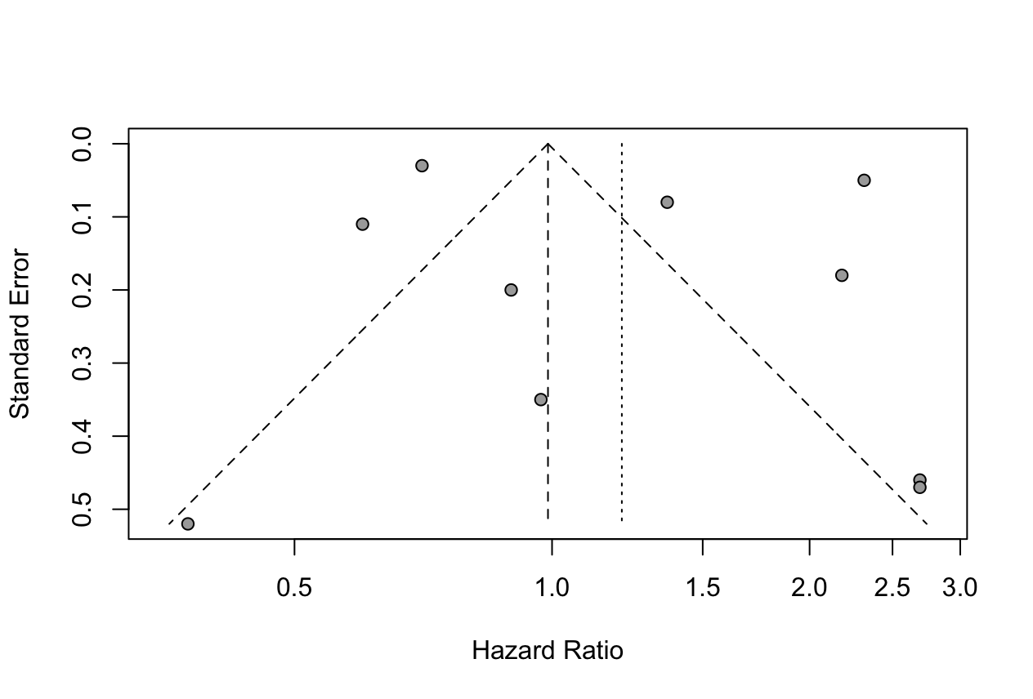
Figure 1. Funnel Plot for publication bias of OS.

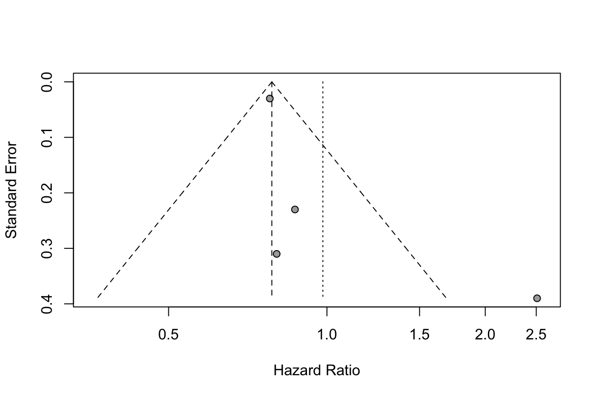
Figure 2. Funnel Plot for publication Bias of DFS.

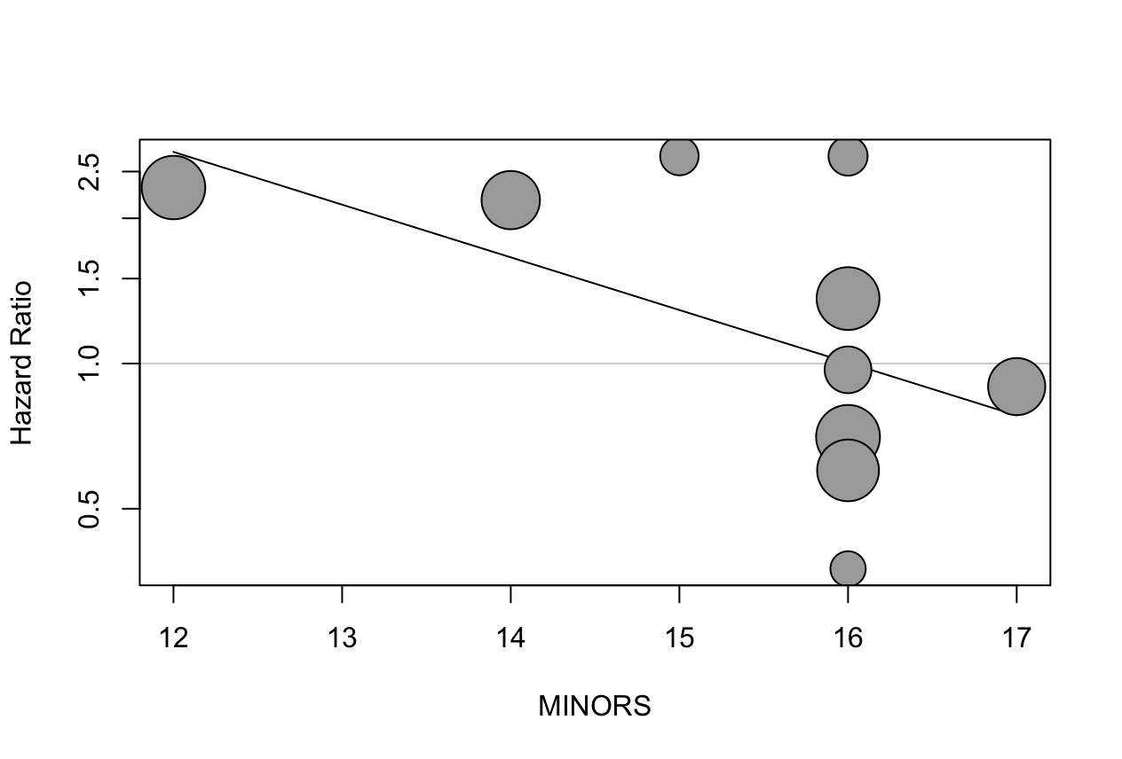
Figure 3. Bubble plot describing the relationship between quality of included studies (MINORS) and HR. To an increase of studies quality correspond to a decrease of HR (no differences of survival between two groups), and this can explain the 47.5% of heterogeneity (R2=47.5%, ß (SE)=-0.25 (0.10), p=0.014, after Monte Carlo Permutation p= 0.036).
Covariates | Number of studies | Beta coefficient (SE) | Adjusted R² (%) | P-value | P-value after Monte Carlo Permutation | Residue I² (%)
Year  PSM  MINORS  East-Western Study  Age MD  Male sex RR  PD RR  Stage I-II RR  T1-2 RR  N0 RR  PNI RR  LVI RR  R0 RR  G3 RR  Tubular Histology RR  5-FU (%)  Gemcitabine (%)  FOLFIRINOX (%)  RT (%) | 10  10  10  10  3  4  3  3  3  5  4  4  6  5  3  4  6  5  4 | -0.04 (0.04)  -0.33 (0.68)  -0.25 (0.10)  1.25 (0.78)  -0.52 (0.38)  5.86 (2.06)  7.03 (1.68)  -3.27 (3.96)  -1.15 (0.65)  -1.81 (2.34)  0.02 (0.71)  0.21 (0.52)  -3.23 (3.44)  1.25 (0.71)  0.23 (0.63)  -0.05 (0.94)  -0.26 (0.73)  -7.00 (6.24)  -0.31 (1.57) | 0.0  0.0  47.9  11.1  38.7  100  100  0.0  100  0.0  0.0  0.0  0.0  43.8  0.0  0.0  0.0  2.8  0.0 | 0.271  0.624  0.014  0.109  0.164  0.005  <0.001  0.409  0.077  0.439  0.978  0.687  0.348  0.077  0.706  0.956  0.719  0.262  0.840 | 0.301  0.800  0.032  0.100  0.500  0.083  0.167  0.667  0.167  0.517  1.000  0.833  0.417  0.175  1.000  0.875  0.678  0.300  0.916 | 97.5  97.9  92.1  97.5  67.3  0.0  0.0  67.1  0.0  98.3  87.8  92.7  97.6  94.5  71.7  98.6  98.3  98.8  97.6

Table 2: Univariate meta-regression analysis.

Legend: SE= standard error; R² = relative reduction in between-study variance, the value indicates the proportion of between-study variance explained by covariate; Residue I²= Residue heterogeneity; MD= mean difference; RR= risk ratio;
PSM = Propensity Score Matching; MINORS = Quality assessment using the Methodological Index for Non-Randomized Studies; PD= Pancreaticoduodenectomy; PNI= Perineural invasion; LVI= Lymph-vascular invasion; R0= radical resection with negative margins; G3= high grade; 5-FU= 5-Fluorouracil; RT= Radiotherapy.

