Supplemental Materials

Figure S1. HRS Cohorts selection

Figure S2. Flowchart of the selection of the study population
All individuals with information on multimorbidity
Early Baby Boomers
(N=4947)
War Babies
(N=2762)
Original HRS
(N=11966)

Overall sample (N=19675)

Selection of individuals who were healthy (free of chronic diseases) at baseline

Individuals free of chronic diseases at baseline (N=5593)

Selection of individuals who developed at least one disease over the follow up

Individuals with available information on health expectancy (N=4274)

Selection of individuals aged 51 or older

Individuals aged 51 or above (N=3511)

Table S1. Characteristics of the study sample population (n=4274)

Characteristics | Study Sample
Baseline Age, years  Mean (±sd) | 55.1 (±6.3)
Sex (men)  N (%) | 1849 (43.3%)
Ethnicity  - Caucasian  - African American  - Others  N(%) | 3536 (82.8%)  480 (11.2%)  254 (5.9%)
Education (years)  Median (IQR) | 13 (12-16)
Baseline BMI, kg/m²  Mean (±sd) | 26.5 (±4.6)
Health expectancy (=years of life free of chronic diseases)  Mean (±sd) | 61.3 (± 7.6)
Rate of accumulation of additional diseases after the first onset,  N^ Diseases per year  Mean (±sd) | 0.09 (±0.002)
Follow up time, years  Mean (±sd) | 9.4 (±5.4)
Survival rate N (%) | 3279 (76.7%)

Figure S3. Distribution of Age at onset of first chronic disease (=End of Health Expectancy) and Rate of accumulation of additional diseases (N=4274)
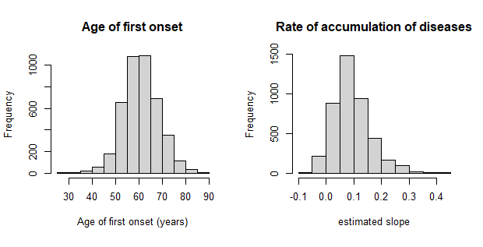

Figure S4. Plot exploring the correlation between Age at onset of first chronic disease (years) and the rate of diseases accumulation (N=4274)
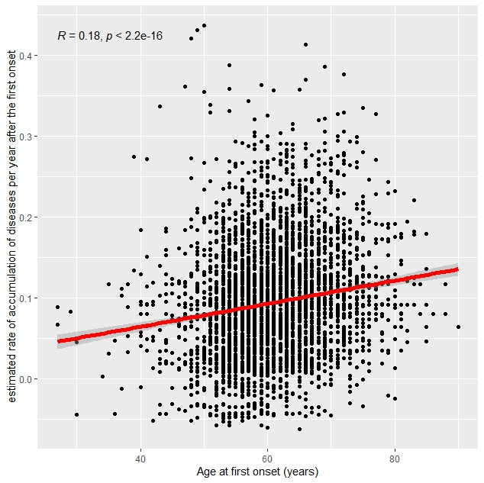

Figure S5. Kaplan Meier Survival Curves according to different tertiles of age at onset of the first diseases (N=4274)

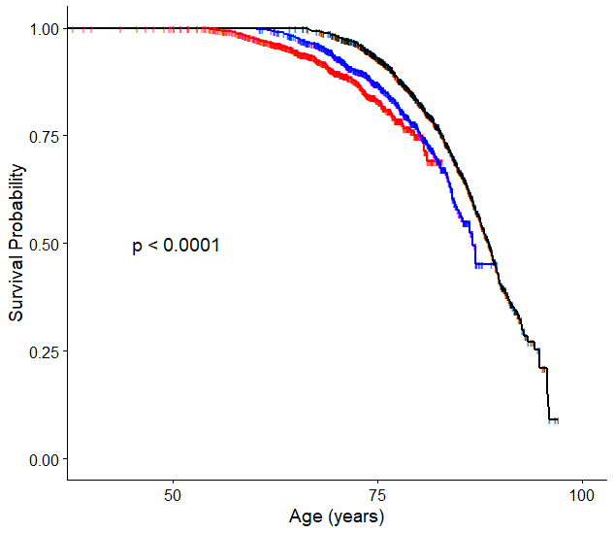
Legend: Red line: younger tertile (=shorter health expectancy); Blue line: medium tertile; Black line: older tertile (= longer health expectancy)
Note: P value refers to the log-rank test

Figure S6. Kaplan Meier Survival Curves according to different tertiles of rate of diseases accumulation after the end of health expectancy (N=4274)

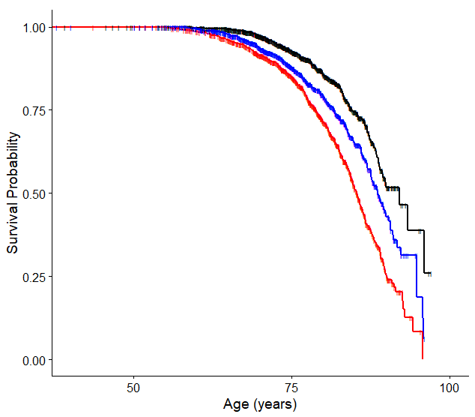

Legend: Red line: faster tertile; Blue line: medium tertile; Black line: slower tertile
Note: P value refers to the log-rank test

