Supplementary S1 | Sensitivity of state trajectories across governance regimes
This section reports a local first-order sensitivity analysis for the biomass and biodiversity trajectories generated by the deterministic finite-horizon systems in the main text. Let
$$y\left(t\right)∈\left\{x\left(t\right),B\left(t\right)\right\} (S1.1)$$
denote a state variable, and let $θ$ denote a scalar ecological or economic parameter. Along the baseline solution path, the time-varying sensitivity of $y\left(t\right)$ with respect to $θ$ is approximated by the centered finite-difference derivative
$$S_{y}^{θ}\left(t\right)=\frac{y\left(t;θ\left(1+h\right)\right)-y\left(t;θ\left(1-h\right)\right)}{2hθ}, h={10}^{-4} (S1.2)$$
For each perturbation, the corresponding forward–backward boundary-value problem is re-solved while all other parameters and the initial conditions are held fixed. The endpoint structure is preserved across baseline and perturbed runs: fixed-endpoint regimes impose the same terminal state targets, whereas free-endpoint regimes impose the same transversality conditions. Thus, the reported sensitivities are local, regime-consistent comparative statics rather than global robustness measures.
To summarize the sensitivity paths, we compute two scalar indices. The first is the peak absolute sensitivity,
$$M_{∞}\left(y,θ\right)=\max_{t∈\left[0,T\right]}\left|S_{y}^{θ}\left(t\right)\right|, (S1.3)$$
and the second is the time-integrated absolute sensitivity,
$$M_{1}\left(y,θ\right)=\int_{0}^{T}{\left|S_{y}^{θ}\left(t\right)\right|dt}, (S1.4)$$
The quantity $M_{∞}$ measures the largest local response over the horizon, while $M_{1}$ measures cumulative responsiveness. In the numerical implementation, $M_{1}$ is approximated by quadrature on the solver mesh.
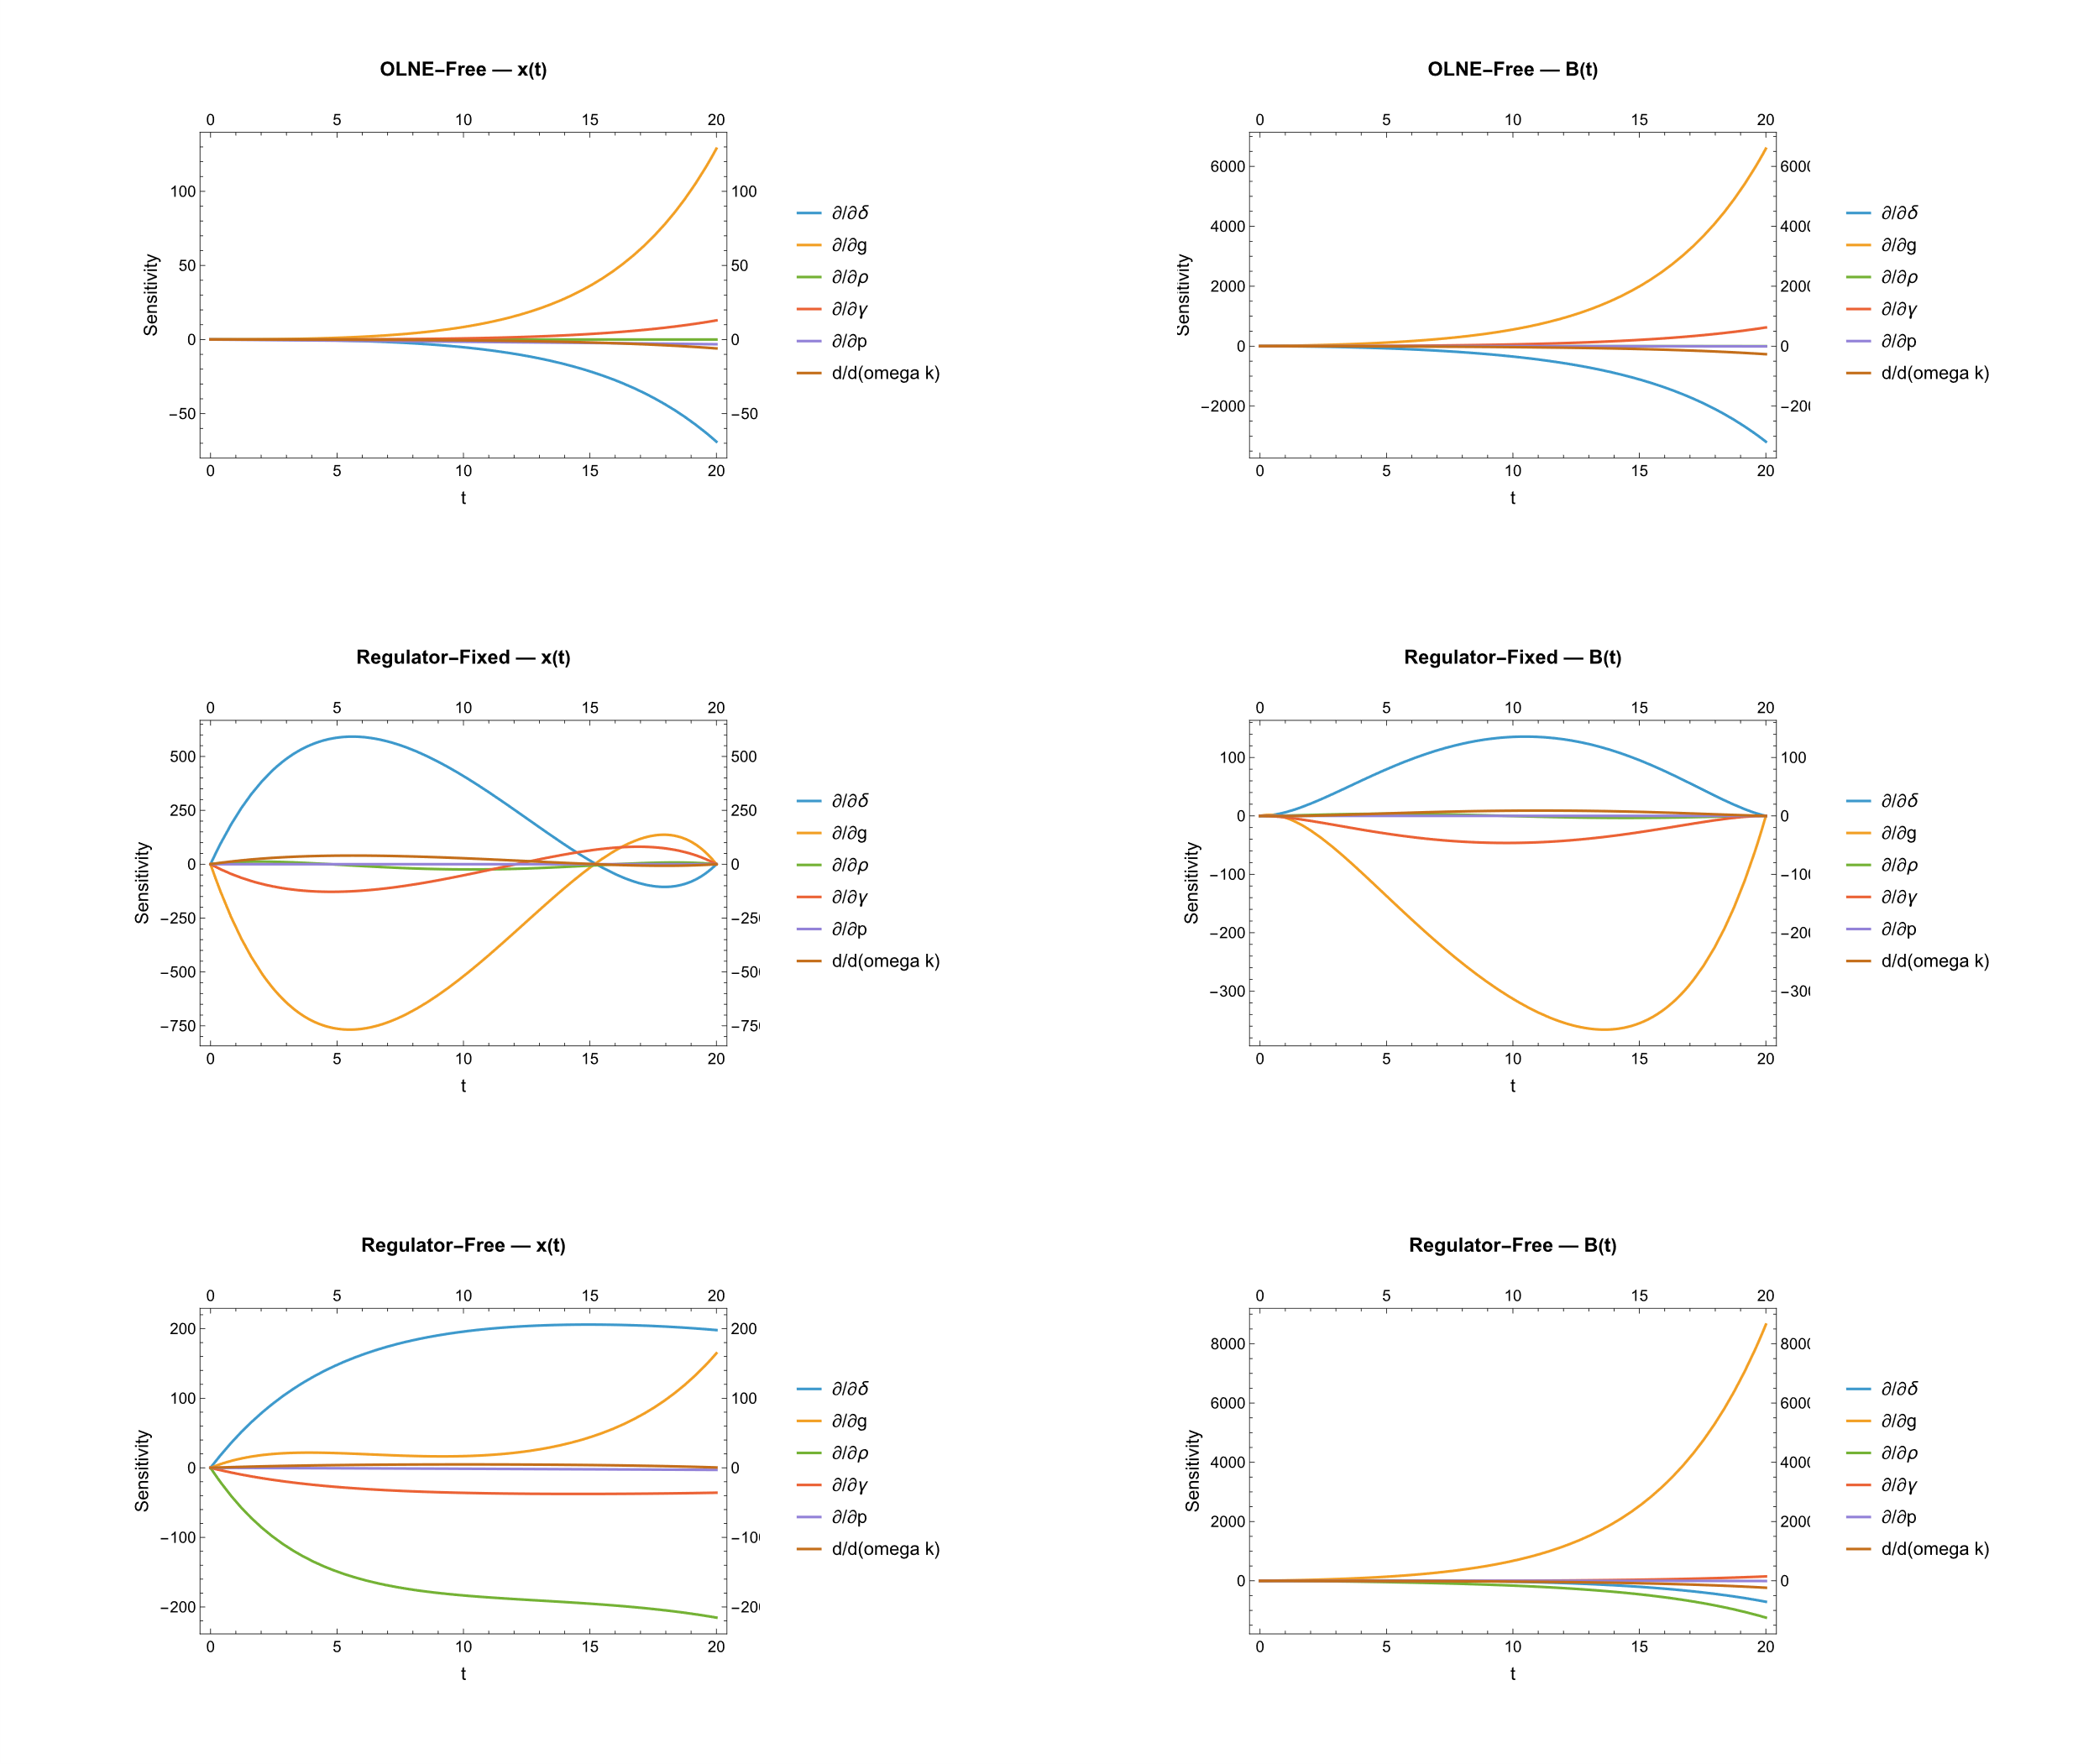
Supplementary Figure S1. Local sensitivity of biomass and biodiversity trajectories across governance regimes. The figure reports $S_{y}^{θ}\left(t\right)$ for biomass $x\left(t\right)$ and biodiversity $B\left(t\right)$ under the OLNE-Free, Regulator-Fixed, and Regulator-Free regimes. The left column shows biomass sensitivities and the right column shows biodiversity sensitivities; rows correspond, respectively, to OLNE-Free, Regulator-Fixed, and Regulator-Free. In the reported calibration, the profiles indicate that sensitivity patterns differ across both governance regime and endpoint design: the OLNE-Free case displays largely monotone responses, the Regulator-Fixed case exhibits non-monotone paths with visible terminal adjustment, and the Regulator-Free case produces smoother free-endpoint responses without convergence to prescribed terminal states. These profiles should be interpreted as local comparative-static responses around the calibrated baseline, not as global robustness results.

Supplementary S2 | Calibration and numerical reproducibility
This section reports the baseline calibration and numerical settings used for the simulations in the main text and the sensitivity analysis in Supplementary S1. The model is solved on the finite horizon $T=20$ with common initial conditions $\left(x_{0},B_{0},Z_{0}\right)=\left(500,10,0.1\right)$.
Biomass is measured in normalized stock units, biodiversity is represented by a dimensionless ecological index, and cumulative harvesting pressure is a stock variable that records past extraction effects subject to decay. The disturbance-loss component enters only through the deterministic expected-drift term $ϖκ$, as specified in the main text.
Table S2.1. Baseline calibration and numerical settings. Parameter values, initial conditions, endpoint targets, and numerical settings are held common across regimes except for objective structure and endpoint conditions.
Symbol | Description | Baseline value | Units / scale
$$n$$ | Number of harvesters | 15 | count
$$T$$ | Planning horizon | 20 | time units
$$K$$ | Biomass carrying capacity | 1000 | biomass units
$$A$$ | Productivity scale in $r\left(B\left(t\right)\right)=A{\left(B\left(t\right)\right)}^{ξ}$ | 0.00002 | scaled
$$ξ$$ | Biodiversity–productivity elasticity | 1 | dimensionless
$$α_{C}$$ | Harvest-cost curvature under symmetry | 100 | $$\frac{cost}{{harvest}^{2}}$$
$$g$$ | Biodiversity regeneration parameter | 0.2 | $${time}^{-1}$$
$$δ$$ | Effect of cumulative harvesting pressure on biodiversity | 0.1 | $$\frac{biodiversity}{pressure×time}$$
$$γ$$ | Decay rate of cumulative harvesting pressure | 0.3 | $${time}^{-1}$$
$$ρ$$ | Discount rate | 0.01 | $${time}^{-1}$$
$$p$$ | Biomass price | 40 | $$\frac{price}{biomass}$$
$$ϖκ$$ | Expected disturbance-loss drift | 0.0001 | $$\frac{biodiversity}{time}$$
$$x_{0}$$ | Initial biomass | 500 | biomass units
$$B_{0}$$ | Initial biodiversity | 10 | index
$$Z_{0}$$ | Initial cumulative harvesting pressure | 0.1 | pressure units
$$\left(x_{T},B_{T},Z_{T}\right)$$ | Fixed terminal targets, fixed-endpoint regime only | (400,150,10) | state units
$$h$$ | Relative perturbation step for sensitivity analysis | $${10}^{(-4)}$$ | dimensionless
$$Solver$$ | Numerical implementation | Mathematica NDSolve | stiffness-adaptive
$$Precision$$ | Working precision | 14 digits | numerical

The same baseline parameter values are used across governance regimes to preserve comparability. Regimes differ by their objective structure and endpoint conditions: free-endpoint cases impose $λ\left(T\right)=μ\left(T\right)=ν\left(T\right)=0,$ whereas the fixed-endpoint case imposes $\left(x\left(T\right), B\left(T\right), Z\left(T\right)\right)=\left(x_{T},B_{T},Z_{T}\right).$
The forward–backward systems are solved by a shooting procedure. Initial states are fixed, and the unknown initial costates are adjusted until the relevant terminal conditions are satisfied. The coupled systems are integrated using stiffness-adaptive methods with high working precision. Numerical reliability is assessed through mesh refinement, boundary-residual diagnostics, and stability of the solution path under tighter solver tolerances.
We assess local responses around the baseline calibration while preserving the same governance regime and endpoint conditions. Accordingly, the results provide evidence on the stability of the reported trajectories in a neighborhood of the calibrated parameter values, but they should not be interpreted as establishing global robustness over the entire parameter space.

