SUPPLEMENTARY MATERIAL
Food Chemistry

Application of Flash GC and linear and non-linear chemometric techniques as a rapid screening tool to discriminate monovarietal Grappa distillates
Silvia Arduini ^{a, *}, Chiara Cevoli ^{b, c}, Enrico Valli ^{b, c}, Alessandra Bendini ^{b, c}, Fabio Chinnici ^{a, c}
ª Department of Agricultural and Food Sciences, Alma Mater Studiorum-University of Bologna, Viale Fanin 40, 40127 Bologna, Italy, silvia.arduini2@unibo.it; fabio.chinnici@unibo.it.
^{b} Department of Agricultural and Food Science, Alma Mater Studiorum- University of Bologna, Piazza Goidanich 60, 47521 Cesena, Italy, chiara.cevoli3@unibo.it; enrico.valli4@unibo.it; alessandra.bendini@unibo.it.
^{c} Interdepartmental Center for Agri-Food Industrial Research (Ciri-Agro), Via Quinto Bucci 336, 47521 Cesena, Italy

* Correspondence: silvia.arduini2@unibo.it

Figure S1 Chromatograms of all Grappa samples, grouped according to grape variety (BA = Barolo, BR = Brunello, MU = Muscat, PR = Prosecco).

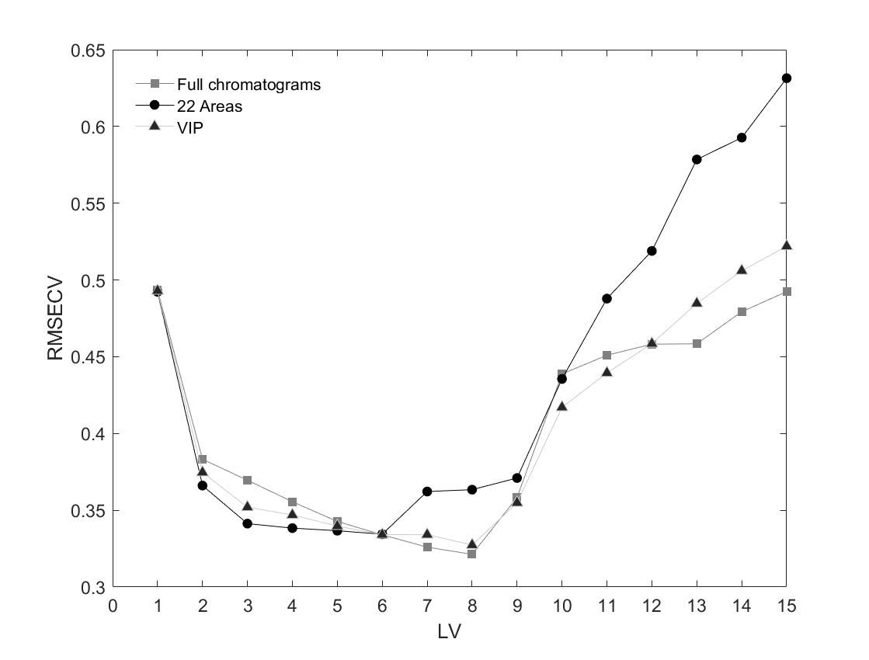
Figure S2 Root mean square error of cross-validation (RMSECV) as a function of the number of latent variables (LVs) for PLS-DA models constructed using full chromatograms (squares), VIP-selected variables (triangles), and 22 peak areas (circles).
Figure S3 Variable Importance in Projection (VIP) scores from the PLS-DA model based on the full chromatographic dataset. Regions above the significance threshold (VIP = 1) were considered most significant for class separation. BA = Barolo; BR = Brunello; MU = Muscat; PR = Prosecco.

