Hyperspectral imaging for precision nitrogen management: a comparative exploration of two methodological approaches to estimate optimal nitrogen rate in processing tomato

Vito Aurelio Cerasolaª, Francesco Orsiniª, Giuseppina Pennisi^{a*}, Gaia Morettiª, Stefano Bona^{b}, Francesco Mirone^{b}, Jochem Verrelst^{c}, Katja Berger^{c,d}, Giorgio Gianquintoª
ª Department of Agricultural and Food Sciences (DISTAL), Alma Mater Studiorum - University of Bologna, Viale Fanin 44, 40127, Bologna, Italy; vito.cerasola@unibo.it, gaia.moretti6@unibo.it; f.orsini@unibo.it; giuseppina.pennisi@unibo.it; giorgio.gianquinto@unibo.it
^{b} Department of Agronomy, Food, Natural resources, Animals and Environment (DAFNAE), University of Padova, Viale dell’Università, 16, 35020 Legnaro (PD), Italy; stefano.bona@unipd.it; francesco.mirone@unipd.it
^{c} Image Processing Laboratory (IPL), Universitat de València, València, Spain
^{d} Helmholtz Center Potsdam, GFZ German Research Center for Geosciences, 14473 Potsdam, Germany

Supplementary materials

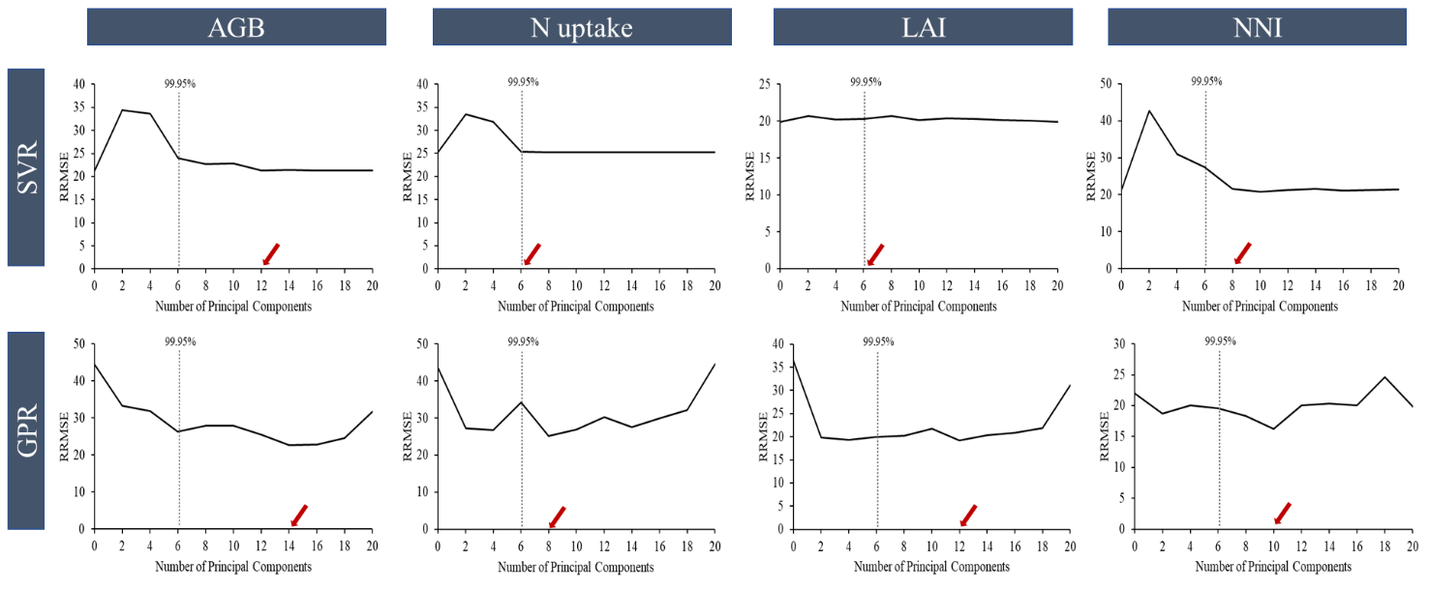

S1 MLRAs performances (RRMSE) as a function of the number of principal components included. The red arrows indicate the number of PCs selected

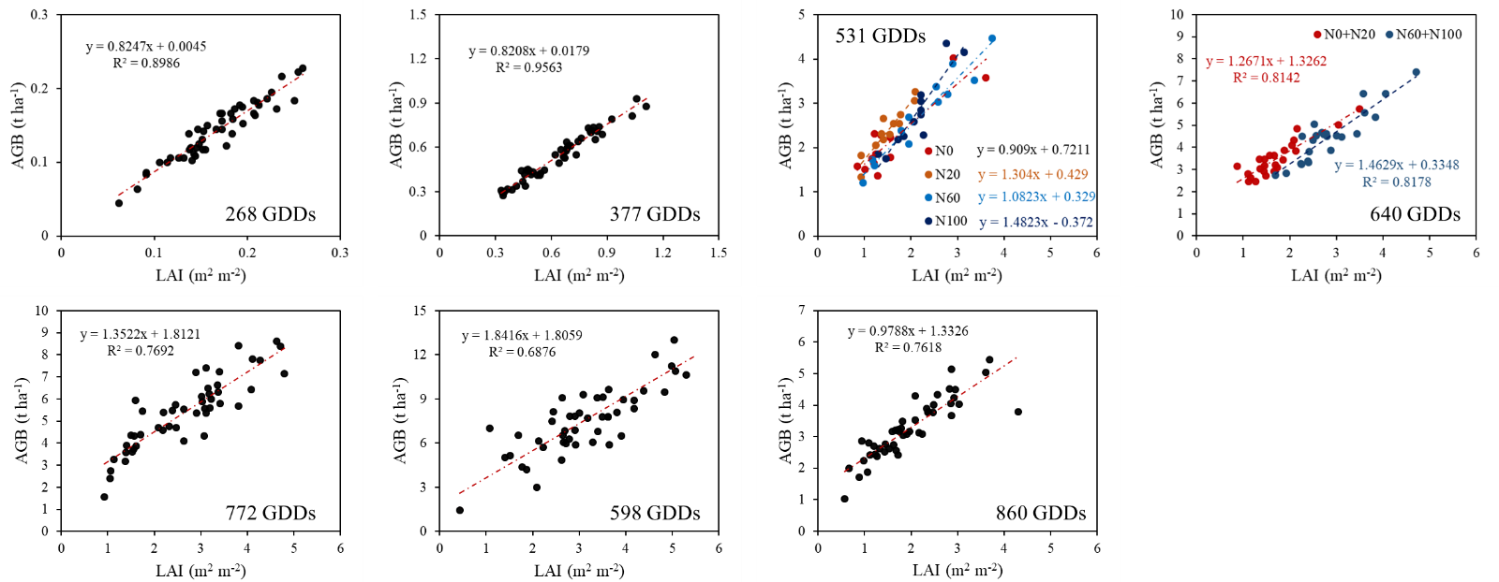

S2 Linear relationships between LAI and AGB at each growth stage

Year | GDD | Model | AIC | RSS | df | F | p-value
 |  | Full | -274 | 0.007 | 43
2023 | 268 | Reduced | -277 | 0.007 | 46
 |  | Partial F test |  |  |  | 0.998 | 0.403 | ns
 |  | Full | -181 | 0.05 | 43
2023 | 377 | Reduced | -180 | 0.057 | 46
 |  | Partial F test |  |  |  | 2.2 | 0.101 | ns
 |  | Full | 34.05 | 4.449 | 43
2023 | 531 | Reduced | 38.95 | 5.584 | 46
 |  | Partial F test |  |  |  | 3.654 | 0.019 | *
 |  | Full | 59.24 | 7.51 | 43
2023 | 640 | Reduced | 70.8 | 10.84 | 46
 |  | Partial F test |  |  |  | 6.33 | 0.001 | **
 |  | Full | 117 | 25.44 | 43
2023 | 772 | Reduced | 116 | 28.37 | 46
 |  | Partial F test |  |  |  | 1.653 | 0.191 | ns
 |  | Full | 60.84 | 7.78 | 42
2022 | 598 | Reduced | 59.69 | 8.625 | 45
 |  | Partial F test |  |  |  | 1.521 | 0.223 | ns
 |  | Full | 177 | 87.57 | 43
2022 | 860 | Reduced | 174 | 94.37 | 46
 |  | Partial F test |  |  |  | 1.112 | 0.354 | ns

S3 Assessment of empirical models (full and reduced) according to the Partial F Test. Akaike Information Criterion (AIC), Residual Sum of Square (RSS) and degree of freedom (df) are reported.
GDD | Model | AIC | RSS | df | F | p-value
 | Combined | 37.39 | 5.18 | 45
531 | Reduced | 38.95 | 5.58 | 46
 | Partial F test |  |  |  | 3.466 | 0.069 | ns
 | Combined | 62.19 | 8.69 | 45
640 | Reduced | 70.8 | 10.84 | 46
 | Partial F test |  |  |  | 11.122 | 0.001 | **

S4 Assessment of the differences of empirical models (combined and reduced) according to the Partial F Test. The combined model included the combination of lower N treatment (N0+N20), and the combination of higher N treatment (N60+N100)

