Additional File 1

Supporting Treatment Decision-Making for Patients with Multiple Myeloma post-DRd in Italy: A Multi-Criteria Decision Framework

Contents
Figure S.1 – Criteria selection process ………………………………………………………. | 2
Appendix 1 – Pragmatic literature review ……………………………………………………. | 3
Figure S.2 – PRISMA Flow Diagram for Kd-related queries ………………………………… | 5
Figure S.3 – PRISMA Flow Diagram for PVd-related queries ……………………………... | 6
Figure S.4 – PRISMA Flow Diagram for SVd-related queries ……………………………... | 7
Appendix 2 – Questionnaire structure ……………………………………………………….. | 8
Appendix 3 – Aggregation model …………………………………………………………….. | 10
Bibliography …………………………………………………………………………………….. | 11

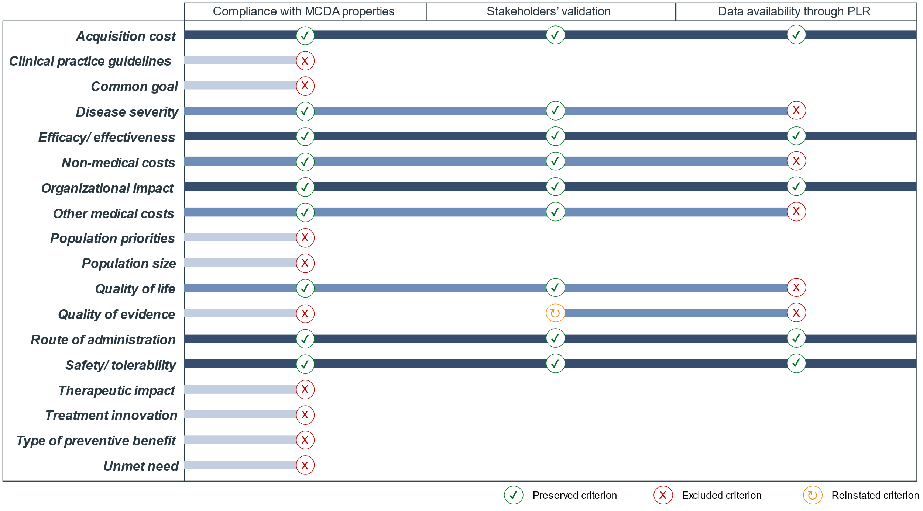
Figure S.1
The graph illustrates the process underwent by the preliminary list of main criteria identified through an initial focused literature review through PubMed, cross-references, and targeted research and composed by criteria mentioned in at least 20% of found studies as well as all other criteria mentioned in found MCDA studies related to hematological tumors. The preliminary list of 18 criteria was initially scrutinized in light of the properties required for an MCDA set of criteria, compliant ones were discussed in a multi-stakeholder workshop to validate their real-world relevance, and validates ones were considered for inclusion in the final list of criteria by means of a pragmatic literature review (PLR) to assess data availability for Kd, PVd, and SVd.
During the first workshop, the “quality of evidence” criterion (e.g. preference of randomized controlled trials over non-randomized studies) (Jommi and Ravasio, 2019) was reinstated to the list of compliant criteria, despite its initial exclusion due to its perceived redundancy. This addition was based on the feedback from workshop attendees who highlighted that the “quality of evidence” is one of the three criteria assessed by Italian Medicine Agency in the evaluation of a drug innovation status (AIFA, 2017).
Appendix 1
A pragmatic literature review (PLR) was conducted to identify data sources to populate the performance matrix in cases where their selection was not implicitly dictated by criteria definitions as validated during the first workshop. For instance, no PLR was needed for the “organizational impact,” “route of administration,” and “safety” criteria as measurements of alternatives’ performances were directly retrieved from their randomized clinical trials (RCTs) (Dimopoulos et al., 2016; Richardson et al., 2019; Grosicki et al., 2020) and European Medicines Agency’s Summaries of Product Characteristics (EMA, 2022, 2023b, 2023a).
Instead, in cases where data source selection was not implicit – specifically for the criteria of “efficacy,” “quality of life,” “other medical costs,” and “non-medical costs” – a pragmatic literature review was performed according to PRISMA guidelines. Each alternative was associated to a unique research string (0-A for Kd, 0-B for PVd, and 0-C for SVd) and the search included studies published between 1 January 2015 and 1 November 2023.
No. | String Definition
0-A | “Carfilzomib AND Dexamethasone"[Title/Abstract:~0]
0-B | “Pomalidomide AND Dexamethasone AND Bortezomib"[Title/Abstract:~0]
0-C | “Selinexor AND Dexamethasone AND Bortezomib"[Title/Abstract:~0]

Records identified through database search were screened based on titles and abstracts containing keywords related to multiple myeloma; Progression-Free Survival; fertility, sexual, social, and psychological aspects; costs of adverse events, visits, and exams; and indirect costs sustained due to the time waited for administration.
The PLR provided multiple sources for “efficacy” for all alternatives, including a network meta-analysis evaluating all of them and focused on lenalidomide-refractory patients (Kastritis et al., 2023). This also led to the “disease severity” criterion being dropped, as during the first workshop participants had validated its definition as alternatives’ RCTs’ representativeness of the population under the decision problem and they had agreed on it being dropped had efficacy data for lenalidomide-refractory patients been found. Instead, no evidence for “quality of life,” “other medical costs,” and “non-medical costs” was provided stratified by treatment, leading to the exclusion of these criteria from the final list. Specifically, the search for “quality of life” data resulted in two potential sources for Kd (Ludwig et al., 2019; Siegel et al., 2020), one for SVd (Sanchez et al., 2021), and none for PVd. Besides the unavailability of a data source for PVd, retrieved sources for Kd and SVd did not provide comparable measurements. In fact, for SVd only the impact of peripheral neuropathy symptoms was analyzed, while for Kd more general quality of life measures were reported. Detailed information on the PRISMA flow diagram by alternative is provided in Figure S.2, S.3, and S.4.

Figure S.2
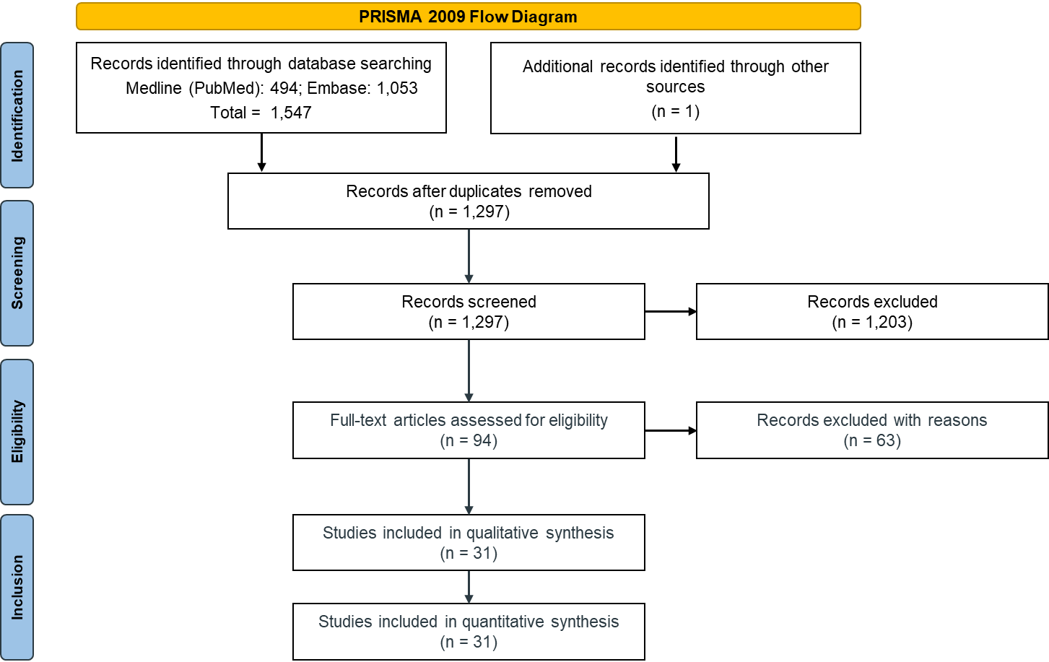
PRISMA Flow Diagram for Kd-related queries

Figure S.3
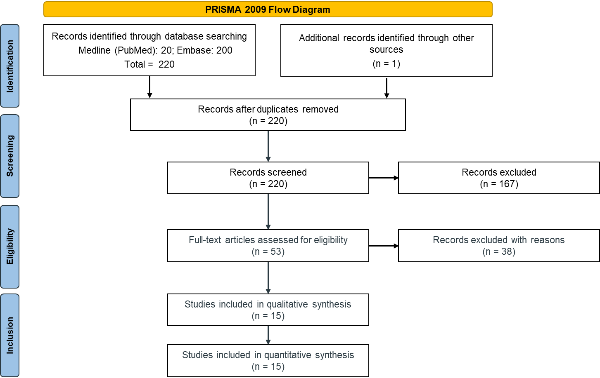
PRISMA Flow Diagram for PVd-related queries

Figure S.4
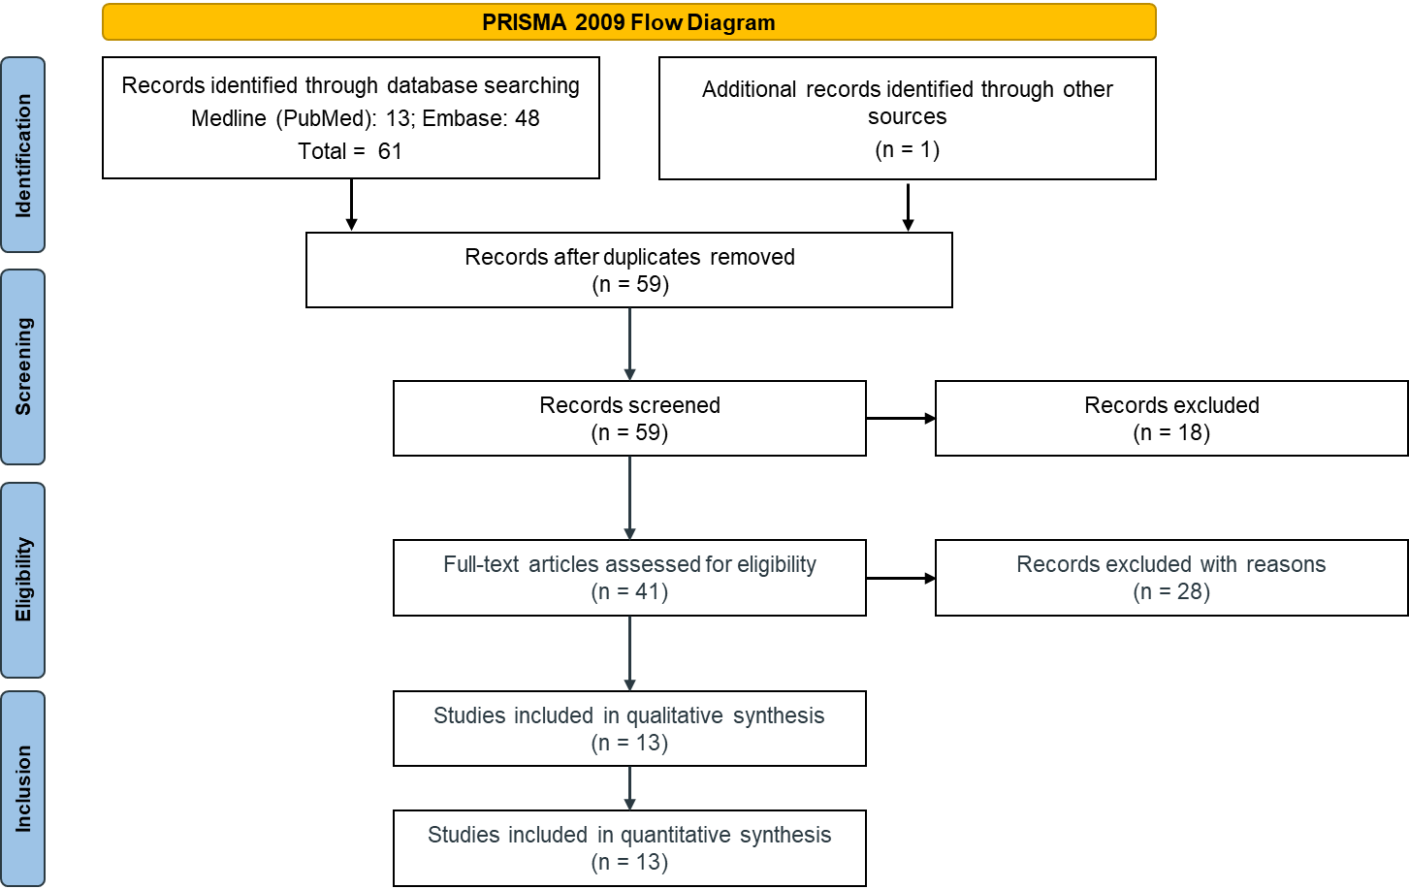
PRIMA Flow Diagram for SVd-related queries

Appendix 2
- ‘Section 1: Weighting of sub-criteria’ aimed at defining the relative importance among sub-criteria. Participants were presented with improvements in each sub-criterion and asked to select the most important improvement, by indicating a perceived strength of importance among six levels: “extremely,” “very strongly,” “strongly,” “moderately,” “weakly,” and “very weakly important,”. Subsequently, they had to identify the second-most important improvement and compare it with the most important one. This exercise was repeated as long as participants found the gaps presented relevant, with the option of skipping them if they were deemed unimportant at all. By iterating this exercise until no relevant improvements were left, participants implicitly assigned a weight to all sub-criteria, which can be considered a measure of relative importance. In other words, considering 100% as a total value spectrum of importance, each stakeholder allocated his/her 100% among criteria with larger shares associated with improvements perceived as the most important. Skipped sub-criteria, instead, were implicitly assigned a 0% weight.
- ‘Section 2: Scoring of sub-criteria’ aimed at defining the relative importance within each sub-criterion. For each sub-criterion participants were asked to assign a measure of preference for the following three pairwise comparisons of the treatment options: 1) comparison between the best and the worst performance level, 2) comparison between the intermediate and the worst performance level, and 3) comparison between the best and the intermediate performance level. Preference options were “very weakly,” “weakly,” “moderately,” “strongly,” “very strongly,” and “extremely preferable,”. The exercise was repeated for each sub-criterion not skipped in the previous section. The assigned scores to each sub-criterion resulted in individual value functions for each sub-criterion. These functions could be convex, concave, or linear depending on whether the preference in the comparison between the best and the intermediate performance levels was stronger, weaker, or equal to the preference in the comparison between the intermediate and the worst performance levels.
- ‘Section 3: Weighting of main criteria’ and ‘Section 4; Scoring of main criteria’ replicated the same exercises of Sections 1 and 2 for the main criteria respectively. Unlike the weighting exercise for the sub-criteria, in Section 3 stakeholders could not skip any main criterion and thus no weight of 0% could be assigned.

Appendix 3
Aggregate scores of the three alternatives (Kd, PVd, and SVd) were computed for each participant by implementing an additive aggregation model. Based on previous studies (Angelis and Kanavos, 2017; Angelis et al., 2020), the overall score S_{j} (a) of an alternative a for the participant j was given by:
$$S_{j}\left(a\right)= \sum_{i=1}^{m}{w_{j, i}v_{j, i}(a)}$$
where v_{j,i} (a) is the value score of alternative a obtained by applying participant j’s value function for criterion i to the performance of a in that criterion, w_{j,i} is participant j’s weight for criterion i, and m is the total number of main criteria. For the criterion composed by sub-crtieria, v_{j} (a) was computed using the same formula as above employing weights related to sub-criteria.
The global aggregate score for each therapeutic option corresponded to the median value of the aggregate scores from all participants. These global aggregate scores led then to an overall ranking of Kd, PVd, and SVd. Using the rankings method, we also assessed, the proportion of participants whose aggregate scores were consistent with the given rankings of Kd, PVd, and SVd.

Bibliography
AIFA (2017) Resolution No. 1535/2017 - Criteria for the classification of innovative medicinal products and innovative oncological medicinal products. Available at: https://www.aifa.gov.it/documents/20142/516919/Determina_criteri_classificazione_farmaci_innovativi.pdf (Accessed: 4 September 2024).
Angelis, A. et al. (2020) ‘Multiple Criteria Decision Analysis for HTA across four EU Member States: Piloting the Advance Value Framework’, Social Science & Medicine, 246, p. 112595. Available at: https://doi.org/10.1016/j.socscimed.2019.112595.
Angelis, A. and Kanavos, P. (2017) ‘Multiple Criteria Decision Analysis (MCDA) for evaluating new medicines in Health Technology Assessment and beyond: The Advance Value Framework’, Social Science & Medicine, 188, pp. 137–156. Available at: https://doi.org/10.1016/j.socscimed.2017.06.024.
Dimopoulos, M.A. et al. (2016) ‘Carfilzomib and dexamethasone versus bortezomib and dexamethasone for patients with relapsed or refractory multiple myeloma (ENDEAVOR): a randomised, phase 3, open-label, multicentre study’, The Lancet Oncology, 17(1), pp. 27–38. Available at: https://doi.org/10.1016/S1470-2045(15)00464-7.
EMA (2022) Kyprolis - Summary of Product Characteristics.
EMA (2023a) Imnovid - Summary of Product Characteristics.
EMA (2023b) Nexpovio - Summary of Product Characteristics.
Grosicki, S. et al. (2020) ‘Once-per-week selinexor, bortezomib, and dexamethasone versus twice-per-week bortezomib and dexamethasone in patients with multiple myeloma (BOSTON): a randomised, open-label, phase 3 trial’, The Lancet, 396(10262), pp. 1563–1573. Available at: https://doi.org/10.1016/S0140-6736(20)32292-3.
Jommi, C. and Ravasio, R. (2019) ‘Il valore di obinutuzumab per il trattamento in prima linea del Linfoma Follicolare: un’analisi basata su approccio Multicriteria Decision Analysis (MCDA)’, AboutOpen, 6(1), pp. 78–85. Available at: https://doi.org/10.33393.abtpn.2019.302.
Kastritis, E. et al. (2023) ‘Network Meta-Analysis of Randomized Trials in Relapsed/Refractory Multiple Myeloma: Relative Efficacy for Patients Who Are Lenalidomide-Refractory’, 65th ASH Annual Meeting Abstracts, 142, p. 7424. Available at: https://doi.org/10.1182/blood-2023-180947.
Ludwig, H. et al. (2019) ‘Health-related quality of life in the ENDEAVOR study: carfilzomib-dexamethasone vs bortezomib-dexamethasone in relapsed/refractory multiple myeloma’, Blood Cancer Journal, 9(3), p. 23. Available at: https://doi.org/10.1038/s41408-019-0181-0.
Richardson, P.G. et al. (2019) ‘Pomalidomide, bortezomib, and dexamethasone for patients with relapsed or refractory multiple myeloma previously treated with lenalidomide (OPTIMISMM): a randomised, open-label, phase 3 trial’, The Lancet Oncology, 20(6), pp. 781–794. Available at: https://doi.org/10.1016/S1470-2045(19)30152-4.
Sanchez, L. et al. (2021) ‘Peripheral neuropathy symptoms, pain, and functioning in previously treated multiple myeloma patients treated with selinexor, bortezomib, and dexamethasone’, American Journal of Hematology, 96(10). Available at: https://doi.org/10.1002/ajh.26282.
Siegel, D.S.D. et al. (2020) ‘Health related quality of life (HRQoL) outcomes from the phase III CANDOR study comparing carfilzomib, dexamethasone, and daratumumab (KdD) to carfilzomib and dexamethasone (Kd) in patients (Pts) with relapsed or refractory multiple myeloma.’, Journal of Clinical Oncology, 38(15_suppl), pp. e20563–e20563. Available at: https://doi.org/10.1200/JCO.2020.38.15_suppl.e20563.

