Appendix 1 –
A standardized Robot-Assisted Technique of Giant Paraesophageal Hernia repair: a relationship between surgical details and long-term follow-up

Stepwise Surgical Technique

This technique was developed during 20 years of surgical experience, in minimally invasive laparoscopic and robotic upper GI and gastroesophageal junction repairs for benign diseases (23). During this time, 2 different da Vinci® robotic platforms were used (the Si and Xi since 2017).
The patient is placed in reverse Trendelenburg position with legs apart. A nasogastric tube is placed to empty the stomach. In emergency presentations, the nasogastric tube is placed before general anesthesia. Pneumoperitoneum is then established with the Veress needle in Palmer’s point.
The da Vinci® Robotic Platform (Intuitive Surgical, Sunnyvale, California, USA) is docked above the head using the Si platform. For the Xi platform, the robot is docked at the left flank, with the robotic arms coming from above the patient head. Concerning the Xi platform, the port placements are shown in Appendix 1 Figure 2, where four 8-mm incisions are made along a line running about half distance between the xiphoid and the umbilicus. A fifth 12-mm port (AirSeal® device) is placed about 3 cm below the robotic port line between the camera port (T3) and operative port (T4). Rarely for challenging cases, a sixth 5-mm port may be placed at the same level of the AirSeal in the right abdomen (for a better stomach retraction during sac excision). With regards to the robotic instruments, we generally prefer a bipolar grasper on port T2, a Cadiere grasper on port T1 (for liver retraction) a monopolar robotic hook or/and vessel sealer on port T4. A needle driver will be used during suture. An atraumatic laparoscopic Johanna grasper forceps is preferred for stomach and omentum retraction. A 30° robotic camera is always used.
Step 1. The operation begins with the evaluation of stomach reducibility into the abdomen by a gentle traction of the stomach wall or omentum. As the robot doesn't allow tactile feedback, this manoeuvre must be done cautiously. Any bleeding from omental vessels or gastric lesions may be troublesome at this stage and be very time-consuming to arrest, so the use of gauze to reduce trauma is suggested. The resection of the first few upper short gastric vessels along the angle of His and the fundus may be performed easily and safely using the VesselSealer robotic device or using the robotic hook (Appendix 1, Figure 3A). We consider this first step to be very useful as it allows for easier retraction and reduction of the stomach, back into the abdomen. Furthermore, fundus mobilization will be useful for the anatomical exposure of the left crus and also facilitates the performance of a floppy Nissen at the end of the operation. We also generally perform the hernia sac dissection by first identifying the left crus, before proceeding with the sac dissection in a counterclockwise fashion.
Step 2. Once the left crus is exposed, we start the hernia sac dissection and its removal, preferably using the monopolar robotic hook or VesselSealer (Appendix 1, Figure 3B). The dissection is done whilst paying attention to preserve the peritoneum covering the muscle fibers. The dissection is carried out in a counterclockwise direction. The robotic hook allows for a better and more precise anatomical dissection of the sac from the left pleural membrane, whilst avoiding accidential entry into the sac. If a small hole occurs on the pleura we can easily repair it with absorbable stitches without any anesthesiologic consequences. No cases in our series required pleural drainage. Once the sac is completely dissected free from the left to the right side, we then open the upper pars flaccida of gastro-hepatic ligament (paying attention to preserve the vagal branch to the liver as it runs along the replaced left hepatic artery). Finally, the right crus is exposed, taking care to preserve its peritoneal covering. The pillars are completely exposed up to the origin, where they form a V shape. Once the sac is completely dissected free, its resection is performed as much as possible taking care to avoid injury to the anterior vagus nerve. The abdominal esophagus may be retracted into the abdomen without tension for at least 2-3 cm. A retroesophageal window is then created and inferior traction is applied on the stomach. For an easier and effective dissection we generally use a cloth string (or a Penrose drain) that is passed around the esophagus for a more effective traction of the stomach downward.
Step 3. The mediastinal esophageal dissection then continues intrathoracially as far as possible up to the pulmonary veins. It is mandatory to recognize and preserve the posterior vagus nerve, to avoid troublesome postoperative gastroparesis (Appendix 1, Figure 4A). The nerve may be kept close to the esophagus or separate when a retroesophageal window is created. The anterior nerve may be more difficult to recognize as it is very close to the esophagus. The 3D-view allows for a fine and safe dissection, superior to that of the laparoscopic approach. The use of bipolar coagulation and articulated instruments allows for optimal hemostasis during the circumferential esophageal dissection. A paraesophageal lipoma may be present, especially in obese patients; its removal is not always necessary. At least 2-3 cm of abdominal esophagus needs to be reduced into the abdomen without excessive traction. This test is crucial to identify a short-esophagus which might necessitate a Collis-Nissen surgery. No cases in our experience so far required a Collis-Nissen operation.
Step 4. The posterior cruroplasty is performed to reduce the hiatal space by suturing the right and left crus together, using non-absorbable sutures (2-0 Polypropylene or Polyester), together with pladgets made from a Bio-A mesh ® (GORE BIO-A ®) (Appendix 1, Figure 4B). Generally 2 to 4 stitches are necessary, with at least 1 cm of free space between the last stitch and the esophageal wall to avoid postoperative dysphagia. In all the cases of elective repair of GHH, we used a bioabsorbable reinforcement of Bio-A tissue. The U-shaped mesh is placed around the esophagus with its concavity facing up and subsequently fixed using 2-3 absorbable stitches (3-0 Vicryl) (Appendix 1, Figure 5). This mesh is thick enough and degrades in vivo through hydrolysis and is fully absorbed within 3–6 months.

Step 5. The fundoplication (generally a floppy-Nissen wrap) is then performed through the retro-esophageal window, with the intention to reduce recurrence rather than antireflux in these cases of giant hiatal hernias. Ideally, pre-operative esophageal manometry should be done to evaluate esophageal motility. This information is useful when deciding between performing a partial (posterior Toupet) or a complete (360°Nissen) fundoplication (Appendix 1, Figure 6A). In only 1 case in our series, we avoided fundoplication as the patient presented as an emergency with ischemic gastric mucosa secondary to a prolonged volvulus (33). We have never used a bougie for calibration. The fundoplication is performed easily by passing the articulated bipolar forceps behind the esophagus, whilst grasping the gastric fundus and pulling it through the retroesophageal space. This pulled through gastric fundus has to stay in place without tension, which in turn is made possible by previously sectioning the short gastric in step 1. The length of the valve in Nissen fundoplication is generally 2-3 cm long and anchored by two or three stitches. Conversely, a 270° posterior Toupet fundoplication is constructed by placing three interrupted sutures between the posterior fundus and the right side of the esophagus at and proximal to the gastroesophageal junction. Thereafter the nasogastric tube’s position is checked and kept in place for 24 hours.
Step 6. Finally, the operation is concluded by performing an anterior gastropexy (Appendix 1, Figure 6B). In our technique we use 2 absorbable 0-Vicryl stitches to secure the anterior wall of the corpus of the stomach to the abdominal wall. This is done by using a suture passer device. The stitches are secured in the subcutaneous space via small left subcostal skin incisions and tied down after desufflating the pneumoperitoneum. A drain is placed through the hiatal space just before desufflation.
To frame our surgical steps in the context of other variants, we aim to underline our consistent use of the robotic fourth arm for liver retraction and of bipolar and monopolar tools for dissection contrasts with other authors who adopt ultrasonic devices or perform sac dissection from right to left.

Figure 1. X-ray (A) and Computed Tomography scan (B) of patients affected by Giant Hiatal Hernia during preoperative study.
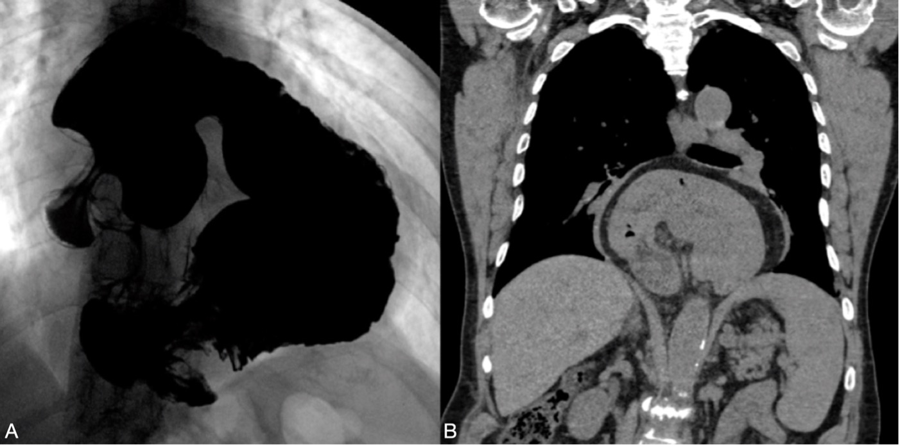

Figure 2. Port position and instruments for robotic GHH repair. T1: Robotic arm for liver retraction (Cadier); T2: Robotic bipolar forceps; T3: Robotic camera; T4: Robotic Hook or Vessel Sealer; AS: Assistant port (Air Seal); O: Optional 5 mm port for assistant.
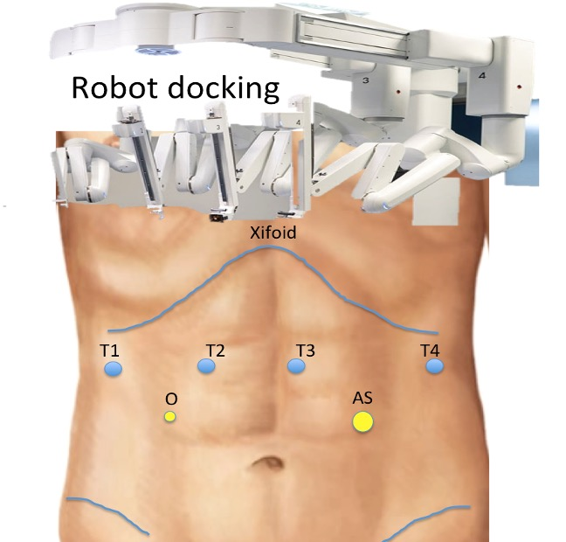

Figure 3. A) Step 1: short gastric vessels resection; B) Step 2: hernia sac dissection.
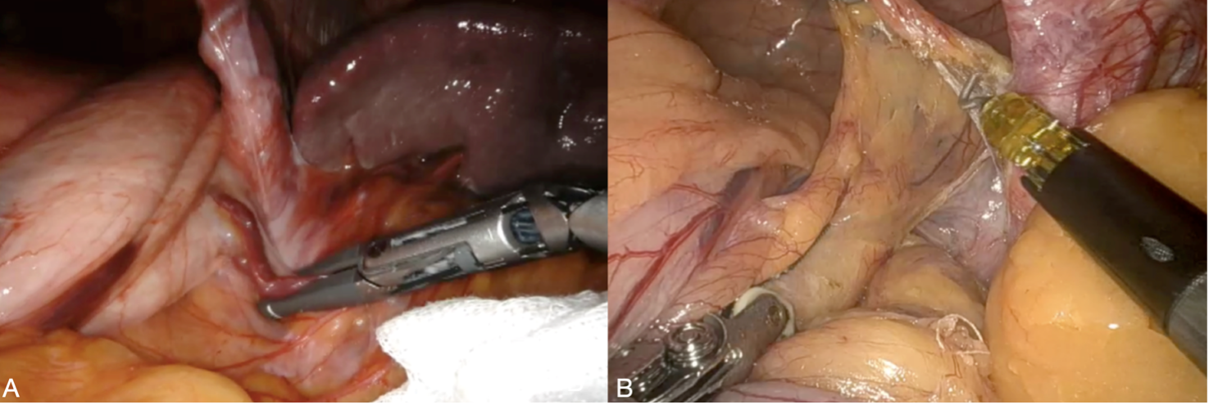

Figure 4. A) Step 3: Esophagus dissection and vagus nerve identification; B) Pladgets from Bio-A mesh.
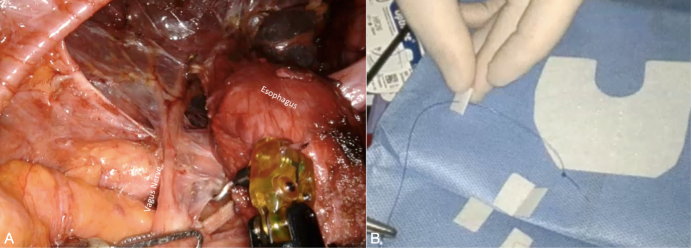

Figure 5. A) Step 4: Cruroplasty using pladgets; B) Bioabsorbable mesh positioning.
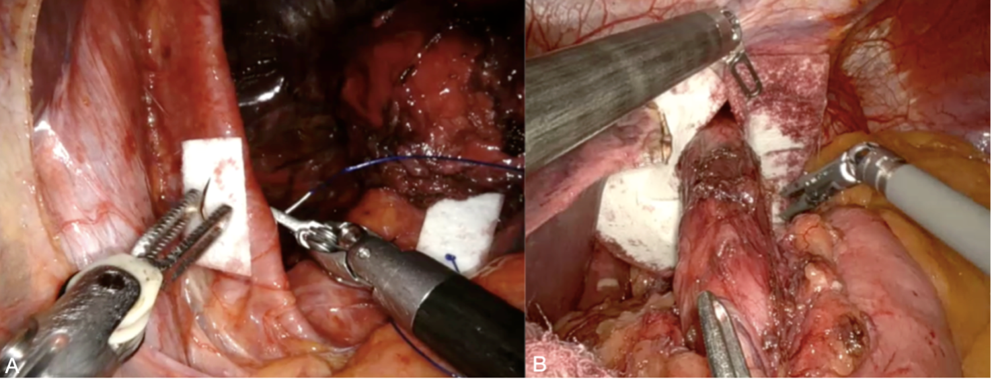

Figure 6. A) Step 5: 360° Nissen fundoplication; B) Step 6: Anterior gastropexy.
