Supporting information

Archaeological contexts

Titolo
Titolo is a coastal village encircled by large walls which were frequently rebuilt, protecting the settlement from wind-blown sands off the nearby coast. The site occupies a space between coastal dunes and a lagoon, and the area was characterised by the presence of marshes during the Neolithic (Figure 1) (Caldara et al. 2011). Settlement at Titolo corresponds to the Early to Middle Neolithic, with evolved impressed ware ceramics present, as well as later red-banded wares, Serra d’Alto and Diana styles. In the funerary area, nine single graves and one feature containing secondary deposits of human bone were recovered, with human skeletal remains belonging to 12 individuals accompanied by the sporadic presence of faunal bones. Three individuals were previously radiocarbon dated (T2, LTL-15552A: 6541±50 BP, 5617-5380 cal BCE [95.4%]; T6, LTL-14541A: 6230±50 BP, 5311-5045 cal BCE [95.4%]; T9, LTL-19755A: 6815±45 BP, 5786-5627 cal BCE [95.4%]) (Radina et al. 2020) and more have been dated in the course of this research, with the results presented herein (T3, SUERC-106332: 6452±29 BP, 5479-5363 cal BCE [95.4%]; T7, SUERC-106949: 6381±24 BP, 5471-5229 cal BEC [95.4%]; T8, GU61653: failed).

Passo di Corvo
Passo di Corvo is a large multi-ditched village on the Tavoliere plain of northern Puglia, approximately 25 km inland from the sea (Tinè 1983). The Tavoliere stands as a vast expanse, distinguished by its network of interfluvial valleys, clay terraces and coastal wetlands (Boenzi et al. 2006). The village was in use during the 6th millennium BCE, and extended over 40 ha, consisting of multiple C-shaped ditches surrounding house compounds, with the whole village surrounded by three large concentric ditches (Tinè 1983). It was occupied by sedentary people farming and herding domestic species. The C-shaped ditches probably marked space for individual residence groups, fostering group self-identity (Cassano and Manfredini 1983; Tafuri et al. 2014). The remains of 16 individuals from 13 graves and scattered disarticulated remains of at least another five individuals have been identified (Mariotti et al. 2020). Previous stable carbon and nitrogen isotope analysis suggests a predominantly terrestrial diet (Tafuri et al. 2014; Tafuri et al. 2023), while strontium isotope analysis of a selection of individuals showed that they were local to the site (Tafuri et al. 2016).

Materials

Titolo

Collagen was extracted for stable isotope analysis from bone fragments of 11 individuals and from 11 faunal bone fragments associated with the burials (studied by MDM). The stable carbon and nitrogen isotope values of the 11 human individuals were previously presented (Tafuri et al. 2023), while the stable sulphur isotopes values are published here for the first time. For the incremental dentine analysis, the lower left first, second and third molars (36, 37 and 38) were selected from individual T2, the upper left second molar (27) from T3 and the upper left canine (23) from T6.

Passo di Corvo
Stable carbon and nitrogen isotope data from bone collagen from Passo di Corvo is available from earlier studies (Tafuri et al. 2014; Tafuri et al. 2023). In this study, we re-analysed bone samples for bulk C, N and S analysis from individuals T5 and T11, with the purpose of providing comparative δ³⁴S (‰), which was not measured previously, as well as from the limited (n = 4) available fauna (studied by MDM). Additionally, we included 15 faunal bones from the nearby site of Masseria Candelaro to account for the otherwise minimal baseline (studied by FA). In view of the proximity of Masseria Candelaro to Passo di Corvo, and the chronological consistency of the two sites, we can reasonably assume that animals from both sites were raised in similar conditions. For the incremental dentine signal, we selected the upper left first molar (26) from individual T5 and the upper right first molar and upper left third molar from T11 (16 and 28). Furthermore, this study incorporates the results of the incremental dentine analysis conducted on the upper left first molar (tooth 26) from T10bis by SB as a preliminary investigation. However, this specific tooth is excluded from the current discussion as stable sulphur isotope analysis was not carried out at the time, and it cannot be directly compared with the other individuals in this study due to the use of a distinct age alignment method.

Methods
Prior to destructive analysis, all human remains from Titolo were assessed by JET to estimate osteological age at death and sex following standard methods (Buikstra and Ubelaker 1994; Ferembach et al. 1980; Brickley 2004; Phenice 1969; Rogers 1999; Brooks and Suchey 1990; Falys et al. 2005; Smith 1984; Scott 1979).

Observation of enamel hypoplasia (EH) (JET)
The age of onset for enamel hypoplastic defects was estimated on the individuals from Titolo (Palese, FG) following Cares Henriquez and Oxenham (2019) for anterior teeth, and Goodman and Rose (1990) for posterior teeth (although it should be noted that there are currently no formulae available for third molars). Hypoplasia, or irregularities in enamel thickness, is linked to elevated cortisone during the secretion of amelogenin, which is visible as interruptions in the spacing of perikymata (Hillson 1992; Hillson and Bond 1997). Individual perikymata are formed in a period of 6–12 days, and hypoplastic defects can therefore represent short-lived periods of stress or disruptions of homeostasis. This may be caused by (but is not limited to) poor nutrition, infections, weaning stress, fever/flu, systemic diseases, or other physical or psychological traumas during approximately the first seven years of life (Ortner 2003; Lewis 2007; Cares Henriquez and Oxenham 2019).

Radiocarbon date model for Titolo (JET)
The stratigraphy of the burials at Titolo was disturbed and difficult to interpret, complicating the ability to model the radiocarbon dates according to stratigraphy. Burials T6 and T9 were both found in contact with the wall foundations and the sterile soil, suggesting they were the earliest burials. T7 was said to be above T9 and in an intermediate layer with T8 and T10. T5, T3 and T2 were in an upper layer. Of these, radiocarbon dates are available from T2, T3, T6, T7 and T9, and show that T9 belonged to an initial Early Neolithic phase of burial, while the remaining burials are dated to the middle of the 6th millennium BCE (Table S1). As such, the stratigraphy was not informative for modelling the radiocarbon dates. A Bayesian model of the radiocarbon dates in OxCal (v4.4.4) described a contiguous sequence, allowing for an interval between the earliest burial (T9) and the later burials (Figure S1) (Bronk Ramsey 2009). Although, it should be noted that the dates can also be modelled in ways which are compatible with other interpretations of the stratigraphy. It should also be noted that the element sampled for radiocarbon dating from T9 is a tooth (34) for which we do not have stable isotope measurements, therefore we cannot exclude a potential effect of marine consumption on the resulting oldest date. We are submitting a new bone element from T9 to confirm the date obtained for this individual.
The overall span of burial at Titolo is modelled as lasting from 390–675 years (68.3%) or 315–1080 years (95.4%), probably beginning in the first quarter of the 6th millennium BCE with the inhumation of individual T9. Burial T9 is modelled as forming the boundary of the Early Neolithic phase, which is placed between 5830–5655 cal BCE (68.3%) or 6190–5625 cal BCE (95.4%). If we assume that there was a gap between the Early and Middle Neolithic burial phases, based on the available dates, this interval is modelled as lasting from 0–155 years (68.3%) or between 0–260 years (95.4%). The Middle Neolithic phase of burials is modelled as lasting between 100–255 years (68.3%) or between 35–380 years (95.4%), probably starting at the end of the second quarter of the 6th millennium BCE. Burial at Titolo is modelled as ending between 5310–5145 cal BCE (68.3%) or between 5365–4950 cal BCE (95.4%).
Table S1: Radiocarbon dates from human bone at Titolo, calibrated with IntCal20 and modelled in OxCal v4.4.4
Lab code | 14C determination (BP) | Calibrated date (cal BCE) | Modelled date (cal BCE) | Context
LTL-19755A | 6815±45 | 5735–5660 (68.3%)  5790–5625 (95.4%) | 5735–5655 (68.3%)  5785–5625 (95.4%) | T9 (tooth 34)
LTL-15552A | 6541±50 | 5610–5470 (68.3%)  5620–5375 (95.4%) | 5515–5380 (68.3%)  5560–5365 (95.4%) | T2 (femur)
LTL-14541A | 6230±50 | 5300–5070 (68.3%)  5315–5045 (95.4%) | 5320–5205 (68.3%)  5375–5110 (95.4%) | T6 (bone fragments)
SUERC-106332 | 6452±29 | 5475–5380 (68.3%)  5480–5360 (95.4%) | 5445–5375 (68.3%)  5480–5360 (95.4%) | T3 (rib)
SUERC-106949 | 6381±24 | 5375–5315 (68.3%)  5475–5225 (95.4%) | 5375–5320 (68.3%)  5470–5235 (95.4%) | T7 (rib)
GU61653 | failed |  |  | T8 (rib frags)
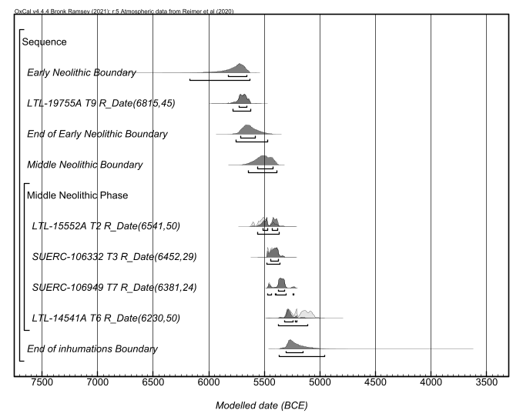
Figure S1: OxCal plot of probability distributions of radiocarbon dates from Titolo
OxCal Code
Sequence("Inhumations")
{
Span("of inhumation at Titolo");
Boundary("Early Neolithic");
R_Date("LTL-19755A T9", 6815, 45);
Boundary("End of Early Neolithic");
Interval("Early to Middle Neo");
Boundary("Middle Neolithic");
Phase("Middle Neolithic")
{
Span("of Middle Neolithic burials");
R_Date("LTL-15552A T2", 6541, 50);
R_Date("SUERC-106332 T3", 6452, 29);
R_Date("SUERC-106949 T7", 6381, 24);
R_Date("LTL-14541A T6", 6230, 50);
};
Boundary("End of inhumations");
};

Collagen extraction from human and faunal bone samples
Human collagen bone values were included in this paper to account for isotopic signals closer to the time of death. These, with the exclusion of δ³⁴S (‰) values, were already available for Passo di Corvo (Tafuri et al. 2023); however, to provide comparative δ³⁴S (‰) values for the incremental dentine signals of T5 and T11, collagen was re-extracted from these two individual and from the available fauna. Collagen was also extracted from the individuals from Titolo; δ¹³C (‰), δ¹⁵N (‰) values have been previously reported in (Tafuri et al. 2014; Tafuri et al. 2023), while δ³⁴S (‰) results are presented in this paper for the first time. Small bone fragments (500-1000 mg) were demineralised following two different protocols. All samples with the exception of the humans from Titolo were demineralised using a modified Longin (1971)’s method. This protocol consists of using 0.5 M HCl solution, which is changed every two days until the demineralisation is completed. Once demineralised, samples were rinsed three times with deionised water. Due to their visible poor preservation, human samples from Titolo were instead treated with ethylenediaminetetraacetic acid (EDTA) following Tuross (2012). These were demineralised in 50 mL 0.5M EDTA at pH 7.4 changing the solution every 4 days. When the process was complete, samples were rinsed 14 times with deionised water, leaving one of the washes overnight. All samples (HCl and EDTA treated) were then gelatinised in pH 3 HCl solution at 75 °C for 48 hrs and the solution filtered off with 5–8 μm Ezee filters. The filtered solution was frozen and then freeze dried. Collagen samples were run at SUERC, East Kilbride (UK) using a Delta V Advantage continuous-flow isotope ratio mass spectrometer coupled via a ConfloIV to an IsoLink elemental analyser (Thermo Scientific, Bremen). In total, 139 samples were analysed including dentine increments. Eight failed quality control parameters (Ambrose 1990; Nehlich and Richards 2009), and were therefore excluded from the analysis (Supplementary Table 1). We further excluded δ³⁴S (‰) values for sample PDC020 (the right humerus from Passo di Corvo T5) as the %S is too high compared to %N and %C. We did not exclude δ³⁴S (‰) of 22 samples with S%, C/S and N/S ratios slightly outside the suggested range; however, we do interpret them with caution and they are reported as semi-transparent symbols in the figures in the main text.

Incremental dentine analysis
Teeth were only sampled when antimeres were present, and all sampling was as minimally invasive as possible. Unfortunately, female adults from both sites presented incomplete dentitions and did not fulfil this criterion; as a result, we could not include them in the analysis. Enamel was preemptively sampled from the selected teeth for future research (e.g., strontium, oxygen and carbon stable isotope analyses). In the past few years, several methods have been proposed to investigate stable isotopes in dentine increments of humans (Beaumont et al. 2013; Beaumont and Montgomery 2016; Burt and Garvie-Lok 2013; Czermak et al. 2018; Czermak et al. 2020; Cocozza et al. 2021; Curtis et al. 2022; Eerkens et al. 2011; Fuller et al. 2003; Henderson et al. 2014; Sandberg et al. 2014; Scharlotta et al. 2018). Among these, Method 2 from Beaumont et al. (2013) is certainly the most applied (Ganiatsou et al. 2022) as it is easy to replicate and allows the sampling of enough material to be run in duplicate or to be used for other analysis, such as stable sulphur isotope analysis (Goude et al. 2020; Rey et al. 2021) or compound specific stable isotope analysis of amino acids (CSIA-AA)(Harris 2020). However, this method does not account for the complexity of dentine deposition patterns, therefore leading to a larger uncertainty around the age estimate for each section (Tsutaya 2020). Recent approaches have improved the temporal resolution of dentine increments but they require sampling of very small amounts of dentine (Czermak et al. 2018; Czermak et al. 2020; Curtis et al. 2022). Since collagen preservation is unlikely to be optimal in Neolithic contexts from southeastern Italy and since our aim was also to investigate stable sulphur isotopes, for which more material is needed for the IRMS analysis (Sayle et al. 2019), here we applied Method 2 from Beaumont et al. (2013), accepting a lower temporal resolution (Cheung et al. 2022). Each tooth was embedded in plaster and sectioned following the transverse plane across the full length of the extant tooth, according to the tooth preservation (i.e. from less cusp wear to complete apex); the cut was performed using an IsoMet® precision saw mounting a diamond blade. By doing so, we obtained two halves of each tooth, one to be used for the incremental dentine analysis and one to be stored for future reference or analyses. Teeth from the Titolo individuals were sectioned across the root to expose the pulp cavity and sample any secondary dentine. However, this often did not provide enough material for the analysis of δ³⁴S (‰) from dentine increments in the root and apex (Supplementary Table 1). Therefore, in the subsequent analysis of teeth from T5 and T11 from Passo di Corvo, the entire root was used for the analysis, since secondary dentine was not observed in the pulp cavity (Ostrum et al. 2022). Collagen was extracted from the tooth portion using a modified Longin (1971)’s method, as described above. Once the teeth were completely demineralised, these were sectioned in ~1 mm slices using a scalpel following the transverse/occlusal plane, although these might have varied in special cases (e.g., not enough material left for the last slice), from the apex to the crown of each tooth. Secondary dentine, when visible, was also sampled from the pulp chamber and from the root. It should be noted that its growth is inwards starting from the coronal area (Nudel et al. 2021). Therefore, we distinguished between the two portions when enough material was available, as the material from the coronal region may be representative of an earlier period (Bernardini et al. 2023). Each section was added to an Eppendorf tube and covered by ~1 ml of pH 3 HCl solution. Samples were heated at 75°C for 48 hours. To maximise the yield, gelatinised collagen was not filtered (Beaumont and Montgomery 2016). The samples were frozen and freeze-dried.

Assignment of ages to dentine sections
Age alignment was conducted considering the different tooth portions (i.e., crown, neck, root and apex) following Czermak et al. (2020) using AlQahtani et al. (2010) as reference for the growth ranges. We tested multiple age alignment methods on individual T2 from Titolo, from whom we have sampled all three molars from the same quadrant (36, 37 and 38), resulting in overlapping age ranges, to find the best method for individuals from this group. Poor alignment is often experienced with the incremental dentine approach, mostly related to individual or group differences in growth rate and/or initiation timing (Scharlotta et al. 2018). We found that employing AlQahtani et al. (2010) and Czermak et al. (2020) is the most effective method in our case when we compared different approaches (Scharlotta et al. 2018; Moorrees et al. 1963), although some misalignment is still experienced. It should be noted that many factors influence the age estimation of each dentine section, such as oblique growth layers and changing extension rates of each section; these are further compounded by individual error introduced directly during the dentine sectioning sampling process (Tsutaya 2020). Moreover, it was recently suggested that comparing stable isotope curves from multiple individuals is imprecise, as each section is characterised by its own temporal scale (Cocozza et al. 2021). For this reason we recognise difficulties in referring to specific age estimates and instead we discuss the results in relation to life stages which are mapped onto specific age ranges, trying to avoid referring to specific numbers.

ZooMS
Zooarchaeology by Mass Spectrometry (ZooMS) is a Peptide Mass Fingerprinting (PMF) application which enables taxonomic identification using collagen peptides (Buckley et al. 2009). Here we have applied it to the faunal remains from Titolo. Not enough collagen or remaining bone chips were available from all faunal remains; moreover only a few provided spectra of good enough quality to allow species identification, resulting in 7 samples assigned taxa via ZooMS (Table 1 in the main text). For those samples which had sufficient extracted collagen remaining after stable isotope analysis, a small portion (0.3-0.7 mg) of extracted collagen was resuspended in 50 μL of 50 mM ammonium bicarbonate buffer (NH₄HCO₃, AmBic, pH 8). For bone samples, 10-30 mg of bone was demineralised in 250 μL of 0.6 M HCl. Once demineralised, the HCl was removed and the samples were rinsed three times with 200 μL of AmBic. The samples were gelatinised in 100 μL of AmBic at 65°C for 1 hour, and 50 μL of the supernatant was transferred to a new tube. The collagen was then digested in both the bone and collagen samples with the addition of 1 μL of trypsin (0.4 μg/μL) and incubated overnight at 37 °C, after which 1 μL of 5 % v/v trifluoroacetic acid (TFA) was added to each sample to stop the action of the trypsin. Peptide extraction was performed by using C₁₈ resin ZipTip® pipette tips (Millipore) previously conditioned using 200 μL of 50 % acetonitrile (ACN) and 0.1 % v/v TFA (“conditioning solution”) and 200 μL of 0.1% v/v TFA (“washing solution”). The peptides were then elutedin 50 μL conditioning solution. 1 μL of eluted peptides mixed with 1 μL of matrix solution (α-cyano-hydroxycinnamic acid) were spotted in triplicate on a SCIEX Opti ToF stainless steel MALDI plate and analysed with an AB SCIEX 4700 MALDI-ToF- MS in the Unitat d'Espectrometria de Masses de Caracterització Molecular at CCiTUB. Species were identified manually by screening the mass spectra for peptide m/z markers using the open-source software mMass1 (Strohalm et al. 2010). The signal-to-noise threshold was set at 3.0 and the relative intensity threshold at 0.3. The identification was performed using previously published markers (Buckley et al. 2009; Buckley et al. 2010; Buckley and Collins 2011; Kirby et al. 2013; Welker et al. 2016; Buckley et al. 2017; McGrath et al. 2019; Jensen et al. 2020; Buckley and Kansa 2011).

Modeling Human Dentin Serial Sectioning (MDSS)
In a recent study, Tsutaya (2020) developed a mathematical model called "Modeling Human Dentin Serial Sectioning" (MDSS), available as an R package, to address the challenges in determining the age range of dentin serial sections using the classic approach of horizontal sectioning. This model considers the variability in extension rates and the natural obliqueness of dentin layers. The main goal of the study was to compare the estimates from the traditional method of age estimation, with the Model Age Ranges (MARS) generated by the MDSS.
In this supplementary analysis, we applied the MDSS to our dataset to quantify the uncertainty in the age ranges of dentin sections. Our results (Figures S2-S18) underscore the complexities in assigning precise age ranges, also in this case. It is important to mention that the model is based on growth rates established by Hillson (1996). To ensure consistency and comparability for this supplementary investigation, we also used Hillson's (1996) growth rates, but only within this context, to highlight any differences observed.
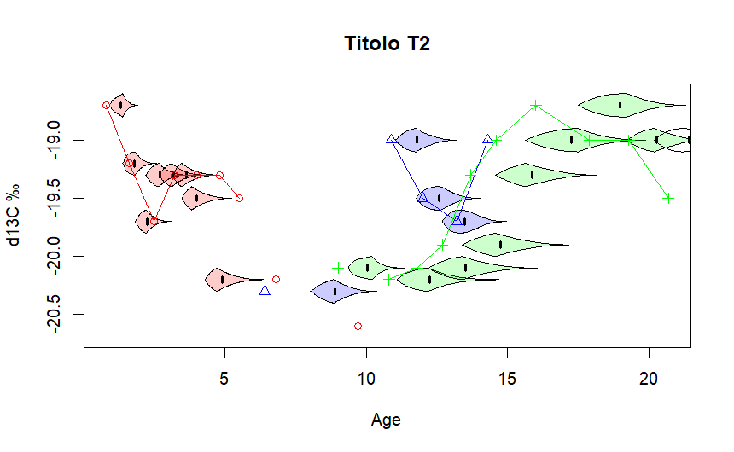Figure S2. Calculated Model Age Ranges (MARs) and their distribution for the carbon isotopic results of T2 using M1 (red), M2 (blue) and M3 (green) calculated using MDSS. Dots represent the estimates using Hillson (1996).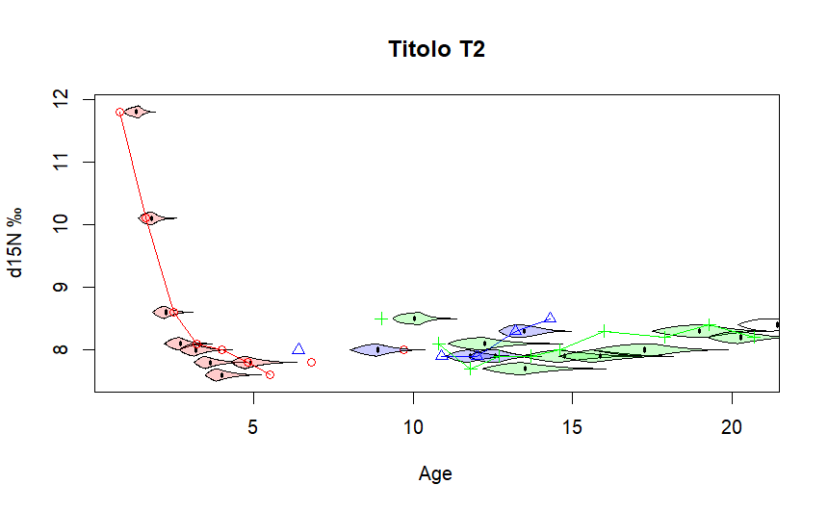Figure S3. Calculated Model Age Ranges (MARs) and their distribution for the nitrogen isotopic results of T2 M1 (red), M2 (blue) and M3 (green) calculated using MDSS. Dots represent the estimates using Hillson (1996).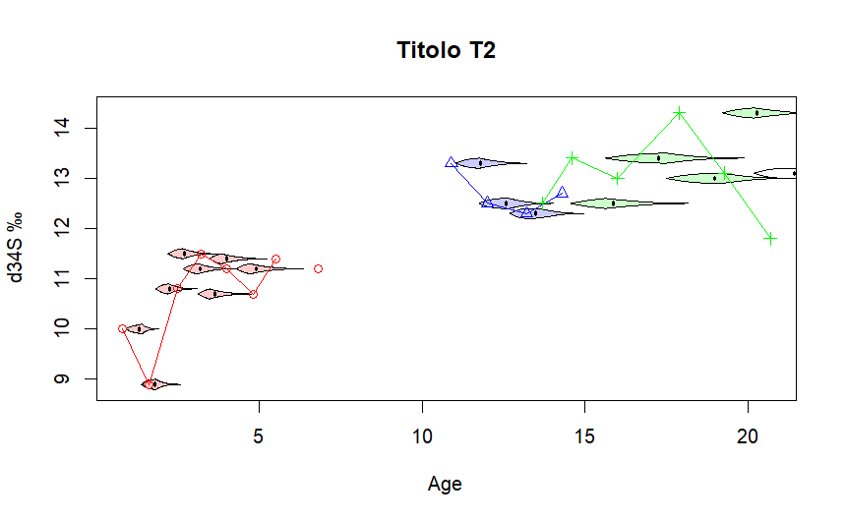Figure S4. Calculated Model Age Ranges (MARs) and their distribution for the carbon isotopic results of T2 using M1 (red), M2 (blue) and M3 (green) calculated using MDSS. Dots represent the estimates using Hillson (1996).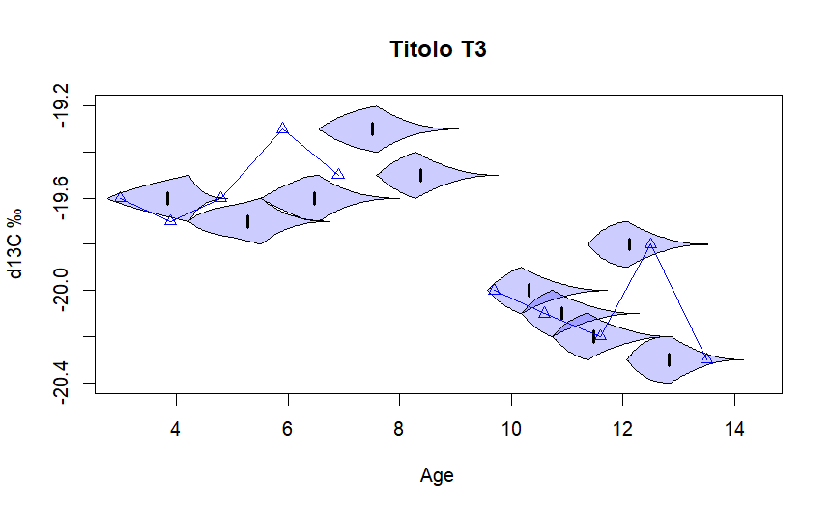Figure S5. Calculated Model Age Ranges (MARs) and their distribution for the carbon isotopic results of T3 using M2 (blue) calculated using MDSS. Dots represent the estimates using Hillson (1996).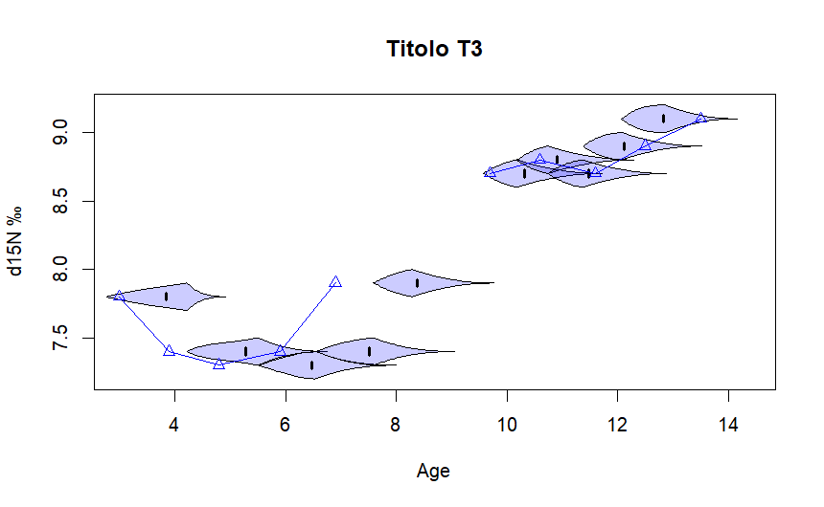Figure S6. Calculated Model Age Ranges (MARs) and their distribution for the nitrogen isotopic results of T3 using M2 (blue) calculated using MDSS. Dots represent the estimates using Hillson (1996).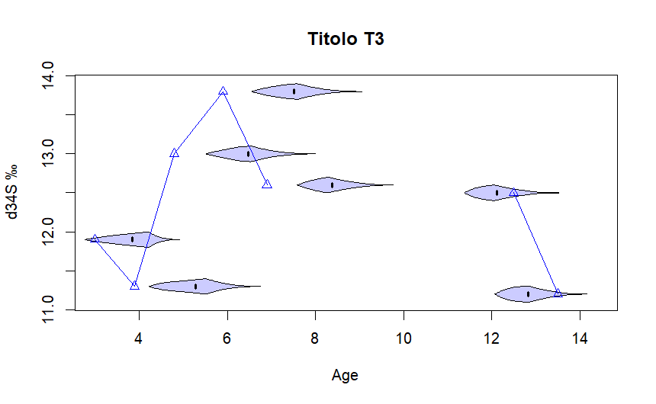Figure S7. Calculated Model Age Ranges (MARs) and their distribution for the sulphur isotopic results of T3 using M2 (blue) calculated using MDSS. Dots represent the estimates using Hillson (1996).
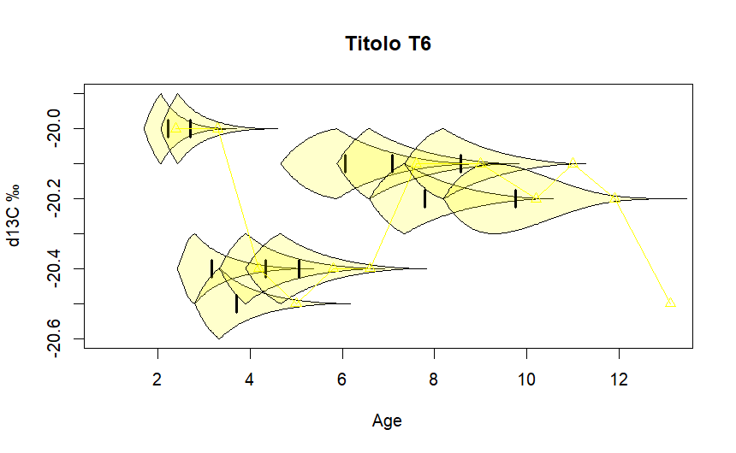Figure S8. Calculated Model Age Ranges (MARs) and their distribution for the carbon isotopic results of T6 using C (yellow) calculated using MDSS. Dots represent the estimates using Hillson (1996).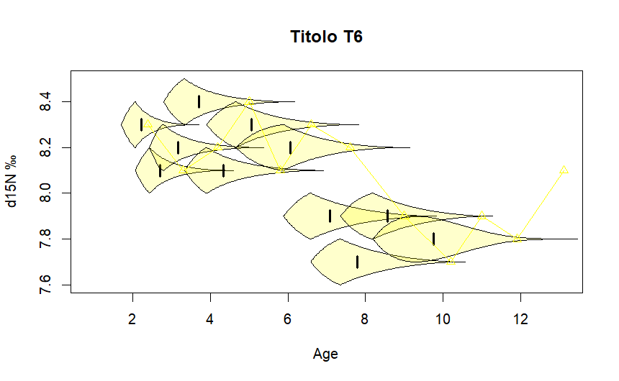Figure S9. Calculated Model Age Ranges (MARs) and their distribution for the nitrogen isotopic results of T6 using C (yellow) calculated using MDSS. Dots represent the estimates using Hillson (1996).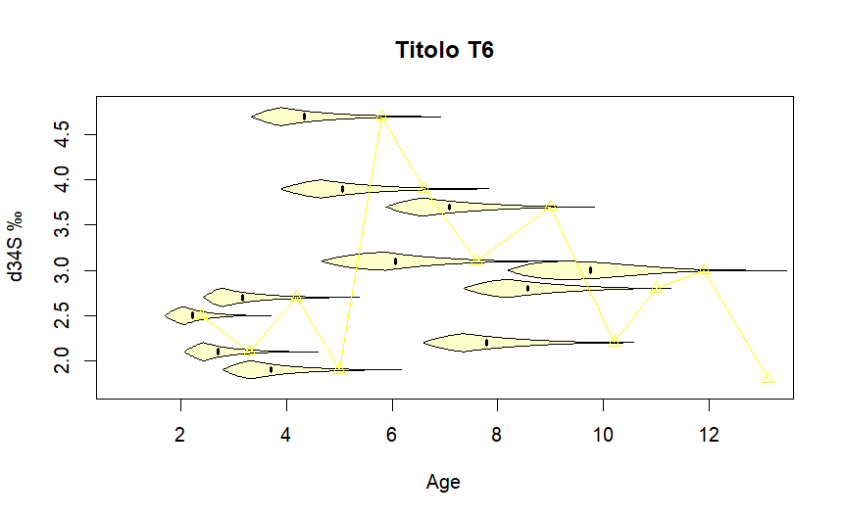Figure S10. Calculated Model Age Ranges (MARs) and their distribution for the sulphur isotopic results of T6 using C (yellow) calculated using MDSS. Dots represent the estimates using Hillson (1996).
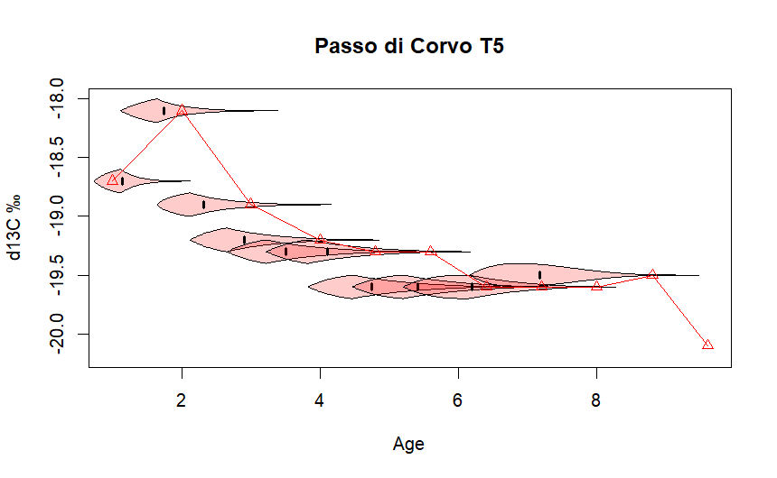Figure S11. Calculated Model Age Ranges (MARs) and their distribution for the carbon isotopic results of T5 using M1 (red) calculated using MDSS. Dots represent the estimates using Hillson (1996).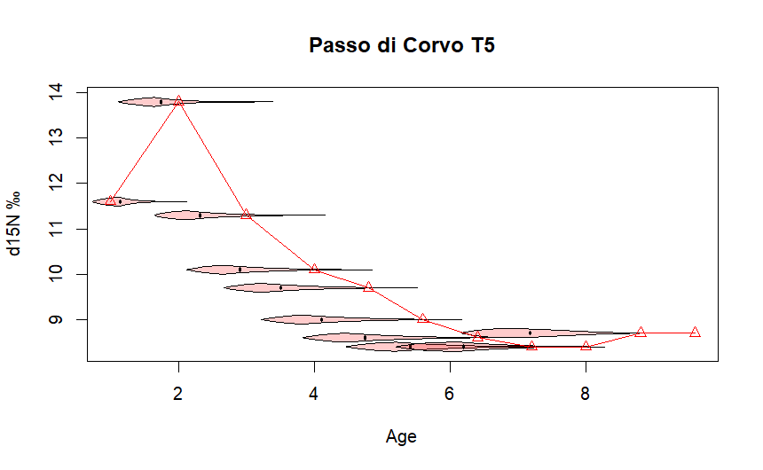Figure S12. Calculated Model Age Ranges (MARs) and their distribution for the nitrogen isotopic results of T5 using M1 (red) calculated using MDSS. Dots represent the estimates using Hillson (1996).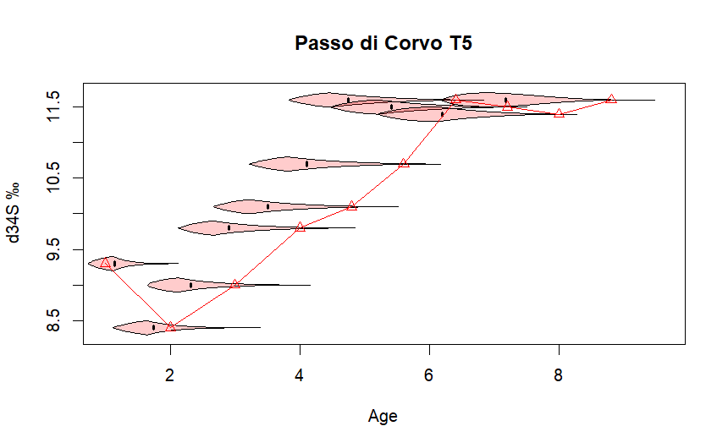
Figure S13. Calculated Model Age Ranges (MARs) and their distribution for the sulphur isotopic results of T5 using M1 (red) calculated using MDSS. Dots represent the estimates using Hillson (1996).
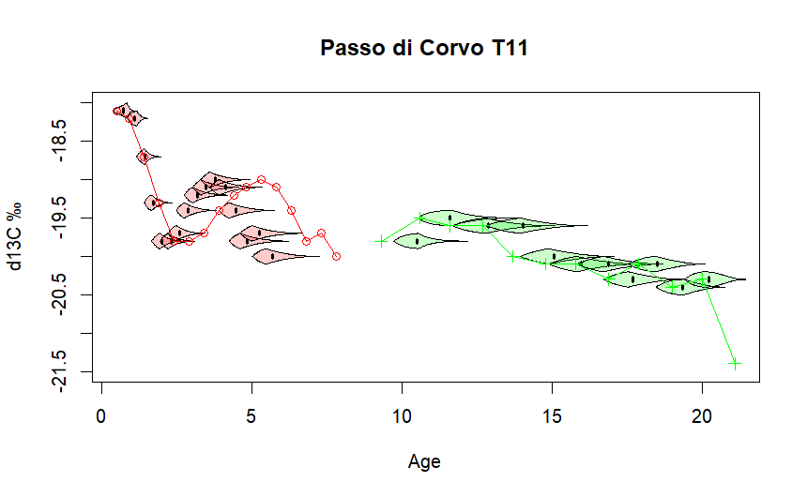Figure S14. Calculated Model Age Ranges (MARs) and their distribution for the carbon isotopic results of T11 using M1 (red) and M3 (green) calculated using MDSS. Dots represent the estimates using Hillson (1996).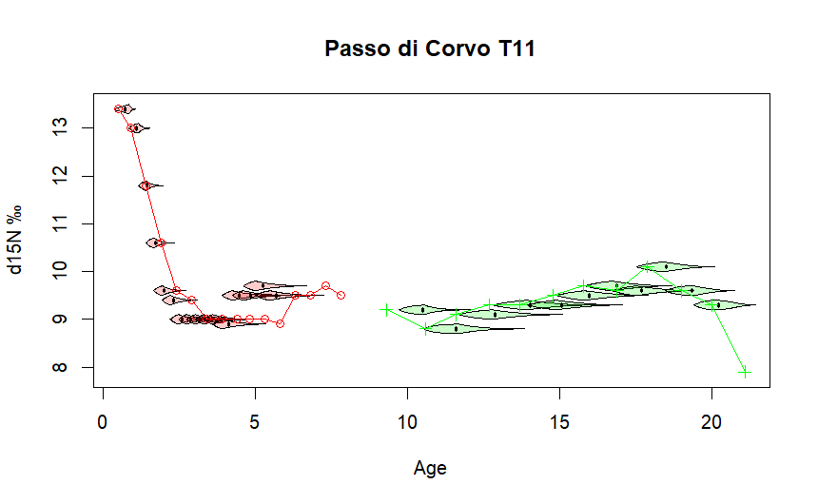Figure S15. Calculated Model Age Ranges (MARs) and their distribution for the nitrogen isotopic results of T11 using M1 (red) and M3 (green) calculated using MDSS. Dots represent the estimates using Hillson (1996).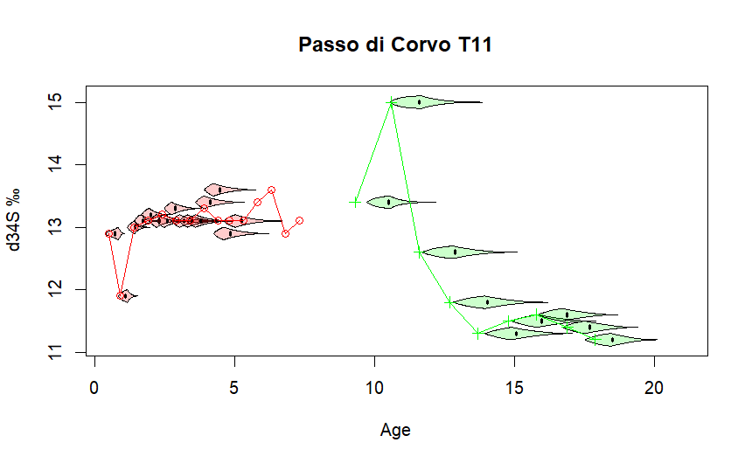Figure S16. Calculated Model Age Ranges (MARs) and their distribution for the sulphur isotopic results of T11 using M1 (red) and M3 (green) calculated using MDSS. Dots represent the estimates using Hillson (1996).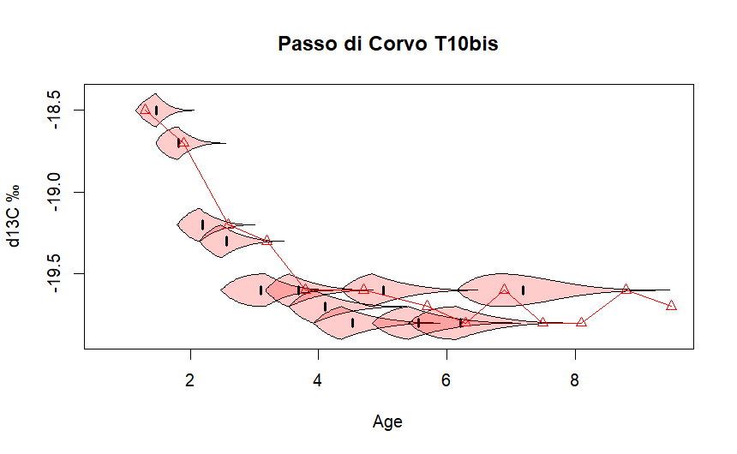Figure S17. Calculated Model Age Ranges (MARs) and their distribution for the carbon isotopic results of T10bis using M1 (red) calculated using MDSS. Dots represent the estimates using Hillson (1996).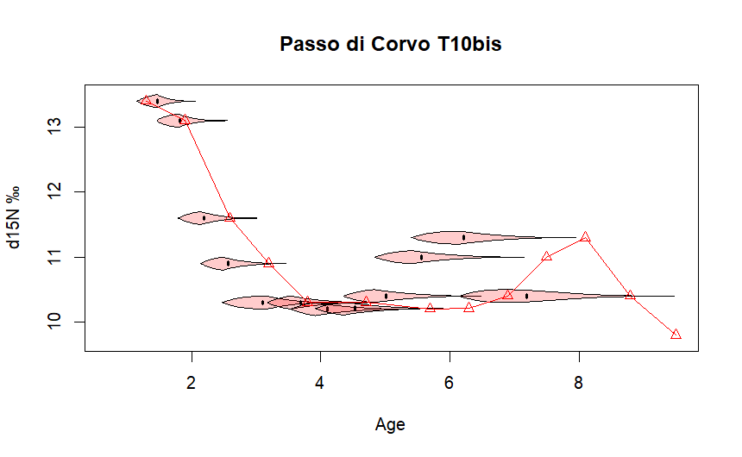
Figure S18. Calculated Model Age Ranges (MARs) and their distribution for the nitrogen isotopic results of T10bis using M1 (red) calculated using MDSS. Dots represent the estimates using Hillson (1996).

T10bis from Passo di Corvo (FG)

Methods
Tooth 26 from T10bis (Passo di Corvo) was part of a preliminary work by SB. The collagen extraction included a modified acid-base-acid method described in Goude et al. (2020). After demineralisation, the tooth was sampled following Method 2 from Beaumont et al. (2013), which was also used to generate the age alignment referring to AlQahtani et al. (2010). This means that the age assigned to each slide is derived from the total period of growth of the tooth, which in this case goes from 0.4 to 9.5 years old (AlQahtani et al. 2010). Collagen was analysed at Iso-Analytical Ltd., Crewe (UK) using an Europa Scientific 20-20 IRMS.

Results and discussion
The individual from T10bis is an adult with non identifiable sex (Mariotti et al. 2020). We sampled for incremental analysis tooth 26 (the upper left first molar) which covers approximately from ca. 04 to 9.5 years old. Due to wear present on the crown, data about breastfeeding period are missing. Weaning appears to be gradual and was completed during early childhood (Figure S19). On average, the stable nitrogen isotope values of the increments are higher than the bone values from the humans from Passo di Corvo, suggesting that this individual consumed slightly higher amounts of animal products, lagoonal fish or manured plants. The δ¹⁵N values during weaning, however, are as high as those from the other two individuals from the same site. We observe a temporary increase of stable nitrogen isotope values around late childhood, probably the result of briefly increased consumption of the above-mentioned food sources (Figure S19). The lack of stable sulphur isotope data and of the bone values from this individual does not allow for further discussion, however the observed intake of food sources likely different from the rest of the group seems in line with the in-life variations seen for the other two individuals from Passo di Corvo. Also considering the results from T5 and T11, the results from T10bis do not exclude an intra-life mobility or an exploitation of non-local resources as suggested for them.
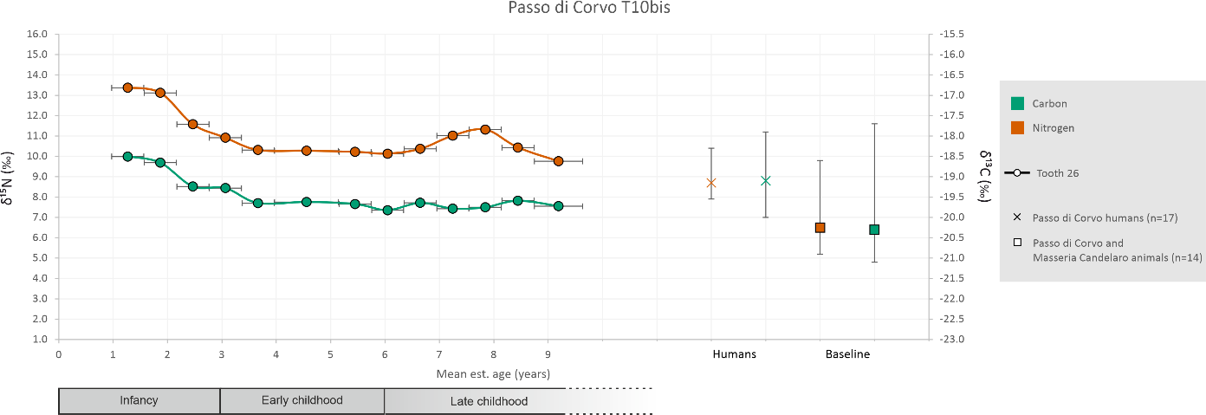
Figure S19. δ¹³C (dark green) and δ¹⁵N (red) values of dentine increments from the upper left first molar (tooth 26, circles) from individual T10b from Passo di Corvo (FG) according to estimated mean age intervals. Human bone values from the site (crosses) and animal bone values from the site (squares) are also reported as median with min and max for comparison purposes.

Additional considerations and evaluations on the causes of isotopic fluctuations
In the main text, we have briefly mentioned what are the possible causes affecting the frequent fluctuations of stable isotope values observed in the isobiographies of the individuals from Titolo and Passo di Corvo. Following, we explore them fully to provide a better frame to our interpretations.

Dietary adaptations
Sulphur isotope values can act as indicators of both diet and mobility. To interpret δ³⁴S trends accurately, it is important to consider δ¹³C and δ¹⁵N values from the same samples. Typically, changes in all three isotopic systems should point towards dietary shifts, whereas isolated changes in δ³⁴S values are more likely linked to mobility (Richards 2023). In this case, steady minor increases in δ³⁴S values are not equally accompanied by changes in δ¹⁵N values and are only occasionally mirrored by slight increases in δ¹³C values. In relation to diet, increased δ³⁴S values point to the consumption of marine resources, as should ¹³C-enriched δ¹³C values. However, marine consumption is also expected to raise δ¹⁵N values. The lack of this pattern in our data complicates interpretations and suggests that local ecological and cultural factors should be considered. Specifically, marine fish in the Mediterranean basin often display lower δ¹⁵N values compared to other regions, potentially masking minor marine contributions in the consumer tissues (Craig et al. 2013; Cubas et al. 2019; Vika and Theodoropoulou 2012). Additionally, a high consumption of plants, as is expected for Neolithic communities in this region, could easily account for the majority of calories and even proteins (Hedges 2004). Therefore, any minor δ¹³C and δ¹⁵N signal from aquatic sources would be easily masked in the overall consumer’s isotope values (Craig et al. 2013). In Mediterranean contexts, interpreting δ¹³C is further complicated by environmental factors. Coastal wetlands and lagoons—which were present in Neolithic Puglia—are expected to exhibit mixed freshwater–marine δ¹³C signals in fish (Tafuri et al. 2023).
Considering these complexities, it is possible that the observed minor fluctuations in δ³⁴S values (without corresponding effects on the stable carbon and nitrogen isotopes) are related to occasional consumption of aquatic resources from marine or lagoonal environments. A marine/lagoonal environment could have been accessed by individuals from both sites. Titolo is a coastal settlement located between a dune and a lagoon. Conversely, Passo di Corvo is not directly located in proximity to a body of water, but it is reasonable to assume that it was in contact with other villages situated nearer to river mouths and lagoons, such as Masseria Candelaro (Tafuri et al. 2016). The significance of fishing per se to these local communities remains unclear based on the available archaeological evidence. Fish remains have only occasionally been recovered from sites on the Tavoliere and the coastal Murge plateau, where Titolo is located. However, the substantial quantity of edible aquatic shelled mollusc remains suggests that their exploitation played a significant role in the Tavoliere area. At Masseria Candelaro, over 1,000 shell remains were unearthed from different Neolithic phases, primarily bivalves such as Solen marginatus (grooved razor shell, ~70%), Cerastoderma edule (common cockle, ~17%), Ostrea spp. (oysters, ~9%), and Tapes decussatus (cross-cut carpet shell, ~1%) (Minniti 2002). Similar findings from nearby sites indicate that shelled molluscs’ gathering was an important subsistence activity in the Tavoliere region in the Neolithic, where the brackish bivalve species Cerastoderma glaucum has often been recorded (Deith 1987). These bivalves are typically found in sandy, muddy, and rocky substrates, with muddy ones often situated in coastal zones near rivers or lagoons where water stagnates (Minniti 2002). Therefore, they were likely collected in the extended lagoonal area connected to the open sea, possibly forming a gulf or inlet where the Candelaro River discharged into a broad estuary (as visible in Figure 1 in the main text). Marine shells are also the most abundant faunal remains found at Titolo; over 2,500 were recovered, mostly of Patella sp. (limpets), likely gathered from the rocky marine coast (Minniti et al. 2024).
It is challenging to predict how marine or even lagoonal shelled molluscs’ consumption would be reflected in the consumer's isotopic values, since organic material is not preserved, therefore making direct isotope measurement impossible. Modern analogues from lagoonal and coastal areas in the Mediterranean basin exhibit similar or just slightly higher stable carbon and nitrogen isotope values than those observed in the terrestrial animal baseline from Neolithic Passo di Corvo and Masseria Candelaro, with higher δ¹⁵N values typically observed in more polluted areas (Dubois et al. 2014; Dominik et al. 2014; Carlier et al. 2009; Persic et al. 2004; Žvab Rožič et al. 2014; Sedano et al. 2020). Although a true direct comparison with our archaeological samples is precluded due to the effect of anthropogenic activities on modern samples (Sabadel et al. 2020), it is reasonable to conclude that detecting the isotopic signature of marine/lagoonal shelled molluscs would be difficult against the local terrestrial baseline. Stable sulphur isotope values may assist, since these are only related to the assimilation of the essential amino acid methionine with negligible fractionation. It is reasonable to expect a clear ³⁴S-enriched marine signal in Patella sp. specimens from Titolo (presumably collected from the rocky coast), while it is difficult to try to reconstruct the presumed δ³⁴S (‰) values of shelled molluscs from the lagoonal Tavoliere. It has been previously observed that fish inhabiting estuaries, lagoons, and marshes (although none of these in the Mediterranean sea) exhibit a mixed freshwater/marine signal ranging from approximately 10‰ to 15‰, consistent with the values observed in our human incremental dentine samples (Nehlich et al. 2013). However, recent research has otherwise shown that wetlands dominated by seagrasses (also without data from the Mediterranean sea) determine ³⁴S-depleted δ³⁴S (‰) values in fish (Guiry et al. 2021). In the only modern example we found for the Mediterranean, modern manila clams (Ruditapes philippinarum) from Adriatic lagoons in the Po River delta, show ³⁴S-enriched δ³⁴S (‰) values roughly from 13.5‰ to 20.5‰ (Brombin et al. 2022). These values would be in line with those observed in our ³⁴S-enriched incremental dentine samples, but again direct comparison is unsuitable due to anthropogenic factors likely contributing to the values observed in the modern samples.
The consumption of shelled molluscs or other aquatic organisms (possibly including finfish) either from a brackish or marine environment is not a definitive explanation for the trends that we have observed in some of these individuals, but it is one possibility worth consideration. If the consumption of aquatic resources is accepted, we observe a significant decline or abandonment of this source during adulthood, and even during adolescence in one instance (T11 from Passo di Corvo). This suggests that aquatic resources were typically consumed by children but not adults. Among foragers, it is common for children to engage in aquatic subsistence activities, frequently involving the gathering of shellfish, as an easy means of procuring food for themselves (Bird and Bird, 2000). However, it is unknown how or if this practice was present in the Neolithic period where other foodstuffs were more easily accessible.
Following weaning, the δ³⁴S values of dentine increments rarely remain stable and these fluctuations are sometimes accompanied by similar oscillations of δ¹³C values. Towards the end of adolescence in T11, this involves δ¹³C and δ¹⁵N values. This may reflect other sporadic dietary adjustments related to climatic or environmental changes. These fluctuations might not be captured by the animal baseline used here due to differences in resolution scales, yet such an “average” baseline represents the only available data for comparison.

Growth-related metabolic processes
Another plausible explanation for the observed stable isotope trends is the influence of growth-related metabolic processes, particularly during neonatal and childhood stages, on the stable isotope values obtained from dentine collagen. This has been considered and discussed recently by (Feuillâtre et al. 2022) in relation to observed δ¹³C and δ¹⁵N trends. For example, they observe dips in stable nitrogen curves in relation to a growth stage happening around the age 12–14. In our individuals, there is no evidence of such dips around those ages. However, we do observe some fluctuations: at Titolo, T2 shows depleted δ¹³C values at 14–19 years, while δ¹⁵N remains stable and δ³⁴S data is unavailable. In T3, δ¹³C values start decreasing at around 10 years, while δ¹⁵N rises, and δ³⁴S is partially unavailable; where available, δ³⁴S is consistent with earlier values. T6 exhibits slight dips in δ¹³C and δ³⁴S values around 14 years, but δ¹⁵N remains stable. At Passo di Corvo T11 shows decreasing δ¹³C and δ³⁴S values beginning at approximately 12 years, while δ¹⁵N remains stable. The absence of the expected nitrogen dips in our individuals, along with the variability in carbon and sulphur trends, is challenging to explain. Further studies on archaeological samples are necessary to investigate these patterns in greater detail and improve our understanding of potential metabolic influences on isotopic variability.
To the best of our knowledge, stable sulphur isotope values have not been investigated in relation to physiological or nutritional stress. However, growth phases are typically characterized by heightened metabolic activity, including an increased demand for sulphur-containing amino acids which are essential for protein synthesis and other biosynthetic pathways (Elango 2020). It is possible that these physiological requirements may alter how dietary sulphur is metabolised and incorporated into body tissues. This may result in isotopic fractionation, particularly if dietary sulphur availability is constrained, for example through the transsulphuration pathway for the synthesis of cysteine (Jahoor 2012). Notably, we observed enamel hypoplastic defects in the dentition of all these individuals, which indicate periods of childhood physiological stress, perhaps caused by malnutrition or other illnesses. This could exacerbate metabolic needs and potentially influence isotopic patterns. Consequently, the decline observed in adulthood in all cases may reflect a shift to a different dietary pattern with less ³⁴S-enriched sulphur sources, or simply reduced physiological demands after growth cessation and/or nutritional instability. Clearly, this interpretation remains speculative due to the lack of studies on sulphur isotopic fractionation during human growth, and underscores the need to integrate physiological stress and metabolic dynamics into sulphur isotope interpretations.

Short-range mobility
Another possibility involves short-range relocations, with consequent adjustment to the local stable sulphur and carbon isotopic signal. Relocation from a coastal to a more inland location would determine more ³⁴S-depleted δ³⁴S (‰) collagen values (Richards 2023). We believe this is the most plausible explanation for the high differences observed in stable sulphur isotope values in dentine increments and bone elements in Titolo. Short-range mobility slightly more inland or more coastal (depending on the values observed) might be an explanation for the less pronounced changes observed in δ³⁴S and in δ¹³C values. It is known that woodlands determine more ¹³C-depleted δ¹³C (‰) values, a result of the ‘canopy effect’, while open environments such as Titolo would exhibit higher δ¹³C (‰) values (Bonafini et al. 2013). Looking at individuals in detail, T2 from Titolo may have initially been raised slightly more inland during the early years of their life, then moved to Titolo during weaning, evidenced by the δ³⁴S (‰) values mirroring those of the local fauna, subsequently spending childhood and adolescence there. T5 and T11 from Passo di Corvo exhibit δ³⁴S values during childhood that are consistently higher than the local terrestrial baseline (which is represented mostly by animals from Masseria Candelaro which is located in the proximity of the Tavoliere lagoon). This suggests that they were possibly living in a location closer to the sea compared to Passo di Corvo itself. More in general, stable sulphur isotope values are highly dependent on the local geology and hydrology, therefore these fluctuations might also reflect relocations to areas with slightly different characteristics ( Goude et al. 2019; Nehlich 2015). Notably, all individuals from Passo di Corvo, appear to be local to the area based on strontium isotopes (Tafuri et al. 2016). Our stable sulphur isotopic evidence emerging from dentine and bone collagen contributes a piece to the puzzle for mobility at Passo di Corvo, since it suggests that these two individuals were indeed mobile, but only across relatively short distances.

Reference list
AlQahtani, S. J., Hector, M. P. and Liversidge, H. M. 2010. “Brief Communication: The London Atlas of Human Tooth Development and Eruption.” American Journal of Physical Anthropology 142 (3): 481–90. https://doi.org/10.1002/ajpa.21258.
Ambrose, S. H. 1990. “Preparation and Characterization of Bone and Tooth Collagen for Isotopic Analysis.” Journal of Archaeological Science 17 (4): 431–51. https://doi.org/10.1016/0305-4403(90)90007-R.
Beaumont, J., Gledhill, A., Lee-Thorp, J., and Montgomery, J. 2013. “Childhood Diet: A Closer Examination of the Evidence from Dental Tissues Using Stable Isotope Analysis of Incremental Human Dentine.” Archaeometry 55 (2): 277–95. https://doi.org/10.1111/j.1475-4754.2012.00682.x.
Beaumont, J., and Montgomery, J. 2016. “The Great Irish Famine: Identifying Starvation in the Tissues of Victims Using Stable Isotope Analysis of Bone and Incremental Dentine Collagen.” PloS One 11 (8): e0160065. https://doi.org/10.1371/journal.pone.0160065.
Bernardini, S., Zeppilli, C., Micarelli, I., Goude, G., Sayle, K. L., Manzi, G., and Tafuri, M. A. 2023. “Multi‐isotope Analysis of Primary and Secondary Dentin as a Mean to Broaden Intra‐life Dietary Reconstruction. A Case from Longobard Italy.” International Journal of Osteoarchaeology 33 (2). https://doi.org/10.1002/oa.3200.
Boenzi, F., Caldara, M., Pennetta, L., and Simone, O. 2006. “Environmental Aspects Related to the Physical Evolution of Some Wetlands Along the Adriatic Coast of Apulia (Southern Italy): A Review.” Journal of Coastal Research 39: 170–75.
Bonafini, M., Pellegrini, M., Ditchfield, P., and Pollard, A. M. 2013. “Investigation of the ‘Canopy Effect’ in the Isotope Ecology of Temperate Woodlands.” Journal of Archaeological Science 40 (11): 3926–35. https://doi.org/10.1016/j.jas.2013.03.028.
Brickley, M. 2004. “Determination of Sex from Archaeological Skeletal Material and Assessment of Parturition.” In Guidelines to the Standards for Recording Human Remains (IFA Paper No. 7), edited by M. Brickley and J. I. McKinley, 22–25. UK: Southampton and Reading.
Brombin, V., Natali, C., Frijia, G., Schmitt, K., Casalini, M. and Bianchini, G. 2022. “Isotope Geochemistry for Seafood Traceability and Authentication: The Northern Adriatic Manila Clams Case Study.” Foods 11 (19). https://doi.org/10.3390/foods11193054.
Bronk Ramsey, C. 2009. “Bayesian Analysis of Radiocarbon Dates.” Radiocarbon 51 (1): 337–60. https://doi.org/10.1017/S0033822200033865.
Brooks, S., and Suchey, J. M. 1990. “Skeletal Age Determination Based on the Os Pubis: A Comparison of the Ascadi-Nemeskeri and Suchey-Brooks Methods.” Human Evolution 5: 227–38.
Buckley, M., Collins, M., Thomas-Oates, J., and Wilson, J. C. 2009. “Species Identification by Analysis of Bone Collagen Using Matrix-Assisted Laser Desorption/Ionisation Time-of-Flight Mass Spectrometry.” Rapid Communications in Mass Spectrometry: RCM 23 (23): 3843–54. https://doi.org/10.1002/rcm.4316.
Buckley, M., Harvey, V. L., and Chamberlain, A. T. 2017. “Species Identification and Decay Assessment of Late Pleistocene Fragmentary Vertebrate Remains from Pin Hole Cave (Creswell Crags, UK) Using Collagen Fingerprinting.” Boreas 46 (3): 402–11. https://doi.org/10.1111/bor.12225.
Buckley, M., and Collins, M. 2011. “Collagen Survival and Its Use for Species Identification in Holocene-Lower Pleistocene Bone Fragments from British Archaeological and Paleontological Sites.” Antiqua 1 (1): 1. https://doi.org/10.4081/antiqua.2011.e1.
Buckley, M., and Kansa, S. W. 2011. “Collagen Fingerprinting of Archaeological Bone and Teeth Remains from Domuztepe, South Eastern Turkey.” Archaeological and Anthropological Sciences 3 (3): 271–80. https://doi.org/10.1007/s12520-011-0066-z.
Buckley, M., Kansa, S. W., Howard, S., Campbell, S., Thomas-Oates, J., and Collins, M. 2010. “Distinguishing between Archaeological Sheep and Goat Bones Using a Single Collagen Peptide.” Journal of Archaeological Science 37 (1): 13–20. https://doi.org/10.1016/j.jas.2009.08.020.
Buikstra, J. E., and Ubelaker, D. H. 1994. Standards for Data Collection from Human Skeletal Remains. Fayetteville: Arkansas Archaeological Survey Research Series 44.
Burt, N. M., and Garvie-Lok, S. 2013. “A New Method of Dentine Microsampling of Deciduous Teeth for Stable Isotope Ratio Analysis.” Journal of Archaeological Science 40 (11): 3854–64. https://doi.org/10.1016/j.jas.2013.05.022.
Caldara, M., Muntoni, I. M., Fiorentino, G., Primavera, M., and Radina, F. 2011. “Hidden Neolithic Landscapes in Apulian Region.” In Hidden Landscapes of Mediterranean Europe Cultural and Methodological Biases in Pre- and Protohistoric Landscape Studies. Proceedings of the International Meeting Siena, edited by G. van Leusen, L. Pizziolo, and M. Sarti, 2320:183–91. BAR. BRITISH SERIES. Archeopress.
Cares Henriquez, A., and Oxenham, M. F. 2019. “New Distance-Based Exponential Regression Method and Equations for Estimating the Chronology of Linear Enamel Hypoplasia (LEH) Defects on the Anterior Dentition.” American Journal of Physical Anthropology 168 (3): 510–20. https://doi.org/10.1002/ajpa.23764.
Carlier, A., Riera, P., Amouroux, J., Bodiou, J., Desmalades, M., and Grémare, A. 2009. “Spatial Heterogeneity in the Food Web of a Heavily Modified Mediterranean Coastal Lagoon: Stable Isotope Evidence.” Aquatic Biology 5: 167–79. https://doi.org/10.3354/AB00147.
Cassano, S. M., and Manfredini, A. 1983. Studi Sul Neolitico Del Tavoliere Della Puglia: Indagine Territoriale in Un’area-Campione. Vol. 160. British Archaeological Reports.
Cheung, C., Fernández-Crespo, T., Mion, L., Di Giusto, M., Goude, G., Macdonald, R. A., Richards, M. P., and Herrscher, E. 2022. “Micro-Punches versus Micro-Slices for Serial Sampling of Human Dentine: Striking a Balance between Improved Temporal Resolution and Measuring Additional Isotope Systems.” Rapid Communications in Mass Spectrometry: RCM 36 (21): e9380. https://doi.org/10.1002/rcm.9380.
Cocozza, C., Fernandes, R., Ughi, A., Groß, M., and Alexander, M. M. 2021. “Investigating Infant Feeding Strategies at Roman Bainesse through Bayesian Modelling of Incremental Dentine Isotopic Data.” International Journal of Osteoarchaeology 31 (3): 429–39. https://doi.org/10.1002/oa.2962.
Craig, O. E., Bondioli, L., Fattore, L., Higham, T., and Hedges, R. 2013. “Evaluating Marine Diets through Radiocarbon Dating and Stable Isotope Analysis of Victims of the AD79 Eruption of Vesuvius.” American Journal of Physical Anthropology 152 (3): 345–52. https://doi.org/10.1002/ajpa.22352.
Cubas, M., Peyroteo-Stjerna, R., Fontanals-Coll, M., Llorente-Rodríguez, L., Lucquin, A., Craig, O. E., and Colonese, A. C. 2019. “Long-Term Dietary Change in Atlantic and Mediterranean Iberia with the Introduction of Agriculture: A Stable Isotope Perspective.” Archaeological and Anthropological Sciences 11 (8): 3825–36. https://doi.org/10.1007/s12520-018-0752-1.
Curtis, M. J., Beaumont, J., Elamin, F., Wilson, A. S., and Koon, H. E. C. 2022. “Method of Micro-Sampling Human Dentine Collagen for Stable Isotope Analysis.” Rapid Communications in Mass Spectrometry: RCM 36 (13): e9305. https://doi.org/10.1002/rcm.9305.
Czermak, A., Fernández-Crespo, T., Ditchfield, P. W., and Lee-Thorp, J. A. 2020. “A Guide for an Anatomically Sensitive Dentine Microsampling and Age-Alignment Approach for Human Teeth Isotopic Sequences.” American Journal of Physical Anthropology 173 (4): 776–83. https://doi.org/10.1002/ajpa.24126.
Czermak, A., Schermelleh, L., and Lee-Thorp, J. 2018. “Imaging-Assisted Time-Resolved Dentine Sampling to Track Weaning Histories.” International Journal of Osteoarchaeology 28 (5): 535–41. https://doi.org/10.1002/oa.2697.
Deith, M. R. 1987. “La Raccolta Dei Molluschi Nel Tavoliere in Epoca Preistorica.” In Coppa Nevigata e Il Suo Territorio. Testimonianze Archeologiche Dal VII al II Millennio a.C., edited by S. M. Cassano, A. Cazzella, A. Manfredini, and M. Moscoloni, 101–5. Edizioni Quasar.
Dominik, J., Tagliapietra, D., Bravo, A. G., Sigovini, M., Spangenberg, J. E., Amouroux, D., and Zonta, R. 2014. “Mercury in the Food Chain of the Lagoon of Venice, Italy.” Marine Pollution Bulletin 88 (1–2): 194–206. https://doi.org/10.1016/j.marpolbul.2014.09.005.
Dubois, S., Blanchet, H., Garcia, A., Massé, M., Galois, R., Grémare, A., Charlier, K., Guillou, G., Richard, P., and Savoye, N. 2014. “Trophic Resource Use by Macrozoobenthic Primary Consumers within a Semi-Enclosed Coastal Ecosystem: Stable Isotope and Fatty Acid Assessment.” Journal of Sea Research 88: 87–99. https://doi.org/10.1016/j.seares.2014.01.004.
Eerkens, J. W., Berget, A. G., and Bartelink, E. J. 2011. “Estimating Weaning and Early Childhood Diet from Serial Micro-Samples of Dentin Collagen.” Journal of Archaeological Science 38 (11): 3101–11. https://doi.org/10.1016/j.jas.2011.07.010.
Elango, R. 2020. “Methionine Nutrition and Metabolism: Insights from Animal Studies to Inform Human Nutrition.” The Journal of Nutrition 150 (1): 2518S-2523S. https://doi.org/10.1093/jn/nxaa155.
Falys, C. F., Schutkowski, H., and Weston, D. A. 2005. “The Distal Humerus--a Blind Test of Rogers’ Sexing Technique Using a Documented Skeletal Collection.” Journal of Forensic Sciences 50 (6): 1289–93.
Ferembach, D., Schwidetzky, I., and Stloukal, M. 1980. “Recommendations for Age and Sex Diagnoses of Skeletons.” Journal of Human Evolution 9: 517-549.
Feuillâtre, C., Beaumont, J., and Elamin, F. 2022. “Reproductive Life Histories: Can Incremental Dentine Isotope Analysis Identify Pubertal Growth, Pregnancy and Lactation?” Annals of Human Biology 49 (3–4): 171–91. https://doi.org/10.1080/03014460.2022.2091795.
Fuller, B. T., Richards, M. P., and Mays, S. A. 2003. “Stable Carbon and Nitrogen Isotope Variations in Tooth Dentine Serial Sections from Wharram Percy.” Journal of Archaeological Science 30 (12): 1673–84. https://doi.org/10.1016/S0305-4403(03)00073-6.
Ganiatsou, E., Vika, E., Georgiadou, A., Protopsalti, T., and Papageorgopoulou, C. 2022. “Breastfeeding and Weaning in Roman Thessaloniki. An Investigation of Infant Diet Based on Incremental Analysis of Human Dentine.” Environmental Archaeology, 1–19. https://doi.org/10.1080/14614103.2022.2083925.
Goodman, A. H., and Rose, J. C. 1990. “Assessment of Systemic Physiological Perturbations from Dental Enamel Hypoplasias and Associated Histological Structures.” American Journal of Physical Anthropology 33 (S11): 59-110. https://doi.org/10.1002/ajpa.1330330506
Goude, G., Dori, I., Sparacello, V. S., Starnini, E., and Varalli, A. 2020. “Multi-Proxy Stable Isotope Analyses of Dentine Microsections Reveal Diachronic Changes in Life History Adaptations, Mobility, and Tuberculosis-Induced Wasting in Prehistoric Liguria (Finale Ligure, Italy, Northwestern Mediterranean).” International Journal of Paleopathology 28: 99–111. https://doi.org/10.1016/j.ijpp.2019.12.007.
Goude, G.,Domingo, D. C., Salazar-García, C., Power, R. C., Terrom, J., Rivollat, M., Deguilloux, M. F., Pemonge, M. H., Le Bailly, M., Andre, G., Coutelas, A., and Hauzerur, A. 2019. “A Multidisciplinary Approach to Neolithic Life Reconstruction.” Journal of Archaeological Method and Theory 26 (2): 537–60. https://doi.org/10.1007/s10816-018-9379-x.
Guiry, E.J., Kennedy, J. R., O’Connell, M. T., Gray, D. R., Grant, C., and Szpak, P. 2021. “Early Evidence for Historical Overfishing in the Gulf of Mexico.” Science Advances 7 (32). https://doi.org/10.1126/sciadv.abh2525.
Harris, A. 2020. “Palaeodiet and Infant Feeding in Coastal Arctic Settlements : Insights from Stable Isotope Analysis of Bone and Dentine Collagen and Amino Acids.” Department of Archaeology and Classical Studies, Stockholm University.
Hedges, R. E. M. 2004. “Isotopes and Red Herrings: Comments on Milner et al. and Lidén et Al.” Antiquity 78 (299): 34–37. https://doi.org/10.1017/S0003598X00092905.
Henderson, R. C., Lee-Thorp, J., and Loe, L. 2014. “Early Life Histories of the London Poor Using Δ13C and Δ15N Stable Isotope Incremental Dentine Sampling.” American Journal of Physical Anthropology 154 (4): 585–93. https://doi.org/10.1002/ajpa.22554.
Hillson, S., and Bond, S. 1997. “Relationship of Enamel Hypoplasia to the Pattern of Tooth Crown Growth: A Discussion.” American Journal of Physical Anthropology 104 (1): 89–103. https://doi.org/10.1002/(SICI)1096-8644(199709)104:1<89::AID-AJPA6>3.0.CO;2-8.
Hillson, S. W. 1992. “Dental Enamel Growth, Perikymata and Hypoplasia in Ancient Tooth Crowns.” Journal of the Royal Society of Medicine 85 (8): 460–66. https://doi.org/10.1177/014107689208500813.
Jahoor, F. 2012. “Effects of Decreased Availability of Sulfur Amino Acids in Severe Childhood Undernutrition.” Nutrition Reviews 70 (3): 176–87. https://doi.org/10.1111/j.1753-4887.2011.00462.x.
Jensen, T. Z. T., Sjöström, A., Fischer, A., Rosengren, E., Lanigan, L. T., Bennike, O., Korzow Richter, K., Gron, K. J., Mackie, M., Mortensen, M. F., Sørensen, L., Chivall, D., Iversen, K. H., Taurozzi, A. J., Olsen, J., Schroeder, H., Milner, N., Sørensen, M., and Collins, M. J. 2020. “An Integrated Analysis of Maglemose Bone Points Reframes the Early Mesolithic of Southern Scandinavia.” Scientific Reports 10 (1): 17244. https://doi.org/10.1038/s41598-020-74258-8.
Kirby, D. P., Buckley, M., Promise, E., Trauger, S. A., and Holdcraft, T. R. 2013. “Identification of Collagen-Based Materials in Cultural Heritage.” The Analyst 138 (17): 4849–58. https://doi.org/10.1039/c3an00925d.
Lewis, M. E. 2007. The Bioarchaeology of Children: Perspectives from Biological and Forensic Anthropology. Cambridge: Cambridge University Press.
Longin, R. 1971. “New Method of Collagen Extraction for Radiocarbon Dating.” Nature 230 (5291): 241–42. https://doi.org/10.1038/230241a0.
Mariotti, V., Muntoni, I. M., and Belcastro, M. G. 2020. “New Insights into the Funerary Rituals of the Neolithic Site of Passo Di Corvo (Apulia, Italy): The Study of the Human Remains.” Journal of Archaeological Science: Reports 34 (Part B): 102643. https://doi.org/10.1016/j.jasrep.2020.102643.
McGrath, K., Rowsell, K., Gates St-Pierre, C., Tedder, A., Foody, G., Roberts, C., Speller, C., and Collins, M. 2019. “Identifying Archaeological Bone via Non-Destructive ZooMS and the Materiality of Symbolic Expression: Examples from Iroquoian Bone Points.” Scientific Reports 9 (1): 11027. https://doi.org/10.1038/s41598-019-47299-x.
Minniti, C., Radina, F., and Sivilli, S. 2024. “Il Sito Di Titolo Di Bari Nel Quadro Economico E Ambientale Del Neolitico Nell’italia Meridionale: Analisi Preliminare Dei Resti Animali Dagli Scavi 2012-14.” In Atti Del 9° Convegno Nazionale Di Archeozoologia, edited by A. Curci, E. Maini, and E. Serrone, 85–93. Associazione Italiana di ArcheoZoologia.
Minniti, C. 2002. “I Resti Di Molluschi Marini.” In Masseria Candelaro. Vita Quotidiana e Mondo Ideologico in Un Villaggio Neolitico Sul Tavoliere, edited by Selene E. Cassano and Alessandra Manfredini, 441–46. Claudio Grenzi Editore.
Moorrees, C. F., Fanning, E. A., and Hunt, E. E. Jr. 1963. “Age Variation of Formation Stages for Ten Permanent Teeth.” Journal of Dental Research 42 (6).
Nehlich, O. 2015. “The Application of Sulphur Isotope Analyses in Archaeological Research: A Review.” Earth-Science Reviews 142 (March): 1–17. https://doi.org/10.1016/j.earscirev.2014.12.002.
Nehlich, O., Barrett, J. H., and Richards, M. P. 2013. “Spatial Variability in Sulphur Isotope Values of Archaeological and Modern Cod (Gadus Morhua).” Rapid Communications in Mass Spectrometry: RCM 27 (20): 2255–62. https://doi.org/10.1002/rcm.6682.
Nehlich, O., and Richards, M. P. 2009. “Establishing Collagen Quality Criteria for Sulphur Isotope Analysis of Archaeological Bone Collagen.” Archaeological and Anthropological Sciences 1 (1): 59–75. https://doi.org/10.1007/s12520-009-0003-6.
Nudel, I., Pokhojaev, A., Bitterman, Y., Shpack, N., Fiorenza, L., Benazzi, S., and Sarig, R. 2021. “Secondary Dentin Formation Mechanism: The Effect of Attrition.” International Journal of Environmental Research and Public Health 18 (19). https://doi.org/10.3390/ijerph18199961.
Ortner, D. J. 2003. Identification of Pathological Conditions in Human Skeletal Remains. London: Academic Press.
Ostrum, B., Gröcke, D. R., and Montgomery, J. 2022. “A Comparison of Dietary Isotopes in Pulp Stones and Incremental Dentine from Early Neolithic Individuals of the Whitwell Long Cairn, England.” American Journal of Biological Anthropology 177 (4): 769–83. https://doi.org/10.1002/ajpa.24479.
Persic, A., Roche, H., and Ramade, F. 2004. “Stable Carbon and Nitrogen Isotope Quantitative Structural Assessment of Dominant Species from the Vaccarès Lagoon Trophic Web (Camargue Biosphere Reserve, France).” Estuarine, Coastal and Shelf Science 60 (2): 261–72. https://doi.org/10.1016/j.ecss.2004.01.009.
Phenice, T. W. 1969. “A Newly Developed Visual Method of Sexing the Os Pubis.” American Journal of Physical Anthropology 30: 297–302.
Radina, F., Aprile, G., Russo, G., Sicolo, M., Sivilli, S., and Tiberi, I. 2020. “Società Neolitiche Del Sud-Est Italiano Tra VI e V Millennio a.C. : Simboli e Modelli Di Circolazione Mediterranea Nella Documentazione Funeraria.” Società Neolitiche Del Sud-Est Italiano Tra VI e V Millennio a.C. : Simboli e Modelli Di Circolazione Mediterranea Nella Documentazione Funeraria, 109–24. https://doi.org/10.32097/1119.
Rey, L., Rottier, S., Santos, F., and Goude, G. 2021. “Sex and Age-Related Social Organization in the Neolithic: A Promising Survey from the Paris Basin.” Journal of Archaeological Science: Reports 38 (August): 103092. https://doi.org/10.1016/j.jasrep.2021.103092.
Richards, M. P. 2023. “Sulphur Isotope Ratios of Archaeological Human Collagen as a Mobility Indicator.” In Isotopic Proveniencing and Mobility: The Current State of Research, edited by T. Douglas Price, 187–97. Cham: Springer International Publishing. https://doi.org/10.1007/978-3-031-25722-3_8.
Rogers, T. L. 1999. “A Visual Method of Determining the Sex of Skeletal Remains Using the Distal Humerus.” Journal of Forensic Sciences 44 (1): 57–60.
Sabadel, A. J. M., Durante, L. M., and Wing, S. R. 2020. “Stable Isotopes of Amino Acids from Reef Fishes Uncover Suess and Nitrogen Enrichment Effects on Local Ecosystems.” Marine Ecology Progress Series 647: 149–60. https://doi.org/10.3354/meps13414.
Sandberg, P. A., Sponheimer, M., Lee-Thorp, J., and Van Gerven, D. 2014. “Intra-Tooth Stable Isotope Analysis of Dentine: A Step toward Addressing Selective Mortality in the Reconstruction of Life History in the Archaeological Record.” American Journal of Physical Anthropology 155 (2): 281–93. https://doi.org/10.1002/ajpa.22600.
Sayle, K. L., Brodie, C. R., Cook, G. T., and Hamilton, D. W. 2019. “Sequential Measurement of Δ15 N, Δ13 C and Δ34 S Values in Archaeological Bone Collagen at the Scottish Universities Environmental Research Centre (SUERC): A New Analytical Frontier.” Rapid Communications in Mass Spectrometry: RCM 33 (15): 1258–66. https://doi.org/10.1002/rcm.8462.
Scharlotta, I., Goude, G., Herrscher, E., Bazaliiskii, V. I., and Weber, A. W. 2018. “‘Mind the Gap’-Assessing Methods for Aligning Age Determination and Growth Rate in Multi-Molar Sequences of Dietary Isotopic Data.” American Journal of Human Biology: The Official Journal of the Human Biology Council 30 (5): e23163. https://doi.org/10.1002/ajhb.23163.
Scott, E. C. 1979. “Dental Wear Scoring Technique.” Amerccan Journal of Physical Anthropology 51: 213–18.
Sedano, F., Guerra-García, J. M., Navarro-Barranco, C., Sempere-Valverde, J., Pavón, A., and Espinosa, F. 2020. “Do Artificial Structures Affect the Diet of the Limpet Patella Caerulea Linnaeus, 1758?” Regional Studies in Marine Science 36: 101261. https://doi.org/10.1016/j.rsma.2020.101261.
Smith, B. H. 1984. “Patterns of Molar Wear in Hunter-Gatherers and Agriculturalists.” American Journal of Physical Anthropology 63: 39–56.
Strohalm, M., Kavan, D., Novák, P., Volný, M., and Havlícek, V. 2010. “MMass 3: A Cross-Platform Software Environment for Precise Analysis of Mass Spectrometric Data.” Analytical Chemistry 82 (11): 4648–51. https://doi.org/10.1021/ac100818g.
Tafuri, M. A., Fullagar, P. D., O’Connell, T. C., Belcastro, M. G., Iacumin, P., Conati Barbaro, C., Sanseverino, R., and Robb, J. 2016. “Life and Death in Neolithic Southeastern Italy: The Strontium Isotopic Evidence.” International Journal of Osteoarchaeology 26 (6): 1045–57. https://doi.org/10.1002/oa.2516.
Tafuri, M. A., Robb, J., Belcastro, M. G., Mariotti, V., Iacumin, P., Di Matteo, A., and O'Connell, T. 2014. “Herding Practices in the Ditched Villages of the Neolithic Tavoliere (Apulia, South-East Italy): A Vicious Circle? The Isotopic Evidence.” In Early Farmers, edited by A. Whittle and P. Bickle, 143–58. British Academy.
Tafuri, M. A., Soncin, S., Panella, S., Thompson, J. E., Tiberi, I., Fabbri, P. F., Sivilli, S., Radina, F., Minozzi, S., Muntoni, I. M., Fiorentino, G., and Robb, J. 2023. “Regional Long-Term Analysis of Dietary Isotopes in Neolithic Southeastern Italy: New Patterns and Research Directions.” Scientific Reports 13 (1): 7914. https://doi.org/10.1038/s41598-023-34771-y.
Tinè, S. 1983. Passo Di Corvo e La Civiltà Neolitica Del Tavoliere. Genova: Sagep.
Tsutaya, T. 2020. “Blurred Time Resolution of Tooth Dentin Serial Sections.” American Journal of Physical Anthropology 173 (4): 748–59. https://doi.org/10.1002/ajpa.24113.
Tuross, N. 2012. “Comparative Decalcification Methods, Radiocarbon Dates, and Stable Isotopes of the VIRI Bones.” Radiocarbon 54 (3–4): 837–44. https://doi.org/10.1017/S0033822200047482.
Vika, E., and Theodoropoulou, T. 2012. “Re-Investigating Fish Consumption in Greek Antiquity: Results from Δ13C and Δ15N Analysis from Fish Bone Collagen.” Journal of Archaeological Science 39 (5): 1618–27. https://doi.org/10.1016/j.jas.2012.01.016.
Welker, F., Hajdinjak, M., Talamo, S., Jaouen, K., Dannemann, M., David, F., Julien, M., Meyer, M., Kelso, J., Barnes, I., Brace, S., Kamminga, P., Fischer, R., Kessler, B. M., Stewart, J. R., Pääbo, S., Collins, M. J., and Hublin, J. J. 2016. “Palaeoproteomic Evidence Identifies Archaic Hominins Associated with the Châtelperronian at the Grotte Du Renne.” Proceedings of the National Academy of Sciences of the United States of America 113 (40): 11162–67. https://doi.org/10.1073/pnas.1605834113.
Žvab R., Tadej Dolenec, P., Lojen, S., Kniewald, G., and Dolenec, M. 2014. “Using Stable Nitrogen Isotopes in Patella Sp. to Trace Sewage-Derived Material in Coastal Ecosystems.” Ecological Indicators 36 (January): 224–30. https://doi.org/10.1016/j.ecolind.2013.07.023.

