SUPPLEMENTARY MATERIAL 1 - DNA extraction and quality control
The DNA extraction protocol adopted in this study was critical for ensuring the high quality of DNA necessary for the ddRAD method, which demands accurate quantification and equitable representation of all samples in the final library. The following 6-steps workflow was adopted in the study: 1) initial DNA extraction; 2) first quality control check using gel electrophoresis and Nanodrop spectrophotometer measurements to assess purity and integrity; 3) post-extraction treatment included RNase application to remove residual RNA, which might interfere with subsequent analyses; 4) second quality control with gel electrophoresis ensured RNA removal and DNA integrity; 5) DNA quantification using a Qubit Fluorometer and Qubit dsDNA BR Assay to confirm sample quality; 6) final concentration adjustments for library construction, including diluting and transferring samples to 96-well plates.
Quality was categorized based on the presence and clarity of high molecular weight (HMW) DNA bands: good quality samples showed a sharp, distinct HMW DNA band with no smearing; medium quality had both a HMW DNA band and some smearing; poor quality was indicated by the absence of a HMW DNA band, making the sample unsuitable for use.
Attempts to use alternative DNA extraction methods involving commercial kits were made, particularly for problematic samples, but these did not yield HMW DNA, likely due to the low quality of the tissues available and the reduced efficiency and yield of these kits.

SUPPLEMENTARY MATERIAL 2 - Library preparation and sequencing
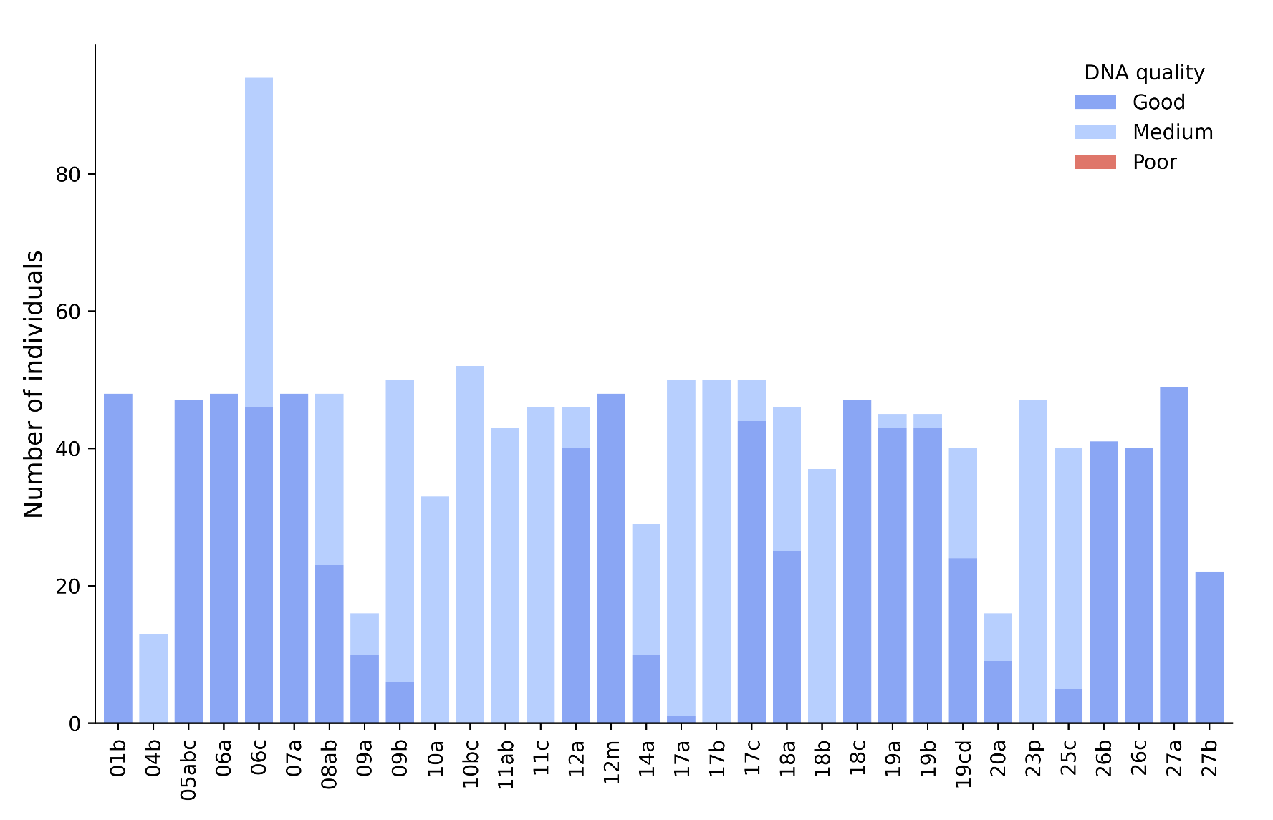
Supplementary Figure 2.1 - DNA quality distribution across geographical localities
DNA quality of the 1,373 Mullus barbatus specimens included in the sequencing libraries. No specimens with poor-quality DNA were finally included.

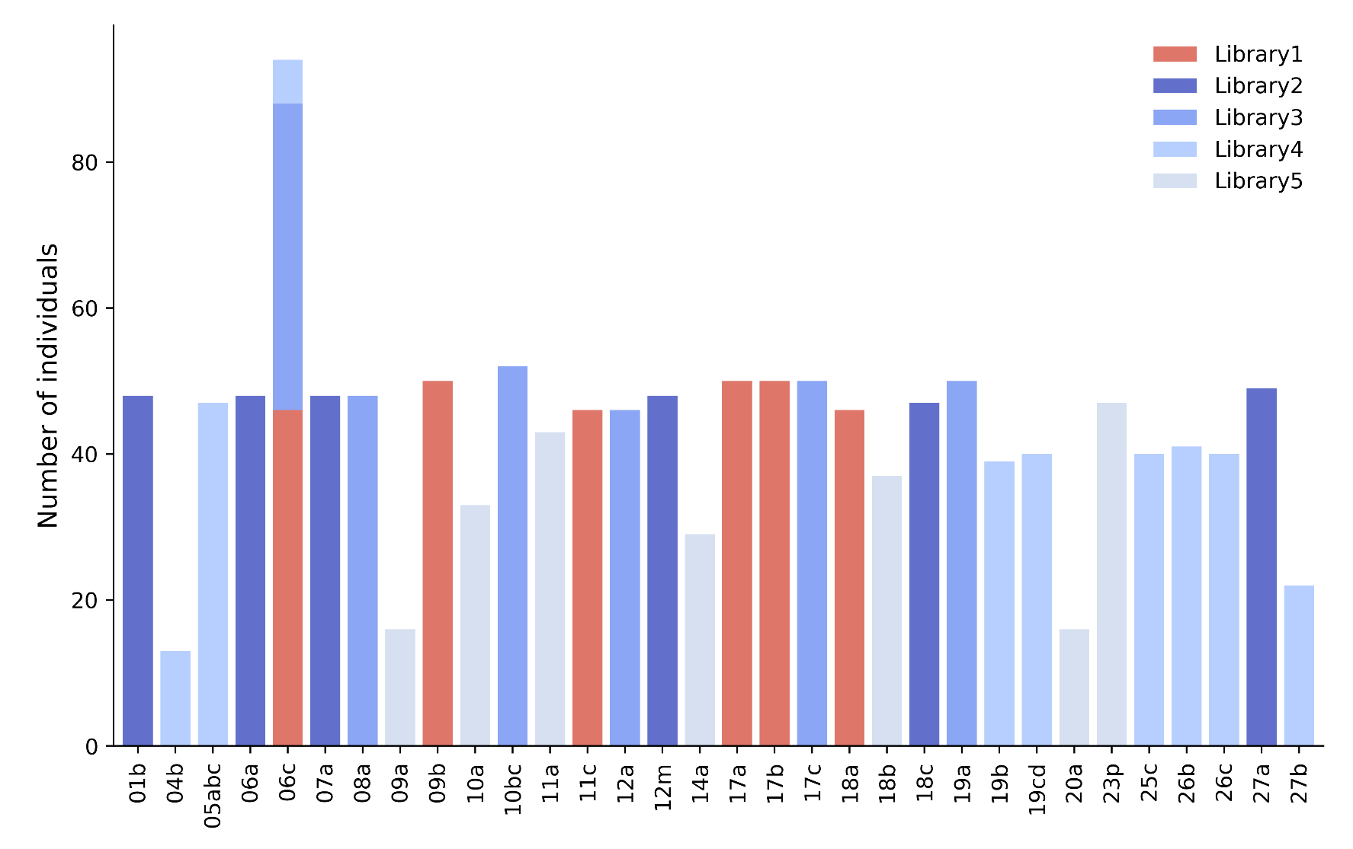
Supplementary Figure 2.2 - Distribution of individuals across sequencing libraries
Distribution of the 1,373 M. barbatus specimens selected for sequencing across five sequencing libraries. The first library (red) served as a pilot to refine the sequencing protocols, while the subsequent four libraries (blues) were part of the comprehensive study.

SUPPLEMENTARY MATERIAL 3 - Raw data processing and genome mapping
Raw fastq files generated at the sequencing facilities underwent comprehensive pre-genotype calling filtering, focusing on read and mapping qualities (1).
The initial step involved demultiplexing, adapters trimming and quality filtering using the process_radtags program from Stacks (v2.62, (2)). This program was used with default settings to first verify the integrity of the barcode and the RAD cutsite. It allows for corrections in the barcode or RAD site within a specified tolerance. Following this, it applies a sliding window analysis (15% of the read length) to assess the average quality score within the window. Reads are discarded if the score falls below a 90% probability of accuracy (phred score of 10). Additionally, reads exhibiting excessive poly-G runs at the 3’ end are also discarded.
This filtering process resulted in an average of 2,160,405 reads per individual. However, performance varied across geographical sites, with some sites yielding lower number of reads (Supplementary Figure 3.1).

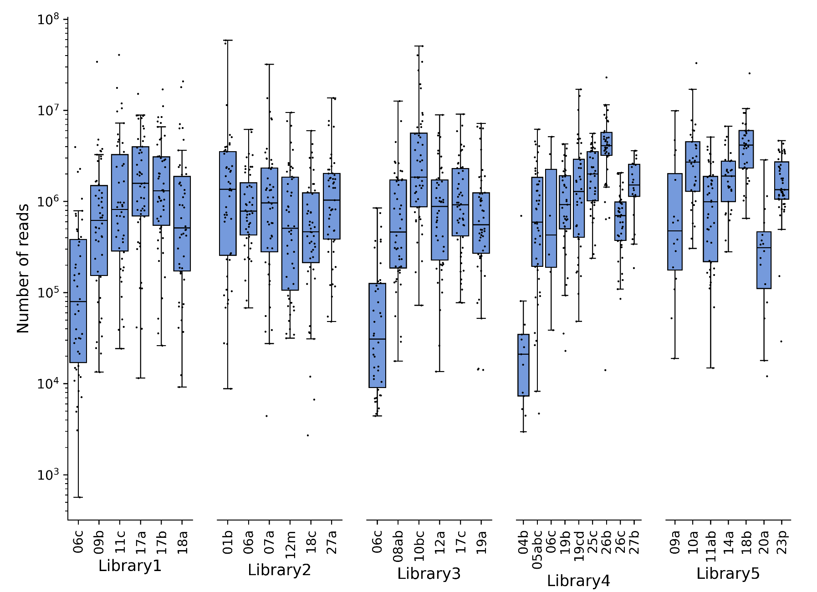
Supplementary Figure 3.1 - Number of processed reads per geographical site
Number of reads resulting from running Stacks process_radtags on 1,373 M. barbatus specimens. The y-axis, representing the number of reads, is displayed on a logarithmic scale to better visualize the range and distribution across several orders of magnitude. Each box represents the interquartile range of reads per site, with the median marked inside the box. Individual specimens are depicted as black dots.

Processed reads were aligned to the newly produced reference genome using the bwa mem algorithm (v0.7.17, (3)), which is recognized for its speed and accuracy with reads longer than 100bp. Default settings were applied during the mapping process to maintain consistency and reliability in the results. Post-alignment, mapping statistics were extracted using the samtools flagstat program (v1.7, (4)).
The mapping step resulted in a slight reduction in the average number of reads retained for downstream analyses, with an average of 2,149,809 reads per specimen. The high average mapping efficiency, at 93.78%, reflects the robustness of the reference genome and the effectiveness of the alignment process. However, performance varied notably across geographical sites, with some sites, particularly those sequenced in Library 3, displaying a lower percentage of mapping (Supplementary Figure 3.2).

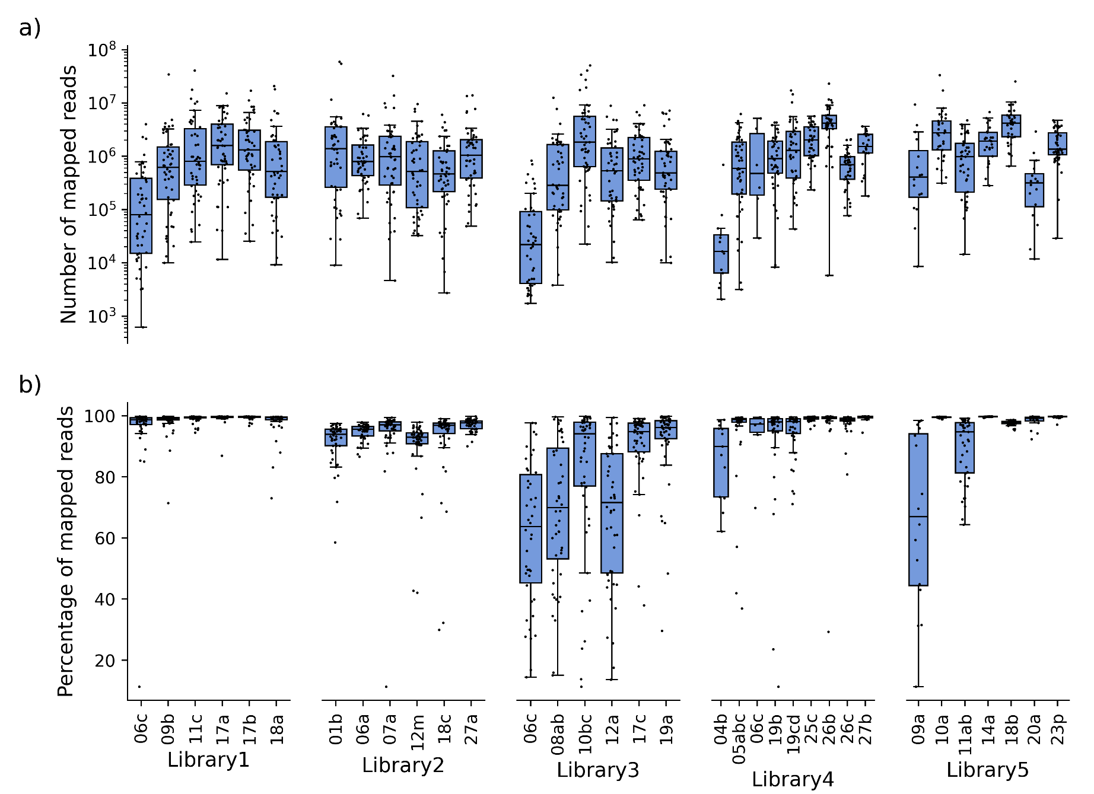
Supplementary Figure 3.2 - Number and percentage of mapped reads per geographical site
a) Number of mapped reads for 1,373 M. barbatus specimens, grouped by geographical site and sequencing library. The y-axis, representing the number of mapped reads, is displayed on a logarithmic scale to better visualize the range and distribution across several orders of magnitude. b) Percentage of mapped reads. In both figures each box represents the interquartile range of reads per site, with the median marked inside the box. Individual specimens are depicted as black dots.

Pre-genotype calling filtering should encompass not only read and mapping quality but also read depth (1). This statistic was measured using the samtools depth utility on BAM files generated from the mapping process. This depth analysis revealed significant variability in per-base read depth both within and across geographical sites (Supplementary Figure 3.3). A notable portion of the specimens displayed extreme values in read depth: 305 specimens had a median per-base read depth lower than 10, while 204 specimens exhibited values higher than 100. These disparities underscore the inconsistent performance across sequencing libraries previously observed.

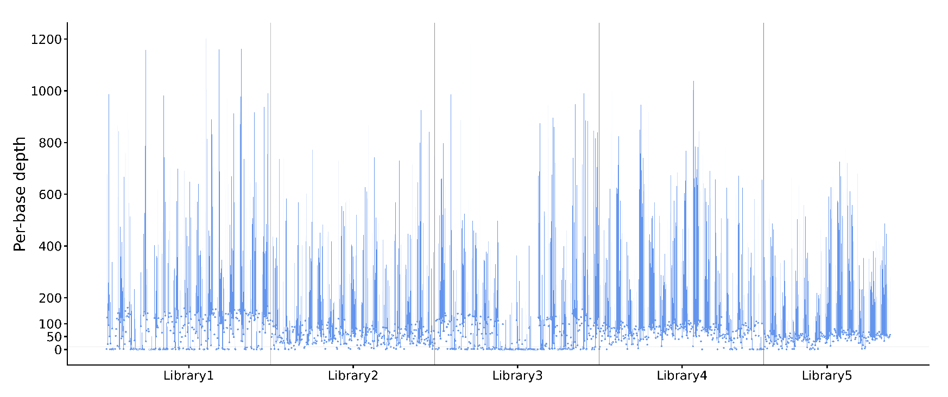
Supplementary Figure 3.3 - Read depth per individual
Per-base read depth for 1,373 M. barbatus specimens as derived from BAM files using the samtools depth utility. Each specimen's read depth variation is visualized by blue bars representing the interquartile range, with the median read depth for each specimen marked by a blue dot. Specimens are organized by sequencing library, with divisions between libraries indicated by vertical grey lines.

During the individuals filtering and genotype calling stages, loci with low coverage are typically excluded from downstream analyses to maintain data quality. However, in this study, a significant challenge was presented by the widespread high depth observed across many loci and individuals. Removing these highly covered loci would have further reduced the number of SNPs available for population genomics analyses, thus negatively impacting the study’s overall genomic resolution. Additionally, the ddRAD sequencing protocols used do not allow for the identification and removal of PCR duplicates, which could have indeed mitigated the potential biases introduced by the latter on genotype calls (5,6). This limitation required the inclusion of highly covered loci in the dataset while carefully considering the potential biases they might introduce in the interpretation of the final results.

SUPPLEMENTARY MATERIAL 4 - Call rate thresholds and missing data patterns
Following published guidelines (1,7) SNP data were defined following these criteria: a minor allele frequency of 0.01 (--min-maf 0.01), a maximum observed heterozygosity of 0.70 (--max-obs-het 0.70) and a minimum call rate threshold of 80% within each geographical site (-r 80 -p 32).
Under the above described criteria no SNPs were resulting from the dataset of 1,373 individuals, highlighting the inflation of poorly sequenced samples within the dataset, as already observed in previous data processing steps (Supplementary Material 3). When switching the minimum call rate from population to whole dataset level, more SNPs were recovered underlying the inconsistent distribution of poorly sequenced samples across geographical sites already observed (Supplementary Figure 4.1).

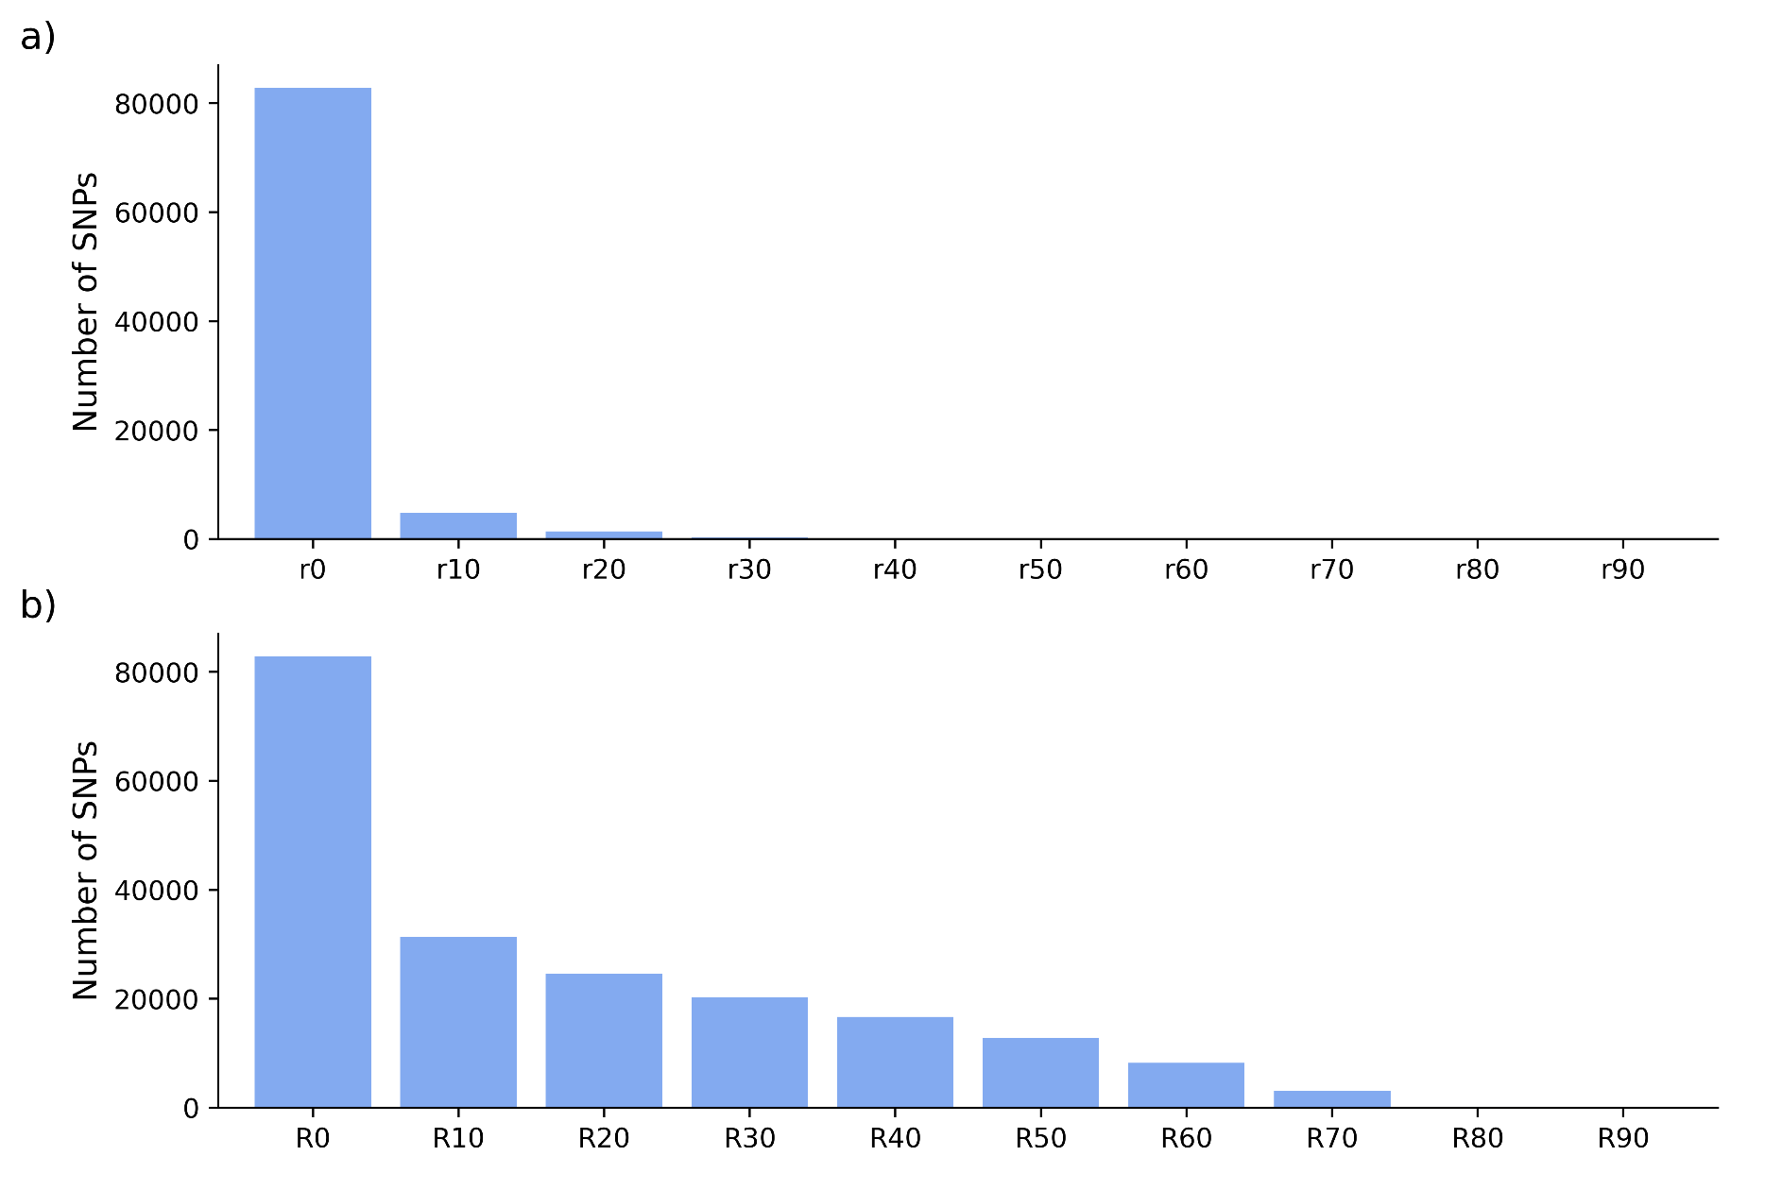
Supplementary Figure 4.1 - SNP retention across different call rates
Number of SNPs retained from 1,373 M. barbatus specimens across 32 geographical sites, under increasing per-site minimum call rates (Stacks populations r parameter) (a) and overall minimum call rates (R parameter) (b). Additionally, the minimum minor allele frequency (--min-maf) was set to 0.01 and the maximum observed heterozygosity (--max-obs-het) to 0.70.

Indeed, even though the use of filters on the overall loci call rate (-R parameter) led to a higher number of SNPs saved, it also caused inconsistent levels of missing data across geographical sites. Same inconsistency is observed across sequencing libraries (Supplementary Figure 4.2).

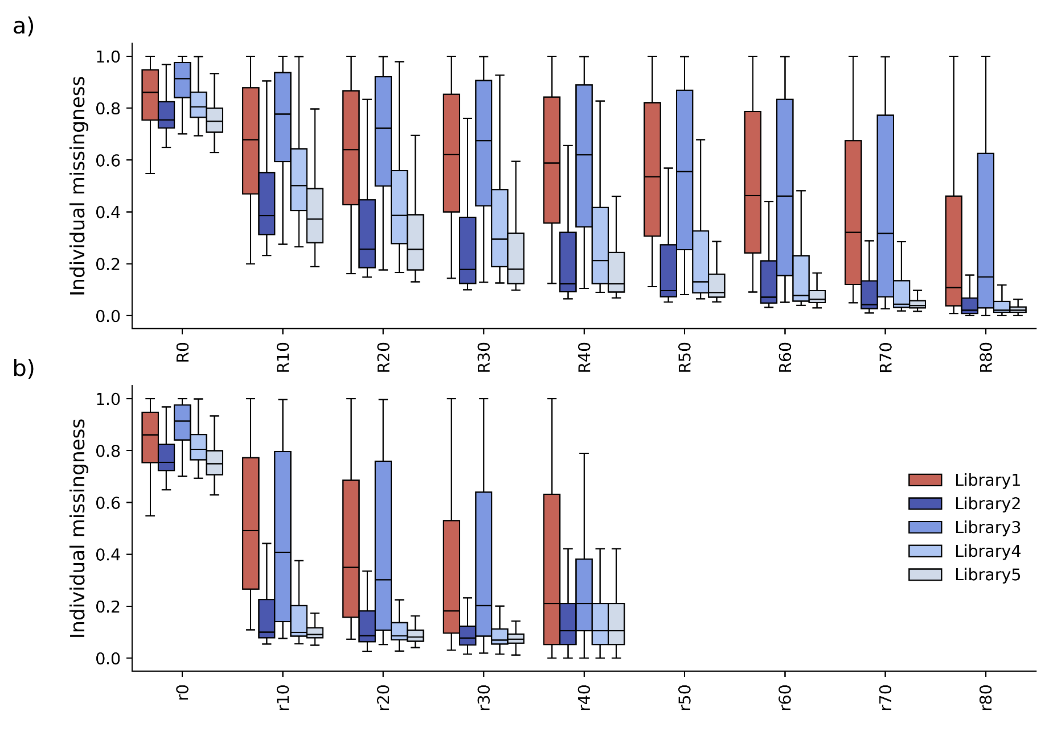
Supplementary Figure 4.2 - Missingness across different call rates
Individual missingness at 1,373 M. barbatus specimens across 32 geographical sites, under increasing per-site minimum call rates (Stacks populations -r parameter) (a) and overall minimum call rates (Stacks populations -R parameter) (b). Additionally, the minimum minor allele frequency (--min-maf) was set to 0.01 and the maximum observed heterozygosity (--max-obs-het) to 0.70. The sequencing library from the pilot study (Library1) is reported in red, while the ones from the comprehensive study are shown in blue.

Missing loci in RADseq data are often attributed to polymorphisms at restriction sites, although this typically exerts a minor effect unless genetic diversity is exceedingly high (5,8,9). Accordingly, given the low genetic diversity measured in the present and previous studies (10–14) and the batch effect observed in previous data processing steps (Supplementary Material 3), poor and inconsistent library complexity is most likely the primary cause of missing data in this study (5,6). This strengthened the strategy of filtering over the minimum call rate across geographical sites (-r parameter).

SUPPLEMENTARY MATERIAL 5 - Iterative filtering
High missingness can obscure biological signals in population structure analyses (15). In such cases, filtering loci with high missingness is preferable (1,7,16). However, when poorly sequenced specimens are widespread, this approach can drastically reduce the SNP set. Iterative filtering approaches (1,17) are better suited for such cases since high missingness individuals and loci are gradually removed almost simultaneously, optimizing the balance between individual retention and SNP call rate.
Given the widespread inflation of poorly sequenced specimens across the dataset (Supplementary Material 3) a first individual filtering on the sequencing and mapping performance was applied. Specimens with a number of mapped reads lower than 500,000 or a mapping performance lower than 95% were removed. Finally, geographical sites ending up with less than 15 individuals were completely removed. 768 individuals from 26 geographical sites resulted from this first filtering step (Supplementary Figure 5.1).

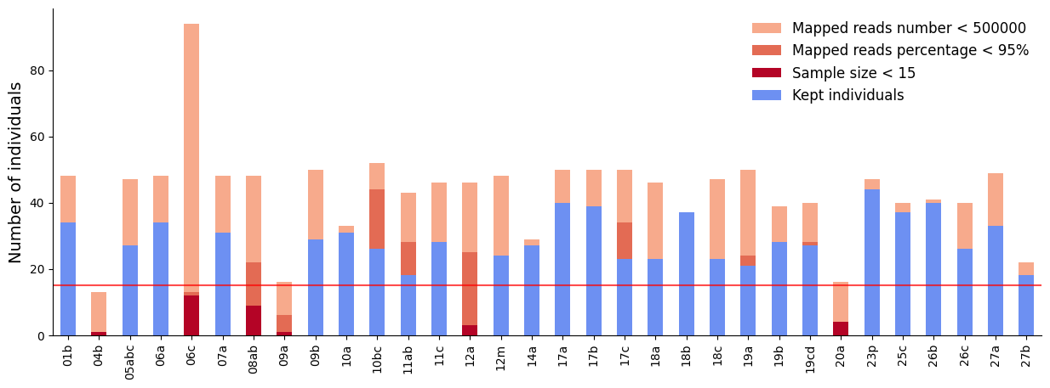
Supplementary Figure 5.1 - First step of individual filtering
Number of M. barbatus specimens removed from the starting 1,373 individuals dataset at the first individual filtering step: 491 individuals with less than 500,000 mapped reads (light red), 84 individuals with less than 95% of mapped reads (red) and 6 geographical sites (30 individuals) with a sample size smaller than 15 (dark red). 768 individuals from 26 geographical sites were finally kept (blue). A red horizontal line is drawn at the minimum sample size.

In order to finally keep a consistent representativeness across geographical sites we set a minimum and maximum sample size, 15 and 25 respectively, as a compromise between the number of high quality individuals within savable sites (resulting from previous filtering attempts) and the sample size required for population genomics inferences. These criteria led to the 625 specimens showing the least missingness from each of the 26 sites resulting from the first filtering step (Supplementary Figure 5.2).

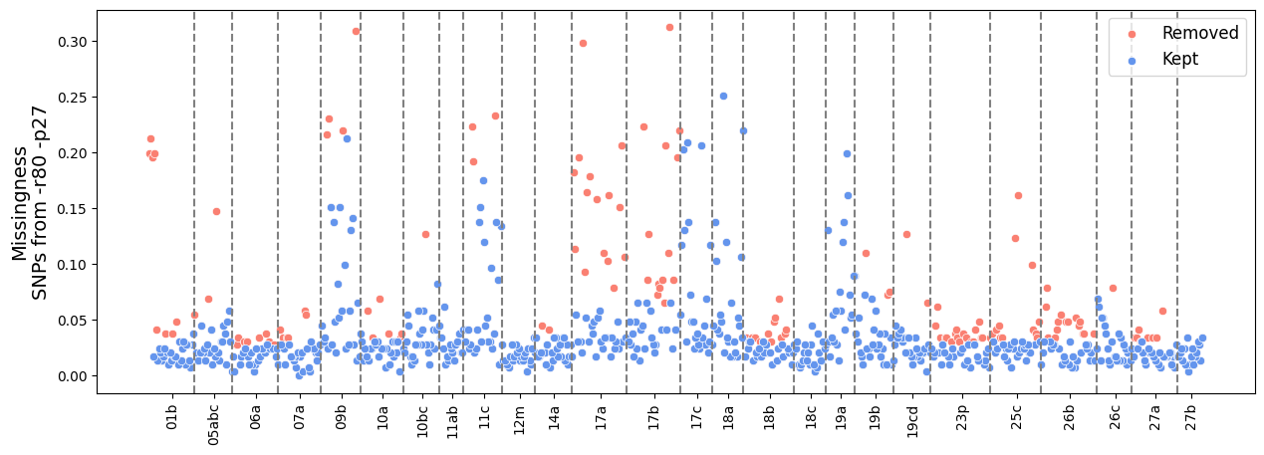
Supplementary Figure 5.2 - Second step of individual filtering
Missingness (measured from SNPs defined by the -r80 -p27 Stacks populations parameters) of the 768 M. barbatus specimens resulting from the previous filtering step. 143 individuals with the highest missingness were removed from geographical sites exceeding the maximum sample size (25) (red) at the second filtering step. 625 individuals from 26 geographical sites were finally kept (blue).

Starting from the resulting 625 individuals dataset the iterative filtering has been performed: at each step individuals showing a missingness at the r80 SNPs dataset lower than 0.1 were removed, consequently geographical sites with a sample size lower than 15 are completely removed. After three iterations no individuals were further removed given the low and consistent missingness measured at the obtained dataset of 416 individuals from 18 geographical sites (Supplementary Figure 5.3).

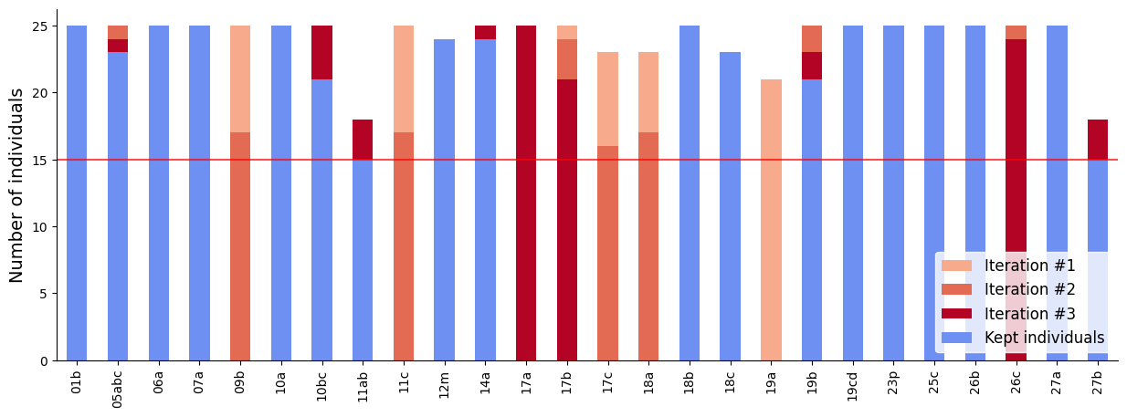
Supplementary Figure 5.3 - Iterative filtering
Number of M. barbatus specimens removed at each iteration of the iterative filtering from the 625 individuals dataset resulting from the previous filtering step: 51 individuals and 1 geographical site from iteration #1 (light red), 74 individuals and 4 geographical sites from iteration #2 (red), 84 individuals and 3 geographical sites from iteration #3 (dark red). 416 individuals from 18 geographical sites were finally kept (blue). A red horizontal line is drawn at the minimum sample size.

Given the low number of individuals from certain kept geographical sites, a further sample size reduction to 20 was applied to geographical sites exceeding this size to guarantee consistency. Differently from what was done previously, individuals were randomly selected within each geographical site at this final step in order to maintain consistency in terms of missingness across sites.
A final dataset of 350 high quality individuals consistently arranged across 18 geographical sites was produced. The entire Mediterranean coverage was maintained, but some areas were unfortunately lost due to low quality (e.g. Northern Adriatic and Northern Tyrrhenian Seas) (Supplementary Figure 5.4).

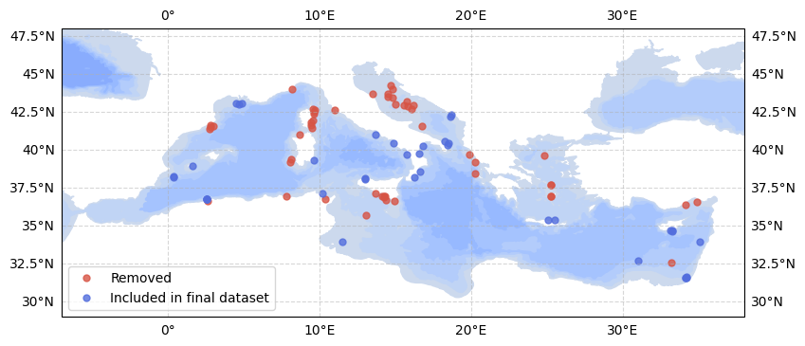
Supplementary Figure 5.4 - Sampling sites included in the final dataset
Map showing the locations of the 1,373 M. barbatus specimens sequenced. 350 individuals included in the final dataset are reported in blue, removed individuals in red.

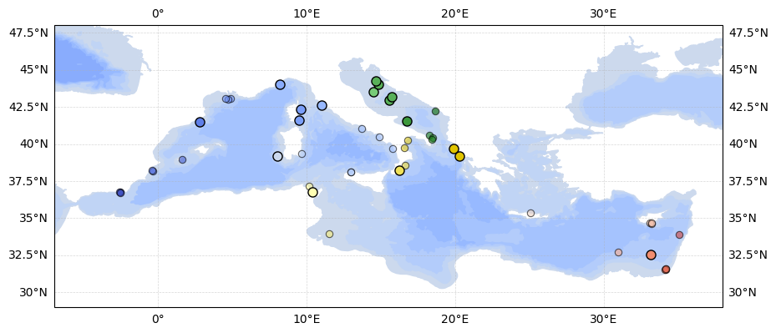
Supplementary Figure 5.5 – Re-integrated geographical sites
Map showing the sampling sites of the 350 M. barbatus individuals retained in the final dataset as small dots. Large dots indicate an additional set of 58 individuals that were re-integrated from the pool of initially excluded samples in a supplementary exploratory analysis aimed at improving geographic coverage. To recover these samples, we re-extracted the 1,592 SNPs used in the main analysis from a VCF file generated by running Stacks on all 1,373 sequenced individuals (without filtering). We then selected those with less than 20% missing data at these sites. This approach allowed partial recovery of samples from underrepresented areas, including the northern Adriatic and Tyrrhenian Seas.

This filtering strategy effectively standardized sequencing yield and mapping performance. In the initial dataset of 1,373 specimens, the number of reads per individual ranged from 568 to 59,036,450 (Supplementary Figure 3.1), with mapping performance between 11.31% and 99.88% (Supplementary Figure 3.2). After filtering, the final dataset of 350 specimens showed a more consistent range of 526,068 to 7,108,806 reads per individual, with mapping performance improving to 96.48%–99.86% (Supplementary Figure 5.6).

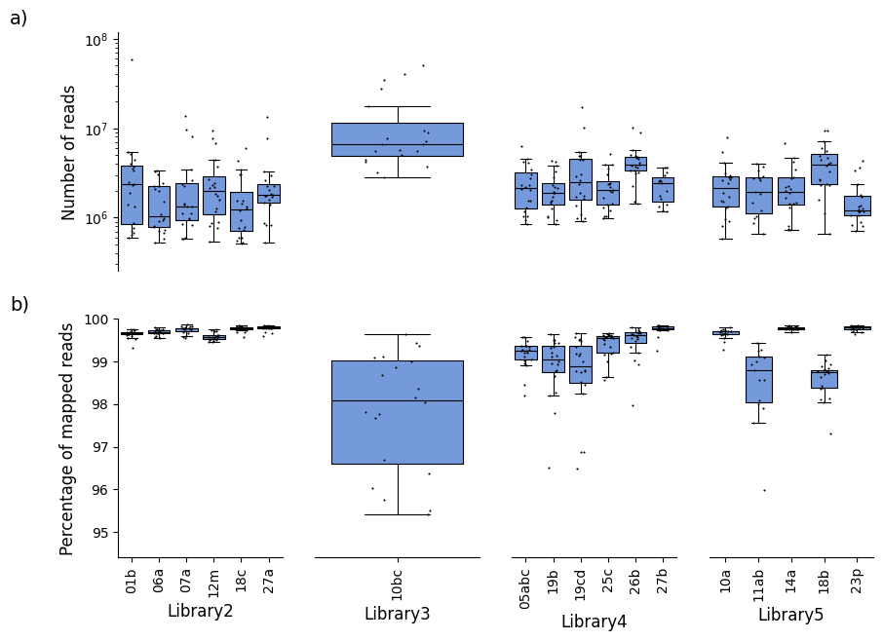
Supplementary Figure 5.6 - Number of reads and percentage of mapping per geographical site in the final dataset
a) Number of reads for 350 M. barbatus specimens, grouped by geographical site and sequencing library. The y-axis, representing the number of reads, is displayed on a logarithmic scale to better visualize the range and distribution across several orders of magnitude. b) Percentage of mapped reads. In both figures each box represents the interquartile range of reads per site, with the median marked inside the box. Individual specimens are depicted as black dots.

This iterative approach effectively optimized the balance between individual retention and SNP call rate. While the number of individuals was reduced from 1,373 to 350, the number of called SNPs increased from 0 to 7,569, with 1,592 retained when randomly selecting one SNP per locus, as applied in the population structure analysis (Supplementary Figure 5.7).

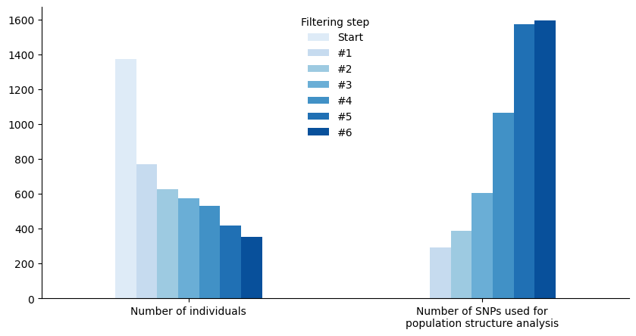
Supplementary Figure 5.7 - Number of individuals and SNPs at each filtering step
Number of M. barbatus specimens and SNPs used for population structure analysis (Stacks populations -r80 -p[N_POP] -min-maf0.01 -max-obs-het -write-random-snp) at each filtering step.

To note, sequencing library 1 was completely removed and one single geographical site was kept from sequencing library 3 (Supplementary Figure 5.8). This further proved the effectiveness of the adopted filtering strategy in removing the batch effect resulting from different quality across sequencing libraries observed at previous data processing steps (Supplementary Material 3).

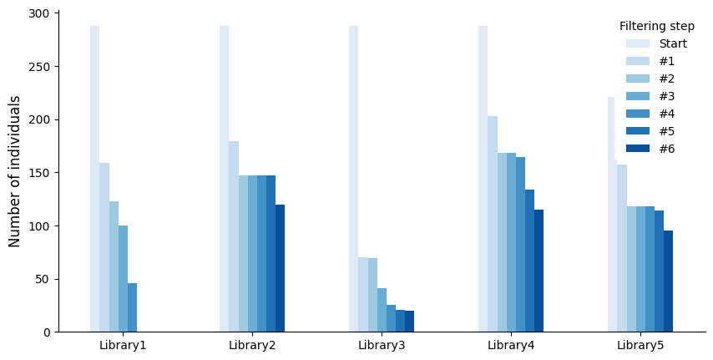
Supplementary Figure 5.8 - Number of individuals kept from sequencing libraries at each filtering step
Number of M. barbatus specimens kept at each filtering step from each of the five sequencing libraries.

The final dataset displayed consequently consistent levels of missing data across geographical sites and sequencing libraries (Supplementary Figure 5.9).

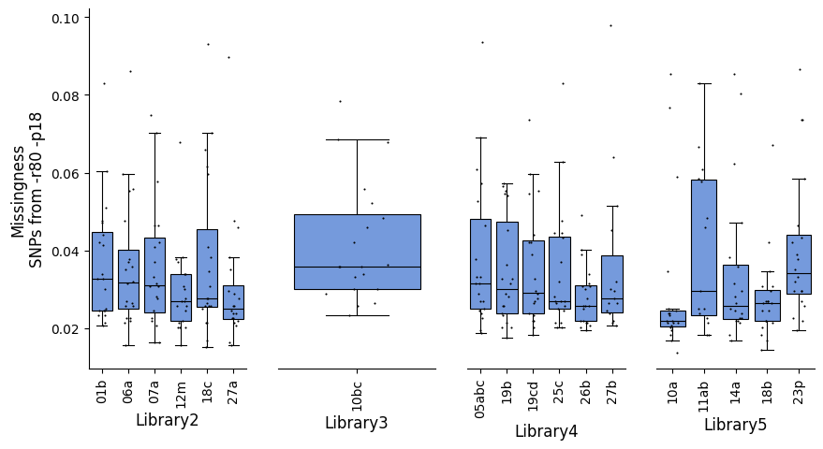
Supplementary Figure 5.9 - Missingness across geographical sites in final dataset
Missingness (measured from SNPs defined by the -r80 -p18 Stacks populations parameters) of the 350 M. barbatus specimens resulting from the final filtering step. Each box represents the interquartile range of missingness per site, with the median marked inside the box. Individual specimens are depicted as black dots.

SUPPLEMENTARY MATERIAL 6 - Macro-areas subdivision for AMOVA and outliers detection
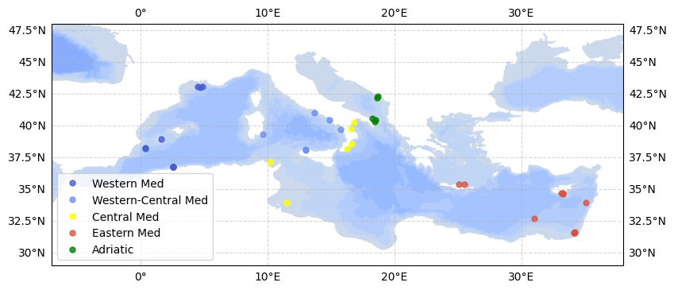
Supplementary Figure 6.1 - Sampling sites grouped by macro-areas
Map showing the locations of the 350 M. barbatus specimens included in the final dataset, grouped in five macro-areas based on the subregional technical units defined by the General Fisheries Commission for the Mediterranean (GFCM, (18)). The western Mediterranean macroarea has been splitted in two macro-areas given the larger sample coverage compared to other macro-areas.

SUPPLEMENTARY MATERIAL 7 - Population structure
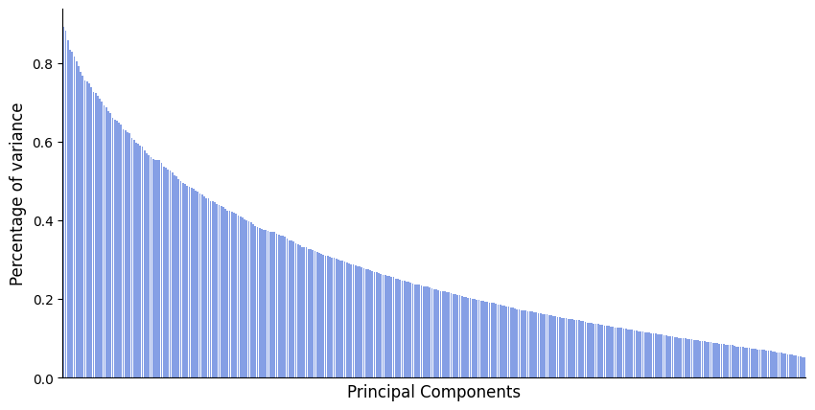
Supplementary Figure 7.1 - Percentage of variance of each principal component from PCA
Percentage of variance kept by each principal component from PCA shown in Figure 2b.

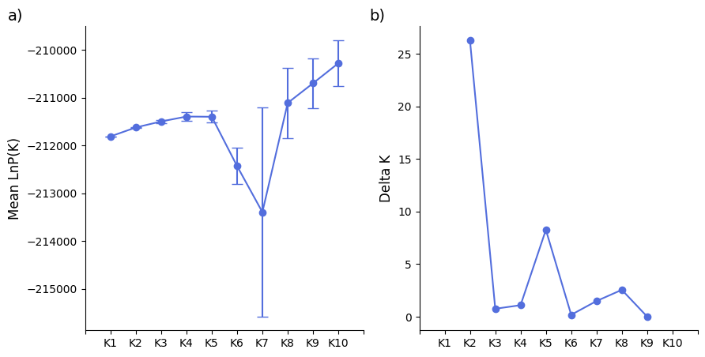
Supplementary Figure 7.2 - Detection of the true number of groups from STRUCTURE output
a) Mean and standard deviation of the posterior probability of the data for each K (10 runs each), as the model choice criterion implemented in structure to detect the true K (19). b) Second order rate of change of the posterior probability function with respect to K, as the model choice criterion implemented in Evanno et al. (2005) (20).

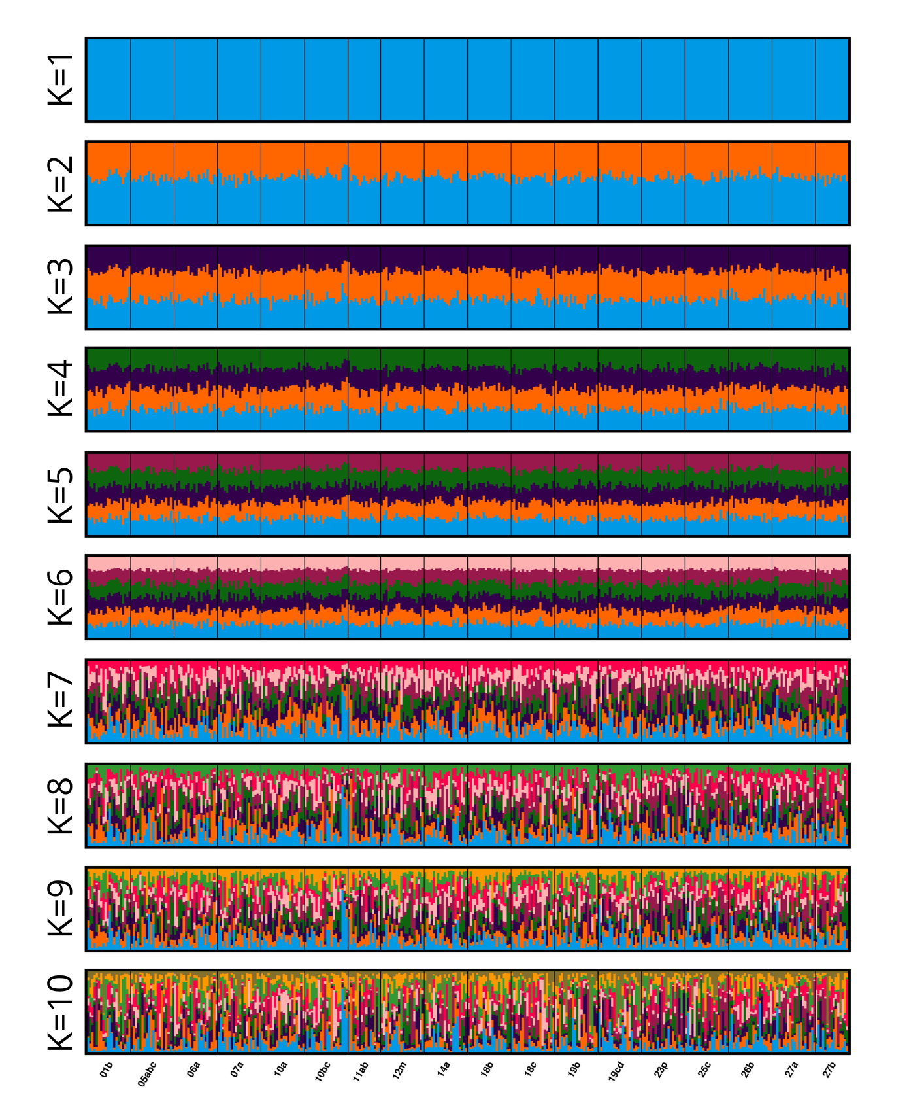
Supplementary Figure 7.3 - Ancestral proportions from each inspected model in STRUCTURE
Ancestral proportions of 350 M. barbatus specimens for each K model (10 runs each) as resulting from CLUMPAK (21). Mean similarity scores: K1 1.000, K2 0.999, K3 0.987, K4 0.959, K5 0.959, K6 0.955, K7 0.886, K8 0.819, K9 0.817, K10 0.845.

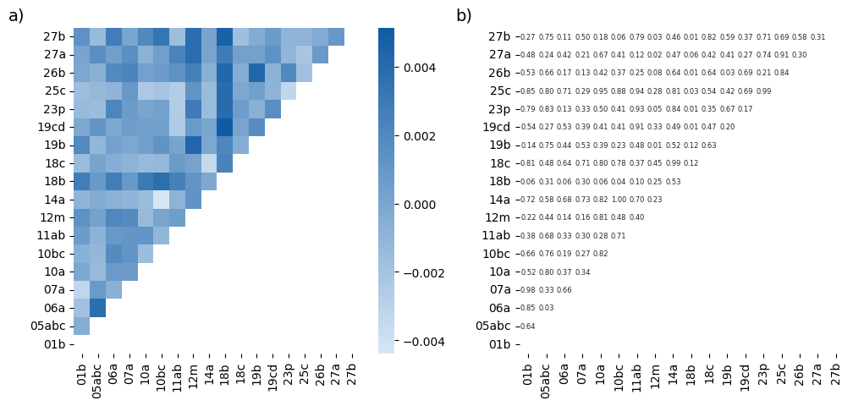
Supplementary Figure 7.4 - Pairwise F_{ST} values and statistical significance
Pairwise F_{ST} values (a) and p-values (b) calculated from 350 M. barbatus specimens across 18 geographical sites using StAMPP (v1.6.3; (22)) with 100,000 permutations. No values showed statistical significance after correction for multiple tests (α < 0.05, (23)).

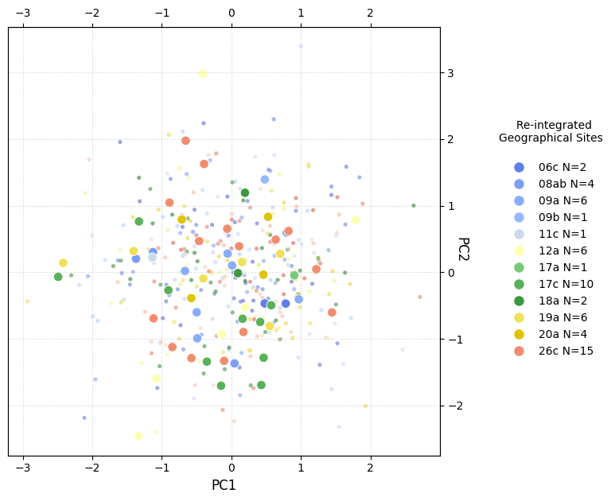
Supplementary Figure 7.5 – Principal Component Analysis including re-integrated individuals
Principal Component Analysis performed on Adegenet (v2.1.10, (24)) (PC1 and PC2 shown, explaining 0.85% and 0.80% of the total variance, respectively), based on the 1,592 SNP dataset used for population structure analyses. The plot displays the 350 individuals included in the final dataset (small dots) alongside 58 additional individuals recovered from previously excluded samples (large dots; see Supplementary Figure 5.5 for details). Dot colors indicate the geographic origin of the recovered individuals, with corresponding sample sizes reported in the legend. The recovered samples cluster within the same multidimensional space as the original dataset, showing no distinct grouping or separation. This result reinforces the conclusion of genetic homogeneity across the Mediterranean and suggests that the absence of population structure is maintained even when geographic coverage is expanded.

Supplementary Table 7.1 - Results from Powsim
Fst | Ne | Generations | Power
0.0010 | 4820 | 10 | 70%
0.0012 | 4820 | 12 | 100%
0.0012 | 7228 | 18 | 90%
0.0014 | 7228 | 20 | 100%
0.0011 | 14294 | 32 | 80%
0.0013 | 14294 | 36 | 100%
0.0012 | 16229 | 40 | 90%
0.0014 | 16229 | 44 | 100%
This table reports the results of statistical power simulations performed with Powsim (v4.1; Powsim_b module), aimed at evaluating the minimum detectable levels of genetic differentiation (F_{ST}) given the empirical dataset characteristics. We tested a range of expected divergence values using population sizes derived from empirical estimates of effective population size (Ne), obtained through the linkage disequilibrium method implemented in NeEstimator (Supplementary Table 7.2). The lower and upper bounds of the 95% confidence interval around the Ne estimate were also considered. In addition, the most recent Ne value inferred by MSMC2 (Supplementary Figure 8.1) was included to assess consistency across methods. Power was assessed through 10 replicates. At the end of each simulation, samples were drawn with the same number and sizes as in the empirical dataset. Statistical homogeneity was tested using chi-square and Fisher’s exact test approaches. The proportion of significant outcomes (p < 0.05) across replicates was used to estimate statistical power.

Supplementary Table 7.2 - Results from NeEstimator
Harmonic Mean Sample Size | Independent Comparisons | OverAll r^2 | Expected r^2 Sample | Estimated Ne | 95% CIs for Ne
320.2 | 148764 | 0.003188 | 0.003142 | 7228.3 | 4819.4 - 14294.2
This table presents the results of NeEstimator (v2.0, (26)). Effective population size was estimated directly from the empirical 1,592 SNP dataset used for population structure inferences. The linkage disequilibrium method implemented in NeEstimator was used.

Supplementary Table 7.3 - Results from CurrentNe
min-mac/min-maf | Estimated Ne | 90% CIs for Ne
1 | 4425.65 | 3957.10 - 4949.68
2 | 5732.17 | 5057.50 - 6496.84
3 | 4286.46 | 3832.42 - 4794.29
0.01 | 5149.19 | 4557.55 - 5817.63
0.05 | 8890.44 | 7587.43 - 10417.49

This table summarizes the results obtained with CurrentNe (v1.0, (27)), which performs well even in scenarios with large population sizes or small sample sizes. Analyses were conducted using the empirical dataset of 1,592 SNPs employed for population structure inferences (min-maf 0.01). To assess the robustness of the estimates, alternative thresholds for minimum minor allele frequency (min-maf) and minimum minor allele count (min-mac) were also tested, taking advantage of CurrentNe’s reduced sensitivity to rare alleles (27). Comparable Ne values were obtained across parameter settings, indicating stability of the estimates.

Supplementary Table 7.3 - Results from AMOVA
Source of variation | df | Sum of squares | Variance component (σ²) | p-value | Variance coefficient | Phi-Statistics (Φ)
Pop (macro-areas) | 4 | 459.8294 | 0.036124 | 0.2465 | 19.39639 | 0.0003234266
Subpop (geographical sites) | 13 | 1462.1272 | 0.044339 | 0.3148 | 19.56887 | 0.0007204020
Ind | 332 | 37054.9542 | 111.611308 |  | 68.60714 | 0.0003971038
Table presenting the results of Analysis of Molecular Variance (AMOVA) performed in pegas (v1.3, (28)) based on 100,000 permutations. Source of Variation: The hierarchical levels at which genetic variation is assessed. df (Degrees of Freedom): The number of independent comparisons for each level. Sum of Squares: The total genetic variation attributed to each level. Variance Component (σ²): The estimated genetic variance at each level. p-value: Statistical significance of variance at each level, testing whether the genetic differentiation is greater than expected by chance. Variance Coefficient: The proportion of total variance attributed to each level. Phi-Statistics (Φ): Measures of genetic differentiation indicating the proportion of genetic variance explained at each hierarchical level.

SUPPLEMENTARY MATERIAL 8 – Population demography with MSMC2
Coalescent-based methods are widely used to reconstruct historical demographic patterns with high temporal resolution. One such approach is the Multiple Sequentially Markovian Coalescent (MSMC (29)), which infers changes in effective population size and population structure through time from genome sequence data. MSMC approximates the coalescent with recombination using a Markovian model across multiple loci, capturing how local genealogies vary due to ancestral recombination events (30).
Unlike many other population genetic methods, the precision of MSMC in reconstructing demographic history depends primarily on the number of independent genealogies sampled across the genome, rather than the number of individuals analyzed (31). Therefore, whole-genome data provide significant power by allowing the sampling of a large number of unlinked loci, each representing a distinct genealogical history.
Although Sequentially Markovian Coalescent (SMC) methods were originally developed for full genome sequences, they have also been applied to reduced-representation datasets (e.g., RADseq). Simulations suggest that a portion of the coalescent signal can still be recovered from such data, provided that the marker density is sufficiently high (32).
However, given that this condition is not met in our dataset, we applied MSMC2 (v2.1.4, (30,33)) to long-read whole-genome sequencing data generated from individual fMulBarb1, the same specimen used to assemble the reference genome.
High-accuracy basecalling of ONT reads was performed with Guppy (v5.0.13, (34)), followed by quality filtering with Filtlong (v0.2.1, (35)) to retain reads longer than 1,000 bp, targeting a total base count of 45 Gbp. Filtered reads were aligned to the newly generated reference genome using Minimap2 (v2.17, (36)). Unmapped reads and secondary alignments were removed using samtools (v1.7, (4)).
BCFtools (v1.22, (37)) was used to identify biallelic SNPs, retaining only those with a depth greater than 20. Whatshap (v2.8, (38)) was used to phase variants per chromosome, resulting in 2,117,540 deeply covered phased variant sites.
A genome mappability mask was generated using the SNPable tool (39). First, all overlapping 35-mer subsequences of the genome were extracted with splitfa, and then aligned back to the genome using bwa aln (v0.7.17, (3)). Raw mappability masks were generated using the gen_raw_mask.pl and gen_mask scripts, and refined into chromosome-level masks with the makeMappabilityMask.py script from msmc-tools (40).
MSMC2 input files were then generated by combining the phased VCF with the mappability mask using generate_multihetsep.py. MSMC2 was run for 100 iterations. Estimates of effective population size were converted into real values assuming a mutation rate of 1e-8 (default), and generation times ranging from 1 to 3 years (with 3.2 years reported in fishbase.com (41) as a reference) (see Supplementary Figure 8.1).

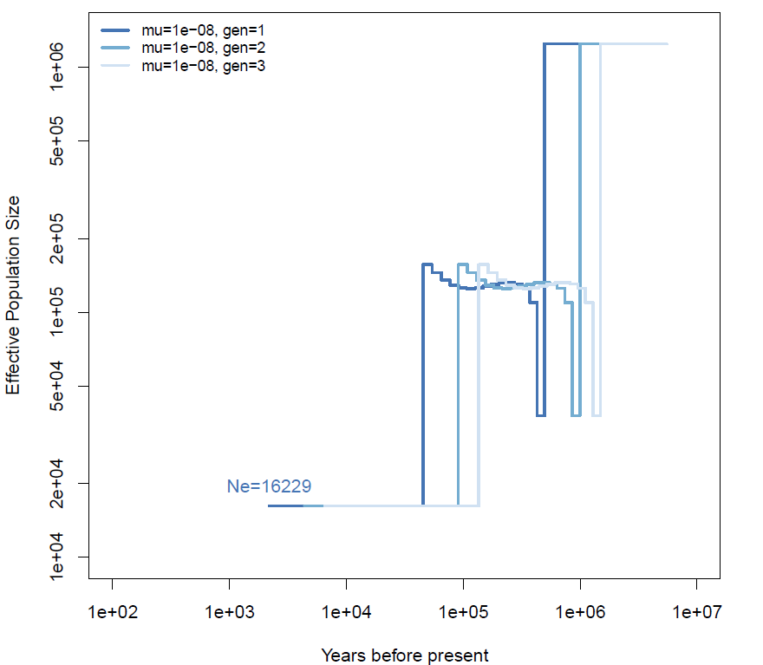
Supplementary Figure 8.1 – Population demography inferred by MSMC2
Historical effective population size inferred from whole-genome ONT data of individual fMulBarb1 using MSMC2. Mutation rate was set to 1e-8; generation time varied from 1 (dark blue) to 3 years (light blue). Both axes are on a logarithmic scale.

The most recent Ne values inferred with MSMC2 were consistent with those obtained using NeEstimator, providing additional support for our estimate of a contemporary Ne in the order of 10⁴. In addition, in silico simulations conducted with PowSim confirmed that the final set of 1,592 high-quality SNPs retained for population structure analyses had sufficient statistical power to detect subtle levels of genetic differentiation, even under the most recent Ne values inferred by MSMC2 (1,622, see Supplementary Table 7.3). Moreover, MSMC2 detected a pronounced demographic contraction around 100,000 years ago, coinciding with the Wurm glaciation, an event frequently associated with historical bottlenecks in Mediterranean fish populations (42,43). This further validates the reliability of the demographic reconstruction.
Although MSMC2 can produce meaningful estimates from a single diploid genome, the limited number of sequences restricts resolution, especially in recent time periods (30,31). In fact, the most recent estimates correspond to thousands of years before present, and potential post-glacial population recoveries are likely not captured in this analysis. Greater resolution in the recent past would require phased genome sequences from multiple individuals (30).
New whole-genome sequences will improve the resolution of demographic inference, particularly in the most recent time periods, and allow the detection of more subtle shifts in effective population size.

SUPPLEMENTARY MATERIAL 9 - Parameters and results of outliers detection pipelines
Bayescan (v2.1, (44))
Bayescan allows the identification of SNPs that are under selection because they show FST coefficients that are significantly more different than expected under neutrality and a given demographic model. BayeScan uses logistic regression to partition FST coefficients into a population-specific component (β), common to all loci, and a locus-specific component (α), common to all populations. Selection is detected when α is significantly different from zero, which occurs when the locus-specific component α explains the observed pattern of diversity. If α > 0, directional selection is assumed to be acting on the locus under analysis, whereas α < 0 suggests balancing or purifying selection.
BayeScan analyses comprised 50 pilot runs of 5,000 iterations, a burn-in of 50,000 iterations, a thinning interval of 50 (5,000 iterations were used for the estimation of posterior odds), and a prior odds ratio of 10 (prior belief that a selection model is 1/10 as likely as a neutral model for a given SNP). The threshold of significance was set at 0.05 after correction for multiple testing (q-values). 10 outliers resulted from the analysis.

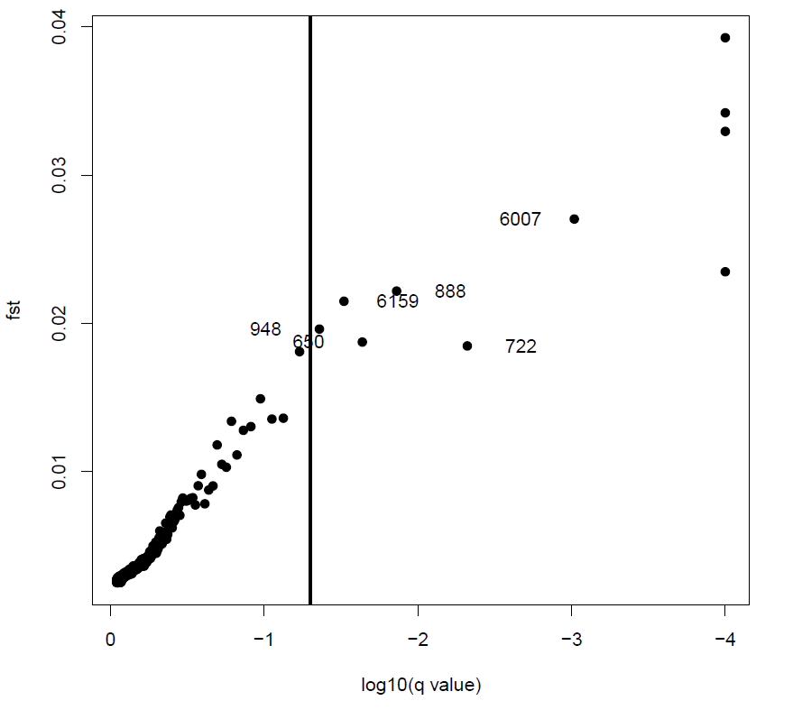
Supplementary Figure 9.1 - Outliers detected from Bayescan
Fst and log₁₀(q-value) are reported. A vertical black line indicates the threshold of significance set at 0.05 after correction for multiple testing (q-values).

FstHet (v1.0.1, (45))
The F_{ST}-heterozygosity outlier detection approach implemented in FstHet R package estimates outliers based on empirical quantiles rather than a simulated null model. The fhsthet() wrapper was used to calculate smoothed quantiles from empirical Fst-heterozygosity distributions. SNPs above the 95% confidence intervals constructed with 1000 bootstraps for the expected relationship between He and F_{ST} were considered as outlier SNPs. SNPs showing F_{ST} values lower than 0.0 were considered to be under balancing selection, thus they were excluded from the 203 resulting outliers dataset.

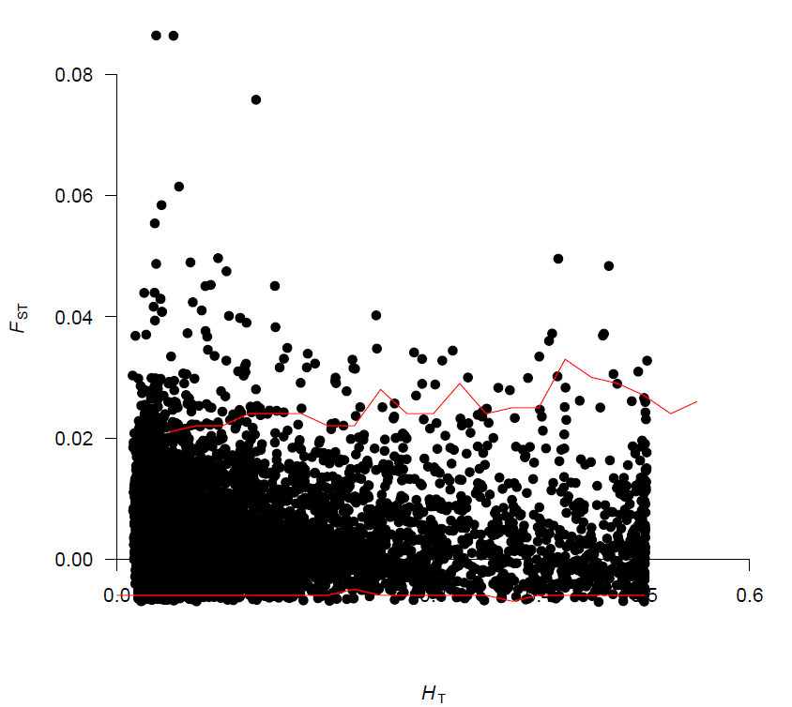
Supplementary Figure 9.2 - Outliers detected from FstHet
Heterozygosity and F_{ST} values measured from the FstHet R package. Thresholds of confidence are shown in red.

OutFLANK (v0.2, (46))
OutFLANK uses likelihood on a trimmed distribution of F_{ST} values to infer the distribution of F_{ST} for neutral markers. This distribution is then used to assign q-values to each locus to detect outliers that may be due to spatially heterogeneous selection.
The F_{ST} distribution from the entire SNP set was generated. A subset was then selected by randomly sorting out one SNP from each RAD locus. The neutral distribution of F_{ST} was then calibrated by trimming out right and left tails (0.05).
The mean F_{ST} and the degrees of freedom on the chi-square distribution measured from the estimated neutral F_{ST} distribution were finally used to detect outliers (q-value < 0.05). 6 outliers resulted from the analysis (Supplementary Figure 9.3).

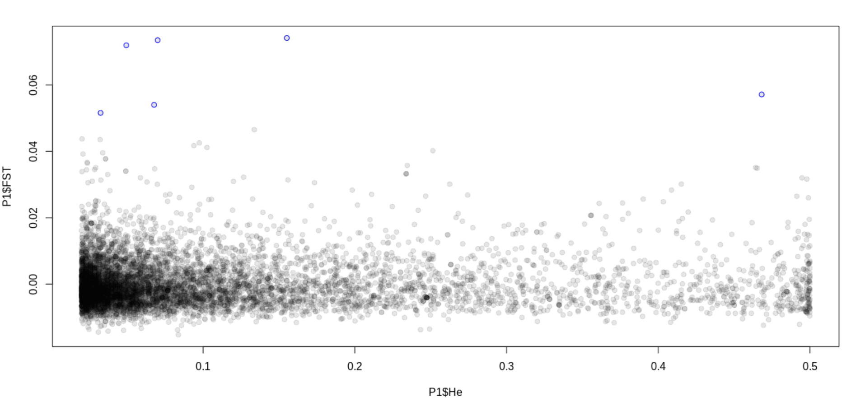
Supplementary Figure 9.3 - Outliers detected from OutFLANK
Heterozygosity and F_{ST} values measured from the OutFLANK R package. Outliers are marked as blue dots.

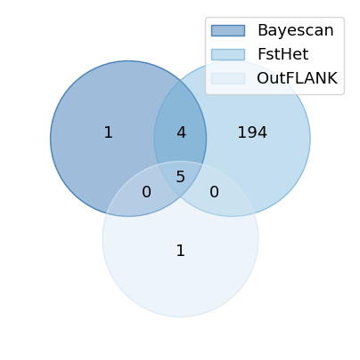
Supplementary Figure 9.4 - Outliers detected by each pipeline
Venn diagram showing the number of outliers detected by each pipeline (OutFLANK: light blue; FstHet: blue; Bayescan: dark blue). Outliers detected by at least two pipelines (9) were considered the strongest candidates for directional selection.

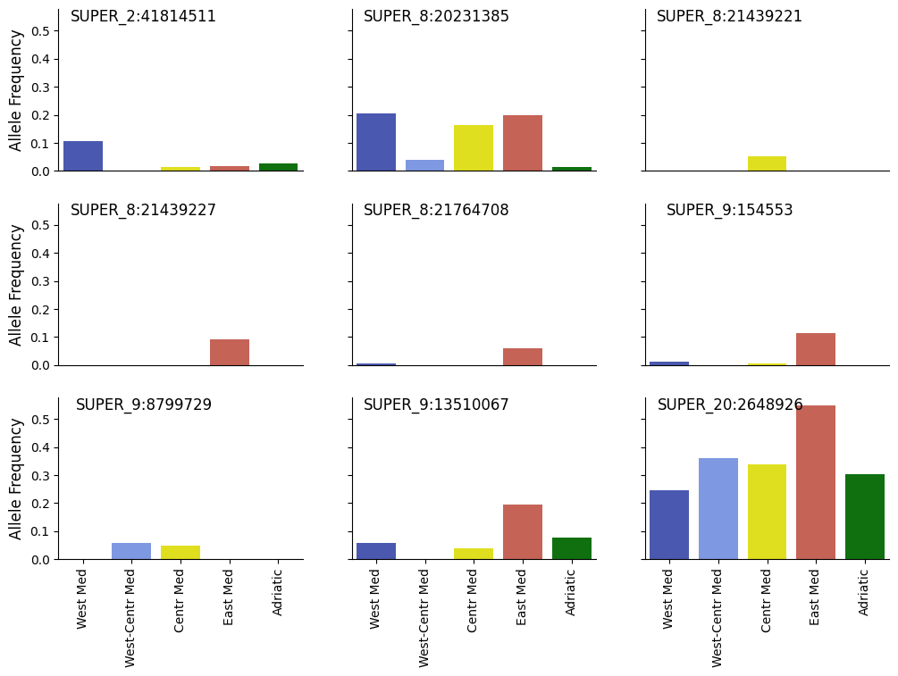
Supplementary Figure 9.5 - Allele frequency of candidate SNPs for directional selection
Minor allele frequencies are shown for the 9 outliers considered as the strongest candidates for directional selection since shared by two out of three outliers detection pipelines. Allele frequencies are measured across the five macro-areas used as putative populations for outliers detection analysis based on the subregional technical units defined by GFCM (Supplementary Figure 6.1).

SUPPLEMENTARY MATERIAL REFERENCES
1. Hemstrom W, Grummer JA, Luikart G, Christie MR. Next-generation data filtering in the genomics era. Nat Rev Genet. 2024 Nov;25(11):750–67.
2. Rochette NC, Rivera-Colón AG, Catchen JM. Stacks 2: Analytical methods for paired-end sequencing improve RADseq-based population genomics. Mol Ecol. 2019;28(21):4737–54.
3. Li H. Aligning sequence reads, clone sequences and assembly contigs with BWA-MEM. arXiv. 2013. https://doi.org/10.48550/arXiv.1303.3997. Accessed 3 April 2025.
4. Li H, Handsaker B, Wysoker A, Fennell T, Ruan J, Homer N, et al. The Sequence Alignment/Map format and SAMtools. Bioinformatics. 2009 Aug 15;25(16):2078–9.
5. Rivera-Colón AG, Rochette NC, Catchen JM. Simulation with RADinitio improves RADseq experimental design and sheds light on sources of missing data. Mol Ecol Resour. 2021;21(2):363–78.
6. Rochette NC, Rivera-Colón AG, Walsh J, Sanger TJ, Campbell-Staton SC, Catchen JM. On the causes, consequences, and avoidance of PCR duplicates: Towards a theory of library complexity. Mol Ecol Resour. 2023;23(6):1299–318.
7. Paris JR, Stevens JR, Catchen JM. Lost in parameter space: a road map for stacks. Methods Ecol Evol. 2017;8(10):1360–73.
8. Gautier M, Gharbi K, Cezard T, Foucaud J, Kerdelhué C, Pudlo P, et al. The effect of RAD allele dropout on the estimation of genetic variation within and between populations. Mol Ecol. 2013;22(11):3165–78.
9. Andrews KR, Good JM, Miller MR, Luikart G, Hohenlohe PA. Harnessing the power of RADseq for ecological and evolutionary genomics. Nat Rev Genet. 2016 Feb;17(2):81–92.
10. Garoia F, Guarniero I, Piccinetti C, Tinti F. First Microsatellite Loci of Red Mullet (Mullus barbatus) and Their Application to Genetic Structure Analysis of Adriatic Shared Stock. Mar Biotechnol. 2004 Oct 1;6(5):446–52.
11. Galarza JA, Turner GF, Macpherson E, Rico C. Patterns of genetic differentiation between two co-occurring demersal species: the red mullet (Mullus barbatus) and the striped red mullet (Mullus surmuletus). Can J Fish Aquat Sci. 2009 Sep;66(9):1478–90.
12. Maggio T, Lo Brutto S, Garoia F, Tinti F, Arculeo M. Microsatellite analysis of red mullet Mullus barbatus (Perciformes, Mullidae) reveals the isolation of the Adriatic Basin in the Mediterranean Sea. ICES J Mar Sci. 2009 Oct 1;66(9):1883–91.
13. Félix-Hackradt FC, Hackradt CW, Pérez-Ruzafa Á, García-Charton JA. Discordant patterns of genetic connectivity between two sympatric species, Mullus barbatus (Linnaeus, 1758) and Mullus surmuletus (Linnaeus, 1758), in south-western Mediterranean Sea. Mar Environ Res. 2013 Dec 1;92:23–34.
14. Matić-Skoko S, Šegvić-Bubić T, Mandić I, Izquierdo-Gomez D, Arneri E, Carbonara P, et al. Evidence of subtle genetic structure in the sympatric species Mullus barbatus and Mullus surmuletus (Linnaeus, 1758) in the Mediterranean Sea. Sci Rep. 2018 Jan 12;8(1):676.
15. Elhaik E. Principal Component Analyses (PCA)-based findings in population genetic studies are highly biased and must be reevaluated. Sci Rep. 2022 Aug 29;12(1):14683.
16. Cerca J, Maurstad MF, Rochette NC, Rivera-Colón AG, Rayamajhi N, Catchen JM, et al. Removing the bad apples: A simple bioinformatic method to improve loci-recovery in de novo RADseq data for non-model organisms. Methods Ecol Evol. 2021;12(5):805–17.
17. O’Leary SJ, Puritz JB, Willis SC, Hollenbeck CM, Portnoy DS. These aren’t the loci you’e looking for: Principles of effective SNP filtering for molecular ecologists. Mol Ecol. 2018;27(16):3193–206.
18. Area of application | General Fisheries Commission for the Mediterranean - GFCM | Food and Agriculture Organization of the United Nations. https://www.fao.org/gfcm/about/area-of-application/en/. Accessed 3 April 2025.
19. Pritchard JK, Stephens M, Donnelly P. Inference of Population Structure Using Multilocus Genotype Data. Genetics. 2000 Jun 1;155(2):945–59.
20. Evanno G, Regnaut S, Goudet J. Detecting the number of clusters of individuals using the software structure: a simulation study. Mol Ecol. 2005;14(8):2611–20.
21. Kopelman NM, Mayzel J, Jakobsson M, Rosenberg NA, Mayrose I. Clumpak: a program for identifying clustering modes and packaging population structure inferences across K. Mol Ecol Resour. 2015;15(5):1179–91.
22. Pembleton LW, Cogan NOI, Forster JW. StAMPP: an R package for calculation of genetic differentiation and structure of mixed-ploidy level populations. Mol Ecol Resour. 2013;13(5):946–52.
23. Benjamini Y, Hochberg Y. Controlling the False Discovery Rate: A Practical and Powerful Approach to Multiple Testing. J R Stat Soc Ser B Methodol. 1995;57(1):289–300.
24. Jombart T. adegenet: a R package for the multivariate analysis of genetic markers. Bioinformatics. 2008 June 1;24(11):1403–5.
25. Ryman N, Palm S. POWSIM: a computer program for assessing statistical power when testing for genetic differentiation. Mol Ecol Notes. 2006;6(3):600–2.
26. Do C, Waples RS, Peel D, Macbeth GM, Tillett BJ, Ovenden JR. NeEstimator v2: re-implementation of software for the estimation of contemporary effective population size (N) from genetic data. Mol Ecol Resour. 2014;14(1):209–14.
27. Santiago E, Caballero A, Köpke C, Novo I. Estimation of the contemporary effective population size from SNP data while accounting for mating structure. Molecular Ecology Resources. 2024;24(1):e13890.
28. Paradis E. pegas: an R package for population genetics with an integrated–modular approach. Bioinformatics. 2010 Feb 1;26(3):419–20.
29. Schiffels S, Durbin R. Inferring human population size and separation history from multiple genome sequences. Nat Genet. 2014 Aug;46(8):919–25.
30. Schiffels S, Wang K. MSMC and MSMC2: the multiple sequentially Markovian coalescent. In: Dutheil JY, editor. Statistical population genomics. New York (NY): Humana; 2020. p. 147–65.
31. Beichman AC, Huerta-Sanchez E, Lohmueller KE. Using Genomic Data to Infer Historic Population Dynamics of Nonmodel Organisms. Annual Review of Ecology, Evolution, and Systematics. 2018 Nov 2;49(Volume 49, 2018):433–56.
32. Liu S, Hansen MM. PSMC (pairwise sequentially Markovian coalescent) analysis of RAD (restriction site associated DNA) sequencing data. Molecular Ecology Resources. 2017;17(4):631–41.
33. Wang K, Mathieson I, O’Connell J, Schiffels S. Tracking human population structure through time from whole genome sequences. PLOS Genetics. 2020 Mar 9;16(3):e1008552.
34. Oxford Nanopore Technologies. Guppy protocol. 2018. https://nanoporetech.com/document/Guppy-protocol. Accessed 3 April 2025.
35. Wick R. rrwick/Filtlong, GitHub. 2025. https://github.com/rrwick/Filtlong. Accessed 3 April 2025.
36. Li H. Minimap2: pairwise alignment for nucleotide sequences. Bioinformatics. 2018 Sep 15;34(18):3094–100.
37. Danecek P, Bonfield JK, Liddle J, Marshall J, Ohan V, Pollard MO, et al. Twelve years of SAMtools and BCFtools. GigaScience. 2021 Feb 1;10(2):giab008.
38. Martin M, Patterson M, Garg S, O Fischer S, Pisanti N, Klau GW, et al. WhatsHap: fast and accurate read-based phasing. bioRxiv. 2016 Jan 1;085050.
39. Li H 2009. SNPable. https://lh3lh3.users.sourceforge.net/snpable.shtml. Accessed 26 July 2025.
40. Schiffels S, GitHub. 2025. https://github.com/stschiff/msmc-tools. Accessed 26 July 2025.
41. Fishbase. 2025. https://fishbase.se/summary/790. Accessed 26 July 2025.
42. Larmuseau MHD, Van Houdt JKJ, Guelinckx J, Hellemans B, Volckaert FAM. Distributional and demographic consequences of Pleistocene climate fluctuations for a marine demersal fish in the north-eastern Atlantic. Journal of Biogeography. 2009;36(6):1138–51.
43. Li J, Bian C, Yi Y, Yu H, You X, Shi Q. Temporal dynamics of teleost populations during the Pleistocene: a report from publicly available genome data. BMC Genomics. 2021 Dec;22(1):1–11.
44. Foll M, Gaggiotti O. A Genome-Scan Method to Identify Selected Loci Appropriate for Both Dominant and Codominant Markers: A Bayesian Perspective. Genetics. 2008 Oct 1;180(2):977–93.
45. Flanagan SP, Jones AG. Constraints on the FST–Heterozygosity Outlier Approach. J Hered. 2017 Jul 1;108(5):561–73.
46. Whitlock MC, Lotterhos KE. Reliable Detection of Loci Responsible for Local Adaptation: Inference of a Null Model through Trimming the Distribution of FST. Am Nat. 2015 Oct;186(S1):S24–36.

