Table S1 – Sociodemographic and clinical chart: collected data in the Pr-EP program.

Baseline data
Gender, age at entry, ethnic group, migrant status, level of education (in years), civil and living status, occupation, source of referral, family history of psychosis (in first-degree relatives), past specialist contact, baseline hospitalization, baseline compulsory admission, current substance abuse, DUP, previous suicide attempt, psychopharmacological prescription and dosage, and acceptance of psychosocial treatments’ proposal.

Longitudinal data (every 12 months during the 2-year follow-up period)
Service disengagement, new hospitalization, new compulsory admission, new suicide attempt, new self-harm behavior, suicidal ideation, and functional recovery, psychopharmacological prescription ad dosage, and total number of psychosocial treatments’ sessions.

Outcome definitions
Suicide attempt was defined as a potentially injurious, self-inflicted behavior without a fatal outcome for which there was (explicit or implicit) evidence of intent to die (Silverman et al., 2007).
Self-harm behavior was defined was intended as acts of deliberate self-harm or intoxication with alcohol or drugs, but where there was no clear intention to die (Silverman et al., 2007).
Current suicidal ideation was defined as “at least occasional suicidal thoughts without intent or specific plan, or the patients feel they would be better off dead” (as indicated by a BPRS item 4 score ≥ 3) (Shafer et al., 2017).
Functional recovery was simply intended as “return to work/school” (Hylkema et al., 2021).
Service disengagement was defined as as complete lack of contact or untraceable for at least 3 months despite a need of treatment, counted from the date of the last face-to-face meeting with the clinical staff (Pelizza et al., 2023).

Note – Pr-EP = Parma-Early Psychosis; DUP = Duration of Untreated Psychosis (defined as the time interval [in months] between the onset of overt psychotic symptoms and the first antipsychotic prescription) (Woods et al., 2020).

References
- Hylkema, T.H., Stevens, M., van Beveren, J., Rijk, P.C., Brouwer, R.W., Bulstra, S.K., Kuijer, P.P.F.M., Brouwer, S. 2021. Recovery courses of patients who return to work by 3, 6 or 12 months after total knee arthroplasty. J. Occup. Rehabil. 31, 627-637. https://doi.org/10.1007/s10926-021-09959-6.
- Pelizza, L., Leuci, E., Quattrone, E., Azzali, S., Pupo, S., Paulillo, G., Pellegrini, P., Menchetti, M. 2023. Short-term disengagement from early intervention service for first-episode psychosis: findings from the “Parma Early Psychosis” program. Soc. Psychiatry Psychiatr. Epidemiol. 59, 1201-1213. https://doi.org/10.1007/s00127-023-02564-3.
- Silverman, M.M., Berman, A.L., Sanddal, N.D., O’carroll, P.W., Joiner, T.E. 2007. Rebuilding the tower of Babel: a revised nomenclature for the study of suicide and suicidal behaviors - Part 2: suicide-related ideations, communications, and behaviors. Suicide Life Threat. Behav. 37, 264-277. https://doi.org/10.1521/suli.2007.37.3.264.
- Shafer, A., Dazzi, F., Ventura, J. 2017. Factor structure of the Brief Psychiatric Rating Scale - Expanded (BPRS-E) in a large hospitalized sample. J. Psychiatr. Res. 93, 79-86. https://doi.org/10.1016/j.jpsychires.2017.05.011.
- Woods, S.W., Yung, A.R., McGorry, P.D., McGlashan, T.H. 2020. Duration of untreated psychosis: getting both the timing and the sample right. Am. J. Psychiatry. 177, 1183. https://doi.org/10.1176/appi.ajp.2020.20040389.

Table S2 – Cumulative incidence rates of FEP patients with compulsory admission across a 2-year follow-up period (n = 500).
Variable | n (%) | Compulsory admission/hospitalization ratio
Crude prevalence rates  Baseline hospitalization  Baseline compulsory admission  Crude incidence rates  1-year hospitalization  1-year compulsory admission  2-year hospitalization  2-year compulsory admission | 220 (44.0%)  53 (10.6%)  90 (18.0%)  25 (5.0%)  117 (23.4%)  30 (6.0%) | .241  .288  .256
Kaplan-Meier cumulative incidence rate | Estimate | SE
1-year compulsory admission  2-year compulsory admission | .052  .068 | .010  .012

Note. FEP = First Episode Psychosis; Ratio = number of compulsory admission/total number of hospitalizations; SE = Standard Error. Frequencies (and percentages) and estimate of cumulative proportion surviving at the time (and standard error) are reported.

Figure S1 – Profile plots: mixed ANOVA results on psychopathological and outcome parameters across the 2-year follow-up period in the two FEP subgroups.

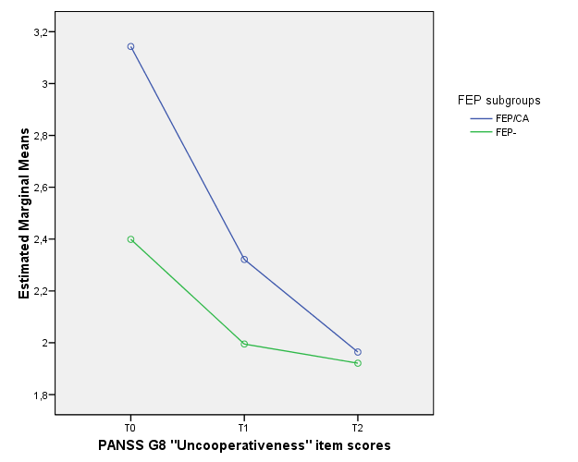

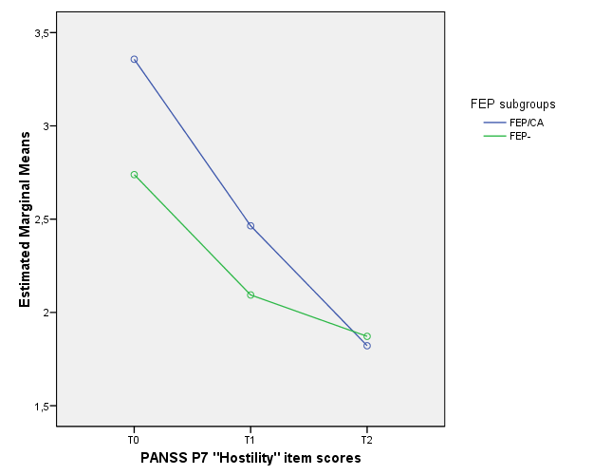

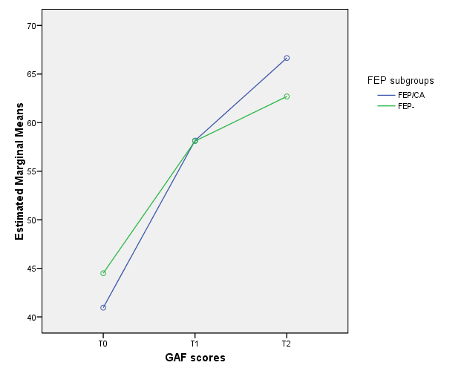

Note - ANOVA = analysis of variance; FEP/CA = First Episode Psychosis with baseline compulsory admission; FEP- = First Episode Psychosis without baseline compulsory admission; PANSS = Positive And Negative Syndrome Scale; GAF = Global Assessment of Functioning; T0 = baseline assessment; T1 = 1-year assessment time; T2 = 2-year assessment time.

