SUPPLEMENTARY INFORMATION

Supplementary Figure 2
Supplementary Figure 1: Flow chart summarizing the study cohort (n=291). 2
Supplementary Table 3
Supplementary Table 1: Percentage of missing data in each variable (n=291) 3

Supplementary Figure

Supplementary Figure 1: Flow chart summarizing the study cohort (n=291)

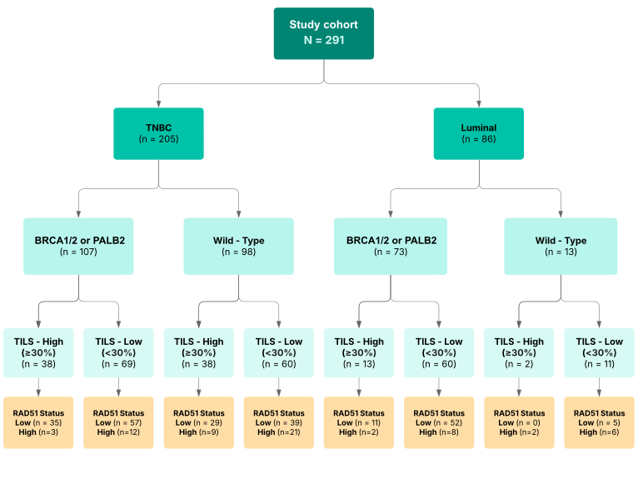
Supplementary Table

Supplementary Table 1: Percentage of missing data in each variable (n=291)

 | n | %
Age | 131 | 45.0
Stage | 51 | 17.5
Histological type | 175 | 60.1
Estrogen receptor status | 18 | 6.2
HER2 status | 0 | 0
Breast cancer subtype | 4 | 1.4
Germline HRR mutations | 0 | 0
RAD51 | 0 | 0
TILs | 23 | 7.9
Neoadjuvant treatment | 0 | 0
Adjuvant treatment | 0 | 0

