Supporting Information

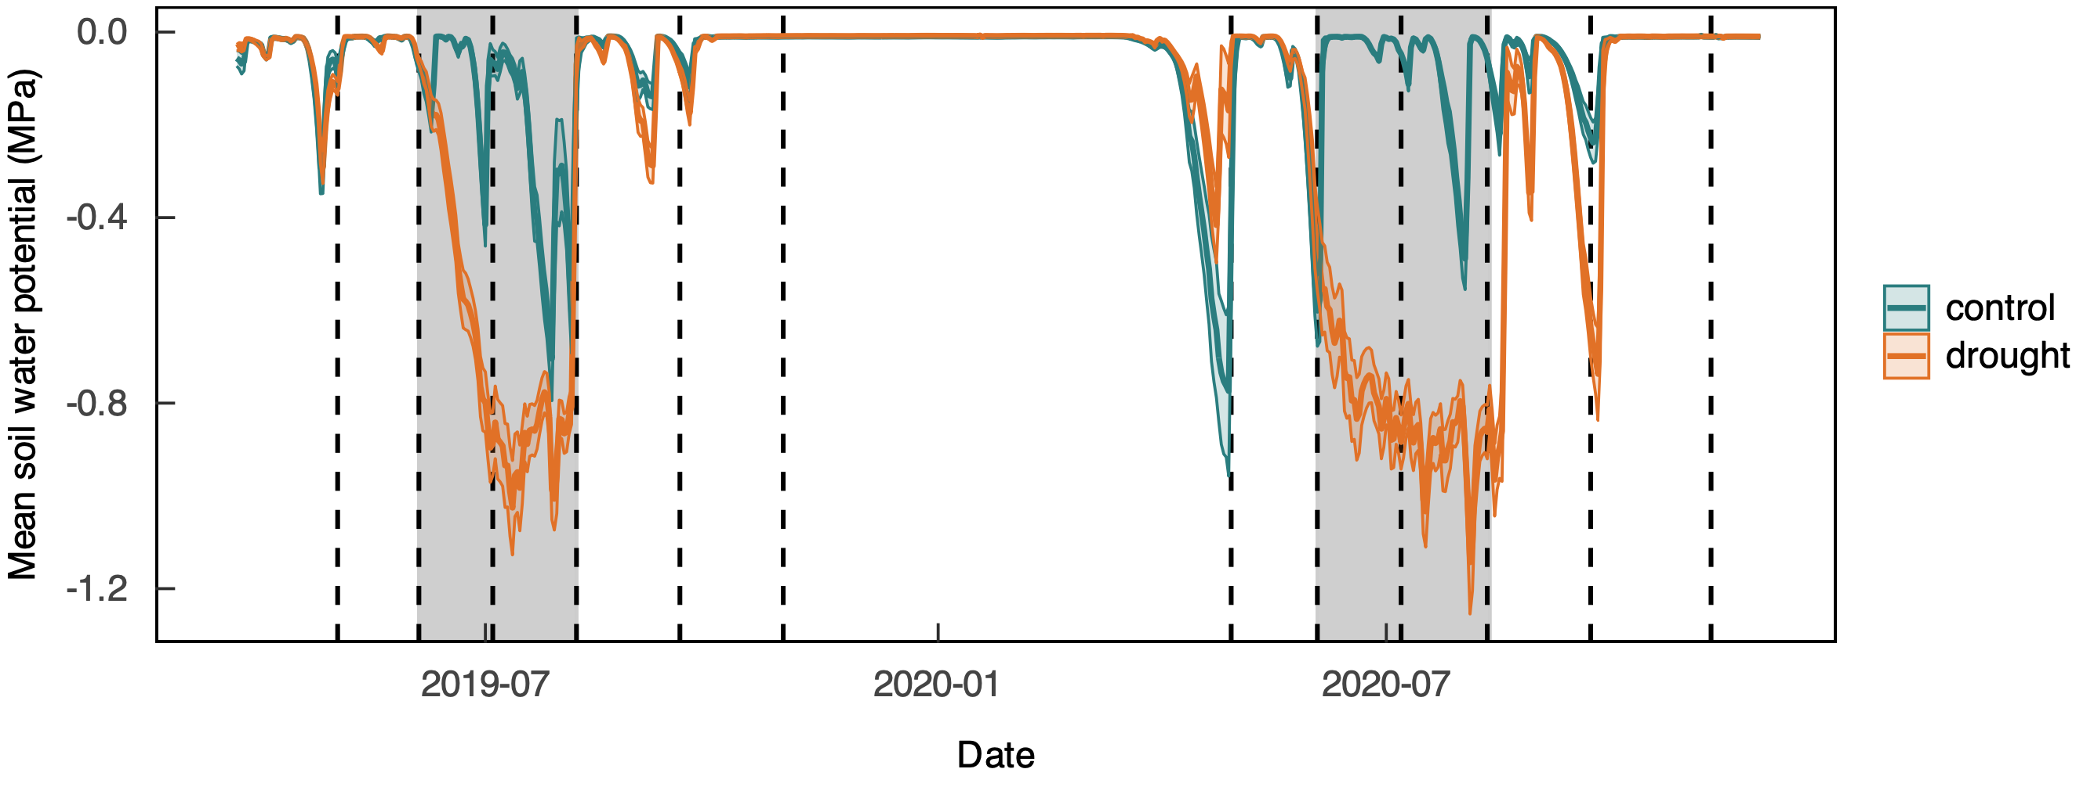
Figure S1 Soil water potentials (means ± SE, n = 5) measured in rainfed control subplots (blue) and experimentally drought-stressed subplots (orange) and over the growing seasons 2019 and 2020. Gray areas represent periods of experimental drought. The dotted lines indicate dates of harvests.

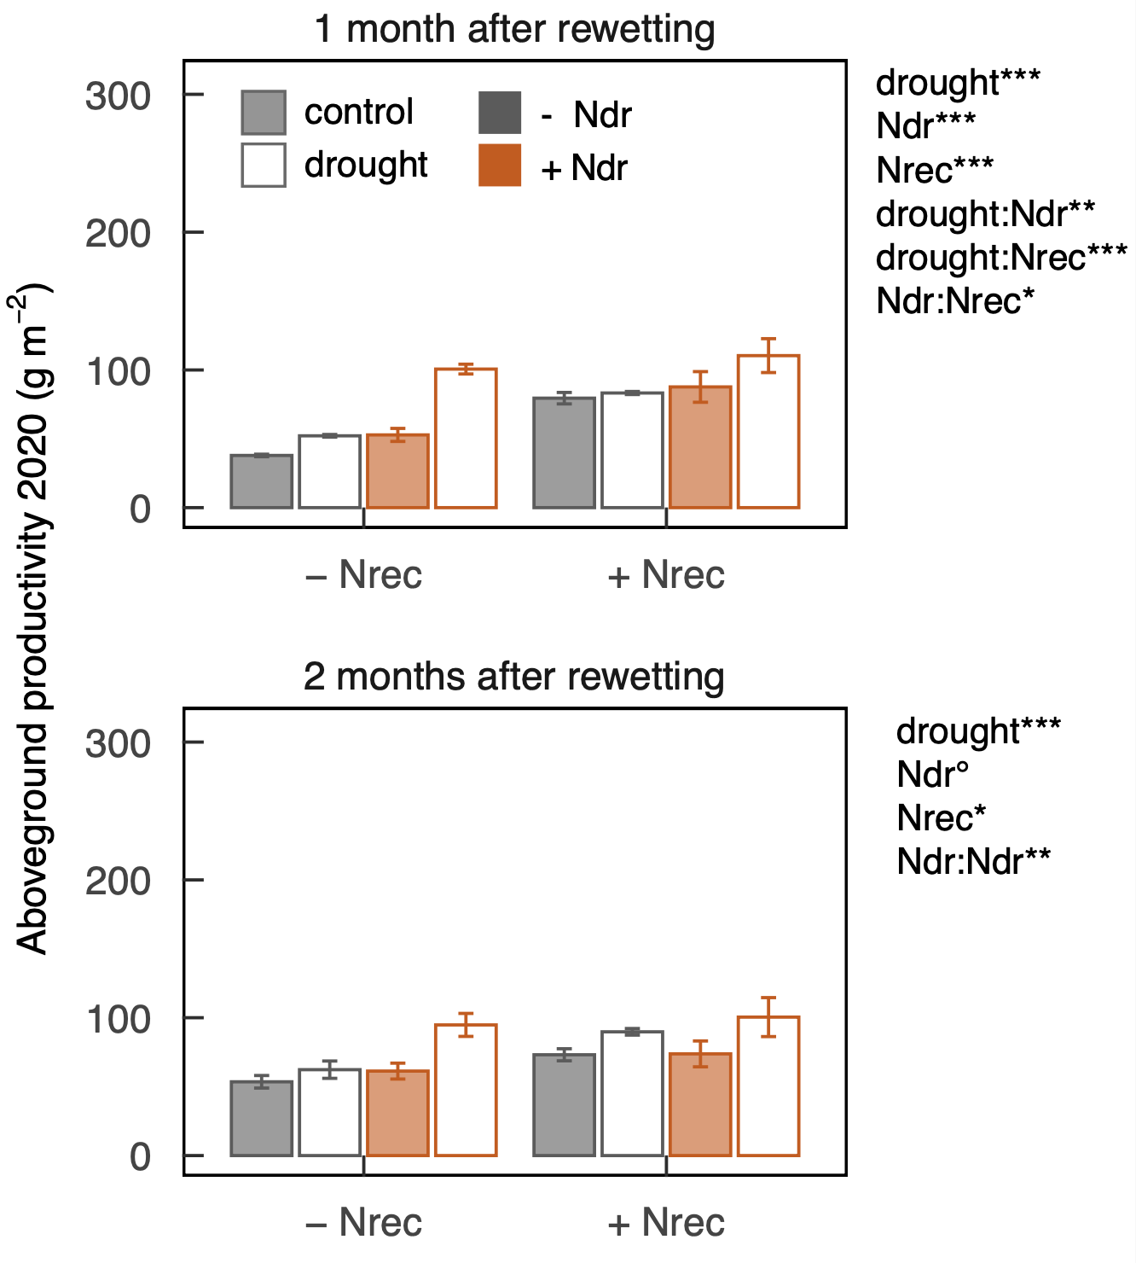
Figure S2 Aboveground productivity (means ± SE, n = 4) of rainfed control (filled bars) and formerly drought-stressed and rewetted subplots (empty bars) at the end of the 1st and the 2nd recovery regrowth 1 and 2 months after rewetting, respectively, measured in 2020. Plots priorly not N-fertilized during drought (- Ndr) and N-fertilized during drought (+ Ndr) are indicated in gray and orange, respectively. N-fertilization at the beginning of recovery is indicated along the x-axis with plots not N-fertilized (- Nrec) and plots N-fertilized (+ Nrec) upon rewetting. Due to better readability, only statistically significant treatment interactions are displayed (*P < 0.05, **P < 0.01, ***P < 0.001). For more statistical information see Table 1.
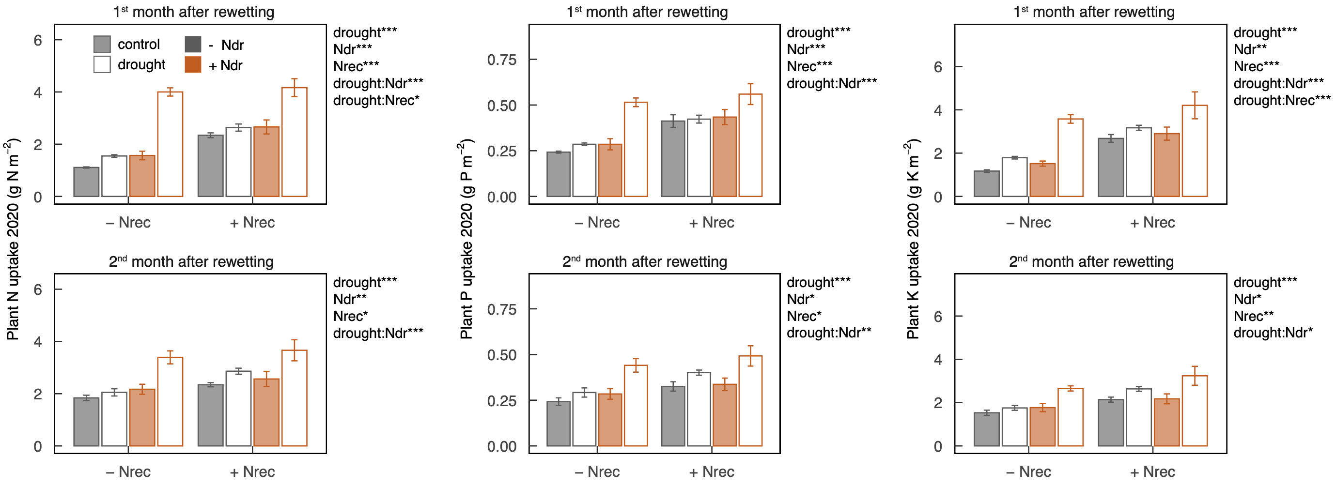
Figure S3 Plant N, P and K uptake (means ± SE, n = 4, in g N per m subplot area) in rainfed control (filled bars) and formerly drought-stressed and rewetted subplots (empty bars) during the 1st and 2nd month after rewetting in 2019. Plots priorly not N-fertilized during drought (- Ndr) and N-fertilized during drought (+ Ndr) are indicated in gray and orange, respectively. N-fertilization at the beginning of recovery is indicated along the x-axis with plots not N-fertilized (- Nrec) and plots N-fertilized (+ Nrec) upon rewetting. Due to better readability, only statistically significant treatment interactions are displayed (°P < 0.1, *P < 0.05, **P < 0.01, ***P < 0.001). For more statistical information see Table 1.

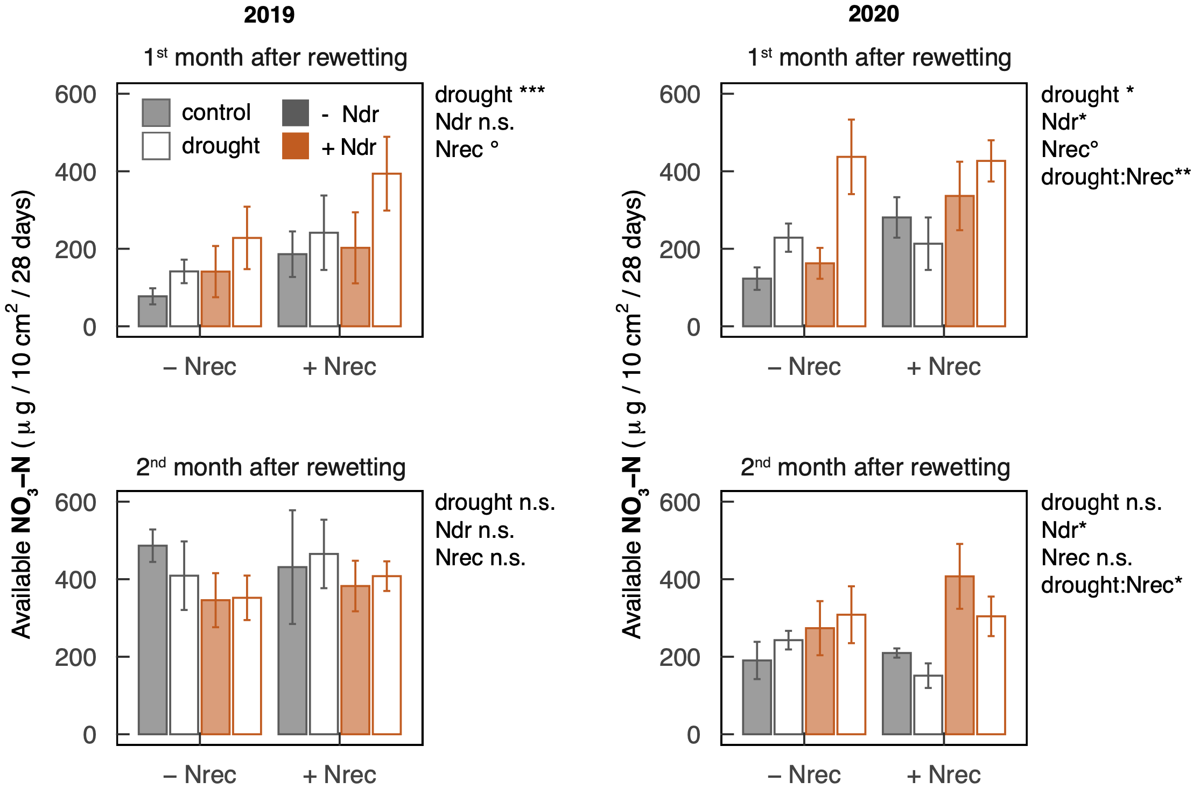
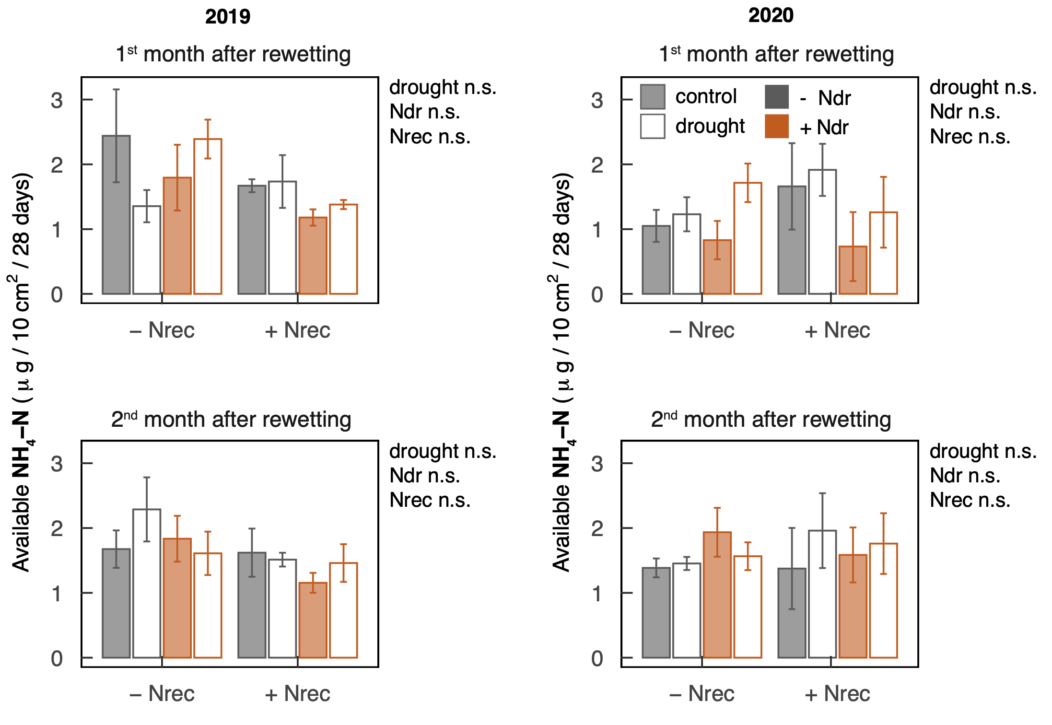
Figure S4 Availability of NO₃-N and NH₄-N (means ± SE, n = 4) in rainfed control (filled bars) and formerly drought-stressed and rewetted subplots (empty bars) during the 1st and the 2nd month after rewetting in 2019 and 2020. Nutrient availabilities were measured with plant root simulator (PRS) probes. Plots not N-fertilized during drought (- Ndr) and N-fertilized during drought (+ Ndr) are indicated in gray and orange, respectively. N-fertilization at the beginning of recovery is indicated along the x-axis with plots not N-fertilized (- Nrec) and plots N-fertilized (+ Nrec) upon rewetting. Due to better readability, only statistically significant treatment interactions are displayed (°P < 0.1, *P < 0.05, **P < 0.01, ***P < 0.001). For more statistical information see Table 1.

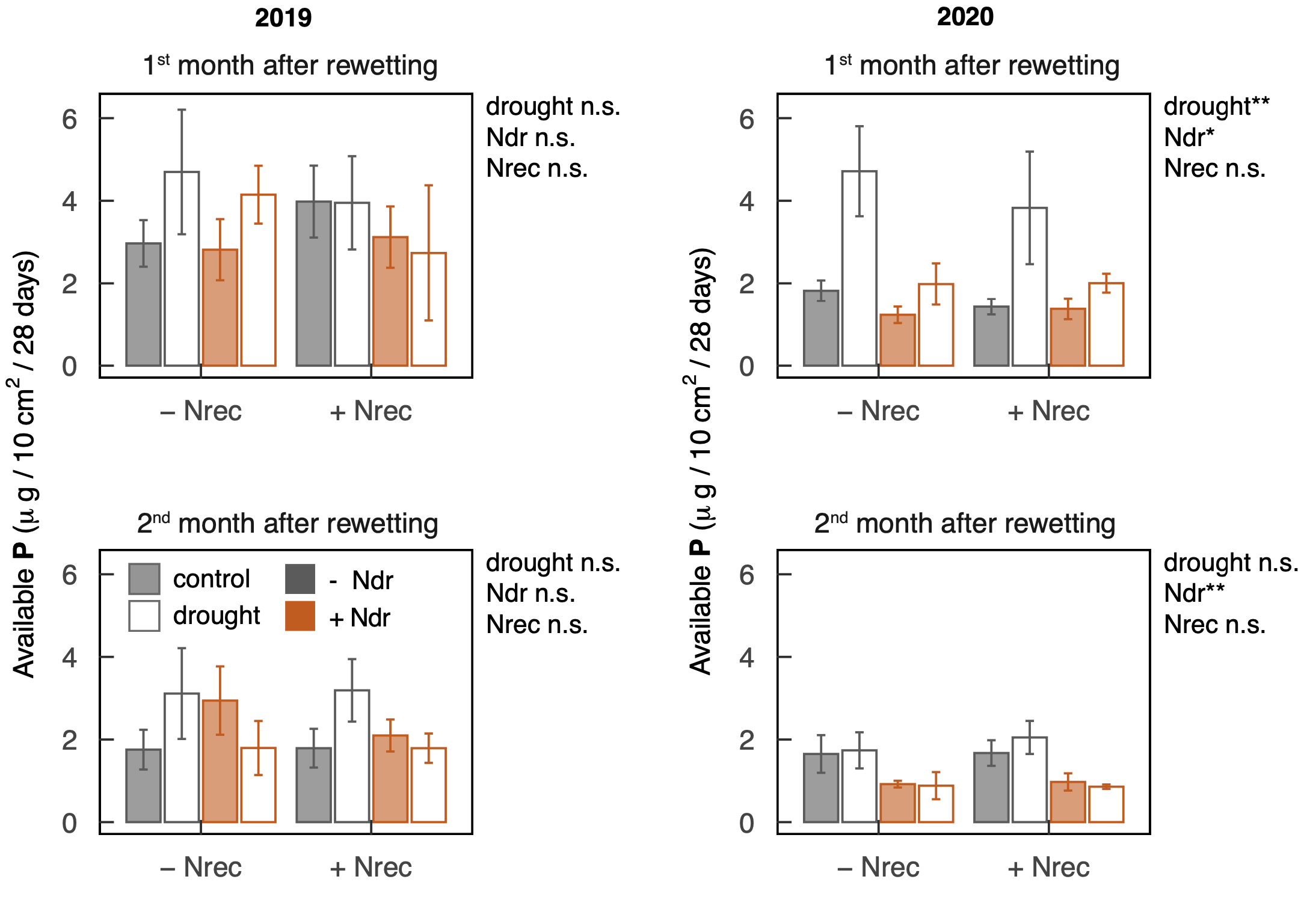
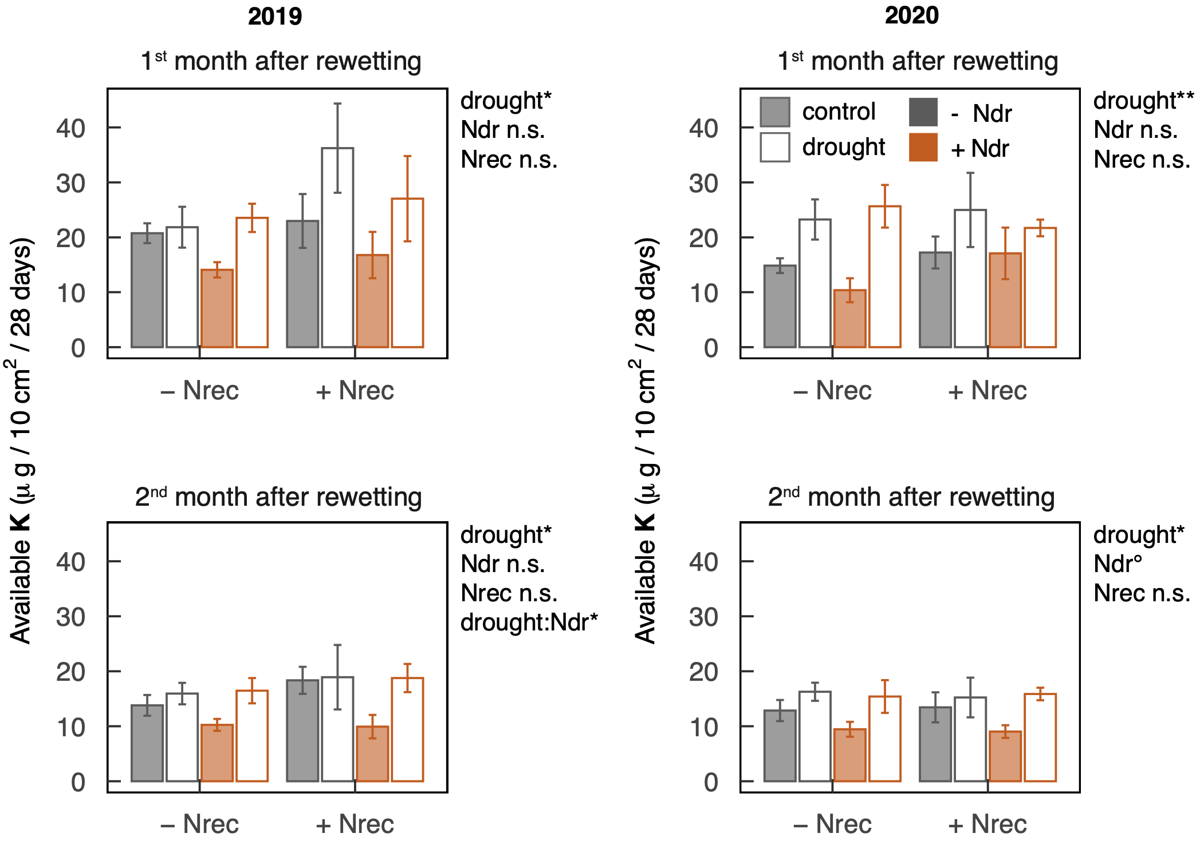
Figure S5 Availability of P and K (means ± SE, n = 4) in rainfed control (filled bars) and formerly drought-stressed and rewetted subplots (empty bars) during the 1st and the 2nd month after rewetting in 2019 and 2020. Nutrient availabilities were measured with plant root simulator (PRS) probes. Plots not N-fertilized during drought (- Ndr) and N-fertilized during drought (+ Ndr) are indicated in gray and orange, respectively. N-fertilization at the beginning of recovery is indicated along the x-axis with plots not N-fertilized (- Nrec) and plots N-fertilized (+ Nrec) upon rewetting. Due to better readability, only statistically significant treatment interactions are displayed (°P < 0.1, *P < 0.05, **P < 0.01, ***P < 0.001). For more statistical information see Table 1.
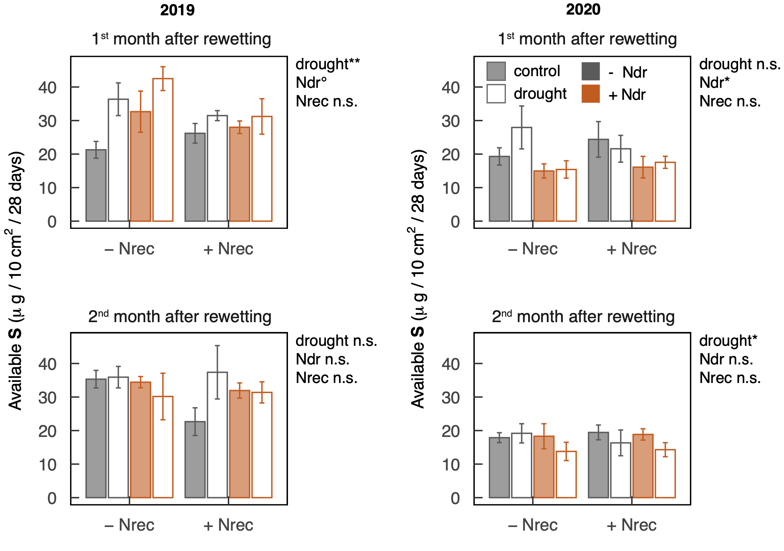

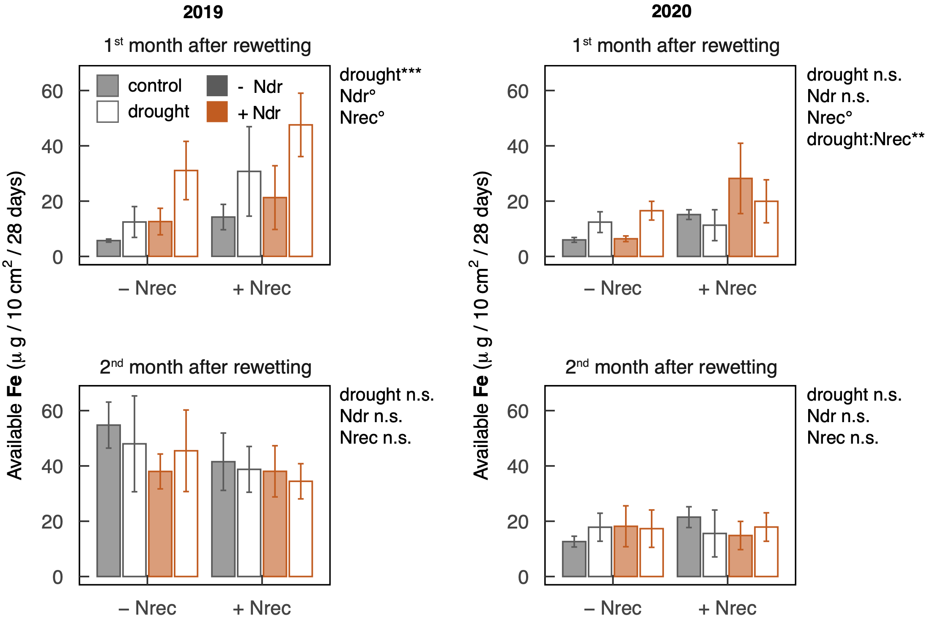

Figure S6 Availability of S and Fe (means ± SE, n = 4) in rainfed control (filled bars) and formerly drought-stressed and rewetted subplots (empty bars) during the 1st and the 2nd month after rewetting in 2019 and 2020. Nutrient availabilities were measured with plant root simulator (PRS) probes. Plots not N-fertilized during drought (- Ndr) and N-fertilized during drought (+ Ndr) are indicated in gray and orange, respectively. N-fertilization at the beginning of recovery is indicated along the x-axis with plots not N-fertilized (- Nrec) and plots N-fertilized (+ Nrec) upon rewetting. Due to better readability, only statistically significant treatment interactions are displayed (°P < 0.1, *P < 0.05, **P < 0.01, ***P < 0.001). For more statistical information see Table 1.
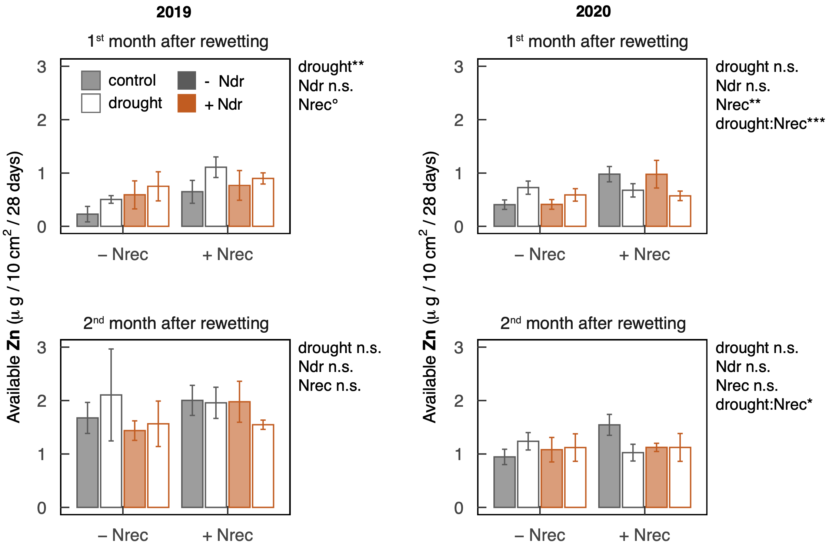

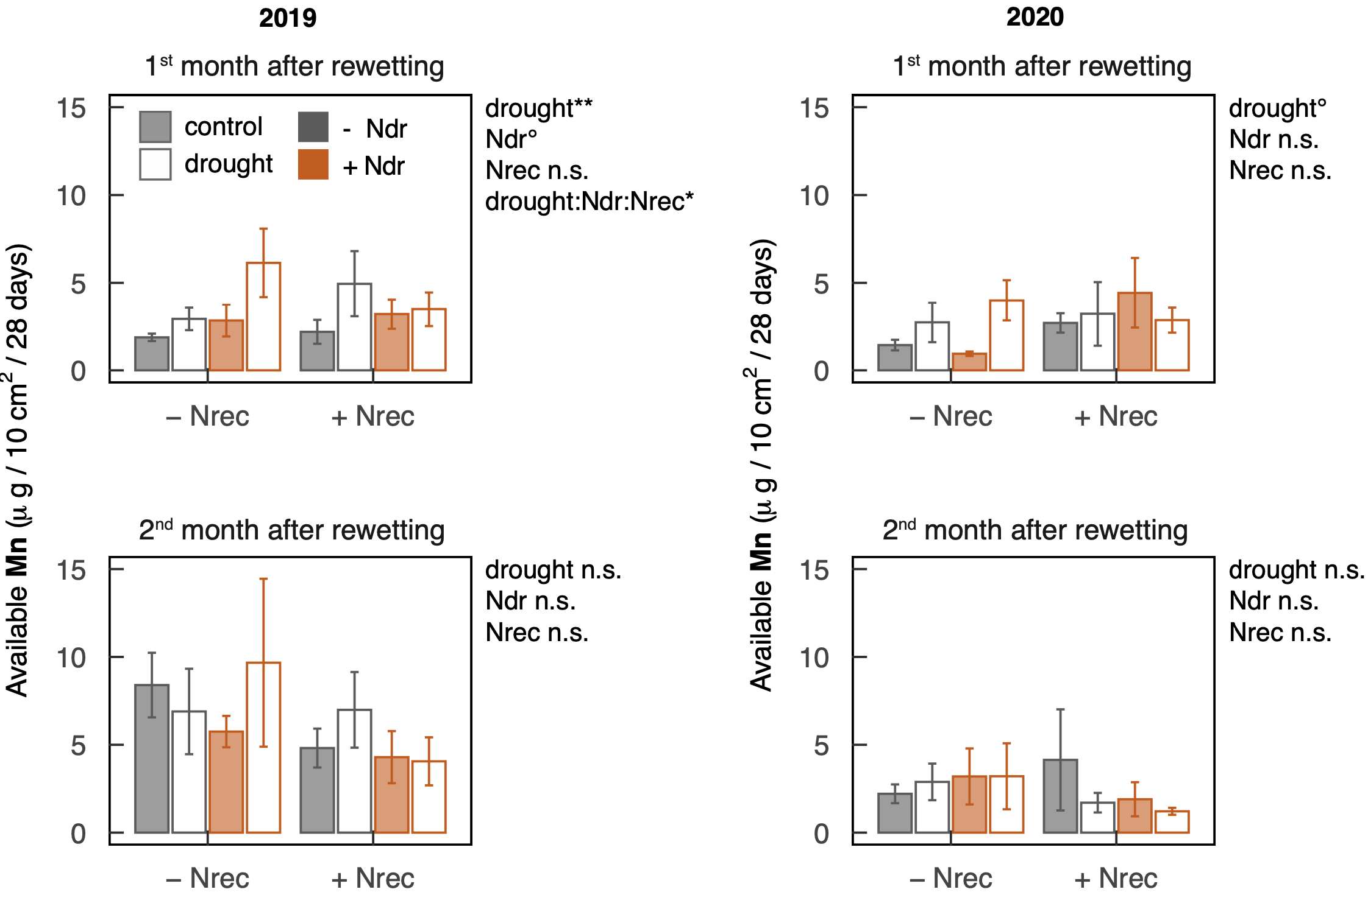
Figure S7 Availability of Zn and Mn (means ± SE, n = 4) in rainfed control (filled bars) and formerly drought-stressed and rewetted subplots (empty bars) during the 1st and the 2nd month after rewetting in 2019 and 2020. Nutrient availabilities were measured with plant root simulator (PRS) probes. Plots not N-fertilized during drought (- Ndr) and N-fertilized during drought (+ Ndr) are indicated in gray and orange, respectively. N-fertilization at the beginning of recovery is indicated along the x-axis with plots not N-fertilized (- Nrec) and plots N-fertilized (+ Nrec) upon rewetting. Due to better readability, only statistically significant treatment interactions are displayed (°P < 0.1, *P < 0.05, **P < 0.01, ***P < 0.001). For more statistical information see Table 1.
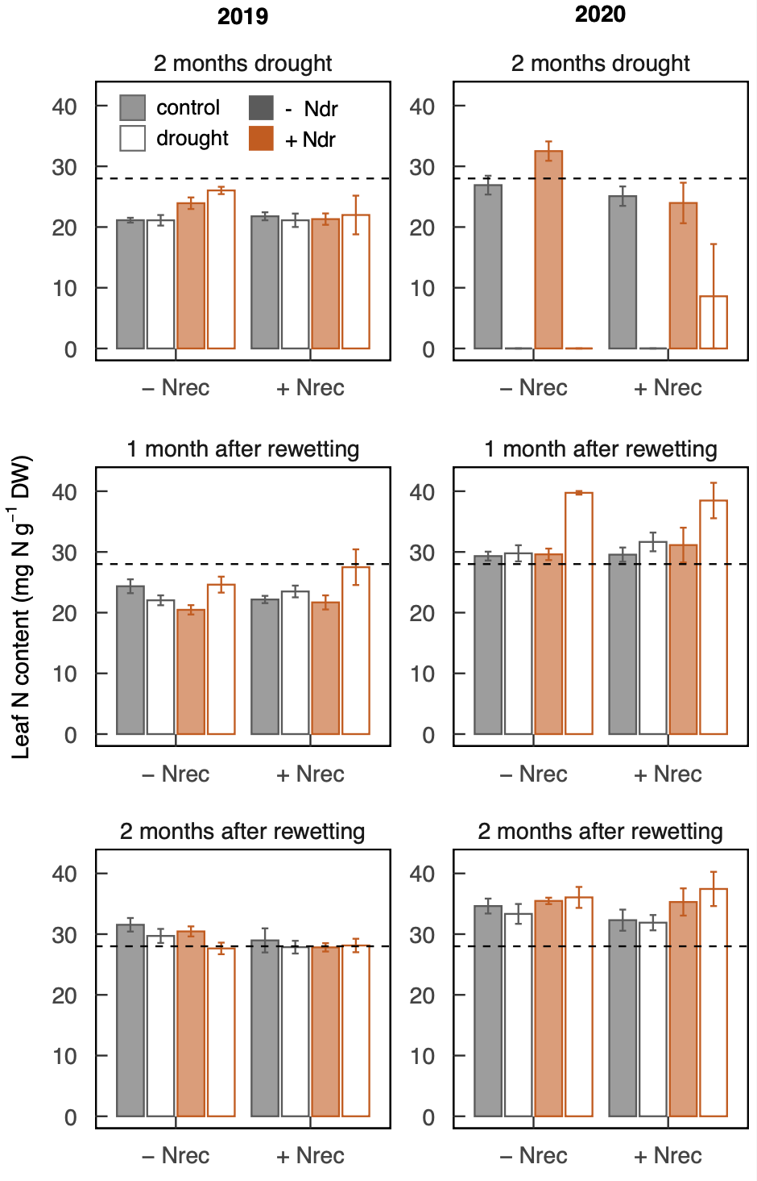
Figure S8 Leaf N contents (means ± SE, n = 4) in rainfed control (filled bars) and formerly drought-stressed and rewetted swards (empty bars) after 2 months experimental drought, and 1 and 2 months after rewetting in 2019 and 2020. Plots not N-fertilized during drought (- Ndr) and N-fertilized during drought (+ Ndr) are indicated in gray and orange, respectively. N-fertilization at the beginning of recovery is indicated along the x-axis with plots not N-fertilized (- Nrec) and plots N-fertilized (+ Nrec) upon rewetting. The dotted line represents the critical leaf N content under which perennial ryegrass is limited in growth, as proposed by Moll et al. (1982).

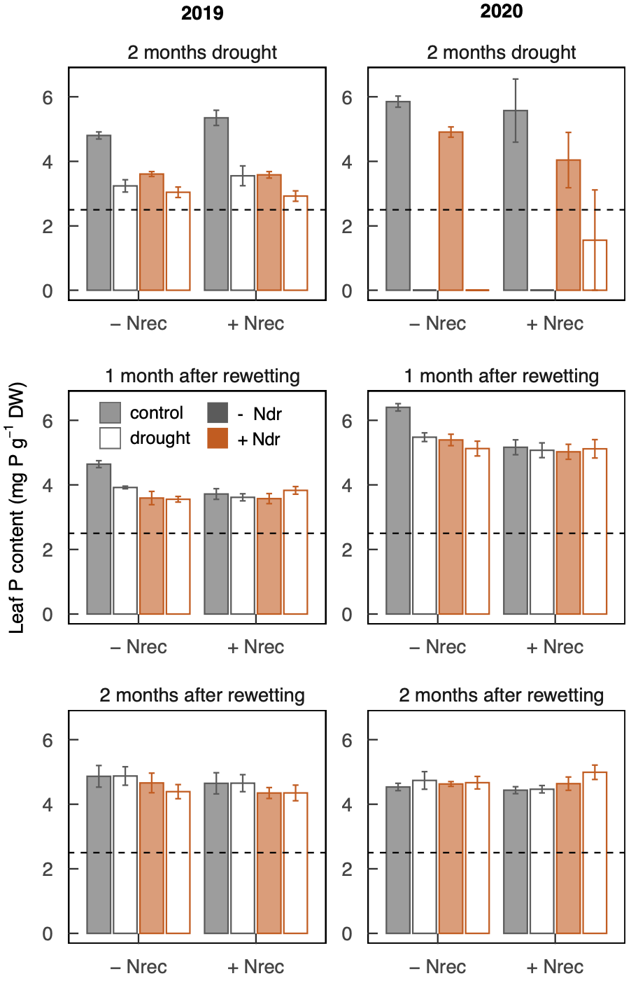
Figure S9 Leaf P contents (means ± SE, n = 4) in rainfed control (filled bars) and formerly drought-stressed and rewetted swards (empty bars) after 2 months experimental drought, and 1 and 2 months after rewetting in 2019 and 2020. Plots not N-fertilized during drought (- Ndr) and N-fertilized during drought (+ Ndr) are indicated in gray and orange, respectively. N-fertilization at the beginning of recovery is indicated along the x-axis with plots not N-fertilized (- Nrec) and plots N-fertilized (+ Nrec) upon rewetting. The dotted line represents the critical leaf P content under which perennial ryegrass is limited in growth, as proposed by Moll et al. (1982).

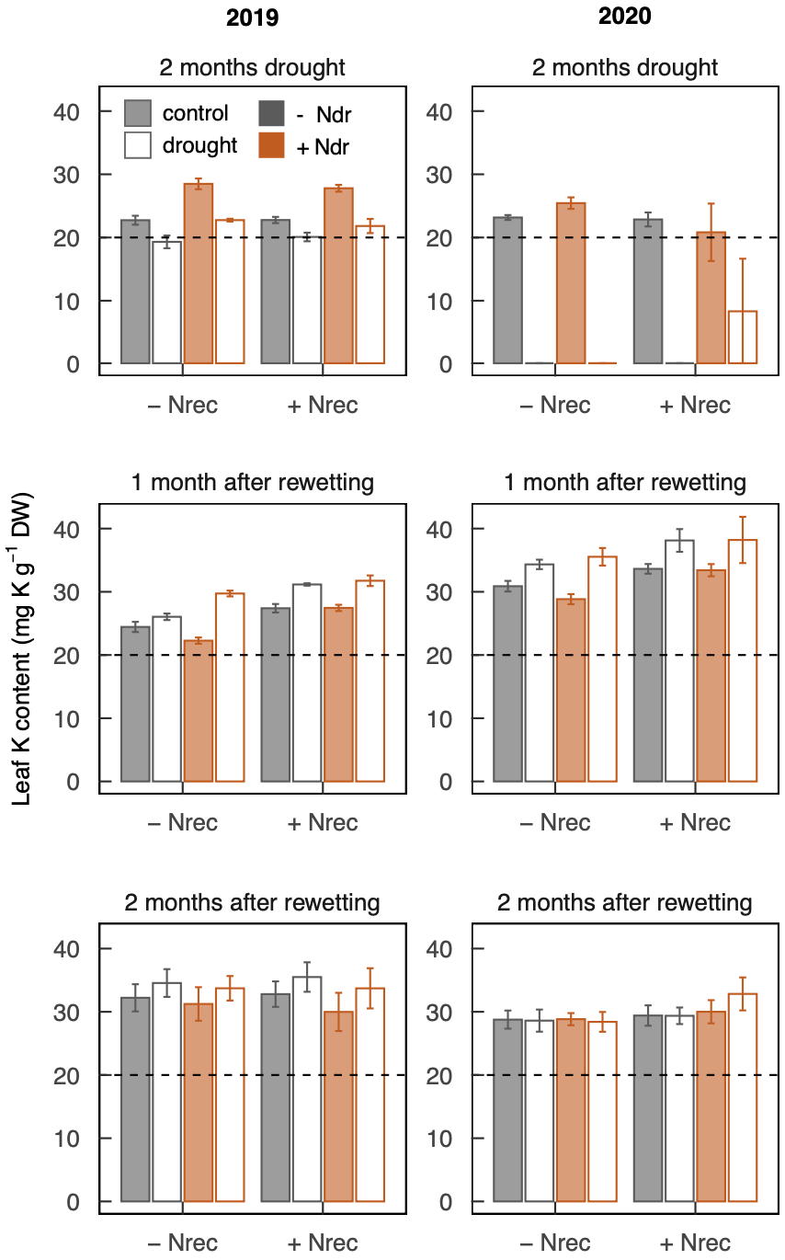
Figure S10 Leaf K contents (means ± SE, n = 4) in rainfed control (filled bars) and formerly drought-stressed and rewetted swards (empty bars) after 2 months experimental drought, and 1 and 2 months after rewetting in 2019 and 2020. Plots not N-fertilized during drought (- Ndr) and N-fertilized during drought (+ Ndr) are indicated in gray and orange, respectively. N-fertilization at the beginning of recovery is indicated along the x-axis with plots not N-fertilized (- Nrec) and plots N-fertilized (+ Nrec) upon rewetting. The dotted line represents the critical leaf K content under which perennial ryegrass is limited in growth, as proposed by Moll et al. (1982).

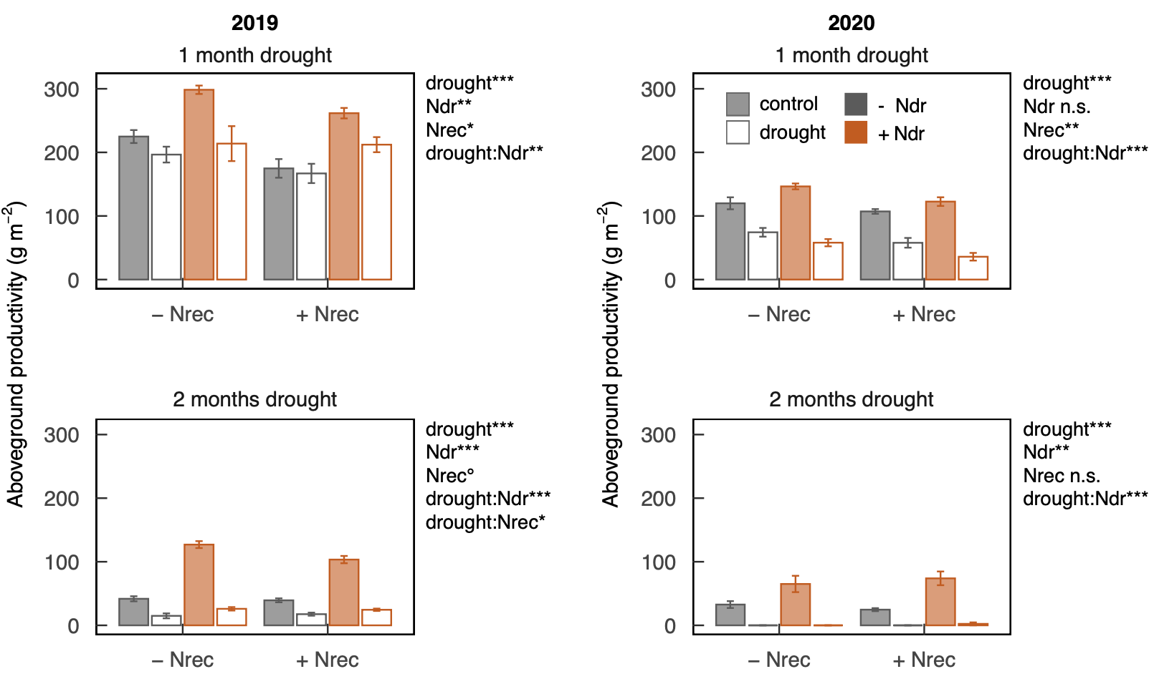
Figure S11 Aboveground productivity (means ± SE, n = 4) in rainfed control (filled bars) and formerly drought-stressed and rewetted swards (empty bars) after 1 and 2 months of experimental drought in 2019 and 2020. Plots not N-fertilized during drought (- Ndr) and N-fertilized during drought (+ Ndr) are indicated in gray and orange, respectively. N-fertilization at the beginning of recovery is indicated along the x-axis with plots not N-fertilized (- Nrec) and plots N-fertilized (+ Nrec) upon rewetting. Due to better readability, only statistically significant treatment interactions are displayed (°P < 0.1, *P < 0.05, **P < 0.01, ***P < 0.001). For more statistical information see Table 1.

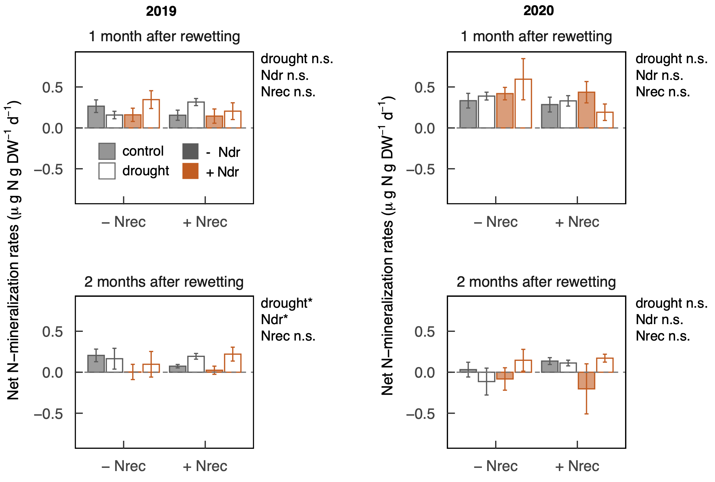

Figure S12 Net N mineralization rates (means ± SE, n = 4) in rainfed control (filled bars) and formerly drought-stressed and rewetted swards (empty bars) 1 and 2 months after rewetting in 2019 and 2020. Plots not N-fertilized during drought (- Ndr) and N-fertilized during drought (+ Ndr) are indicated in gray and orange, respectively. N-fertilization at the beginning of recovery is indicated along the x-axis with plots not N-fertilized (- Nrec) and plots N-fertilized (+ Nrec) upon rewetting. **P < 0.01. For more statistical information see Table 1.

Supplementary Tables

Table S1 Field harvests and N-fertilization doses applied in 2019 and 2020 during the period before experimental drought (‘pre-drought’), during experimental drought (orange), and during post-drought recovery (blue). N-fertilization doses are given for the factorial treatments N-fertilization during drought (with the levels not N-fertilized (-Ndr) and Nfertilized during drought (+ Ndr)), as well as N-fertilization at the beginning of recovery (with the levels not N-fertilized (-Nrec) and N-fertilized at the beginning of recovery (+Nrec)). Values of N-fertilization doses are given in kg ammonium nitrate (27% N) per hectare. The dates on which plots were harvested right before applying the respective N-fertilization treatment are indicated by an ‘X’. The experimental drought period in 2019 and 2020 started immediately after the harvests and N-fertilization additions in June and lasted until the harvests in August.
 | Year |  | Pre-drought |  |  |  | Experimental drought |  | Post-drought Recovery
N-fertilization dates | 2019 |  | 05.03.19 | 09.04.19 | 02.05.19 | 04.06.19 | 04.07.19 | 07.08.19 | 18.09.19 | 30.10.19
 | 2020 |  | 24.02.20 | 09.04.20 | 29.04.20 | 03.06.20 | 07.07.20 | 11.08.20 | 22.09.20 | 10.11.20
Harvests |  |  |  |  | X | X | X | X | X | X
N-fertilization treatment | +Ndr | +Nrec | 20 | 35 | 35 | 35 | 35 | 50 | 30 | 0
N-fertilization treatment |  | -Nrec | 20 | 47.5 | 47.5 | 47.5 | 47.5 | 0 | 30 | 0
N-fertilization treatment | -Ndr | +Nrec | 20 | 70 | 70 | 0 | 0 | 50 | 30 | 0
N-fertilization treatment |  | -Nrec | 20 | 95 | 95 | 0 | 0 | 0 | 30 | 0

Table S2 Dates of PRS® installation, replacement and deinstallation in the growing seasons 2019 and 2020 and during the 1st month and the 2nd month after drying and rewetting (DRW).
Year | Period | Installation date | Replacement date | Deinstallation date
2019 | 1st month after DRW | 20.08.2019 | 03.09.2019 | 22.10.2019
 | 2nd month after DRW | 24.09.2019 | 08.10.2019 | 22.10.2019
2020 | 1st month after DRW | 24.08.2020 | 07.09.2020 | 21.09.2020
 | 2nd month after DRW | 12.10.2020 | 26.10.2020 | 09.11.2020

Table S3 Enzymes related to the N-, C- and P-cycle and their substrates used to determine potential enzyme activities (adapted from Canarini et al. (2021)).
Cycle | Enzyme | Substrate | Enzyme function
N-cycle & C-cycle | Leucine (‘Leu’)-Aminopeptidase | 4-Methylumbelliferyl β-D-glucopyranoside | Degrades peptides
 | Exochitinase (N-acetyl-β-glucosaminidase) | 4-Methylumbelliferyl N-acetyl-β-D-glucosaminide | Releases glucosamine from chitin
C-cycle only | β-Glucosidase | L-Leucine-7-amido-4-methylcoumarin | Releases glucose from cellulose and other b-glucans
P-cycle | Phosphatase (Acid Phosphatase) | 4-Methylumbelliferyl phosphate | Releases inorganic P from organic P

Table S4 Summary of the linear mixed effects models for the effects experimental drought, N-fertilization during drought (Ndr) and N-fertilization at the beginning of recovery (Nrec) on the aboveground productivity of perennial ryegrass 1 and 2 months after rewetting in 2019 and 2020. °P < 0.1, *P < 0.05, **P < 0.01, ***P < 0.001.
Variable | Regrowth | Year | Factor | numDF | denDF | F-value | P-Value |  | R²m | R²c
Aboveground productivity | 1 month drought | 2019 | drought | 1 | 11 | 28.50 | < 0.001 | *** | 0.64 | 0.84
Aboveground productivity | 1 month drought |  | Ndr | 1 | 9 | 19.63 | 0.002 | **
Aboveground productivity |  |  | Nrec | 1 | 9 | 5.57 | 0.043 | *
 |  |  | drought:Ndr | 1 | 11 | 11.09 | 0.007 | **
 |  |  | drought:Nrec | 1 | 11 | 4.24 | 0.064 | °
 |  |  | Ndr:Nrec | 1 | 9 | 0.48 | 0.504
 |  |  | drought:Ndr:Nrec | 1 | 11 | 0.55 | 0.474
 |  | 2020 | drought | 1 | 12 | 222.59 | < 0.001 | *** | 0.89 | 0.91
 |  |  | Ndr | 1 | 9 | 0.05 | 0.834
 |  |  | Nrec | 1 | 9 | 18.97 | 0.002 | **
 |  |  | drought:Ndr | 1 | 12 | 19.66 | < 0.001 | ***
 |  |  | drought:Nrec | 1 | 12 | 0.01 | 0.918
 |  |  | Ndr:Nrec | 1 | 9 | 0.93 | 0.359
 |  |  | drought:Ndr:Nrec | 1 | 12 | 0.09 | 0.765
 | 2 months drought | 2019 | drought | 1 | 12 | 518.62 | < 0.001 | *** | 0.96 | 0.98
 | 2 months drought |  | Ndr | 1 | 9 | 203.33 | < 0.001 | ***
 |  |  | Nrec | 1 | 9 | 4.48 | 0.063 | °
 |  |  | drought:Ndr | 1 | 12 | 171.17 | < 0.001 | ***
 |  |  | drought:Nrec | 1 | 12 | 7.31 | 0.019 | *
 |  |  | Ndr:Nrec | 1 | 9 | 4.65 | 0.060 | °
 |  |  | drought:Ndr:Nrec | 1 | 12 | 2.86 | 0.117
 |  | 2020 | drought | 1 | 12 | 138.34 | < 0.001 | *** | 0.84 | 0.87
 |  |  | Ndr | 1 | 9 | 20.12 | 0.002 | **
 |  |  | Nrec | 1 | 9 | 0.03 | 0.870
 |  |  | drought:Ndr | 1 | 12 | 23.09 | < 0.001 | ***
 |  |  | drought:Nrec | 1 | 12 | 0.01 | 0.930
 |  |  | Ndr:Nrec | 1 | 9 | 1.05 | 0.333
 |  |  | drought:Ndr:Nrec | 1 | 12 | 0.77 | 0.397
 | 1 month after rewetting | 2019 | drought | 1 | 12 | 77.75 | < 0.001 | *** | 0.88 | 0.94
 | 1 month after rewetting |  | Ndr | 1 | 9 | 39.41 | < 0.001 | ***
 |  |  | Nrec | 1 | 9 | 81.14 | < 0.001 | ***
 |  |  | drought:Ndr | 1 | 12 | 38.90 | < 0.001 | ***
 |  |  | drought:Nrec | 1 | 12 | 2.90 | 0.114
 |  |  | Ndr:Nrec | 1 | 9 | 2.16 | 0.176
 |  |  | drought:Ndr:Nrec | 1 | 12 | 0.05 | 0.827
 |  | 2020 | drought | 1 | 12 | 99.98 | < 0.001 | *** | 0.84 | 0.95
 |  |  | Ndr | 1 | 9 | 24.00 | < 0.001 | ***
 |  |  | Nrec | 1 | 9 | 43.82 | < 0.001 | ***
 |  |  | drought:Ndr | 1 | 12 | 17.13 | 0.001 | **
 |  |  | drought:Nrec | 1 | 12 | 29.84 | < 0.001 | ***
 |  |  | Ndr:Nrec | 1 | 9 | 5.73 | 0.040 | *
 |  |  | drought:Ndr:Nrec | 1 | 12 | 1.39 | 0.261
 | 2 months after rewetting | 2019 | drought | 1 | 12 | 43.81 | < 0.001 | *** | 0.85 | 0.88
 | 2 months after rewetting |  | Ndr | 1 | 9 | 43.73 | < 0.001 | ***
 |  |  | Nrec | 1 | 9 | 131.12 | < 0.001 | ***
 |  |  | drought:Ndr | 1 | 12 | 2.32 | 0.154
 |  |  | drought:Nrec | 1 | 12 | 0.43 | 0.525
 |  |  | Ndr:Nrec | 1 | 9 | 7.25 | 0.025 | *
 |  |  | drought:Ndr:Nrec | 1 | 12 | 2.04 | 0.179
 |  | 2020 | drought | 1 | 12 | 81.62 | < 0.001 | *** | 0.53 | 0.91
 |  |  | Ndr | 1 | 9 | 3.68 | 0.087 | °
 |  |  | Nrec | 1 | 9 | 5.90 | 0.038 | *
 |  |  | drought:Ndr | 1 | 12 | 13.42 | 0.003 | **
 |  |  | drought:Nrec | 1 | 12 | 0.01 | 0.914
 |  |  | Ndr:Nrec | 1 | 9 | 1.16 | 0.309
 |  |  | drought:Ndr:Nrec | 1 | 12 | 2.40 | 0.147

Table S5 Summary of the linear mixed effects models for the effects experimental drought, N-fertilization during drought (Ndr) and N-fertilization at the beginning of recovery (Nrec) on N, P, and K uptake of perennial ryegrass in the 1st and the 2nd month after rewetting in 2019 and 2020. °P < 0.1, *P < 0.05, **P < 0.01, ***P < 0.001.
Variable | Regrowth | Year | Factor | numDF | denDF | F-value | P-Value |  | R²m | R²c
Plant N uptake | 1st month after rewetting | 2019 | drought | 1 | 12 | 107.16 | < 0.001 | *** | 0.90 | 0.94
 | 1st month after rewetting |  | Ndr | 1 | 9 | 75.99 | < 0.001 | ***
 |  |  | Nrec | 1 | 9 | 135.48 | < 0.001 | ***
 |  |  | drought:Ndr | 1 | 12 | 61.92 | < 0.001 | ***
 |  |  | drought:Nrec | 1 | 12 | 0.01 | 0.914
 |  |  | Ndr:Nrec | 1 | 9 | 0.67 | 0.435
 |  |  | drought:Ndr:Nrec | 1 | 12 | 0.24 | 0.631
 |  | 2020 | drought | 1 | 12 | 149.58 | < 0.001 | *** | 0.89 | 0.94
 |  |  | Ndr | 1 | 9 | 66.14 | < 0.001 | ***
 |  |  | Nrec | 1 | 9 | 37.43 | < 0.001 | ***
 |  |  | drought:Ndr | 1 | 12 | 70.28 | < 0.001 | ***
 |  |  | drought:Nrec | 1 | 12 | 7.89 | 0.016 | *
 |  |  | Ndr:Nrec | 1 | 9 | 3.30 | 0.103
 |  |  | drought:Ndr:Nrec | 1 | 12 | 4.19 | 0.063 | °
 | 2nd month after rewetting | 2019 | drought | 1 | 12 | 29.78 | < 0.001 | ***
 | 2nd month after rewetting |  | Ndr | 1 | 9 | 18.83 | 0.002 | **
 |  |  | Nrec | 1 | 9 | 55.92 | < 0.001 | ***
 |  |  | drought:Ndr | 1 | 12 | 2.01 | 0.181
 |  |  | drought:Nrec | 1 | 12 | 0.00 | 0.990
 |  |  | Ndr:Nrec | 1 | 9 | 2.63 | 0.139
 |  |  | drought:Ndr:Nrec | 1 | 12 | 0.60 | 0.454
 |  | 2020 | drought | 1 | 12 | 83.88 | < 0.001 | *** | 0.66 | 0.91
 |  |  | Ndr | 1 | 9 | 11.67 | 0.008 | **
 |  |  | Nrec | 1 | 9 | 6.31 | 0.033 | *
 |  |  | drought:Ndr | 1 | 12 | 22.83 | < 0.001 | ***
 |  |  | drought:Nrec | 1 | 12 | 0.30 | 0.591
 |  |  | Ndr:Nrec | 1 | 9 | 0.69 | 0.429
 |  |  | drought:Ndr:Nrec | 1 | 12 | 1.65 | 0.223
Plant P uptake | 1st month after rewetting | 2019 | drought | 1 | 12 | 63.87 | < 0.001 | *** | 0.89 | 0.93
 | 1st month after rewetting |  | Ndr | 1 | 9 | 94.29 | < 0.001 | ***
 |  |  | Nrec | 1 | 9 | 210.08 | < 0.001 | ***
 |  |  | drought:Ndr | 1 | 12 | 39.56 | < 0.001 | ***
 |  |  | drought:Nrec | 1 | 12 | 0.51 | 0.490
 |  |  | Ndr:Nrec | 1 | 9 | 1.54 | 0.246
 |  |  | drought:Ndr:Nrec | 1 | 12 | 0.15 | 0.701
 |  | 2020 | drought | 1 | 12 | 36.27 | < 0.001 | *** | 0.74 | 0.86
 |  |  | Ndr | 1 | 9 | 23.70 | < 0.001 | ***
 |  |  | Nrec | 1 | 9 | 31.98 | < 0.001 | ***
 |  |  | drought:Ndr | 1 | 12 | 19.73 | < 0.001 | ***
 |  |  | drought:Nrec | 1 | 12 | 4.06 | 0.067 | °
 |  |  | Ndr:Nrec | 1 | 9 | 1.64 | 0.232
 |  |  | drought:Ndr:Nrec | 1 | 12 | 1.12 | 0.311
 | 2nd month after rewetting | 2019 | drought | 1 | 12 | 48.17 | < 0.001 | *** | 0.66 | 0.84
 | 2nd month after rewetting |  | Ndr | 1 | 9 | 3.60 | 0.090 | °
 |  |  | Nrec | 1 | 9 | 23.39 | < 0.001 | ***
 |  |  | drought:Ndr | 1 | 12 | 1.46 | 0.250
 |  |  | drought:Nrec | 1 | 12 | 0.32 | 0.581
 |  |  | Ndr:Nrec | 1 | 9 | 2.06 | 0.185
 |  |  | drought:Ndr:Nrec | 1 | 12 | 1.81 | 0.203
 |  | 2020 | drought | 1 | 12 | 80.33 | < 0.001 | *** | 0.61 | 0.89
 |  |  | Ndr | 1 | 9 | 6.84 | 0.028 | *
 |  |  | Nrec | 1 | 9 | 6.97 | 0.027 | *
 |  |  | drought:Ndr | 1 | 12 | 14.67 | 0.002 | **
 |  |  | drought:Nrec | 1 | 12 | 0.25 | 0.623
 |  |  | Ndr:Nrec | 1 | 9 | 0.61 | 0.456
 |  |  | drought:Ndr:Nrec | 1 | 12 | 0.30 | 0.592

Table S5 continued from previous page.
Variable | Regrowth | Year | Factor | numDF | denDF | F-value | P-Value |  | R²m | R²c
Plant K uptake | 1st month after rewetting | 2019 | drought | 1 | 12 | 121.52 | < 0.001 | *** | 0.89 | 0.94
 | 1st month after rewetting |  | Ndr | 1 | 9 | 37.32 | < 0.001 | ***
 |  |  | Nrec | 1 | 9 | 87.44 | < 0.001 | ***
 |  |  | drought:Ndr | 1 | 12 | 50.38 | < 0.001 | ***
 |  |  | drought:Nrec | 1 | 12 | 0.23 | 0.643
 |  |  | Ndr:Nrec | 1 | 9 | 1.18 | 0.306
 |  |  | drought:Ndr:Nrec | 1 | 12 | 0.37 | 0.556
 |  | 2020 | drought | 1 | 11 | 242.34 | < 0.001 | *** | 0.90 | 0.98
 |  |  | Ndr | 1 | 8 | 18.58 | 0.003 | **
 |  |  | Nrec | 1 | 8 | 65.90 | < 0.001 | ***
 |  |  | drought:Ndr | 1 | 11 | 42.41 | < 0.001 | ***
 |  |  | drought:Nrec | 1 | 11 | 22.22 | < 0.001 | ***
 |  |  | Ndr:Nrec | 1 | 8 | 3.95 | 0.082 | °
 |  |  | drought:Ndr:Nrec | 1 | 11 | 0.61 | 0.452
 | 2nd month after rewetting | 2019 | drought | 1 | 11 | 133.44 | < 0.001 | *** | 0.70 | 0.92
 | 2nd month after rewetting |  | Ndr | 1 | 9 | 2.82 | 0.127
 |  |  | Nrec | 1 | 9 | 21.80 | 0.001 | **
 |  |  | drought:Ndr | 1 | 11 | 8.96 | 0.012 | *
 |  |  | drought:Nrec | 1 | 11 | 0.29 | 0.604
 |  |  | Ndr:Nrec | 1 | 9 | 3.89 | 0.080 | °
 |  |  | drought:Ndr:Nrec | 1 | 11 | 1.34 | 0.271
 |  | 2020 | drought | 1 | 12 | 32.54 | < 0.001 | *** | 0.63 | 0.77
 |  |  | Ndr | 1 | 9 | 8.28 | 0.018 | *
 |  |  | Nrec | 1 | 9 | 15.97 | 0.003 | **
 |  |  | drought:Ndr | 1 | 12 | 6.92 | 0.022 | *
 |  |  | drought:Nrec | 1 | 12 | 0.92 | 0.355
 |  |  | Ndr:Nrec | 1 | 9 | 0.65 | 0.443
 |  |  | drought:Ndr:Nrec | 1 | 12 | 0.04 | 0.846

Table S6 Summary of the linear mixed effects models for the effects experimental drought, N-fertilization during drought (Ndr) and N-fertilization at the beginning of recovery (Nrec) on NO₃⁻ -N, NH₄⁺-N, P, K, S, Fe, Zn, and Mn availability during the 1st and the 2nd month after rewetting in 2019 and 2020. °P < 0.1, *P < 0.05, **P < 0.01, ***P < 0.001.
Variable | Regrowth | Year | Factor | numDF | denDF | F-value | P-Value |  | R²m | R²c
NO₃-N availability | 1st month after rewetting | 2019 | drought | 1 | 11 | 23.98 | < 0.001 | *** | 0.30 | 0.87
NO₃-N availability | 1st month after rewetting |  | Ndr | 1 | 9 | 1.78 | 0.215
 |  |  | Nrec | 1 | 9 | 4.21 | 0.071 | °
 |  |  | drought:Ndr | 1 | 11 | 2.78 | 0.123
 |  |  | drought:Nrec | 1 | 11 | 1.88 | 0.198
 |  |  | Ndr:Nrec | 1 | 9 | 0.00 | 0.986
 |  |  | drought:Ndr:Nrec | 1 | 11 | 1.27 | 0.284
 |  | 2020 | drought | 1 | 11 | 9.39 | 0.011 | * | 0.53 | 0.79
 |  |  | Ndr | 1 | 9 | 6.80 | 0.028 | *
 |  |  | Nrec | 1 | 9 | 4.73 | 0.058 | °
 |  |  | drought:Ndr | 1 | 11 | 2.54 | 0.139
 |  |  | drought:Nrec | 1 | 11 | 18.62 | 0.001 | **
 |  |  | Ndr:Nrec | 1 | 9 | 0.27 | 0.614
 |  |  | drought:Ndr:Nrec | 1 | 11 | 0.00 | 0.983
 | 2nd month after rewetting | 2019 | drought | 1 | 10 | 0.01 | 0.931 |  | 0.09 | 0.35
 | 2nd month after rewetting |  | Ndr | 1 | 9 | 2.06 | 0.185
 |  |  | Nrec | 1 | 9 | 0.19 | 0.670
 |  |  | drought:Ndr | 1 | 10 | 0.13 | 0.729
 |  |  | drought:Nrec | 1 | 10 | 0.33 | 0.578
 |  |  | Ndr:Nrec | 1 | 9 | 0.24 | 0.633
 |  |  | drought:Ndr:Nrec | 1 | 10 | 0.20 | 0.667
 |  | 2020 | drought | 1 | 12 | 0.63 | 0.444 |  | 0.33 | 0.86
 |  |  | Ndr | 1 | 9 | 6.41 | 0.032 | *
 |  |  | Nrec | 1 | 9 | 0.08 | 0.779
 |  |  | drought:Ndr | 1 | 12 | 0.44 | 0.520
 |  |  | drought:Nrec | 1 | 12 | 6.99 | 0.021 | *
 |  |  | Ndr:Nrec | 1 | 9 | 1.05 | 0.333
 |  |  | drought:Ndr:Nrec | 1 | 12 | 0.08 | 0.779
NH₄-N availability | 1st month after rewetting | 2019 | drought | 1 | 10 | 0.18 | 0.677 |  | 0.21 | 0.80
NH₄-N availability | 1st month after rewetting |  | Ndr | 1 | 9 | 0.39 | 0.547
 |  |  | Nrec | 1 | 9 | 3.12 | 0.111
 |  |  | drought:Ndr | 1 | 10 | 2.90 | 0.119
 |  |  | drought:Nrec | 1 | 10 | 0.25 | 0.628
 |  |  | Ndr:Nrec | 1 | 9 | 0.22 | 0.652
 |  |  | drought:Ndr:Nrec | 1 | 10 | 1.69 | 0.222
 |  | 2020 | drought | 1 | 12 | 2.27 | 0.158 |  | 0.18 | 0.36
 |  |  | Ndr | 1 | 9 | 1.66 | 0.229
 |  |  | Nrec | 1 | 9 | 0.52 | 0.488
 |  |  | drought:Ndr | 1 | 12 | 0.64 | 0.440
 |  |  | drought:Nrec | 1 | 12 | 0.05 | 0.823
 |  |  | Ndr:Nrec | 1 | 9 | 3.27 | 0.104
 |  |  | drought:Ndr:Nrec | 1 | 12 | 0.12 | 0.732
 | 2nd month after rewetting | 2019 | drought | 1 | 11 | 0.66 | 0.432 |  | 0.19 | 0.66
 | 2nd month after rewetting |  | Ndr | 1 | 9 | 1.18 | 0.305
 |  |  | Nrec | 1 | 9 | 2.31 | 0.163
 |  |  | drought:Ndr | 1 | 11 | 0.30 | 0.597
 |  |  | drought:Nrec | 1 | 11 | 0.03 | 0.858
 |  |  | Ndr:Nrec | 1 | 9 | 0.03 | 0.872
 |  |  | drought:Ndr:Nrec | 1 | 11 | 2.61 | 0.135
 |  | 2020 | drought | 1 | 11 | 1.42 | 0.258 |  | 0.07 | 0.92
 |  |  | Ndr | 1 | 9 | 0.14 | 0.719
 |  |  | Nrec | 1 | 9 | 0.03 | 0.872
 |  |  | drought:Ndr | 1 | 11 | 4.74 | 0.052 | °
 |  |  | drought:Nrec | 1 | 11 | 4.71 | 0.053 | °
 |  |  | Ndr:Nrec | 1 | 9 | 0.13 | 0.724
 |  |  | drought:Ndr:Nrec | 1 | 11 | 0.05 | 0.819

Table S6 continued from previous page.
Variable | Regrowth | Year | Factor | numDF | denDF | F-value | P-Value |  | R²m | R²c
P availability | 1st month after rewetting | 2019 | drought | 1 | 10 | 0.02 | 0.881 |  | 0.23 | 0.53
 | 1st month after rewetting |  | Ndr | 1 | 9 | 1.30 | 0.284
 |  |  | Nrec | 1 | 9 | 0.04 | 0.842
 |  |  | drought:Ndr | 1 | 10 | 0.04 | 0.847
 |  |  | drought:Nrec | 1 | 10 | 3.42 | 0.094 | °
 |  |  | Ndr:Nrec | 1 | 9 | 3.81 | 0.083 | °
 |  |  | drought:Ndr:Nrec | 1 | 10 | 2.39 | 0.153
 |  | 2020 | drought | 1 | 11 | 14.95 | 0.003 | ** | 0.55 | 0.69
 |  |  | Ndr | 1 | 9 | 8.65 | 0.016 | *
 |  |  | Nrec | 1 | 9 | 2.70 | 0.135
 |  |  | drought:Ndr | 1 | 11 | 4.06 | 0.069 | °
 |  |  | drought:Nrec | 1 | 11 | 1.57 | 0.236
 |  |  | Ndr:Nrec | 1 | 9 | 3.72 | 0.086 | °
 |  |  | drought:Ndr:Nrec | 1 | 11 | 1.44 | 0.256
 | 2nd month after rewetting | 2019 | drought | 1 | 11 | 0.16 | 0.693 |  | 0.19 | 0.33
 | 2nd month after rewetting |  | Ndr | 1 | 9 | 0.41 | 0.537
 |  |  | Nrec | 1 | 9 | 0.00 | 0.987
 |  |  | drought:Ndr | 1 | 11 | 4.79 | 0.051 | °
 |  |  | drought:Nrec | 1 | 11 | 0.27 | 0.615
 |  |  | Ndr:Nrec | 1 | 9 | 0.23 | 0.641
 |  |  | drought:Ndr:Nrec | 1 | 11 | 0.15 | 0.705 |  | 0.34 | 0.43
 |  | 2020 | drought | 1 | 12 | 0.03 | 0.871
 |  |  | Ndr | 1 | 9 | 15.49 | 0.003 | **
 |  |  | Nrec | 1 | 9 | 0.54 | 0.482
 |  |  | drought:Ndr | 1 | 12 | 0.70 | 0.420
 |  |  | drought:Nrec | 1 | 12 | 0.30 | 0.594
 |  |  | Ndr:Nrec | 1 | 9 | 0.00 | 0.962
 |  |  | drought:Ndr:Nrec | 1 | 12 | 0.01 | 0.916
K availability | 1st month after rewetting | 2019 | drought | 1 | 12 | 7.61 | 0.017 | * | 0.28 | 0.63
 | 1st month after rewetting |  | Ndr | 1 | 9 | 2.18 | 0.174
 |  |  | Nrec | 1 | 9 | 0.90 | 0.369
 |  |  | drought:Ndr | 1 | 12 | 1.06 | 0.324
 |  |  | drought:Nrec | 1 | 12 | 0.50 | 0.491
 |  |  | Ndr:Nrec | 1 | 9 | 0.30 | 0.599
 |  |  | drought:Ndr:Nrec | 1 | 12 | 0.68 | 0.426
 |  | 2020 | drought | 1 | 12 | 15.05 | 0.002 | ** | 0.40 | 0.61
 |  |  | Ndr | 1 | 9 | 1.49 | 0.254
 |  |  | Nrec | 1 | 9 | 1.78 | 0.215
 |  |  | drought:Ndr | 1 | 12 | 1.12 | 0.311
 |  |  | drought:Nrec | 1 | 12 | 2.11 | 0.172
 |  |  | Ndr:Nrec | 1 | 9 | 0.43 | 0.528
 |  |  | drought:Ndr:Nrec | 1 | 12 | 0.86 | 0.371
 | 2nd month after rewetting | 2019 | drought | 1 | 11 | 9.03 | 0.012 | * | 0.29 | 0.64
 | 2nd month after rewetting |  | Ndr | 1 | 9 | 1.38 | 0.270
 |  |  | Nrec | 1 | 9 | 0.24 | 0.634
 |  |  | drought:Ndr | 1 | 11 | 8.01 | 0.016 | *
 |  |  | drought:Nrec | 1 | 11 | 0.05 | 0.823
 |  |  | Ndr:Nrec | 1 | 9 | 0.23 | 0.646
 |  |  | drought:Ndr:Nrec | 1 | 11 | 2.04 | 0.181
 |  | 2020 | drought | 1 | 12 | 6.56 | 0.025 | * | 0.32 | 0.38
 |  |  | Ndr | 1 | 9 | 4.12 | 0.073 | °
 |  |  | Nrec | 1 | 9 | 0.02 | 0.885
 |  |  | drought:Ndr | 1 | 12 | 1.50 | 0.245
 |  |  | drought:Nrec | 1 | 12 | 0.01 | 0.941
 |  |  | Ndr:Nrec | 1 | 9 | 0.19 | 0.673
 |  |  | drought:Ndr:Nrec | 1 | 12 | 0.23 | 0.640

Table S6 continued from previous page.
Variable | Regrowth | Year | Factor | numDF | denDF | F-value | P-Value |  | R²m | R²c
S availability | 1st month after rewetting | 2019 | drought | 1 | 12 | 10.73 | 0.007 | ** | 0.35 | 0.60
 | 1st month after rewetting |  | Ndr | 1 | 9 | 4.25 | 0.069 | °
 |  |  | Nrec | 1 | 9 | 1.55 | 0.244
 |  |  | drought:Ndr | 1 | 12 | 0.98 | 0.342
 |  |  | drought:Nrec | 1 | 12 | 2.92 | 0.113
 |  |  | Ndr:Nrec | 1 | 9 | 3.52 | 0.093 | °
 |  |  | drought:Ndr:Nrec | 1 | 12 | 0.05 | 0.833
 |  | 2020 | drought | 1 | 12 | 0.70 | 0.419 |  | 0.25 | 0.48
 |  |  | Ndr | 1 | 9 | 6.90 | 0.028 | *
 |  |  | Nrec | 1 | 9 | 0.03 | 0.861
 |  |  | drought:Ndr | 1 | 12 | 0.19 | 0.675
 |  |  | drought:Nrec | 1 | 12 | 1.28 | 0.280
 |  |  | Ndr:Nrec | 1 | 9 | 0.17 | 0.693
 |  |  | drought:Ndr:Nrec | 1 | 12 | 1.82 | 0.202
 | 2nd month after rewetting | 2019 | drought | 1 | 11 | 0.41 | 0.535 |  | 0.17 | 0.45
 | 2nd month after rewetting |  | Ndr | 1 | 9 | 0.20 | 0.665
 |  |  | Nrec | 1 | 9 | 0.64 | 0.443
 |  |  | drought:Ndr | 1 | 11 | 2.10 | 0.175
 |  |  | drought:Nrec | 1 | 11 | 1.74 | 0.214
 |  |  | Ndr:Nrec | 1 | 9 | 0.54 | 0.482
 |  |  | drought:Ndr:Nrec | 1 | 11 | 0.65 | 0.438
 |  | 2020 | drought | 1 | 12 | 5.32 | 0.040 | * | 0.13 | 0.82
 |  |  | Ndr | 1 | 9 | 0.61 | 0.455
 |  |  | Nrec | 1 | 9 | 0.00 | 0.981
 |  |  | drought:Ndr | 1 | 12 | 2.36 | 0.151
 |  |  | drought:Nrec | 1 | 12 | 0.88 | 0.366
 |  |  | Ndr:Nrec | 1 | 9 | 0.06 | 0.816
 |  |  | drought:Ndr:Nrec | 1 | 12 | 0.87 | 0.370
Fe availability | 1st month after rewetting | 2019 | drought | 1 | 12 | 27.88 | < 0.001 | *** | 0.39 | 0.81
 | 1st month after rewetting |  | Ndr | 1 | 9 | 3.86 | 0.081 | °
 |  |  | Nrec | 1 | 9 | 3.74 | 0.085 | °
 |  |  | drought:Ndr | 1 | 12 | 2.41 | 0.147
 |  |  | drought:Nrec | 1 | 12 | 0.10 | 0.761
 |  |  | Ndr:Nrec | 1 | 9 | 0.18 | 0.677
 |  |  | drought:Ndr:Nrec | 1 | 12 | 0.03 | 0.863
 |  | 2020 | drought | 1 | 11 | 0.02 | 0.878 |  | 0.39 | 0.83
 |  |  | Ndr | 1 | 9 | 2.67 | 0.137
 |  |  | Nrec | 1 | 9 | 4.16 | 0.072 | °
 |  |  | drought:Ndr | 1 | 11 | 0.38 | 0.551
 |  |  | drought:Nrec | 1 | 11 | 19.10 | 0.001 | **
 |  |  | Ndr:Nrec | 1 | 9 | 1.71 | 0.224
 |  |  | drought:Ndr:Nrec | 1 | 11 | 3.91 | 0.074 | ° | 0.08 | 0.73
 | 2nd month after rewetting | 2019 | drought | 1 | 11 | 0.07 | 0.800
 | 2nd month after rewetting |  | Ndr | 1 | 9 | 0.57 | 0.470
 |  |  | Nrec | 1 | 9 | 0.83 | 0.387
 |  |  | drought:Ndr | 1 | 11 | 0.40 | 0.542
 |  |  | drought:Nrec | 1 | 11 | 0.13 | 0.721
 |  |  | Ndr:Nrec | 1 | 9 | 0.08 | 0.782
 |  |  | drought:Ndr:Nrec | 1 | 11 | 0.44 | 0.522
 |  | 2020 | drought | 1 | 11 | 0.00 | 1.000 |  | 0.04 | 0.64
 |  |  | Ndr | 1 | 9 | 0.01 | 0.910
 |  |  | Nrec | 1 | 9 | 0.08 | 0.783
 |  |  | drought:Ndr | 1 | 11 | 0.01 | 0.923
 |  |  | drought:Nrec | 1 | 11 | 0.50 | 0.495
 |  |  | Ndr:Nrec | 1 | 9 | 0.15 | 0.711
 |  |  | drought:Ndr:Nrec | 1 | 11 | 1.12 | 0.313

Table S6 continued from previous page.
Variable | Regrowth | Year | Factor | numDF | denDF | F-value | P-Value |  | R²m | R²c
Zn availability | 1st month after rewetting | 2019 | drought | 1 | 12 | 12.07 | 0.005 | ** | 0.34 | 0.66
 | 1st month after rewetting |  | Ndr | 1 | 9 | 0.97 | 0.351
 |  |  | Nrec | 1 | 9 | 4.69 | 0.059 | °
 |  |  | drought:Ndr | 1 | 12 | 2.02 | 0.180
 |  |  | drought:Nrec | 1 | 12 | 0.59 | 0.458
 |  |  | Ndr:Nrec | 1 | 9 | 0.68 | 0.430
 |  |  | drought:Ndr:Nrec | 1 | 12 | 0.10 | 0.753
 |  | 2020 | drought | 1 | 11 | 1.53 | 0.242 |  | 0.57 | 0.71
 |  |  | Ndr | 1 | 9 | 0.15 | 0.709
 |  |  | Nrec | 1 | 9 | 12.07 | 0.007 | **
 |  |  | drought:Ndr | 1 | 11 | 2.31 | 0.157
 |  |  | drought:Nrec | 1 | 11 | 29.72 | < 0.001 | ***
 |  |  | Ndr:Nrec | 1 | 9 | 0.54 | 0.482
 |  |  | drought:Ndr:Nrec | 1 | 11 | 0.58 | 0.461
 | 2nd month after rewetting | 2019 | drought | 1 | 11 | 0.04 | 0.842 |  | 0.08 | 0.66
 | 2nd month after rewetting |  | Ndr | 1 | 9 | 0.66 | 0.438
 |  |  | Nrec | 1 | 9 | 0.21 | 0.661
 |  |  | drought:Ndr | 1 | 11 | 0.70 | 0.420
 |  |  | drought:Nrec | 1 | 11 | 1.02 | 0.333
 |  |  | Ndr:Nrec | 1 | 9 | 0.09 | 0.771
 |  |  | drought:Ndr:Nrec | 1 | 11 | 0.03 | 0.866
 |  | 2020 | drought | 1 | 11 | 0.55 | 0.473 |  | 0.16 | 0.76
 |  |  | Ndr | 1 | 9 | 0.07 | 0.793
 |  |  | Nrec | 1 | 9 | 0.62 | 0.451
 |  |  | drought:Ndr | 1 | 11 | 0.13 | 0.722
 |  |  | drought:Nrec | 1 | 11 | 6.16 | 0.031 | *
 |  |  | Ndr:Nrec | 1 | 9 | 0.06 | 0.813
 |  |  | drought:Ndr:Nrec | 1 | 11 | 2.39 | 0.150
Mn availability | 1st month after rewetting | 2019 | drought | 1 | 10 | 12.86 | 0.005 | ** | 0.30 | 0.76
 | 1st month after rewetting |  | Ndr | 1 | 9 | 3.69 | 0.087 | °
 |  |  | Nrec | 1 | 9 | 0.25 | 0.628
 |  |  | drought:Ndr | 1 | 10 | 0.50 | 0.497
 |  |  | drought:Nrec | 1 | 10 | 3.10 | 0.109
 |  |  | Ndr:Nrec | 1 | 9 | 1.62 | 0.235
 |  |  | drought:Ndr:Nrec | 1 | 10 | 5.15 | 0.047 | *
 |  | 2020 | drought | 1 | 10 | 3.63 | 0.086 | ° | 0.26 | 0.53
 |  |  | Ndr | 1 | 9 | 0.99 | 0.347
 |  |  | Nrec | 1 | 9 | 0.18 | 0.685
 |  |  | drought:Ndr | 1 | 10 | 1.99 | 0.188
 |  |  | drought:Nrec | 1 | 10 | 3.06 | 0.111
 |  |  | Ndr:Nrec | 1 | 9 | 0.45 | 0.519
 |  |  | drought:Ndr:Nrec | 1 | 10 | 0.00 | 0.978
 | 2nd month after rewetting | 2019 | drought | 1 | 10 | 0.55 | 0.475 |  | 0.14 | 0.76
 | 2nd month after rewetting |  | Ndr | 1 | 9 | 0.35 | 0.567
 |  |  | Nrec | 1 | 9 | 1.15 | 0.312
 |  |  | drought:Ndr | 1 | 10 | 0.90 | 0.366
 |  |  | drought:Nrec | 1 | 10 | 0.27 | 0.618
 |  |  | Ndr:Nrec | 1 | 9 | 0.24 | 0.633
 |  |  | drought:Ndr:Nrec | 1 | 10 | 2.37 | 0.155
 |  | 2020 | drought | 1 | 9 | 1.42 | 0.264 |  | 0.14 | 0.57
 |  |  | Ndr | 1 | 7 | 0.54 | 0.487
 |  |  | Nrec | 1 | 7 | 0.04 | 0.852
 |  |  | drought:Ndr | 1 | 9 | 0.18 | 0.685
 |  |  | drought:Nrec | 1 | 9 | 0.40 | 0.544
 |  |  | Ndr:Nrec | 1 | 7 | 0.35 | 0.575
 |  |  | drought:Ndr:Nrec | 1 | 9 | 1.72 | 0.222

Table S7 Summary of the linear mixed effects models for the effects experimental drought, N-fertilization during drought (Ndr) and N-fertilization at the beginning of recovery (Nrec) on extractable organic carbon (EOC) contents after 2 months drought, and 1 and 2 months after rewetting in 2019. °P < 0.1, *P < 0.05, **P < 0.01, ***P < 0.001.
Variable | Regrowth | Year | Factor | numDF | denDF | F-value | P-Value |  | R²m | R²c
EOC | 2 months drought | 2019 | drought | 1 | 10 | 32.13 | < 0.001 | *** | 0.65 | 0.77
 | 2 months drought |  | Ndr | 1 | 9 | 11.89 | 0.007 | **
 |  |  | Nrec | 1 | 9 | 0.63 | 0.450
 |  |  | drought:Ndr | 1 | 10 | 5.53 | 0.041 | *
 |  |  | drought:Nrec | 1 | 10 | 1.12 | 0.314
 |  |  | Ndr:Nrec | 1 | 9 | 0.40 | 0.542
 |  |  | drought:Ndr:Nrec | 1 | 10 | 2.37 | 0.155
 | 1 month after rewetting | 2019 | drought | 1 | 12 | 0.34 | 0.569 |  | 0.38 | 0.71
 | 1 month after rewetting |  | Ndr | 1 | 9 | 1.60 | 0.238
 |  |  | Nrec | 1 | 9 | 0.53 | 0.486
 |  |  | drought:Ndr | 1 | 12 | 0.17 | 0.691
 |  |  | drought:Nrec | 1 | 12 | 11.06 | 0.006 | **
 |  |  | Ndr:Nrec | 1 | 9 | 1.90 | 0.201
 |  |  | drought:Ndr:Nrec | 1 | 12 | 7.38 | 0.019 | *
 | 2 months after rewetting | 2019 | drought | 1 | 12 | 2.38 | 0.149 |  | 0.18 | 0.83
 | 2 months after rewetting |  | Ndr | 1 | 9 | 0.01 | 0.933
 |  |  | Nrec | 1 | 9 | 0.19 | 0.670
 |  |  | drought:Ndr | 1 | 12 | 0.03 | 0.855
 |  |  | drought:Nrec | 1 | 12 | 0.67 | 0.428
 |  |  | Ndr:Nrec | 1 | 9 | 3.85 | 0.082 | °
 |  |  | drought:Ndr:Nrec | 1 | 12 | 0.23 | 0.642

Table S8 Summary of the linear mixed effects models for the effects experimental drought, N-fertilization during drought (Ndr) and N-fertilization at the beginning of recovery (Nrec) on gross N mineralization and NH₄⁺ consumption rates after 2 months drought, and 1 and 2 months after rewetting in 2019. °P < 0.1, *P < 0.05, **P < 0.01, ***P < 0.001.
Variable | Regrowth | Year | Factor | numDF | denDF | F-value | P-Value |  | R²m | R²c
Gross N mineralization | 2 months drought | 2019 | drought | 1 | 12 | 98.29 | < 0.001 | *** | 0.62 | 0.86
Gross N mineralization | 2 months drought |  | Ndr | 1 | 9 | 1.62 | 0.235
Gross N mineralization |  |  | Nrec | 1 | 9 | 1.28 | 0.288
 |  |  | drought:Ndr | 1 | 12 | 8.28 | 0.014 | *
 |  |  | drought:Nrec | 1 | 12 | 2.94 | 0.112
 |  |  | Ndr:Nrec | 1 | 9 | 0.36 | 0.565
 |  |  | drought:Ndr:Nrec | 1 | 12 | 10.47 | 0.007 | **
 | 1 month after rewetting | 2019 | drought | 1 | 10 | 0.00 | 0.986 |  | 0.16 | 0.83
 | 1 month after rewetting |  | Ndr | 1 | 8 | 0.79 | 0.400
 |  |  | Nrec | 1 | 8 | 1.17 | 0.311
 |  |  | drought:Ndr | 1 | 10 | 3.21 | 0.104
 |  |  | drought:Nrec | 1 | 10 | 0.43 | 0.525
 |  |  | Ndr:Nrec | 1 | 8 | 0.60 | 0.463
 |  |  | drought:Ndr:Nrec | 1 | 10 | 0.16 | 0.698
 | 2 months after rewetting | 2019 | drought | 1 | 8 | 0.54 | 0.483 |  | 0.22 | 0.83
 | 2 months after rewetting |  | Ndr | 1 | 8 | 0.02 | 0.887
 |  |  | Nrec | 1 | 8 | 1.09 | 0.327
 |  |  | drought:Ndr | 1 | 8 | 0.17 | 0.690
 |  |  | drought:Nrec | 1 | 8 | 2.21 | 0.176
 |  |  | Ndr:Nrec | 1 | 8 | 1.42 | 0.268
 |  |  | drought:Ndr:Nrec | 1 | 8 | 5.93 | 0.041 | *
NH4 consumtion | 2 months drought | 2019 | drought | 1 | 11 | 94.46 | < 0.001 | *** | 0.68 | 0.91
NH4 consumtion | 2 months drought |  | Ndr | 1 | 9 | 3.22 | 0.107
 |  |  | Nrec | 1 | 9 | 0.83 | 0.386
 |  |  | drought:Ndr | 1 | 11 | 9.18 | 0.012 | *
 |  |  | drought:Nrec | 1 | 11 | 1.47 | 0.251
 |  |  | Ndr:Nrec | 1 | 9 | 0.10 | 0.758
 |  |  | drought:Ndr:Nrec | 1 | 11 | 5.94 | 0.033 | *
 | 1 month after rewetting | 2019 | drought | 1 | 11 | 0.13 | 0.729 |  | 0.14 | 0.52
 | 1 month after rewetting |  | Ndr | 1 | 8 | 0.98 | 0.352
 |  |  | Nrec | 1 | 8 | 0.33 | 0.579
 |  |  | drought:Ndr | 1 | 11 | 2.17 | 0.169
 |  |  | drought:Nrec | 1 | 11 | 0.07 | 0.798
 |  |  | Ndr:Nrec | 1 | 8 | 1.24 | 0.299
 |  |  | drought:Ndr:Nrec | 1 | 11 | 0.35 | 0.565
 | 2 months after rewetting | 2019 | drought | 1 | 8 | 0.33 | 0.580 |  | 0.21 | 0.85
 | 2 months after rewetting |  | Ndr | 1 | 8 | 0.01 | 0.945
 |  |  | Nrec | 1 | 8 | 0.52 | 0.492
 |  |  | drought:Ndr | 1 | 8 | 0.12 | 0.733
 |  |  | drought:Nrec | 1 | 8 | 3.84 | 0.086 | °
 |  |  | Ndr:Nrec | 1 | 8 | 1.46 | 0.261
 |  |  | drought:Ndr:Nrec | 1 | 8 | 6.05 | 0.039 | *

Table S9 Summary of the linear mixed effects models for the effects experimental drought, N-fertilization during drought (Ndr) and N-fertilization at the beginning of recovery (Nrec) on potential potential enzyme activities after 2 months drought, and 1 and 2 months after rewetting in 2019. °P < 0.1, *P < 0.05, **P < 0.01, ***P < 0.001.
Variable | Regrowth | Year | Factor | numDF | denDF | F-value | P-Value |  | R²m | R²c
Leu-Aminopeptidase | 1 month after rewetting | 2019 | drought | 1 | 12 | 4.20 | 0.063 | ° | 0.16 | 0.63
Leu-Aminopeptidase | 1 month after rewetting |  | Ndr | 1 | 9 | 5.04 | 0.051 | °
Leu-Aminopeptidase |  |  | Nrec | 1 | 9 | 0.55 | 0.478
 |  |  | drought:Ndr | 1 | 12 | 0.22 | 0.646
 |  |  | drought:Nrec | 1 | 12 | 1.30 | 0.277
 |  |  | Ndr:Nrec | 1 | 9 | 0.16 | 0.698
 |  |  | drought:Ndr:Nrec | 1 | 12 | 0.06 | 0.810
 | 2 months after rewetting | 2019 | drought | 1 | 12 | 0.56 | 0.470 |  | 0.16 | 0.54
 | 2 months after rewetting |  | Ndr | 1 | 9 | 2.17 | 0.175
 |  |  | Nrec | 1 | 9 | 0.40 | 0.544
 |  |  | drought:Ndr | 1 | 12 | 0.00 | 0.970
 |  |  | drought:Nrec | 1 | 12 | 0.10 | 0.754
 |  |  | Ndr:Nrec | 1 | 9 | 1.79 | 0.214
 |  |  | drought:Ndr:Nrec | 1 | 12 | 0.40 | 0.541
Exochitinase | 1 month after rewetting | 2019 | drought | 1 | 12 | 10.29 | 0.008 | ** | 0.29 | 0.31
 | 1 month after rewetting |  | Ndr | 1 | 9 | 0.22 | 0.652
 |  |  | Nrec | 1 | 9 | 0.01 | 0.918
 |  |  | drought:Ndr | 1 | 12 | 0.29 | 0.602
 |  |  | drought:Nrec | 1 | 12 | 0.06 | 0.808
 |  |  | Ndr:Nrec | 1 | 9 | 0.58 | 0.467
 |  |  | drought:Ndr:Nrec | 1 | 12 | 0.76 | 0.401
 | 2 months after rewetting | 2019 | drought | 1 | 12 | 0.16 | 0.696 |  | 0.03 | 0.90
 | 2 months after rewetting |  | Ndr | 1 | 9 | 0.32 | 0.584
 |  |  | Nrec | 1 | 9 | 0.00 | 0.950
 |  |  | drought:Ndr | 1 | 12 | 1.57 | 0.235
 |  |  | drought:Nrec | 1 | 12 | 0.16 | 0.700
 |  |  | Ndr:Nrec | 1 | 9 | 0.04 | 0.837
 |  |  | drought:Ndr:Nrec | 1 | 12 | 0.20 | 0.662
B-Glucosidase | 1 month after rewetting | 2019 | drought | 1 | 12 | 0.91 | 0.358 |  | 0.12 | 0.28
 | 1 month after rewetting |  | Ndr | 1 | 9 | 1.80 | 0.212
 |  |  | Nrec | 1 | 9 | 0.71 | 0.422
 |  |  | drought:Ndr | 1 | 12 | 0.33 | 0.579
 |  |  | drought:Nrec | 1 | 12 | 0.48 | 0.501
 |  |  | Ndr:Nrec | 1 | 9 | 0.53 | 0.485
 |  |  | drought:Ndr:Nrec | 1 | 12 | 0.14 | 0.717
 | 2 months after rewetting | 2019 | drought | 1 | 11 | 10.03 | 0.009 | ** | 0.09 | 0.98
 | 2 months after rewetting |  | Ndr | 1 | 8 | 0.18 | 0.679
 |  |  | Nrec | 1 | 8 | 0.05 | 0.827
 |  |  | drought:Ndr | 1 | 11 | 8.79 | 0.013 | *
 |  |  | drought:Nrec | 1 | 11 | 4.26 | 0.063 | °
 |  |  | Ndr:Nrec | 1 | 8 | 0.72 | 0.422
 |  |  | drought:Ndr:Nrec | 1 | 11 | 0.32 | 0.586
Phosphatase | 1 month after rewetting | 2019 | drought | 1 | 11 | 0.00 | 0.963 |  | 0.15 | 0.93
 | 1 month after rewetting |  | Ndr | 1 | 8 | 0.09 | 0.766
 |  |  | Nrec | 1 | 8 | 2.09 | 0.187
 |  |  | drought:Ndr | 1 | 11 | 3.13 | 0.104
 |  |  | drought:Nrec | 1 | 11 | 0.02 | 0.891
 |  |  | Ndr:Nrec | 1 | 8 | 0.40 | 0.546
 |  |  | drought:Ndr:Nrec | 1 | 11 | 0.44 | 0.520
 | 2 months after rewetting | 2019 | drought | 1 | 12 | 7.01 | 0.021 | * | 0.08 | 0.93
 | 2 months after rewetting |  | Ndr | 1 | 9 | 0.30 | 0.598
 |  |  | Nrec | 1 | 9 | 0.07 | 0.803
 |  |  | drought:Ndr | 1 | 12 | 1.66 | 0.222
 |  |  | drought:Nrec | 1 | 12 | 0.01 | 0.928
 |  |  | Ndr:Nrec | 1 | 9 | 0.62 | 0.451
 |  |  | drought:Ndr:Nrec | 1 | 12 | 0.16 | 0.698

Table S10 Summary of linear mixed effects regression models for iron (Fe) availability during the 1st recovery regrowth and extractable organic soil carbon (EOC) measured at drought end, as well as for potassium (K) availability measured during the 1st recovery regrowth and EOC at drought end. ‘Block’/’main plot’ was specified as random effect.
regression | numDF | denDF | F-value | P-value | R²m | R²c
Fe availability - EOC | 1 | 12 | 27.04 | < 0.001 | 0.48 | 0.67
K availability - EOC | 1 | 13 | 6.82 | 0.02 | 0.15 | 0.68

Table S11 Summary of the linear mixed effects models for the effects experimental drought, N-fertilization during drought (Ndr) and N-fertilization at the beginning of recovery (Nrec) on net N mineralization rates 1 and 2 months after rewetting in 2019 and 2020. °P < 0.1, *P < 0.05, **P < 0.01, ***P < 0.001.
Variable | Regrowth | Year | Factor | numDF | denDF | F-value | P-Value |  | R²m | R²c
Net N mineralization | 1 month after rewetting | 2019 | drought | 1 | 9 | 1.47 | 0.256 |  | 0.20 | 0.30
Net N mineralization | 1 month after rewetting |  | Ndr | 1 | 9 | 0.14 | 0.718
 |  |  | Nrec | 1 | 9 | 0.08 | 0.786
 |  |  | drought:Ndr | 1 | 9 | 0.92 | 0.363
 |  |  | drought:Nrec | 1 | 9 | 0.70 | 0.425
 |  |  | Ndr:Nrec | 1 | 9 | 0.94 | 0.357
 |  |  | drought:Ndr:Nrec | 1 | 9 | 3.22 | 0.106
 |  | 2020 | drought | 1 | 7 | 1.12 | 0.325 |  | 0.22 | 0.33
 |  |  | Ndr | 1 | 9 | 0.01 | 0.924
 |  |  | Nrec | 1 | 9 | 1.26 | 0.291
 |  |  | drought:Ndr | 1 | 7 | 3.98 | 0.086 | °
 |  |  | drought:Nrec | 1 | 7 | 0.57 | 0.476
 |  |  | Ndr:Nrec | 1 | 9 | 0.00 | 0.967
 |  |  | drought:Ndr:Nrec | 1 | 7 | 0.39 | 0.553
 | 2 months after rewetting | 2019 | drought | 1 | 4 | 15.07 | 0.018 | * | 0.66 | 0.67
 | 2 months after rewetting |  | Ndr | 1 | 6 | 6.57 | 0.043 | *
 |  |  | Nrec | 1 | 6 | 0.84 | 0.394
 |  |  | drought:Ndr | 1 | 4 | 6.91 | 0.058 | °
 |  |  | drought:Nrec | 1 | 4 | 0.56 | 0.496
 |  |  | Ndr:Nrec | 1 | 6 | 2.84 | 0.143
 |  |  | drought:Ndr:Nrec | 1 | 4 | 3.80 | 0.123
 |  | 2020 | drought | 1 | 9 | 1.91 | 0.200 |  | 0.18 | 0.25
 |  |  | Ndr | 1 | 9 | 0.18 | 0.686
 |  |  | Nrec | 1 | 9 | 2.21 | 0.172
 |  |  | drought:Ndr | 1 | 9 | 1.67 | 0.228
 |  |  | drought:Nrec | 1 | 9 | 0.35 | 0.567
 |  |  | Ndr:Nrec | 1 | 9 | 0.00 | 0.973
 |  |  | drought:Ndr:Nrec | 1 | 9 | 0.07 | 0.798

Supplementary Methods

Daily net N-mineralization was determined at the end of experimental drought as well as 3 and 9 weeks and 2 and 9 weeks after rewetting in 2019 and 2020, respectively, by in situ incubation (Hart et al., 1994). For this, one soil sample per subplot (4 x 8 cm) was taken inside a central subplot strip using a 4 cm ø soil corer. The samples were stored cold until they were transported to the lab at the same day. There, they were sieved to 2 mm, and fine roots were removed manually. Each sample was divided into three soil aliquots. One of them (10 g) was extracted with 50 ml KCl (1 M) and stored at -20°C until initial NO₃⁻ and NH₄⁺ concentrations were determined using a continuous flow analyser (SAN Plus, Skalar, Erkelenz, Germany). The second aliquot (5 g) was used to determine dry weight - fresh weight ratios after drying at 60° for 48h. The third aliquot of fresh soil sample (160 cm³) was transferred in a PE-bag of 8 x 15 cm and 50 µm film strength and incubated in situ for 14 days. After that, the incubated soil was further divided into two aliquots and NO₃⁻ concentrations, NH₄⁺ concentrations and dry weight – fresh weight ratios were determined as described above. Daily net mineralization rates were calculated on a dry-weight basis following Hart et al. (1994).

References
Canarini, A., Schmidt, H., Fuchslueger, L., Martin, V., Herbold, C. W., Zezula, D., Gündler, P., Hasibeder, R., Jecmenica, M., Bahn, M., & Richter, A. (2021). Ecological memory of recurrent drought modifies soil processes via changes in soil microbial community. Nature Communications, 12(1), 5308. https://doi.org/10.1038/s41467-021-25675-4
Hart, S. C., Stark, J. M., Davidson, E. A., & Firestone, M. K. (1994). Methods of Soil Analysis. SSSA Book Series, 985–1018. https://doi.org/10.2136/sssabookser5.2.c42
Moll, R. H., Kamprath, E. J., & Jackson, W. A. (1982). Analysis and Interpretation of Factors Which Contribute to Efficiency of Nitrogen Utilization1. Agronomy Journal, 74(3), 562–564. https://doi.org/10.2134/agronj1982.00021962007400030037x

