Supplementary material

sTable 1: characteristics of eligible patients that declined participating to the study.
Baseline characteristics | Participants | Eligible patients that declined participating
No. of participants | 142 | 633
Age (year), mean ± SD, N | 41.4 ± 14.5, 142 | 38.2±13.4, 633
Male, n (%) | 141 (99.3) | 626 (98.9%)
Height (cm), mean ± SD, N | 176.4 ± 8.5, 125 | 176.5(8.4), 531
Weight (kg), mean ± SD, N | 86.9 ± 20.3, 141 | 83.9 ±18.7, 631
BMI (kg/m²), mean ± SD, N | 27.8 ± 6.2, 125 | 27.0 ± 6.2, 530
Hemophilia type
Hemophilia A (FVIII) | 115 (81.0) | 517 (81.7)
Hemophilia B (FIX) | 27 (19.0) | 116 (18.3)
Hemophilia severity, count/N (%)
Mild (Factor level 5–40%) | 13 (9.2) | 49 (7.7)
Moderate (Factor level 1–5%) | 25 (17.6) | 124 (19.6)
Severe (Factor level below 1%) | 104 (73.2) | 459 (72.5)
Not known | 0 (0.0) | 1 (0.2)
Current/ history of inhibitor, count/N (%) | 25 (17.6) | 117 (18.5)
Number of bleeds in the past 12 months, count/N (%)
0 | 81 (57.0) | 372 (58.8)
1 | 15 (10.6) | 91 (14.4)
2-3 | 20 (14.1) | 83 (13.1)
4-7 | 17 (12.00) | 43 (6.8)
8-10 | 5 (3.5) | 15 (2.4)
11-15 | 2 (1.4) | 20 (3.2)
16-30 | 1 (1.4) | 7 (1.1)
More than 30 | 0 (0.0) | 2 (0.3)
Bleeds in the past 2 weeks, count/N (%) | 6 (4.2) | 43 (6.8)
Primary treatment regimen, count/N (%)
Prophylaxis | 115 (81.0) | 507 (80.1)
Intermittent | 2 (1.4) | 6 (0.9)
On-demand | 22 (15.5) | 117 (18.5)
No regimen | 3 (2.1) | 3 (0.5)
Current target joint present, count/N (%) | 6 (4.2) | 17 (2.7)
Note: Data is from CBDR at the time of the first emailed survey invitation

sTable 2: characteristics of people with a CBDR record who completed PROBE.
Characteristics | PWH who completed PROBE and CBDR
No. of participants | 313
Age (year), mean ± SD, N | 39.9 ± 14.0, 313
Male, n (%) | 312/313 (99.7)
Height (cm), mean ± SD, N | 176.9 ± 8.1, 282
Weight (kg), mean ± SD, N | 86.0 ± 20.3, 313
BMI (kg/m2), mean ± SD, N | 27.4 ± 5.7, 282
Hemophilia type
Hemophilia A (FVIII) | 263/313 (84.0)
Hemophilia B (FIX) | 50/313 (16.0)
Hemophilia severity, count/N (%)
Mild (Factor level 5–40%) | 22/313 (7.0)
Moderate (Factor level 1–5%) | 57/313 (18.2)
Severe (Factor level below 1%) | 234/313 (74.8)
History of inhibitor, count/N (%) | 29/313 (9.3)
Current inhibitor, count/N (%) | 16/29 (55.2)
Number of bleeds in the past 12 months, count/N (%)
0 | 132/313 (42.2)
1 | 47/313 (15.0)
2-3 | 58/313 (18.5)
4-7 | 43/313 (13.7)
8-10 | 10/313 (3.2)
11-15 | 15/313 (4.8)
16-30 | 8/313 (2.6)
More than 30 | 0/313 (0.0)
Bleeds in the past 2 weeks, count/N (%) | 30/313 (9.6)
Primary treatment regimen, count/N (%)
Prophylaxis | 264/308 (85.7)
Intermittent | 1/308 (0.3)
On-demand | 43/308 (14.0)
3 or more spontaneous bleeds in the past 6 months, count/N (%) | 61/286 (21.3)
Note: CBDR data at the initial visit were presented
CBDR: Canadian bleeding disorders registry; SD: Standard deviation
Data are presented as count/N (%), otherwise stated.

Appendix 1 – PROBE Questionnaire
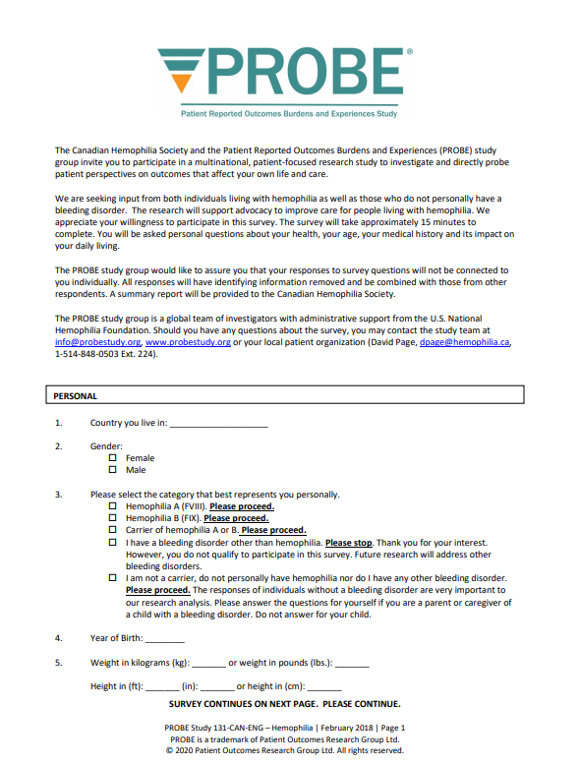
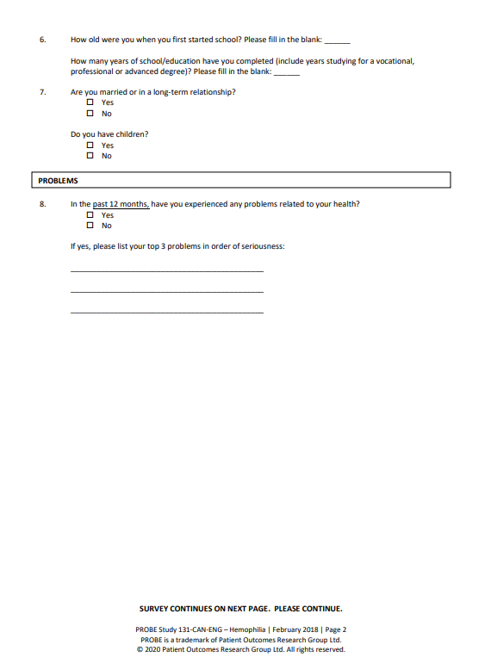
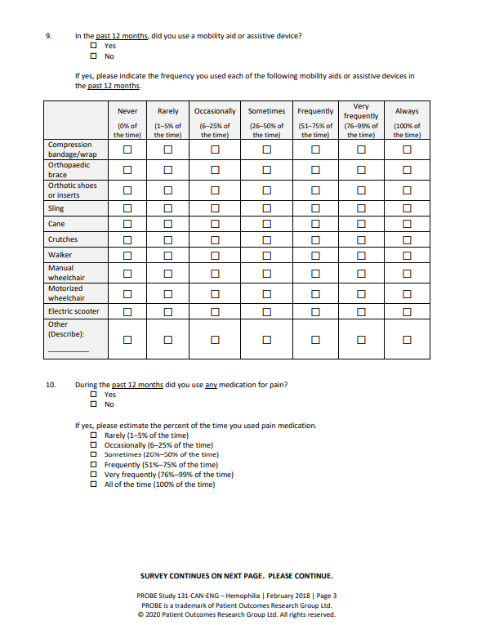
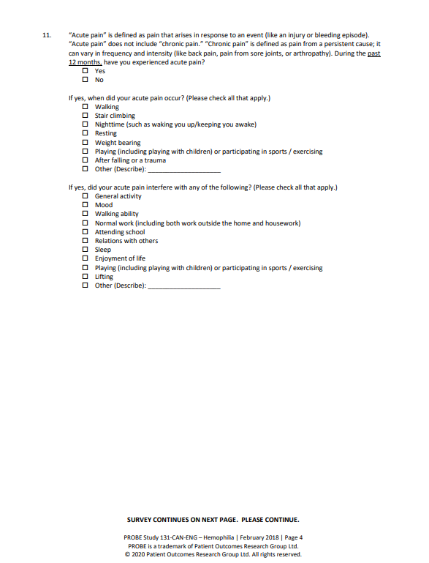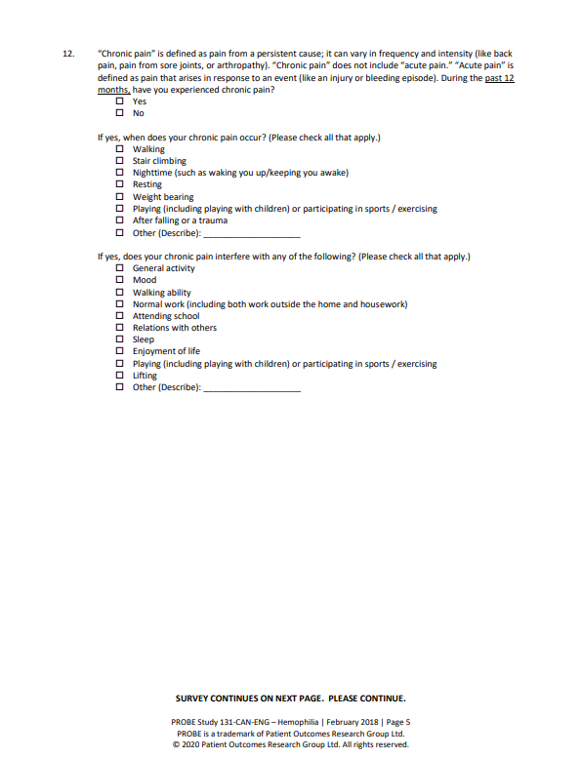
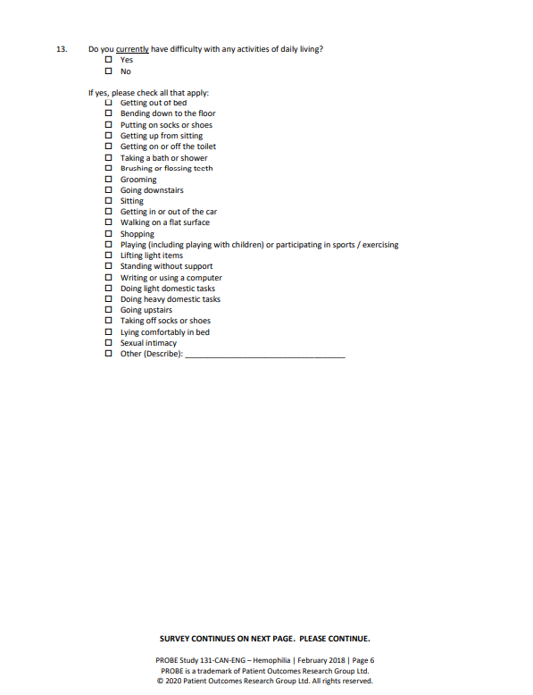
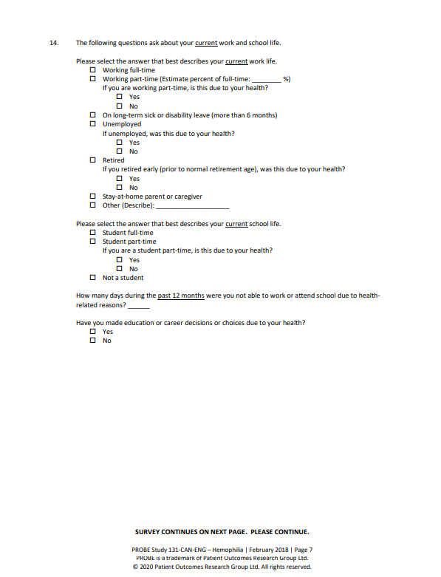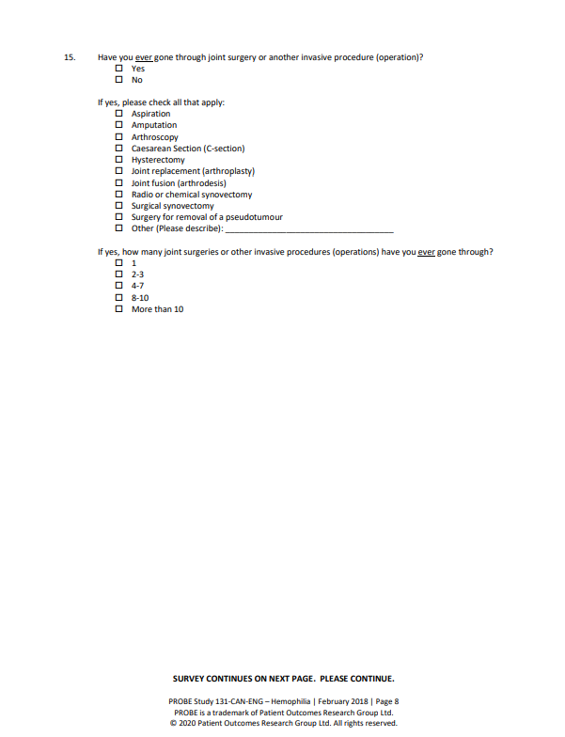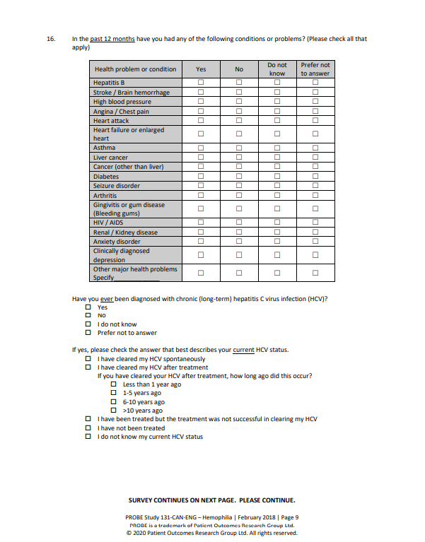
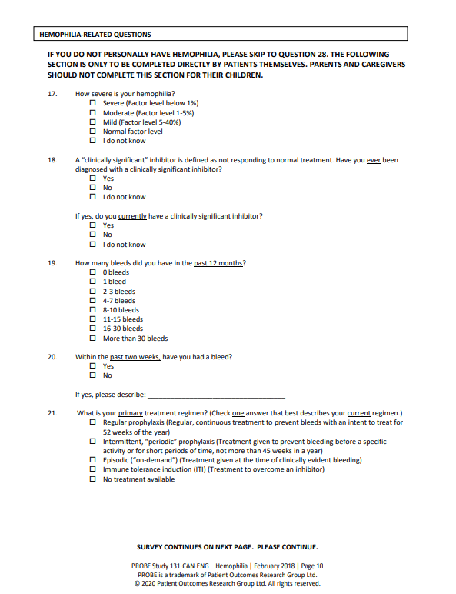
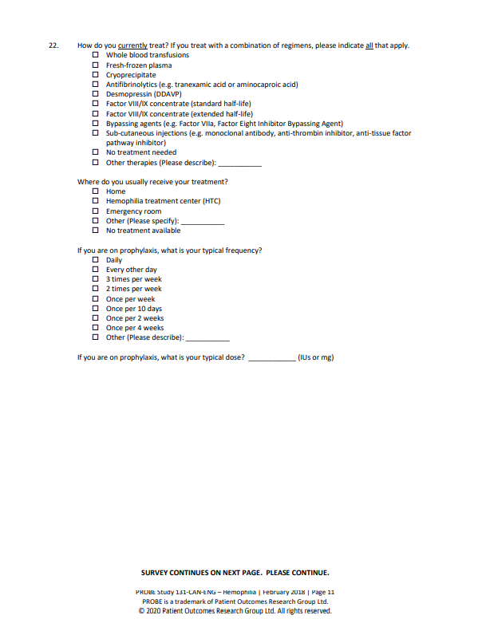
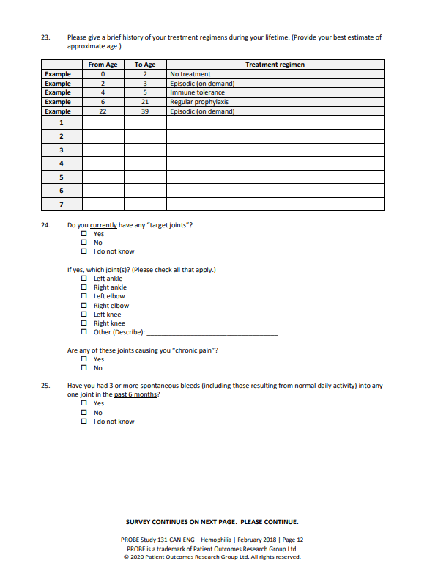
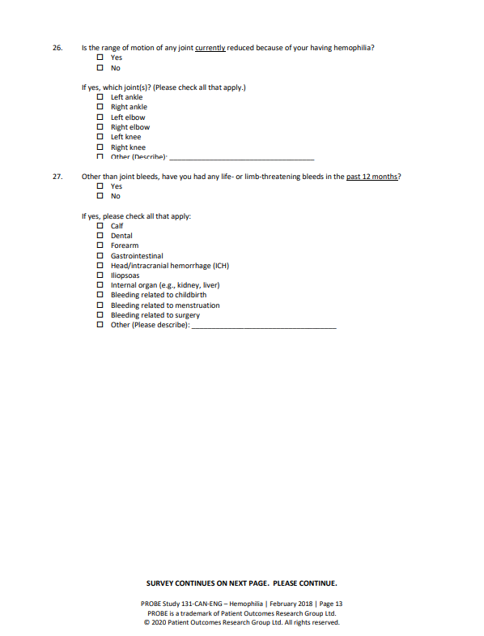
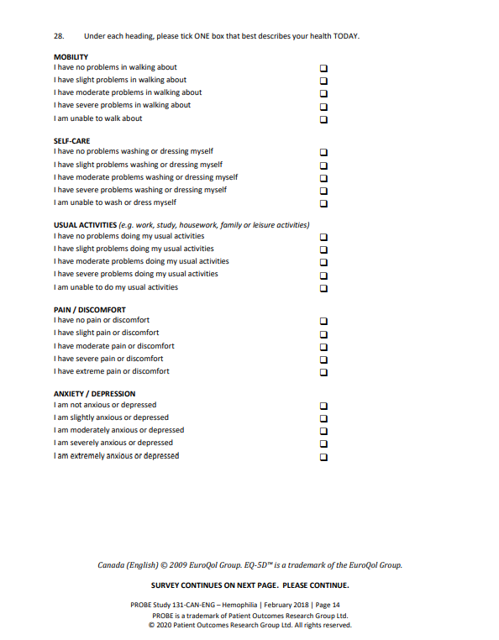
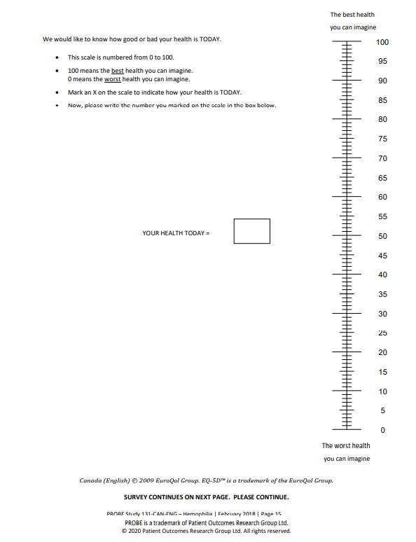
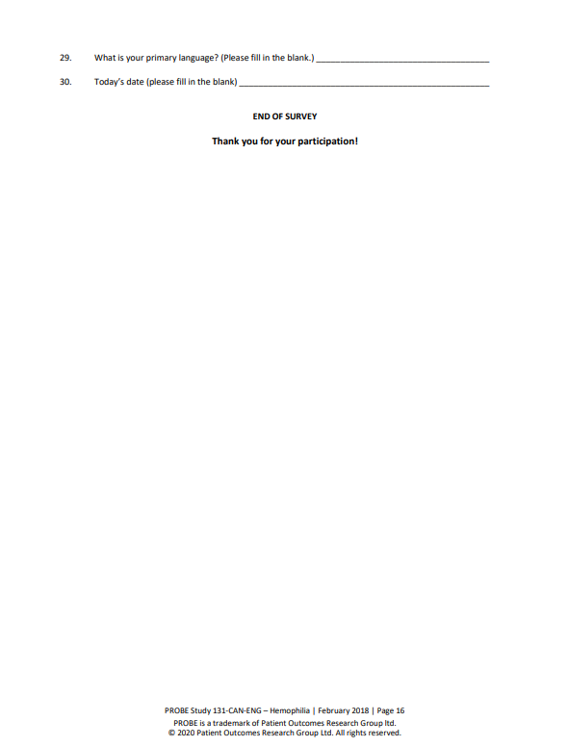

Appendix 2 – Terms of use and privacy agreement
PROBE application (the “Application”) and PROBE website (the “Website”)
Terms of Use Agreement (the “Agreement”)

IMPORTANT - PLEASE READ CAREFULLY: This is an Agreement to access and use the myPROBE Application and is a legally binding agreement between you, McMaster University (“McMaster”), and the Patient Research Outcome Group ltd (“PORG”). By accessing or using the Application and/or the Website and/or the Materials, together as defined Materials in section 2.1 below, you are agreeing to the terms below. You agree to comply with the terms and that the terms control your relationship with McMaster. Please read all the terms carefully. If you use the Application and/or the Materials in conjunction with other products or services, then the terms for those other products or services will also apply. If you do not agree to the terms of this Agreement, you are not authorized to use the Application and must not access and/or use the Application and/or the Materials in any capacity. Any new features or tools added to the Application and/or the Website and/or the Materials will also be subject to the Agreement.

TERMS OF USE

1.0 ACCOUNT AND REGISTRATION
1.1 You may not use the Materials and may not accept the terms of this Agreement if you are a person barred from using or accessing an Application similar to this Application or using or accessing materials and documents similar to the Materials, under the applicable laws of Canada or other countries including the country in which you are resident or from which you use the Application and/or the Materials.

1.2 If you are using the Materials on behalf of an entity, such as a legal dependent, you represent and warrant that you have authority to do so. All references to "you" in the Agreement refer to your use of the Materials on behalf of that entity.

1.3 Use of the Materials through your credentials is for your use by you only. You must not make the Materials available to any other person or entity or allow any other person or entity to access and/or use the Materials using your credentials.

2.0 OWNERSHIP
2.1 You acknowledge that PORG ltd owns all right, title and interest in the copyright and all other intellectual property rights to the PROBE questionnaire. You acknowledge that McMaster owns all right, title and interest in the copyright and all other intellectual property rights to the Application, and website. This includes, but is not limited to, any content, materials, results that are found on or provided by the Website and the Application, as a result of any data, including but not limited to Personal Data, that may be provided by you (the “Materials”). McMaster does not grant you any ownership interest in the Application, and/or the Materials and only grants you permission to access and use the Application and/or the Materials in accordance with the terms of this Agreement. No rights, title or interest in or to any official mark, trade-mark, service mark, logo or trade name of McMaster is granted to you under this Agreement.

3.0 AUTHORIZED USES
3.1 Provided you comply with all the terms and conditions of this Agreement, McMaster grants you a non-exclusive, non-transferable, revocable, license for access and use of the Materials for personal, non-commercial purposes only.

4.0 PROHIBITED USES
4.1 You must not:
4.1.1 sell, download, print, distribute, reproduce, rent, modify, adapt, reverse engineer, translate, make available to anyone other than you, or otherwise distribute copies of the Application and/or the Materials.
4.1.2 include the Application and/or the Materials as a component of a commercial product or use the Application and/or the Materials for performing research (whether commercial, or non-commercial, funded or non-funded) or other non-personal use
4.1.3 remove or obscure any copyright, trade-mark or other proprietary notices from Application and/or the Materials;
4.1.4 otherwise use the Application and/or the Materials on behalf of any third party, with the exception of any legal dependents;
4.1.6 use the Application and/or the Materials to create, develop, distribute or market any product, application or service that is competitive to McMaster and/ or its affiliates (to be determined at McMaster’s sole discretion);
4.1.6 defame, abuse, harass, stalk, or threaten others;
4.1.7 transfer the Application and/or the Materials to any ad network, ad exchange, data broker, or other advertising or monetization-related toolset or to any other service; or
4.1.8 use the Application and/or the Materials in any manner that makes the Application and/or the Materials available to any third party, in whole or in part, with use of your own credentials.
4.1.9 misuse the Application and/or the materials by knowingly introducing viruses, trojans, worms, logic bombs or other material which is malicious or technologically harmful.

5.0 DISCLAIMER OF WARRANTIES
5.1 The Application and the Materials have been developed for McMaster by Design2Code Inc (“D2C”). McMaster is providing you the Application and the Materials “as is” with all faults and without warranty of any kind, either express or implied.

5.2 McMaster expressly disclaims and excludes all warranties and representations expressed or implied, including but not limited to, any implied warranties that the Application or the Materials are merchantable, accurate or fit for a particular purpose. McMaster does not warrant that the Application or the Materials will meet your requirements or that the access and/or use of the Application and the Materials will produce a desired result, or that the Application or the Materials will operate uninterrupted, or error free or that any defects in the Application or the Materials will be corrected. McMaster does not warrant that the use of the Application or the Materials will not infringe any patent, copyright or trade-mark or other rights.

6.0 ASSUMPTION OF RISK
6.1 You assume all risk and responsibility for the selection, installation, use, quality, performance and results obtained from the Application and the Materials.

6.2 McMaster cannot guarantee the continued availability of the Application and/or the Materials and may cease providing the Application and/or the Materials, if for example and without limitation, McMaster is unable to host the Application and/or the Materials on McMaster servers, in a manner acceptable to McMaster or the business model changes for the use and access of the Application and/or the Materials. Should McMaster cease providing the Application and/or the Materials, you agree and acknowledge that your access and use may stop immediately, without any forewarning or any notification to you.

6.3 While McMaster makes every effort to check and test material at all stages of production, McMaster is not able to guarantee that the Application and/or Materials will never be faulty, free of viruses and/or errors, nor that it will work continuously, nor that it will be maintained in a fully operational condition. It is always wise for you to run an anti-virus program on all material downloaded from the internet. McMaster cannot accept any liability for any loss, disruption or damage to your data or your system, which may occur whilst you are using the Application and/or Material derived from the Application. Users must not misuse the Application by knowingly introducing viruses, trojans, worms, logic bombs or other material which is malicious or technologically harmful. Application and/or Materials users must not attempt to gain unauthorized access to the Application, the server on which the Application and/or Materials is stored, or any server, computer or database connected to the Application and/or Materials. Users must not attack our site via a denial-of-service attack or a distributed denial-of service attack. If you breach this provision, you will have committed a criminal offence under the applicable Ontario legislation. McMaster will report any such breach to the relevant law enforcement authorities and will co-operate with those authorities by disclosing the Application user’s identity to them. In the event of such a breach, the Application user’s right to use the Application will cease immediately.

7.0 PERSONAL DATA
7.1 For information about our data practices, please see our Privacy Policy. By using the Application and/or the Material you agree that we can collect and use your information and Personal Data in accordance with the Privacy Policy.

8.0 LIMITATION OF LIABILITY
8.1 In no event will McMaster be liable to you or any other person for any damages of any kind, including lost profits, data, business interruption or special, incidental or consequential damages, in any way arising out of or in connection with the use or performance of the Application, the Materials, even if McMaster has been advised of the possibility of such damages.

8.2 McMaster does not accept any responsibility for your use of the Application and/or the Materials, nor for any reliance which you may place on any information given in connection or derived from the Application and/or the Materials.

9.0 INDEMNITY
9.1 In consideration for the benefit obtained under this Agreement, you indemnify McMaster, and every other employee and student of McMaster (the “Indemnified Parties”), and keep them fully and effectively indemnified, against each and every claim made against any of the Indemnified Parties as a result of your use of the Application and/or the Materials, works or information received from them pursuant to the terms of this Agreement. The liability of McMaster for any breach of this Agreement, any negligence or arising in any other way out of the subject matter of this Agreement, the Application and/or the Materials, or use of Personal Data, will not extend to any indirect damages or losses, or any loss of profits, loss of revenue, loss of data, loss of contracts or opportunity, whether direct or indirect, even if McMaster has been advised of the possibility of those losses, or if they were within your contemplation.

10.0 THIRD PARTY RIGHTS
10.1 The Application and/or the Materials use on your personal device may be dependent on programs, operating systems or other intellectual property of third parties which may require third party Agreements. Compliance to terms and payment of fees associated with these third-party Agreements are the sole responsibility of you and are not included in this Agreement.

11.0 SUPPORT
11.1 During the term of this Agreement, McMaster (or D2C) will provide any technical support or assistance to you in relation to the installation, use or access of the Application and/or the Materials. If you require assistance, please contact info@probestudy.org.

12.0 ACKNOWLEDGMENT OF MCMASTER
12.1 McMaster grants you the right to reference the Application or the Materials in any non-academic, non-research publication (including, electronic documents and/or Applications) however you must include appropriate acknowledgment of McMaster and PORG. You agree and acknowledge that you will not make any statement regarding your use of the Application, and/or the Materials which suggests partnership with, sponsorship by, or endorsement by McMaster without McMaster’s prior written approval.

13.0 TERM AND TERMINATION
13.1 This Agreement commences on the date that you are provided access to the Application and the Materials through the Application registration and continues in effect unless it is terminated earlier by McMaster. It may be terminated by McMaster immediately without notice if you fail to comply with any of the terms and conditions of this Agreement. Upon termination of this Agreement, your rights to use you terminate and you must immediately stop using the Application and the Materials, uninstall all copies of the Application and the Materials and any user documentation in your possession or control.

14.0 REPRESENTATION OF AUTHORITY
14.1 You represent and warrant that you possess the legal authority to enter into this Agreement and that you will be responsible for your access and/or use of the Application and the Materials. You are responsible for supplying any hardware (e.g. mobile device) or software (e.g. device OS) necessary to access and/or use the Application.

15.0 NO ASSIGNMENT
15.1 You must not assign, sublicense or otherwise transfer this Agreement or any rights granted by this Agreement without the prior written consent of McMaster and any attempt to do so without the consent of McMaster will be void.

16.0 FORCE MAJEURE
16.1 Neither party to this Agreement will be liable for delay or failure to perform their respective obligations this Agreement if such delay or failure arises from any cause beyond the reasonable control of the party (“Force Majeure”) provided such party gives the other party written notice of the Force Majeure. Force Majeure includes, without limitation: labour disputes, strikes, other labour or industrial disturbances and any act of God, fire, natural disaster, power failures, accidents, act of government, shortages of materials or supplies and failure of contractors to perform. If a party is temporarily excused from performing its obligations under this Agreement because of Force Majeure, it must promptly resume performance when such Force Majeure is cured or removed.

17.0 COMPLETE AGREEMENT
17.1 This Agreement contains the entire agreement between you and McMaster relating to the Application and the Materials, and supersedes any prior understandings, arrangements, commitments, communications or agreements, oral or written, between you, McMaster, and PORG with respect to the Application. McMaster reserves the right to make changes to this Agreement without notice.

18.0 SEVERABILITY
18.1 If any provision of this Agreement becomes void, invalid, illegal or unenforceable, the remaining provisions will not be affected and will continue in effect as though the unenforceable provision(s) were deleted.

19.0 WAIVER
19.1 If either party omits or delays to require the other party to punctually fulfill any of its obligations under this Agreement, this omission or delay will not operate as a waiver by that party of its rights under this Agreement.

20.0 SURVIVAL
20.1 Sections 2-9 and 12-13 shall survive the termination of this Agreement.

21.0 GOVERNING LAW
21.1 This Agreement will be interpreted in accordance with the laws of the Province of Ontario and the laws of Canada. Any suit, action, or proceeding arising out of or relating to this Agreement must be brought in Ontario, Canada and you submit to the exclusive jurisdiction of the Courts of Ontario and the Courts of Canada as applicable. Use of the Application is prohibited in any jurisdiction which does not give effect to the terms of this Agreement.

□ I have read and understood the above Agreement and agree to be bound by the terms and conditions of this Agreement

PRIVACY POLICY - PROBE mobile application and website

The PROBE (Patient Reported Outcome, Burden and Experience) questionnaire has been developed by the Patient Outcomes Research Group ltd. (referred to as PORG). McMaster University (referred to as “we”, “us”, or “our”) manages the PROBE database, website and app. For the app, this is done in collaboration with Design2Code Inc. (referred as D2C).
This document explains how your information and Personal Data will be collected, used, stored and protected in accordance with the terms of this Privacy Policy and any applicable legislation. By using the Service, you consent to the terms and conditions as set out in this Policy.

Information we collect

When you use the Service, information we collect may include, but is not limited to:
- Your answers to the PROBE questionnaire
- Date of completion of the questionnaire

While using the Service, we may ask you to provide us with certain personally identifiable information (“Personal Data”). Personal Data means any information about an identified individual or an individual whose identity may be inferred or determined from such information, other than business contact information (e.g. name, title, business address) and this may include, but is not limited to:

- Your email address
- A unique identifier of your record in the linked hemophilia registry in your country (for example CBDR number or another external CBDR identifier in Canada)
- Under certain circumstances we may be required to disclose Personal data without your consent. Such circumstances may include, without limitation and subject to applicable laws:
  - where use or disclosure of Personal Data is required by applicable law or by order or requirement of a court, administrative agency or governmental tribunal
  - where the Personal Data is public as permitted by applicable law
  - where the disclosure is to an affiliate, or a third party service provider acting on our behalf
  - where the use or disclosure of Personal Data is reasonable for the purposes of investigating a breach of an agreement, or actual or suspected illegal activity

Who will access your information and Personal Data and how they will be used:

- PROBE will have access to individual, deidentified data;
- We will access the individual data for the following purposes:
  - Detecting and addressing any technical or other issues with the Service;
  - Updating, improving and maintaining the Service.
- D2C will not store any data and will not access any personal information
- Report of the PROBE database data, deidentified and aggregated, will be accessible to the NGO supporting the process, and maybe provided to sponsors of the PROBE project. Independent investigators may request access to de-identified data for research purposes, and possibly granted access after their request has been approved by the PROBE investigator group and ethically cleared as applicable.

The mission of PROBE is to investigate and directly probe patient perspectives on outcomes they deem relevant to their life and care, to enhance the direct patient-voice in health care decision-making. Aggregated de-identified data form patients and controls from your country will be returned in aggregated form at your country’s hemophilia non-governmental organization (NGO) through the PROBE dashboard or through periodical reports under specific data transfer or data reporting agreements.

Your information could be used for research purposes, but only for research projects approved by a research ethics committee and any other authority required by the applicable laws. We anticipate that for most studies (e.g. those using data collected in the past, duly de-identified, aggregate and anonymous information) the research ethics committee might waive the need for your specific individual consent. In all cases, the information will be coded so that researchers using the data bank will not have access to any identifying information. Your email address will never be provided to third parties. We may use your e-mail address to inform you about updates of the Service, research projects you may be entitled to participate through the service, or any other similar activity. We will limit the volume of these communications to the lowest possible level.

In all cases, the information will be fully de-identified to prevent any access to personal information and/or identification of individual patients.

How we store and protect your data

Access to your Personal Data is limited, controlled, and managed to make sure that confidentiality is preserved. Maintaining your privacy and appropriate confidentiality is a top priority to us and strict security rules are in place to guarantee privacy is maintained at all times.

Your information is kept on the PROBE database which is physically located in a secure data centre at McMaster University, in Canada, with appropriate physical, administrative and technical safeguards in place. These procedures protect your information from misuse, unauthorised access, interference, alteration, loss and/or disclosure.
We may retain your information and Personal Data to comply with laws, prevent fraud, resolve disputes, troubleshoot problems, assist with any investigations, enforce our Terms of Use and take other actions otherwise permitted by law.

Data transmission

Your information, including Personal Data, may be transmitted to - and maintained on - computers located outside of your state, province, country or other governmental jurisdiction, where the data protection laws may differ than those from your jurisdiction.
If you are located outside Canada and choose to use the Service, please note the data is sent to our servers in Canada.

Your consent to this Privacy Policy followed by your submission of such information represents your agreement to that transfer.

Your rights to access and control your personal data

Very little personal data is collected through the Service. At any point in time, you may request complete erasure of your personal data. After deleting your information, some of your data may still be stored as part of a previously generated aggregated statistics. At any time, and without providing a reason, you may request to obtain a copy, in an intelligible electronic format, of the data stored in your PROBE record. Any request to obtain or delete your data should be directed to info@probestudy.org.

If you decide to complete the questionnaire anonymously, you will not be able to obtain your data, because we will not be able to retrieve them.

You understand and agree that you assume all responsibility and risk for your use of the Service, the internet generally, and the documents you post or access and for your conduct. Upon your request, we will take reasonable steps to correct, amend or delete your Personal Data that is found to be inaccurate, incomplete or processed in a manner non-compliant with this Privacy Policy except where the burden or expense of providing access would be disproportionate to the risks to your privacy, where the rights of persons other than you would be violated or where doing so is otherwise in contrast with applicable law.

What happens if you decline to use PROBE App, to create a PROBE account, or to login with your national bleeding disorder registry account?

If you choose not to create an account in the PROBE App, PROBE website or to login through your national bleeding disorder registry for longitudinal data collection, you may choose to complete the questionnaire anonymously, either electronically or on paper. The data will be stored separate from the identified PROBE database and could be used in reports and research projects.

Changes to this privacy policy

This Privacy Policy is effective as of December 31st, 2018 and will remain in effect except with respect to any changes in its provisions in the future, which will be in effect immediately after being posted on this page.

We reserve the right to update or change our Privacy Policy at any time and you should check this Privacy Policy periodically. PROBE is committed to assessing, reviewing and updating this Privacy Policy on a case by case basis to meet any changes in regulatory requirements in applicable jurisdictions. Your continued use of the Service after we post any modifications to the Privacy Policy on this page will constitute your acknowledgment of the modifications and your consent to abide and be bound by the modified Privacy Policy.

Contact us

If you have any questions about this privacy policy, please contact us at: info@probestudy.org

Appendix 4 – Consent form
