Supplementary material to:

Multi-center and multi-vendor evaluation study across 1.5T and 3T scanners (part 2): T1 and T2 standardization in the ISMRM/NIST MR phantom
Table of contents:
Figure S1: Phantom positioning inside the scanner
Table. S1: Temperature adjusted measured T1 and T2 values with reference values at 20 °C
Table S2: Initial values and bounds implemented for each parameter used in each fit
Figure S2: Fits obtained with StimFit toolbox compareted with mono-exponential models.
Figure S3: Histograms of T2 measurements normalized to NIST-reference values from all voxels within all vials.
Figure S4: Vials positioning (a) and example of sigmoidal (in orange) and power law fit (in blue) for temperature determination. For the fit the estimated temperature and error are reported.
Figure S5: Linear fit (r²>0.994) obtained by plotting T1 values from the MnCl₂ array as a function of the temperature for each MnCl₂ vial (a). Example of temperature rescaling (b). Error% on T1 measurements after temperature rescaling as a function of the phantom temperature, the measurement error from the fit and assuming a temperature error of 1°C.
Figure S6: Linear fit (r²>0.992) obtained by plotting T2 values from the MnCl₂ array as a function of the temperature for each MnCl₂ vial (a). Example of temperature rescaling (b). Error% on T2 measurements after temperature rescaling as a function of the phantom temperature, the measurement error from the fit and assuming a temperature error of 1°C.
Figure S7: Quadratic fit obtained by plotting T1 values from the NiCl₂ array as a function of the temperature for each NiCl₂ vial (a). Example of temperature rescaling (b). Error% on T1 measurements after temperature rescaling as a function of the phantom temperature, the measurement error from the fit and assuming a temperature error of 1°C.
Table S3: Summary of GLMM statistical significance of predictors for accuracy and precision. Field and vendor were tested as independent predictors and through their interaction for each variable.
Figure S8: Results of GLMM in the reduced range on accuracy error for both T1 on NiCl2 spheres, T1 on MnCl2 spheres and T2 measurements. All results are reported as least-square means and standard errors
Figure S9: Inter-scanner CV% for T1 measurements performed on the same phantom (model 130)
Figure S10: Results of GLMM in the reduced range on precision error for both T1 on NiCl2 spheres, T1 on MnCl2 spheres and T2 measurements. All results are reported as least-square means and standard errors
Table S4: Results of T1 and T2 vairance contributions, ICC_{intra} and ICC_{inter} for both field strengths.
Table S5: Results of T1 and T2 vairance contributions, ICC_{intra} and ICC_{inter} for both field strengths separated across vendors.
Table S6: Within scanner accuracy error% expressed in terms of median, first and third quartile from mono-exponetianl fit and StimFit both in the full range and in the physiologically relevant range for kidneys. P-values of paired sample Wilcoxon signed-rank tests comparing the accuracy errors between the two models are reported for each scanner (ns = p>0.05, * = p<0.05, ** p <0.01, *** = p<0.001)

Figure S1: Example of phantom positioning inside Scanner 10. Phantom and anterior body coil position varied according to the available setup.
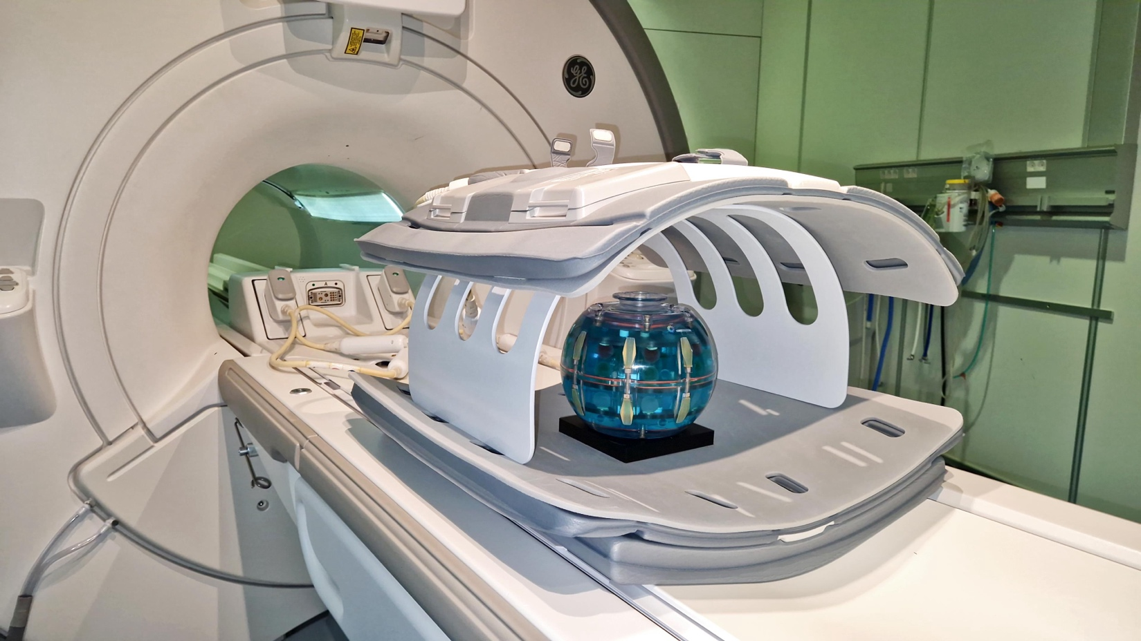
Table S1: Temperature-adjusted measured T1 and T2 values with reference values at 20 °C
1.5T T1 [ms]
ROI | Concentration (mM) | Reference | Scanner 1 | Scanner 2 | Scanner 3 | Scanner 4 | Scanner 5 | Scanner 6
T2-1 | 0,0113 | 2146,00 | 2143,12 | 2170,10 | 2148,17 | 2094,73 | 2081,23 | 2110,08
T1-1 | 0,2900 | 1741,00 | 1891,66 | 1773,09 | 1757,75 | 1827,45 | 1751,17 | 1757,07
T2-3 | 0,0282 | 1655,00 | 1742,68 | 1736,88 | 1706,61 | 1830,38 | 1736,45 | 1690,67
T2-4 | 0,0434 | 1353,00 | 1356,96 | 1459,13 | 1432,85 | 1438,71 | 1410,40 | 1394,95
T1-2 | 0,6000 | 1270,00 | 1429,48 | 1416,64 | 1407,71 | 1392,79 | 1386,49 | 1386,99
T2-5 | 0,0673 | 1049,00 | 1072,94 | 1112,20 | 1099,82 | 1098,82 | 1091,58 | 1077,86
T1-3 | 1,0400 | 962,00 | 1028,03 | 1020,04 | 1012,49 | 1002,69 | 1006,83 | 1001,22
T2-6 | 0,0934 | 900,00 | 942,72 | 969,34 | 966,17 | 967,09 | 952,23 | 951,95
T2-7 | 0,1353 | 707,00 | 758,78 | 770,03 | 768,65 | 772,87 | 769,09 | 755,32
T1-4 | 1,6400 | 685,00 | 695,88 | 698,68 | 696,10 | 689,27 | 691,78 | 686,22
T2-8 | 0,1930 | 528,00 | 565,16 | 579,04 | 579,90 | 581,75 | 572,23 | 556,84
T1-5 | 2,5200 | 487,00 | 494,39 | 498,53 | 496,54 | 491,42 | 487,10 | 488,40
T2-9 | 0,2768 | 380,00 | 409,39 | 403,74 | 411,07 | 420,32 | 419,74 | 401,15
T1-6 | 3,6800 | 346,00 | 352,37 | 354,05 | 357,56 | 348,92 | 345,57 | 350,00
T2-10 | 0,4276 | 259,00 | 278,35 | 281,76 | 281,79 | 286,15 | 281,18 | 275,01
T1-7 | 5,4300 | 246,00 | 257,45 | 259,50 | 256,44 | 252,77 | 250,84 | 249,91
T2-11 | 0,5555 | 200,00 | 224,14 | 214,57 | 217,84 | 226,23 | 217,48 | 214,62
T1-8 | 7,7400 | 179,00 | 186,14 | 187,95 | 187,12 | 183,91 | 183,62 | 181,54
T2-12 | 0,7902 | 140,00 | 158,72 | 156,71 | 155,94 | 160,24 | 159,50 | 151,88
T1-9 | 11,3000 | 124,00 | 130,95 | 133,57 | 133,69 | 128,94 | 128,19 | 126,97
T2-13 | 1,1274 | 103,00 | 115,21 | 120,82 | 117,28 | 115,98 | 118,17 | 111,51
T1-10 | 16,5000 | 88,00 | 91,09 | 95,92 | 95,80 | 89,60 | 89,23 | 89,06
T2-14 | 1,5996 | 73,00 | 81,27 | 82,04 | 86,16 | 82,58 | 79,90 | 75,53
T1-11 | 23,3000 | 62,00 | 63,66 | 67,95 | 68,00 | 62,92 | 63,73 | 62,56
T1-12 | 32,7000 | 44,00 | 44,89 | 47,86 | 48,49 | 44,53 | 45,02 | 44,26
T1-13 | 46,0000 | 31,00 | 32,26 | 32,32 | 35,98 | 31,55 | 31,14 | 30,48
T1-14 | 65,3000 | 22,00 | 22,82 | 23,88 | 26,05 | 21,84 | 23,77 | 21,94
3T T1 [ms]
ROI | Concentration (mM) | Reference | Scanner 7 | Scanner 8 | Scanner 9 | Scanner 10 | Scanner 11 | Scanner 12 | Scanner 13
T2-1 | 0,0110 | 2478,19 | 2208,43 | 2144,35 | 2218,19 | 2139,57 | 2098,08 | — | 2195,20
T2-3 | 0,0280 | 1901,28 | 1741,71 | 1707,64 | 1748,03 | 1738,55 | 1764,59 | 1970,50 | 1754,35
T1-1 | 0,2900 | 1883,97 | 1774,56 | 1786,38 | 1814,66 | 1833,78 | 1787,25 | 1792,83 | 1786,63
T2-4 | 0,0430 | 1549,98 | 1457,86 | 1495,47 | 1481,41 | 1475,91 | 1485,37 | 1568,91 | 1420,67
T1-2 | 0,6000 | 1330,16 | 1408,25 | 1427,27 | 1454,77 | 1419,91 | 1443,59 | 1279,07 | 1454,61
T2-5 | 0,0670 | 1197,57 | 1104,48 | 1128,73 | 1157,33 | 1126,32 | 1122,80 | — | 1107,10
T2-6 | 0,0930 | 1026,43 | 998,18 | 990,95 | 1023,11 | 988,92 | 991,12 | 940,57 | 978,66
T1-3 | 1,0400 | 987,27 | 998,43 | 1009,23 | 1011,06 | 1006,53 | 1017,83 | 922,28 | 1031,41
T2-7 | 0,1350 | 805,10 | 790,70 | 785,23 | 813,73 | 795,93 | 794,29 | 706,34 | 785,07
T1-4 | 1,6400 | 690,08 | 680,07 | 686,84 | 691,62 | 682,16 | 689,72 | 671,88 | 686,85
T2-8 | 0,1930 | 599,96 | 584,95 | 587,44 | 608,64 | 594,55 | 594,93 | 544,06 | 577,84
T1-5 | 2,5200 | 484,97 | 484,80 | 488,72 | 492,81 | 480,34 | 488,50 | 465,87 | 475,07
T2-9 | 0,2770 | 431,22 | 419,81 | 407,14 | 426,61 | 420,75 | 424,12 | 417,63 | 434,82
T1-6 | 3,6800 | 341,58 | 344,76 | 349,77 | 351,03 | 342,33 | 350,77 | 325,62 | 347,46
T2-10 | 0,4280 | 292,87 | 291,37 | 287,89 | 293,28 | 293,38 | 292,82 | 290,03 | 296,06
T1-7 | 5,4300 | 240,86 | 246,15 | 250,94 | 251,90 | 242,97 | 251,05 | 227,28 | 245,90
T2-11 | 0,5550 | 226,53 | 225,27 | 223,53 | 224,63 | 224,74 | 226,56 | 236,01 | 229,03
T1-8 | 7,7400 | 174,95 | 175,24 | 182,33 | 182,51 | 176,20 | 181,05 | 164,68 | 176,92
T2-12 | 0,7900 | 158,17 | 159,81 | 163,56 | 159,62 | 159,53 | 162,00 | 166,85 | 163,02
T1-9 | 11,3000 | 121,08 | 124,56 | 129,14 | 130,00 | 122,23 | 129,87 | 113,70 | 122,61
T2-13 | 1,1270 | 116,70 | 115,17 | 121,41 | 118,85 | 119,60 | 123,73 | 125,76 | 118,58
T1-10 | 16,5000 | 85,75 | 86,64 | 92,76 | 93,42 | 89,30 | 93,95 | 76,68 | 87,48
T2-14 | 1,6000 | 82,46 | 79,30 | 87,19 | 80,92 | 80,80 | 91,62 | 92,51 | 85,22
T1-11 | 23,3000 | 60,21 | 60,99 | 65,30 | 65,87 | 60,19 | 66,31 | 53,37 | 61,17
T1-12 | 32,7000 | 42,89 | 43,55 | 45,88 | 47,05 | 43,07 | 47,28 | 36,95 | 43,12
T1-13 | 46,0000 | 30,40 | 30,96 | 34,08 | 33,93 | 31,05 | 35,01 | 26,50 | 30,67
T1-14 | 65,3000 | 21,44 | 22,62 | 25,00 | 24,87 | 22,57 | 25,09 | 18,91 | 21,51

1.5T T2 [ms]
ROI | Reference | Scanner 1 | Scanner 2 | Scanner 3 | Scanner 4 | Scanner 5 | Scanner 6
T2-1 | 695 | 734,65 | 743,10 | 742,46 | 699,82 | 725,94 | 671,00
T2-3 | 355 | 367,29 | 370,45 | 369,06 | 389,32 | 382,15 | 365,97
T2-4 | 237 | 254,19 | 250,03 | 247,97 | 272,91 | 254,23 | 245,15
T2-5 | 155 | 177,57 | 164,52 | 162,98 | 180,15 | 162,96 | 162,41
T2-6 | 123 | 145,04 | 133,10 | 132,91 | 145,08 | 135,23 | 132,80
T2-7 | 88 | 105,60 | 96,63 | 96,50 | 107,99 | 99,61 | 97,33
T2-8 | 62 | 73,69 | 68,09 | 68,41 | 76,43 | 70,24 | 68,36
T2-9 | 42 | 52,39 | 45,48 | 45,46 | 49,39 | 45,52 | 44,47
T2-10 | 27 | 33,26 | 29,35 | 29,95 | 32,76 | 29,30 | 29,16
T2-11 | 21 | 26,18 | 22,40 | 23,22 | 25,17 | 21,50 | 21,93
T2-12 | 15 | 16,26 | 15,69 | 15,88 | 16,97 | 14,59 | 14,64
T2-13 | 10 | 11,72 | 11,70 | 12,04 | 11,95 | 10,55 | 10,89
T2-14 | 7 | 8,96 | 8,43 | 9,04 | 8,21 | 6,79 | 7,31
3T T2 [ms]
 |  | Scanner 7 | Scanner 8 | Scanner 9 | Scanner 10 | Scanner 11 | Scanner 12 | Scanner 13
T2-1 | 552.2 | 537,96 | 553,39 | 557,15 | 530,72 | 542,21 | — | 572,66
T2-3 | 267.3 | 265,56 | 266,43 | 268,81 | 273,87 | 267,13 | 267,50 | 267,07
T2-4 | 175.1 | 181,75 | 178,63 | 179,96 | 183,55 | 177,49 | 174,63 | 178,02
T2-5 | 112.7 | 118,74 | 115,46 | 117,38 | 118,99 | 117,75 | — | 110,59
T2-6 | 88,9 | 95,50 | 93,26 | 94,17 | 97,25 | 97,57 | 87,39 | 91,83
T2-7 | 63,4 | 70,25 | 68,74 | 68,57 | 70,27 | 72,31 | 61,91 | 66,58
T2-8 | 44,2 | 50,13 | 49,36 | 47,22 | 50,37 | 54,03 | 44,79 | 45,32
T2-9 | 29,9 | 33,35 | 34,27 | 33,16 | 34,50 | 36,98 | 31,39 | 29,66
T2-10 | 19,4 | 23,99 | 22,41 | 22,32 | 22,98 | 24,39 | 18,97 | 19,34
T2-11 | 14,7 | 17,82 | 18,27 | 18,20 | 16,75 | 18,40 | 14,62 | 14,45
T2-12 | 10,5 | 11,77 | 12,50 | 12,19 | 12,67 | 12,45 | 9,97 | 10,02
T2-13 | 7,3 | 10,38 | 8,17 | 8,27 | 9,75 | 8,97 | 7,19 | 7,22
T2-14 | 5,1 | 7,69 | 5,75 | 5,77 | 7,46 | 6,96 | 4,96 | 4,81

Table S2: Initial values and bounds implemented for each parameter used in each fit

Type of fit | Starting points | Lower bounds | Upper bounds
IR: $\left(TI\right)=S_{0}\left|1-\left(1+δ\right)e^{-\frac{TI}{T1}}+δe^{-\frac{TR}{T1}}\right|+n$ | $S_{0}$ = max(S(TI))  $δ$= 1.8  T1 = TI[min(S(TI)))] /log(2)  n = 10 | --  1.2  --  0 | --  2  --  min(S(TI)))
MESE: $S\left(TE\right)=S_{0}e^{-\frac{TE}{T2}}+n$. | $S_{0}$ = max(S(TE))  T2 = 200  n = min(S(TE)) for ROI >7 | --  0  0 | --  --  --

Figure S2: Fits obtained with StimFit toolbox compare with mono-exponential models. Examples are calculated on ROI-6.

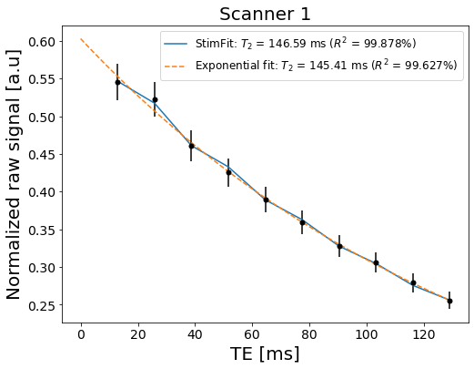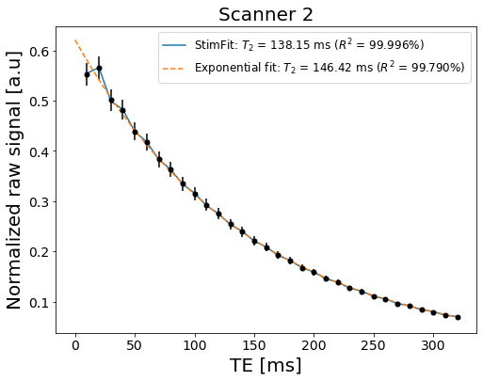
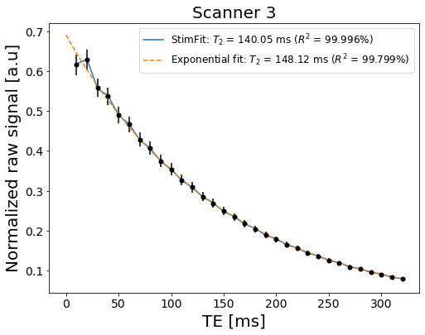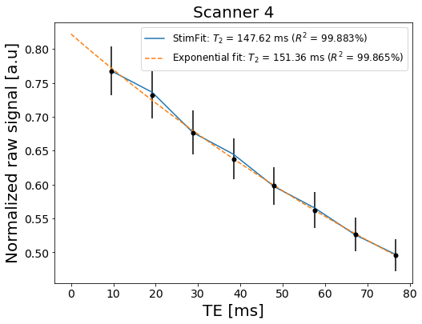
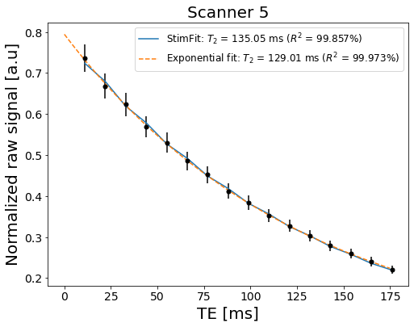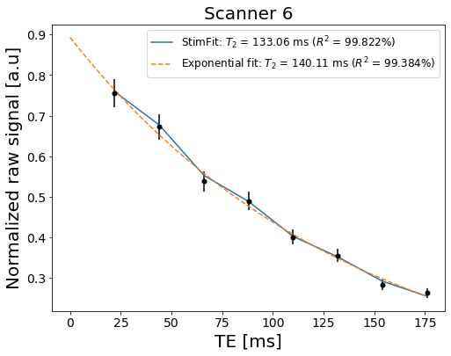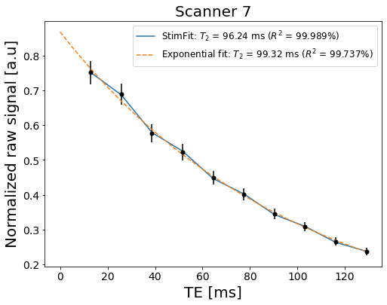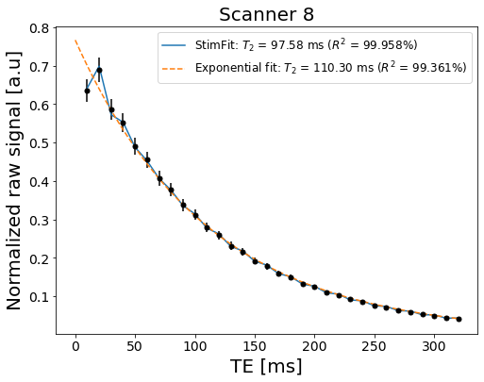
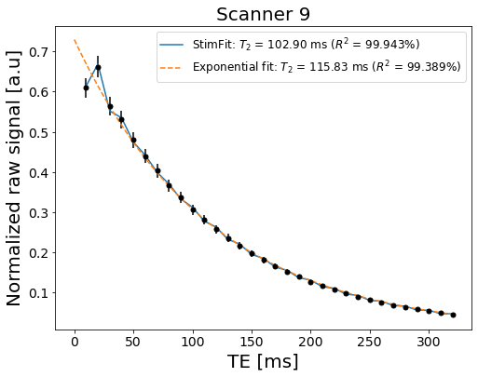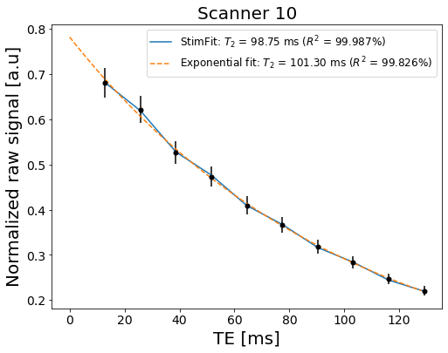
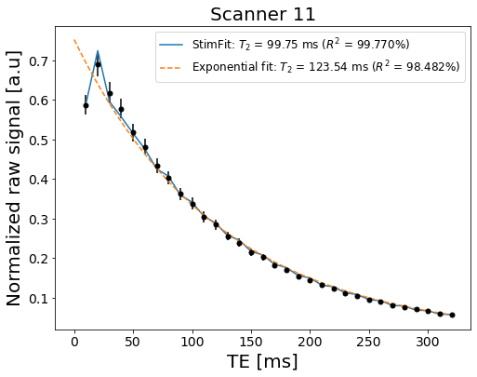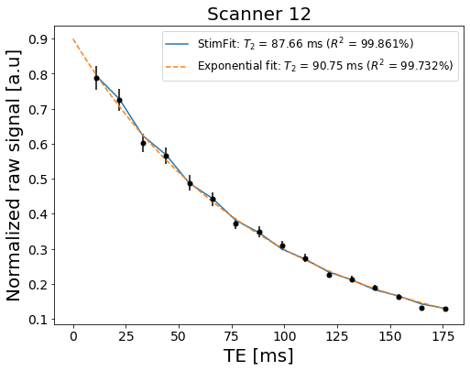
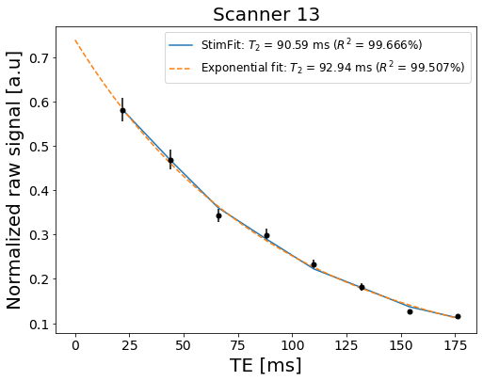

Figure S3: Histograms of T2 measurements normalized to NIST-reference values from all voxels within all vials. Vertical lines in red correspond to a ratio between measurements and reference of 1.
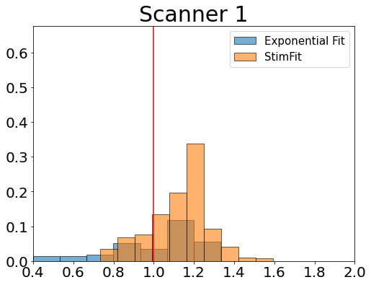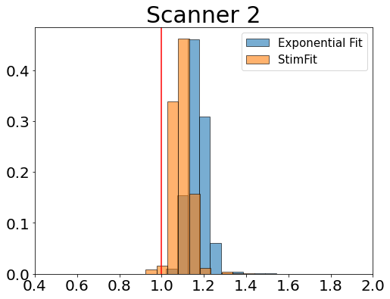
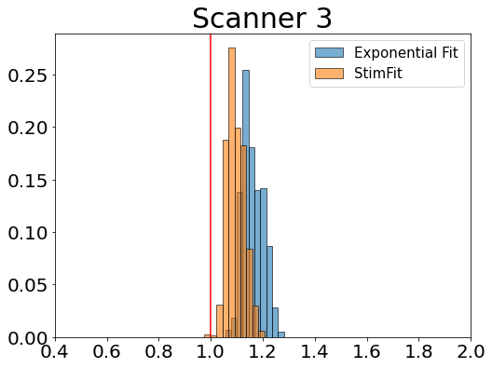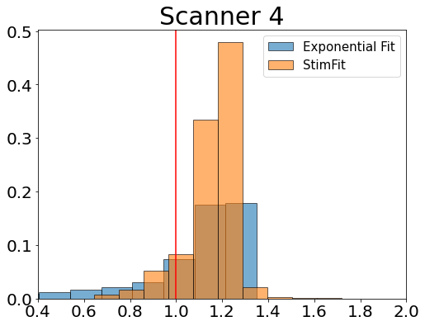
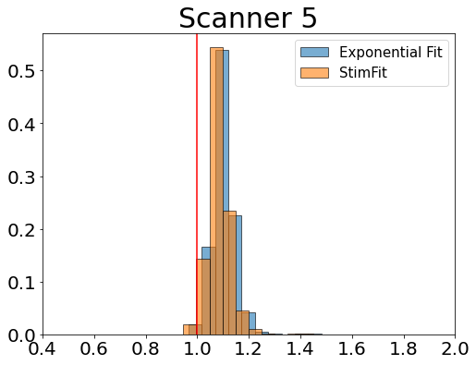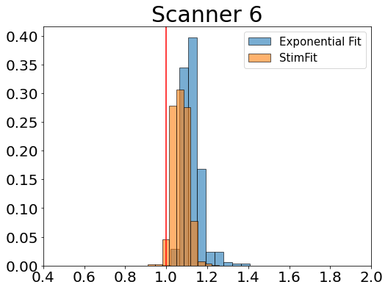
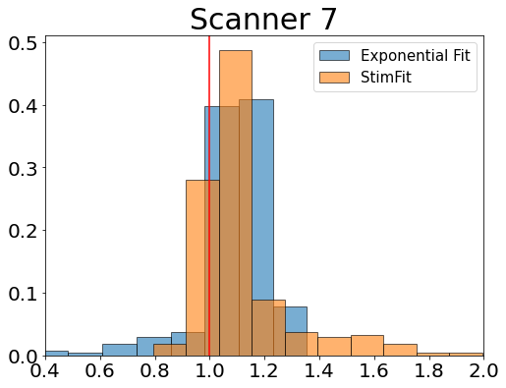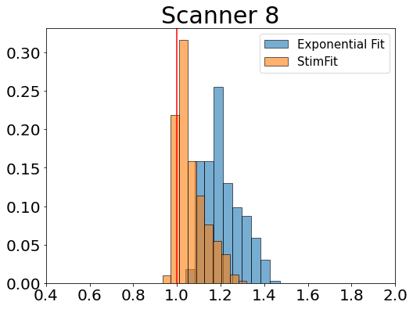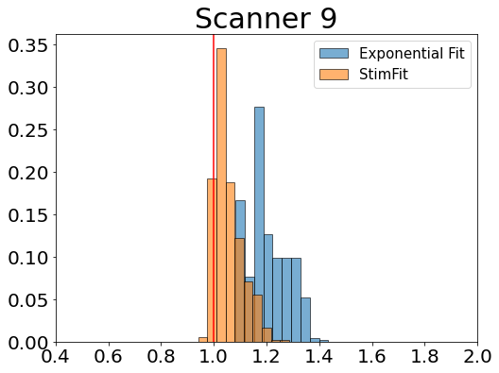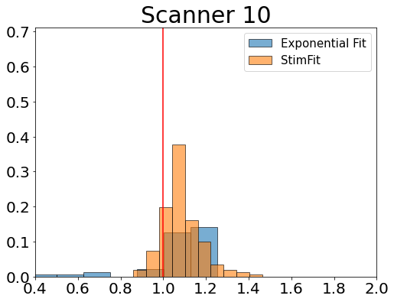
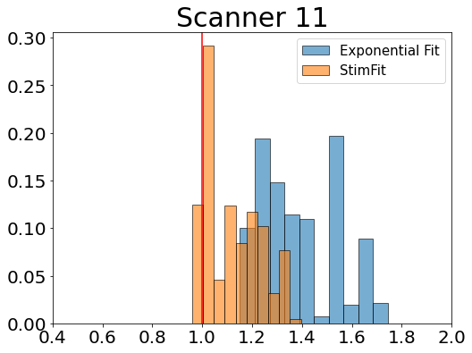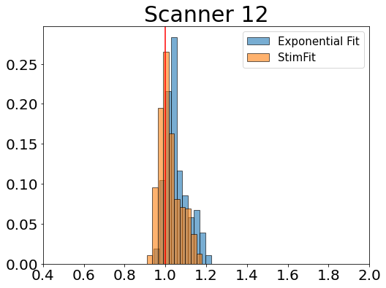
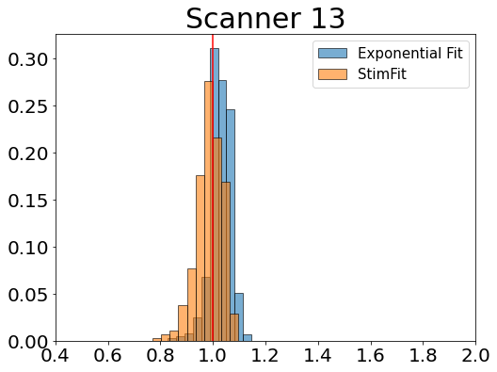

Temperature determination procedure

Figure S4: Vials positioning (a) and example of sigmoidal (in orange) and power law fit (in blue) for temperature determination. For the fit the estimated temperature and error are reported.
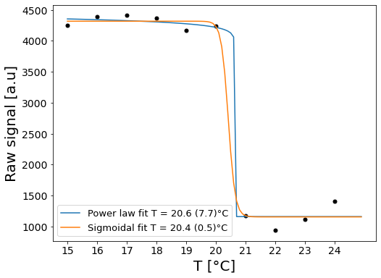
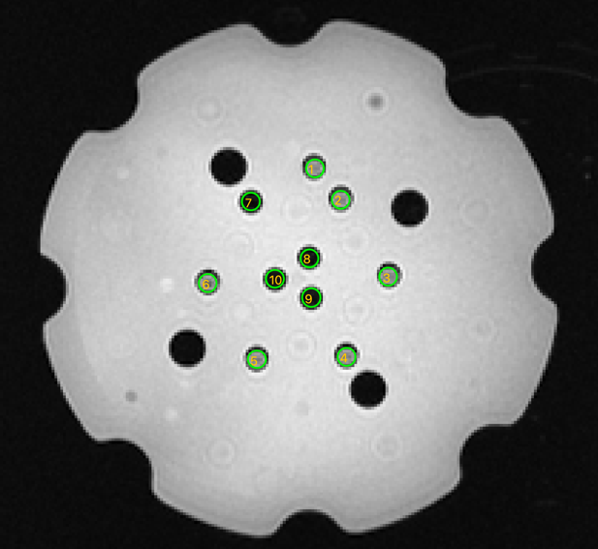
In order to estimate the phantom temperature, ordered circular ROIs (5.5 mm of diameter) were placed over the LC MR-readable thermometer vials as reported in Figure a.
For each ROI, the average signal undergoes a transition from dark to bright at a vial specific temperature. The phantom temperature $T_{C}$ is then found in the range between the highest transition temperature of the vials in a bright state and the lowest of those in a dark state.
To determine the phantom temperature a four-parameters sigmoidal fit given by $S\left(T\right)=A \frac{1}{1+e^{γ\left(T-T_{C}\right)}}+B$ was used. $T_{C}$ estimates the system temperature, $A$ the amplitude in signal intensity from a dark to a bright state, $γ$ the slope of the transition and $B$ the offset defined by the dark state signal. In this case we assume a two-state transition from a bright to a dark state.
An alternative fit, proposed in PhantomViewer, uses a four-parameter power law model to estimate the transition temperature $S\left(T\right)=A⋅{\left(T_{C}-T\right)}^{γ}+B$. In this case we assume that the signal is proportional to the order parameter plus a constant offset and the order parameter goes to zero as the temperature increase as ${(T_{C}-T)}^{γ}$.Based on previous calculations conducted on the Diffusion Phantom using LC thermometers (see Part 1), we determined that the uncertainty in temperature measurements derived from the four-parameters sigmoidal fit does not exceed $±0.6$ °C

Examples of temperature rescaling for T1 and T2 values from MnCl₂ array and T1 values from NiCl₂ array.
Figure S5: Linear fit (r²>0.994) obtained by plotting T1 values from the MnCl₂ array as a function of the temperature for each MnCl₂ vial (a). Example of temperature rescaling (b). Error% on T1 measurements after temperature rescaling as a function of the phantom temperature, the measurement error from the fit and assuming a temperature error of 1°C.
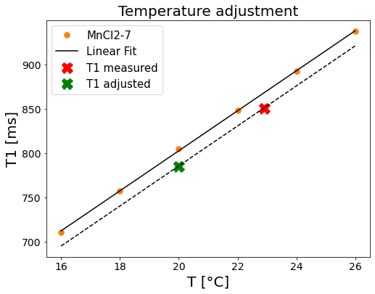
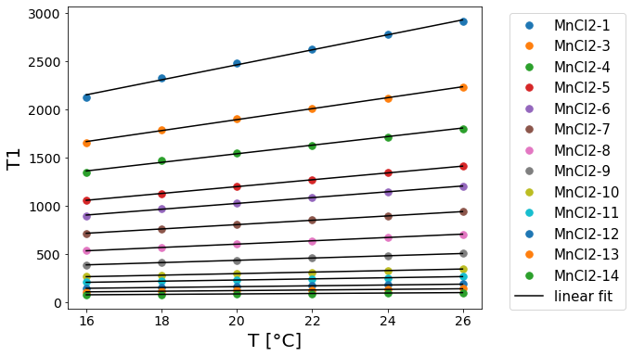
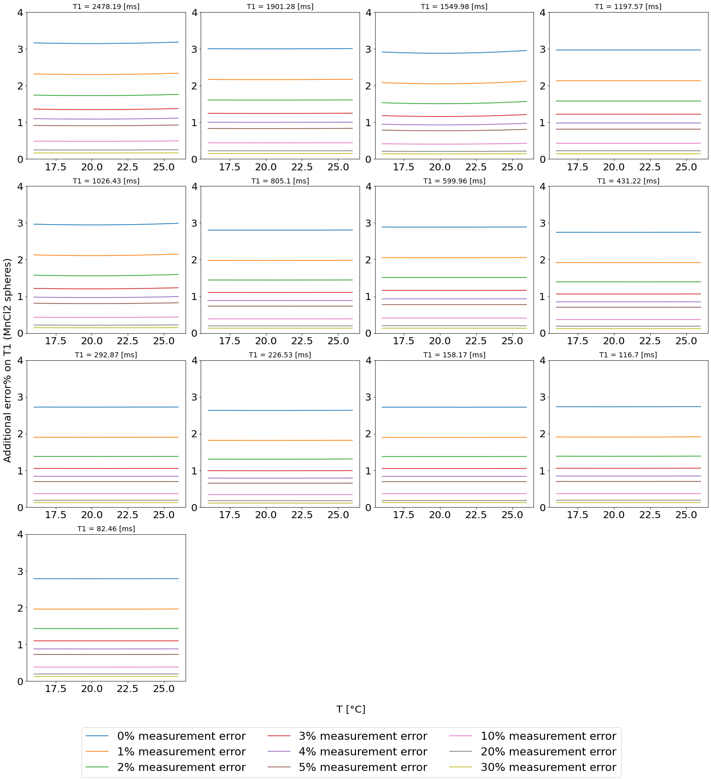
a.
b.
c.

Figure S6: Linear fit (r²>0.992) obtained by plotting T2 values from the MnCl₂ array as a function of the temperature for each MnCl₂ vial (a). Example of temperature rescaling (b). Error% on T2 measurements after temperature rescaling as a function of the phantom temperature, the measurement error from the fit and assuming a temperature error of 1°C.
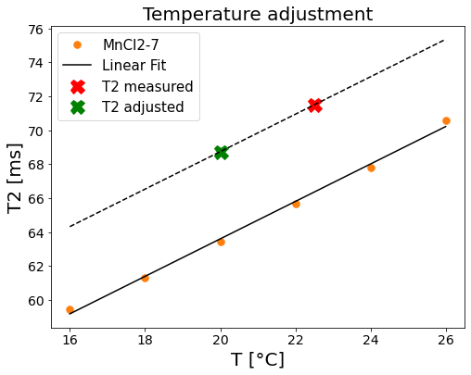
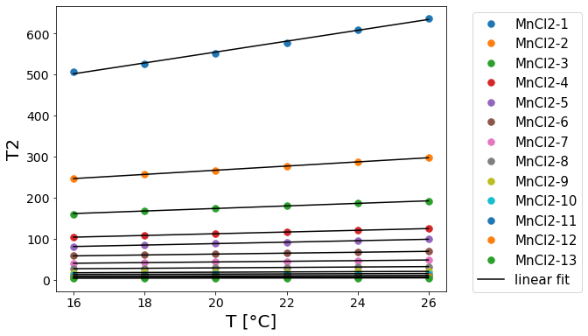
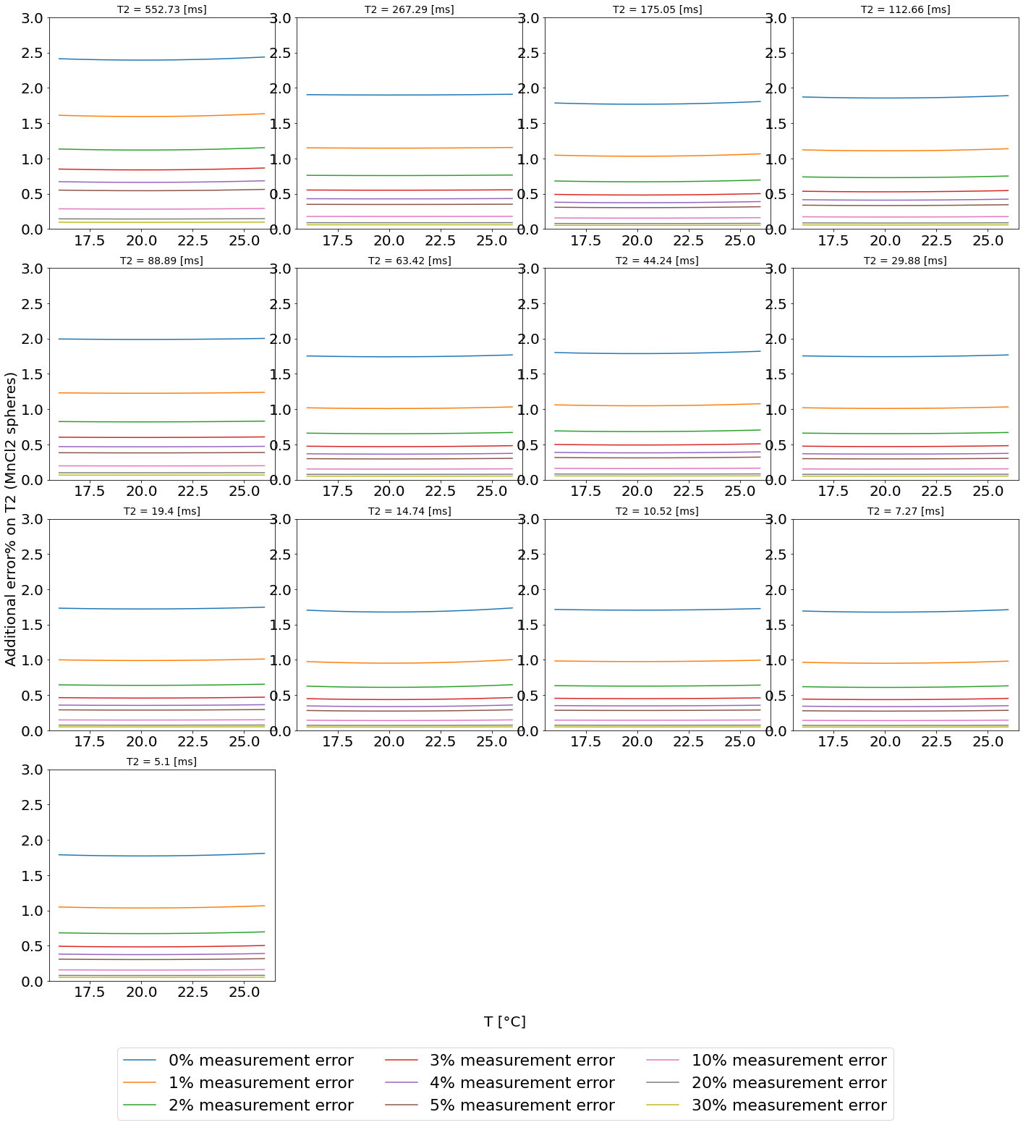
a.
b.
c.

Figure S7: Quadratic fit obtained by plotting T1 values from the NiCl₂ array as a function of the temperature for each NiCl₂ vial (a). Example of temperature rescaling (b). Error% on T1 measurements after temperature rescaling as a function of the phantom temperature, the measurement error from the fit and assuming a temperature error of 1°C.
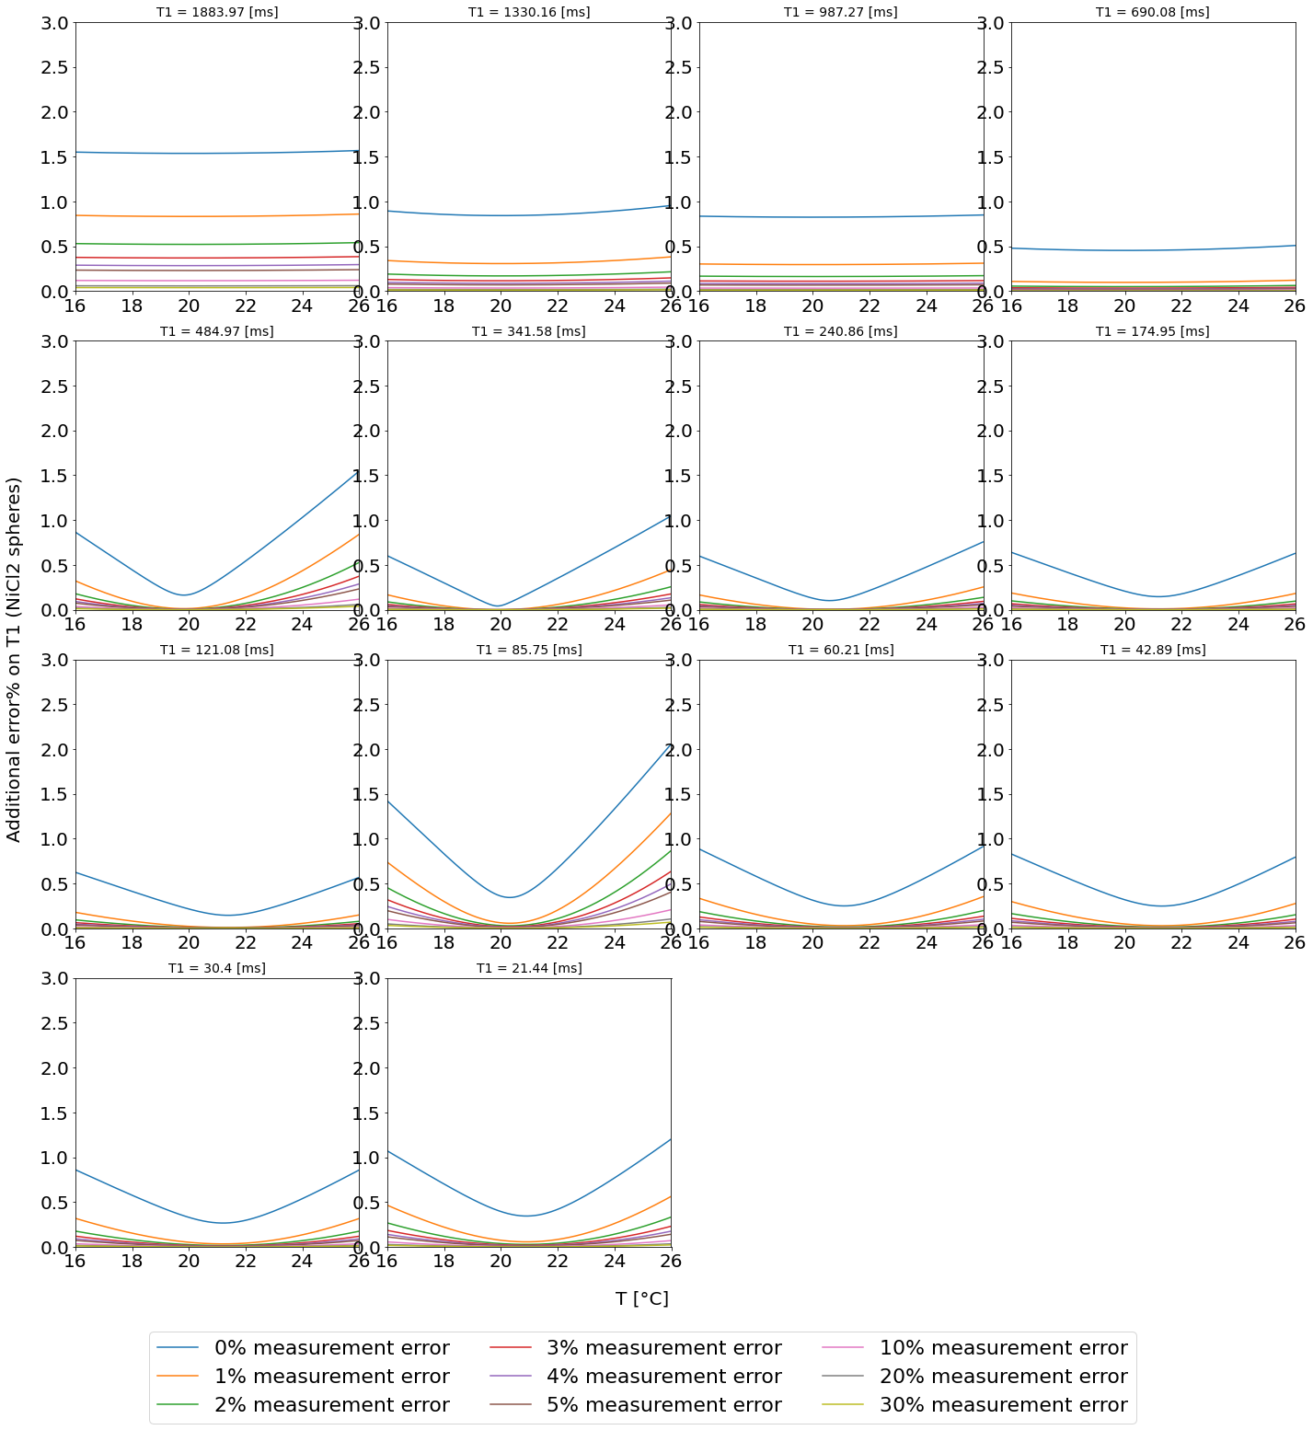
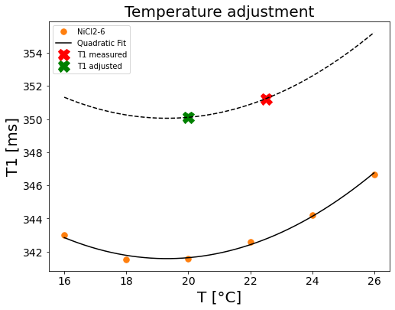
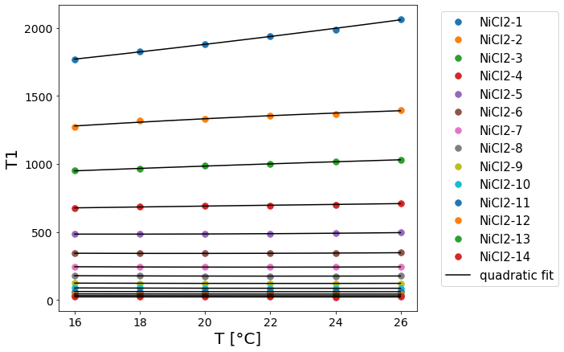
a.
b.
c.
The rescaling was performed as a two-step process.
- The temperature dependence of T1 and T2 values is fit with a linear regression model for MnCl₂ spheres and a quadratic model for NiCl₂ spheres as a function of the temperature $T$
$y= c_{1}+ c_{2}⋅T$ $y=q_{1}+q_{2}T+q_{3}T^{2}$
Linear fits are obtained from reference values provided by the phantom manufacturer are shown in Figure S4a, S5a and S6a.
The coefficients were then estimated for each vial.
vial | $$c_{1}$$ | $$c_{2}$$ | vial | $$c_{1}$$ | $$c_{2}$$ | vial | $$q_{1}$$ | $$q_{2}$$ | $$q_{3}$$
MnCl₂-1 (T2) | 290.522 | 13.2359 | MnCl₂-1 (T1) | 904.935 | 77.9041 | NiCl₂-1 (T1) | 1428.99 | 16.7451 | 0.290491
MnCl₂-3 (T2) | 166.064 | 5.07814 | MnCl₂-3 (T1) | 753.512 | 56.9994 | NiCl₂-2 (T1) | 956.682 | 25.6947 | -0.344866
MnCl₂-4 (T2) | 112.637 | 3.09714 | MnCl₂-4 (T1) | 646.278 | 44.6299 | NiCl₂-3 (T1) | 774.129 | 12.6717 | -0.107724
MnCl₂-5 (T2) | 71.2387 | 2.09229 | MnCl₂-5 (T1) | 486.923 | 35.5314 | NiCl₂-4 (T1) | 616.437 | 4.17661 | -0.0247765
MnCl₂-6 (T2) | 53.692 | 1.76729 | MnCl₂-6 (T1) | 418.707 | 30.2086 | NiCl₂-5 (T1) | 524.656 | -4.82113 | 0.141027
MnCl₂-7 (T2) | 41.4953 | 1.10514 | MnCl₂-7 (T1) | 351.647 | 22.5543 | NiCl₂-6 (T1) | 384.768 | -4.47348 | 0.115848
MnCl₂-8 (T2) | 28.5887 | 0.790857 | MnCl₂-8 (T1) | 253.796 | 17.304 | NiCl₂-7 (T1) | 285.547 | -4.1517 | 0.0960268
MnCl₂-9 (T2) | 19.5693 | 0.521143 | MnCl₂-9 (T1) | 195.303 | 11.8204 | NiCl₂-8 (T1) | 212.452 | -3.3845 | 0.0755357
MnCl₂-10 (T2) | 12.7907 | 0.333857 | MnCl₂-10 (T1) | 134.1 | 7.96571 | NiCl₂-9 (T1) | 146.77 | -2.305 | 0.0510714
MnCl₂-11 (T2) | 9.872 | 0.247286 | MnCl₂-11 (T1) | 107.706 | 5.95757 | NiCl₂-10 (T1) | 108.239 | -1.95359 | 0.0411161
MnCl₂-12 (T2) | 6.96333 | 0.179286 | MnCl₂-12 (T1) | 72.1887 | 4.298 | NiCl₂-11 (T1) | 76.292 | -1.41771 | 0.0307143
MnCl₂-13 (T2) | 4.84933 | 0.121857 | MnCl₂-13 (T1) | 53.292 | 3.18443 | NiCl₂-12 (T1) | 53.8045 | -0.953161 | 0.0204018
MnCl₂-14 (T2) | 3.31267 | 13.2359 | MnCl₂-14 (T1) | 36.6913 | 2.29629 | NiCl₂-13 (T1) | 38.169 | -0.675607 | 0.014375
 |  |  |  |  |  | NiCl₂-14 (T1) | 27.5645 | -0.529589 | 0.0111161
- For each vial the same fit (linear or quadratic) was used to rescale each value
$y_{rescaled}{=y_{measured}+ c_{2}⋅(20- T)}$ $y_{rescaled}{=y_{measured}+ q_{2}⋅\left(20- T\right)+q_{3}⋅({20}^{2}-T^{2})}$
This is shown in Figure S4b, S5b and S6b where measured values (shown in red) are rescaled to 20 °C (shown in green).
Based on this rescaling we estimated that asssuming a maximum error on temperature estimation of 1°C corresponding to the resolution of the LC thermometer, the error on T1 and T2 measurements would be on average lower than 3%.

Table S3: Summary of GLMM statistical significance of predictors for accuracy and precision. Field and vendor were tested as independent predictors and through their interaction for each variable.
 | Field | Vendor | Field x vendor
Accuracy (T1 NiCl₂) | 0.04472 * | 8.140e-13 *** | 0.005004 **
Accuracy (T1 MnCl₂) | 9.062e-13 *** | 0.914572 | 0.27146
Accuracy (T2 MnCl₂) | 0.1880 | 5.037e-08 *** | 3.286e-06 ***
Precision (T1) | 0.0068916 ** | 0.0141274 * | 0.001832 **
Precision (T2 MnCl₂) | 0.337105 | 0.061908 | 0.78704
* = p<0.05, ** p <0.01, *** = p<0.001

Figure S8 Results of GLMM in the reduced range on accuracy error for both T1 on NiCl2 spheres, T1 on MnCl2 spheres and T2 measurements. All results are reported as least-square means and standard errors

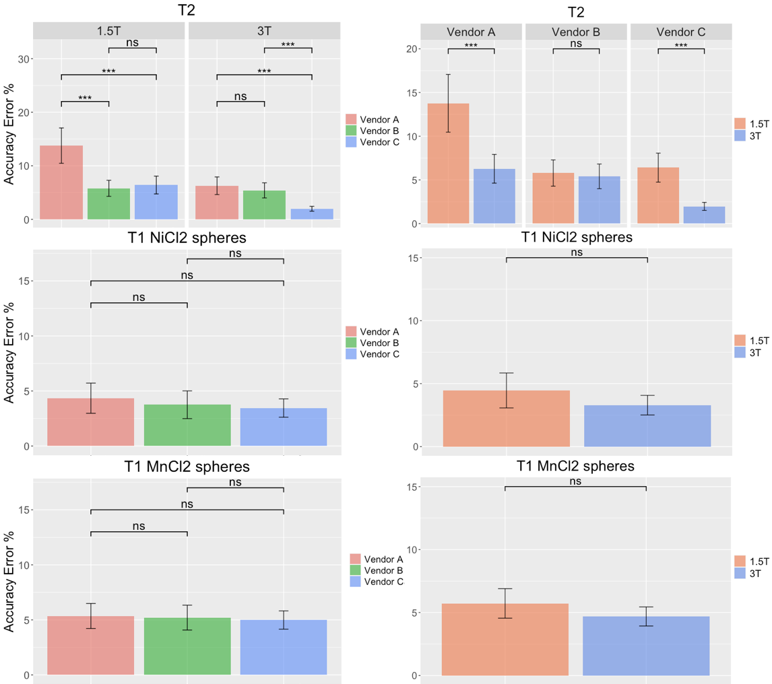

Figure S9: Inter-scanner CV% for T1 measurements performed on the same phantom (model 130)
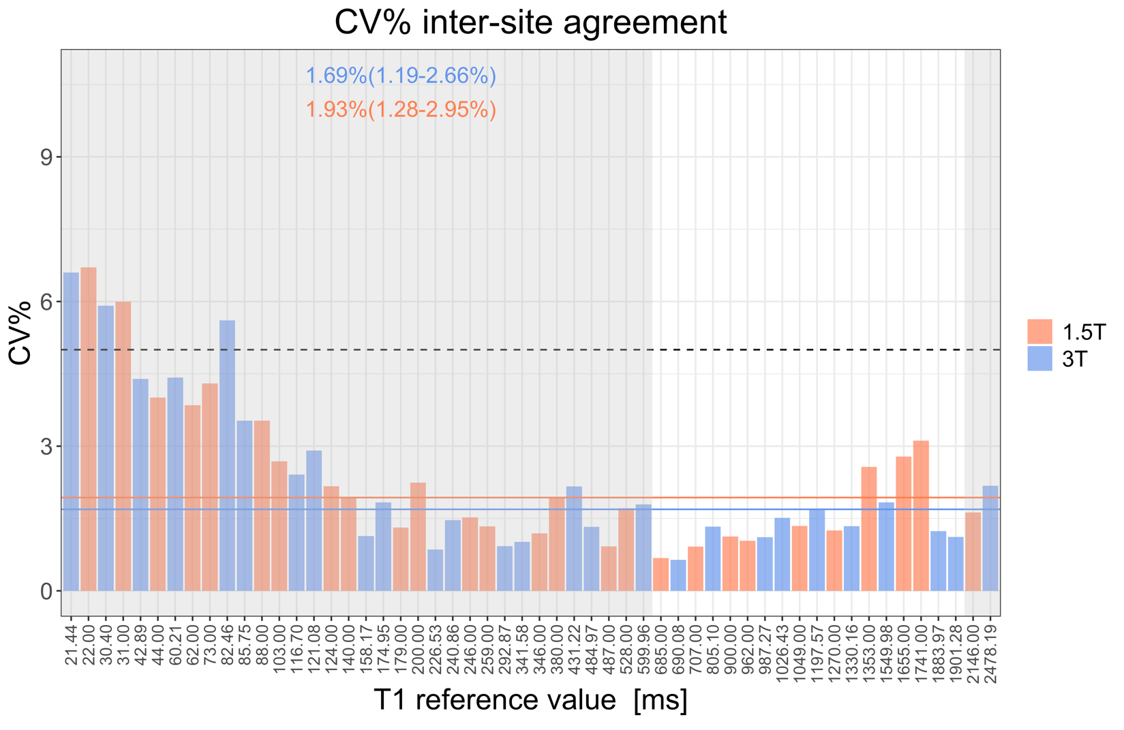

Figure S10: Results of GLMM in the reduced range on precision error for both T1 on NiCl₂ spheres, T1 on MnCl₂ spheres and T2 measurements. All results are reported as least-square means and standard errors
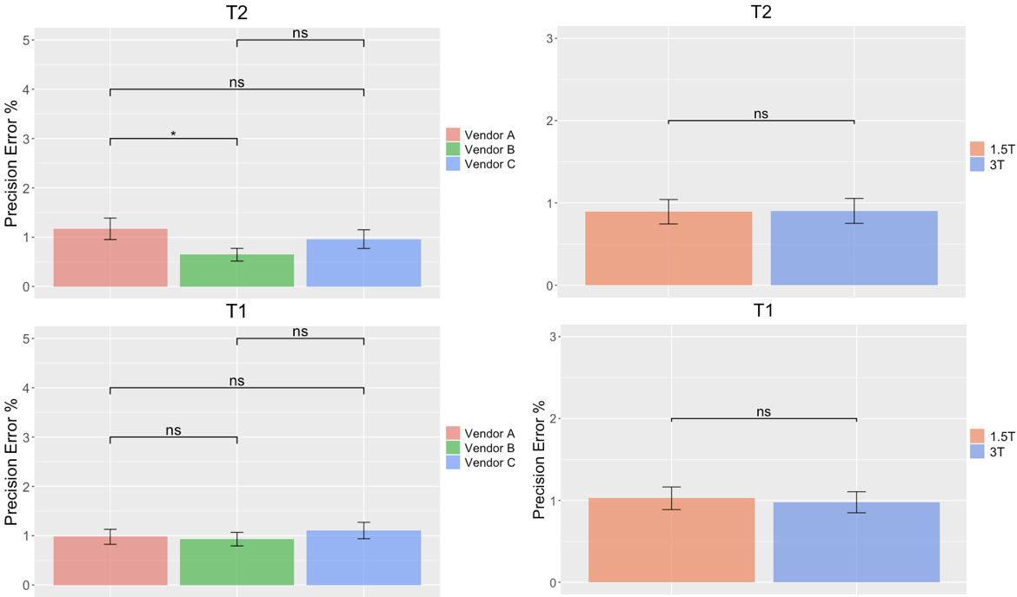

Table S4: Results of T1 and T2 vairance contributions, intra-class correlation coefficient (ICC_{intra}) and inter-class correlation coefficient (ICC_{inter}) are reported for both field strengths

T1
 | 1.5T |  |  |  | 3T
ROI | Reference | ICC_{intra} | ICC_{inter} | ROI | Reference | ICC_{intra} | ICC_{inter}
T2-1 | 2146.00 | 0.133 | 0.867 | T2-1 | 2478.19 | 0.215 | 0.785
T1-1 | 1741.00 | 0.054 | 0.946 | T2-3 | 1901.28 | 0.024 | 0.976
T2-3 | 1655.00 | 0.042 | 0.958 | T1-1 | 1883.97 | 0.553 | 0.447
T2-4 | 1353.00 | 0.173 | 0.827 | T2-4 | 1549.98 | 0.059 | 0.941
T1-2 | 1270.00 | 0.195 | 0.805 | T1-2 | 1330.16 | 0.060 | 0.940
T2-5 | 1049.00 | 0.100 | 0.900 | T2-5 | 1197.57 | 0.149 | 0.851
T1-3 | 962.00 | 0.082 | 0.918 | T2-6 | 1026.43 | 0.064 | 0.936
T2-6 | 900.00 | 0.110 | 0.890 | T1-3 | 987.27 | 0.110 | 0.890
T2-7 | 707.00 | 0.171 | 0.829 | T2-7 | 805.1 | 0.019 | 0.981
T1-4 | 685.00 | 0.241 | 0.759 | T1-4 | 690.08 | 0.628 | 0.372
T2-8 | 528.00 | 0.110 | 0.890 | T2-8 | 599.96 | 0.023 | 0.977
T1-5 | 487.00 | 0.172 | 0.828 | T1-5 | 484.97 | 0.413 | 0.587
T2-9 | 380.00 | 0.442 | 0.558 | T2-9 | 431.22 | 0.337 | 0.663
T1-6 | 346.00 | 0.060 | 0.940 | T1-6 | 341.58 | 0.275 | 0.725
T2-10 | 259.00 | 0.100 | 0.900 | T2-10 | 292.87 | 0.748 | 0.252
T1-7 | 246.00 | 0.030 | 0.970 | T1-7 | 240.86 | 0.138 | 0.862
T2-11 | 200.00 | 0.021 | 0.979 | T2-11 | 226.53 | 0.099 | 0.901
T1-8 | 179.00 | 0.013 | 0.987 | T1-8 | 174.95 | 0.043 | 0.957
T2-12 | 140.00 | 0.119 | 0.881 | T2-12 | 158.17 | 0.224 | 0.776
T1-9 | 124.00 | 0.009 | 0.991 | T1-9 | 121.08 | 0.010 | 0.990
T2-13 | 103.00 | 0.058 | 0.942 | T2-13 | 116.7 | 0.063 | 0.937
T1-10 | 88.00 | 0.001 | 0.999 | T1-10 | 85.75 | 0.020 | 0.980
T2-14 | 73.00 | 0.072 | 0.928 | T2-14 | 82.46 | 0.039 | 0.961
T1-11 | 62.00 | 0.009 | 0.991 | T1-11 | 60.21 | 0.027 | 0.973
T1-12 | 44.00 | 0.055 | 0.945 | T1-12 | 42.89 | 0.037 | 0.963
T1-13 | 31.00 | 0.047 | 0.953 | T1-13 | 30.4 | 0.035 | 0.965
T1-14 | 22.00 | 0.126 | 0.874 | T1-14 | 21.44 | 0.065 | 0.935
MEDIAN (quartile range) | -- | 0.08  (0.05-0.13) | 0.95  (0.87-0.96) | -- | -- | 0.07  (0.04-0.22) | 0.93  (0.78-0.96)
T2
 |  | 1.5T |  |  | 3T
ROI | Reference | ICC_{intra} | ICC_{inter} |  | Reference | ICC_{intra} | ICC_{inter}
T2-1 | 7.00 | 0.010 | 0.990 |  | 5.10 | 0.031 | 0.969
T2-3 | 10.00 | 0.093 | 0.907 |  | 7.27 | 0.018 | 0.982
T2-4 | 15.00 | 0.074 | 0.926 |  | 10.52 | 0.010 | 0.990
T2-5 | 21.00 | 0.017 | 0.983 |  | 14.74 | 0.018 | 0.982
T2-6 | 27.00 | 0.010 | 0.990 |  | 19.40 | 0.008 | 0.992
T2-7 | 42.00 | 0.015 | 0.985 |  | 29.88 | 0.015 | 0.985
T2-8 | 62.00 | 0.051 | 0.949 |  | 44.24 | 0.018 | 0.982
T2-9 | 88.00 | 0.027 | 0.973 |  | 63.42 | 0.017 | 0.983
T2-10 | 123.00 | 0.023 | 0.977 |  | 88.89 | 0.016 | 0.984
T2-11 | 155.00 | 0.022 | 0.978 |  | 112.66 | 0.007 | 0.993
T2-12 | 237.00 | 0.013 | 0.987 |  | 175.05 | 0.129 | 0.871
T2-13 | 355.00 | 0.056 | 0.944 |  | 267.29 | 0.237 | 0.763
T2-14 | 695.00 | 0.056 | 0.944 |  | 552.73 | 0.094 | 0.906
MEDIAN (quartile range) | -- | 0.02  (0.02-0.06) | 0.98  (0.94-0.98) |  | -- | 0.02  (0.01-0.03) | 0.98  (0.97-0.98)

Table S5: Results of T1 and T2 vairance contributions separated for each vendor, intra-class correlation coefficient (ICC_{intra}) and inter-class correlation coefficient (ICC_{inter}) are reported for both field strengths

T1
 |  |  | 1.5T |  |  |  |  |  |  |  |  |  |  |  | 3T
 |  | Vendor |  | A |  | B |  | C |  |  |  |  |  |  |  | A |  | B |  | C
ROI |  | Ref |  | ICC_{intra} | ICC_{inter} | ICC_{intra} | ICC_{inter} | ICC_{intra} | ICC_{inter} |  | ROI |  |  | Ref |  | ICC_{intra} | ICC_{inter} | ICC_{intra} | ICC_{inter} | ICC_{intra} |  | ICC_{inter}
T2-1 |  | 2146.00 |  | 0.052 | 0.948 | 0.341 | 0.659 | 0.292 | 0.708 |  | T2-1 |  |  | 2478.19 |  | 0.283 | 0.717 | 0.196 | 0.804 | — |  | —
T1-1 |  | 1741.00 |  | 0.002 | 0.998 | 0.411 | 0.589 | 0.843 | 0.157 |  | T2-3 |  |  | 1901.28 |  | 0.549 | 0.451 | 0.432 | 0.568 | 0.010 |  | 0.990
T2-3 |  | 1655.00 |  | 0.040 | 0.960 | 0.073 | 0.927 | 0.112 | 0.888 |  | T1-1 |  |  | 1883.97 |  | 0.792 | 0.208 | 0.036 | 0.964 | 0.806 |  | 0.194
T2-4 |  | 1353.00 |  | 0.515 | 0.485 | 0.108 | 0.892 | 0.238 | 0.762 |  | T2-4 |  |  | 1549.98 |  | 0.948 | 0.052 | 0.753 | 0.247 | 0.003 |  | 0.997
T1-2 |  | 1270.00 |  | 0.052 | 0.948 | 0.546 | 0.454 | 0.984 | 0.016 |  | T1-2 |  |  | 1330.16 |  | 0.463 | 0.537 | 0.391 | 0.609 | 0.064 |  | 0.936
T2-5 |  | 1049.00 |  | 0.249 | 0.751 | 0.951 | 0.049 | 0.001 | 0.999 |  | T2-5 |  |  | 1197.57 |  | 0.992 | 0.008 | 0.033 | 0.967 | — |  | —
T1-3 |  | 962.00 |  | 0.005 | 0.995 | 0.290 | 0.710 | 0.358 | 0.642 |  | T2-6 |  |  | 1026.43 |  | 0.318 | 0.682 | 0.052 | 0.948 | 0.105 |  | 0.895
T2-6 |  | 900.00 |  | 0.097 | 0.903 | 0.985 | 0.015 | 0.523 | 0.477 |  | T1-3 |  |  | 987.27 |  | 0.807 | 0.193 | 0.521 | 0.479 | 0.050 |  | 0.950
T2-7 |  | 707.00 |  | 0.238 | 0.762 | 0.833 | 0.167 | 0.100 | 0.900 |  | T2-7 |  |  | 805.1 |  | 0.817 | 0.183 | 0.052 | 0.948 | 0.008 |  | 0.992
T1-4 |  | 685.00 |  | 0.218 | 0.782 | 0.377 | 0.623 | 0.630 | 0.370 |  | T1-4 |  |  | 690.08 |  | 0.700 | 0.300 | 0.349 | 0.651 | 1.000 |  | 0.000
T2-8 |  | 528.00 |  | 0.184 | 0.816 | 0.821 | 0.179 | 0.148 | 0.852 |  | T2-8 |  |  | 599.96 |  | 0.078 | 0.922 | 0.057 | 0.943 | 0.052 |  | 0.948
T1-5 |  | 487.00 |  | 0.361 | 0.639 | 0.594 | 0.406 | 0.563 | 0.437 |  | T1-5 |  |  | 484.97 |  | 0.157 | 0.843 | 0.239 | 0.761 | 0.960 |  | 0.040
T2-9 |  | 380.00 |  | 0.740 | 0.260 | 0.072 | 0.928 | 0.020 | 0.980 |  | T2-9 |  |  | 431.22 |  | 0.644 | 0.356 | 0.014 | 0.986 | 0.625 |  | 0.375
T1-6 |  | 346.00 |  | 0.189 | 0.811 | 0.435 | 0.565 | 0.053 | 0.947 |  | T1-6 |  |  | 341.58 |  | 0.702 | 0.298 | 0.516 | 0.484 | 0.704 |  | 0.296
T2-10 |  | 259.00 |  | 0.106 | 0.894 | 0.990 | 0.010 | 0.110 | 0.890 |  | T2-10 |  |  | 292.87 |  | 0.987 | 0.013 | 0.155 | 0.845 | 0.882 |  | 0.118
T1-7 |  | 246.00 |  | 0.073 | 0.927 | 0.057 | 0.943 | 0.920 | 0.080 |  | T1-7 |  |  | 240.86 |  | 0.770 | 0.230 | 0.245 | 0.755 | 0.406 |  | 0.594
T2-11 |  | 200.00 |  | 0.136 | 0.864 | 0.028 | 0.972 | 0.181 | 0.819 |  | T2-11 |  |  | 226.53 |  | 0.911 | 0.089 | 0.029 | 0.971 | 0.141 |  | 0.859
T1-8 |  | 179.00 |  | 0.095 | 0.905 | 0.375 | 0.625 | 0.072 | 0.928 |  | T1-8 |  |  | 174.95 |  | 0.757 | 0.243 | 0.799 | 0.201 | 0.154 |  | 0.846
T2-12 |  | 140.00 |  | 0.472 | 0.528 | 0.221 | 0.779 | 0.085 | 0.915 |  | T2-12 |  |  | 158.17 |  | 0.840 | 0.160 | 0.360 | 0.640 | 0.264 |  | 0.736
T1-9 |  | 124.00 |  | 0.006 | 0.994 | 0.709 | 0.291 | 0.670 | 0.330 |  | T1-9 |  |  | 121.08 |  | 0.021 | 0.979 | 0.056 | 0.944 | 0.069 |  | 0.931
T2-13 |  | 103.00 |  | 0.197 | 0.803 | 0.192 | 0.808 | 0.033 | 0.967 |  | T2-13 |  |  | 116.7 |  | 0.082 | 0.918 | 0.045 | 0.955 | 0.091 |  | 0.909
T1-10 |  | 88.00 |  | 0.045 | 0.955 | 0.794 | 0.206 | 0.592 | 0.408 |  | T1-10 |  |  | 85.75 |  | 0.084 | 0.916 | 0.083 | 0.917 | 0.081 |  | 0.919
T2-14 |  | 73.00 |  | 0.023 | 0.977 | 0.196 | 0.804 | 0.123 | 0.877 |  | T2-14 |  |  | 82.46 |  | 0.092 | 0.908 | 0.016 | 0.984 | 0.108 |  | 0.892
T1-11 |  | 62.00 |  | 0.254 | 0.746 | 1.000 | 0.000 | 0.018 | 0.982 |  | T1-11 |  |  | 60.21 |  | 0.976 | 0.024 | 0.305 | 0.695 | 0.121 |  | 0.879
T1-12 |  | 44.00 |  | 0.641 | 0.359 | 0.141 | 0.859 | 0.002 | 0.998 |  | T1-12 |  |  | 42.89 |  | 0.906 | 0.094 | 0.474 | 0.526 | 0.123 |  | 0.877
T1-13 |  | 31.00 |  | 0.587 | 0.413 | 0.014 | 0.986 | 0.511 | 0.489 |  | T1-13 |  |  | 30.4 |  | 0.704 | 0.296 | 0.163 | 0.837 | 0.231 |  | 0.769
T1-14 |  | 22.00 |  | 0.446 | 0.554 | 0.088 | 0.912 | 0.008 | 0.992 |  | T1-14 |  |  | 21.44 |  | 0.962 | 0.038 | 0.985 | 0.015 | 0.319 |  | 0.681
Median  (quartile range) |  | -- |  | 0.18 (0.05-0.31) | 0.82 (0.69-0.95) | 0.38 (0.12-0.75) | 0.63 (0.25-0.88) | 0.15 (0.06-0.54) | 0.85 (0.46-0.94) |  | -- |  |  | -- |  | 0.70 (0.30-0.87) | 0.30 (0.13-0.70) | 0.20 (0.05-0.41) | 0.80 (0.59-0.95) | 0.12 (0.07-0.41) |  | 0.87 (0.59-0.93)
T2
 |  | 1.5T |  |  |  |  |  |  | 3T
 | Vendor | A |  | B |  | C |  |  | A |  | B |  | C
ROI | Ref | ICC_{intra} | ICC_{inter} | ICC_{intra} | ICC_{inter} | ICC_{intra} | ICC_{inter} | Ref | ICC_{intra} | ICC_{inter} | ICC_{intra} | ICC_{inter} | ICC_{intra} | ICC_{inter}
T2-1 | 695.00 | 0.443 | 0.557 | 0.664 | 0.336 | 0.019 | 0.981 | 552.73 | 0.240 | 0.760 | 0.366 | 0.634 | — | —
T2-3 | 355.00 | 0.050 | 0.950 | 0.344 | 0.656 | 0.088 | 0.912 | 267.29 | 0.019 | 0.981 | 0.607 | 0.393 | 0.561 | 0.439
T2-4 | 237.00 | 0.020 | 0.980 | 0.221 | 0.779 | 0.044 | 0.956 | 175.05 | 0.502 | 0.498 | 0.323 | 0.677 | 0.021 | 0.979
T2-5 | 155.00 | 0.232 | 0.768 | 0.999 | 0.001 | 0.520 | 0.480 | 112.66 | 0.612 | 0.388 | 0.014 | 0.986 | — | —
T2-6 | 123.00 | 0.944 | 0.056 | 0.654 | 0.346 | 0.053 | 0.947 | 88.89 | 0.086 | 0.914 | 0.010 | 0.990 | 0.139 | 0.861
T2-7 | 88.00 | 0.700 | 0.300 | 0.720 | 0.280 | 0.030 | 0.970 | 63.42 | 0.999 | 0.001 | 0.008 | 0.992 | 0.061 | 0.939
T2-8 | 62.00 | 0.755 | 0.245 | 0.617 | 0.383 | 0.114 | 0.886 | 44.24 | 0.707 | 0.293 | 0.018 | 0.982 | 0.523 | 0.477
T2-9 | 42.00 | 0.079 | 0.921 | 0.948 | 0.052 | 0.296 | 0.704 | 29.88 | 0.017 | 0.983 | 0.003 | 0.997 | 0.500 | 0.500
T2-10 | 27.00 | 0.226 | 0.774 | 0.125 | 0.875 | 0.201 | 0.799 | 19.4 | 0.305 | 0.695 | 0.030 | 0.970 | 0.882 | 0.118
T2-11 | 21.00 | 0.170 | 0.830 | 0.007 | 0.993 | 0.605 | 0.395 | 14.74 | 0.632 | 0.368 | 0.196 | 0.804 | 0.801 | 0.199
T2-12 | 15.00 | 0.193 | 0.807 | 0.575 | 0.425 | 0.921 | 0.079 | 10.52 | 0.020 | 0.980 | 0.517 | 0.483 | 0.872 | 0.128
T2-13 | 10.00 | 0.020 | 0.980 | 0.471 | 0.529 | 0.364 | 0.636 | 7.27 | 0.102 | 0.898 | 0.154 | 0.846 | 0.957 | 0.043
T2-14 | 7.00 | 0.117 | 0.883 | 0.053 | 0.947 | 0.051 | 0.948 | 5.1 | 0.768 | 0.232 | 0.077 | 0.923 | 0.942 | 0.058
Median  (quartile range) | -- | 0.19 (0.08-0.44) | 0.81 (0.56-0.91 | 0.58 (0.22-0.66) | 0.43 (0.36-0.78) | 0.11 (0.05-0.36) | 0.89 (0.64-0.95) |  | 0.30 (0.08-0.63) | 0.70 (0.37-0.91) | 0.08 (0.01-0.32) | 0.92 (0.68-0.98) | 0.56 (0.32-0.88) | 0.44 (0.12-0.68)

Table S6: Within scanner accuracy error% expressed in terms of median, first and third quartile from mono-exponetianl fit and StimFit both in the full range and in the physiologically relevant range for kidneys. P-values of paired sample Wilcoxon signed-rank tests comparing the accuracy errors between the two models are reported for each scanner (ns = p>0.05, * = p<0.05, ** p <0.01, *** = p<0.001).

Accuracy Error %
Scanner | T2 |  |  | T2 (physiologically relevant range)
Scanner | Mono-exponential | StimFit | P-value | Mono-exponential | StimFit | P-value
1 | 22.30 (11.13-23.43) | 22.72 (13.61-26.93) | 0.52 | 19.81 (12.68-23.15) | 16.45 (9.06-21.81) | 0.06
2 | 16.34 (13.60-18.00) | 8.21(6.14-9.81) | <0.001 *** | 14.28 (12.75-17.11) | 7.18 (5.66-9.41) | <0.05 *
3 | 14.93 (11.72-17.60) | 8.23 (5.84-10.58) | <0.001 *** | 13.19 (11.29-15.91) | 6.60 (4.76-9.26) | <0.05 *
4 | 18.32 (16.13-20.62) | 17.95 (15.69-22.03) | 0.24 | 20.18 (18.68-22.97) | 17.09 (15.42-21.53) | <0.05 *
5 | 7.27 (4.45-8.51) | 6.92 (5.54-8.92) | 0.74 | 8.79 (7.36-12.38) | 7.89 (6.56-10.58) | 0.56
6 | 9.34 (6.75-11.59) | 5.89 (3.44-8.00) | 0.09 | 12.06 (9.62-14.09) | 6.37 (3.77-9.69) | <0.05 *
7 | 13.89 (9.85-20.87) | 7.44 (3.83-11.60) | 0.30 | 10.07 (8.52-14.15) | 6.53 (4.27-9.93) | <0.05 *
8 | 19.11 (12.82-23.96) | 11.59 (2.49-20.50) | 0.22 | 19.83 (18.51-22.29) | 3.70 (2.16-7.52) | <0.05 *
9 | 20.03 (13.76-27.12) | 8.11 (4.19-23.50) | 0.17 | 20.20 (18.52-23.84) | 5.06 (3.15-6.53) | <0.05 *
10 | 13.67 (9.45-18.43) | 10.80 (5.24-18.00) | 0.64 | 10.86 (9.00-13.32) | 7.51 (5.05-10.45) | <0.05 *
11 | 24.85 (20.98-31.90) | 14.00 (3.21-24.73) | 0.08 | 25.75 (20.12-30.97) | 7.14 (2.18-12.95) | <0.05 *
12 | 2.53 (1.43-3.11) | 1.39 (0.50-2.20) | 0.49 | 2.53 (1.73-3.12) | 1.24 (0.24-1.69) | 0.31
13 | 2.16 (1.42-5.37) | 2.96 (1.43-5.05) | 0.64 | 3.76 (1.81-5.80) | 3.43 (2.66-4.63) | 0.56
*P < 0.05; **P < 0.01; ***P < 0.001.

