SUPPLEMENTARY MATERIAL
Search strategy
A comprehensive search was conducted among the main database platforms, as Scopus, MEDLINE (PubMed platform), EMBASE and Web of Science Core Collection (Clarivate) to May, 2024. Keywords as “EUS”, “GBD”, “gallbladder drainage”, “malignant biliary obstruction” and “EUS biliary drainage”, were used into various strings. One of the used string is: “((((EUS-GBD) OR (EUS guided gallbladder drainage) OR (EUS gallbladder)) AND (malignant biliary obstruction))) AND (EUS-BD)) OR (EUS biliary drainage)”.
Supplementary figure 1. Flowchart showing the results of the search and the review process. Eight studies were included in the pooled analysis
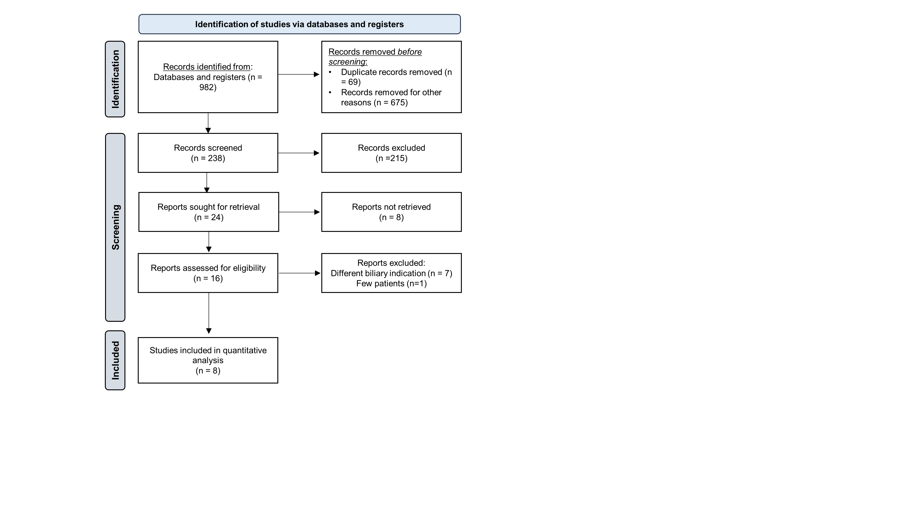

Supplementary figure 2. Pooled mean age among studies divided according to geographical areas (European vs Extra-European)
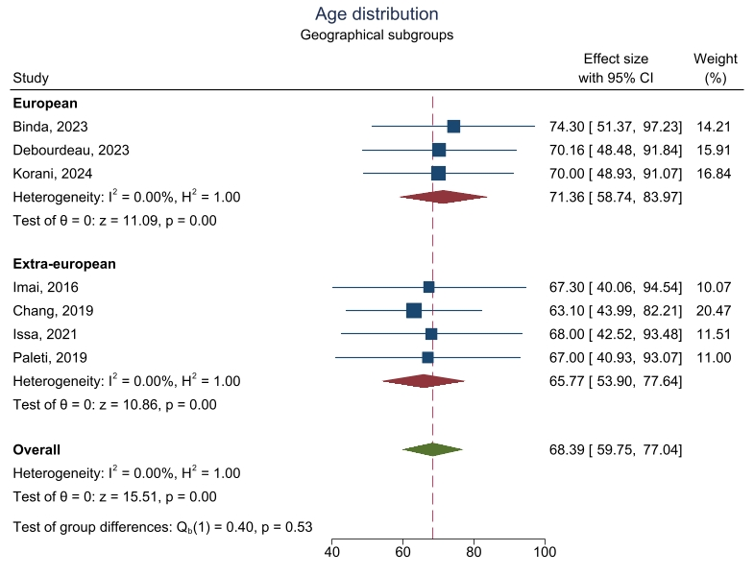
Supplementary figure 3. Gender distribution among studies
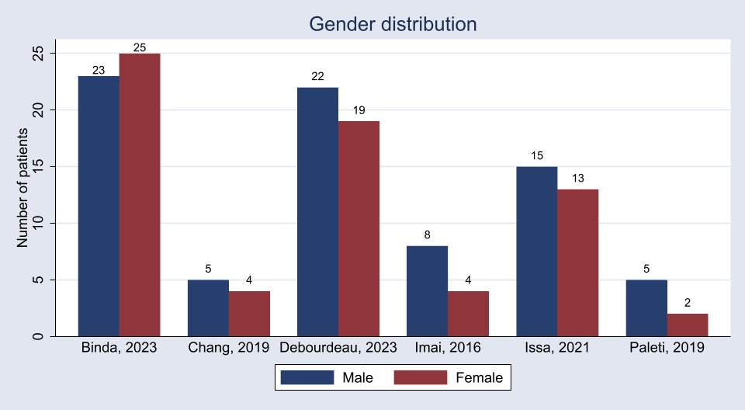

Supplementary figure 4. Mean bilirubin before procedure among the four studies with extractable data. I²=0%, p=0.468
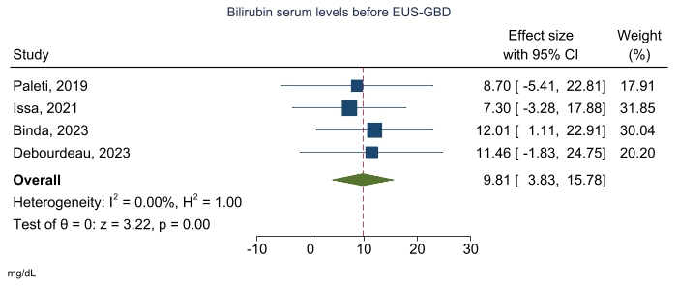
Supplementary figure 5. Mean bilirubin after procedure among the three studies with extractable data. I²=0%, p=0.960
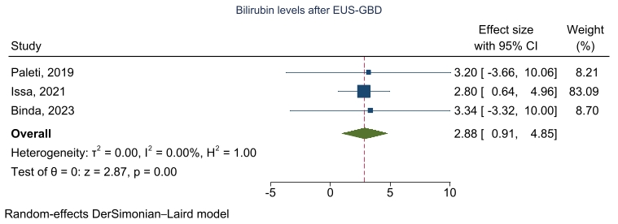

Supplementary figure 6. Subgroup analysis evaluating clinical success based on the definition of clinical success (decrease of bilirubin > 50% vs other)
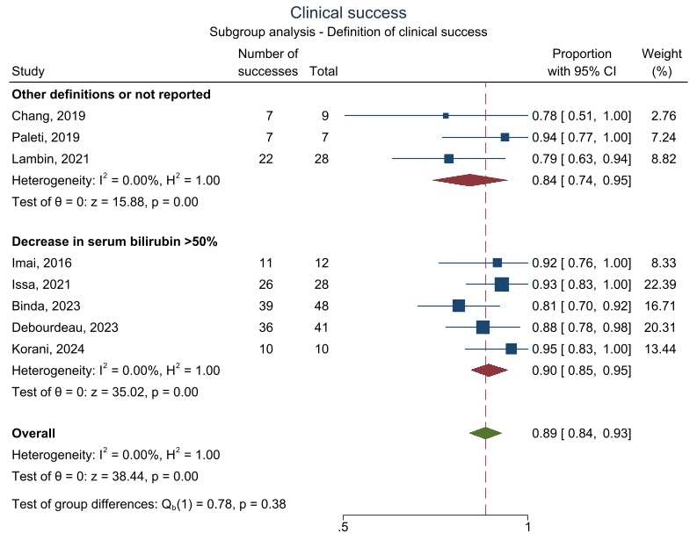
Supplementary figure 7. Subgroup analysis evaluating clinical success based on the involved centers (Single center vs multicentric studies)
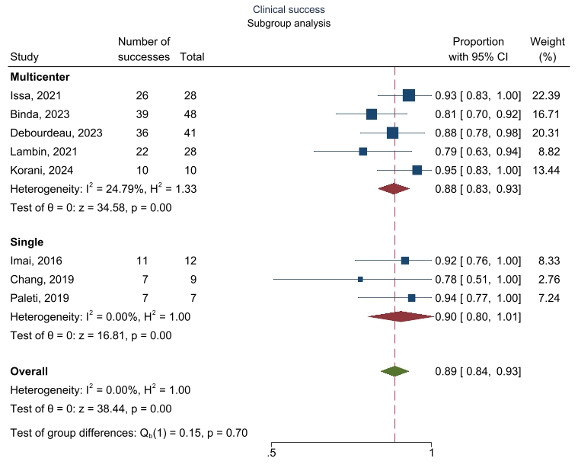
Supplementary figure 8. Subgroup analysis evaluating clinical success based on the quality of the studies (low quality ≤3, moderate quality 4-5, high quality ≥6)
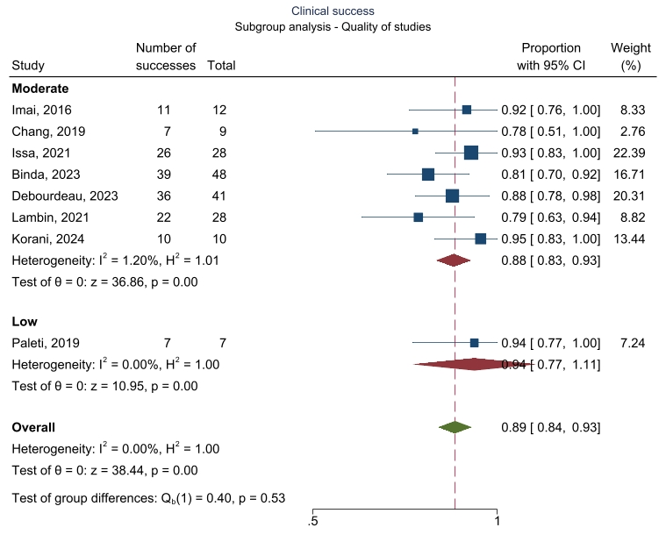
Supplementary figure 9. Subgroup analysis evaluating safety based on the involved centers (Single center vs multicentric studies)
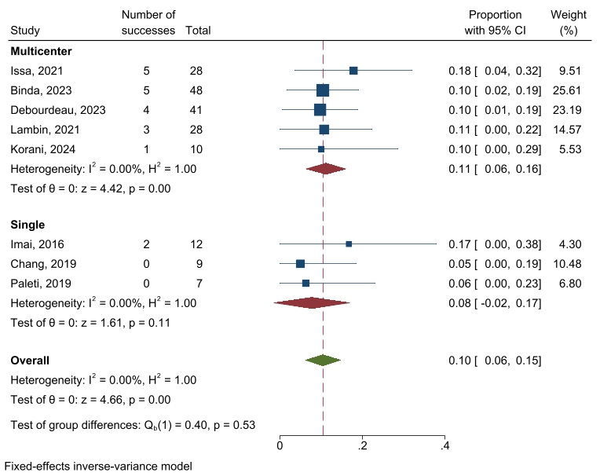

Supplementary figure 10. Subgroup analysis evaluating safety based on the quality of the studies (low quality ≤3, moderate quality 4-5, and high quality ≥6)
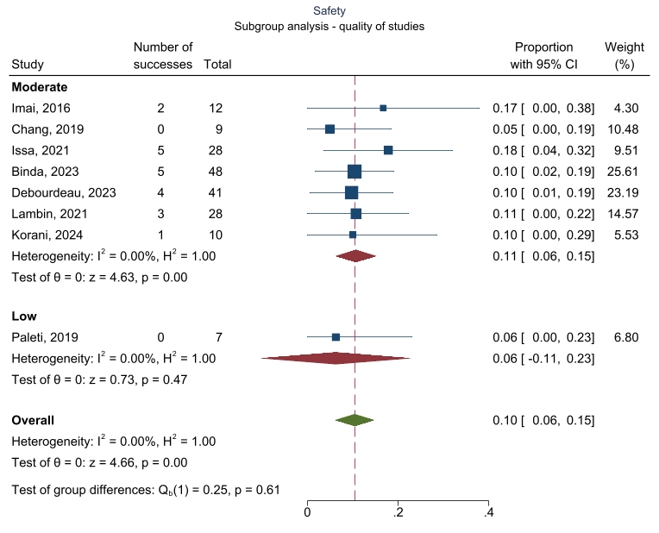
Supplementary figure 11. Subgroup analysis evaluating safety based on the type of stent used.
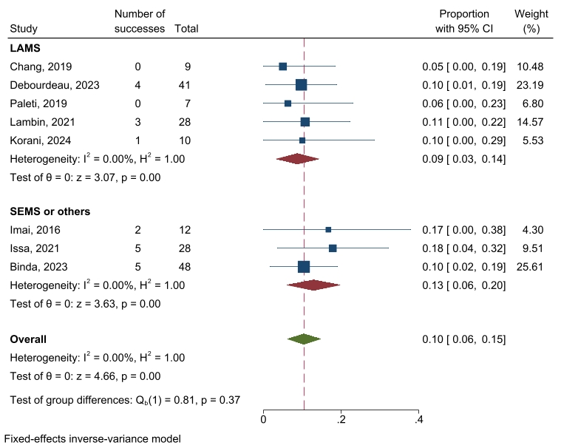

Supplementary figure 12. Subgroup analysis evaluating reintervention rate based on the type of failure (ERCP alone vs both ERCP and EUS-BD)
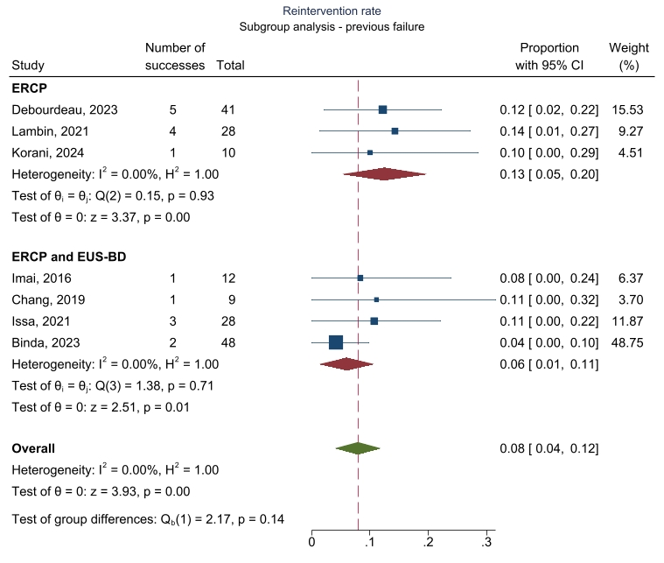

Supplementary Table 1. The Modified New Castle-Ottawa quality assessment scale (NOS) (1)
Study population | 1. Did study group derive from population of interest?  2. Ascertainment of exposure  3. Demonstration that outcome of interest was not present at the start of the study
Comparability | 4. Did the study include a comparative cohort?
Outcomes assessment and confounders | 5. Is the measure of outcome valid?  6. Potential confounders identified (e.g., comorbidities, multicomponent interventions, etc.)?  7. Adequacy of follow up

Supplementary Table 2. The evaluation of the quality among studies according to the Modified New Castle-Ottawa quality assessment scale (NOS)
Study | Representativeness | Ascertainment of exposure | Selection | Comparability | Assessment of outcomes? | Confounders | Adequacy of follow-up | Overall Quality Score  (Maximum = 6)
Imai, 2016 (2) | ★ | ★ | ★ | - | ★ | - | - | 4
Chang, 2019 (3) | ★ | ★ | ★ | - | - | - | ★ | 4
Paleti, 2019 (4) | ★ | ★ | ★ | - | - | - | - | 3
Issa, 2021 (5) | ★ | ★ | ★ | - | ★ | - | ★ | 5
Lambin, 2021 (6) | ★ | ★ | ★ | - | - | - | ★ | 4
Binda,2023 (7) | - | ★ | ★ | - | ★ | - | ★ | 4
Debourdeau, 2023 (8) | ★ | ★ | ★ | ★ | - | - | ★ | 5
Korani, 2024 (9) | ★ | ★ | ★ | - | ★ | - | ★ | 5

REFERENCES
1. NEWCASTLE - OTTAWA QUALITY ASSESSMENT SCALE COHORT STUDIES.
2. Imai H, Kitano M, Omoto S, Kadosaka K, Kamata K, Miyata T, et al. EUS-guided gallbladder drainage for rescue treatment of malignant distal biliary obstruction after unsuccessful ERCP. Gastrointestinal Endoscopy. 2016 Jul;84(1):147–51.
3. Chang JI, Dong E, Kwok KK. Endoscopic ultrasound-guided transmural gallbladder drainage in malignant obstruction using a novel lumen-apposing stent: a case series (with video). Endosc Int Open. 2019 May;7(5):E655–61.
4. Paleti S, Gulati R, Sánchez-Luna SA, Ling C, Rustagi T. Su1191 EUS-GUIDED GALL BLADDER DRAINAGE USING LUMEN APPOSING METAL STENT FOR MALIGNANT BILIARY OBSTRUCTION. Gastrointestinal Endoscopy. 2019 Jun;89(6):AB308.
5. Issa D, Irani S, Law R, Shah S, Bhalla S, Mahadev S, et al. Endoscopic ultrasound-guided gallbladder drainage as a rescue therapy for unresectable malignant biliary obstruction: a multicenter experience. Endoscopy. 2021 Aug;53(08):827–31.
6. Lambin T, Branche J, Privat J, Bourgaux J, Koch S, Palazzo M, et al. Efficacy and Safety of Eus-Guided Transmural Gallbladder Drainage In Malignant Biliary Obstruction Using an Electrocautery-Enhanced Lumen Apposing Metal Stent: a French Multicenter Study. In Going virtual. Staying real.; 2021 [cited 2024 May 22]. p. s-0041-1724353. Available from: http://www.thieme-connect.de/DOI/DOI?10.1055/s-0041-1724353
7. Binda C, Anderloni A, Fugazza A, Amato A, De Nucci G, Redaelli A, et al. EUS-guided gallbladder drainage using a lumen-apposing metal stent as rescue treatment for malignant distal biliary obstruction: a large multicenter experience. Gastrointestinal Endoscopy. 2023 Nov;98(5):765–73.
8. Debourdeau A, Daniel J, Caillo L, Assenat E, Bertrand M, Bardol T, et al. Effectiveness of endoscopic ultrasound (EUS)‐guided choledochoduodenostomy vs. EUS‐guided gallbladder drainage for jaundice in patients with malignant distal biliary obstruction after failed endoscopic retrograde cholangiopancreatography: Retrospective, multicenter study (GALLBLADEUS Study). Digestive Endoscopy. 2024 Feb 21;den.14750.
9. Korani. P396 (ENDOSCOPIC ULTRASOUND) GUIDED GALLBLADDER DRAINAGE (EUS-GBD) FOR DISTAL MALIGNANT BILIARY OBSTRUCTION(D-MBO), FIRST UK MULTICENTER EXPERIENCE OF A NOVEL RESCUE PROCEDURE. In: Poster Presentations [Internet]. BMJ Publishing Group Ltd and British Society of Gastroenterology; 2024 [cited 2024 Nov 19]. p. A293.2-A294. Available from: https://gut.bmj.com/content/73/Suppl_1/A293.1

