Do languages open doors? A Theoretical Model of Linguistic Capital and (Im)Mobility and its application in Spanish Youth Migration
APPENDIX
Tabla de contenido
1. Age and internal migration. 3
Figure A1. Number of interregional migration and age in Spain, 2015-2019 3
2. Ethnic niche. 3
Table B1. Determinants of being employed in public sector positions requiring proficiency in a minority language: Logistic Regression Model, Average Marginal Effects. 5
3. Descriptive statistics. 5
Figure C1. Descriptive statistics 5
4. Full tables. 5
Table D1. Determinants of Internal Migration: Logistic Regression Model, Average Marginal Effects. 6
Table D2. Effect of bilingualism on the probability of being an economic internal migrant: Logistic Regression Model, Average Marginal Effects. 7
5. Robustness check: use region of residence before starting studies as reference. 8
Table E1. Determinants of Internal Migration: Logistic Regression Model, Average Marginal Effects. Region of residence before studies as reference. 8
Figure E1. Determinants of Internal Migration within Catalan-Speaking Regions: Multinomial Regression Model, Average Marginal Effects. Region of residence before studies as reference. 10
6. Determinants of international migration aspirations 10
Figure F1. Determinants of international migration aspirations (without bilingualism and foreign language skills). Lineal Probabilistic Models (LPM). 10
7. Sensitivity analysis of mediation effects 10
Figure G1. Sensitivity analysis of mediation effects. 95% CI (1000 Simulations). 12
8. Other robustness tests: Educational level, parental education and an study of the subsample of internal migrants. 12
Figure H1. The effect of educational attainment and bilingualism on internal migration: Logistic Regression Model, Average Marginal Effects 13
Figure H2. The effect of parental education and bilingualism on internal migration: Logistic Regression Model, Average Marginal Effects 14
Figure H3. Effects of bilingualism on the probability of economic internal migration versus other reasons for internal: Logistic Regression Model, Average Marginal Effects 15

Age and internal migration.
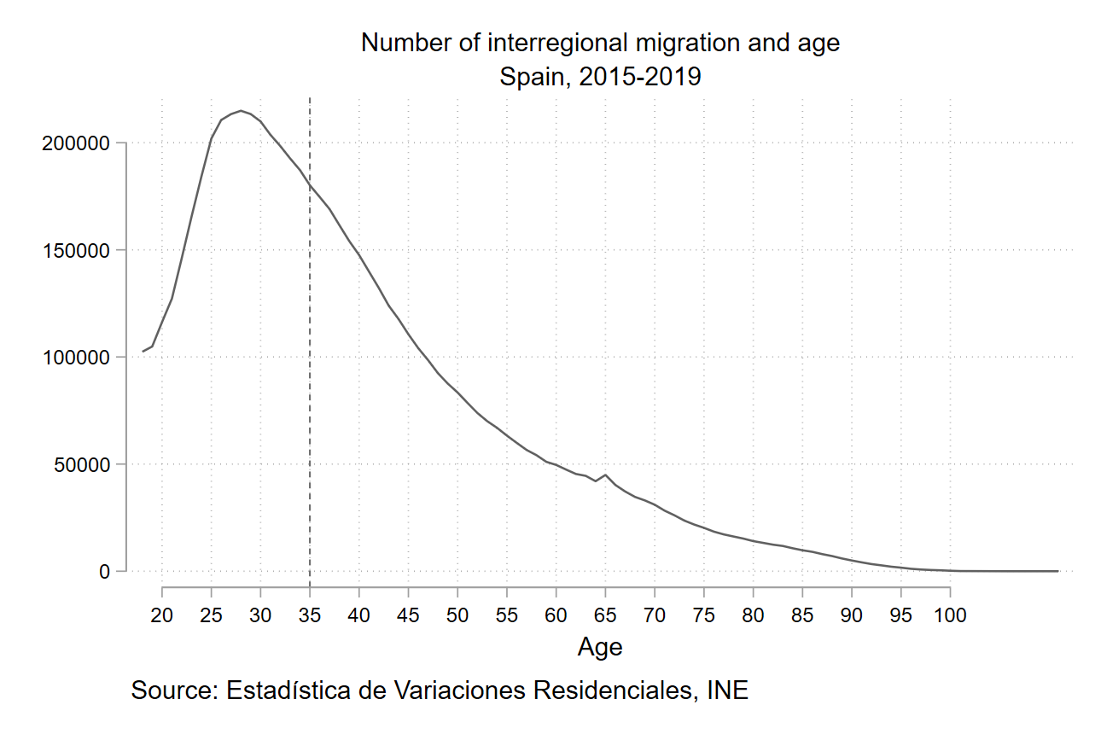

Figure A1. Number of interregional migration and age in Spain, 2015-2019

Ethnic niche.
In this academic paper, one of the arguments presented is related to the immobility of bilinguals, specifically focusing on how the institutional and legal framework favors their concentration in economic sectors where bilingualism provides a competitive advantage over monolinguals. The presence of an ethnic niche is examined by analyzing the probability that bilinguals are overrepresented in such niches. To assess the presence of an ethnic niche, a dummy variable is constructed, with 1 representing a job in public administration where knowledge of the two co-official languages is a legal advantage or a prerequisite for entry, and 0 if it is not. This information is obtained from the National Classification of Economic Activities (CNAE) for each profession, which is the Spanish adaptation of the list NACE for the European Community. In table B1, I present the results of logistic regressions of the probability of being currently working in the public administration within bilingual regions. The results, reported in average marginal effects, are calculated for the three separated areas, showing support to the existence of a niche market. Being bilingual in Catalan/Valencian is associated, on average, with a 4.76% increase in the probability of being employed in public positions within Catalonian/Valencian territories, compared to non-bilinguals, while holding all other factors constant. The average increase rises to 8.31% for Basque bilinguals compared to non-bilinguals and about a 6.52% average increase in the case of Galicians.
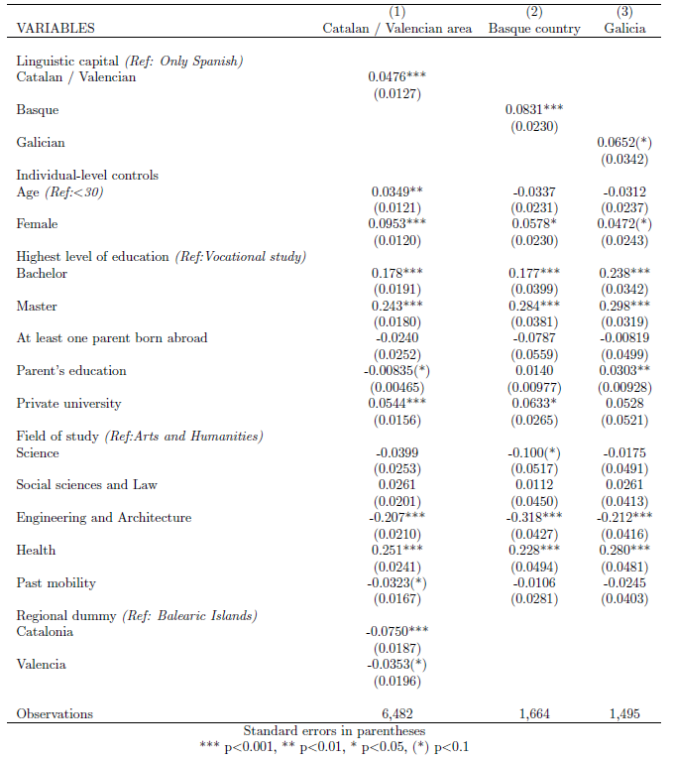

Table B1. Determinants of being employed in public sector positions requiring proficiency in a minority language: Logistic Regression Model, Average Marginal Effects.

Descriptive statistics.
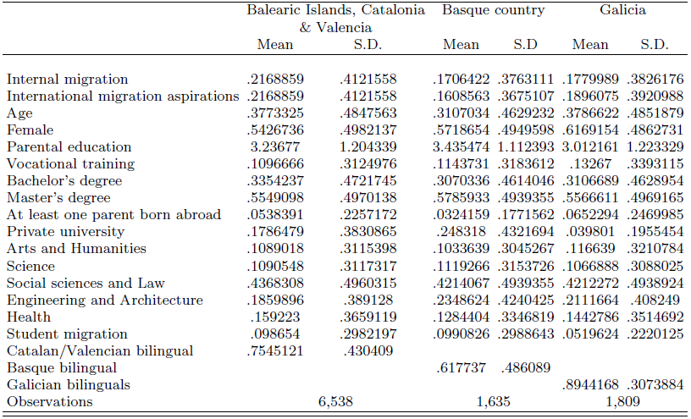

Figure C1. Descriptive statistics

Full tables.

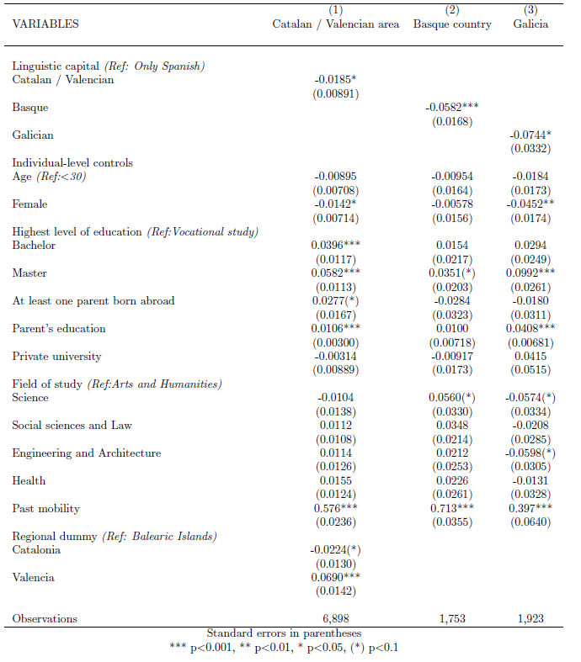

Table D1. Determinants of Internal Migration: Logistic Regression Model, Average Marginal Effects.

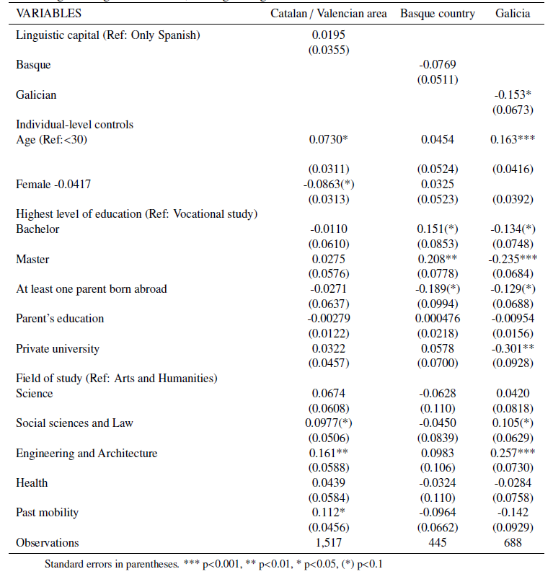

Table D2. Effect of bilingualism on the probability of being an economic internal migrant: Logistic Regression Model, Average Marginal Effects.

Robustness check: use region of residence before starting studies as reference.
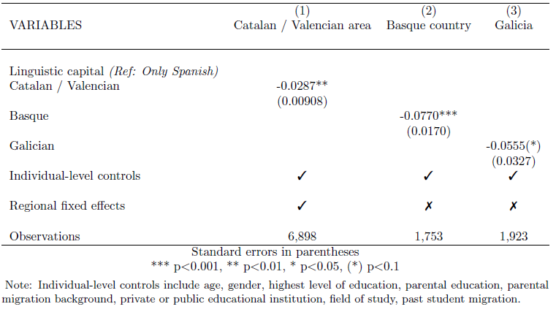

Table E1. Determinants of Internal Migration: Logistic Regression Model, Average Marginal Effects. Region of residence before studies as reference.

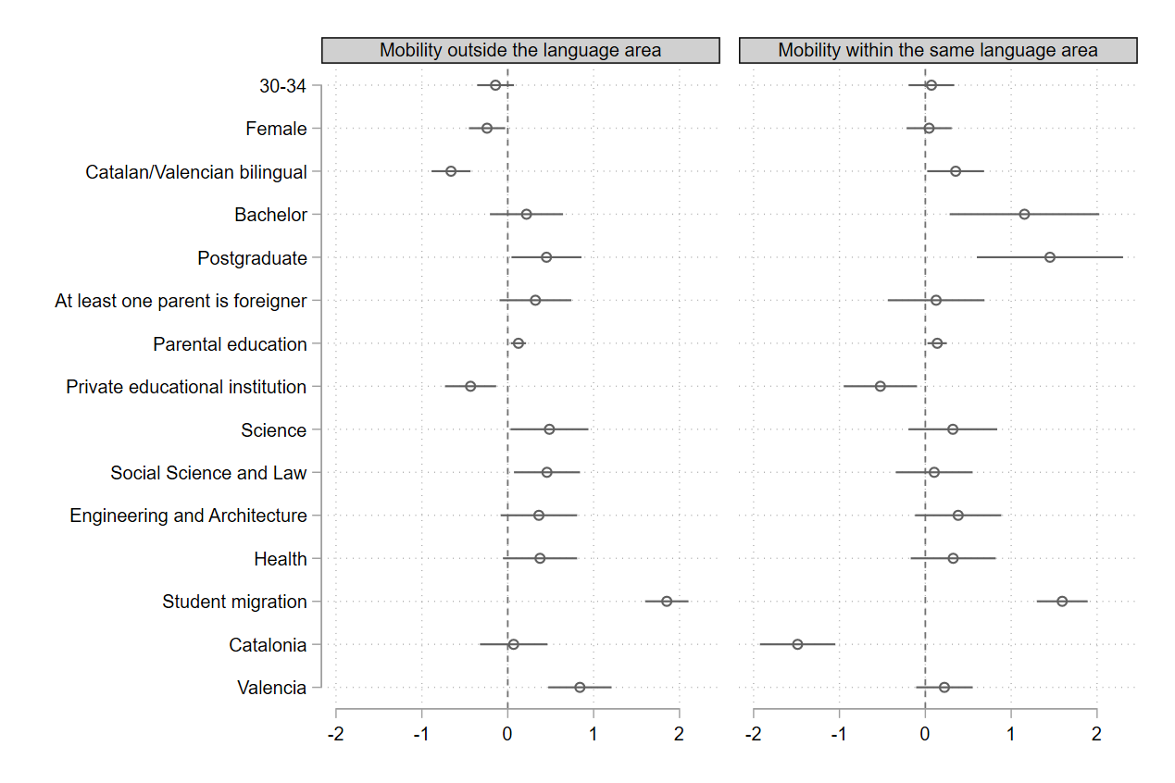

Figure E1. Determinants of Internal Migration within Catalan-Speaking Regions: Multinomial Regression Model, Average Marginal Effects. Region of residence before studies as reference.

Determinants of international migration aspirations
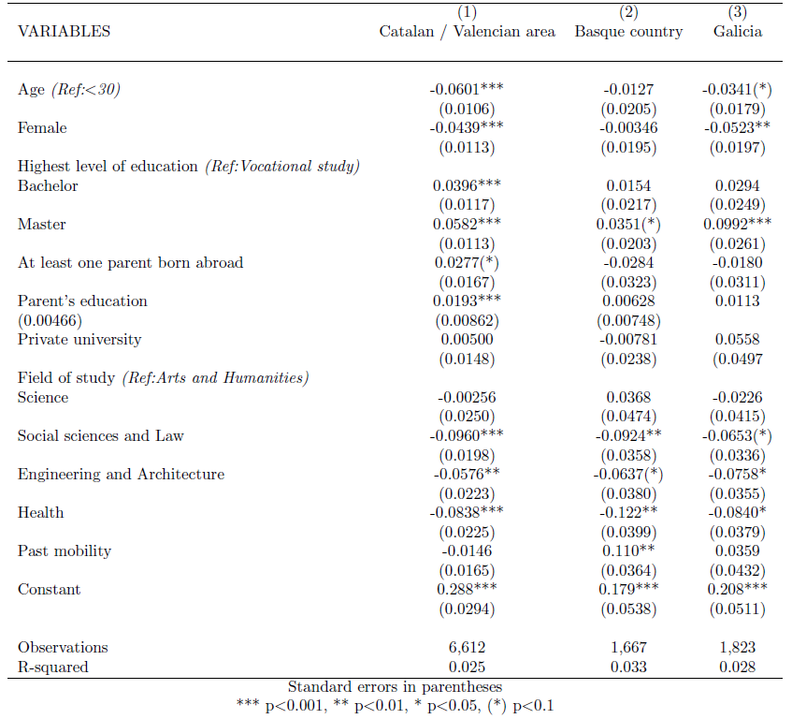

Figure F1. Determinants of international migration aspirations (without bilingualism and foreign language skills). Lineal Probabilistic Models (LPM).

Sensitivity analysis of mediation effects

Figure G1 shows the sensitivity analysis using the STATA package 'medsens' (Hicks & Tingley, 2011) for all outcomes with a statistically significant indirect effect. Each plot displays the expected indirect effect for different values of the parameter p, which measures the influence of all omitted contributors between the mediator and outcome. The p indicates when the outcome would nullify the analysis and reverse its results. Regarding the strength of correlation, mediation analysis is applicable as long as the correlation between error terms falls between 0.10 and 0.20, depending on the foreign language. To provide a benchmark, the $R^{2}$ of the regression of migration aspirations with all control variables (except for foreign language proficiency and bilingualism) ranges from 2% to 3.3%, depending on the language area. This implies that the correlation between omitted variables and the outcome should be at least 5 to 3 times higher than that of observable confounders.
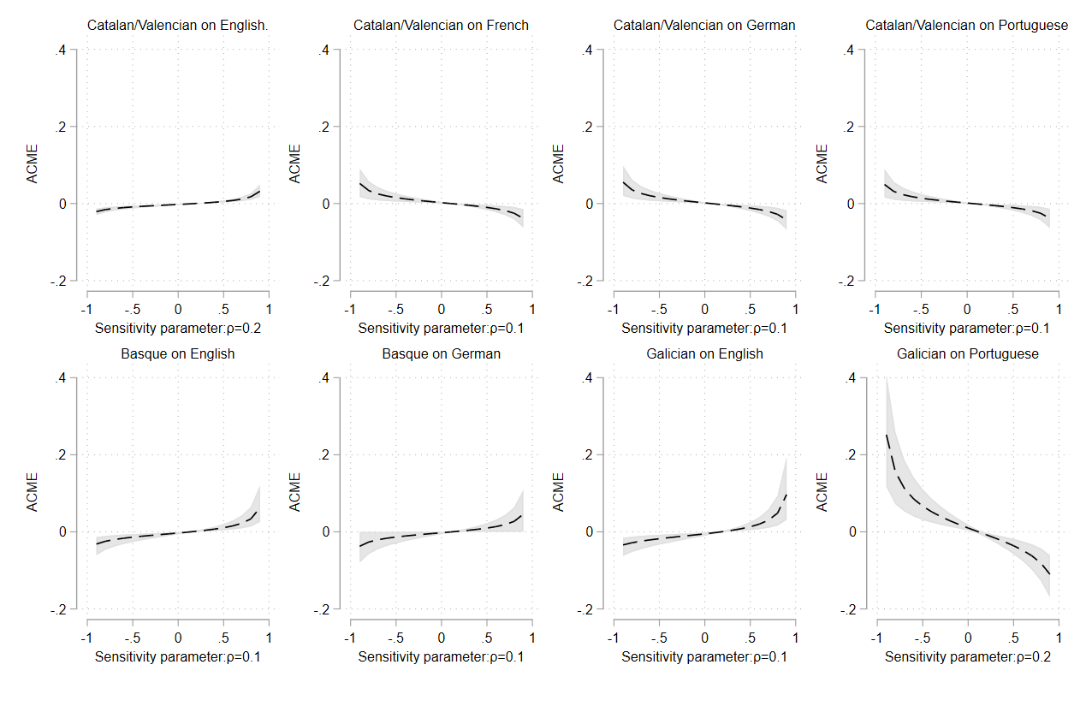

Figure G1. Sensitivity analysis of mediation effects. 95% CI (1000 Simulations).

Other robustness tests: Educational level, parental education and an study of the subsample of internal migrants.
In the first analysis, represented in Figure H1, I explored the interaction between bilingualism and educational attainment, considering the potential complementarity of linguistic capital with other forms of human capital. The findings indicate that in the Catalonian/Valencian and Basque regions, the likelihood of immobility for bilinguals, compared to monolinguals, increases with their level of education. Interestingly, the trend appears to be reversed for Galician speakers. Nonetheless, bilingualism still exerts a greater influence on immobility than monolingualism across all communities. This pattern is particularly evident considering that access to public sector positions, a channel often associated with the returns of bilingualism, typically requires higher education levels.
In Figure H2, I examined the interaction with parental education, which sheds light on how linguistic capital intersects with social class, especially given historical associations between class composition and language use in bilingual regions. The results consistently indicate a tendency toward immobility among bilinguals with more educated parents compared to monolinguals in all regions. However, the magnitude of this effect varies, with Catalonian/Valencian regions exhibiting a less pronounced slope compared to Basque and Galician regions, where the effect of immobility is notably more significant. These findings underscore the independent influence of language proficiency on immobility, irrespective of social origin and historical language usage patterns.
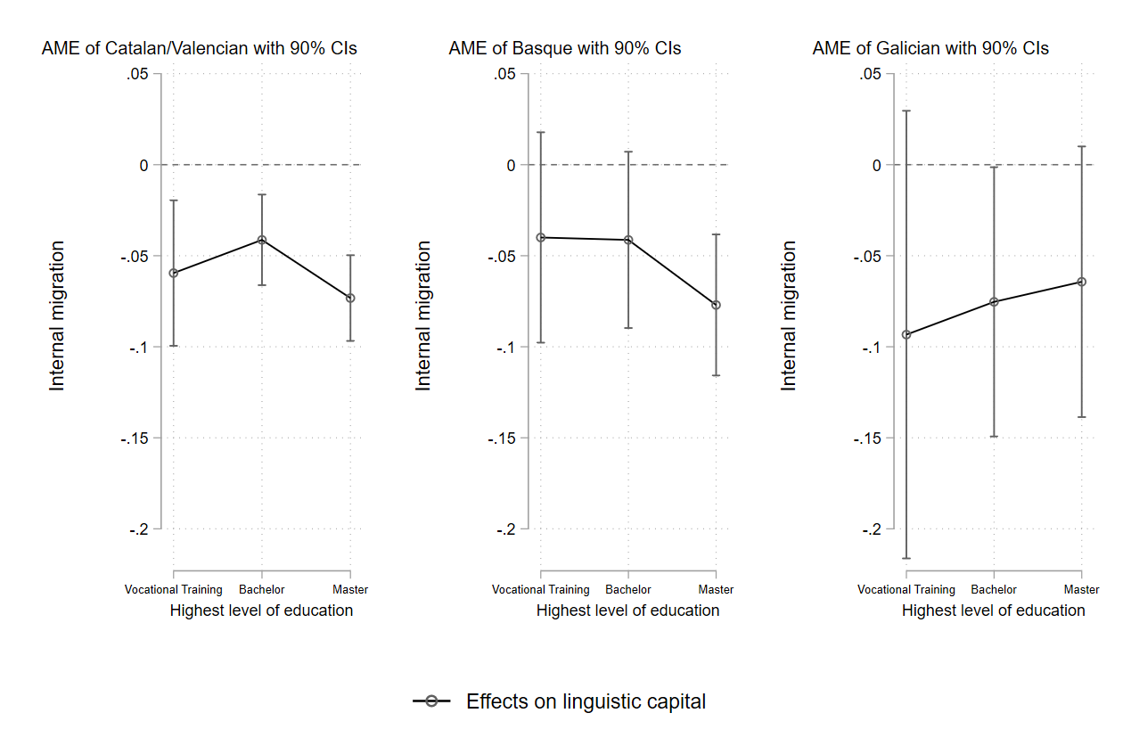

Figure H1. The effect of educational attainment and bilingualism on internal migration: Logistic Regression Model, Average Marginal Effects

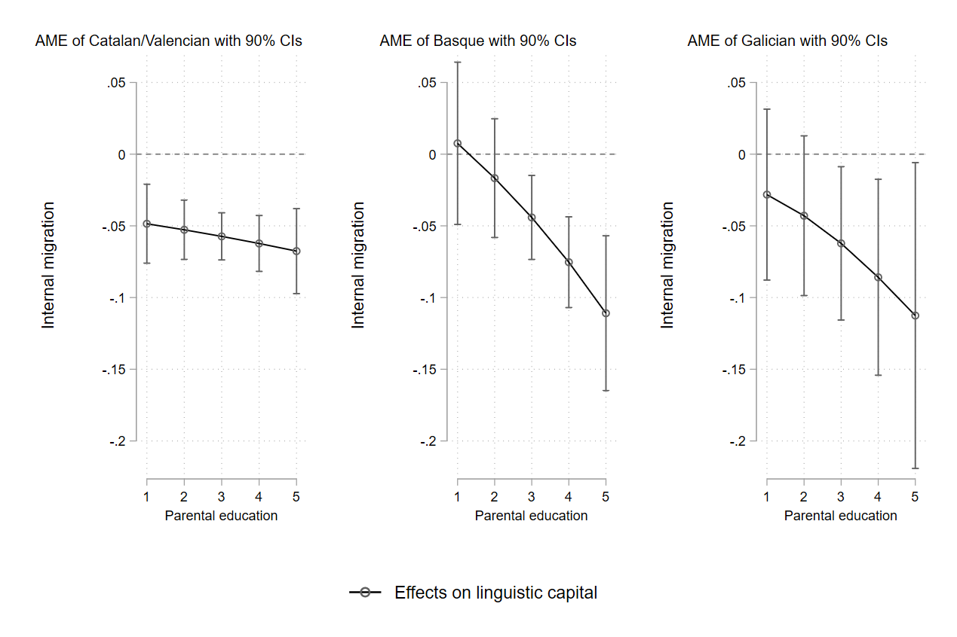

Figure H2. The effect of parental education and bilingualism on internal migration: Logistic Regression Model, Average Marginal Effects

Finally, if my argument holds true, the primary reasons underlying immobility should primarily stem from the instrumental returns of the regional labor market. Although data on the specific reasons for "immobility" is unavailable, we can infer from the motives for internal migration within these regions, where information on several factors such as job opportunities, education, and personal/family considerations is available. Figure H3 illustrates the average marginal effects (AME) of a logistic regression on internal migration for economic reasons, combining responses related to job-seeking activities. The results predominantly indicate a negative effect of bilingualism on economic migration in the Galician region, consistent with my hypotheses. Additionally, although statistical significance thresholds are not met, likely due to the smaller sample size of internal migrants, confidence intervals suggest potential negative effects on economic migration for Basque bilinguals. This reinforces the idea that bilingual individuals may be less inclined to seek economic opportunities outside their linguistic communities.
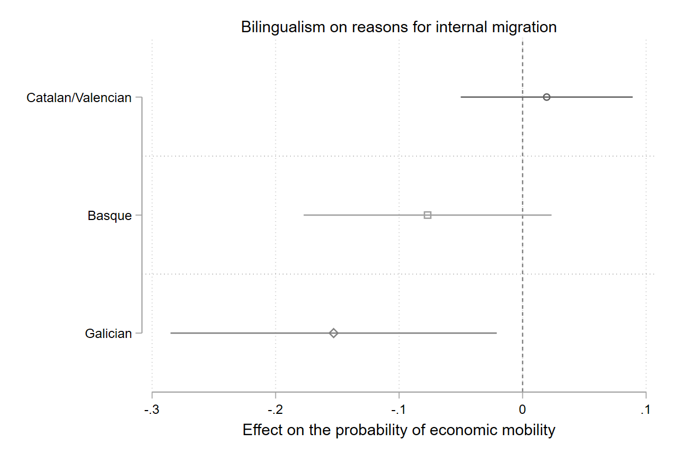

Figure H3. Effects of bilingualism on the probability of economic internal migration versus other reasons for internal migration: Logistic Regression Model, Average Marginal Effects

More precisely, these professions are those included in the inscriptions on public administration and defense, education, and health and social services.

