Name | Docking Score (Kcal/mol) | Interaction Summary
A | -6,7 | 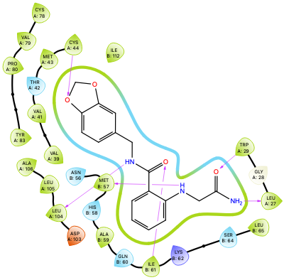
B | -6,9 | 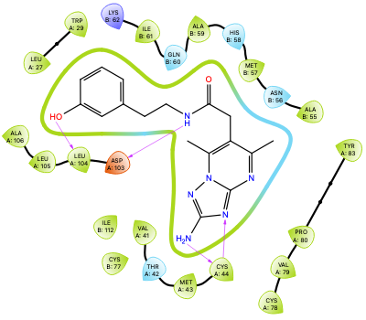
C | -7,2 | 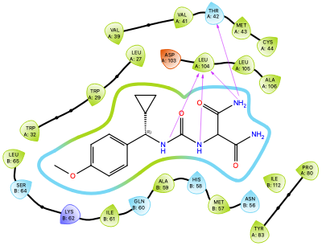
D | -9,7 | 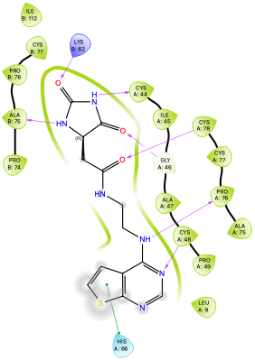
E | -8,9 | 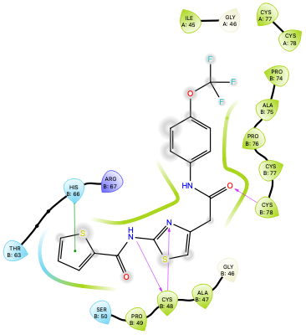
F | -9,2 | 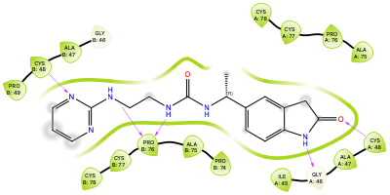
Suppl. Table 1: Docking score and interaction diagrams for the selected compounds

