SUPPLEMENT

Title: Predicting de-novo portal vein thrombosis after HCV eradication: a long-term competing risk analysis in the ongoing PITER cohort

Table of contents
Supplementary tables ……………………………………………………………………………………………………………………...2
Supplementary figure ……………………………………………………………………………………………………………….……..5

Supplementary Table 1 – Pre-treatment variables associated with PVT occurrence in never decompensated DAA successfully treated patients. Competing Risk model results.

 | Univariable |  |  | Multivariable
Pre-treatment factors | SubHR | 95% CI | p | SubHR | 95% CI | p
Gender (ref. male) | 1.31 | 0.53-3.22 | 0.561
Age (increasing years) | 1.01 | 0.96-1.07 | 0.599
Esophageal varices (ref. absence) | 8.49 | 2.20-22.50 | <0.001 | 7.57 | 2.59-22.16 | <0.001
Platelets (ref. >120,000/µL) | 17.38 | 2.32-130.35 | 0.005
ALBI (ref. grade 1) | 4.67 | 1.37-15.94 | 0.014 | 8.74 | 2.15-35.53 | 0.002
INR (ref. < 1.1) | 1.88 | 0.74-4.77 | 0.184
PVT events N=19
SubHR=subHazard Ratio. CI= Confidence Interval.

Supplementary Table 2 – Post-treatment variables associated with PVT occurrence in never decompensated DAA successfully treated patients. Competing Risk model results.

 | Univariable |  |  | Multivariable
Variables | SubHR | 95% CI | p | SubHR | 95% CI | p
Gender (ref. male) | 0.84 | 0.29-2.39 | 0.739
Age (increasing years) | 1.02 | 0.97-1.08 | 0.413
Esophageal varices (ref. absence) | 11.58 | 3.61-37.12 | <0.001 | 7.44 | 2.53-21.84 | <0.001
Post-treatment factors
Platelets (ref. >120,000/µL) | 7.86 | 1.75-35.30 | 0.007
ALBI (ref. grade 1) | 13.00 | 2.89-58.37 | 0.001 | 8.43 | 2.08-34.24 | 0.003
PVT events N=14.
SubHR: subHazard Ratio. CI= Confidence Interval.

Supplementary Table 3 – Adverse liver-related events by PVT occurrence.

 |  | No PVT (N=1577*) |  | PVT occurrence (N=32*) |  |  | TOTAL  (N=1609*)
Events |  | N. | % | N. | % | p*** | N. | %
Death |  | 76 | 4.8 | 9 | 28.1 | <0.001 | 85 | 5.3
Cause of death | Liver related | 33 | 43.4 | 4 | 44.4 | 0.165 | 37 | 43.5
 | Non Liver related | 19 | 25.0 | 0 | 0.0 |  | 19 | 22.4
 | Unclassified | 24 | 31.6 | 5 | 55.6 |  | 29 | 34.1
Liver Transplant |  | 32 | 2.0 | 1 | 3.1 | 0.665 | 33 | 2.1
HCC | Pre-therapy | 121 | 7.7 | 3 | 9.4 | <0.001 | 124 | 7.7
 | Post-therapy | 96 | 6.1 | 9 | 28.1 |  | 105 | 6.5
Decompensation | Pre-therapy | 94 | 6.0 | 3 | 12.5 | <0.001 | 97 | 6.0
 | Pre/Post-therapy | 72 | 4.6 | 9 | 28.1 |  | 82 | 5.1
 | Post-therapy | 84 | 5.3 | 12** | 37.5 |  | 96 | 6.0

* For some variables inconsistencies are due to missing values
** Three out of 12 decompensating event occurred before PVT; of the 9 patients who experienced hepatic decompensation after development of PVT, 3 experienced variceal hemorrhage and 6 experienced ascites with/without hepatic encephalopathy.
*** p value Chi-square test

Supplementary Figure 1 – Comparison of the main comorbidities in percent rates between cases with and without de novo PVT occurrence.

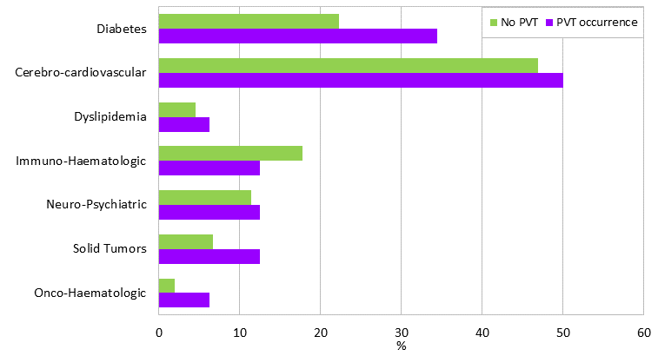

Chi-square test shows no significant association between No PVT and PVT groups for any comorbidity (all p value>0.05).

