APPENDIX 3
TABLE S3.1. Occurrences of the absence (0) or the presence (1) loci of fusion for the cervical (ncf_C) and caudal (ncf_Ca) vertebrae with their respective references. FAD and LAD of each taxon are reported in the last two columns on the right.
Taxon | ncf_C | ncf_Ca | References | FAD (Mya) | LAD (Mya)
Alligator | 0 | 1 | Brochu (1996); Verrière et al. (2022) | 23.04 | 0
Allosauroidea indet. | 1 | 1 | Malafaia et al. (2017) | 152.21 | 149.2
Anhanguera | 1 | 1 | Kellner & Tomida (2000); Griffin et al. (2021) | 119.57 | 113.2
Barosaurus | 1 | 1 | Melstrom et al. (2016) | 157.9 | 145.06
Bonitasaura | 1 | 1 | Gallina (2011); Verrière et al. (2022) | 85.7 | 83.6
Camarasaurus | 1 | 1 | Ikejiri (2003); Verrière et al. (2022) | 161.5 | 143.1
Camptosaurus | 0 | 1 | Gilmore (1909, 1925); Irmis (2007); Carpenter & Wilson (2008) | 154.8 | 143.1
Chasmosaurus | 0 | 1 | Currie et al. (2016); Griffin et al. (2021) | 83.6 | 72.2
Coelophysis | 1 | 1 | Griffin (2018); Griffin et al. (2021) | 227.3 | 201.4
Crocodylus | 0 | 1 | Brochu (1996) | 23.04 | 0
Desmatosuchus | 0 | 1 | Irmis (2007); Verrière et al. (2022) | 237 | 205.7
Dilong | 1 | 1 | Xu et al. (2004); Verrière et al. (2022) | 125.77 | 119.57
Dromaius | 1 | 1 | Verrière et al. (2022); Caldwell et al. (2025) | 15.98 | 0
Dryosaurus | 0 | 1 | Galton (1981); Verrière et al. (2022) | 154.8 | 143.1
Dysalotosaurus | 1 | 1 | This study; Hübner (2018) | 152.21 | 149.2
Effigia | 0 | 1 | Nesbitt (2007) | 205.7 | 201.4
Eustreptospondylus | 0 | 1 | Sadleir et al. (2008); Verrière et al. (2022) | 165.3 | 161.5
Galeamopus | 1 | 1 | Tschopp & Mateus (2017) | 154.8 | 145.06
Haplocanthosaurus | 0 | 1 | Hatcher (1903); Irmis (2007) | 154.8 | 145.06
Hyperodapedon | 1 | 1 | Heinrich et al. (2021); Verrière et al. (2022) | 237 | 205.7
Hypsilophodon | 0 | 1 | Galton (1974, 2009); Verrière et al. (2022) | 125.77 | 119.57
Majungasaurus | 1 | 1 | O'Connor (2007); Griffin et al. (2021) | 72.2 | 66
Microraptor | 1 | 1 | Wang & Pei (2025); Caldwell et al. (2025) | 121.4 | 113.2
Montanoceratops | 1 | 0 | Chinnery & Weishampel (1998); Verrière et al. (2022) | 72.2 | 66
Nqwebasaurus | 1 | 0 | De Klerk et al. (2000); Verrière et al. (2022) | 143.1 | 132.6
Oksoko | 0 | 1 | Funston (2024); Caldwell et al. (2025) | 72.2 | 66
Osteolaemus | 0 | 1 | Brochu (1996) | 11.63 | 0
Pantydraco | 0 | 1 | Galton & Kermarck (2010) | 237 | 227.3
Plateosaurus | 0 | 1 | Hofmann & Sander (2014); Griffin et al. (2021) | 227.3 | 201.4
Protoceratops | 1 | 0 | Brown & Schlaikjer (1940); Irmis (2007) | 83.6 | 72.2
‘Raptorex' | 1 | 1 | Fowler et al. (2011) | 125.77 | 66
Spinophorosaurus | 0 | 1 | Fronimos & Wilson (2017) | 170.9 | 165.3
Sterna | 1 | 0 | Verrière et al. (2022); Starck (1993) | 4.7 | 0
Suskityrannus | 1 | 1 | Nesbitt et al. (2019); Caldwell et al. (2025) | 93.9 | 89.8
Thecodontosaurus | 0 | 1 | Yates (2003); Irmis (2007) | 246.7 | 201.4
‘Troodon' | 1 | 1 | Caldwell et al. (2025) | 83.6 | 66
Wulong | 1 | 1 | Poust et al. (2020); Caldwell et al. (2025) | 121.4 | 113.2
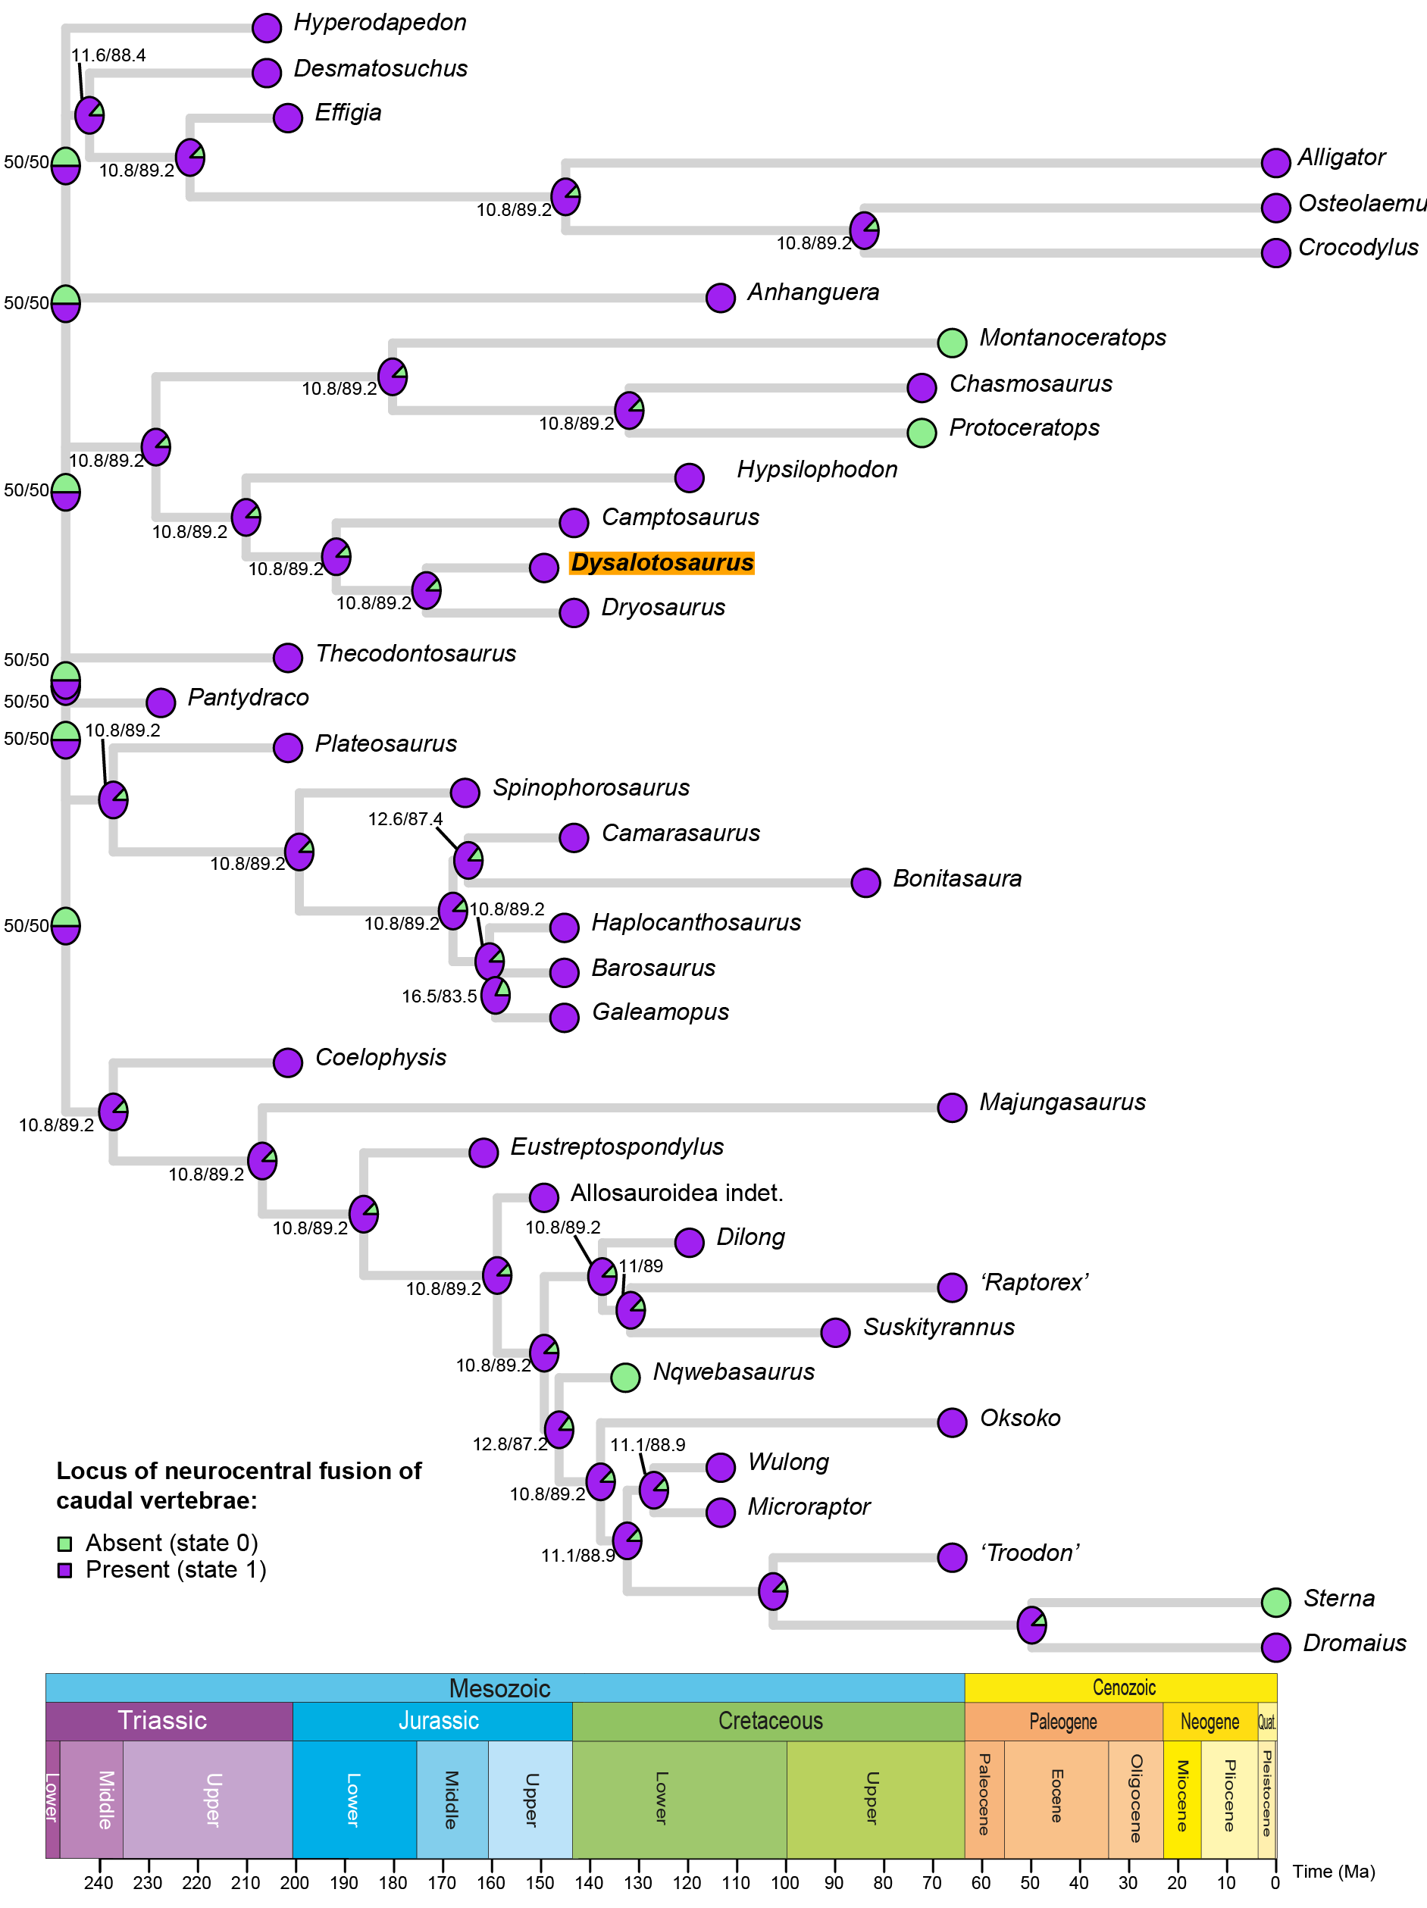
FIG. S3.1. ASR on the presence of the locus of neurocentral fusion of caudal vertebrae. The position of Dysalotosaurus is highlighted in orange. Circles at tips show taxon states, pie charts at nodes show likelihoods of ancestral states. Key shows colors corresponding to the two different states. The time scale is modified from the International Chronostratigraphic Chart v2024/12 (Cohen et al. 2013).

