Supplementary Material
PUBMED
("ivabradine"[MeSH Terms] OR "ivabradine"[MeSH Terms] OR "ivabradine"[All Fields] OR "ivabradin"[All Fields] OR "ivabradine s"[All Fields] OR "corlentor"[All Fields] OR "procoralan"[All Fields]) AND (clinicaltrial[Filter] OR randomizedcontrolledtrial[Filter])

EMBASE
('ivabradine'/exp OR ivabradine) AND ([controlled clinical trial]/lim OR [randomized controlled trial]/lim)

Table S1
List of PTs used to retrieve these suspected reactions
- Supraventricular tachyarrhythmias (SMQ)
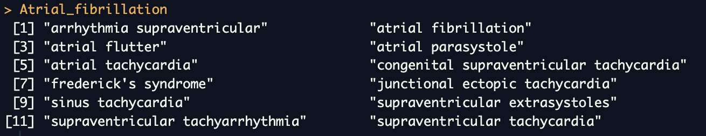
- Ischemic central nervous system vascular conditions (SMQ)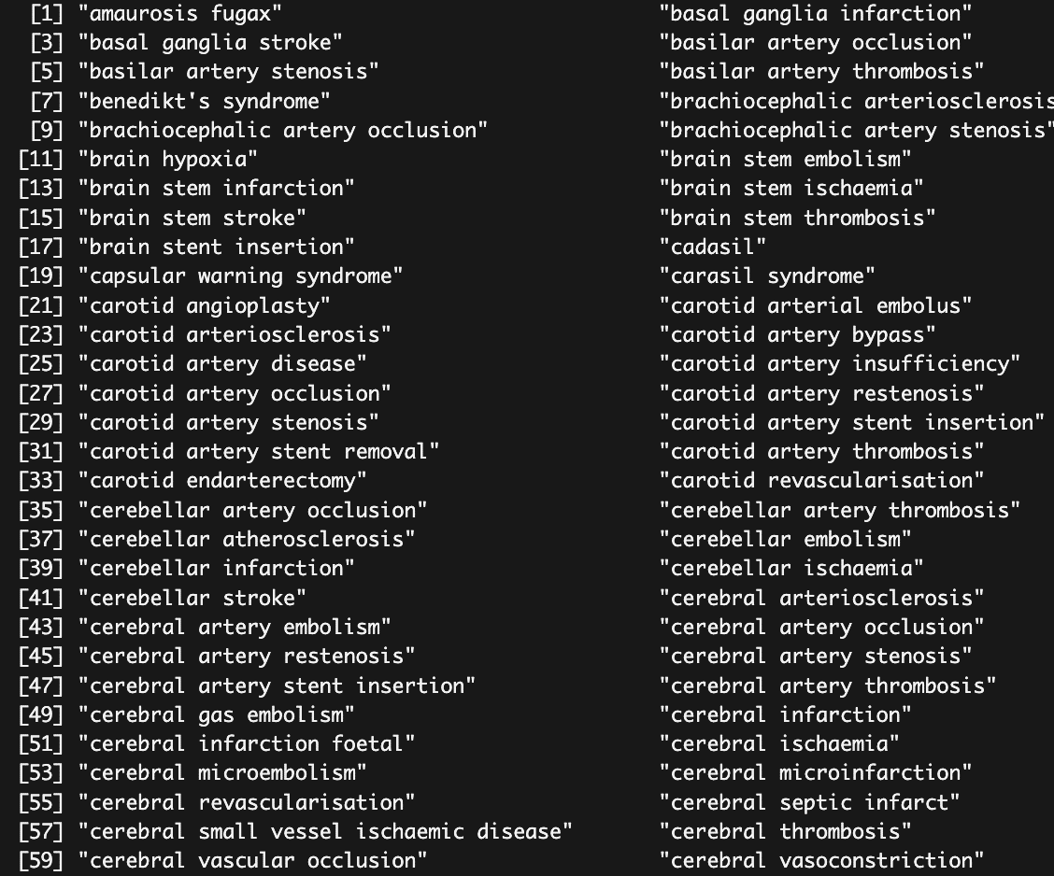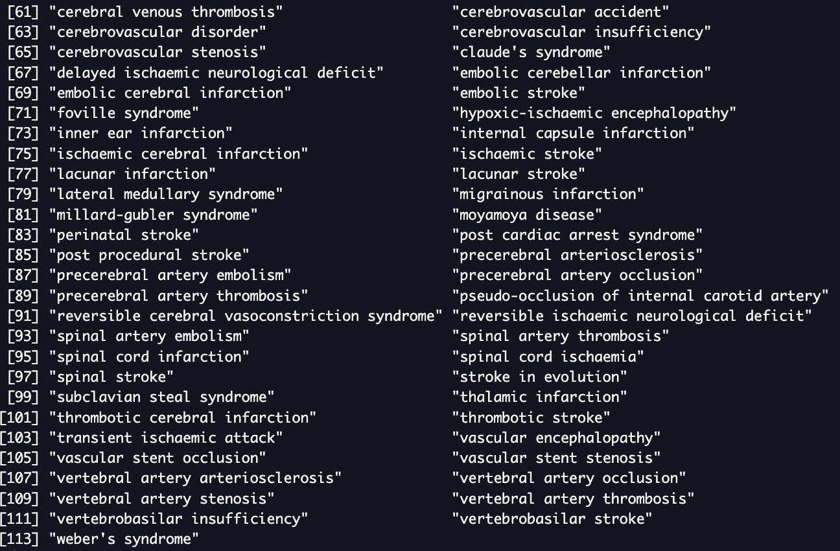
Table S2
List of PTs used to retrieve these approved indications
- Ischemic heart disease (SMQ)
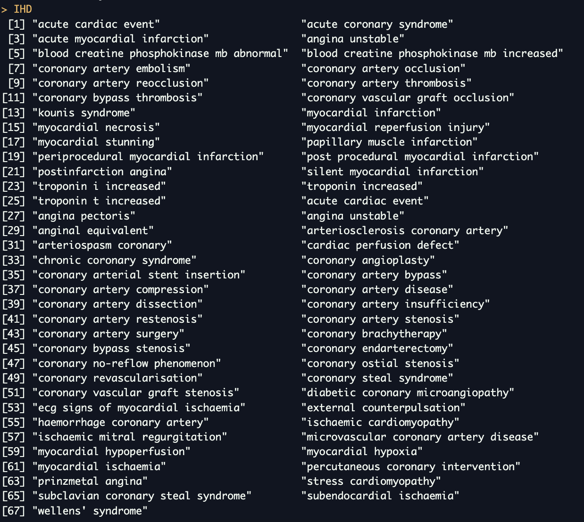
- Cardiac failure (SMQ)
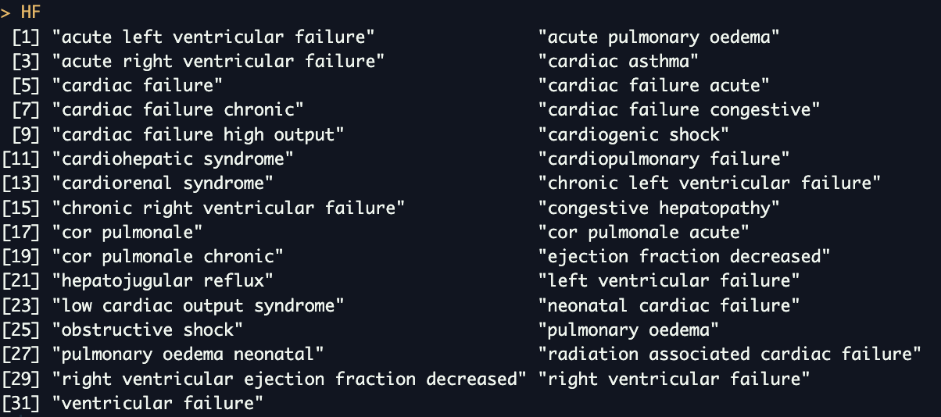

Table S3
Baseline characteristics of the patients enrolled in the studies included in the meta-analysis.
Study | Design | Indication for treatment | Intervention | Number of patients | Age (years) | Sex (male) | HTN | Diabetes | Previuous MI | PAD | LVEF | Betablockers
BEAUTIFUL  (Fox et al., 2008) | RCT | IHD and LVEF<40% | Iva vs. Pla | 5477 vs. 5430 | 65,2 (8,5) | 9047 (83%) | 7720 (71%) | 4036 (37%) | 9645 (88%) | 1440 (13%) | 32,4% (5,5%) | 9487 (87%)
SHIFT  (Swedberg et al., 2010) | RCT | Symptomatic HF and LVEF ≤35% | Iva vs. Pla | 3241 vs. 3264 | 60,4 (11,4) | 4970 (76%) | 4314 (66%) | 1979 (30%) | 3666 (56%) | NA | 29,0% (5%) | 5820 (89%)
SIGNIFY  (Fox et al., 2014) | RCT | IHD | Iva vs. Pla | 9539 vs. 9544 | 65,0 (7,3) | 13839 (72%) | 16466 (86%) | 8230 (43%) | 14002 (73%) | 4016 (21%) | 56,4 (8,5%) | 15878 (83%)
HF, heart failure; HTN, hypertension; IHD, ischemic heart disease; LVEF, left ventricular ejection fraction; MI, myocardial infarction; PAD, peripheral artery disease

Table S4
Studies included in the meta-analysis and reported events retrieved from ClinicalTrials.gov.

Study | Design | Year | Intervention | Number of patients | Ivabradine |  | Placebo |  | Median follow-up
 |  |  |  |  | AF | stroke | AF | stroke | Median follow-up
BEAUTIFUL⁷ | RCT | 2008 | Iva vs. Pla | 5477 vs. 5438 | 334 | 107 | 310 | 119 | 19 months
SHIFT⁹ | RCT | 2010 | Iva vs. Pla | 3241 vs. 3264 | 309 | 68 | 238 | 94 | 22.9 months
SIGNIFY¹⁰ | RCT | 2014 | Iva vs. Pla | 9539 vs. 9544 | 520 | 213 | 374 | 204 | 27.8 months

Table S5
AE | Population | Drug | N. reports | IC (95% CI)
Atrial Fibrillation_PT | HF | Beta_blockers  - Atenolol  - Bisoprolol  - Carvedilol  - Metoprolol  - Nadolol | 839  51  302  246  290  1 | 0.64 (0.53 – 0.72)  1.32 (0.85 – 1.65)  0.75 (0.56 – 0.88)  0.19 (-0.02 – 0.34)  1.05 (0.86 – 1.19)  -0.26 (-4.04 – 1.43)
Atrial Fibrillation_PT | HF | Ivabradine | 56 | 0.76 (0.31 – 1.08)
Atrial Fibrillation_PT | IHD | Beta_blockers  - Atenolol  - Bisoprolol  - Carvedilol  - Metoprolol  - Nadolol | 596  69  179  96  286  1 | 0.42 (0.29 – 0.52)  0.49 (0.04 – 0.72)  0.51 (0.26 – 0.68)  0.13 (-0.21 – 0.37)  0.57 (0.38 – 0.71)  -0.43 (-4.22 – 1.26)
Atrial Fibrillation_PT | IHD | Ivabradine | 15 | 0.40 (-0.47 – 1.00)
Atrial Fibrillation_PT | IHD_HF | Beta_blockers  - Atenolol  - Bisoprolol  - Carvedilol  - Metoprolol  - Nadolol | 1344  114  453  314  540  2 | 0.53 (0.44 – 0.60)  0.55 (0.24 – 0.77)  0.69 (0.53 – 0.80)  0.29 (0.10 – 0.42)  0.68 (0.54 – 0.78)  -0.45 (-3.04 – 0.94)
Atrial Fibrillation_PT | IHD_HF | Ivabradine | 66 | 0.84 (0.43 – 1.14)
Atrial Fibrillation_PT | IHD_HF post-approval | Beta_blockers  - Atenolol  - Bisoprolol  - Carvedilol  - Metoprolol  - Nadolol | 824  52  340  164  307  2 | 0.57 (0.46 – 0.65)  0.94 (0.48 – 1.27)  0.76 (0.58 – 0.89)  0.07 (-0.19 – 0.25)  0.72 (0.53 – 0.86)  0.35 (-2.24 – 1.74)
Atrial Fibrillation_PT | IHD_HF post-approval | Ivabradine | 61 | 0.92 (0.49 – 1.22)
Stroke | HF | Beta_blockers  - Atenolol  - Bisoprolol  - Carvedilol  - Metoprolol  - Nadolol | 740  28  303  274  176  0 | 0.45 (0.33 – 0.54)  0.46 (-0.17 – 0.9)  0.74 (0.55 – 0.88)  0.34 (0.14 – 0.48)  0.32 (0.07 – 0.5)  -1.85 (-12.17 – 0.13)
Stroke | HF | Ivabradine | 34 | 0.04 (-0.54 – 0.44)
Stroke | IHD | Beta_blockers  - Atenolol  - Bisoprolol  - Carvedilol  - Metoprolol  - Nadolol | 1346  155  361  287  619  2 | 0.12 (0.03 – 0.19)  0.13 (-0.13 – 0.32)  0.05 (-0.13 – 0.17)  0.23 (0.04 – 0.38)  0.21 (0.08 – 0.31)  -0.92 (-3.51 – 0.47)
Stroke | IHD | Ivabradine | 20 | -0.63 (-1.38 - -0.10)
Stroke | IHD_HF | Beta_blockers  - Atenolol  - Bisoprolol  - Carvedilol  - Metoprolol  - Nadolol | 1954  178  603  512  759  2 | 0.25 (0.18 – 0.31)  0.37 (0.12 – 0.55)  0.28 (0.15 – 0.38)  0.17 (0.03 – 0.28)  0.35 (0.23 – 0.44)  -1.17 (-3.77 – 0.22)
Stroke | IHD_HF | Ivabradine | 52 | -0.31 (-0.77 – 0.02)
Stroke | IHD_HF post-approval | Beta_blockers  - Atenolol  - Bisoprolol  - Carvedilol  - Metoprolol  - Nadolol | 1087  44  456  303  330  0 | 0.26 (0.16 – 0.33)  -0.01 (-0.51 – 0.35)  0.47 (0.32 – 0.58)  0.24 (0.05 – 0.38)  0.11 (-0.07 – 0.25)  -2.53 (-12.86 – -0.55)
Stroke | IHD_HF post-approval | Ivabradine | 40 | -0.39 (-0.92 – -0.01)

Table S6

AE | Population | Drug | N. reports | IC (95% CI)
Atrial Fibrillation_SMQ | HF | Beta_blockers  - Atenolol  - Bisoprolol  - Carvedilol  - Metoprolol  - Nadolol | 1016  58  365  332  336  2 | 0.65 (0.55 – 0.72)  1.24 (0.81 – 1.56)  0.75 (0.58 – 0.88)  0.36 (0.17 – 0.49)  1.00 (0.82 – 1.13)  0.28 (-2.31 – 1.67)
Atrial Fibrillation_SMQ | HF | Ivabradine | 81 | 1.02 (0.65 – 1.29)
Atrial Fibrillation_SMQ | IHD | Beta_blockers  - Atenolol  - Bisoprolol  - Carvedilol  - Metoprolol  - Nadolol | 773  88  225  141  369  3 | 0.45 (0.33 – 0.54)  0.44 (0.09 – 0.70)  0.49 (0.27 – 0.65)  0.34 (0.06 – 0.54)  0.60 (0.42 – 0.72)  0.53 (-1.54 – 1.73)
Atrial Fibrillation_SMQ | IHD | Ivabradine | 18 | 0.33 (-0.46 – 0.88)
Atrial Fibrillation_SMQ | IHD_HF | Beta_blockers  - Atenolol  - Bisoprolol  - Carvedilol  - Metoprolol  - Nadolol | 1666  139  544  426  664  4 | 0.55 (0.47 – 0.61)  0.54 (0.26 – 0.74)  0.66 (0.51-0.76)  0.43 (0.27 – 0.55)  0.68 (0.55 – 0.77)  0.14 (-1.62 – 1.22)
Atrial Fibrillation_SMQ | IHD_HF | Ivabradine | 93 | 1.04 (0.70 – 1.29)
Atrial Fibrillation_SMQ | IHD_HF post-approval | Beta_blockers  - Atenolol  - Bisoprolol  - Carvedilol  - Metoprolol  - Nadolol | 1003  63  412  218  371  2 | 0.60 (0.50 – 0.68)  0.96 (0.55 – 1.26)  0.79 (0.62 – 0.90)  0.23 (0 – 0.39)  0.74 (0.57 – 0.87)  0.16 (-2.43 – 1.55)
Atrial Fibrillation_SMQ | IHD_HF post-approval | Ivabradine | 88 | 1.20 (0.84 – 1.45)

Figure S1
These conceptual DAGs are proposed as a framework to interpret the observed association between ivabradine exposure and AF reporting. Both diagrams indicate a positive association between ivabradine and AF due to confounding by indication, as the diseases for which ivabradine is prescribed carry a higher risk of AF.
Under H₀ (biological causation), ivabradine exerts a direct pro-arrhythmic effect (D → E₁), leading to a genuine increase in AF incidence and occurrence of ischemic cerebrovascular events.
Under H₁ (enhanced detection), the apparent rise in AF reports may stem from a higher likelihood of diagnosis (D → M₁): by lowering heart rate during sinus rhythm, ivabradine may amplify symptom perception when AF occurs, thereby facilitating arrhythmia recognition and prompting earlier initiation of anticoagulation, with the potential to reduce ischemic cerebrovascular events.
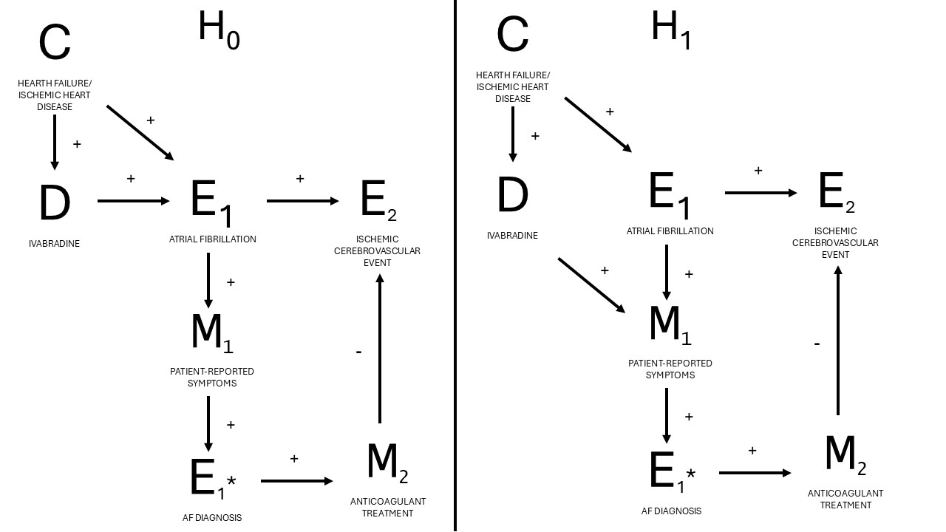

Figure S2
Egger’s plot assessing publication bias among included studies
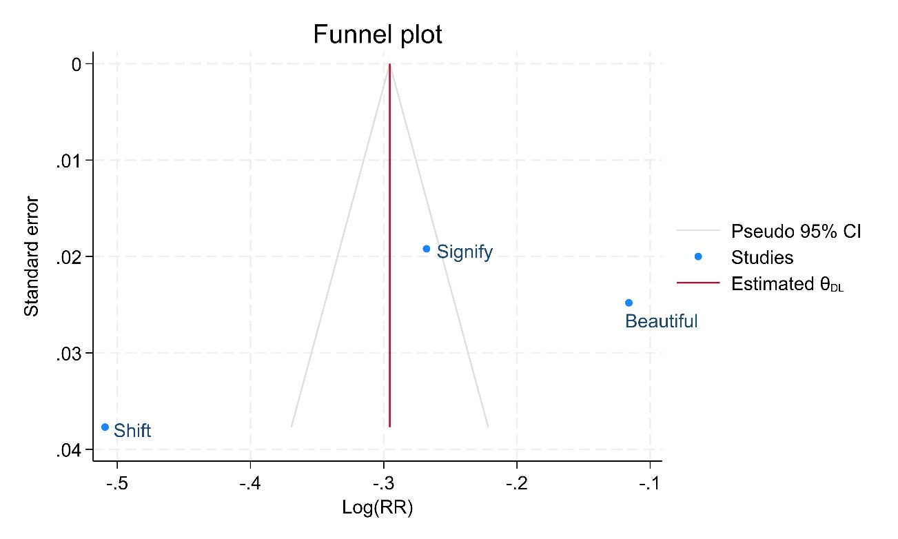

Figure S3
Forest plot showing the ratio of ischemic cerebrovascular events to atrial fibrillation with data retrieved from ClinicalTrials.gov.
