Increasing acidification does not affect sexual reproduction of a solitary zooxanthellate coral transplanted at a carbon dioxide vent
Chiara Marchini^{a,f,†}, Fiorella Prada^{b,c,†}, Erik Caroselli^{c,f,*}, Francesca Gizzi^{c,d}, Valentina Airi^{c}, Dragana Palečekª, Ilaria Zuccaro Destefani^{c}, Arianna Mancuso^{a,f}, Umberto Valdrè^{c}, Giuseppe Falini^{a,f}, Zvy Dubinsky^{d}, Stefano Goffredo^{c,f,*}

ª Department of Chemistry “Giacomo Ciamician”, University of Bologna, 40126 Bologna, Italy
^{b} Department of Marine and Coastal Sciences, Rutgers, The State University of New Jersey, New Brunswick, NJ 08901, USA.
^{c} Marine Science Group, Department of Biological, Geological and Environmental Sciences, University of Bologna, Via F. Selmi 3, 40126 Bologna, Italy
^{d} MARE - Marine and Environmental Sciences Centre, Agência Regional para o Desenvolvimento da Investigação, Tecnologia e Inovação (ARDITI), Funchal, Madeira, Portugal
^{e} The Mina and Everard Goodman Faculty of Life Sciences, Bar-Ilan University, Ramat-Gan 52900, Israel
^{f} Fano Marine Center, The Inter-Institute Center for Research on Marine Biodiversity, Resources and Biotechnologies, Viale Adriatico 1/N 61032 Fano, Italy
† These authors contributed equally to this work (co-first authors)
This paper is dedicated to the memory of Prof. Zvy Dubinsky who led a key role in this research, but is no longer with us.
*Corresponding authors: s.goffredo@unibo.it; erik.caroselli@unibo.it

Supporting Information for:
Supporting Figures
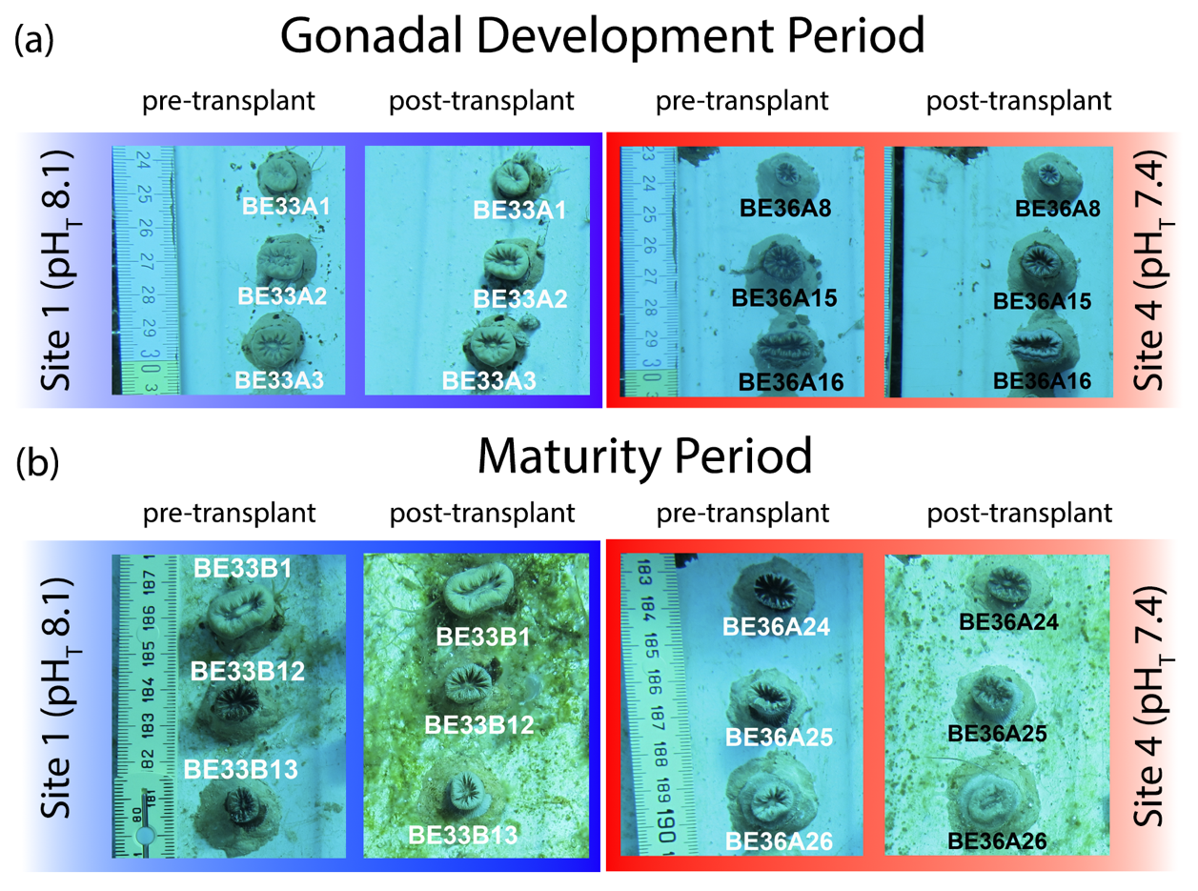
Supporting Information Figure S1. Pre and post experimental images for Balanophyllia europaea under different pH conditions during two gamete activity periods. Images of specimens at the beginning and at the end of transplant experiments in sites 1 and 4, during representative (a) Gonadal Development (June-July 2011) and (b) Maturity periods (December 2011-April 2012).

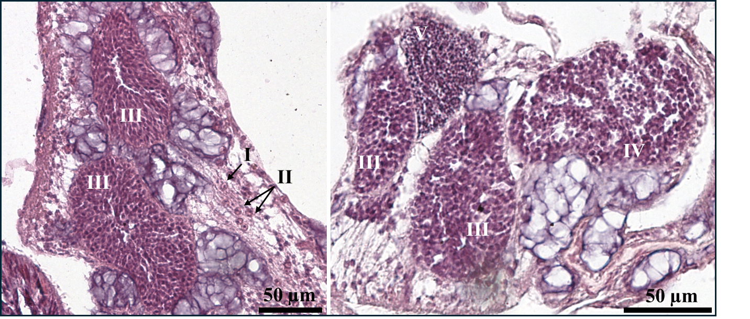
Supporting Information Figure S2. Five stages of spermatogenesis in Balanophyllia europaea. I: undifferentiated germ cells (spermatogonia) in the gastrodermis. II: spermatocytes undergo meiosis to compose the spermary. III: spermaries delineated by a wall arising from the mesoglea. IV: spermary with an external layer of spermatocytes and an internal mass of spermatids. V: spermary made of small spermatozoa.
Supporting Tables
Supporting Information Table S1. Oocyte reproductive parameters (mean abundance, mean gonadal index and mean diameter with the 95% confidence interval in brackets) at the four sites in the gonadal development period.
Gonadal development period
Oocytes
Site | pH_{TS} | N_{p} | Abundance (#/100 mm³) | Gonadal index (%) | N_{o} | Diameter (μm)
1 | 8.07 | 12 | 890 (464-1317) | 0.55 (0.32-0.78) | 1857 | 116 (113-119)
2 | 7.87 | 12 | 735 (353-1117) | 0.66 (0.16-1.16) | 1518 | 127 (123-131)
3 | 7.74 | 12 | 955 (518-1392) | 1.00 (0.51-1.50) | 2158 | 138 (135-142)
4 | 7.40 | 9 | 1114 (76-2151) | 0.59 (0.34-0.84) | 1748 | 104 (101-108)
p |  |  | NS (0.881) | NS (0.377) |  | * (0.037)
N_{p}, polyp number for abundance and gonadal index; N_{o}, oocyte number for diameter; p, the significance of the non-parametric Kruskal-Wallis; * p < 0.05; NS p > 0.05

Supporting Information Table S2. Spermary reproductive parameters (mean abundance, mean gonadal index and mean diameter with the 95% confidence interval in brackets) at the four sites in the gonadal development period.
Gonadal development period
Spermaries
Site | pH_{TS} | N_{p} | Abundance (#/100 mm³) | Gonadal index (%) | N_{s} | Diameter (μm)
1 | 8.07 | 6 | 5938 (791-12667) | 0.08 (0.00-0.16) | 1531 | 26 (25-26)
2 | 7.87 | 6 | 766 (268-1264) | 0.02 (0.00-0.03) | 272 | 32 (30-34)
3 | 7.74 | 6 | 1351 (197-2504) | 0.03 (0.01-0.05) | 489 | 32 (31-33)
4 | 7.40 | 3 | 4179 (468-7890) | 0.07 (0.03-0.11) | 718 | 29 (28-30)
p |  |  | NS (0.216) | NS (0.078) |  | NS (0.493)
N_{p,} polyp number for abundance and gonadal index; N_{s,} spermary number for diameter. p, the significance of the non-parametric Kruskal-Wallis test; NS p > 0.05

Supporting Information Table S3. Embryos reproductive parameters (mean fertility, mean embryonal index and mean diameter with the 95% confidence interval in brackets) at the four sites in the gonadal development period.
Gonadal development period
Embryos
Site | pH_{TS} | N_{p} | Fertility (#/100 mm³) | Embryonal index (%) | N_{e} | Diameter (μm)
1 | 8.07 | 6 | 33 (11-55) | 2.92 (1.49-4.34) | 165 | 683 (660-705)
2 | 7.87 | 6 | 12 (4-20) | 1.13 (0.54-1.71) | 116 | 669 (654-683)
3 | 7.74 | 6 | 34 (15-53) | 2.26 (1.38-4.55) | 181 | 666 (640-692)
4 | 7.38 | 6 | 19 (11-26) | 1.77 (0.91-2.63) | 133 | 680 (663-697)
p |  |  | NS 0.815 | NS 0.895 |  | NS 0.614
N_{p} = polyp number for fertility and embryonal index; N_{e} = embryo number for diameter; p, the significance of the non-parametric Kruskal-Wallis test; NS p > 0.05.

Supporting Information Table S4. Oocyte reproductive parameters (mean abundance, mean gonadal index and mean diameter with the 95% confidence interval in brackets) at the four sites in the maturity period.
Maturity period
Oocytes
Site | pH_{TS} | N_{p} | Abundance (#/100 mm³) | Gonadal index (%) | N_{o} | Diameter (μm)
1 | 8.07 | 7 | 336 (120-552) | 2.23 (0.56-3.90) | 985 | 286 (273-298)
2 | 7.87 | 6 | 443 (177-708) | 1.86 (0.35-3.37) | 866 | 229 (217-242)
3 | 7.74 | 2 | 58 (56-60) | 0.06 (-0.01-0.14) | 44 | 144 (118-170)
4 | 7.40 | 6 | 314 (140-488) | 2.08 (1.16-2.99) | 812 | 284 (271-297)
p |  |  | NS (0.214) | NS (0.132) |  | NS (0.069)
N_{p,} polyp number for abundance and gonadal index; N_{o,} oocyte number for diameter; p, the significance of the non-parametric Kruskal-Wallis test; *** p < 0.001; NS p > 0.05

Supporting Information Table S5. Spermary reproductive parameters (mean abundance, mean gonadal index, mean diameter with the 95% confidence interval in brackets) at the four sites in the maturity period.
Maturity period
Spermaries
Site | pH_{TS} | N_{p} | Abundance (#/100 mm³) | Gonadal index (%) | N_{s} | Diameter (μm)
1 | 8.07 | 7 | 2728 (223-5232) | 2.37 (-0.03-4.78) | 4831 | 131 (129-133)
2 | 7.87 | 6 | 1586 (615-2557) | 1.02 (0.33-1.71) | 2138 | 119 (117-121)
3 | 7.74 | 2 | 298 (-227-822) | 0.11 (-0.10-0.33) | 177 | 99 (93-105)
4 | 7.40 | 6 | 3298 (1369-5226) | 1.56 (0.56-2.56) | 4064 | 104 (103-105)
p |  |  | NS (0.185) | NS (0.229) |  | NS (0.195)
N_{p,} polyp number for abundance and gonadal index; N_{s,} spermary number for diameter; p, the significance of the non-parametric Kruskal-Wallis test; NS p > 0.05.

