Figure S 1: Illustration of GMM algorithm
$Y_{i}=(Y_{i1}, Y_{i2}, Y_{i3},…,Y_{it})$, where $t$ is number of points – SALT % CFB repeated measures of each patient.
$Y_{ij}=α_{0k}+β_{1k}×{Time}_{j}+ε_{ij},$
$α_{0k}=μ_{0k}+ϵ_{oi}$,
$β_{1k}=μ_{1k}+ϵ_{1i}$.
CFB=change from baseline; GMM=growth mixture model; SALT = Severity of Alopecia Tool
Figure S2: Identification of response patterns from growth mixture modelling based on SALT score percent change from baseline among 4mg-treated patients.
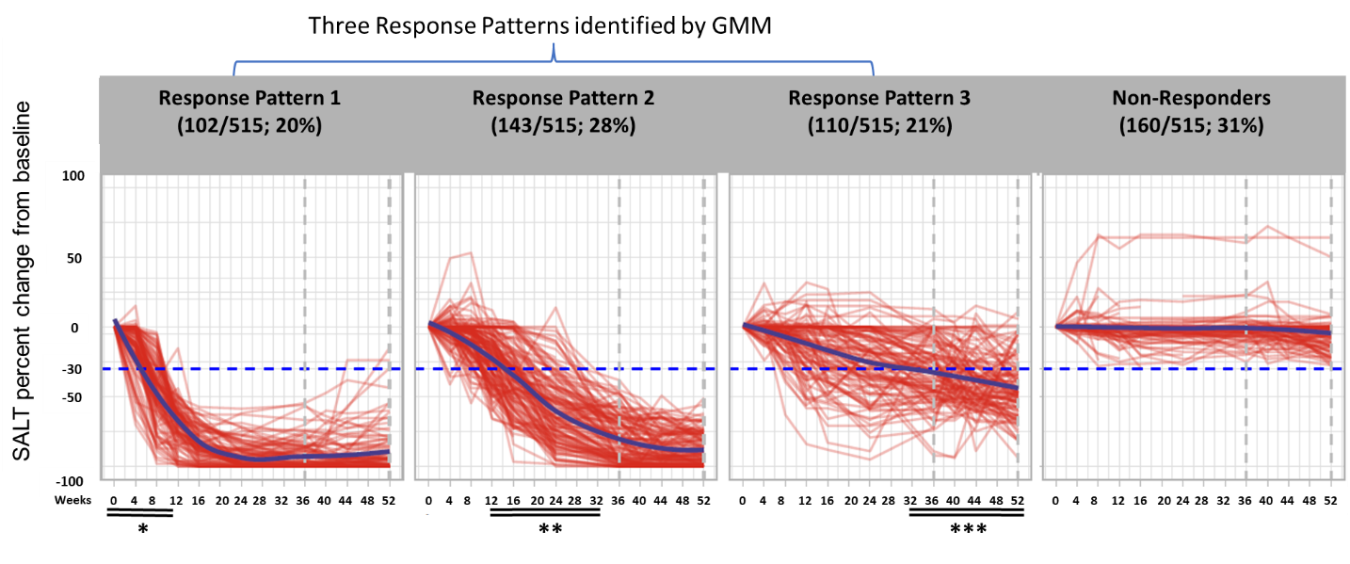
The red lines indicate individual patients, the thick purple lines are the smoothing lines using local polynomial regression fitting, and the blue dotted line indicates a 30% improvement from baseline in SALT score (SALT₃₀).
*Most patients in Response Pattern 1 achieved a SALT₃₀ by Week 12.
**Most patients in Response Pattern 2 achieved a SALT₃₀ within Weeks 12 through 32.
*** Patients in Response Pattern 3 had high variability in their response over 52 weeks, with a regression line crossing the SALT₃₀ threshold at approximately Week 32.
Data were censored after permanent study drug discontinuation or data collected at remote visits due to the COVID-19 pandemic.
GMM=growth mixture modelling; SALT =Severity of Alopecia Tool

Figure S3: Identification of response patterns from growth mixture modelling based on SALT score percent change from baseline among 2mg-treated patients.
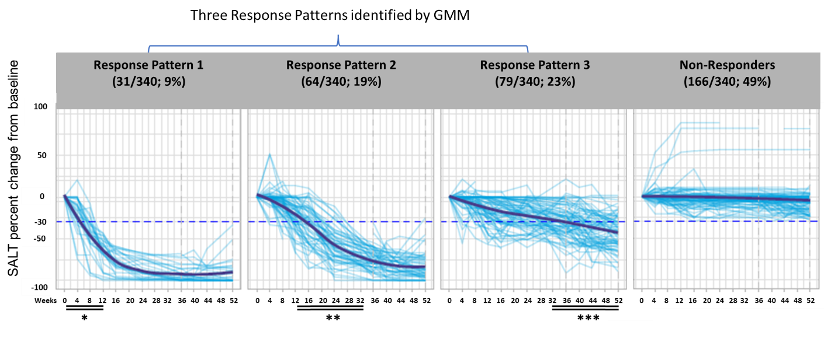
The thin blue lines indicate individual patients, the thick blue lines are the smoothing lines using local polynomial regression fitting, and the blue dotted lines indicates a 30% improvement from baseline in SALT score (SALT₃₀).
*Patients in Response Pattern 1 achieved a SALT₃₀ by Week 12.
**Most patients in Response Pattern 2 achieved a SALT₃₀ within Weeks 12 through 32
***Patients in Response Pattern 3 had high variability in their response over 52 weeks, with a regression line crossing the SALT₃₀ threshold at approximately Week 36.
Data were censored after permanent study drug discontinuation or data collected at remote visits due to the COVID-19 pandemic.
GMM=growth mixture modelling; SALT =Severity of Alopecia Tool

