Supplementary materials: Combining circulating tumor cell and circulating cell-free DNA analyses broadens clinical applicability of liquid biopsy in high grade serous ovarian cancer

Cavina et al.

Methods 2
Supplementary tables 11
Supplementary figures 16
Supplementary References 19

Methods
Aim, design and setting of the study
The primary aim was to demonstrate that circulating tumor cell (CTC) analysis coupled to circulating cell-free DNA (cfDNA) assay increases peripheral blood (PB) liquid biopsy-based disease detection rate in high grade serous tubo-ovarian cancer (HGSOC) compared to single analyte approach. We first developed specific assays for each analyte of interest, ensured the analytical validity and then evaluated the clinical validity. For CTC analysis, we compared two enrichment methods (Parsortix and CD45-negative immunomagnetic selection) and tested three nucleic acid-based detection techniques (Fig.1A): (i) gene expression assays based on cDNA preamplification coupled to quantitative Real Time-PCR (qRT-PCR); (ii) gene expression detection via digital PCR (dPCR); and (iii) CTC mutation identification by TP53 Next Generation Sequencing (NGS) with Ion AmpliSeq HD laboratory-developed panel (Thermo Fisher Scientific). Analytical validity of each CTC detection approach was evaluated by using healthy donor PB spiked with known numbers of cancer cells, whereas clinical validity was evaluated by analyzing HGSOC patients and healthy donor controls (Fig.1H). For circulating cell-free tumor DNA (ctDNA) detection, TP53 NGS with Ion AmpliSeq HD laboratory-developed panel (Thermo Fisher Scientific) was used. Analytical validity was ensured by setting the Variant Allele Frequency (VAF) threshold which most accurately identifies primary tumor mutations in plasma cfDNA (Fig.1K), whereas clinical validity was evaluated by comparing HGSOC cases and low grade serous ovarian cancer (LGSOC) patients used as controls, since the latter display high cfDNA concentrations due to tumor burden, but latter lack TP53 mutations (Fig.1N).
Finally, to demonstrate that including CTC analysis provides more informative liquid biopsy, compared to ctDNA approach alone, the data derived from clinical validation of single-analyte methods were compared to sensitivities obtained when both analytes were considered.
Patients and healthy controls enrolment
For validation of OC CTC gene expression markers, primary tumor tissues of four advanced stage (III, IV) and four early stage (I, II) HGSOC patients who underwent debulking surgery in period between May 2016 and October 2019 were analyzed, together with three PB mononuclear cell (PBMC) samples derived from healthy controls (Tab.S1). For clinical validation of the assays, liquid biopsy samples were collected between September 2020 and March 2025, from HGSOC patients who underwent surgery, either primary or interval debulking, at diagnosis or at the disease relapse (n=30, Fig.S1). Inclusion criteria comprised histologic diagnosis of HGSOC, presence of macroscopic disease at surgery in newly diagnosed and relapsed patients, as well as in subjects after neoadjuvant chemotherapy (NACT). Controls used in Fig.1J to define specificity of CTC detection via gene expression (n=10), and CTC detection via TP53 sequencing (n=6), derived from healthy female donors (inclusion criteria: women aged ≥ 25, with no history of oncologic disease; exclusion criteria: pregnancy, history of oncologic disease) (Tab.S1). Controls for clinical validity assessment of cfDNA TP53 deep sequencing were patients newly diagnosed with advanced stage LGSOC, whose liquid biopsy was collected between September 2019 and April 2023 (n=6, Tab.S1). Post-hoc power calculations were performed using Clincalc [1]. Regarding CTC gene profiling, 88.4% post hoc power was calculated to estimate accuracy with alpha of 0.05, considering case versus control incidence of 52.5% and 0%, as previously published when using the same method [2]. Since TP53 sequencing was never used for CTC detection of HGSOC up to date, we considered 66.7% case incidence reported in a breast cancer study which used a mutation-based liquid biopsy assay [3], and 94.5% post hoc power to estimate accuracy with alpha of 0.05 was calculated. For ctDNA detection, the subjects enrolled for clinical validation allowed 100% post-hoc statistical power to estimate efficiency, considering 0.05 alpha and case versus control incidence of 73% and 0%, respectively [4].
The study was conducted in accordance with the Declaration of Helsinki and the protocol was approved by the Independent Ethics Committee "Comitato Etico di Area Vasta Emilia Centro” (Protocol EM363-2024_107/2011/U/Tess/AOUBo). All subjects enrolled in the study provided written informed consent for their participation.
Cell lines
OV90 (#ATCC-CRL-3585) and SKOV3 (#ATCC-HTC-77) cells were purchased from ATCC, whereas OC314 (RRID: CVCL_1616) cell line was kindly gifted by Prof. Ada Funaro (University of Turin). Cells were authenticated using AMPFISTRIdentifiler kit (Applied Biosystems #4322288), confirming their putative STR profile. Cells were regularly screened for mycoplasma and were cultured in RPMI 1640 (Euroclone #ECB9006L) supplemented with 10% FBS South America origin EU Approved (Euroclone #ECS5000L), 2 mM L-glutamine (Euroclone #ECB3000D), and 1% penicillin/streptomycin (Euroclone #ECB3001D) in an incubator at 37°C with a humidified atmosphere at 5% CO2. EVOS M5000 Imaging System (ThermoFisher Scientific #AMF5000) was used for cell line monitoring.
Lentiviral transduction of green fluorescent protein (GFP) in SKOV3 cells
Lentiviral particles expressing green fluorescent protein (GFP) were produced using HEK293T cells, seeded in 10 cm tissue culture dishes at 40-50% confluency and incubated overnight. At 80% confluence, cells were transfected using Xtreme Gene Roche Transfection reagent (Cat. No. 6366236001, Roche) according to manufacturer's instructions. Specifically, the transfection mixture consisted of 7.5 μg psPAX2 packaging plasmid and 2.5 μg pMD2-VSVG envelope plasmid, 10 μg GFP-expressing lentiviral plasmid, (total DNA: 20 μg), diluted in 2 mL Opti-MEM medium. Packaging and envelope plasmids were a kind gift from Prof. Marco Montagner (University of Padova), whereas the GFP-expressing plasmid was a kind gift from Dr. Ilaria Malanchi [5]. Xtreme Gene transfection reagent was added to the DNA with a ratio of 1:3, incubated for 15 min at room temperature, and then added dropwise to the HEK293T cells. Concomitantly, SKOV3 recipient cells were seeded in a T25 flask at 20-30% confluency to achieve optimal cell density for transduction the following day. Viral supernatant was harvested 48 hours post HEK293T transfection and filtered through 0.45 μm syringe filters to remove cellular debris. For SKOV3 transduction, filtered viral particles were mixed 1:1 with fresh culture medium supplemented with polybrene (final concentration: 8 μg/mL) to enhance viral uptake efficiency. SKOV3 cells were incubated with the virus-containing medium for 48 hours. Clonal selection was performed to identify the cells with the highest GFP expression, which was checked with EVOS M5000 Imaging System (Thermo Fisher Scientific #AMF5000), and a pool of 30 clones was made for use in the subsequent experiments.
Spiked samples preparation
Healthy donor PB (7.5 mL) was collected in 10 mL EDTA tube and manually spiked within 24 hours with known numbers of SKOV3^{GFP} cells: 0, 5, 50, 500, 5’000, or 500’000. In detail, SKOV3 were trypsinized (Sigma #T4049) and counted using Neubauer chamber with Trypan Blue (Sigma #T8154) staining to exclude dead cells. A PBS suspension (200 μL) of 500, 5’000 or 500’000 live cells was then added to PB. To prepare PB samples carrying five, and 50 SKOV3^{GFP} single-cell picking was performed: trypsinized cells were diluted in PBS solution, visualized with phase-contrast microscopy under the sterilized hood, individually picked using 10 μL pipette tip and collected in 1.5 mL Eppendorf tube. PBS was eventually added to final volume of 200 μL and spiked in PB. The same amount of PBS alone was used as a negative control (0 SKOV3^{GFP}). Spiked samples were then enriched using Parsortix or CD45 negative sorting for downstream analysis. EVOS M5000 Imaging System (Thermo Fisher Scientific #AMF5000) was used to confirm the presence of SKOV3^{GFP} prior to elution.
CTC enrichment
At least 7.5 mL of PB was processed for microfluidic-based CTC enrichment by using Parsortix® Cell Separation System (ANGLE) with GEN3D6.5 Cell Separation cassettes according to the manufacturer’s instructions. Default pressure protocol was used, and the captured cells were eluted in 1.2 mL of PBS. For negative affinity-based CTC enrichment, PB was processed using automatic magnetic-activated cell sorting (MACS) for CD45-negative selection. Red Blood Cell Lysis Solution (Miltenyi Bioitec #130-094-183) was used to lyse erythrocytes, and human CD45 MicroBeads (Miltenyi Bioitec #130-045-801) were employed to deplete CD45+ leukocytes, following the manufacturer’s protocol. The stained cell suspension was sorted using AutoMACS® (Miltenyi Biotec) with protocol Depl05 [6]. CTC-enriched solutions obtained from both Parsortix and AutoMACS were centrifuged at 1’200 rpm for 5 min and the pellets were resuspended in 350 μL of RLT buffer for subsequent RNA extraction. For DNA extraction, Parsortix CTC enriched fraction was centrifuged at 1’200 rpm for 5 min and the pellet was stored at -80°C for the subsequent analysis.
Nucleic acid extraction
RNA extraction from tumor biopsies, cell lines, and CTC-enriched fractions was performed using RNeasy Mini Kit (QIAGEN #74106), while for DNA isolation from formalin fixed paraffin embedded (FFPE) samples Maxwell® CSC DNA FFPE Kit (Promega, #AS1350) was used. Nucleic acid concentrations were assessed with NanoDrop (Thermo Fisher) and stored at -20°C. Peripheral blood for cfDNA analysis was processed within 2 hours from withdrawal and we performed a two-step plasma preparation protocol. In detail, the 10 mL EDTA tube was centrifuged at 3’500 g for 15 min at 4°C, and then plasma was further centrifuged for 10 min at maximum speed. Plasma was stored at -80°C until cfDNA extraction, as we previously confirmed that our preanalytical handling does not affect the downstream analysis. Quick-cfDNA Serum&Plasma Kit (Zymo research #D4076) was used for plasma cfDNA extraction, eluted in a final volume of 30 μL. DNA was isolated from CTC enriched fractions by using QIAamp DNA Blood mini kit (QIAGEN #51106) and eluted in a final volume of 30 μL. The same kit was used also for DNA extraction from patients/healthy donors derived PBMC. cfDNA and CTC derived DNA were quantified using Qubit™ (Invitrogen) with High Sensitivity dsDNA assay kit (Invitrogen #Q32851) and stored at -20°C. Liquid biopsy DNA concentration was calculated based on ng/μL eluted after extraction from plasma or CTC-fraction, quantified fluorometrically by using Qubit HS assay, multiplied by μL used and finally divided by either the total mL of plasma analyzed or the total mL of enriched PB.
cDNA synthesis and preamplification
High-Capacity cDNA Reverse Transcription Kit (Applied Biosystem #4368814) was used for cDNA preparation with random hexamers starting from different RNA concentrations based on samples. When available, 100 ng of RNA was used for cDNA synthesis and we used the maximum possible RNA quantity (14 μL) for CTC-enriched samples, independently from their starting concentration. Reaction was performed using T100 Thermal Cycler (Bio-Rad) following the protocols: 25°C 10 min, 37°C 120 min, 85°C 5 min. A total of 20 μL concentrated cDNA was obtained. For the following preamplification reaction cDNA diluted 1:2 was used as starting material, added with TaqMan® PreAmp Master Mix (2X) (Thermo Fisher Scientific #4384267) and TaqMan gene expression assay of interest pooled at a final concentration of 0.2X, according to the manufacturer’s instructions. Reaction was performed using T100 Thermal Cycler (Bio-Rad) following the protocols: 95°C 10 min; 95°C 15 sec and 60°C 4 min, for 14 cycles, 99°C 10 min. For the downstream gene expression analysis, native cDNA was diluted 1:5, while PA cDNA was diluted 1:2.
Gene expression quantitative real-time PCR (SybrGreen and TaqMan)
Quantitative RT–PCR was performed using either the intercalating dye SYBR Green dye (Promega) or 5’ nuclease probes PrimeTime™ qPCR Probes (TaqMan assay). For the SYBR Green assay, the primer sequences were designed using Primer3 software [7], the presence of 3’ intra/inter primer homology was excluded using the IDT OligoAnalyzer tool [8] and the availability of the target sequence was estimated by predicting cDNA secondary structure by the Mfold web server [9]. Forward and reverse primers sequences for each target are listed in Methods Table 1. For TaqMan assays, the qPCR Probes assay for each gene was selected on the Thermo Fisher website [10], and the predesigned qPCR assays recommended by the manufacturer were used. qRT–PCR with SYBR Green assay was performed with GoTaq qPCR Master Mix (Promega #A6002) and run in 7500 Fast Real-Time PCR System (Applied Biosystem), using the following conditions: 95°C 5 min; 45 cycles of 95°C 15 sec and 63°C 45 sec. The qRT–PCR with TaqMan assay was performed with GoTaq R Probe qPCR Master Mix (Promega #A6101 and #A6102) and run in the abovementioned system, using the following conditions: 95°C 2 min; 40 cycles of 95°C 15 sec and 60°C 1 min.
Methods Table 1. Target gene primer sequences used for SYBR qRT-PCR analysis
Gene | Forward | Reverse
PGR | ACCTGACACCTCCAGTTCTT | TCCATCCTAGACCAAACACCA
CDH3 | GAAGCGGAAGATCAAGGAGC | GTGGAGCTGGGTGATGTCAT
CDH2 | GGCTTCTGGTGAAATCGCAT | TCCACCTTAAAATCTGCAGGC
TUSC3 | AAGCAGCAACTTCGAAAGGC | GGATAGCCGTGGTACTTGGA
MAL2 | GCCACATCCCTGCATGATTT | CGGTCGCCATCTTCGTAAAG
LAMB1 | GAAGCTTTCGGTGACCTCG | CTGTCAGGATTCAGGGTCTCA
SERPINE2 | CCTCTGCCTGTGATTCCATC | CTTTGTGTTCTCGGGTTGGA
PRAME | CTGCAGGCTCTCTATGTGGA | GACACTTAGCTGACTGACGC
AGR2 | ATTGGCAGAGCAGTTTGTCC | TCTTCCAGTGATATCGGCTCT
MUC1 | CCAGTCTCCTTTCTTCCTGC | TTCTCTGGGTAGCCGAAGTC
GPX8 | CGGAGTAACTTTCCCCATCTTC | TGGCTTCCAGAACTTCACAAC
EPCAM | ACTACAAGCTGGCCGTAAAC | CCCCTTCAGGTTTTGCTCTTC
KRT18 | CTTGGAGAAGAAGGGACCCC | GTCATCAGCAGCAAGACGG
KRT19 | GAGCAGGTCCGAGGTTACTG | CTGGGCTTCAATACCGCTG
ERCC1 | CTGGGAAGGACAAAGAGGGG | ATTCGGCGTAGGTCTGAGG
PPIC | GCAGAATTGTGATTGGCCTC | TGATGACACGATGAAACTTGC
WT1 | AGAGCGATAACCACACAACG | CATGAAGGGGCGTTTCTCAC
TFF1 | AGACGTGTACAGTGGCCC | GGAGGGACGTCGATGGTATT
ERBB3 | GACAACCTGGCAACCAC | GCTCCCAGAAACTGCAGACT
TIMP1 | TACTTCCACAGGTCCCACAA | ACAGCCAACAGTGTAGGTCT
ERBB2 | ACCTGGAACTCACCTACCTG | TTGTCCTCAAAGAGCTGGGT

Digital PCR
Digital PCR assay was performed using Absolute Q™ DNA Digital PCR Master Mix (5X) (Thermo Fisher Scientific #A52490), TaqMan assay selected for gene expression analysis, and 10 ng of cDNA according to manufacturer’s instructions. The MAP16 plate kit (Thermo Fisher Scientific #A52865) was loaded and run on Absolute Q 22120661 instrument, using the following conditions: 50°C 2 min, 96°C 10 min; 40 cycles of 96°C 5 sec and 60°C 15 sec. The downstream analysis was performed using QuantStudio Absolute Q Software Version 6.3.
Sequencing of TP53
To comprehensively characterize TP53 genotypes across different sample types, we employed distinct sequencing approaches as follows. Macro dissected FFPE primary tumor tissue was sequenced using previously validated “solid biopsy” NGS laboratory-developed multi-gene panel [11], covering 21.77 kb with 330 amplicons, including TP53 CDS, as already described in [12]. Mutations were considered valid if present in at least 5% of the total number of analyzed reads and observed in both strands, as per previously established validation criteria [13]. The somatic nature of the identified primary tumor mutations was confirmed by Sanger sequencing of matched PBMC following the standard protocol [12]. Liquid biopsy-derived samples (i.e., cfDNA and CTC enriched fraction-derived DNA) were sequenced using the Ion AmpliSeq HD laboratory-developed “liquid biopsy” panel (Thermo Fisher Scientific) targeting the entire coding sequence (CDS) of TP53 (NM_000546.6, human reference genome hg19/GRCh37), overall covering 1.71 Kb with 39 amplicons. Single-nucleotide variants/indels present in at least 0.2% of the total number of analyzed reads were considered for variant calling [14–16]. The “liquid biopsy” panel was also used for sequencing healthy donor control PBMC during analytical validity evaluation for CTC detection, as well as for HGSOC patient PBMC samples sequenced to exclude clonal hematopoiesis as the source of liquid biopsy variants. For NGS library preparation, approximately 10 ng of liquid biopsy-derived DNA or 30 ng for FFPE-derived DNA were processed. Sequencing was carried out on an Ion 530 chip. The data were analyzed with the Ion Reporter tool (version 5.20, Thermo Fisher Scientific) and IGV software [17,18] (Integrative Genome Viewer version 2.12.2). Variant classification was performed using American College of Medical Genetics and genomics guidelines with the Varsome database [19,20].
Statistical analyses
The statistical analyses were performed using R version 4.3.1 with the pROC, dplyr, ggplot2, binom, and presize packages. Clinical validity was assessed using standard 2x2 contingency tables, which allow calculation of specificity, sensitivity, accuracy, positive predictive value, and negative predictive value. Accuracy estimates of clinical sensitivity and specificity were determined with exact 95% confidence intervals (CI) using the Wilson method. Fisher’s exact test assessed associations between patient group and test results. For VAF threshold optimization, Receiver Operating Characteristic (ROC) curve analysis was performed to identify the best ctDNA VAF threshold via Youden’s J statistic. The same data set was used for running Leave-One-Out cross-validation (LOOCV) to account for model generalizability, which provided the threshold and relative Area Under the Curve (AUC) for each iteration. ROC statistical significance was evaluated using permutation testing and the Hanley-McNeil Z-test against the null hypothesis of AUC=0.5. cfDNA concentration differences between HGSOC and LGSOC patients were compared using Unpaired t test with Welch’s correction (F test to compare variances p<0.0001; GraphPad Prism 8). Statistical significance was defined as p <0.05. Data visualization was performed using GraphPad Prism 8, R version 4.3.1, and BioRender.com.

Supplementary tables

Tab.S1. Demographic and clinical characteristics of participants used for assay validations: HGSOC patients (T1-T8) and healthy donors (CNTR1-3) used for target gene validation (Fig.1C); Healthy donors (CNTR4-13) used as controls to define specificity of CTC detection via gene expression (Fig.1J); Healthy donors (CNTR14-19) used as controls to define specificity of CTC detection via TP53 NGS (Fig.1J); LGSOC patients (L1-L6) used as controls to define specificity of ctDNA detection via TP53 NGS (Fig.1Q).
ID | AGE | FIGO stage | Analysis
T1 | 66 | IV
T2 | 39 | IV
T3 | 69 | IIIC
T4 | 60 | IIIC
T5 | 68 | IC
T6 | 65 | II | Gene validation
T7 | 70 | IC | HGSOC cases (T) and healthy donor controls (CNTR)
T8 | 54 | II
CNTR1 | 40 | /
CNTR2 | 44 | /
CNTR3 | 25 | /
CNTR4 | 44 | /
CNTR5 | 40 | /
CNTR6 | 28 | /
CNTR7 | 26 | /
CNTR8 | 25 | / | Healthy donor controls for
CNTR9 | 43 | / | CTC detection via
CNTR10 | 39 | / | Gene expression
CNTR11 | 25 | /
CNTR12 | 52 | /
CNTR13 | 64 | /
CNTR14 | 74 | / | Healthy donor controls for  CTC detection via  TP53 NGS
CNTR15 | 69 | / | Healthy donor controls for  CTC detection via  TP53 NGS
CNTR16 | 73 | / | Healthy donor controls for  CTC detection via  TP53 NGS
CNTR17 | 69 | / | Healthy donor controls for  CTC detection via  TP53 NGS
CNTR 18 | 56 | / | Healthy donor controls for  CTC detection via  TP53 NGS
CNTR 19 | 59 | / | Healthy donor controls for  CTC detection via  TP53 NGS
L1 | 74 | IIIC
L2 | 84 | IIIC | LGSOC controls for
L3 | 71 | IIIC | ctDNA detection via
L4 | 68 | IIIB | TP53 NGS
L5 | 69 | IV
L6 | 71 | IIIC

Tab.S2. NCBI genes selected as putative ovarian cancer (OC) CTC markers from scientific literature (Ref). Na-Not available.
Gene ID | Symbol | Full name | Ref. | Patient number | Positivity rate (%)
5241 | PGR | progesterone receptor | [2] | 19 | 0
102886151 | CDH3 | cadherin 3 | [21] | 200 | 4
1000 | CDH2 | cadherin 2 | [2] | 19 | 36.8
7991 | TUSC3 | tumor suppressor candidate 3 | [21] | 200 | 3.5
114569 | MAL2 | mal, T cell differentiation protein 2 | [2] | 19 | 31.6
3912 | LAMB1 | laminin subunit beta 1 | [21] | 200 | 1.5
5270 | SERPINE2 | serpin family E member 2 | [2] | 19 | 89.5
23532 | PRAME | PRAME nuclear receptor transcriptional regulator | [2] | 19 | 15.8
10551 | AGR2 | anterior gradient 2, protein disulphide isomerase family member | [21] | 200 | 0.5
4582 | MUC1 | mucin 1, cell surface associated | [22] | 137 | Na
493869 | GPX8 | glutathione peroxidase 8 (putative) | [21] | 200 | 5.5
4072 | EPCAM | epithelial cell adhesion molecule | [21] | 200 | 2
3875 | KRT18 | keratin 18 | [23] | 40 | Na
3880 | KRT19 | keratin 19 | [23] | 40 | Na
2067 | ERCC1 | ERCC excision repair 1, endonuclease non-catalytic subunit | [24] | 143 | 8
5480 | PPIC | peptidylprolyl isomerase C | [21] | 200 | 17
7490 | WT1 | WT1 transcription factor | [23] | 40 | Na
7031 | TFF1 | trefoil factor 1 | [21] | 200 | 0
2065 | ERBB3 | erb-b2 receptor tyrosine kinase 3 | [2] | 19 | 26.3
7076 | TIMP1 | TIMP metallopeptidase inhibitor 1 | [25] | 38 | Na
2064 | ERBB2 | erb-b2 receptor tyrosine kinase 2 | [2] | 19 | 84.2

Tab.S3. TP53 variants and their allele frequencies found by CTC fraction NGS in liquid biopsies of cohort 2. del=deletion; fs=frameshift
HGSOC- | TP53 variant |  |  | CTC VAF (%)
16 | p.R337C | c.1009C>T | 0.29
17 | p.D186Efs*61 | c.558del | 0.27
17 | p.E343Sfs*2 | c.1027del | 0.20
18 | / |  | 0
19 | p.R273H | c.818G>A | 0.75
20 | p.R273H | c.818G>A | 82.9
20 | p.K292E | c.874A>G | 6.07
20 | p.V272A | c.815T>C | 1.30
20 | p.Y220C | c.659A>G | 0.29
20 | p.H178P | c.533A>C | 0.3
21 | / |  | 0
22 | p.R273H | c.818G>A | 3.17
22 | p.P300A | c.898C>G | 1.47
22 | p.K292E | c.874A>G | 0.48
22 | p.L330P | c.989T>C | 0.25
23 | / |  | 0
24 | p.G226Afs*21 | c.677del | 0.21
25 | / |  | 0
26 | p.S90Pfs*33 | c.268del | 1.69
27 | / |  | 0
28 | / |  | 0
29 | / |  | 0
30 | / |  | 0

Tab.S4. TP53 variants and their allele frequencies found by cfDNA NGS in liquid biopsies of cohorts 1 and 2. del=deletion; fs=frameshift
HGSOC- | TP53 variant |  | ctDNA VAF (%)
1 | / | c.376-2A>G | 1.38
2 | p.T253_I254del | c.758_763del | 26
3 | p.Q167Hfs*3 | c.501del | 0.5
3 | p.Y205C | c.614A>G | 0.4
4 | / |  | 0
5 | / |  | 0
6 | / |  | 0
7 | p.G245D | c.734G>A | 3.78
8 | p.L201Ffs*8 | c.602dup | 3.05
9 | / |  | 0
10 | p.E287Rfs*58 | c.858del | 3.80
11 | p.I195T | c.584T>C | 3.31
12 | p.M246T | c.737T>C | 4.56
13 | p.Y126* | c.378C>A | 2.53
14 | / |  | 0
15 | / |  | 0
16 | p.G112Ffs*33 | c.334_344del | 15.00
17 | / |  | 0
18 | p.I195N | c.584T>A | 3.07
19 | p.R273H | c.818G>A | 1.16
19 | p.C275G | c.823T>G | 0.53
20 | p.R273H | c.818G>A | 15.98
20 | p.K292E | c.874A>G | 2.47
21 | / |  | 0
22 | p.R273H | c.818G>A | 4.62
22 | p.P300A | c.898C>G | 1.77
22 | p.K292E | c.874A>G | 0.62
22 | p.Y234C | c.701A>G | 1.03
23 | p.R213Hfs*34 | c.638del | 6.16
24 | / |  | 0
25 | p.C277F | c.830G>T | 21.73
26 | p.P153Rfs*24 | c.453_463del | 0.59
27 | p.W91* | c.272G>A | 0.34
28 | p.G244C | c.730G>T | 1.25
29 | / | c.560-1G>A | 0.84
30 | p.R248W | c.742C>T | 3.06

Supplementary figures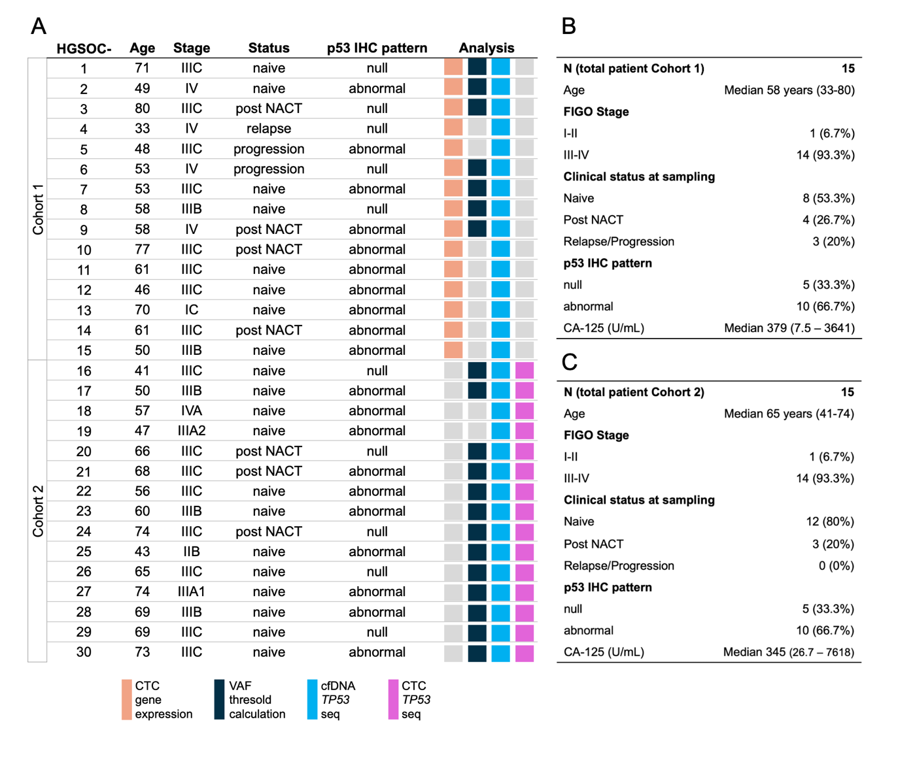
Fig.S1. Overview of HGSOC patient characteristics. (A) Demographic and clinical data of HGSOC patients enrolled for the study, with coloured boxes describing the analyses for which the patient material was used. (B-C) Summaries of demographic and clinical data of cohort 1 (B) and cohort 2 (C) enrolled for the study. FIGO - International federation of gynaecology and obstetrics, NACT – neoadjuvant chemotherapy, IHC – immunohistochemistry.

Fig.S2. dPCR analytical validity assessment. Raw data extrapolated from QuantStudio Absolute Q dPCR software, indicating fluorescence signal on Y axis and microchamber location on X axis for WT1, GPX8 and AGR2. The black dotted line indicates the detection threshold. Genes for which positive signals were detected in mock liquid biopsy samples are indicated in bold, while the computed cDNA concentration for each gene is indicated in brackets.

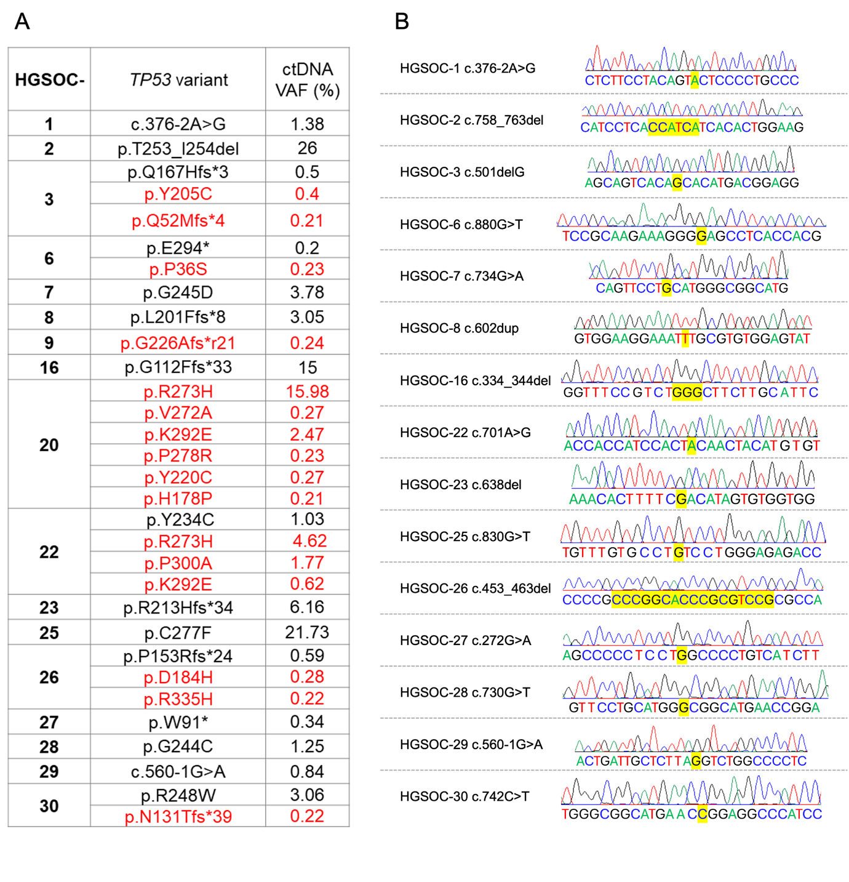
Fig.S3. TP53 sequencing results used for setting the VAF threshold for ctDNA mutational call. (A) Table listing all variants found in cfDNA of 17 out of 20 patients analyzed by TP53 NGS prior the optimal VAF threshold application. Mutations found in primary tumor are indicated in black, whereas variants undetected in solid biopsy are indicated in red. (B) PBMC sequencing results confirming somatic nature of primary tumor mutations. For each HGSOC patient, the TP53 mutation is reported, together with corresponding Sanger sequencing chromatograms of matching PBMC, where wild-type genotype is highlighted in yellow. GRCh37 - ENST00000269305.4 TP53-001 was used as reference.

Supplementary References

[1] ©2025 - ClinCalc LLC. n.d. https://clincalc.com/stats/Power.aspx.
[2] Obermayr E, Maritschnegg E, Agreiter C, Pecha N, Speiser P, Helmy-Bader S, et al. Efficient leukocyte depletion by a novel microfluidic platform enables the molecular detection and characterization of circulating tumor cells. Oncotarget 2018;9:812–23. https://doi.org/10.18632/oncotarget.22549.
[3] Alba-Bernal A, Godoy-Ortiz A, Domínguez-Recio ME, López-López E, Quirós-Ortega ME, Sánchez-Martín V, et al. Increased blood draws for ultrasensitive ctDNA and CTCs detection in early breast cancer patients. Npj Breast Cancer 2024;10:36. https://doi.org/10.1038/s41523-024-00642-6.
[4] Kutz O, Drukewitz S, Krüger A, Aust D, William D, Oster S, et al. Exploring evolutionary trajectories in ovarian cancer patients by longitudinal analysis of ctDNA. Clin Chem Lab Med 2024;62:2070–81. https://doi.org/10.1515/cclm-2023-1266.
[5] Ombrato L, Nolan E, Kurelac I, Mavousian A, Bridgeman VL, Heinze I, et al. Metastatic-niche labelling reveals parenchymal cells with stem features. Nature 2019;572:603–8. https://doi.org/10.1038/s41586-019-1487-6.
[6] AutoMACS programs n.d. https://static.miltenyibiotec.com/asset/150655405641/document_bvcjtgs8p50d37gcdh9u6g1m13/autoMACS%20Pro%20Separator%20user%20manual.pdf?content-disposition=inline.
[7] Primer 3 n.d. https://primer3.ut.ee/.
[8] IDT OligoAnalayzer n.d. https://eu.idtdna.com/pages/tools/oligoanalyzer?utm_source=google&utm_medium=cpc&utm_campaign=00588_1i_03&utm_content=search&gad_source=1&gad_campaignid=6452807278&gclid=CjwKCAjwiY_GBhBEEiwAFaghvtRBR5wOxx9I5YamuZNzugLwopQCAxG5BGU8Pf0pIpalGq4bxwJhgRoCGgUQAvD_BwE.
[9] Mfold n.d. https://www.unafold.org/.
[10] TaqMan Real-Time PCR Assay - Thermo Fisher Scientific n.d. https://www.thermofisher.com/it/en/home/life-science/pcr/real-time-pcr/real-time-pcr-assays.html?ef_id=:G:s&s_kwcid=AL!3652!3!!p!!o!!taqman%20protocol!471018260!1239150678510493&cid=gsd_pcr_sbu_r01_co_cp1491_pjt9623_gsd00000_0se_gaw_bt_lgn_con&msclkid=c6770a84b0b81f747beb6dfe1159bb52.
[11] Raics J. [The effect of changing the indication for Cesarean sectionson the perinatal infant mortality]. Zentralbl Gynakol 1967;89:91–102.
[12] Kurelac I, Sollazzo M, De Luise M, Nanetti F, Lanteri L, D’Angelo L, et al. Immunomagnetic enrichment coupled to PAX8/TP53 molecular pathology approach increases sensitivity in the detection of ovarian cancer cells in ascites. Front Mol Biosci 2025;12:1537407. https://doi.org/10.3389/fmolb.2025.1537407.
[13] De Biase D, Acquaviva G, Visani M, Sanza V, Argento CM, De Leo A, et al. Molecular Diagnostic of Solid Tumor Using a Next Generation Sequencing Custom-Designed Multi-Gene Panel. Diagnostics 2020;10:250. https://doi.org/10.3390/diagnostics10040250.
[14] Mack PC, Banks KC, Espenschied CR, Burich RA, Zill OA, Lee CE, et al. Spectrum of driver mutations and clinical impact of circulating tumor DNA analysis in non–small cell lung cancer: Analysis of over 8000 cases. Cancer 2020;126:3219–28. https://doi.org/10.1002/cncr.32876.
[15] Deveson IW, Gong B, Lai K, LoCoco JS, Richmond TA, Schageman J, et al. Evaluating the analytical validity of circulating tumor DNA sequencing assays for precision oncology. Nat Biotechnol 2021;39:1115–28. https://doi.org/10.1038/s41587-021-00857-z.
[16] Couraud S, Vaca-Paniagua F, Villar S, Oliver J, Schuster T, Blanché H, et al. Noninvasive Diagnosis of Actionable Mutations by Deep Sequencing of Circulating Free DNA in Lung Cancer from Never-Smokers: A Proof-of-Concept Study from BioCAST/IFCT-1002. Clin Cancer Res 2014;20:4613–24. https://doi.org/10.1158/1078-0432.CCR-13-3063.
[17] Robinson JT, Thorvaldsdóttir H, Winckler W, Guttman M, Lander ES, Getz G, et al. Integrative genomics viewer. Nat Biotechnol 2011;29:24–6. https://doi.org/10.1038/nbt.1754.
[18] IGV Software n.d. https://igv.org/doc/desktop/.
[19] Kopanos C, Tsiolkas V, Kouris A, Chapple CE, Albarca Aguilera M, Meyer R, et al. VarSome: the human genomic variant search engine. Bioinformatics 2019;35:1978–80. https://doi.org/10.1093/bioinformatics/bty897.
[20] Varsome website n.d. https://varsome.com/.
[21] Obermayr E, Castillo-Tong DC, Pils D, Speiser P, Braicu I, Van Gorp T, et al. Molecular characterization of circulating tumor cells in patients with ovarian cancer improves their prognostic significance — A study of the OVCAD consortium. Gynecol Oncol 2013;128:15–21. https://doi.org/10.1016/j.ygyno.2012.09.021.
[22] Obermayr E, Bednarz-Knoll N, Orsetti B, Weier H-U, Lambrechts S, Castillo-Tong DC, et al. Circulating tumor cells: potential markers of minimal residual disease in ovarian cancer? a study of the OVCAD consortium. Oncotarget 2017;8:106415–28. https://doi.org/10.18632/oncotarget.22468.
[23] Kolostova K, Pinkas M, Jakabova A, Pospisilova E, Svobodova P, Spicka J, et al. Molecular characterization of circulating tumor cells in ovarian cancer. Am J Cancer Res 2016;6:973–80.
[24] Kuhlmann JD, Wimberger P, Bankfalvi A, Keller T, Schöler S, Aktas B, et al. ERCC1-Positive Circulating Tumor Cells in the Blood of Ovarian Cancer Patients as a Predictive Biomarker for Platinum Resistance. Clin Chem 2014;60:1282–9. https://doi.org/10.1373/clinchem.2014.224808.
[25] Abreu M, Cabezas-Sainz P, Alonso-Alconada L, Ferreirós A, Mondelo-Macía P, Lago-Lestón RM, et al. Circulating Tumor Cells Characterization Revealed TIMP1 as a Potential Therapeutic Target in Ovarian Cancer. Cells 2020;9:1218. https://doi.org/10.3390/cells9051218.

