Supplementary materials

S1. Preliminary operations

S1.1 Packages used:
R - "devtools", "terra", "tidyterra", "osmdata", "sf", "dplyr", "ggplot2", "lubridate", "sp", "leaflet", "grDevices", "colorRamps", "colorspace", "elevatr", "reticulate", "sfdep", "spdep", "tidyr".
Python – “osmnx”, “pyproj”, “rasterio”, “geopandas”, “shapely”, “matplotlib”,

S1.2 Folder structure
The folder structure is built in the local folder path set by the user: an upper folder named after the city of interest, and, inside, the folders “input”, which contains also a “landsat” folder, “processing” and “output”.

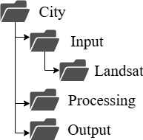

Figure S 1. Folders structure.

S2. Data download

S2.1 OSM

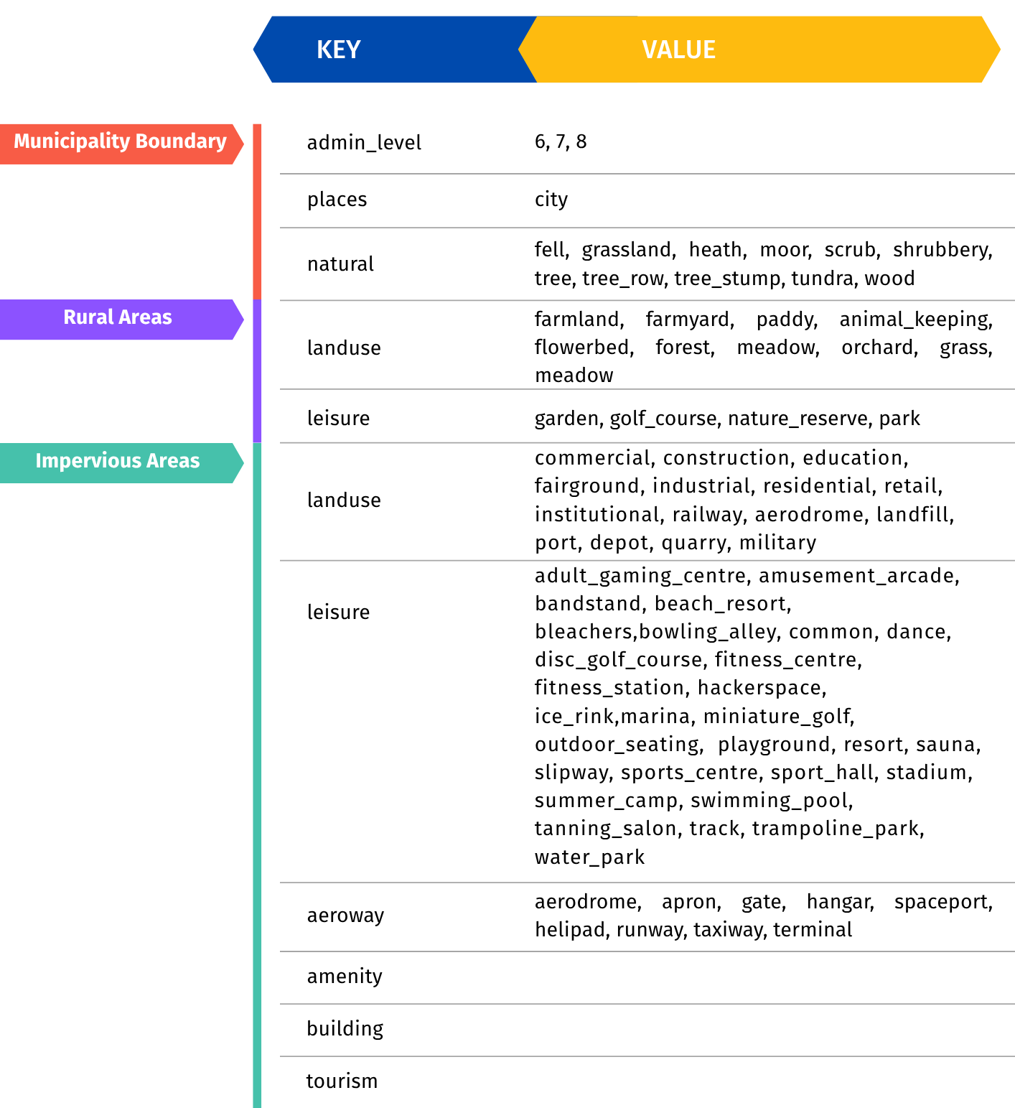
Figure S 2. OSM keys and values combinations for the retrieval of the layers of interest for the analysis (https://wiki.openstreetmap.org/wiki/Category:Key_descriptions).
S2.2 DEM
- R: the DEM is retrieved via the OpenTopography API through the elevatr package in R (https://cran.r-project.org/web/packages/elevatr/vignettes/introduction_to_elevatr.html). This service provides elevation data, from various sources listed at the provided link, at different spatial resolution. In the workflow the elevation data is requested resampled at 30 m resolution, ensuring consistent resolution with Landsat data.
- Python: the same final 30 m resolution is maintained by downloading the SRTM 1 arc-second, specifically the SRTM_GL1 dataset, through the OpenTopography’s API (NASA SRTM, 2013).
S2.3 Landsat
Landsat data are downloaded directly accessing the USGS.gov API, which allows to access the Earth’s land surface images attained by the Landsat satellites relative to a specific geographical location. Also, the R script call the python code to perform this step.

Table S 1. Statistics (horizontal entries) about different cloud cover thresholds (vertical entries): Mean LST (°C), Standard deviation (SD, °C), Interquartile range (IQR, °C), Mean pixel depth per scene, Not Available (NA) pixel percentage per scene. Pct = percentage.

↓LST / Cloud cover→ | <20% | <30% | <50% | <70%
Pct scenes used | 60 | 66 | 78 | 87
Mean (°C) | 32.19 | 31.92 | 30.37 | 28.38
SD (°C) | 6.35 | 6.69 | 9.11 | 11.43
IQR (°C) | 6.29 | 6.69 | 7.24 | 9.80
Mean pixel depth | 13.93 | 15.27 | 18.48 | 21.59
NA coverage pct | 7.16 | 6.85 | 4.63 | 4.63

S3. Algorithm

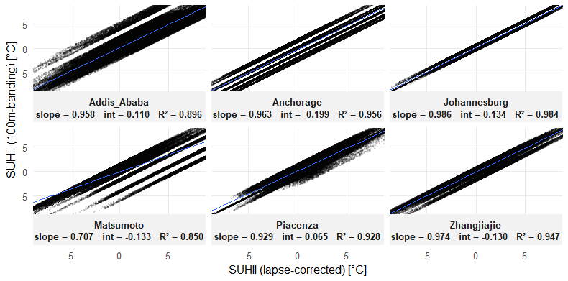
Figure S 3. Scatter plots of SUHII computed with the 100m-bending vs lapse-rate approaches.

Table S 2. Scalability summary metrics (Mean and Standard Deviation) computed over 40 cities (I= input, P = processing, O = output data).
Metric | Mean | SD
Core metrics
Processing Time (min) | 11.32 | 18.08
Memory Allocated (MB) | 17061.71 | 45251.17
Area (km²) | 2163.49 | 3340.39
Landsat Downloaded | 32 | 29
Landsat Used | 11 | 10
Landsat Percentage Used (%) | 45 | 28
Data size (MB)
Rural Areas (I) | 56.48 | 114.86
Urban Areas (I) | 15.87 | 94.78
DEM (I) | 25.02 | 46
Landsat data (I) | 2576.69 | 2253.55
Processing folder (P) | 91.30 | 240.83
Data size (KB)
Thermal Anomaly (O) | 14035 | 42463
Seasonal Mean LST (O) | 13506 | 37403
SUHII (O) | 13210 | 41129
Distance from GUA (O) | 13584 | 40332
Processing step times (min)
Preliminary operations | 0.01 | 0.00
OSM Download | 4.57 | 7.95
Landsat Download | 4.56 | 3.69
DEM Download | 0.30 | 0.37
LST Processing | 0.53 | 1.79
Thermal Anomaly & SUHII | 1.34 | 6.44
Distance from GI | 0.01 | 0.01

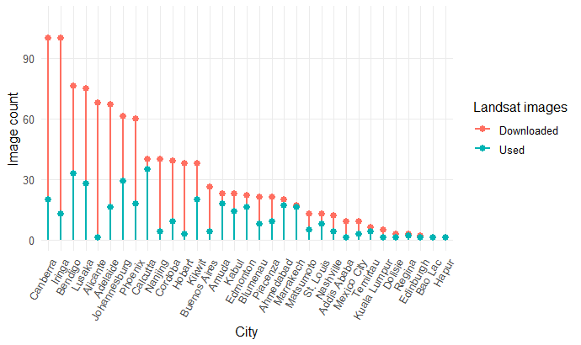
Figure S 4. Landsat data downloaded vs used.

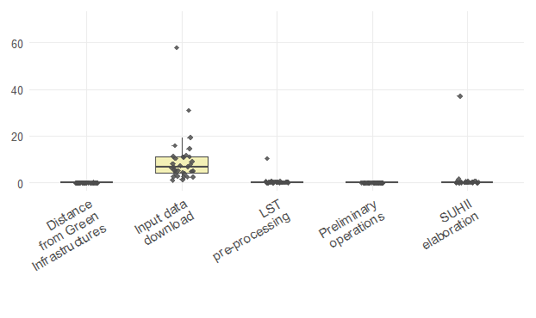
Figure S 5. Processing time by steps.

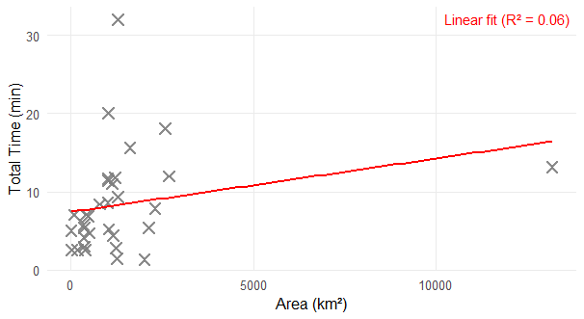
Figure S 6. Total processing time (minutes), Y axis, compared to the city area (km²), X axis.

Session information

R version 4.3.3 (2024-02-29 ucrt)
Platform: x86_64-w64-mingw32/x64 (64-bit)
Running under: Windows 11 x64 (build 26100)

attached base packages:
[1] tools stats graphics grDevices utils datasets methods base

other attached packages:
[1] kgc_1.0.0.2 plyr_1.8.9 shinythemes_1.2.0 shiny_1.10.0
[5] purrr_1.0.4 bench_1.1.4 httr_1.4.7 jsonlite_2.0.0
[9] tidyr_1.3.1 spdep_1.3-11 spData_2.3.4 sfdep_0.2.5
[13] reticulate_1.42.0 elevatr_0.99.0 colorspace_2.1-1 colorRamps_2.3.4
[17] leaflet_2.2.2 sp_2.2-0 lubridate_1.9.4 ggplot2_3.5.2
[21] dplyr_1.1.4 googledrive_2.1.1 sf_1.0-21 osmdata_0.2.5
[25] tidyterra_0.7.2 terra_1.8-54 devtools_2.4.5 usethis_3.1.0

loaded via a namespace (and not attached):
[1] tidyselect_1.2.1 farver_2.1.2 fastmap_1.2.0 promises_1.3.3
[5] digest_0.6.37 timechange_0.3.0 mime_0.13 lifecycle_1.0.4
[9] ellipsis_0.3.2 magrittr_2.0.3 compiler_4.3.3 rlang_1.1.6
[13] htmlwidgets_1.6.4 curl_6.2.3 pkgbuild_1.4.8 classInt_0.4-11
[17] RColorBrewer_1.1-3 pkgload_1.4.0 KernSmooth_2.23-26 miniUI_0.1.2
[21] withr_3.0.2 grid_4.3.3 urlchecker_1.0.1 profvis_0.4.0
[25] xtable_1.8-4 e1071_1.7-16 progressr_0.15.1 scales_1.4.0
[29] dichromat_2.0-0.1 cli_3.6.1 generics_0.1.4 remotes_2.5.0
[33] rstudioapi_0.17.1 sessioninfo_1.2.3 DBI_1.2.3 cachem_1.1.0
[37] proxy_0.4-27 s2_1.1.9 vctrs_0.6.5 boot_1.3-31
[41] Matrix_1.6-5 crosstalk_1.2.1 units_0.8-7 glue_1.6.2
[45] codetools_0.2-20 gtable_0.3.6 later_1.4.2 deldir_2.0-4
[49] tibble_3.2.1 pillar_1.10.2 rappdirs_0.3.3 htmltools_0.5.8.1
[53] R6_2.6.1 httr2_1.1.2 wk_0.9.4 lattice_0.22-7
[57] png_0.1-8 memoise_2.0.1 gargle_1.5.2 httpuv_1.6.16
[61] class_7.3-23 Rcpp_1.0.14 fs_1.6.6 pkgconfig_2.0.3

