Appendix S5 - Non-metric Multidimensional Scaling (NMS) of compositional data before correcting for pseudoturnover

Supplementary material to the paper:
Sabatini, F. M., M. D. Musciano, and A. Chiarucci. 2025. “Using Yearly Resolved Time‐Series to Disentangle Interannual Variability, Directional Change, and Pseudoturnover in Plant Community Composition.” Journal of Vegetation Science e70052. https://doi.org/10.1111/jvs.70052

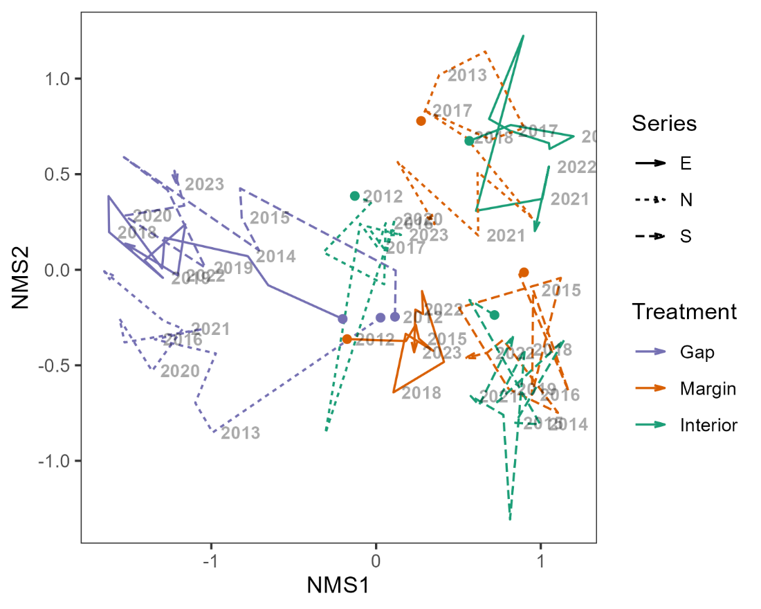
Appendix S5 - Non-metric Multidimensional Scaling (NMS) of compositional data before correcting for pseudoturnover (i.e., based on matrix T).

