Supplementary Information

Source apportionment of gaseous pollutants in oil and gas extraction areas: a comparison between Positive Matrix Factorization and Self-Organizing Maps approaches
Mariassunta Biondi ª, Alessandro Zappi ^{a,}*, Erika Brattich ^{b}, Serena Sabia ^{c}, Rosa Caggiano ^{c}, Laura Tositti ª
ª Department of Chemistry “Giacomo Ciamician”, University of Bologna, Bologna, BO 40129, Italy
^{b} Department of Physics and Astronomy “Augusto Righi”, University of Bologna, Bologna, BO 40126, Italy
^{c} Institute of Methodologies for Environmental Analysis (IMAA), Italian National Research Council (CNR), Tito Scalo, PZ 85050, Italy

* Corresponding author:
Department of Chemistry “Giacomo Ciamician”, University of Bologna, Via Gobetti 85, 40129 Bologna, BO, Italy.
e-mail address: alessandro.zappi4@unibo.it (A. Zappi)
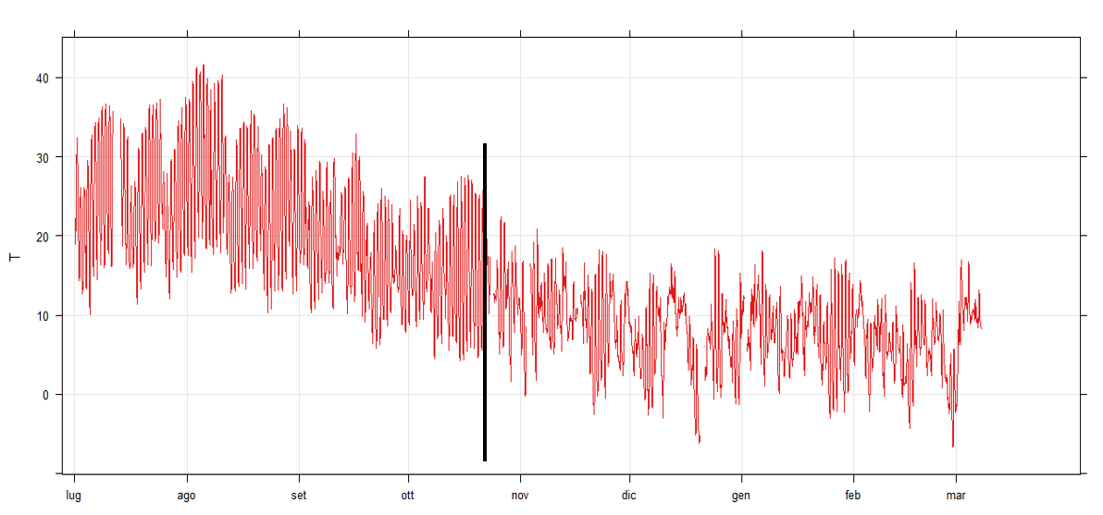
Figure S1. Time plot of hourly temperature values, in °C, measured at the Viggiano station during the entire sampling period (July 18 - March 31), with a focus (black bar) on the selected date (23/10/2017, 23:00) for dividing the dataset into the two seasonal phases of the warm and cold seasons.

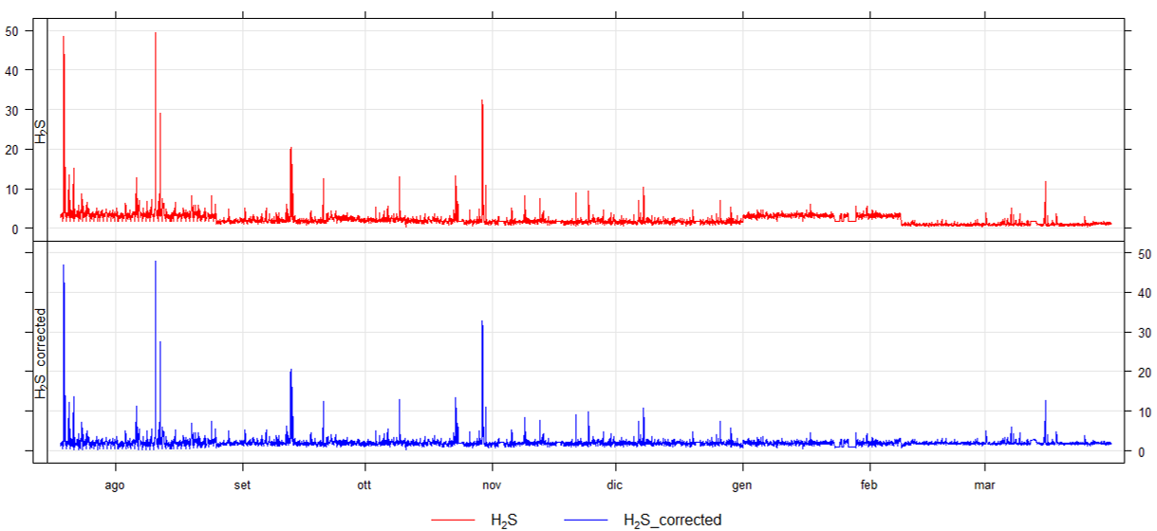
Figure S2. Example of the effect of the baseline correction procedure on H2S time series. The upper plot shows not-corrected data, the lower plot shows baseline-corrected data. The baseline shift is mostly visible in the periods July-August and January-February.

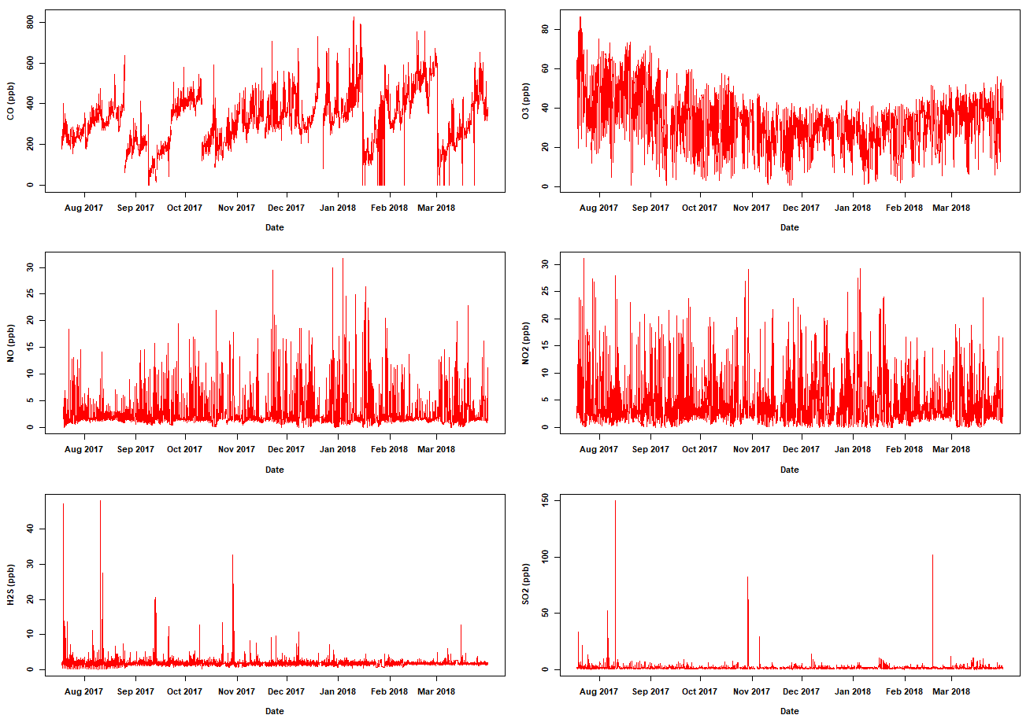
Figure S3. Time plot of hourly concentration of (from top-left to bottom-right): CO, O₃, NO, NO₂, H₂S, and SO₂. All reported data are in ppb, after baseline correction procedure. Measurments were carried out at the Viggiano station in the period July 18 - March 31, 2017.
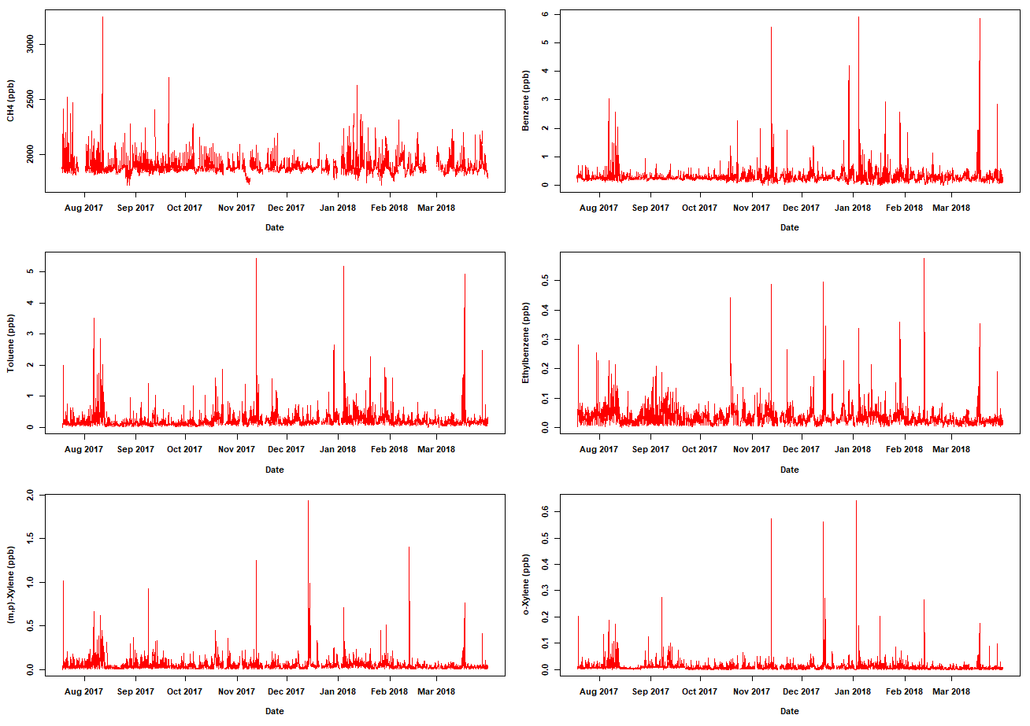
Figure S4. Time plot of hourly concentration of (from top-left to bottom-right): CH4, Benzene, Toluene, Ethylbenzene, (m,p)-Xylene, and o-Xylene. All reported data are in ppb, after baseline correction procedure. Measurments were carried out at the Viggiano station in the period July 18 - March 31, 2017.

Table S1. Descriptive statistics of the gaseous pollutants concentrations (ppb) data for the “cold period” of sampling (24/10/2017-31/03/2018): arithmetic mean, standard deviation (SD), minimum (Min) and maximum (Max), median, first and third quartile (Q1 and Q3), and Inter-Quartile (Q3–Q1)
ppb | CH₄ | CO | O₃ | NO₂ | NO | H₂S | SO₂ | Benz | Tol | m.p-Xil | Etbenz | o-Xil
Mean | 1889.4 | 355.3 | 29.4 | 4.9 | 3.2 | 1.9 | 1.6 | 0.31 | 0.23 | 0.04 | 0.03 | 0.01
SD | 78.0 | 125.4 | 10.4 | 4.6 | 3.8 | 1.0 | 3.1 | 0.3 | 0.3 | 0.1 | 0.0 | 0.0
Min | 1.1 | 0.0 | 0.8 | 0.0 | 0.0 | 0.5 | 0.0 | 0.0 | 0.0 | 0.0 | 0.0 | 0.0
Q1 | 1853.0 | 280.2 | 22.8 | 1.9 | 1.3 | 1.6 | 0.9 | 0.2 | 0.1 | 0.0 | 0.0 | 0.0
Median | 1876.3 | 350.9 | 30.7 | 3.2 | 1.7 | 1.9 | 1.2 | 0.3 | 0.2 | 0.0 | 0.0 | 0.0
Q3 | 1907.9 | 435.3 | 37.0 | 6.2 | 3.4 | 2.1 | 1.6 | 0.4 | 0.3 | 0.1 | 0.0 | 0.0
Max | 2632.0 | 826.6 | 56.2 | 29.2 | 31.6 | 32.7 | 101.8 | 5.9 | 5.4 | 1.9 | 0.6 | 0.6
Q3 - Q1 | 54.9 | 155.0 | 14.3 | 4.3 | 2.1 | 0.5 | 0.7 | 0.2 | 0.1 | 0.0 | 0.0 | 0.0
Max - Min | 2630.9 | 826.6 | 55.4 | 29.2 | 31.6 | 32.2 | 101.8 | 5.9 | 5.4 | 1.9 | 0.6 | 0.6

Table S2. Descriptive statistics of the gaseous pollutants concentrations (ppb) data for the “warm period” of sampling (18/07/2017-23/10/2017): arithmetic mean, standard deviation (SD), minimum (Min) and maximum (Max), median, first and third quartile (Q1 and Q3), and Inter-Quartile (Q3–Q1)
ppb | CH₄ | CO | O₃ | NO₂ | NO | H₂S | SO₂ | Benz | Tol | m.p-Xil | Etbenz | o-Xil
Mean | 1894.3 | 272.3 | 38.5 | 4.7 | 2.7 | 2.2 | 1.7 | 0.29 | 0.18 | 0.05 | 0.04 | 0.01
SD | 100.7 | 104.8 | 17.8 | 4.5 | 2.5 | 2.2 | 4.3 | 0.19 | 0.24 | 0.07 | 0.04 | 0.02
Min | 1.1 | 16.9 | 0.9 | 0.01 | 0.1 | 0.2 | 0.02 | 0.08 | 0.00 | 0.00 | 0.00 | 0.00
Q1 | 1854.8 | 192.6 | 26.5 | 1.9 | 1.4 | 1.6 | 0.9 | 0.22 | 0.08 | 0.02 | 0.02 | 0.00
Median | 1876.1 | 259.7 | 38.6 | 3.1 | 1.7 | 1.9 | 1.2 | 0.25 | 0.13 | 0.03 | 0.03 | 0.01
Q3 | 1910.6 | 358.5 | 50.0 | 5.7 | 2.9 | 2.2 | 1.7 | 0.31 | 0.19 | 0.06 | 0.05 | 0.01
Max | 3256.1 | 637.4 | 375.1 | 31.1 | 22.0 | 47.9 | 149.9 | 3.05 | 3.52 | 1.02 | 0.44 | 0.27
Q3 - Q1 | 55.9 | 165.9 | 23.5 | 3.8 | 1.5 | 0.7 | 0.8 | 0.09 | 0.11 | 0.05 | 0.03 | 0.01
Max - Min | 1909.54 | 341.62 | 49.06 | 5.70 | 2.81 | 2.06 | 1.65 | 0.23 | 0.19 | 0.06 | 0.05 | 0.01

