Supplementary Information

Autocatalytic Electrochemiluminescence

Claudia Martinez Asenjoª, Francesco Petrini^{b}, Alessandro Fracassaª, Sara Knežević^{c}, Elisa D’Arrigo^{d}, Paul S. Francis^{e}, Francesco Paolucciª, Neso Sojic^{d}, Frederic Kanoufi^{b}*, Giovanni Valentiª*
ª Department of Chemistry ‘‘Giacomo Ciamician’’, Alma Mater Studiorum – University of Bologna, Via Gobetti 85, 40129 Bologna, Italy
^{b} Université Paris Cité, ITODYS, CNRS UMR 7086, 15 rue J.A. de Baïf, 75013 Paris, France
^{c} Sorbonne Université, CNRS, Laboratoire Chimie de la Matière Condensée de Paris, LCMCP, 4 Place Jussieu, 75005 Paris, France
^{d} University of Bordeaux, CNRS, Bordeaux INP, ISM, UMR 5255, ENSMAC, 33607, Pessac, France
^{e} Centre for Sustainable Bioproducts, Faculty of Science, Engineering and Built Environment, Deakin University, Geelong, Victoria 3220, Australia

Methods
Chemicals
Potassium peroxydisulfate (K₂S₂O₈, ≥99.0%), hexaammineruthenium(III) chloride (Ru(NH₃)₆Cl₃, 98%), tris(2,2′-bipyridyl)dichlororuthenium(II) hexahydrate ([Ru(bpy)₃]Cl₂·6H₂O, 99.95%), sodium hydroxide (NaOH, ≥98.0 % pellets), sulfuric acid (H₂SO₄, 95.0-98.0 %) and sodium sulfate anhydrous (Na₂SO₄) were purchased from Sigma Aldrich. Sodium oxalate (Na₂C₂O₄, ≥99.5 %) was purchased from Carlo Erba Reagents. [Ir(dfppy)₂(pt-TEG)]Cl (bis(2-(2,4-difluorophenyl)pyridine)(1-(2-(2-(2-(2-hydroxyethoxy)ethoxy)ethoxy)ethyl)-1-(4-pyridil)-1,2,3-triazole)iridium(III) chloride) was synthetized as reported in literature.^{[1]}
Electrochemiluminescence
All measurements were carried out in a quartz cuvette (dimensions 1×1×4.5 cm) including a platinum (Pt) (d = 2 mm) or glassy carbon (GC) (d = 3 mm) working electrode, a Ag/AgCl (3 M KCl) reference electrode and a Pt wire as counter-electrode. The electrochemical apparatus was controlled with a SP-300 potentiostat. All solutions were prepared in Na₂SO₄ 0.1 M (pH 6.8) and contained the required concentrations of S₂O₈²⁻, C₂O₄²⁻, Ru(NH₃)₆³⁺ and Ru(bpy)₃²⁺ or [Ir(dfppy)₂(pt-TEG)]⁺. Concerning the CV-ECL (cyclic voltammetry coupled with an ECL emission detector) experiments, the Pt working electrode potential was scanned from 0.4 V to -0.4 V and back to 0.4 V; the GC working electrode potential was scanned from 0.1 V to -0.5 V and back to 0.1 V. In all experiments, the counter electrode potential was monitored and remained below 0.85 V vs Ag/AgCl (where the ECL is not generated as demonstrated in Fig. S11). The evolution of the ECL signal on the GC working electrode as a function of time was recorded during double chronoamperometric pulses: open circuit potential (OCP) for 3 s and a second pulse at -0.5 V for 60 s. The current and the ECL intensity were recorded simultaneously. To avoid any interferences with the external light, the system was enclosed in a homemade dark box. The ECL was collected with a Hamamatsu R928 photomultiplier tube (PMT; Hamamatsu Photonics K.K., Japan) set to 750 V. The recorded signal was eventually amplified with a Keithley Model 6485 Picoammeter (Keithley Instruments Inc., Ohio, United States), where the amplification level was set to 0.0 µA. The ECL spectrum was acquired using a SpectraPro2300i spectrophotometer (Princeton Instruments) and the emitted light was collected with an optical fiber placed below the electrochemical chamber with an exposure time of 30 s. A constant potential of -0.2 V was applied using a PalmSens4 potentiostat during the spectral acquisition.
In the microscopy setup, a three-electrode electrochemical cell was employed, including a carbon fiber (CF, d = 7 µm) as working electrode, a Ag/AgCl (3 M KCl) reference electrode and a Pt wire as counter-electrode. The setup consisted of an epifluorescence microscope from Nikon (Chiyoda, Tokyo, Japan) in a bottom-view configuration equipped with an ultrasensitive EMCCD camera (EM-CCD 9100-13 from Hamamatsu, Japan) with a resolution of 512 × 512 pixel. The system was enclosed in a homemade dark box to avoid interferences from external light. It also included a motorized microscope stage (Corvus, Märzhäuser, Wetzlar, Germany) for sample positioning and with long-distance objective from Nikon (magnification 100×/numerical aperture 0.80/WD 4.5). Additionally, the integrated system included a SP300 potentiostat (BioLogic Science Instrument, France) triggered with the camera. ECL images were recorded by applying a double chronoamperometric pulse: OCP for 2 s and -0.5 V vs Ag/AgCl for the next 60 s. The total integration time of the EM-CCD camera was set to 60 s. Gain and sensitivity parameters of the EM-CCD camera were set to 5 and 1200, respectively.
a)
b)
Figure S1. (a) Cyclic voltammograms and (b) corresponding ECL of solutions prepared in 0.1 M Na₂SO₄ (pH 6.8) containing initially 30 mM S₂O₈²⁻, 30 mM C₂O₄²⁻ and 0.03 mM Ru(bpy)₃²⁺ (black trace) and removing S₂O₈²⁻ (red trace), C₂O₄²⁻ (blue trace) and Ru(bpy)₃²⁺ (green trace). The Pt working electrode (d = 2 mm) potential was scanned at a rate of 100 mV∙s⁻¹.
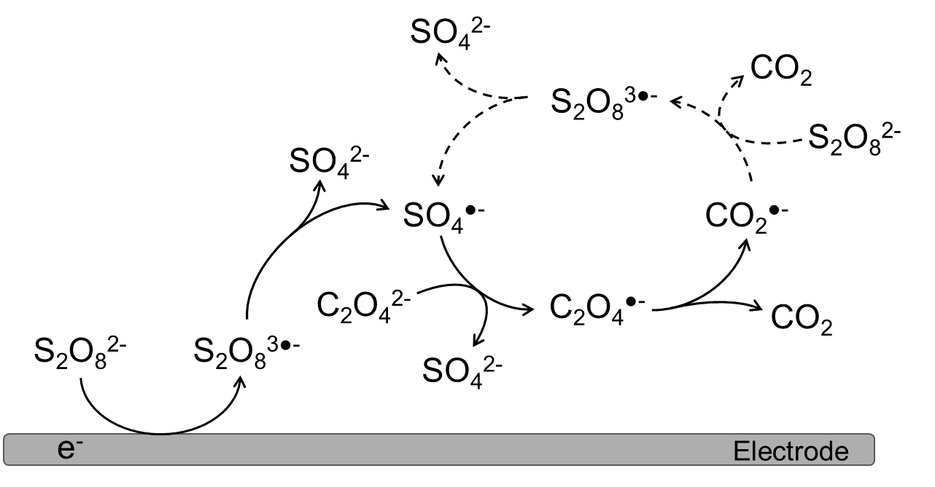
Scheme S1. Schematics of the proposed mechanism of the electrochemical peroxydisulfate-oxalate autocatalytic reaction.^{[2]}

Figure S2. Cyclic voltammogram of a solution prepared in 0.1 M Na₂SO₄ (pH 6.8) containing 0.1 mM Ru(NH₃)₆³⁺. The GC working electrode (d = 3 mm) potential was scanned at a rate of 100 mV∙s⁻¹.
Figure S3. ECL emission spectrum recorded during a chronoamperometric measurement of a 0.1 M Na₂SO₄ (pH 6.8) solution containing 30 mM S₂O₈²⁻, 30 mM C₂O₄²⁻, 0.1 mM Ru(NH₃)₆³⁺ and 0.03 mM Ru(bpy)₃²⁺. A constant potential of -0.2 V vs Ag/AgCl was applied on the GC working electrode (d = 3 mm).

a)
b)
Figure S4. (a) Cyclic voltammograms and (b) corresponding ECL of solutions prepared in 0.1 M Na₂SO₄ (pH 6.8) containing 30 mM S₂O₈²⁻, 30 mM C₂O₄²⁻, 0.03 mM Ru(bpy)₃²⁺ and 0.1 mM Ru(NH₃)₆³⁺. The GC working electrode (d = 3 mm) potential was scanned at a rate of 10 (black trace), 30 (red trace), 100 (dark blue trace), 300 (green trace), 500 (orange trace) and 1000 (clear blue trace) mV∙s⁻¹.
Calculation of k_{fcat} through foot of the wave analysis (FOWA)
$\frac{i}{i_{p}^{o}}=\frac{2.24\sqrt{\frac{RT}{Fv}2k_{fcat}C_{A}^{o}}}{1+e^{\left(-\frac{F}{RT}\left(E-E_{cat}^{o}\right)\right)}}$ (S1)
i: current (mA)
iº_{p}: cathodic peak current of the catalyst Ru(NH₃)₆³⁺ in the absence of the substrate (mA)
R: normal gas constant (J/K∙mol)
T: temperature (K)
F: Faraday constant (C/mol)
v: scan rate (V∙s⁻¹)
k_{fcat}: apparent rate constant of the homogeneous redox catalysis reaction (M⁻¹∙s⁻¹)
$C_{A}^{o}$: substrate (S₂O₈²⁻) concentration in the bulk solution (M)
E: applied potential (V)
$E_{cat}^{o}$: standard potential of the redox couple Ru(NH₃)₆^{3+/2+} (V)
Table S1. k_{fcat} values calculated from the experimental data employing Eq. S1.
$C_{{S_{2}O_{8}}^{2-}}^{o}$ / mM | $C_{{C_{2}O_{4}}^{2-}}^{o}$/ mM | $C_{{{Ru\left({NH}_{3}\right)}_{6}}^{3+}}^{o}$/ mM | $C_{{Ru{(bpy)}_{3}}^{2+}}^{o}$ / mM | K_{fcat} / M⁻¹∙s⁻¹
30 | 30 | 0.1 | - | 2.2 × 10⁵
30 | 30 | 0.1 | 0.03 | 1.8 × 10⁵
30 | 30 | 0.3 | 0.03 | 7.5 × 10⁵
30 | 30 | 0.5 | 0.03 | 8.3 × 10⁵

b)
a)
Figure S5. (a) Cyclic voltammograms and (b) corresponding ECL of solutions prepared in 0.1 M Na₂SO₄ (pH 6.8) containing 30 mM S₂O₈²⁻, 30 mM C₂O₄²⁻, 0.03 mM Ru(bpy)₃²⁺ and 0.1 mM Ru(NH₃)₆³⁺ (black trace), 0.3 mM Ru(NH₃)₆³⁺ (red trace) and 0.5 mM Ru(NH₃)₆³⁺ (blue trace). The GC working electrode (d = 3 mm) potential was scanned at a rate of 100 mV∙s⁻¹.
a)
b)
Figure S6. (a) Cyclic voltammograms and (b) corresponding ECL of solutions prepared in 0.1 M Na₂SO₄ (pH 6.8) containing 0.1 mM Ru(NH₃)₆³⁺, 0.03 mM Ru(bpy)₃²⁺ and 30 mM S₂O₈²⁻ and 30 mM C₂O₄²⁻ (black trace); 10 mM S₂O₈²⁻ and 10 mM C₂O₄²⁻ (red trace); and 10 mM S₂O₈²⁻ and 5 mM C₂O₄²⁻ (blue trace). Scan rate: 100 mV s⁻¹. Working electrode: GC (d = 3 mm).
a)
b)
Figure S7. (a) Cyclic voltammograms and (b) corresponding ECL of solutions prepared in 0.1 M Na₂SO₄ (pH 6.8) containing 0.5 mM Ru(NH₃)₆³⁺, 0.03 mM Ru(bpy)₃²⁺ and 30 mM S₂O₈²⁻ and 30 mM C₂O₄²⁻ (black trace); 10 mM S₂O₈²⁻ and 5 mM C₂O₄²⁻ (red trace); and 1 mM S₂O₈²⁻ and 10 mM C₂O₄²⁻ (blue trace). Scan rate: 100 mV∙s⁻¹. Working electrode: GC (d = 3 mm).

Figure S8. ECL intensity as a function of Ru(bpy)₃²⁺ concentration (10 – 300 µM) in solutions containing 30 mM S₂O₈²⁻, 30 mM C₂O₄²⁻, 0.1 mM Ru(NH₃)₆³⁺, prepared in 0.1 M Na₂SO₄ (pH 6.8). The GC working electrode (d = 3 mm) potential was scanned between 0.1 and -0.5 V vs Ag/AgCl at a scan rate of 100 mV∙s⁻¹. The reported values correspond to the average ECL intensity (n = 3) at -0.5 V vs Ag/AgCl. The amplification level was set to 000.0 nA.

Finite element simulations
Digital simulations were carried out by the commercial finite element software COMSOL Multiphysics (Version 6.0). Finite element model used to simulate ECL emission is available free of charge at 10.5281/zenodo.17770612. In this simulation, a 1D model was built to simulate the physical geometry of the substrate used in ECL experiments with a refined mesh at the electrode surface boundary, as shown in Figure S8. The bulk boundary is set at constant concentrations of ${\left[Ru{\left(bpy\right)}_{3}\right]}^{2+}$ ($30 μM$).
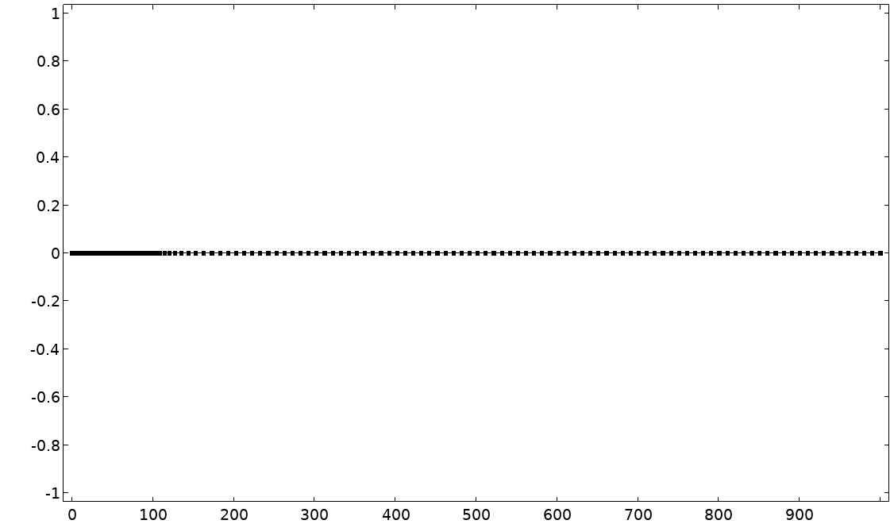
Figure. S9. Mesh for COMSOL simulation with progressively growing mesh size over three domains starting from electrode surface boundary (left) towards bulk (right). Electrode boundary: Maximum element size, $5×{10}^{-4} μm$; $0-5 μm$ domain: Maximum element size, $5×{10}^{-3} μm$; $5-50 μm$ domain: Maximum element size, $5×{10}^{-2} μm$; $50 μm-$ bulk: Maximum element size: $10 μm$. All domains have Maximum element growth rate: $1.1$.
The reactive species considered in the model include all the redox-active states of the luminophore and the coreactants involved in the generation of the ECL signal, together with those of the mediator.
The two radicals $C_{2}O_{4}^{⋅-}$ and $S_{2}O_{8}^{3⋅-}$ are not included as reactive species because they have a very limited lifetime ($\sim 1 μs$ and $\sim 1 ps$, respectively),^{[2]} thus whenever they are formed, we consider that they immediately decompose according to Eq. S2-3:
$C_{2}O_{4}^{⋅-}→CO_{2}+CO_{2}^{⋅-}$ (S2)
$S_{2}O_{8}^{3⋅-}→SO_{4}^{2-}+SO_{4}^{⋅-}$ (S3)
Namely, the simulation encompasses ${\left[Ru{\left(bpy\right)}_{3}\right]}^{2+}$, and its excited, oxidized and reduced forms ${\left[Ru{\left(bpy\right)}_{3}\right]}^{2*}, {\left[Ru{\left(bpy\right)}_{3}\right]}^{3+}$ and ${\left[Ru{\left(bpy\right)}_{3}\right]}^{+}$, respectively; the anion $C_{2}O_{4}^{2-}$, along with the products of the decomposition of its radical form $C_{2}O_{4}^{⋅-}$ ($CO_{2}^{⋅-}$ and $CO_{2}$); the anion $S_{2}O_{8}^{2-}$ along with the products of the decomposition of its radical form $S_{2}O_{8}^{3⋅-}$ ($SO_{4}^{⋅-}$ and $SO_{4}^{2-}$); the mediator ${\left[Ru{\left(NH_{3}\right)}_{6}\right]}^{3+}$ and its reduced form ${\left[Ru{\left(NH_{3}\right)}_{6}\right]}^{2+}$.
Equations describing all the electrochemical and chemical reaction steps incorporated in the model are provided in Table S2. All parameters used in the simulation are summarized in Table S3.
Table S2. Reactions considered in the autocatalytic simulation model.
Category | Reaction Equation | N°
Charge-Transfer Reactions | $$Ru{\left(NH_{3}\right)}_{6}^{3+}+e^{-}↔Ru{\left(NH_{3}\right)}_{6}^{2+}$$ | $$(S4)$$
Charge-Transfer Reactions | $$SO_{4}^{⋅-}+e^{-}→SO_{4}^{2-}$$ | $$(S5)$$
Charge-Transfer Reactions | $$CO_{2}^{⋅-}→CO_{2}+e^{-}$$ | $$(S6)$$
Charge-Transfer Reactions | $$Ru{\left(bpy\right)}_{3}^{3+}+e^{-}→Ru{\left(bpy\right)}_{3}^{2+}$$ | $$(S7)$$
Charge-Transfer Reactions | $$Ru{\left(bpy\right)}_{3}^{+}→Ru{\left(bpy\right)}_{3}^{2+}+e^{-}$$ | $$(S8)$$
Homogeneous Reactions | $$Ru{\left(NH_{3}\right)}_{6}^{2+}+S_{2}O_{8}^{2-}→Ru{\left(NH_{3}\right)}_{6}^{3+}+SO_{4}^{2-}+SO_{4}^{⋅-}$$ | $$(S9)$$
Homogeneous Reactions | $$C_{2}O_{4}^{2-}+SO_{4}^{⋅-}→CO_{2}+CO_{2}^{⋅-}+SO_{4}^{2-}$$ | $$(S10)$$
Homogeneous Reactions | $$CO_{2}^{⋅-}+S_{2}O_{8}^{2-}→CO_{2}+SO_{4}^{⋅-}+SO_{4}^{2-}$$ | $$\left(S11\right)$$
Homogeneous Reactions | $$Ru{\left(NH_{3}\right)}_{6}^{2+}+SO_{4}^{⋅-}→Ru{\left(NH_{3}\right)}_{6}^{3+}+SO_{4}^{2-}$$ | $$(S12)$$
Homogeneous Reactions | $$Ru{\left(NH_{3}\right)}_{6}^{3+}+CO_{2}^{⋅-}→Ru{\left(NH_{3}\right)}_{6}^{2+}+CO_{2}$$ | $$(S13)$$
Homogeneous Reactions | $$Ru{\left(bpy\right)}_{3}^{3+}+Ru{\left(NH_{3}\right)}_{6}^{2+}→Ru{\left(bpy\right)}_{3}^{2+}+Ru{\left(NH_{3}\right)}_{6}^{3+}$$ | $$(S14)$$
Homogeneous Reactions | $$Ru{\left(NH_{3}\right)}_{6}^{3+}+Ru{\left(bpy\right)}_{3}^{+}→Ru{\left(NH_{3}\right)}_{6}^{2+}+Ru{\left(bpy\right)}_{3}^{2+}$$ | $$(S15)$$
Homogeneous Reactions | $$Ru{\left(bpy\right)}_{3}^{2+}+CO_{2}^{⋅-}→Ru{\left(bpy\right)}_{3}^{+}+CO_{2}$$ | $$(S16)$$
Homogeneous Reactions | $$Ru{\left(bpy\right)}_{3}^{3+}+CO_{2}^{⋅-}→Ru{\left(bpy\right)}_{3}^{2+*}+CO_{2}$$ | $$(S17)$$
Homogeneous Reactions | $$Ru{\left(bpy\right)}_{3}^{2+}+{SO}_{4}^{⋅-}→Ru{\left(bpy\right)}_{3}^{3+}+SO_{4}^{2-}$$ | $$(S18)$$
Homogeneous Reactions | $$Ru{\left(bpy\right)}_{3}^{+}+{SO}_{4}^{⋅-}→Ru{\left(bpy\right)}_{3}^{2+*}+SO_{4}^{2-}$$ | $$(S19)$$
Homogeneous Reactions | $$Ru{\left(bpy\right)}_{3}^{3+}+Ru{\left(bpy\right)}_{3}^{+}→Ru{\left(bpy\right)}_{3}^{2+*}+Ru{\left(bpy\right)}_{3}^{2+}$$ | $$(S20)$$
Homogeneous Reactions | $$Ru{\left(bpy\right)}_{3}^{3+}+C_{2}O_{4}^{2-}→Ru{\left(bpy\right)}_{3}^{2+}+CO_{2}+CO_{2}^{⋅-}$$ | $$(S21)$$
Homogeneous Reactions | $$Ru{\left(bpy\right)}_{3}^{+}+S_{2}O_{8}^{2-}→Ru{\left(bpy\right)}_{3}^{2+}+SO_{4}^{2-}+SO_{4}^{⋅-}$$ | $$(S22)$$
Homogeneous Reactions | $$Ru{\left(bpy\right)}_{3}^{2+*}+S_{2}O_{8}^{2-}→Ru{\left(bpy\right)}_{3}^{3+}+SO_{4}^{2-}+SO_{4}^{⋅-}$$ | $$(S23)$$
Homogeneous Reactions | $$SO_{4}^{⋅-}→SO_{4}^{2-}$$ | $$(S24)$$
Homogeneous Reactions | $$CO_{2}^{⋅-}→CO_{2}$$ | $$(S25)$$
Homogeneous Reactions | $$Ru{\left(bpy\right)}_{3}^{2+*}→Ru{\left(bpy\right)}_{3}^{2+}+hν$$ | $$(S26)$$

Table S3. Comprehensive summary of simulation parameters.
Name | Value | Description
cd | 1[mm] | Cell Dimension
alp | 0.5 | symmetry coefficient
f | n*F_const/(Texp*R_const) | Constant factor in the Butler-Volmer exponential
n | 1 | Number of electrons exchanged
T_exp | 298.15[K] | Experimental Temperature
E_i | 0.1[V] | Initial Potential
E_f | -0.5[V] | Final Potential
v | 100[mV/s] | Scan rate
t_rev | (E_i-E_f)/v | Reverse time for CV
dt | 1[mV]/v | Increment time for CV (time of collection)
bRuhex | 0.1[mM] | Bulk concentration of mediator $Ru{\left(NH_{3}\right)}_{6}^{3+}$
bPS | 30[mM] | Bulk concentration of peroxydisulfate
bOX | 30[mM] | Bulk concentration of oxalate
bRub2 | 30[μM] | Bulk concentration of luminophore $Ru{\left(bpy\right)}_{3}^{2+}$
D_Ruhex | 5.71e-10[m²/s] | Diffusion coefficient of $Ru{\left(NH_{3}\right)}_{6}^{3+}$
D_PS | 1e-9[m²/s] | Diffusion coefficient $S_{2}O_{8}^{2-}$ and $SO_{4}^{⋅-}$
D_OX | 1.03e-9[m²/s] | Diffusion coefficient $C_{2}O_{4}^{2-}$
D_rCO | 2.2e-9[m²/s] | Diffusion coefficient $CO_{2}^{⋅-}$
D_Rub2 | 1e-9[m²/s] | Diffusion coefficient $Ru{\left(bpy\right)}_{3}^{2+/3+/+/2*}$
D_SP | 1e-9[m²/s] | Diffusion coefficient subproducts ($SO_{4}^{2-}$ and $CO_{2}$)
D_hv | 1e-15[m²/s] | Diffusion coefficient for photons (static)
E0_Ruhex | -0.197[V] | Standard potential for mediator couple $Ru{\left(NH_{3}\right)}_{6}^{3+/2+}$
E0_rSO | 2.24[V] | Standard potential for sulfate radical
E0_rCO | -2.17[V] | Standard potential for carbonyl radical
E0_Rub3 | 1.27[V] | Standard potential for $Ru{\left(bpy\right)}_{3}^{2+/3+}$
E0_Rub1 | -1.31[V] | Standard potential for $Ru{\left(bpy\right)}_{3}^{2+/+}$
k0el_Ruhex | 0.1[cm/s] | Standard ET rate mediator
k0el_rSO | 10[cm/s] | Standard ET rate sulfate radical
k0el_rCO | 2.4e-6[cm/s] | Standard ET rate carbonyl radical
k0el_Rub3 | 10[cm/s] | Standard ET rate luminophore oxidation
k0el_Rub1 | 10[cm/s] | Standard ET rate luminophore reduction
k1 | 2e5[1/(M∙s)] | Ruhex2 + PS → Ruhex3 + rSO + P
k2 | 2e7[1/(M∙s)] | OX + rSO → 2P + rCO
k3 | 1e5[1/(M∙s)] | rCO + PS → 2P + rSO
k4 | 1e9[1/(M∙s)] | Ruhex2 + rCO → Ruhex3 + P
k5 | 1e7[1/(M∙s)] | Ruhex3 + rCO → Ruhex2 + P
k6 | 1e9[1/(M∙s)] | Ruhex2 + Rub3 → Ruhex3 + Rub2
k7 | 1e7[1/(M∙s)] | Ruhex3 + Rub1 → Ruhex2 + Rub2
k8 | 7e7[1/(M∙s)] | Rub2 + rCO → Rub1 + P
k9 | 1e9[1/(M∙s)] | Rub3 + rCO → Rub2ex + P
k10 | 1e8[1/(M∙s)] | Rub2 + rSO → Rub3 + P
k11 | 1e9[1/(M∙s)] | Rub1 + rSO → Rub2ex + P
k12 | 1e9[1/(M∙s)] | Rub3 + Rub1 → Rub2 + Rub2ex
k13 | 1.3e4[1/(M∙s)] | Rub3 + OX → Rub2 + rCO + P
k14 | 9.8e4[1/(M∙s)] | Rub1 + PS → Rub2 + rSO + P
k15 | 9.8e8[1/(M∙s)] | Rub2ex + PS → Rub3 + rSO + P
kdS | 3e4[1/s] | Sulfate radical decay: rsO → P
kdC | 1e5[1/s] | Carbonyl radical decay: rCO → P
kem | 1e6[1/s] | Ru2ex → Ru2 + hv
The value of concentration reported in Table S3 for $Ru{\left(NH_{3}\right)}_{6}^{3+},$ $S_{2}O_{8}^{2-}, C_{2}O_{4}^{2-}$ is the optimal one, these were used as parameters to monitor the variation of ECL Area and profile over several orders of magnitude.
The rate constants for heterogeneous electrochemical reactions at the studied overpotential ($E_{el}$), modelled according to Butler-Volmer laws, are presented in Table S4. The rate constants at zero potential were taken from literature.^{[2,3]}
Table S4. Butler-Volmer equations for determining the rate constants of electrode reactions of electroactive species.
Name | Butler-Volmer Equation | Description
$$k_{Ruhex}^{red}$$ | $$-k_{el-Ruhex}^{0}⋅\exp\left(-α⋅f⋅\left(E_{el}-E_{Ruhex}^{0}\right)\right)$$ | Constant for $Ru{\left(NH_{3}\right)}_{6}^{3+}$ reduction
$$k_{Ruhex}^{ox}$$ | $$k_{el-Ruhex}^{0}⋅\exp\left((1-α)⋅f⋅\left(E_{el}-E_{Ruhex}^{0}\right)\right)$$ | Constant for $Ru{\left(NH_{3}\right)}_{6}^{2+}$ oxidation
$$k_{rSO}^{red}$$ | $$-k_{el-rSO}^{0}⋅\exp\left(-α⋅f⋅\left(E_{el}-E_{rSO}^{0}\right)\right)$$ | Constant for $SO_{4}^{⋅-}$ reduction
$$k_{rCO}^{ox}$$ | $$-k_{el-rCO}^{0}⋅\exp\left((1-α)⋅f⋅\left(E_{el}-E_{rCO}^{0}\right)\right)$$ | Constant for $CO_{2}^{⋅-}$ oxidation
$$k_{Rub1}^{ox}$$ | $$-k_{el-Rub1}^{0}⋅\exp\left((1-α)⋅f⋅\left(E_{el}-E_{Rub1}^{0}\right)\right)$$ | Constant for $Ru{\left(bpy\right)}_{3}^{+}$ oxidation
$$k_{Rub3}^{red}$$ | $$-k_{el-Rub3}^{0}⋅\exp\left(-α⋅f⋅\left(E_{el}-E_{Rub3}^{0}\right)\right)$$ | Constant for $Ru{\left(bpy\right)}_{3}^{3+}$ reduction

The inward flux $(J)$ at the electrode surface associated with each species can be expressed as follows in Eqs. S27-32:
$J_{Ru{\left(NH_{3}\right)}_{6}^{3+}}=k_{Ruhex}^{red}⋅[Ru{\left(NH_{3}\right)}_{6}^{3+}]+k_{Ruhex}^{ox}⋅[Ru{\left(NH_{3}\right)}_{6}^{2+}]$ (S27)
$J_{SO_{4}^{⋅-}}=k_{rSO}^{red}⋅\left[SO_{4}^{⋅-}\right]=-J_{SO_{4}^{2-}}$ (S28)
$J_{CO_{2}^{⋅-}}=k_{rCO}^{ox}⋅\left[CO_{2}^{⋅-}\right]=-J_{CO_{2}}$ (S29)
$J_{Ru{\left(bpy\right)}_{3}^{3+}}=k_{Rub3}^{red}⋅[Ru{\left(bpy\right)}_{3}^{3+}]$ (S30)
$J_{Ru{\left(bpy\right)}_{3}^{+}}=k_{Rub1}^{ox}⋅[Ru{\left(bpy\right)}_{3}^{+}]$ (S31)
$J_{Ru{\left(bpy\right)}_{3}^{2+}}=-J_{Ru{\left(bpy\right)}_{3}^{3+}}-J_{Ru{\left(bpy\right)}_{3}^{3+}}$ (S32)
The right boundary in the model (Fig. S8) represents the bulk solution where the initial concentrations remain constant throughout the simulation, promoting diffusion along the solution.
Isotropic diffusion of species in solution is formulated according to Fick’s second law (Eq. S33), assuming that the contribution from migration and convection is negligible:
$\frac{∂c_{i}}{∂t}=D_{i}Δ^{2}c_{i}+R_{i}$ (S33)
where $c_{i}$ and $D_{i}$ represent the local concentration and diffusion coefficient of $i^{th}$ species, respectively, while $t$ is the time, $Δ$ represents the Laplacian, and $R_{i}$ is the reaction flux necessary to maintain equilibrium.
We approximated the diffusion coefficient for $S_{2}O_{8}^{2-}$ and$SO_{4}^{⋅-}$ to be $1⋅{10}^{-9} m^{2}⋅s^{-1}$ ($D_{PS}$), the same coefficient was used for $Ru{\left(bpy\right)}_{3}^{2+}$, its redox derivatives and its excited state ($D_{Rub2}$) and also for the subproducts $SO_{4}^{2-}$and $CO_{2}$ ($D_{SP}$). A diffusion coefficient of $1.03⋅{10}^{-9} m^{2}⋅s^{-1}$ is considered for $C_{2}O_{4}^{2-}$ ($D_{OX}$), and a faster diffusion coefficient of $2.2⋅{10}^{-9} m^{2}⋅s^{-1}$ was assigned to $CO_{2}^{⋅-}$ ($D_{rCO}$) and, eventually, the slowest coefficient of $5∙{10}^{-15} m^{2}∙s^{-1}$ was attributed to $hν$ ($D_{hν}$).
The concentration changes of every species involved in the ECL process because of Eqs. S9-26 are described in Table S5. Where $ru3=\left[Ru{\left(NH_{3}\right)}_{6}^{3+}\right]$; $\left(bRuhex3-Ruhex3\right)=\left[Ru{\left(NH_{3}\right)}_{6}^{2+}\right]$; $PS=\left[S_{2}O_{8}^{2-}\right]$; $SO=\left[SO_{4}^{2-}\right]$; $rSO=\left[SO_{4}^{⋅-}\right]$; $OX=\left[C_{2}O_{4}^{2-}\right]$; $CO=\left[CO_{2}\right]$; $rCO=\left[CO_{2}^{⋅-}\right]$;$Ru1=\left[Ru{\left(bpy\right)}_{3}^{+}\right]$; Ru$2=\left[Ru{\left(bpy\right)}_{3}^{2+}\right]$; $Ru3=\left[Ru{\left(bpy\right)}_{3}^{3+}\right]$; $Ru2ex=[Ru{\left(bpy\right)}_{3}^{2*}]$.
Table S5. Concentration changes of every species involved in the ECL process.
Concentration Change | Expression | N°
$$\frac{∂\left[Ru{\left(NH_{3}\right)}_{6}^{3+}\right]}{∂t}$$ | $$k_{1}⋅\left(bRuhex-Ruhex\right)⋅PS+k_{4}⋅rSO⋅\left(bRuhex-Ruhex\right)$$  $$-k_{5}⋅rCO⋅Ruhex+k_{6}⋅\left(bRuhex-Ruhex\right)⋅Ru3-k_{7}⋅Rub1⋅Ruhex$$ | $$(S34)$$
$$\frac{∂\left[S_{2}O_{8}^{2-}\right]}{∂t}$$ | $$-k_{1}⋅\left(bRuhex-Ruhex\right)⋅PS-k_{3}⋅rCO⋅PS-k_{14}⋅PS⋅Rub1$$  $$-k_{15}⋅PS⋅Rub2ex$$ | $$(S35)$$
$$\frac{∂\left[C_{2}O_{4}^{2-}\right]}{∂t}$$ | $$-k_{2}⋅ rSO⋅OX-k_{13}⋅ Rub3⋅OX$$ | $$(S36)$$
$$\frac{∂\left[SO_{4}^{⋅-}\right]}{∂t}$$ | $$k_{1}⋅\left(bRuhex-Ruhex\right)⋅PS-k_{2}⋅rSO⋅OX+k_{3}⋅rCO⋅PS$$  $$-k_{4}⋅rSO⋅\left(bRuhex-Ruhex\right)-k_{10}⋅Rub2⋅rSO-k_{11}⋅Rub1⋅rSO$$  $$+k_{14}⋅Rub1⋅PS+k_{15}⋅Rub2ex⋅PS-kdS⋅rSO$$ | $$(S37)$$
$$\frac{∂\left[CO_{2}^{⋅-}\right]}{∂t}$$ | $$k_{2}⋅rSO⋅OX-k_{3}⋅rCO⋅PS-k_{5}⋅ Ruhex⋅rCO-k_{8}⋅Rub2⋅rCO$$  $$-k_{9}⋅ Rub3⋅rCO+k_{13}⋅ Rub3⋅OX-kdC⋅rCO$$ | $$(S38)$$
$$\frac{∂\left[SO_{4}^{2-}/CO_{2}\right]}{∂t}$$ | $$k_{1}⋅ \left(bRuhex-Ruhex\right)⋅PS+2⋅k_{2}⋅rSO⋅OX+2⋅k_{3}⋅rCO・PS$$  $$+k_{4}⋅\left(bRuhex-Ruhex\right)⋅rSO+k_{5}⋅Ruhex⋅rCO+k_{8}⋅Rub2⋅rCO$$  $$+k_{9}⋅Rub3⋅rCO+k_{10}⋅Rub2⋅rSO+k_{11}⋅Rub1⋅rSO$$  $$+k_{13}⋅Rub3⋅OX+k_{14}⋅Rub1⋅PS+k_{15}⋅Rub2ex⋅PS$$  $$+k_{dS}⋅rSO+k_{dC}⋅rCO$$ | $$(S39)$$
$$\frac{∂\left[Ru{\left(bpy\right)}_{3}^{+}\right]}{∂t}$$ | $$-k_{7}⋅Rub1⋅Ruhex+k_{8}⋅Rub2⋅rCO-k_{11}⋅Rub1⋅rSO$$  $$-k_{12}⋅Rub1⋅Rub3-k_{14}⋅ Rub1⋅PS$$ | $$(S40)$$
$$\frac{∂\left[Ru{\left(bpy\right)}_{3}^{2+}\right]}{∂t}$$ | $$k_{6}⋅\left(bRuhex-Ruhex\right)⋅Rub3+k_{7}⋅Rub1⋅Ruhex-k_{8}⋅Rub2⋅rCO$$  $$-k_{10}⋅Rub2⋅rSO+k_{12}⋅Rub1⋅Rub3+k_{13}⋅Rub3⋅OX$$  $$+k_{14}⋅ Rub1⋅PS+k_{em}⋅Rub2ex$$ | $$(S41)$$
$$\frac{∂\left[Ru{\left(bpy\right)}_{3}^{3+}\right]}{∂t}$$ | $$-k_{6}⋅Rub3⋅\left(bRuhex-Ruhex\right)-k_{9}⋅Rub3⋅rCO+k_{10}⋅Rub2⋅rSO$$  $$-k_{12}⋅Rub1⋅Rub3-k_{13}⋅Rub3⋅OX+k_{15}⋅Rub2ex⋅PS$$ | $$(S42)$$
$$\frac{∂\left[Ru{\left(bpy\right)}_{3}^{2*}\right]}{∂t}$$ | $$k_{9}⋅Rub3⋅rCO+k_{11}⋅Rub1⋅rSO+k_{12}⋅Rub3⋅Rub1$$  $$-k_{15}⋅Rub2ex⋅PS-k_{em}⋅Rub2ex$$ | $$(S43)$$
$$\frac{∂\left[hν\right]}{∂t}$$ | $$k_{em}⋅Rub2ex$$ | $$(S44)$$

The heatmaps presented in Fig. S9 and in Fig. 3 were created using Python to visualize the simulation results. We started with a matrix of 25 simulations, each representing a unique combination of concentration ratios. To generate the continuous color heatmaps, an interpolation grid was created using the scipy.interpolate package. The axes of each heatmap are on a logarithmic scale, with a simulated data point corresponding to every half-unit on the log scale. The specific concentration values used in the simulations are as follows:
- $[S_{2}O_{8}^{2-}]$ and $[C_{2}O_{4}^{2-}]$ were varied at $1, 3, 10, 30,$and $100 mM$
- $[Ru{\left(NH_{3}\right)}_{6}^{3+}]$ was varied at $0.03, 0.1, 0.3, 0.5, 1.0,$and $3.0 mM$

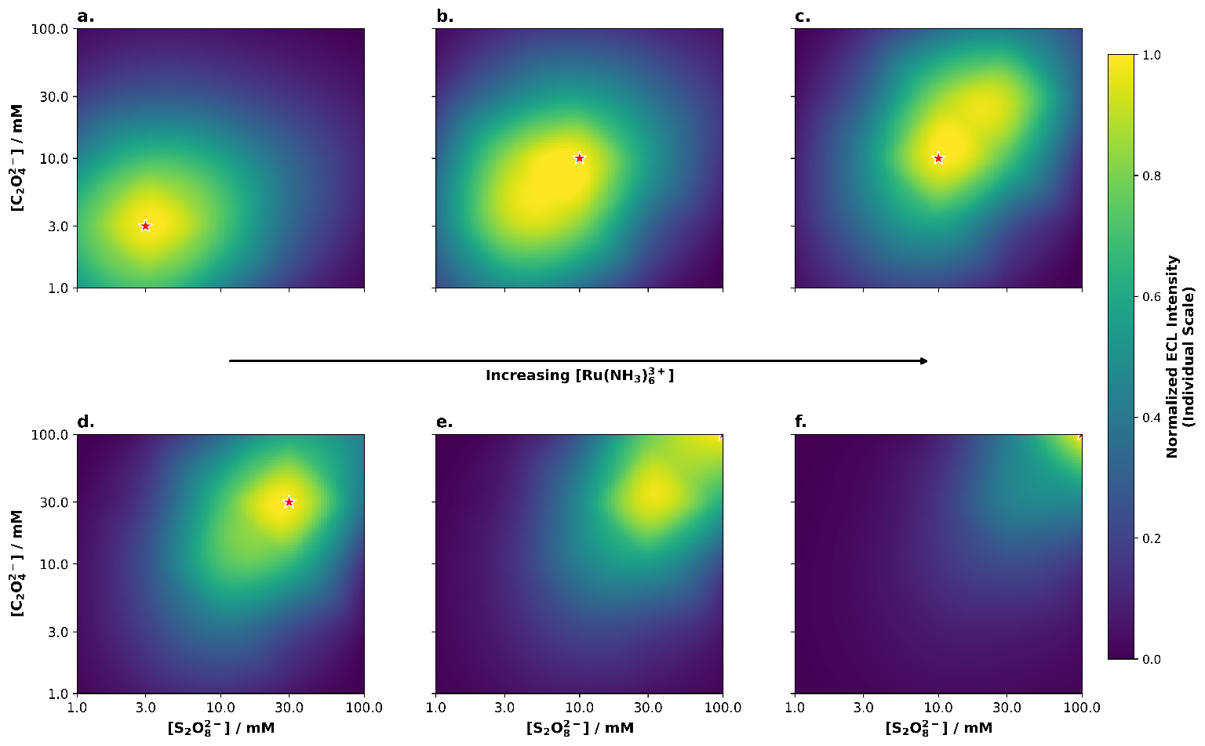Figure S10. Simulated 2D heatmap of ECL intensity as a function of [S₂O₈²⁻] and [C₂O₄²⁻] at 0.03 mM Ru(bpy)₃²⁺ and different concentration of Ru(NH₃)₆³⁺: (a) 0.01, (b) 0.03, (c) 0.1, (d) 0.3, (e) 0.5, and (f) 1.0 mM.

Figure S11. CV-ECL measurement of solutions prepared in 0.1 M Na₂SO₄ (pH 6.8) containing 30 mM S₂O₈²⁻, 30 mM C₂O₄²⁻, 0.1 mM Ru(NH₃)₆³⁺ and 0.03 mM Ru(bpy)₃²⁺ (black trace), or 30 mM C₂O₄²⁻ and 0.03 mM Ru(bpy)₃²⁺ (red trace). The GC working electrode (d = 3 mm) potential was scanned at a rate of 100 mV∙s⁻¹ starting from 0.1 V to 0.5 V, and back to 0.1 V (vs Ag/AgCl) (black trace); and starting at 0.3 V until 1.4 V, and back to 0.3 V (vs Ag/AgCl) (red trace).

Figure S12. Normalized ECL response during a double chronoamperometric sequence applying the OCP for 3 seconds and 1.2 V vs Ag/AgCl (black trace) or -0.5 V (vs Ag/AgCl) (red trace) for 60 seconds on a GC working electrode (d = 3 mm). The solutions were prepared in Na₂SO₄ 0.1 M (pH 6.8) both containing a fixed concentration (30 µM) of Ru(bpy)₃²⁺ and either 30 mM C₂O₄²⁻ (black trace), or 10 mM S₂O₈²⁻, 5 mM C₂O₄²⁻, and 0.1 mM Ru(NH₃)₆³⁺ (red trace).

Figure S13. CV (dashed line) and ECL (continuous line) on GC (black traces) and Pt (red traces) working electrodes. The measurements were carried out in a different solution for each electrode: 30 mM S₂O₈²⁻, 30 mM C₂O₄²⁻, 0.1 mM Ru(NH₃)₆³⁺ and 0.03 mM Ru(bpy)₃²⁺ for GC, and 30 mM S₂O₈²⁻, 30 mM C₂O₄²⁻ and 0.03 mM Ru(bpy)₃²⁺ for Pt, both in 0.1 M Na₂SO₄ (pH 6.8). The working electrode potential was swept at a scan rate of 100 mV∙s⁻¹ from 0.1 V to 0.5 V, and back to 0.1 V (vs Ag/AgCl) for GC, and from 0.4 V until -0.4 V, and back to 0.4 V (vs Ag/AgCl) for Pt.

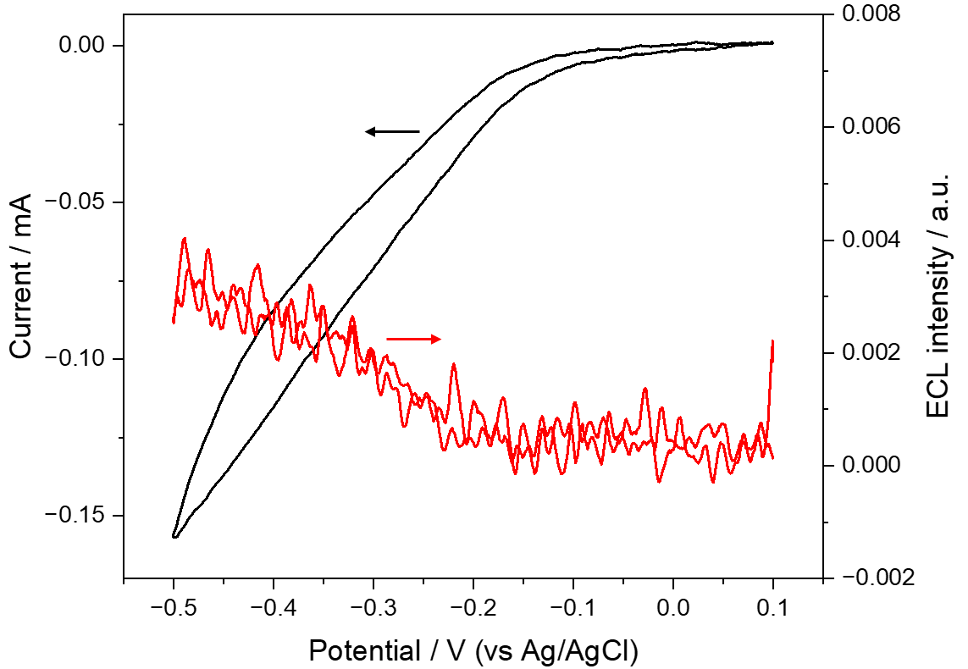
Figure S14. CV (black trace) and ECL (red trace) of a 10 mM S₂O₈²⁻, 10 mM C₂O₄²⁻, 0.1 mM Ru(NH₃)₆³⁺, 0.03 mM Ir(dfppy)₂(pt-TEG)⁺ solution prepared in 0.1 M Na₂SO₄ (pH 6.8). The GC working electrode (d = 3 mm) potential was swept at a scan rate of 100 mV∙s⁻¹ from 0.1 V to 0.5 V, and back to 0.1 V (vs Ag/AgCl).

References
[1] L. Chen, D. J. Hayne, E. H. Doeven, J. Agugiaro, D. J. D. Wilson, L. C. Henderson, T. U. Connell, Y. H. Nai, R. Alexander, S. Carrara, C. F. Hogan, P. S. Donnelly, P. S. Francis, “A conceptual framework for the development of iridium(iii) complex-based electrogenerated chemiluminescence labels” Chem. Sci. 2019, 10, 8654–8667.
[2] J. N. Janusz, J. A. Beeler, S. Hosseini, M. Tanwar, R. Zeng, H. Wang, H. D. Abruña, M. Neurock, H. S. White, “The Electrochemical Peroxydisulfate-Oxalate Autocatalytic Reaction” J. Am. Chem. Soc. 2024, 146, 25088–25100.
[3] S. Hosseini, G. T. Solymosi, H. S. White, “Investigation of the Electrocatalytic Reduction of Peroxydisulfate Using Scanning Electrochemical Microscopy” Anal. Chem. 2024, 96, 8424–8431.

