Electronic properties of PVA‑PVAm ligands dictate mechanistic pathways in Au/AC‑catalyzed HMF oxidation

Francesca Liuzzi^{1,2}, Stefano Scurti¹*, Giacomo Fanciullo¹, Alessandro Allegri^{1,2}*, Min Hu³, Ivan Rivalta^{1,2,4}, Carmine D’Agostino^{3,5}, Atul Bansode⁶, Daniele Caretti¹, Nikolaos Dimitratos^{1,2*}, Stefania Albonetti^{1,2}*

¹ Industrial Chemistry “Toso Montanari” Department, University of Bologna, Via Piero Gobetti 85, Bologna 40129, Italy
² Center for Chemical Catalysis-C3, Alma Mater Studiorum Università di Bologna, Via Piero Gobetti 85, Bologna 40129, Italy
³ Department of Chemical Engineering, The University of Manchester, Oxford Road, M13 9PL, UK
⁴ ENSL, CNRS, Laboratoire de Chimie UMR 5182, 46 allée d'Italie, 69364 Lyon, France
⁵ Dipartimento di Ingegneria Civile, Chimica, Ambientale e dei Materiali (DICAM), Alma Mater Studiorum – Università di Bologna, Via Terracini, 28, 40131 Bologna, Italy
⁶ Department of Chemical Engineering, Delft University of Technology, Van der Maasweg 9, 2629 HZ Delft, The Netherlands

Supplementary information
- Polymers synthesis and characterization
  - Synthesis of poly(vinyl alcohol) (PVA)-based ligands
Figure S1. PVA synthetic route.
The polymerisation of vinyl acetate was conducted in a Schlenk flask (Figure S1). To initiate the polymerisation process, 10 mL of the monomer (0.1 mol) was dissolved in 10 mL of ethanol, and azo-bis-isobutyronitrile (AIBN) as radical initiator was introduced in an amount equivalent to 1% mol/mol of the monomer. The "freeze-pump-thaw" technique repeated three times, was carried out through a vacuum-nitrogen line, allowing for the removal of oxygen present in the solvent. The reaction mixture was maintained at 70 °C for 48 hours.
Subsequently, the mixture was cooled to room temperature and purified by a solvent-nonsolvent approach using ethyl ether to precipitate the polymer. The resulting polymer was separated by filtration and subjected to multiple washes with ethyl ether to remove impurities.
Poly (vinyl acetate):
¹H-NMR (400 MHz in d₆-DMSO): 1.75 ppm (2H, CH₂-CH); 2.0 ppm (3H, CH₃); 4.9 ppm (1H, CH₂-CH); IR ν (cm⁻¹): 2950 (C-H symmetric stretch), 1729 (C=O stretch ester), 1430-1370 (C-H₂ bend), 1228-1010 (C–O stretch).
The subsequent saponification reaction was carried out in a 50 mL round-bottom flask, to which 0.5 g of PVAc was added in 8 mL of acetone. The mixture was stirred at a temperature of 50 °C to promote polymer dissolution. Once dissolved, 5M NaOH was added. The quantity of the base varies depending on the degree of hydrolysis desired for the product. The reaction was conducted for 1 hour under reflux. At the end, the product precipitated in the reaction environment was filtered and washed with acetone several times to remove the presence of co-products.
Poly (vinyl alcohol):
¹H-NMR (400 MHz in CDCl₃): 1.45 ppm (2H, CH₂-CH); 3.70 ppm (1H, CH₂-CH); 4-5 ppm (1H, OH); IR ν (cm⁻¹): 3400 (O-H stretch), 2950 (C-H symmetric stretch), 1470-1350 (C-H₂ bend), 1083 (C-O stretch and O-H bend)

  - Synthesis of poly (N-vinyl amine-co-vinyl alcohol) (PVA-co-PVAm) ligands
Figure S2. PVA-co-PVAm synthetic route.

The copolymers were synthesised by solution free-radical polymerization (Figure S2), changing the co-monomers composition in the feed mixture to modify the amount of amino groups on the final macromolecules. In a Schlenk flask N-vinyl formamide and/or vinyl acetate was/were added using different molar ratios reported. Then 10 ml of ethanol and 1% mol/mol of AIBN as initiator were added. The "freeze-pump-thaw" technique repeated three times, was carried out through a vacuum-nitrogen line, allowing for the removal of oxygen present in the solvent. The mixture was heated to 70 °C for 48h. After cooling down to room temperature, the reaction mixture was dropped in a non-solvent, subsequently filtered and subjected to several solvent/non-solvent cycles. In the purification step, methanol was used as a non-solvent for PNVF and ethyl acetate for the copolymers.
Poly (N-vinyl formamide):
¹H-NMR (400 MHz in d₆-DMSO): 1.5 ppm (2H, CH₂-CH); 3.8 ppm (1H, CH₂-CH); 8.0 ppm (1H, H-CO); IR ν (cm⁻¹): 3300 (N-H stretch), 1690 (C=O stretch amide), 1550 (N-H bend) 1430-1370 (C-H₂ bend)
Poly (N-vinyl formamide)-co-(vinyl acetate):
¹H-NMR (400 MHz in d₆-DMSO): 1.5 ppm (2H, CH₂-CH_PNVF), 1.75 ppm (2H, CH₂-CH_PVAc), 2.0 ppm (3H, CH₃), 3.8 ppm (1H, CH2-CH_PNVF), 4.9 ppm (1H, CH2-CH_PVAc), 8.0 ppm (1H, H-CO); IR ν (cm⁻¹): 3300 (N-H stretch), 2950 (C-H symmetric stretch), 1729 (C=O stretch ester), 1690 (C=O stretch amide), 1550 (N-H bend), 1430-1370 (C-H2 bend), 1228-1010 (C–O stretch)

The as-obtained products were hydrolysed solubilising the polymers in distilled water in a round-bottomed flask with a condenser. A freshly prepared NaOH 5M solution was added in excess with respect to the polymeric substrates. Then the mixture was heated until the reflux for 4h to have the complete hydrolysis.
After cooling down, the polymers were dropped in ethyl acetate (non-solvent) and purified with solvent/non-solvent cycles. The products were filtered and kept in the oven at 70 °C for the night.
Poly (vinyl amine):
¹H-NMR (400 MHz in D₂O): 1.25 ppm (2H, CH₂-CH), 2.7 ppm (1H, CH₂-CH), 4.0-3.5 (2H, H₂-N); IR ν (cm⁻¹): 3350 (NH₂ stretch), 2950 (C-H symmetric stretch), 1430-1370 (C-H₂ bending), 936 (N-H₂ out of plane bend)
Poly (vinyl amine)-co-(vinyl alcohol):
¹H-NMR (400 MHz in D₂O): 1.25 ppm (2H, CH₂-CH_PVAm), 1.45 ppm (2H, CH₂-CH_PVA), 2.7-3 ppm (1H, CH₂-CH_PVAm), 3.70 ppm (1H, CH₂-CH_PVA); IR ν (cm⁻¹): 3500-3300 (O-H and N-H₂ stretch), 2950 (C-H symmetric stretch), 1430-1370 (C-H₂ bending), 1083 (O-H bend), 936 (N-H₂ out of plane bend)

  - Polymer characterisation
The polymer structures were confirmed by ¹H-NMR spectroscopy using a Varian “Mercury 400” spectrometer, operating at 400 MHz. Tetramethylsilane (TMS) was used as an internal reference standard. All polymeric ligands were characterised by Fourier Transform Infrared Spectroscopy (FT-IR), acquiring the spectra through an ATR-IR Bruker Alpha I spectrometer. To investigate copolymers thermal behaviour, DSC analyses were performed with a TA Instrument Q2000, using unsealed aluminium pans, and loading 3 to 5 mg of sample. The DSC analyses were carried out by applying two subsequent heating ramps from − 50 °C to 150 °C (heating/cooling ramps at 10 °C/min).

1.4. Calculation of reactivity ratio
The reactivity ratio[1] (r_{n}) is a parameter that quantifies a comonomer's inclination to prefer insertion into a developing polymer chain when the most recent unit added to the chain is of the same type (auto-polymerization), or derived from the other comonomer (cross-polymerization). Before describing the methods to calculate them, it’s important to define from the copolymerisation equation the feed (f) and copolymer (F) composition:
$f=\frac{M_{1}}{M_{2}}$ $F=\frac{dM_{1}}{{dM}_{2}}$
where M_{n} represents the molar fraction of the monomer. The calculation of reactivity ratios typically involves conducting several polymerisation reactions with varying monomer ratios. The composition of the copolymer can be determined using techniques such as ¹H-NMR, ¹³C-NMR, or Fourier Transform Infrared Spectroscopy (FT-IR).
These polymerisation reactions are carried out at low conversions, allowing us to assume constant monomer concentrations and appreciate the real monomers reactivity. In this work, three different methods to calculated reactivity ratio were employed: Mayo-Lewis; Fineman-Ross and Kelen Tudosh method.
The Mayo-Lewis method employs a modification of the copolymer equation that establishes the relationship between r₁ and r₂:
$$r_{2}=r_{1}\frac{f^{2}}{F}+\left(\frac{f}{F}-f\right)$$
For each unique monomer composition, a series of lines is generated using arbitrary r₁ values. The point of intersection of these lines determines the values of r₁ and r₂ for the system. Frequently, these lines do not converge at a single point; instead, they form an area where most lines intersect, indicating a range of possible reactivity ratio values.
The Fineman-Ross equation derived from a rearrangement in a linear form of the copolymerisation equation:
$$\left(\frac{F-1}{F}\right)f=\frac{r_{1}}{F}f^{2}-r_{2}$$
Through several copolymerisation reactions, the values of the copolymer composition F can be determined as a function of the feed mixture. By plotting the results, a line can be constructed with -r₂ as the intercept at the origin and r₁ as the slope.
The equations described have been characterised by the limits of the model, leading to a high degree of error in the obtained results. For this reason, a third method (Kelen-Tudosh) has been employed.[2] Also in this case it’s necessary to rewrite the copolymerization reaction in another form defining two new parameters:
$$G=\frac{f(F-1)}{F} H=\frac{f^{2}}{F}$$
Trought several algebraic passages other two parameters can be obtain:
$$η=\frac{G}{α+H} ξ=\frac{H}{α+H}$$
Where α values is selected in order to have a uniform distribution of experimental values, this coefficient is calculated with the following equation:
$$α= \sqrt{F_{m}F_{M}}$$
where F_{m} and F_{M} represent the minimum and maximus experimental values assumed from H parameter. Inserting the new parameters in the copolymerization equation can be obtained the following relation:
$$η=r_{1}ξ-\frac{r_{2}}{α}(1-ξ)$$
By plotting the η values as a function of ξ, a line can be constructed where r₁ was determined imposing ξ=1 and r₂/α when ξ=0.

1.4.1 Reactivity ratio of PVA-co-PVAm stabilisers
The real composition of the synthesised copolymers was evaluated by an integration process of the related ¹H-NMR spectra recorder by a Varian Mercury 400 (400 Mhz) spectrometer. Specifically, the signals considered include the amidic proton (at 8 ppm) and the signals within the range of 2-1.5 ppm, which were associated with the -CH₂ groups of both repeating units, along with the methylic group (Figure S3A). The following equation (1) was utilised to calculate the percentage of amidic units in the system:
$$\%Amidic groups: \frac{A_{H, amidic}}{\frac{A_{H, amidic}}{1}+\left(\frac{A_{CH2+CH3-}\left(A_{H, amidic}∙2\right)}{5}\right)} (1)$$
Based on the copolymer composition reported in Table S1 and applying the model described in the previous paragraph, reactivity ratios were calculated, and the results were reported in Figure S4-S3B and Tables S2-3.
In Table S1 the obtained data reported shows the real compositions of the synthesised copolymers (F1) in relation to the feed mixture (f1). Observing the trend of the graph, it can be noted that the real copolymer’s compositions have higher content in NVF compared to the theoretical ones, indicating the presence of a greater quantity of amide units. To gain a deeper understanding of this behaviour, the reactivity ratios of the copolymers were calculated using the models described previously (Figure S4, Tables S2-S3). By examining the obtained r values (Table S3), it becomes apparent that r₁ > r₂ in all models applied. This observed trend indicates that N-vinyl formamide tends to preferentially react with itself rather than with the other co-monomer (vinyl acetate). Consequently, the resulting copolymers exhibit an abundance of amidic moieties, as depicted in Figure S3B.
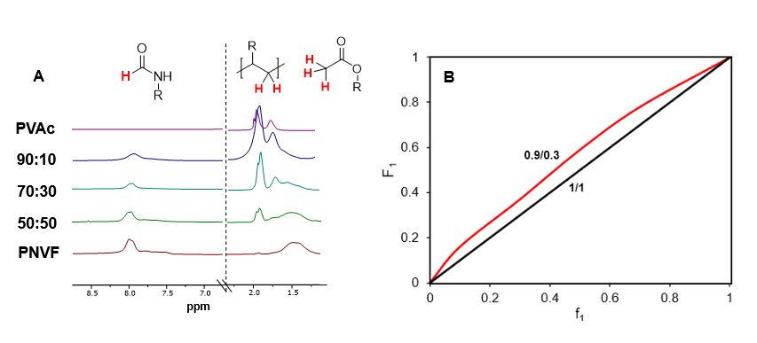
Figure S3. A) PVAc-co-PNVF ¹H-NMR spectra in d₆-DMSO: focus on the spectral range involved in the integration process; B) copolymer composition plot.

Table S1. Feed (f1) and real composition (F1) (molar ratio) of the co-monomers
Feed composition  (PVAc:PNVF molar ratio) | Real composition  (PVAc:PNVF molar ratio) | Vinyl acetate (n)  (mol) | N-vinyl formamide (m)  (mol) | f1 | F1
100:0 | 100:0 | 5 | - | - | -
90:10 | 84:16 | 4.5 | 0.5 | 0.1 | 0.16
70:30 | 63:37 | 3.5 | 1.5 | 0.3 | 0.37
50:50 | 41:59 | 2.5 | 2.5 | 0.5 | 0.59
0:100 | 0:100 | - | 5 | - | -

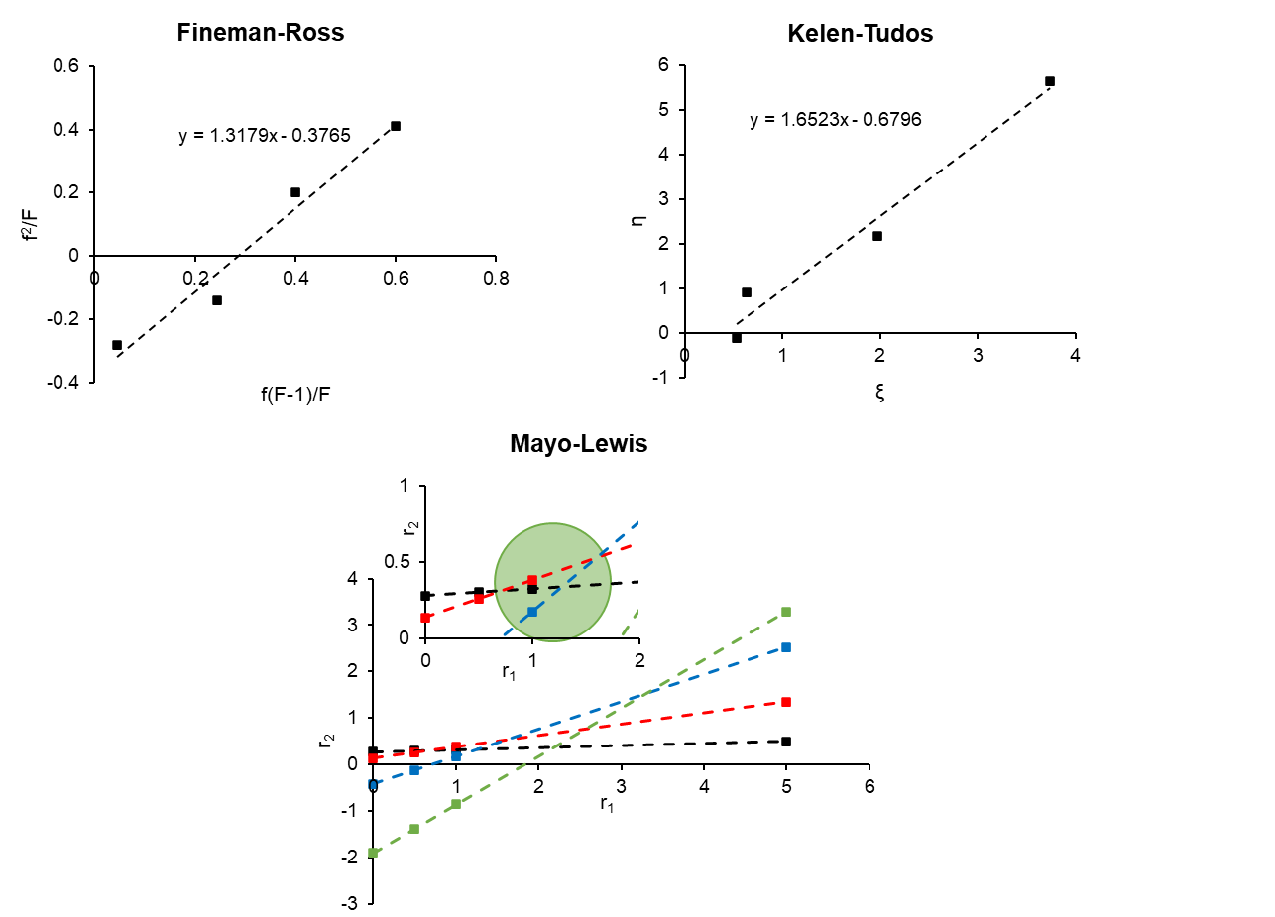
Figure S4. Reactivity ratio plots calculated with different models.

Table S2. Parameters used to calculate the reactivity ratio.
f₁ | F₁ | f | F | H | G | ξ | η
0.1 | 0.22 | 0.11 | 0.28 | 0.15 | -0.10 | 0.53 | -0.09
0.3 | 0.43 | 0.43 | 0.75 | 0.18 | 0.29 | 0.64 | 0.91
0.5 | 0.63 | 1 | 1.70 | 0.57 | 0.66 | 1.98 | 2.18
0.7 | 0.84 | 2.33 | 5.25 | 1.08 | 1.87 | 3.73 | 5.66

Table S3. Reactivity ratio calculated with different models.
 | Mayo-Lewis | Fineman-Ross | Kelen-Tudos
r₁ | ≈ 1.2 | 1.31 | 0.97
r₂ | ≈ 0.3 | 0.37 | 0.27

1.5. Thermal characterisation
The thermal behaviour of the synthesized copolymers was determined by DSC analysis to evaluate the coherence with the following Flory-Fox equation for random copolymers:

$$\frac{1}{T_{g}}=\frac{w_{A}}{T_{g,A}}+\frac{w_{B}}{T_{g,B}}$$

where w_{A} and w_{B} are the weight fractions of the two comonomers A and B, and T_{g,A} and T_{g,B} are the glass transition temperatures of the homopolymers A and B, respectively. However, this relationship doesn't account for the steric and electronic effects between the two adjacent co-units, as well as the change in free volume of units A and B in the copolymer compared to their corresponding homopolymers. In Table S4 the theoretical values of Tg obtained through the application of the Flory-Fox equation were reported, alongside the experimentally determined actual values. It is evident that as the quantity of amide groups increases, the Tg value also rises.
Moreover, it is noticeable that the experimental Tg values do not deviate significantly from the theoretical values, indicating minimal deviations from the model. The changes in free volume are, in fact, almost negligible due to the similar molecular structures of the co-monomers involved.

Table S4. Tg values (theoretical and experimental) as a function of copolymer compositions *calculated by Flory-Fox equation,**evaluated by the midpoint of the step-change
 | Tg* (°C) |  | Tg,exp**(°C)
PVAc |  | 37 | 37
PNVF16  PNVF37  PNVF59  PNVF |  | 44  52  66  121 | 42  50  65  121

2. Catalysts characterisation
2.1. Characterisation of fresh samples
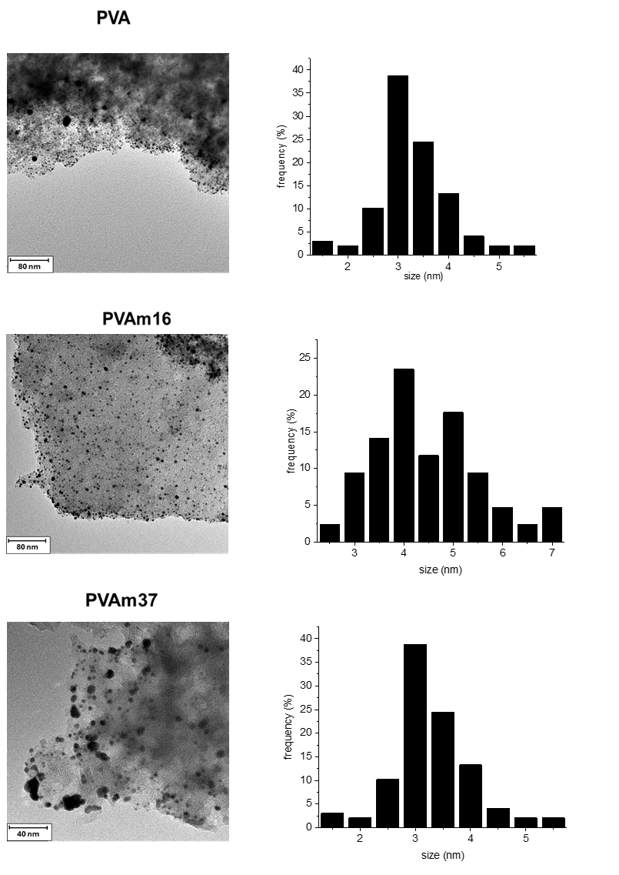
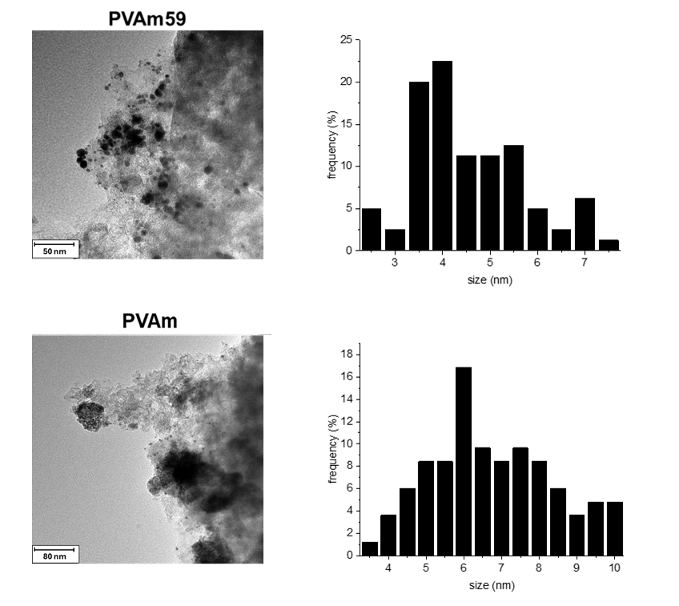
Figure S5. TEM images of Au/AC prepared using homopolymeric and copolymeric stabilisers with different co-monomers composition.

Table S5. XRD and TEM diameters (with related asymmetry) of Au/AC catalysts prepared using the PVA:PVAm with different composition
Sample | d_{XRD} (nm) | d (nm) | σ
Au/AC_PVA | 3 | 3.2±0.7 | 0.35
Au/AC_PVAm16 | 4 | 4.4±1.3 | 0.5
Au/AC_PVAm37 | 5 | 4.9±0.9 | 0.6
Au/AC_PVAm59 | 5 | 4.7±1.3 | 0.7
Au/AC_PVAm | 5 | 5.0±1.4 | 0.6

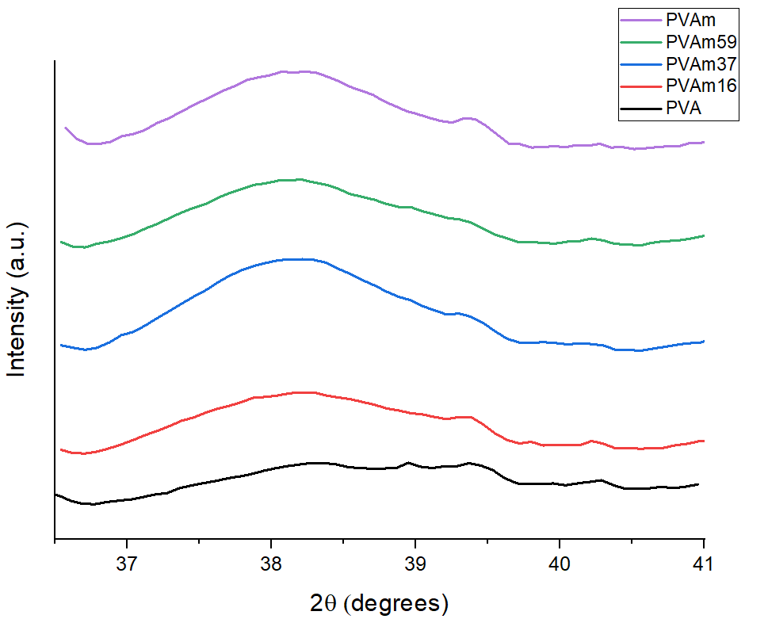
Figure S6. XRD data for all Au/AC samples with different stabilisers (PVA, PVAm and copolymer with different molar composition PVA:PVAm), focused on the (1 1 1) peak position for Au.

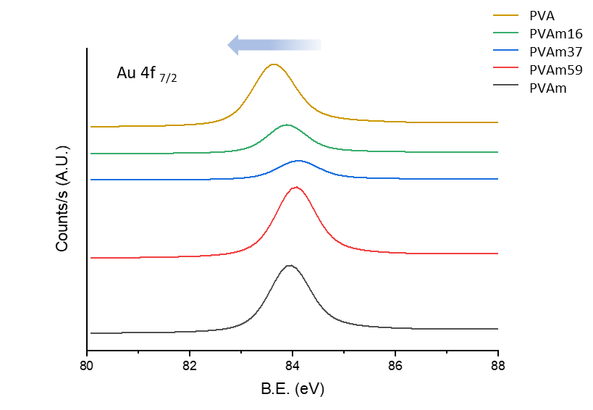
Figure S7. Au 4f_{7/2} peak of the XPS spectra of Au/AC samples with different stabilisers (PVA, PVAm and copolymer with different molar composition PVA:PVAm).

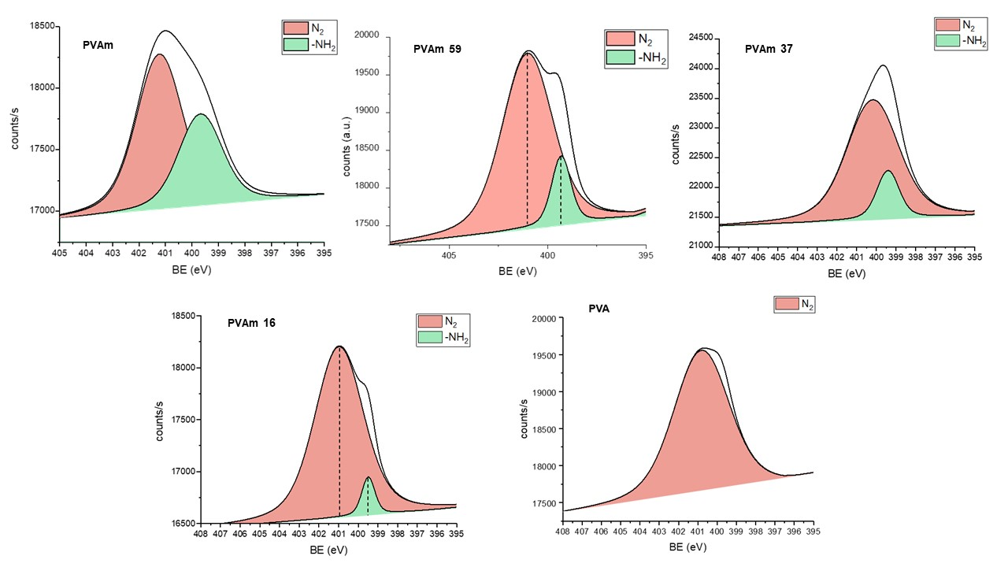
Figure S8. XPS spectra of Au/AC prepared using homopolymeric and copolymeric stabilisers (PVA, PVAm and copolymer with different molar composition PVA:PVAm) focusing on N1s.

Table S6. XPS data of Au/AC prepared using homopolymeric and copolymeric stabilisers (PVA, PVAm and copolymer with different molar composition PVA:PVAm).

Catalyst | BE Au4f_{7/2} (eV) | % Au on surface | % N on surface | % -NH₂ on surface | Surface Atomic ratio Au/C
Au/AC_PVA | 84.0 | 1.63 | 0.48 | - | 0.01
Au/AC_PVAm16 | 84.1 | 0.89 | 1.15 | 0.42 | 0.01
Au/AC_PVAm37 | 84.1 | 0.82 | 1.68 | 0.33 | 0.01
Au/AC_PVAm59 | 83.9 | 2.01 | 1.24 | 0.47 | 0.01
Au/AC_PVAm | 83.7 | 0.97 | 2.12 | 0.95 | 0.01

2.2. Characterisation of spent samples
Table S7. XPS and TEM data of Au/AC using homopolymeric and copolymeric stabilisers (PVA, PVAm and copolymer with different molar composition PVA:PVAm) after 3 reaction cycles.
Catalyst  (after 3 uses) | BE Au4f_{7/2} (eV) | % Au on surface | % N on surface | Surface Atomic ratio Au/C | NPs diameter (nm)
Au/AC_PVA | 83.9 | 0.18 | 0.39 | 0.002 | 20±10
Au/AC_PVAm16 | 84.0 | 0.22 | 1.18 | 0.002 | -
Au/AC_PVAm59 | 83.9 | 0.27 | 0.81 | 0.003 | -
Au/AC_PVAm | 83.8 | 0.21 | 2.46 | 0.002 | -

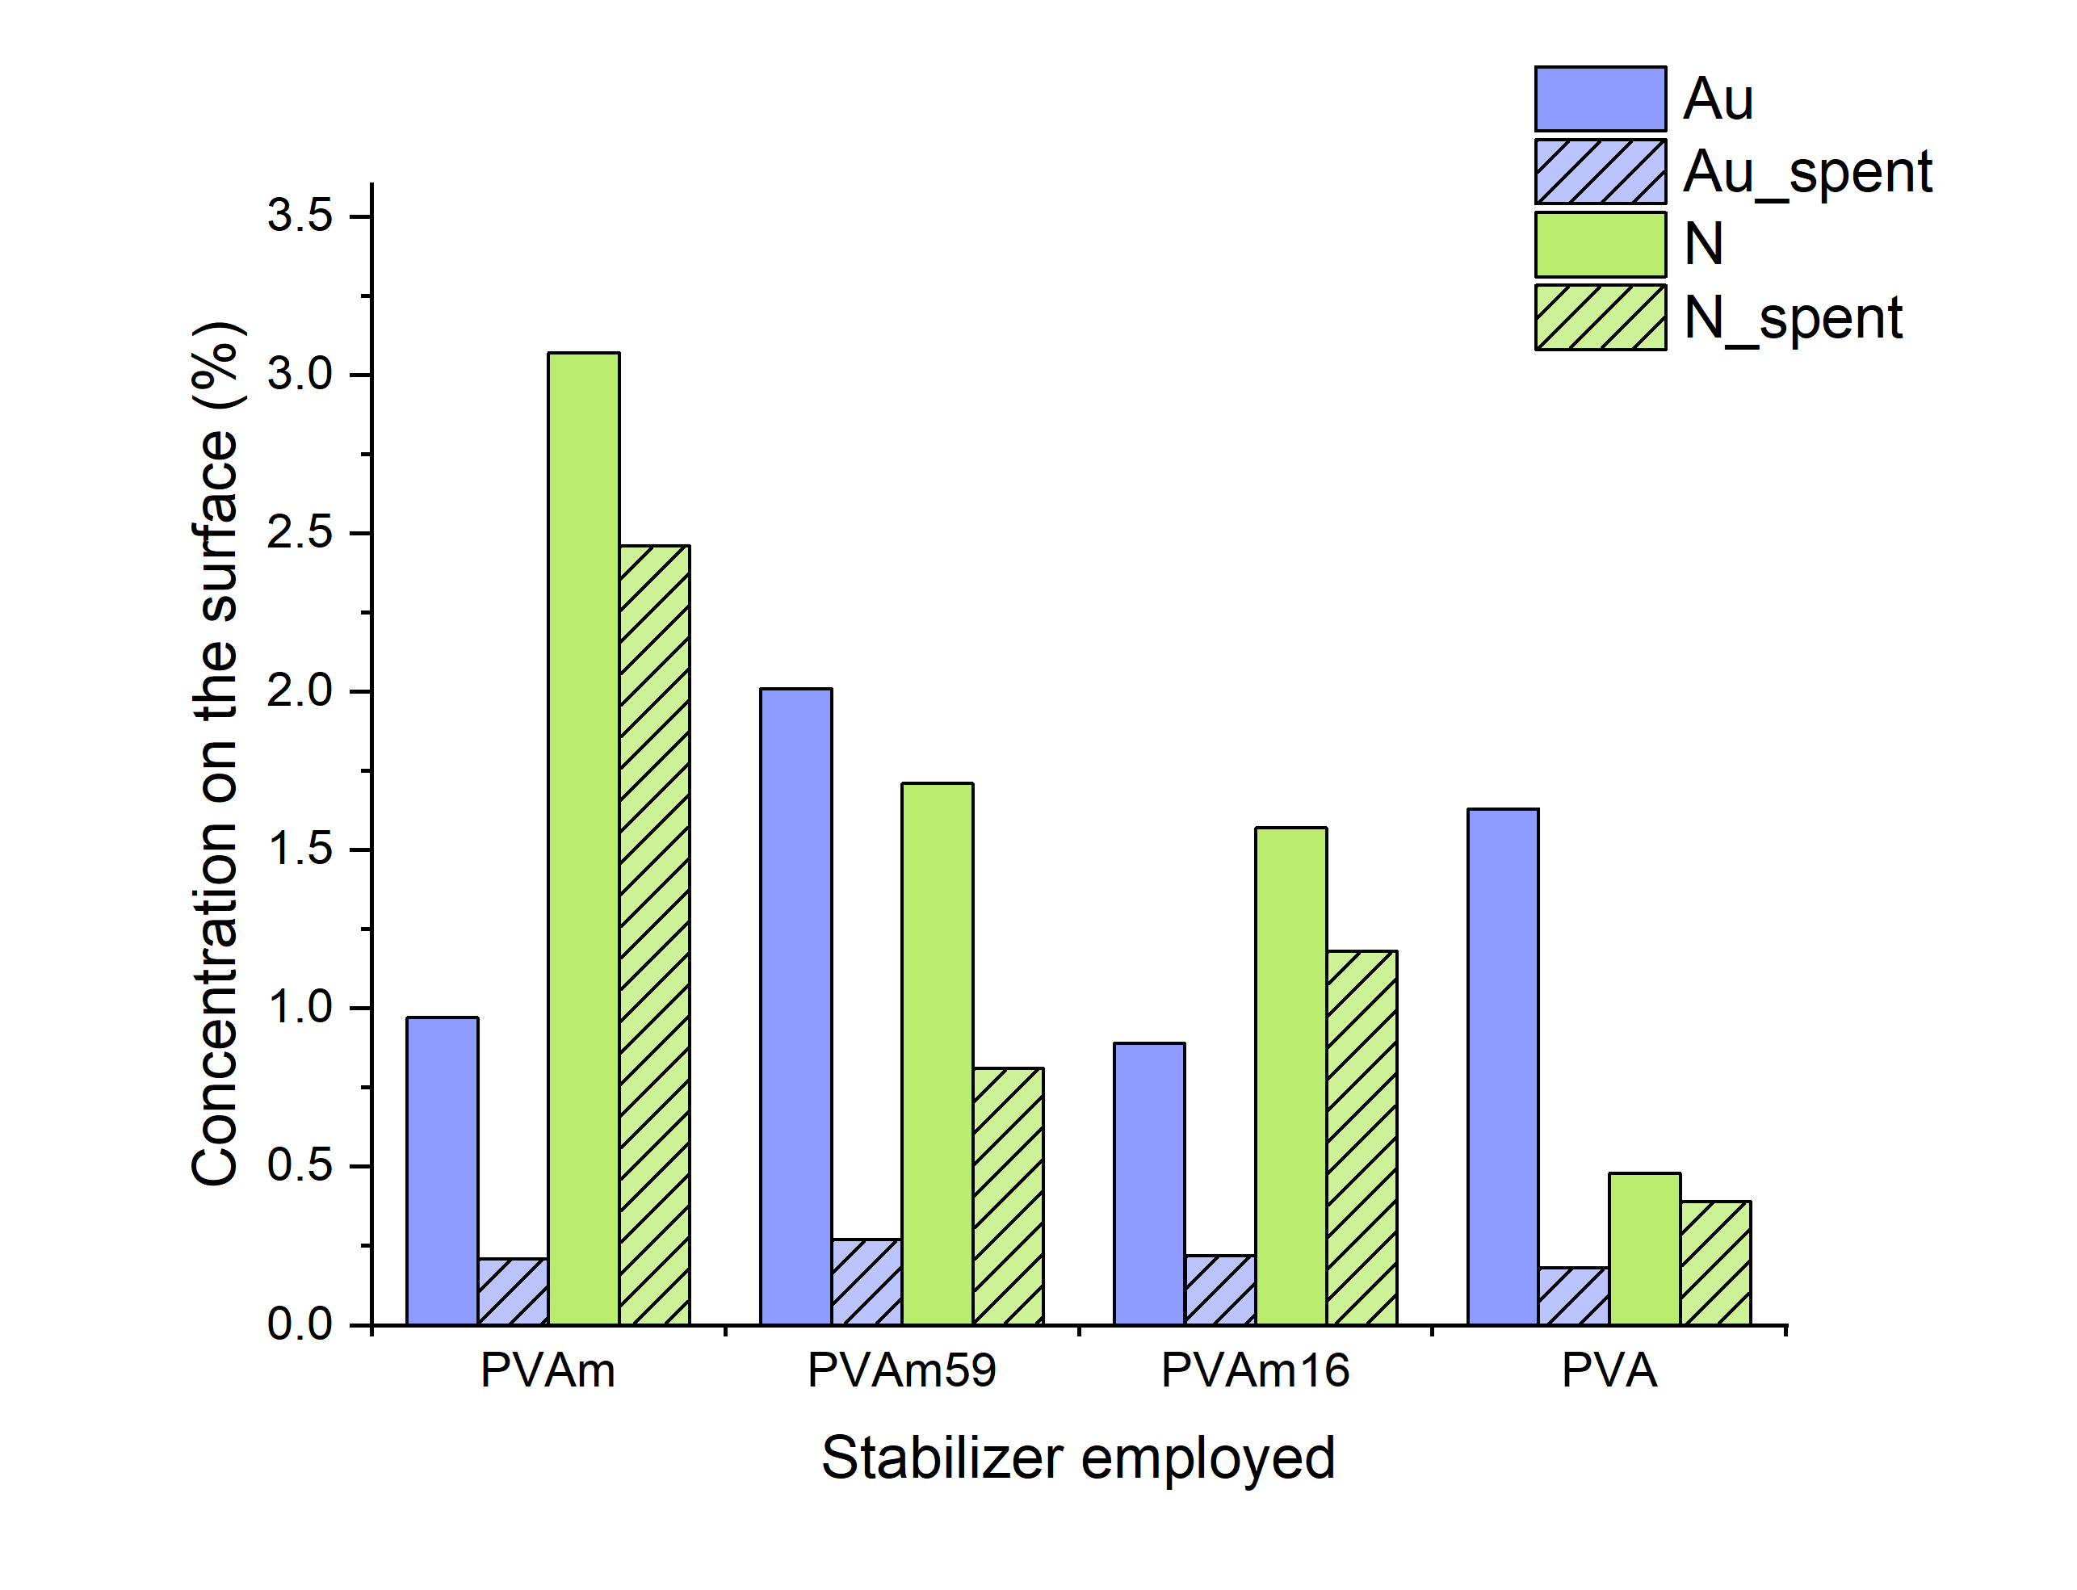
Figure S9. XPS data of gold and nitrogen percentage on the surface of fresh and used catalyst.

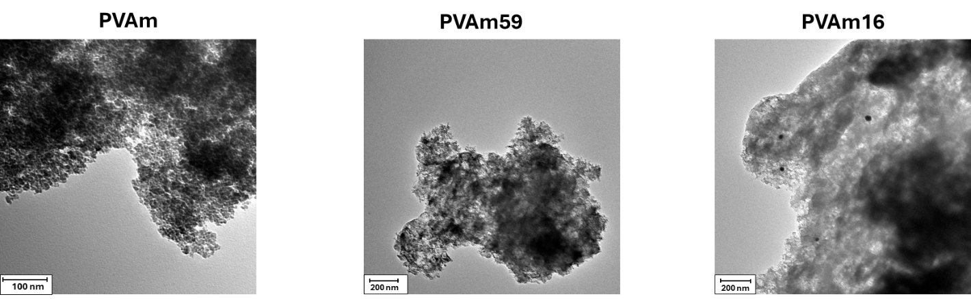
Figure S10. TEM images of Au/AC_PVAm, Au/AC_PVAm59, and Au/AC_PVAm16 catalysts after 3 reaction cycles.

3. Reactivity
3.1. NMR relaxation measurements
Table S8. T₁/T₂ relaxation measurements for probe solvents in catalysts stabilized with PVA and PVAm.
 | Pentanal (AD) |  |  | Pentanoic acid (AC) |  |  | T₁/T₂ _{AC}/T₁/T₂ _{AD}
Catalyst | T₁ (ms) | T₂ (ms) | T₁/T₂ | T₁ (ms) | T₂ (ms) | T₁/T₂ | T₁/T₂ _{AC}/T₁/T₂ _{AD}
Au/AC_PVA | 163.2$\text{±}$3.2 | 22.6$\text{±}$0.4 | 7.22$\text{±}$0.36 | 162.5$\text{±}$3.2 | 12.7$\text{±}$0.2 | 12.80$\text{±}$ 0.64 | 1.77$\text{±}$0.08
Au/AC_PVAm | 146.6$\text{±}$2.9 | 25.7$\text{±}$0.5 | 5.70$\text{±}$0.28 | 177.6$\text{±}$3.6 | 11.9 $\text{±}$0.2 | 14.92$\text{±}$0.75 | 2.61$\text{±}$0.13

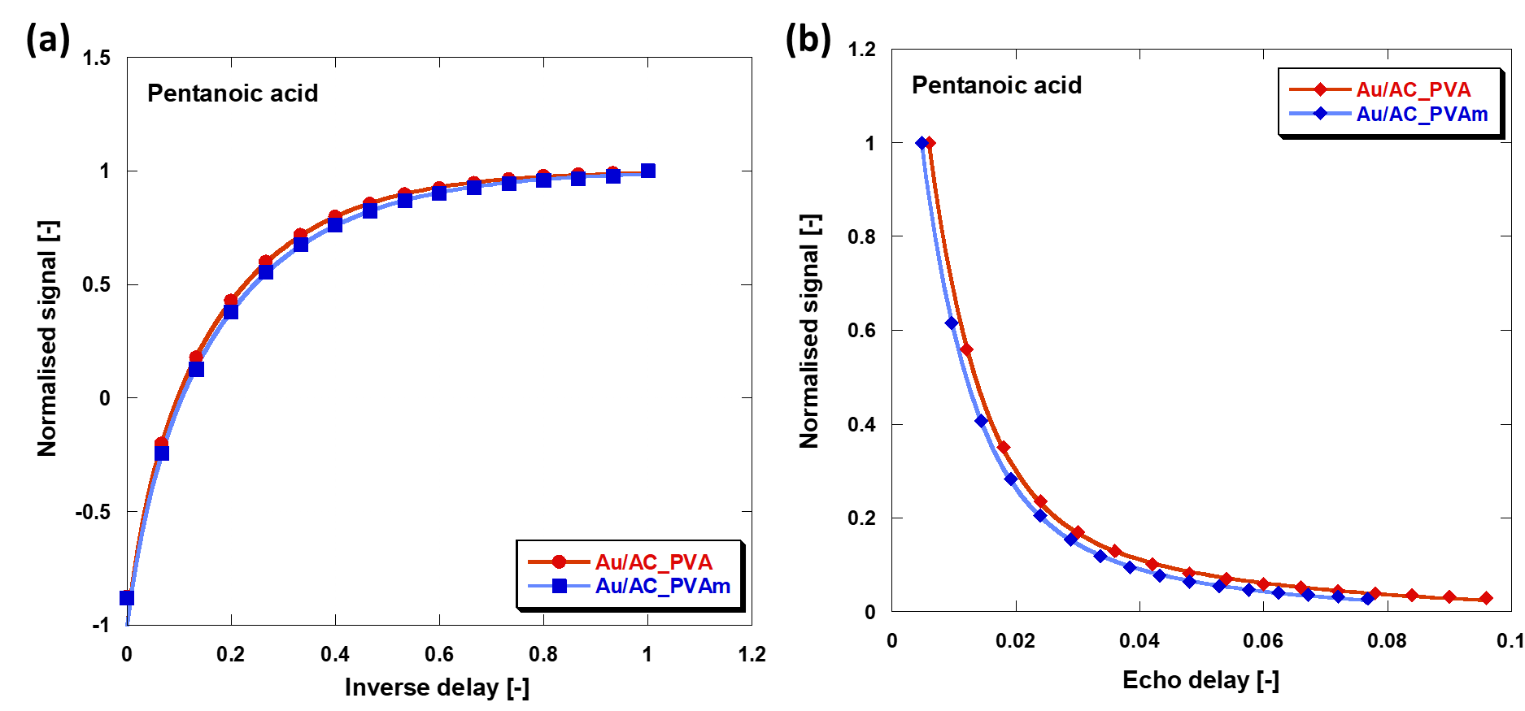
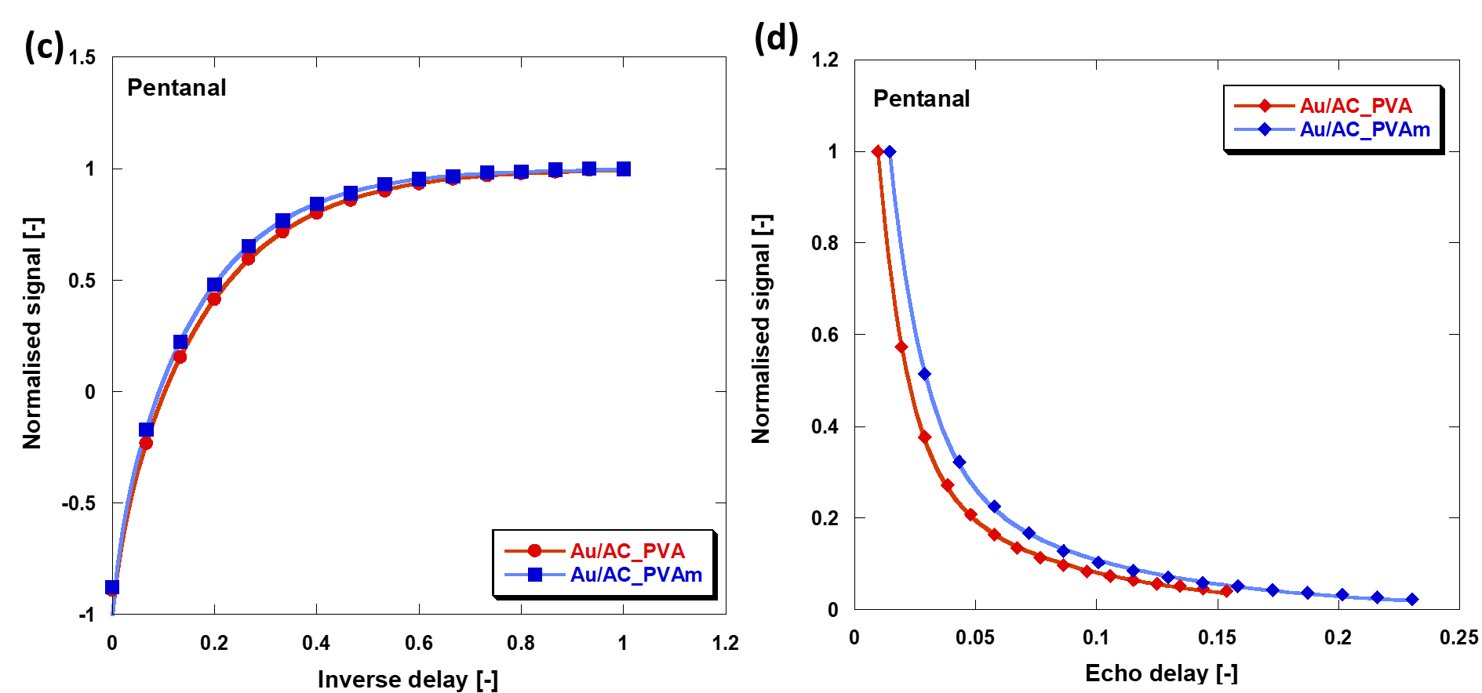
Figure S11. (a) &(c) T₁ inversion recovery plots and (b) & (d) T₂ CPMG decay plots for solvents adsorbed within Au/AC_PVA and Au/AC_PVAm.

3.2. Test on PVA-based Au catalysts
Figure S12. Effect of the stirring rate on the sample Au/AC_PVA. Reaction conditions: 1 h, 70 °C, 10 bar O₂, HMF:Met:NaOH=1:0.01:4.
Figure S13. Effect of the O₂ pressure on the sample Au/AC_PVA. Reaction conditions: 2 h, 70 °C, HMF:Met:NaOH=1:0.01:4.

Figure S14. Effect of the PVA:Au weight ratio. Reaction conditions: 4 h, 70 °C, 10 bar O₂, HMF:Met:NaOH=1:0.01:4.
Figure S15. Effect of the NaOH equivalent on the sample Au/AC_PVA. Reaction conditions: 2 h, 70 °C, 10 bar O₂, HMF:Met:NaOH=1:0.01:4.
Figure S16. Effect of the PVA molecular weight. Reaction conditions: 4 h, 70 °C, 10 bar O₂, HMF:Met:NaOH=1:0.01:4.
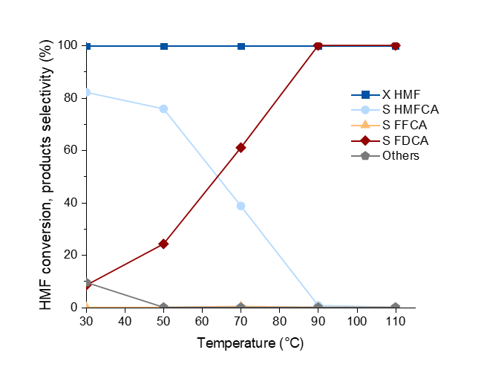
Figure S17. Effect of the reaction temperature. Catalyst: Au/AC_PVA. Reaction conditions: 2 h, 10 bar O₂, HMF:Met:NaOH=1:0.01:4.
Figure S18. Reusability tests for the catalyst Au/AC_PVA. Reaction conditions: 70 °C, 2 h, 10 bar O₂, HMF:Met:NaOH=1:0.01:4.

3.3. Test on PVAm-based Au catalysts
Figure S19. Effect of the PVAm:Au weight ratio. Reaction conditions: 4 h, 70 °C, 10 bar O₂, HMF:Met:NaOH=1:0.01:4.
Figure S20. Effect of the NaOH equivalent on the sample Au/AC_PVAm. Reaction conditions: 4 h, 70 °C, 10 bar O₂, HMF:Met:NaOH=1:0.01:4
Figure S21. Effect of the PVAm molecular weight. Reaction conditions: 4 h, 70 °C, 10 bar O₂, HMF:Met:NaOH=1:0.01:4.
Figure S22. Effect of the reaction temperature. Catalyst: Au/AC_PVAm. Reaction conditions: 2 h, 10 bar O₂, HMF:Met:NaOH=1:0.01:4.
Figure S23. Reusability tests for the catalyst Au/AC_PVAm. Reaction conditions: 70 °C, 2 h, 10 bar O₂, HMF:Met:NaOH=1:0.01:4.

3.4. Tests on copolymers-based catalysts
3.4.1. Au/AC_PVAm_59
Figure S24. Effect of the reaction time. Catalyst: Au/AC_PVAm_59. Reaction conditions: 70 °C, 10 bar O₂, HMF:Met:NaOH=1:0.01:4.
Figure S25. Reusability tests for the catalyst Au/AC_PVAm_59. Reaction conditions: 70 °C, 2h, 10bar O₂, HMF:Met:NaOH=1:0.01:4.

3.4.2. Au/AC_PVAm_16
Figure S26. Effect of the reaction time. Catalyst: Au/AC_PVAm_16. Reaction conditions: 70 °C, 10 bar O₂, HMF:Met:NaOH=1:0.01:4.
Figure S27. Reusability tests for the catalyst Au/AC_PVAm_16. Reaction conditions: 70 °C, 2 h, 10 bar O₂, HMF:Met:NaOH=1:0.01:4.

3.5. Test on reaction intermediates
3.5.1. Catalyst Au/AC_PVAm
Table S9. Reactivity experiments from reaction intermediates over Au/AC_PVAm catalyst. Reaction conditions: 70 °C, 30 min, 10 bar O₂, HMF:Met:NaOH=1:0.01:4. ªResults reported in moles, not yields.
Entry | Reagent | Conv. (%) | Y HMF (%) | Y HMFCA (%) | Y DFF (%) | Y FFCA (%) | Y FDCA (%) | By-products (%)
1 | HMF (N₂) | 51 | - | 0 | 0 | 0 | 0 | 51
2 | HMF | 85 | - | 34 | 0 | 11 | 3 | 36
3 | HMFCA | 11 | 0 | - | 0 | 3 | 2 | 6
4 | DFF | 99 | 0 | 0 | - | 65 | 2 | 31
5 | DFF (2 eq. NaOH) | 99 | 0 | 0 | - | 69 | 2 | 28
6 | DFF (N₂) | 98 | 0 | 0 | - | 0 | 0 | 98
7 | FFCA | 43 | 0 | 0 | 0 | - | 5 | 38
8 | FFCA (N₂, No cat.) | 0 | 0 | 0 | 0 | - | 0 | 0
9 | FFCA (N₂₎ | 96 | 0 | 0 | 0 | - | 6 | 90
10 | FFCA + HMF | 33 FFCA,  70 HMF | - | 7.2*10⁻⁵  molª | 0 | 0 | 3.5*10⁻⁵  molª | 1.1*10⁻⁴  molª
11 | BHMF | 56 | 21 | 7 | 0 | 4 | 2 | 22

3.5.2. Catalyst Au/AC_PVA
Table S10. Reactivity experiments from reaction intermediates over Au/AC_PVA catalyst. Reaction conditions: 70 °C, 30 min, 10 bar O₂, HMF:Met:NaOH=1:0.01:4.
Entry | Reagent | Conv. (%) | Y HMF (%) | Y HMFCA (%) | Y DFF (%) | Y FFCA (%) | Y FDCA (%) | By-products (%)
1 | HMFCA | 13 | 0 | - | 0 | 3 | 10 | 0
2 | DFF | 99 | 0 | 0 | - | 84 | 11 | 5
3 | FFCA | 99 | 0 | 0 | 0 | - | 95 | 4

3.5.3. Catalysts Au/AC_PVAm_16 and Au/AC_PVAm_59
Table S11. Reactivity experiments from reaction intermediates over Au/AC_PVAm_16 and Au/AC_PVAm_59 catalysts. Reaction conditions: 70 °C, 30 min, 10 bar O₂, HMF:Met:NaOH=1:0.01:4.
Polymeric stabilizer | Reagent | Conv. (%) | Y HMF (%) | Y HMFCA (%) | Y DFF (%) | Y FFCA (%) | Y FDCA (%) | By-products (%)
PVAm_16 | HMFCA | 13 | 0 | - | 0 | 3 | 4 | 6
PVAm_16 | FFCA | 46 | 0 | 0 | 0 | - | 40 | 6
PVAm_59 | HMFCA | 11 | 0 | - | 0 | 0 | 0 | 11
PVAm_59 | FFCA | 99 | 0 | 0 | 0 | - | 4 | 95

3.6. Study on the stabiliser composition
Figure S28. Catalytic results of the two catalysts stabilised with the homopolymer compared with the reference catalyst without stabilizer. Reaction conditions: 70 °C, 4 h, 10 bar O₂, HMF:Met:NaOH=1:0.01:4.

Figure S29. Study on the stabiliser composition with HMF conversion and products selectivity. Reaction conditions: 70 °C, 2 h, 10 bar O₂, HMF:Met:NaOH=1:0.01:4.

3.7. HMF oxidation mechanism
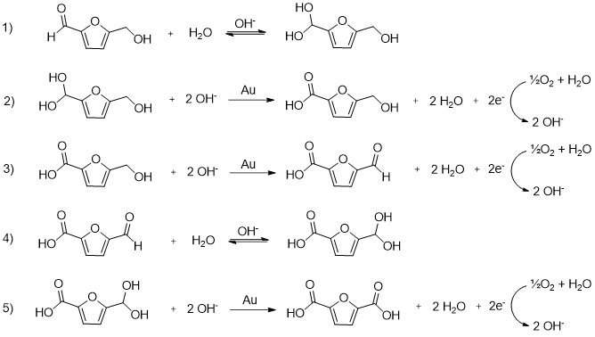
Figure S30. Reaction mechanism for HMF oxidation, proposed by Davis et al.[3]

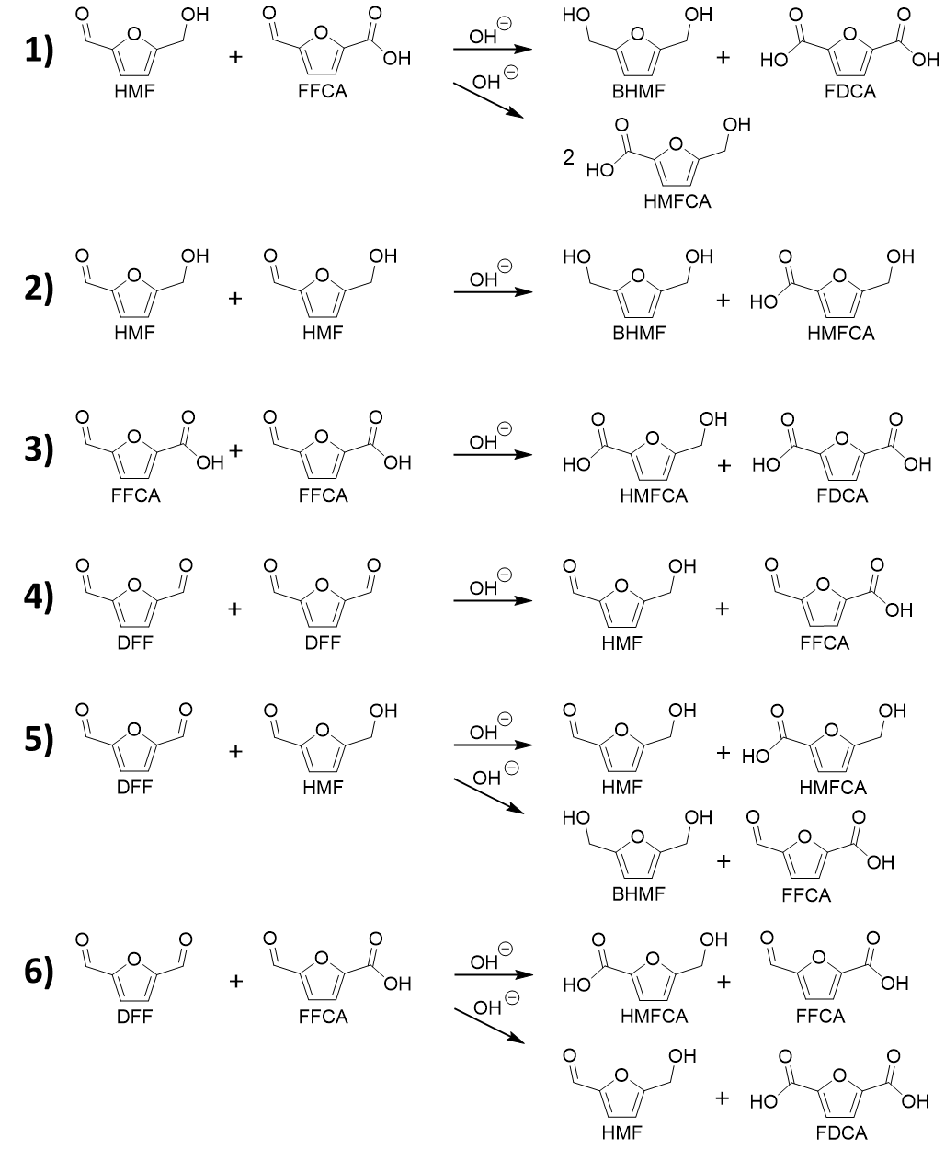
Figure S31. Cannizzaro reactions that can occur with the reactive species formed during HMF oxidation.

4. References
[1] P.W. Tidwell, G.A. Mortimer, An improved method of calculating copolymerization reactivity ratios, J. Polym. Sci. A Gen. Pap. 3 (1965) 369–387. https://doi.org/10.1002/pol.1965.100030137.
[2] T. Kelen, F. TÜd [Otilde] s, Analysis of the linear methods for determining copolymerization reactivity ratios. I. A new improved linear graphic method, Journal of Macromolecular Science—Chemistry 9 (1975) 1–27.
[3] S.E. Davis, B.N. Zope, R.J. Davis, On the mechanism of selective oxidation of 5-hydroxymethylfurfural to 2,5-furandicarboxylic acid over supported Pt and Au catalysts, Green Chem. 14 (2012) 143–147. https://doi.org/10.1039/C1GC16074E.

