Supplementary Materials

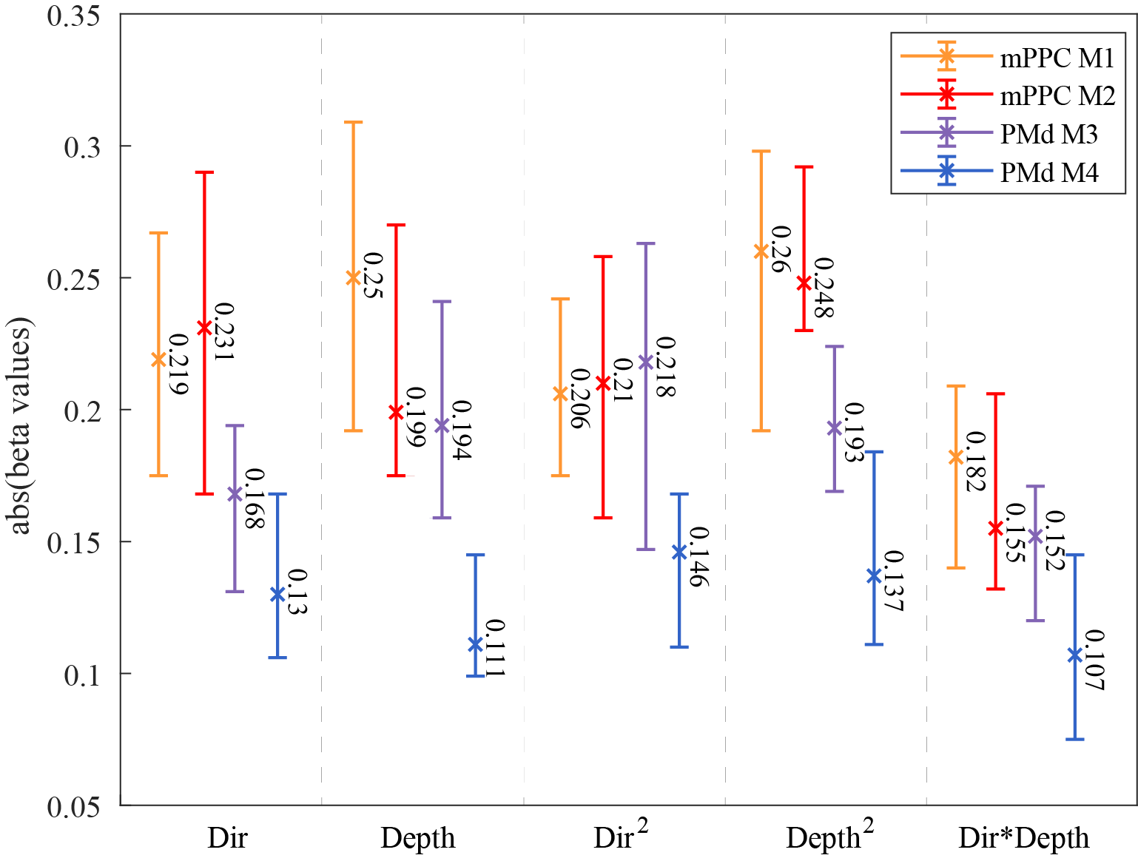
Figure S1. Median Beta Coefficients with 95% Bootstrap Confidence Intervals. The plot shows the median of beta coefficients obtained from the Poisson GLM regression for each regressor. The 95% confidence intervals (CIs) were estimated using bootstrapping with replacement (10,000 resamples). Each median is represented by an x marker, while error bars indicate the CIs. Bootstrapping was applied to the nonzero beta coefficients by randomly sampling with replacement and computing the distribution of medians. Colors correspond to different monkeys.

Area | mPPC.M1 | mPPC.M2 | F2.M3 | F2.M4 | mPPC.M1 | mPPC.M2 | F2.M3 | F2.M4
 | Direction^2 |  |  |  | Depth^2
mPPC.M1 | 1 | 0.824 | 0.646 | 0.002* | 1 | 0.604 | 0.003* | 0.011
mPPC.M2 |  | 1 | 0.986 | 0.003* |  | 1 | <0.001* | 0.002*
F2.M3 |  |  | 1 | 0.002* |  |  | 1 | 0.045
F2.M4 |  |  |  | 1 |  |  |  | 1
Direction*Depth
mPPC.M1 | 1 | 0.565 | 0.341 | 0.005*
mPPC.M2 |  | 1 | 0.547 | 0.013
F2.M3 |  |  | 1 | 0.032
F2.M4 |  |  |  | 1

Table S1. p-values for paired comparisons using the Kolmogorov-Smirnov test on the distributions of Figure 5 beta coefficients missing in Table 1. Asterisks indicate significantly different comparisons (p < 0.05 after Bonferroni correction for multiple testing).

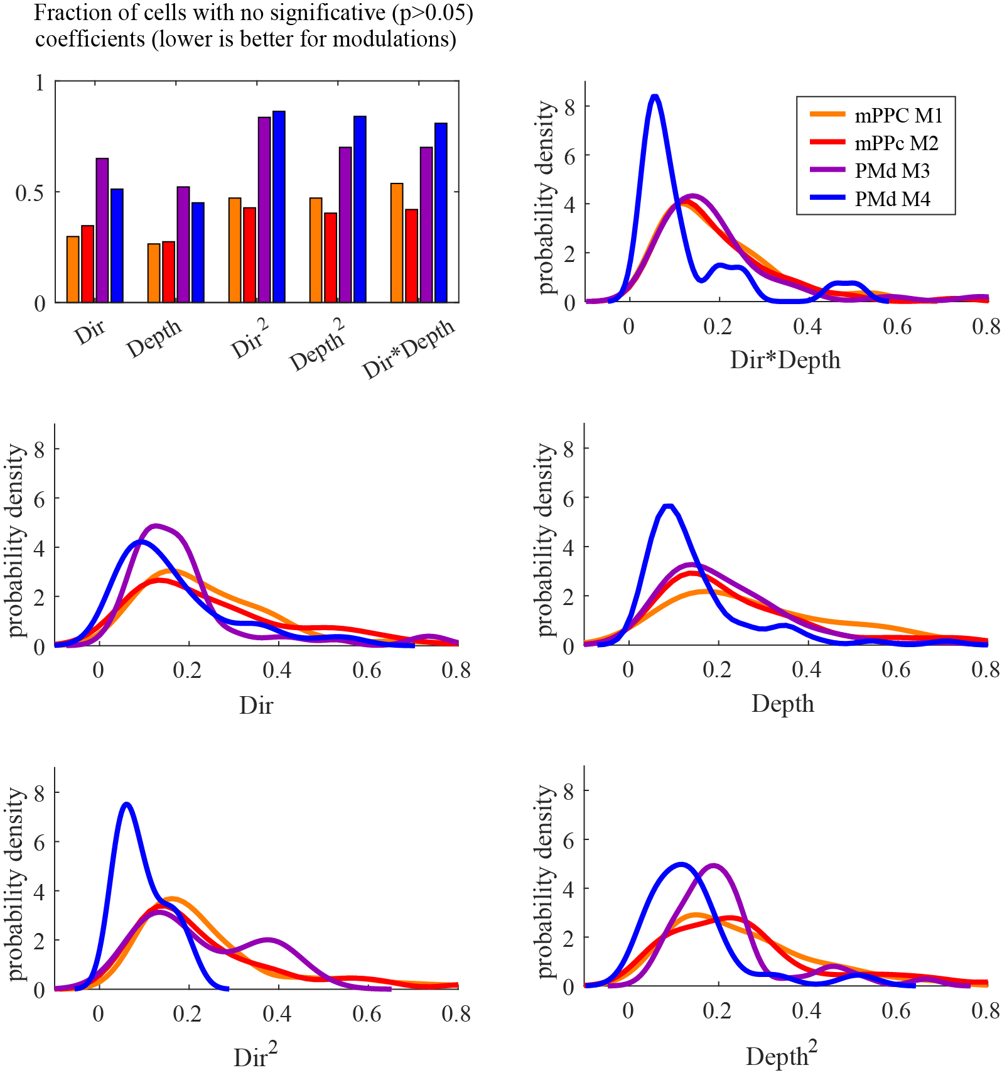

Figure S2. GLMs fitted for neural activity of the PMd and mPPC. Alternative plot to Figure 5 using non-normalized neural activity (with smoothing applied as described in the Methods). No substantial differences are observed compared to the normalized version, reducing the likelihood that the chosen normalization introduces bias in the presented analysis. All annotations are the same as in Figure 5.

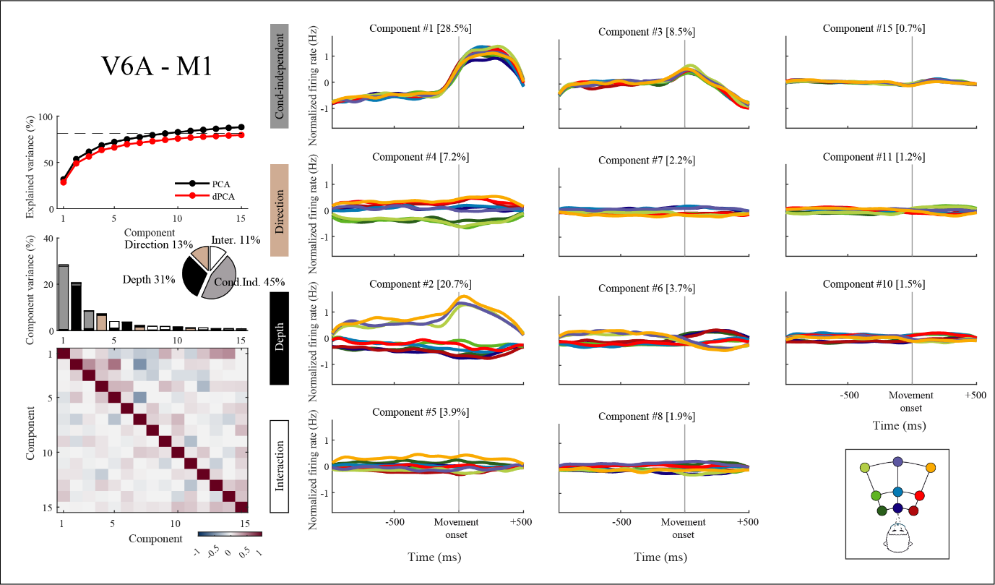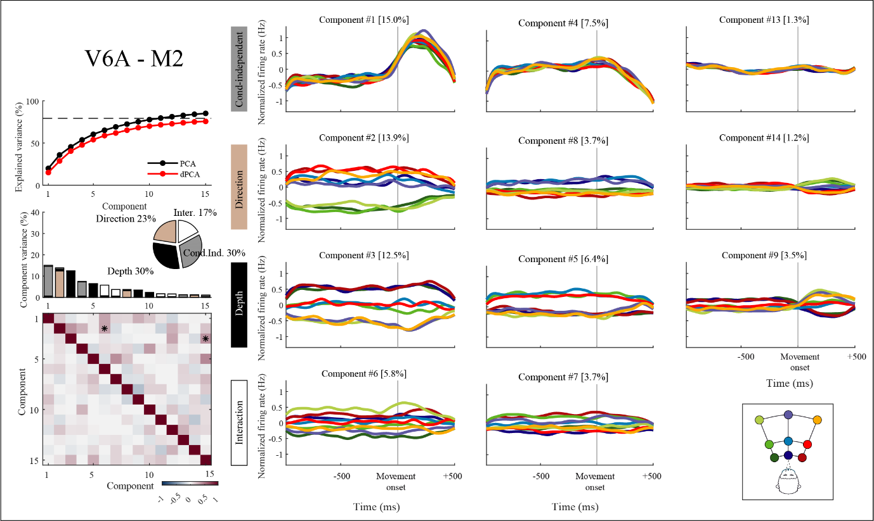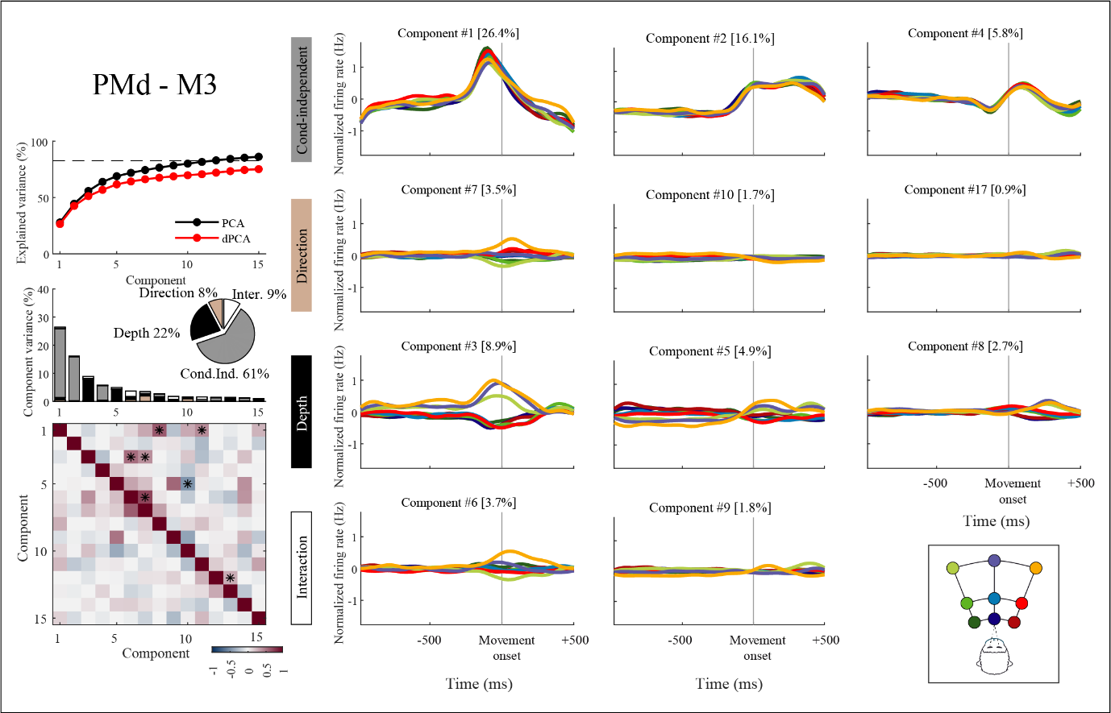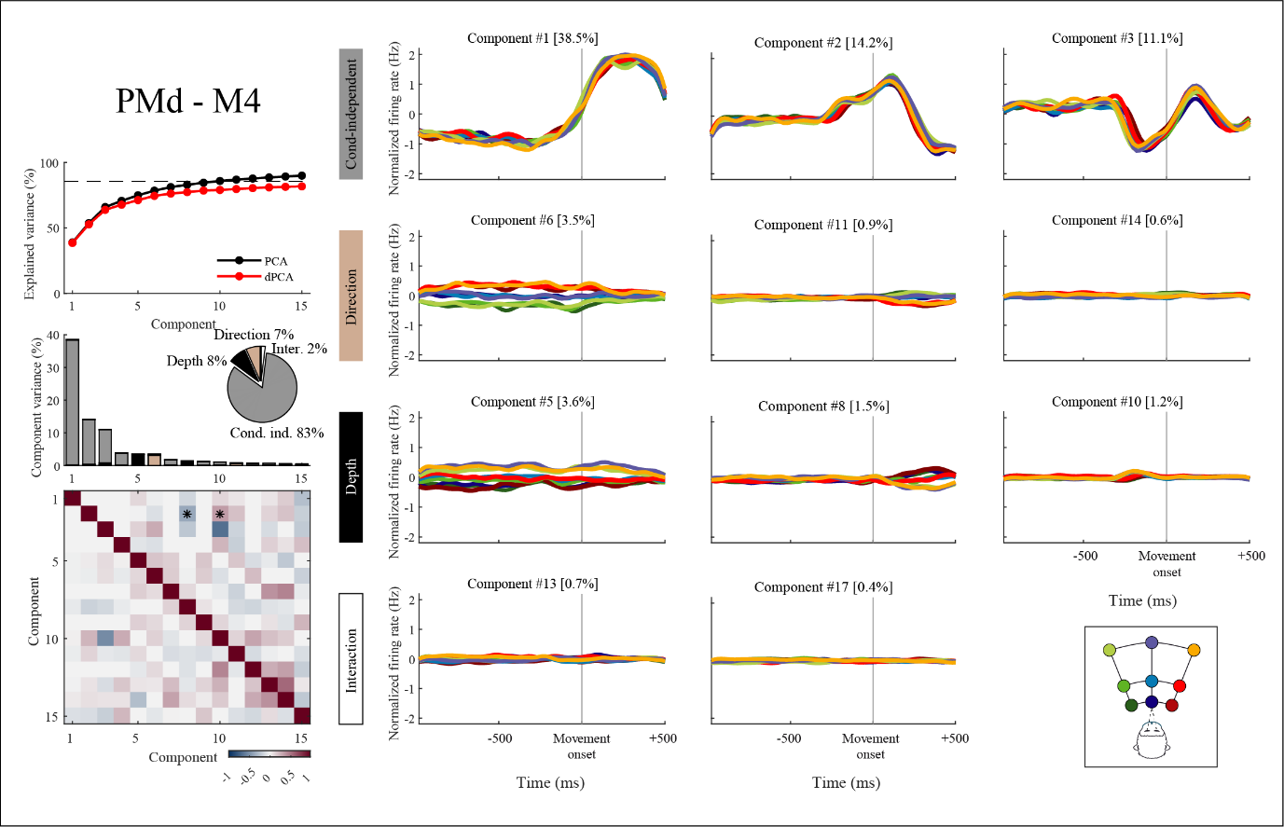
Figure S3. The four panels complete the snapshot of Figure 6 with projections of firing rates to the first 11 principal components. All annotations are the same as in Figure 6.

