SUPPLEMENTARY MATERIAL
Drought conditions, tillage regime and soil phosphorous modulate the incidence of weeds, pests and pathogens in arable crops
Francesco Lami^{1,2}*, Francesco Boscutti³, Stefano Barbieri⁴, Michele Fabro⁴, Roberta Masin¹, Nebojša Nikolić¹, Maurizia Sigura³, Lorenzo Marini¹

¹ DAFNAE, University of Padova, 35020, Legnaro, Padova, Italy
²DISTAL-Department of Agricultural and Food Sciences, University of Bologna, 40127, Bologna, Italy.
³Di4A-Department of Agricultural, Food, Environmental and Animal Sciences, University of Udine, 33100, Udine, Italy.
⁴ERSA – Agenzia Regionale per lo Sviluppo Rurale - Servizio fitosanitario e chimico, ricerca, sperimentazione e assistenza tecnica, 33050, Pozzuolo del Friuli, Udine, Italy.
*Corresponding author: francesco.lami2@unibo.it

Running title: Effects of tillage under drought conditions

Table S1. Features of the fields used during the experiment.
Pair | Field management | Distance between fields in a pair (m) | Coordinates (WGS 84) | Geographical area | Years No till | Soil humidity probes
1 | Conventional | 160 m | 45°52'14.89"N, 13°01'45.60"E | Rivignano (UD) | -
1 | Conservation | 160 m | 45°52'17.28"N, 13°01'44.51"E | Rivignano (UD) | 15
2 | Conventional | 100 m | 45°51'41.27"N, 13°03'09.59"E | Rivignano (UD) | - | May - October 2018
2 | Conservation | 100 m | 45°51'38.98"N, 13°03'13.22"E | Rivignano (UD) | 18 | May - October 2018
3 | Conventional | 200 m | 45°53'12.72"N, 13°02'25.08"E | Rivignano (UD) | -
3 | Conservation | 200 m | 45°53'07.35"N, 13°02'33.14"E | Rivignano (UD) | 18
4 | Conventional | 80 m | 45°52'15.27"N, 13°02'57.16"E | Rivignano (UD) | - | -
4 | Conservation | 80 m | 45°52'18.07"N, 13°02'54.87"E | Rivignano (UD) | 14 | -
5 | Conventional | 0 m | 46°02'53.51"N, 13°22'36.91"E | Orsaria (UD) | - | May - October 2018
5 | Conservation | 0 m | 46°02'54.32"N, 13°22'37.16"E | Orsaria (UD) | 12 | May - October 2018
6 | Conventional | 400 m | 46°02'46.22"N, 13°21'42.26"E | Orsaria (UD) | -
6 | Conservation | 400 m | 46°02'43.77"N, 13°21'55.54"E | Orsaria (UD) | 12
7 | Conventional | 900 m | 46°02'15.24"N, 13°21'40.67"E | Orsaria (UD) | - | -
7 | Conservation | 900 m | 46°02'36.97"N, 13°21'09.03"E | Orsaria (UD) | 12 | -
8 | Conventional | 80 m | 46°01'41.98"N, 13°21'42.06"E | Orsaria (UD) | - | May - October 2018
8 | Conservation | 80 m | 46°01'39.93"N, 13°21'36.74"E | Orsaria (UD) | 12 | May - October 2018
9 | Conventional | 10 m | 46°06'19.51"N, 13°24'14.39"E | Cividale (UD) |  | -
9 | Conservation | 10 m | 46°06'22.21"N, 13°24'13.88"E | Cividale (UD) | 8 | -

Table S2. Soil features in the experimental fields, including % of sand, silt and clay (calculated on the volume minus the skeleton), water pH, organic carbon content, phosphorous content (Olsen P), barium chloride Cation Exchange Capacity (CEC) and % of sand and skeleton. Field IDs are composed of a number referring to each field pair (1-9) and of either T (conventional tillage) or NT (conservation tillage).
Field ID |  | Sand 2 - 0.1 mm (%) | Sand 0.1 - 0.05 mm (%) |  | Silt 0.05 - 0.02 mm (%) | Silt 0.02 - 0.002 mm (%) | Clay <0.002 mm (%) | pH H2O | Ca(CO)3 (%) | Organic Carbon | Olsen P | CEC BaCl2 | Sand and Skeleton (%)
1NT | 9.5 |  |  | 6.0 | 23.0 | 47.0 | 14.5 | 7.8 | 59.8 | 1.5 | 11.5 | 13.4 | 15.5
1T | 15.0 |  |  | 10.0 | 22.0 | 39.0 | 14.0 | 8.1 | 65.3 | 0.9 | 6.3 | 10.0 | 25.0
2NT | 8.5 |  |  | 7.0 | 28.0 | 46.5 | 10.0 | 8.0 | 66.7 | 0.9 | 7.4 | 6.8 | 15.5
2T | 9.0 |  |  | 2.0 | 15.0 | 54.0 | 20.0 | 8.1 | 56.9 | 1.1 | 9.9 | 11.8 | 11.0
3NT | 15.0 |  |  | 8.5 | 24.0 | 35.5 | 17.0 | 7.9 | 52.1 | 2.0 | 16.6 | 20.0 | 27.7
3T | 20.0 |  |  | 12.0 | 29.0 | 27.0 | 12.0 | 8.0 | 47.8 | 1.3 | 17.1 | 11.7 | 32.0
4NT | 11.5 |  |  | 11.0 | 26.0 | 35.5 | 16.0 | 7.9 | 42.7 | 1.8 | 20.9 | 17.6 | 22.5
4T | 22.0 |  |  | 12.0 | 25.0 | 28.0 | 13.0 | 8.0 | 54.1 | 1.4 | 14.2 | 12.2 | 34.0
5NT | 17.0 |  |  | 12.5 | 19.5 | 29.5 | 21.5 | 7.6 | 1.2 | 1.6 | 10.3 | 20.9 | 33.0
5T | 18.5 |  |  | 14.5 | 20.0 | 25.5 | 21.5 | 7.8 | 3.9 | 1.6 | 22.2 | 25.2 | 54.1
6NT | 9.0 |  |  | 7.5 | 22.0 | 31.5 | 30.0 | 6.9 | 0.6 | 1.4 | 23.6 | 21.1 | 20.7
6T | 11.5 |  |  | 8.5 | 22.5 | 32.0 | 25.5 | 7.5 | 0.9 | 1.6 | 30.5 | 22.9 | 36.0
7NT | 12.0 |  |  | 9.5 | 25.0 | 30.0 | 23.5 | 7.1 | 0.6 | 1.2 | 18.3 | 18.4 | 21.5
7T | 18.0 |  |  | 11.0 | 17.0 | 22.0 | 32.0 | 7.6 | 1.5 | 1.5 | 46.2 | 23.4 | 32.6
8NT | 15.0 |  |  | 10.5 | 24.5 | 29.5 | 20.5 | 7.6 | 1.3 | 1.9 | 19.6 | 21.0 | 27.7
8T | 19.0 |  |  | 9.0 | 16.0 | 19.0 | 37.0 | 7.3 | 0.7 | 1.5 | 7.0 | 24.6 | 31.6
9NT | 7.5 |  |  | 14.5 | 25.0 | 32.5 | 20.5 | 7.6 | 1.6 | 1.5 | 35.6 | 23.5 | 22.0
9T | 16.0 |  |  | 17.0 | 23.0 | 27.0 | 17.0 | 7.8 | 12.8 | 1.8 | 24.2 | 21.4 | 33.0

Table S3. Mean Volumetric Water Content (m³/m³) as detected by ECH2O EC-5 soil humidity probes and ICT Em5b data loggers from June 2018 to October 2018 (soybean period) in field pairs 2, 5 and 8.
 | Conservation tillage |  | Conventional tillage
 | Drought | Rainfed | Drought | Rainfed
June 18 | 0.276 | 0.312 | 0.221 | 0.293
July 18 | 0.190 | 0.217 | 0.196 | 0.230
August 18 | 0.163 | 0.176 | 0.186 | 0.212
September 18 | 0.176 | 0.200 | 0.185 | 0.230
October 18 | 0.188 | 0.250 | 0.213 | 0.283

Table S4. Recapitulatory table detailing the number of individuals recorded in each treatment for the main predatory and herbivore arthropod groups in soybean.
Predators
 | Conservation |  | Conventional
 | Rainfed | Drought | Rainfed | Drought | Total
Araneae | 16 | 12 | 4 | 21 | 53
Nabidae | 2 | 6 | 2 | 4 | 14
Syrphidae | 3 | 2 | 2 | 0 | 7
Chrysopidae | 1 | 2 | 2 | 0 | 5
Coccinellidae | 0 | 1 | 2 | 2 | 5
Parasitoids | 0 | 2 | 0 | 0 | 2
Other | 1 | 0 | 2 | 2 | 5
Herbivores
 | Conservation |  | Conventional
 | Rainfed | Drought | Rainfed | Drought | Total
Pentatomidae | 222 | 236 | 102 | 149 | 709
Auchenorrhyncha | 26 | 13 | 17 | 22 | 78
Orthoptera | 8 | 5 | 9 | 18 | 40
Miridae | 8 | 1 | 7 | 8 | 24
Sminthuridae | 1 | 9 | 2 | 10 | 22
Lepidoptera | 5 | 7 | 1 | 5 | 18
Aphidoidea | 2 | 2 | 2 | 8 | 14
Coleoptera (Curculionidae & Chrysomelidae) | 0 | 3 | 6 | 3 | 12
Thysanoptera | 4 | 1 | 0 | 3 | 8
Aleyrodidae | 1 | 5 | 0 | 2 | 8
Acari | 0 | 2 | 0 | 0 | 2
Other | 1 | 1 | 1 | 0 | 3

Table S5. List of weed species with presence (1) or absence (0) as recorded in each treatment during photographic surveys.
 |  | Conservation tillage |  | Conventional tillage
Family | Species | Rainfed | Drought | Rainfed | Drought
Amarantaceae | Chenopodium album L. | 1 | 1 | 1 | 1
Apiaceae | Daucus carota L. | 0 | 1 | 0 | 0
Apiaceae | Foeniculum vulgare Mill. | 1 | 1 | 1 | 1
Asteraceae | Conyza sp. | 0 | 1 | 0 | 0
Asteraceae | Erigeron annuus (L.) Pers. | 1 | 1 | 1 | 1
Asteraceae | Helianthus tuberosus L. | 0 | 0 | 1 | 0
Asteraceae | Picris hieracioides L. | 1 | 1 | 1 | 0
Asteraceae | Senecio inaequidens DC. | 1 | 1 | 1 | 1
Asteraceae | Senecio vulgaris L. | 1 | 1 | 1 | 1
Asteraceae | Sonchus oleraceus L. | 1 | 1 | 1 | 1
Asteraceae | Taraxacum officinale (L.) Weber ex F. H. Wigg | 1 | 1 | 1 | 0
Brassicaceae | Arabidopsis thaliana (L.) Heynh. | 1 | 1 | 1 | 1
Brassicaceae | Capsella bursa-pastoris (L.) Medik. | 0 | 0 | 1 | 1
Brassicaceae | Cardamine hirsuta L. | 1 | 1 | 1 | 1
Brassicaceae | Draba verna L. | 0 | 1 | 1 | 1
Caryophyllaceae | Arenaria serpyllifolia L. | 1 | 1 | 0 | 0
Caryophyllaceae | Cerastium glomeratum Thuill. | 1 | 1 | 1 | 1
Caryophyllaceae | Silene vulgaris (Moench.) Garcke | 0 | 1 | 0 | 0
Caryophyllaceae | Stellaria media (L.) Vill. | 1 | 1 | 1 | 1
Convolvulaceae | Convolvulus arvensis L. | 0 | 0 | 1 | 0
Equisetaceae | Equisetum arvense L. | 1 | 1 | 0 | 0
Fabaceae | Vicia sativa L. | 1 | 1 | 0 | 0
Geraniaceae | Geranium purpureum Vill. | 0 | 0 | 0 | 1
Geraniaceae | Geranium rotundifolium L. | 0 | 0 | 0 | 1
Lamiaceae | Lamium purpureum L. | 0 | 1 | 0 | 1
Malvaceae | Abutilon theophrasti (Medik.) | 0 | 0 | 0 | 1
Papaveraceae | Fumaria officinalis L. | 1 | 1 | 1 | 1
Papaveraceae | Papaver rhoeas L. | 1 | 1 | 1 | 1
Plantaginaceae | Veronica hederifolia L. | 1 | 1 | 1 | 1
Plantaginaceae | Veronica persica Poir. | 1 | 1 | 1 | 1
Poaceae | Dactylis glomerata L. | 0 | 1 | 1 | 1
Poaceae | Elymus repens (L.) Gould | 0 | 1 | 1 | 1
Poaceae | Poa annua L. | 1 | 1 | 1 | 1
Poaceae | Poa trivialis L. | 0 | 1 | 1 | 0
Polygonaceae | Rumex obtusifolius L. | 0 | 1 | 0 | 0
Ranunculaceae | Ranunculus acris L. | 0 | 0 | 1 | 0
Rubiaceae | Galium aparine L. | 1 | 1 | 1 | 0
NA | Morphospecies 1 | 0 | 1 | 0 | 1
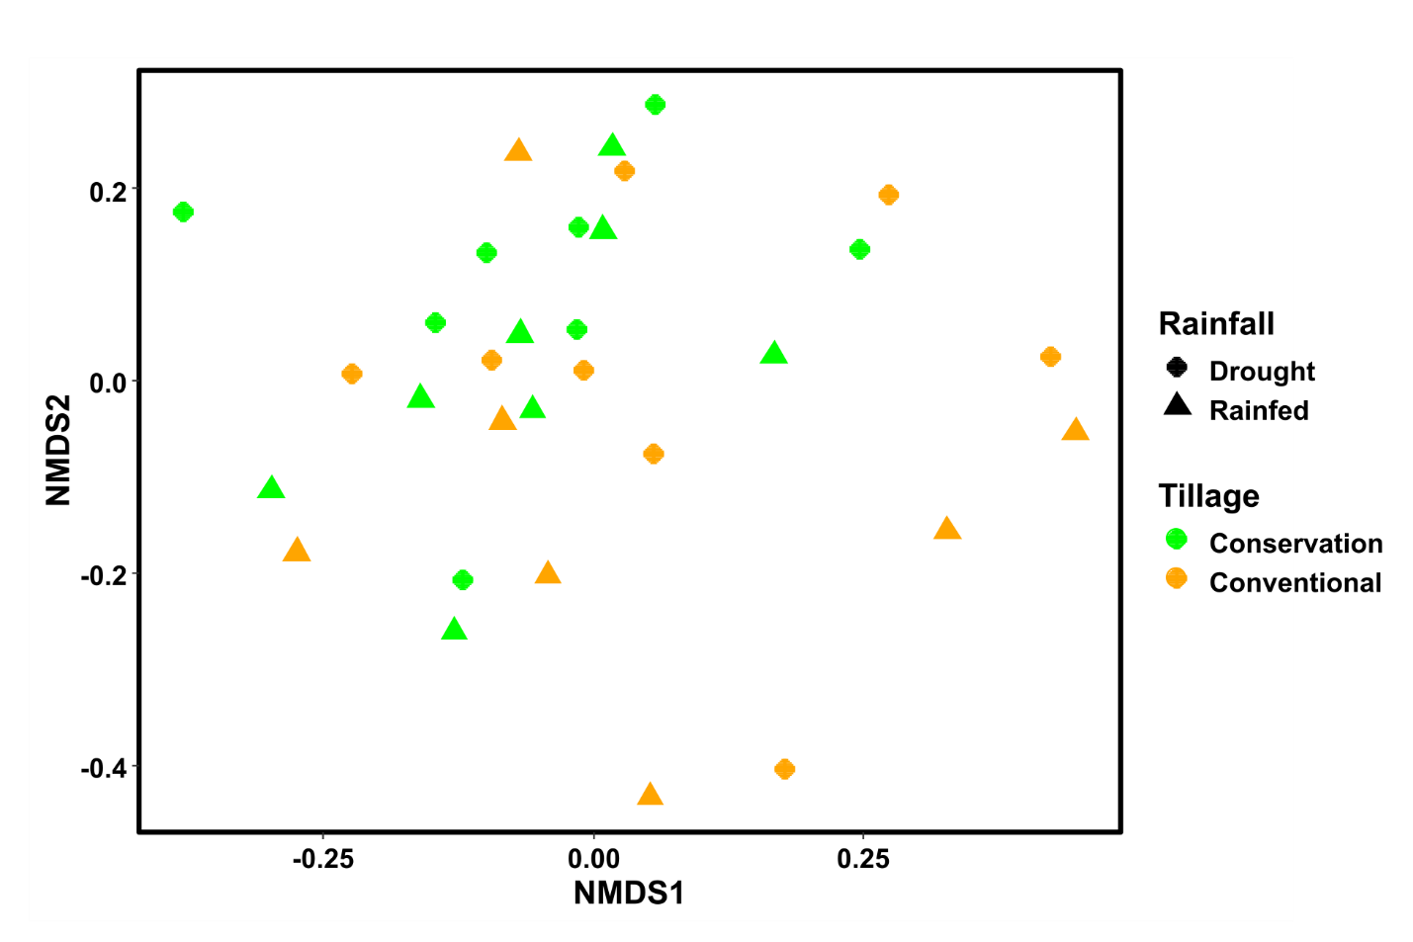
Figure S1. Ordination plot based on Nonmetric MultiDimensional Scaling (NMDS) comparing global ecosystem services provision in drought and rainfed treatments, and in conventional and conservation tillage fields. Each dot is a single experimental plot. ANOSIM indicated no significant difference in the overall provision of services between drought and rainfed plots (R = 0.04; p = 0.16), while it showed a near-significant difference between conventional and conservation tillage (R = 0.06; p = 0.08). We used Bray-Curtis distance in both NMDS and ANOSIM.

