SUPPLEMENTAL INFORMATION

Urine-stable aptamer-conjugated gold nanorods for the early detection of high-grade bladder cancer residual disease

Chiara Venegoni, Silvia Tortorella, Alessandra Caliendo, Irene Locatelli, Alessia Di Coste, Erica Locatelli, Filippo Capancioni, Emanuela Bua, Simona Camorani, Andrea Salonia, Francesco Montorsi, Jithin Jose, Marco Moschini, Laura Cerchia, Mauro Comes Franchini, Massimo Alfano.

- Figure S1. Infrared spectroscopy of GNRs@Chit-linker.
- Figure S2. Binding assay of Alexa 647-Apt-Itg to human and murine cancer cells in the presence of divalent cations.
- Figure S3. Apt-Itg actively internalizes into murine MB49-Luc cells.
- Figure S4. Thermogram of GNRs@Chit-Apt-Itg decomposition
- Figure S5. The hydrodynamic range of the targeted GNRs.
- Figure S6. stability of GNRs@Chit-Apt-Itg at different pH values.
- Figure S7. Visualization of the PA signal of GNRs@Chit-Apt-Itg on tumor mass of different size.
- Figure S8. Cytotoxicity test of GNRs@Chit-Apt-Itg on integrin α5β1+ MB49 cells.
- Supplementary Table S1: Wavelength and absorbance values for a batch of GNRs with different functionalization.
- Supplementary Table S2: Wavelength and absorbance values of GNRs@Chit-Apt-Itg in human urine over time.

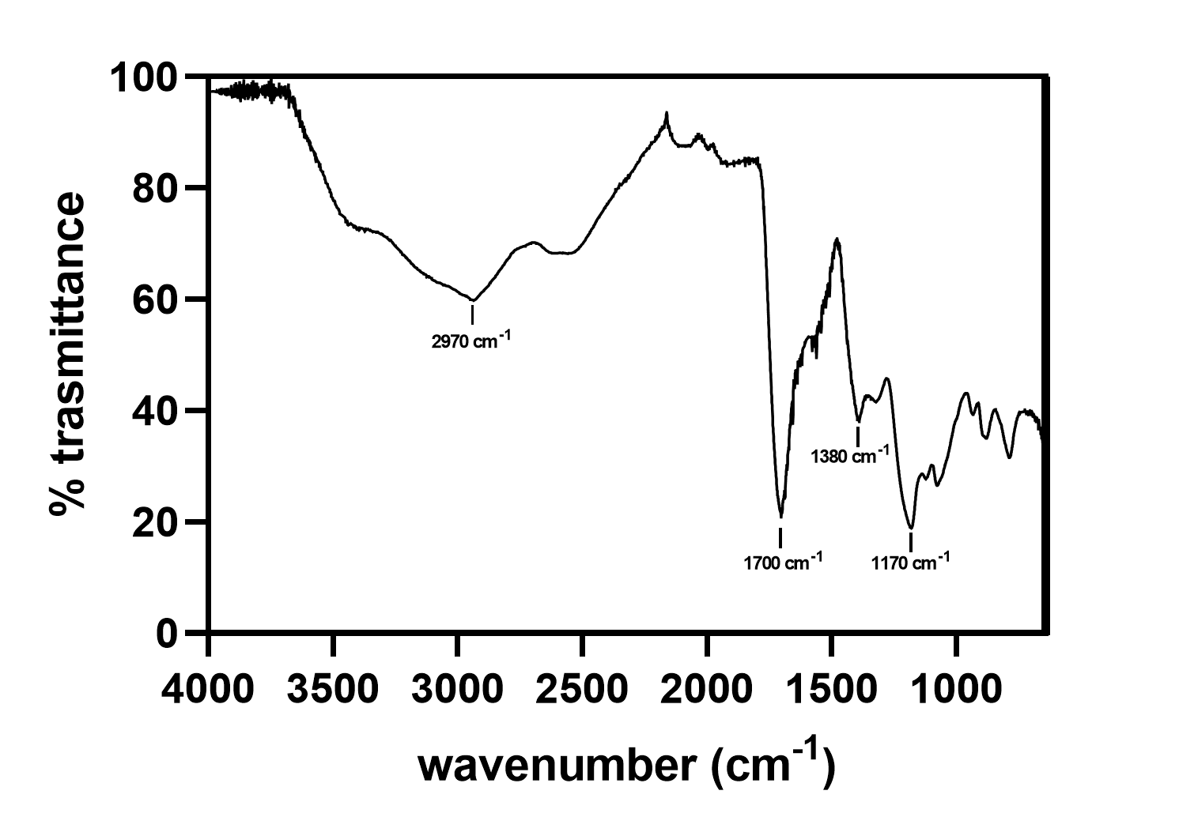
Figure S1. Infrared spectroscopy of GNRs@Chit-linker. We acquired ATR-IR spectrum of GNRs@Chit-linker. The broad band from 3600 and 2200 cm⁻¹ could be attributed to O-H, N-H and C-H stretching; 1700 cm⁻¹ sharp band is the C=O stretching of the amidic carbonyls, deriving from both acetylated monomers (as in the chitin polymer) and the amide group forming after NHS-PEG₁₂-Maleimide coupling; 1380 cm⁻¹ band could be attributed to C-S stretching, while 1170 cm⁻¹ band is due to C-O stretching.

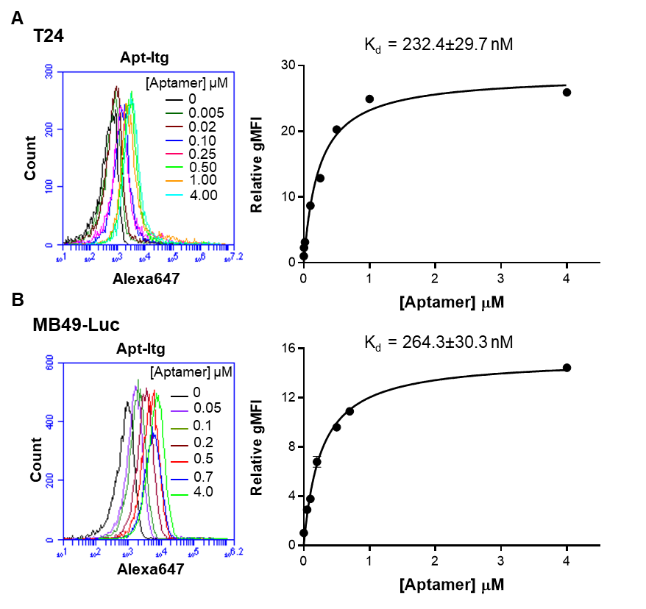

Figure S2. Binding assay of Alexa 647-Apt-Itg to human and murine cancer cells in the presence of divalent cations. Representative binding profiles of increasing concentrations of Alexa 647-Apt-Itg incubated with T24 (A) and MB49-Luc (B) cells in presence of 1 mM MgCl₂ and 0.5 mM CaCl₂. Apparent dissociation curves of aptamer-cell interaction and Kd value of Apt-Itg is shown. Data are presented as the mean ± SD.

Figure S3. Apt-Itg actively internalizes into murine MB49-Luc cells. Representative confocal images of MB49-Luc cells incubated for 120 min at 37°C with 4 μm Alexa 647-Apt-Itg or Alexa 647-Unrelated aptamer. Aptamer, WGA-488 (cell surface), LysoTracker (lysosomes), and DAPI (nuclei) are visualized in red, green, blue, and gray, respectively. All digital images were captured at the same setting to allow direct comparison of staining patterns. Magnification 63x, 1.0x digital zoom, scale bar = 10 μm.

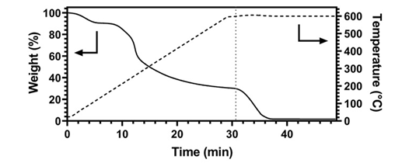

Figure S4. Thermogram of GNRs@Chit-Apt-Itg decomposition. The dashed line corresponds to the switch from N2 atmosphere to air. The TGA profile shows a first loss corresponding to -10% weight loss due to the desorption of residual humidity from the lyophilization process. The first weight change starting from 200 °C is due to the degradation of chitosan in N2 atmosphere, resulting in char formation. Once reached 500°C and observing no weight loss, the atmosphere was switched from N2 to air. The sample was kept at 500 °C for 15 min in air, observing a 2.1 wt% residual mass, corresponding to the total inorganic content.

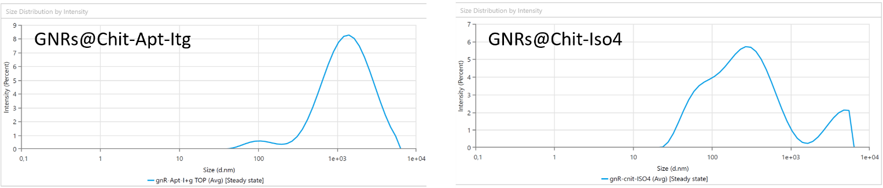
Figure S5. The hydrodynamic range of the targeted GNRs. Histograms showing the hydrodynamic range (Z-average, expressed in nm) of GNRs@Chit-Apt-Itg and GNRs@Chit-Iso4. Histograms display the mean of measurements performed in triplicate.

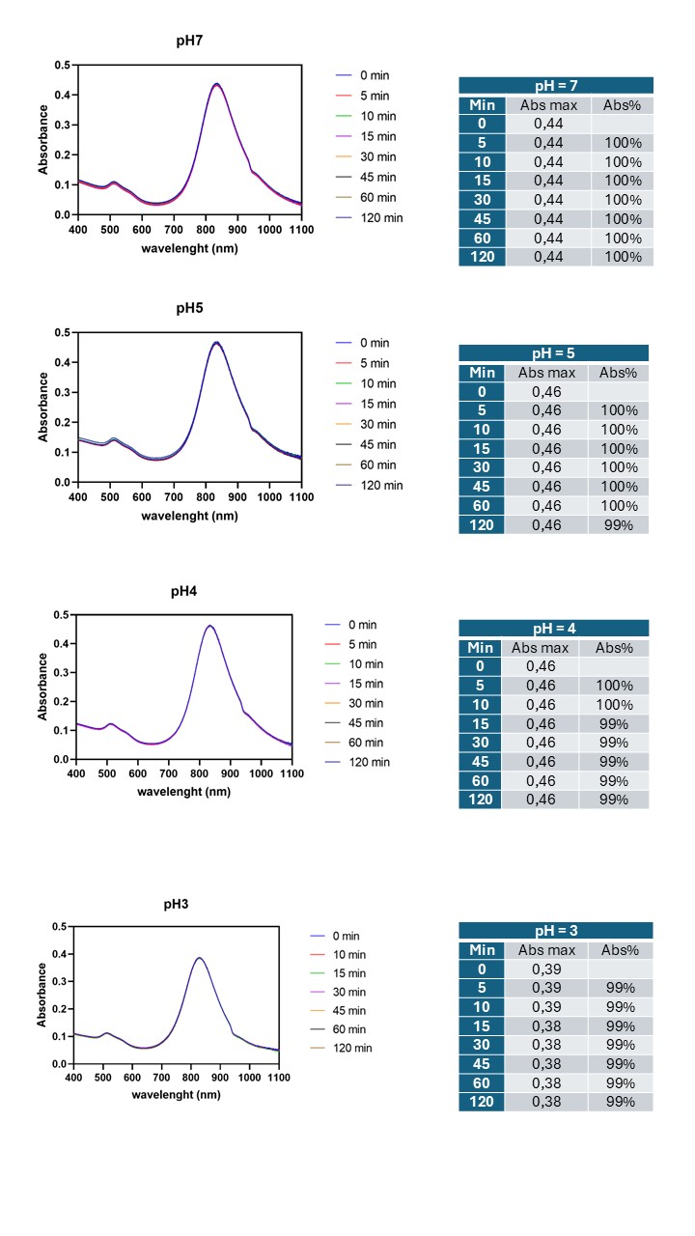

Figure S6. Stability of GNRs@Chit-Apt-Itg at different pH values. The stability of GNRs@Chit-Apt-Itg has been tested at neutral pH, pH=5, pH=4 and pH=3 for 120 minutes, and assessed by checking the maintenance or decrement of the maximum absorption wavelength via UV-Vis analysis. Freeze-dried GNRs@Chit-Apt-Itg were dissolved in 500 μL of H2O obtaining a concentration of 1.0 mM. 100 μL of this solution were diluted to 3 mL and pH was adjusted by adding acetic acid. After repeating the operation for three times varying the acetic acid amount, VIS-NIR spectra from 400 to 1100 nm of GNRs@Chit-Apt-Itg were collected for two hours, using H2O as blank. As shown by the spectra, no LSPR shifting or significant decrease of absorbance from t=0 is observed at different acidic pH (3-4-5) and neutral pH.

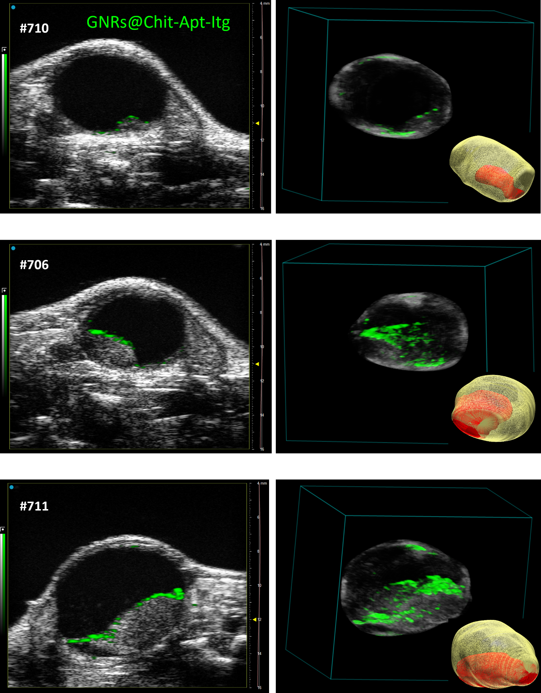
Figure S7. Visualization of the PA signal of GNRs@Chit-Apt-Itg on tumor mass of different size. Ultrasound and PA imaging of GNRs@Chit-Apt-Itg are shown for three different tumor masses, from three independent animals. GNR@Chit-Apt-Itg (100 μl at concentration of 100 μM Au) were instilled intravesically. Imaging was acquired 15 minutes after the intravesical instillation, followed by two intravesical washes with saline solution.
Single frame of ultrasound and PA imaging of GNRs@Chit-Apt-Itg, 3D distribution of nanoparticles, and 3D reconstruction of US imaging of bladder and orthotopic tumor are shown for each animal.

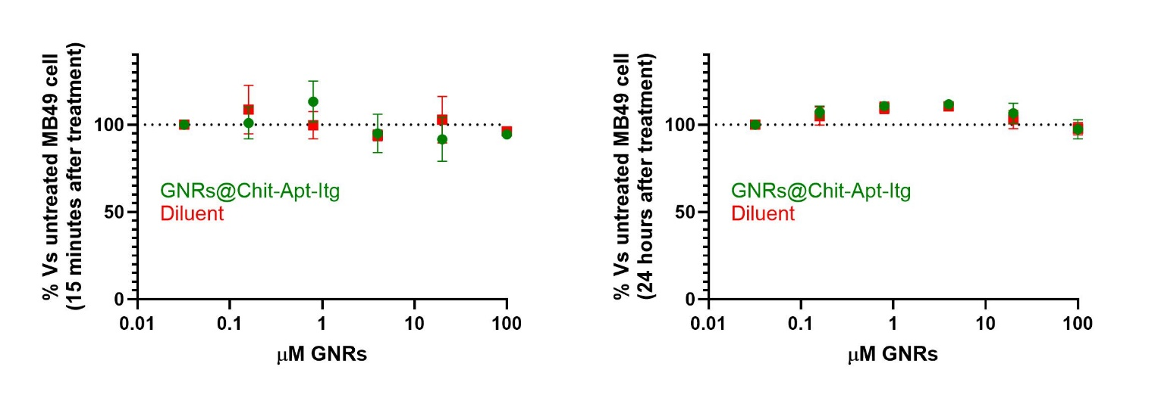
Figure S8. Cytotoxicity test of GNRs@Chit-Apt-Itg on integrin a5b1+ MB49 cells. MB49 cells were incubated for 15 minutes with either nanoparticles or the diluent solution, then washed with culture medium. The time point “15 minutes” was immediately tested, while the cells for the time point “24 hours” were cultivate for an additional 24 hours. The graphs show data from one out of two experiments with similar information; symbols and lines represent median and SEM of conditions tested in quadruplicate.
Table S1: Wavelength and absorbance values for a batch of GNRs with different functionalization.
GNRs formulation | λ _{max} (nm) | A_{max} | A_{800nm}
GNRs@CTAB | 818 | 0.573 | 0.534
GNRs@Chit | 836 | 0.493 | 0.377
GNRs@Chit-Apt-Itg | 834 | 0.418 | 0.336
λ _{max}: maximum wavelength. A_{max}: maximum value of absorbance. A_{800 nm}: absorbance at 800 nm.

Table S2: Wavelength and absorbance values of GNRs@Chit-Apt-Itg in human urine over time.
Time (min) | λ _{max} (nm) | A_{max} | A%
0 | 851 | 0.391 | 100%
5 | 853 | 0.386 | 99%
10 | 850 | 0.386 | 99%
15 | 852 | 0.378 | 97%
30 | 854 | 0.375 | 96%
45 | 854 | 0.376 | 96%
60 | 849 | 0.376 | 96%
120 | 854 | 0.363 | 93%
λ _{max}: maximum wavelength. A_{max}: maximum value of absorbance. A%: percentage of stability of GNRs@Chit-Apt-Itg as compared to time 0.

