Supporting Information

Photoresponsive slide-ring gels enable modulation of sliding dynamics
Dalila Cafagno,^{,,c} Serena Silvi,^{b} Mark W. Tibbittª and Stefan Mommer^{a*}

Table of Contents
1 Experimental part 2
2 NMR spectroscopic data 8
3 Gel permeation chromatography 19
4 MALDI-ToF spectrometry 22
5 Isothermal titration calorimetry 23
6 Photoisomerization studies 24
7 Rheological data 27

Experimental part

Materials

4,4’-azodibenzoyl dichloride (95%, Combi-Blocks), triethylamine (TEA, 99%, Sigma Aldrich), 2-(2-(2-methoxyethoxy) ethanamine (95%, Sigma Aldrich), hydrochloric acid (37%, Bioworld), sodium sulfate anhydrous (Fisher Scientific), PEG (Amine)2, HCl Salt, MW 3500 (JenKem Technology), ethylenediamine (Sigma Aldrich), ⍺-cyclodextrin (⍺-CD, ≥98%, Sigma Aldrich), 1-fluoro-2,4-dinitrobenzene (DNFB, 97%, Sigma Aldrich), sodium hydroxide anhydrous (≥98%, Sigma Aldrich), divinylsulfone (DVS, 97%, Sigma Aldrich) were used without any further purification. Ultrapure Milli-Q water with a resistivity of 18.2 MΩ·cm⁻¹ and all solvents were purchased from commercial sources and used without further modification.

Instrumentation
¹H and ¹³C NMR spectra were recorded on a Bruker Biospin 400 NMR spectrometer (400 MHz) and are reported as follows: chemical shift d (ppm) (multiplicity, coupling constant J (Hz), number of protons, assignment). The residual protonated solvent signals of DMSO-d₆ (δ_{H} = 2.50 ppm) and CDCl₃ (δ_{H} = 7.26 ppm) were used as reference. Chemical shifts are reported in ppm to the nearest 0.01 ppm for ¹H NMR. The data was analyzed using the MestreNova software (Version 14.2.3-29241, Mestrelab Research S.L.).
UV/Vis Spectroscopy were recorded on Cary 300 (Varian-Agilent) double beam spectrophotometer, and Cary 50 Bio single beam spectrophotometer, using cuvettes with 1 cm path length at room temperature (~20-25 °C). Irradiation experiments were performed with a Helios Quartz (125 W) medium-pressure mercury lamp in DMSO and in 15:85 CH₃CN-H₂O solutions at room temperature (~20-25 °C). The desired Hg emission line was selected with an interference filter. The incident light intensity was measured for each experiment using the ferrioxalate actinometer^{[1]} and it was of the order of 10⁻⁷-10⁻⁸ hν/s. The solutions were carefully stirred throughout the whole irradiation to ensure the homogeneity of the solution.
Isothermal Titration Calorimetry (ITC) was performed on a Microcal PEAQ-ITC (Malvern Panalytical Ltd, Malvern, UK) using 15 vol% H₂O/CH₃CN as solvent. In the ITC experiment, the reference cell was filled with the solvent mixture, the sample cell was filled with the guest molecule and the injection pipette was loaded with the host macrocycle, with the concentration of the host being set to be 25 times higher than the concentration of the guest molecule. Then, 19 consecutive injections were carried out (1 x 0.4 μL, 18 x 2 μL), with an interval time of 150 s and the first injection being discarded. To determine the heat of dilution, the host was titrated to solvent mixture and the resulting dataset was used for baseline subtraction. All raw data of ITC were integrated by NITPIC (v.2.1.0),^{[2,3]} fitted in Sedphat (v.15.2b),^{[4]} and plotted through GUSSI (v.2.1.4).^{[5]}
Gel Permeation Chromatography (GPC). Molecular weights (M_{n} and M_{w}) and dispersities (Ð = M_{w}/M_{n}) were determined by size exclusion chromatography (SEC). SEC analyses were carried out on an OMNISEC Resolve system, equipped with an OMNISEC Reveal triple detector (refractive index, light scattering and viscosity). Milli-Q water was used as an eluent and contained 0.1 M of sodium nitrate and 0.02% (w/v) sodium azide, which was filtered through a 0.2 μm Nylon filter before use. One guard column (8 × 50 mm, AGuard, Viscotek) and two A6000M general mixed gel columns (8 × 300 mm) were applied at a flow rate of 0.7 mL·min⁻¹ at 25 °C. The incremental refractive index value was set to dn/dc = 0.135. For sample preparation, polymerized samples were dissolved in the carrier phase at a concentration of 0.25–1 mg·mL⁻¹ for at least two days at ambient conditions. Each sample was injected at least twice and the values for M_{n}, M_{w} and Đ were averaged accordingly. The determination of molecular weights was achieved through triple detection mode and the results were exported using the OMNISEC Software (Version 11.32, Malvern Panalytical).
Rheology. All mechanical characterization experiments were performed on the strain-controlled oscillatory Modular Compact Rheometer (MCR 502, Anton Paar) with a 20 mm diameter stainless steel (1.4404) parallel plate geometry (PP20, Anton Paar). The device was operated using the RheoCompass software (Anton Paar). The samples were loaded using automatic pipettes and excess material was trimmed before starting the measurement. Samples were measured at a gap size of 200 μm and water drops were added at the outside rim of the tool to prevent the evaporation of water and drying of the samples. All measurements were performed at 25 °C. The characterization protocol included a preconditioning step and the actual measurement. For the preconditioning, both storage (G′) and loss modulus (G′′) were recorded. Hereby, 360 data points were acquired in 3600 s at a shear strain of γ = 0.5% and an angular frequency of ω = 1 rad·s⁻¹. During the actual measurements, six data points were recorded per decade using the parameter set described in the following. First, an oscillatory frequency sweep was performed by sweeping the angular frequency from 100 to 0.1 rad·s⁻¹ at a constant shear strain of γ = 0.5% and recording G′ and G′′. Next, the oscillatory amplitude sweep was carried out, varying the shear strain from 0.1 to 2000% at ω = 10 rad·s⁻¹ angular frequency capturing G′ and G′′.
The irradiation experiment was divided into two phases, a preconditioning step and the actual measurement. For the preconditioning, both storage (G′) and loss modulus (G′′) were recorded. Hereby, 360 data points were acquired in 3600 s at a shear strain of γ = 5% and an angular frequency of ω = 1 rad·s⁻¹. During the actual measurement a time sweep was performed with a constant angular frequency ω = 1 rad·s⁻¹ and shear strain γ = 5%, alternating 10 minutes of darkness, with 10 minutes of irradiation at 365 nm, then 10 minutes of darkens again followed by 10 minutes of irradiation at 455 nm.
For the irradiation, a four-channel LED driver (ThorLabs – DC4104) was used, switching between 365 nm and 455 nm. The light power was measured with an optical power meter (ThorLabs – PM100D).
Circular dichroism (CD) spectra were recorded on a Jasco-175 spectropolarimeter. The CD instrument was purged with N₂ for at least 30 min and the instrumental parameters were set as data pitch 0.5 nm, band width 5 nm, response 8 s, sensitivity standard, and scan speed 50 nm min⁻¹. All the experiments were carried out at room temperature in a 1 cm quartz cuvette.
Matrix-assisted laser desorption ionization Time-of-flight mass spectrometry (MALDI-ToF) was performed on a Bruker ultrafleXtreme equipped with a 337 nm smartbeam laser in linear mode. THF solutions of sodium trifluoroacetate, analyte and DHB matrix were mixed and applied on the sample plate. The laser repetition rate was 100 Hz and the number of shots was 1000.

Syntheses

Synthesis of PEG-azobenzene polymer 1
α,ω-Bis(amino) poly(ethylene glycol) (3.5 kDa, 1.14 g, 0.326 mmol) and triethylamine (0.36 ml, 2.6 mmol) were dissolved in CH₂Cl₂ (1.0 mL). In a separate vial, 4,4’-azodibenzoyl dichloride (0.100 g, 0.330 mmol) was dissolved in CH₂Cl₂ (3.7 mL). Then, the azobenzene solution was added dropwise to the PEG solution, followed by the addition of more CH₂Cl₂ (2.0 mL). The reaction was stirred overnight at room temperature. Subsequently, ethylenediamine (0.40 mL, 6.0 mmol) was added to the mixture and the reaction was stirred overnight at room temperature. Then, the reaction mixture was washed with 0.1 M HCl_{(aq.)} (1×) and brine (2×). The organic layer was dried (Na₂SO₄) and evaporated under reduced pressure to give the final product 1 as an orange plastic solid (1.12 g). ¹H NMR (400 MHz, DMSO-d₆) δ 8.76 (t, 2H, H3, backbone), 8.15 (d, 4H, H2, backbone), 8.04 (d, 4H, H1, backbone), 3.70–3.43 (m, 4H, H4–H7, PEG backbone).

Synthesis of the α-CD poly(pseudorotaxane) 2 (threading)
1 (1.00 g, 2.68·10⁻⁴ mmol repeating units, MW_{RU} ~ 3736 g/mol) and α-CD (6.62 g, 6.80 mmol) were dissolved in water at 80 °C for 2 h. Subsequently, the flask was placed to rest at 5 °C overnight. Lyophilization of the mixture gave the polypseudorotaxane 2 as a yellow paste as product, which was used without further purification. ¹H NMR (400 MHz, DMSO-d₆) δ 8.71 (t, 2H, H3, backbone), 8.08 (d, 4H, H2, backbone), 7.97 (d, 4H, H1, backbone), 5.51 (d, 6H, OH2’), 5.42 (d, 6H, OH3’), 4.80 (d, 6H, H1’), 4.45 (t, 6H, OH6’), 3.79–3.25 (m, H4–H8, PEG backbone and H2’-H6’).

Synthesis of the α-CD poly(rotaxane) 3 (stoppering)
The polypseudorotaxane 2 (1.00 g) was dissolved in DMF (29 mL) under Argon atmosphere, followed by the addition of 1-fluoro-2,4-dinitrobenzene (0.96 mL, 7.6 mmol). The mixture was stirred overnight at room temperature. Next, water was added to achieve a 10-fold dilution of the solution. Purification by dialysis using a Spectra/Por dialysis membrane (Spectrumlabs.com, CE, MWCO = 6–8 kDa) in water (10 L) for 2 d prior to lyophilization for 24 h gave the product polymer 3 (1.33 g) as an orange film. ¹H NMR (400 MHz, DMSO-d₆) δ 8.82 (d, 2H, H11), 8.70 (t, 2H, H3, backbone), 8.20 (dd, 2H, H10), 8.07 (d, 4H, H2, backbone), 7.97 (d, 4H, H1, backbone), 7.38 (d, 2H, H9), 5.51 (d, 6H, OH2’), 5.43 (d, 6H, OH3’), 4.80 (d, 6H, H1’), 4.46 (t, 6H, OH6’), 3.79–3.25 (m, H4–H8, PEG backbone and H2’–H6’).

Synthesis of photo-responsive slide-ring gel
Synthesis of a bulk gel:
The poly(rotaxane) 3 (38.5 kDa, 75.0 mg, 1.95·10⁻³ mmol polymer, 1.36·10⁻² mmol repeating units, 2.72·10⁻² mmol CDs) was dissolved in 0.1 M NaOH_{(aq.)} (0.50 mL) at room temperature. Next, DVS (0.013 mL, 0.130 mmol, ~4.8 eq per CD) was added, which acts as crosslinking reagent. The gel can be formed either under stirring in less than 15 minutes or by diffusion within 1 hour.

Synthesis of a thin gel film on the rheometer:
The poly(rotaxane) 3 (31.7 kDa, 12.0 mg, 3.78·10⁻⁴ mmol polymer, 2.271·10⁻³ mmol repeating units, 4.088·10⁻³ mmol CDs) was dissolved in 0.1 M NaOH_{(aq.)} (0.10 mL) at room temperature in a small Eppendorf for 10 min. Next, DVS (2.0 μL, 0.02 mmol, ~4.9 eq per CD) was added and the Eppendorf tube was shaken vigorously to ensure all cross-linker was taken up by the solution and the latter was homogeneous. The gel solution was then pipetted (90 μL) onto the middle of the rheometer plate. The upper plate was then lowered to a gap size of 0.2 mm to spread the gel precursor solution equally throughout the plate geometry. Excess of precursor solution was removed through careful dabbing with a lint-free tissue, prior to the start of the rheological measurement. The gelation process was followed by recording a 1 h time sweep experiment before starting every measurement.

Synthesis of the azobenzene model compound
4,4’-azodibenzoyl dichloride (70.0 mg, 0.230 mmol) was dissolved in CH₂Cl₂ (2 mL). Separately, TEA (0.13 mL, 0.90 mmol) and 2-(2-(2-methoxyethoxy) ethanamine (80.0 μL, 0.50 mmol) were dissolved in CH₂Cl₂ (0.5 mL). The azobenzene solution was added to this mixture, and the reaction was stirred overnight at room temperature. Subsequently, the product was dried and a liquid-liquid extraction with CH₂Cl₂ and 0.1 M HCl was performed (×3). The organic layer was dried (Na₂SO₄) and the solvent was evaporated under reduced pressure to yield product 4 as an orange powder (120 mg, 93.8%).
¹H NMR (500 MHz, DMSO-d₆) δ 8.72 (t, 2H, H6), 8.07 (d, 4H, H3), 7.97 (d, 4H, H2), 3.60-3.41 (m, 24H, H7-H12), 3.21 (s, 6H, H13).
¹³C NMR (125 MHz, DMSO-d₆) δ 165.30 (C5), 153.08 (C1), 137.15 (C4), 128.60 (C3), 122.50 (C2), 71.26 (C12), 69.80-69.58 (C8-C11), 68.80 (C13), 58.07 (C7).
¹H NMR (400 MHz, CDCl₃) δ 7.97 (s, 8H, H2 & H3), 6.96 (s, 2H, H6), 3.70-3.52 (m, 20H, H7-H11), 3.49-3.45 (m, 4H, H12), 3.32 (s, 6H, H13).
¹³C NMR (125 MHz, CDCl₃) δ 165.69 (C5), 153.03 (C1), 135.88 (C4), 127.15 (C3), 122.04 (C2), 70.89 (C12), 69.58 (C10), 69.49 (C8), 69.25 (C11), 68.74 (C9), 57.97 (C13), 38.91 (C7).
HRMS (ESI) m/z for C₂₈H₄₀N₄O₈ (M+Na)⁺ 583.2723 (measured) 583.2738 (theoretical).

NMR spectroscopic data
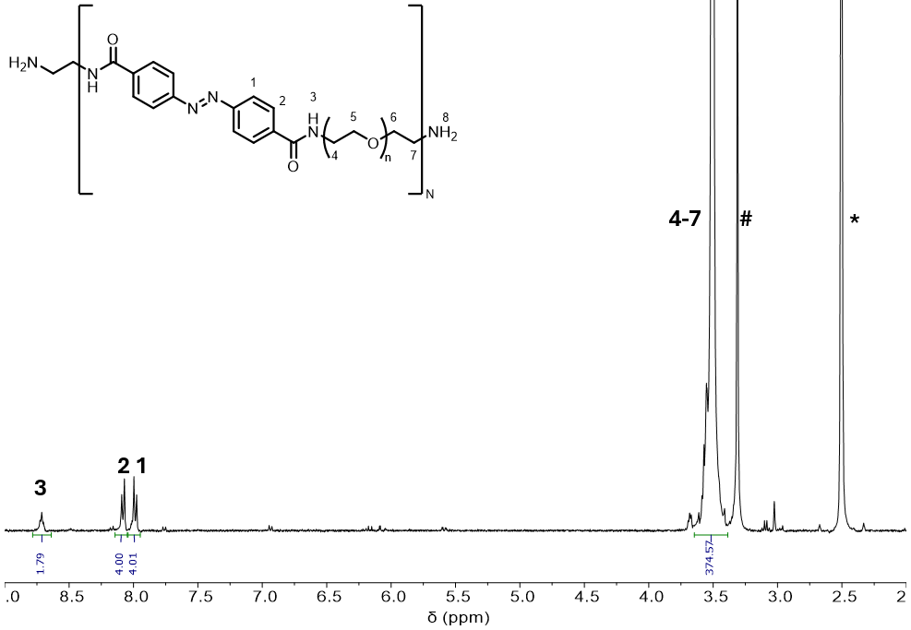
Figure S1. 1H NMR spectrum of the polymer 1 (rxn015). Residual solvent peaks: DMSO-d₆ (*), water (#).
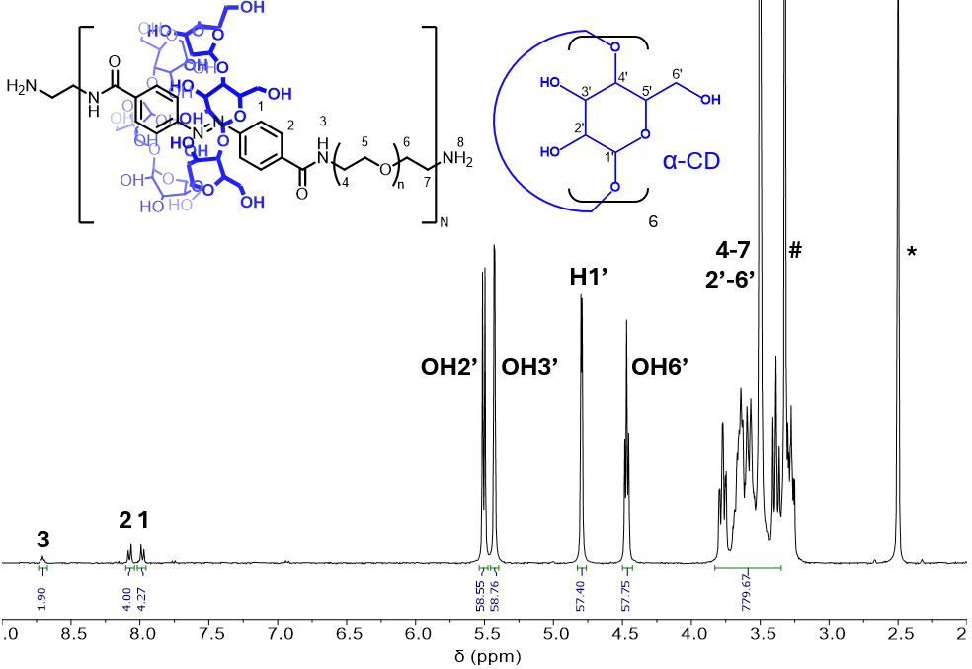
Figure S2. ¹H NMR spectrum of poly(pseudorotaxane) 2. Residual solvent peaks: DMSO-d₆ (*), water (#). Through integration of signals 2, 1, OH2’, OH3’, H1’ and OH6’, an α-CD/azobenzene ratio of 10 is calculated, which is expected due to excess of α-CD.
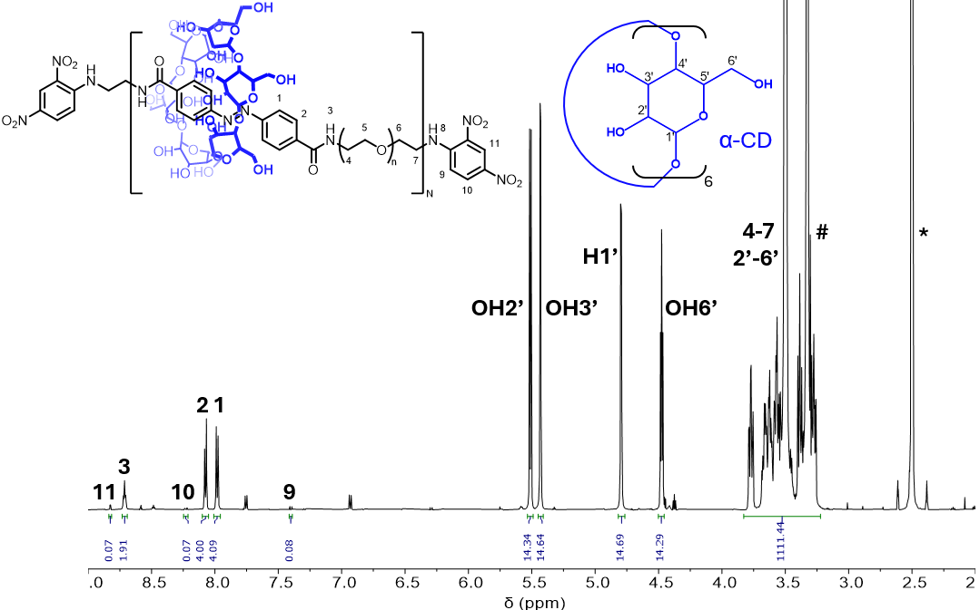p
Figure S3. ¹H NMR spectrum of poly(rotaxane) 3 (rxn014). Residual solvent peaks: DMSO-d₆ (*), water (#). Through integration of signals 2, 1, OH2’, OH3’, H1’ and OH6’, an α-CD/azobenzene ratio of 2.4 is calculated.
Figure S4. NOESY spectrum of poly(rotaxane) 3, recorded in DMSO-d₆.
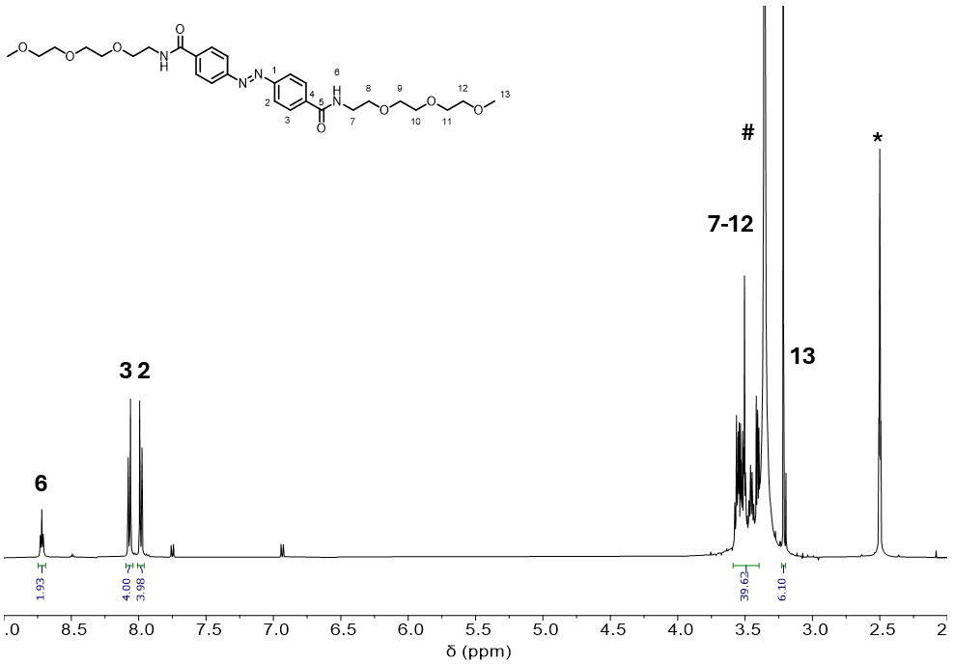
Figure S5.¹H NMR spectrum of model compound 4. Residual solvent peaks: DMSO-d₆ (*), water (#).
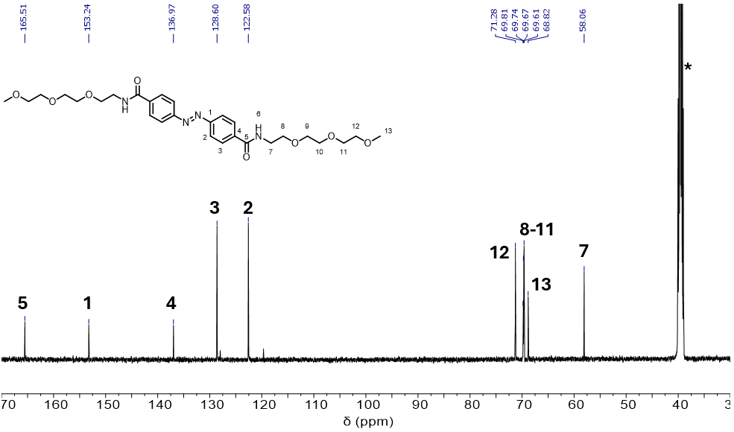
Figure S6. ¹³C NMR spectrum of model compound 4, recorded in DMSO-d₆ (*).
Figure S7. DEPT 135 NMR spectrum of model compound 4, recorded in DMSO-d₆.
Figure S8. ¹H,¹H COSY NMR spectrum of model compound 4, recorded in DMSO-d₆.
Figure S9. ¹H,¹³C HSQC NMR spectrum of mode compound 4, recorded in DMSO-d_{6 .}
Figure S10. ¹H,¹³C HMBC NMR spectrum of mode compound 4, recorded in DMSO-d₆.
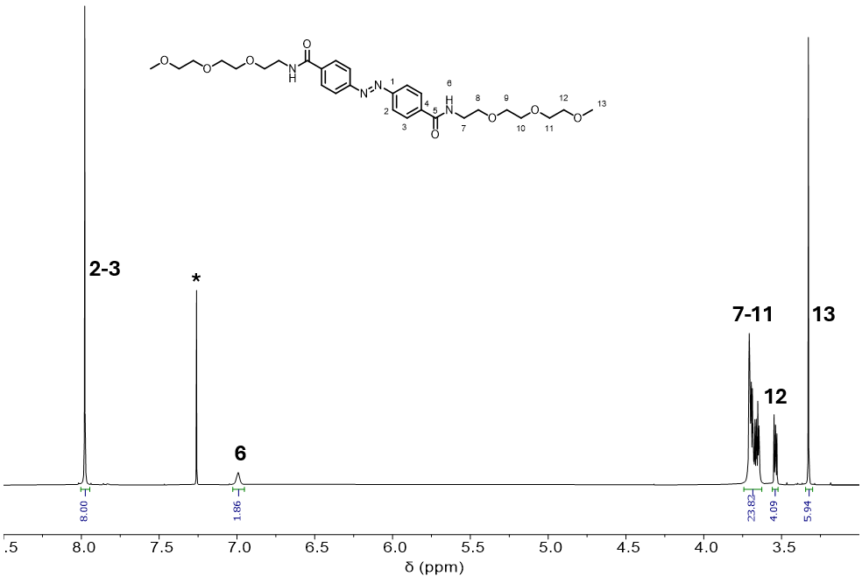
Figure S11. ¹H NMR spectrum of model compound 4, recorded in CDCl₃ (*). Both aromatic signals 2 and 3 collapse into one singlet due to accidental isochrony.^{[6]}
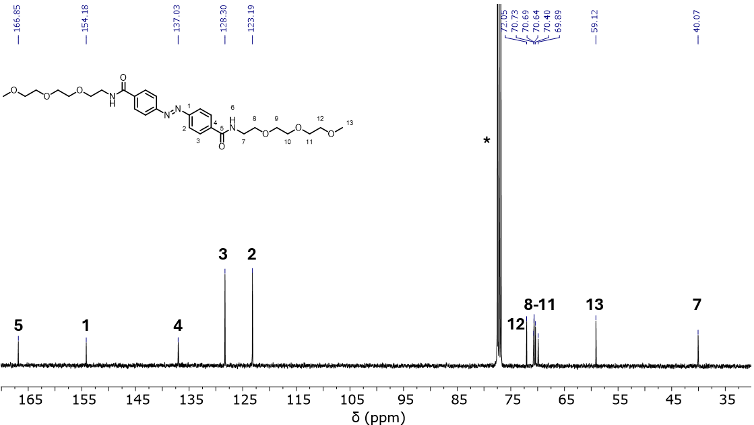
Figure S12. ¹³C NMR spectrum of model compound 4, recorded in CDCl₃ (*).
Figure S13. DEPT 135 NMR spectrum of model compound 4, recorded in CDCl₃.
Figure S14. ¹H,¹H COSY NMR spectrum of model compound 4, recorded in CDCl₃.
Figure S15. ¹H,¹³C HSQC NMR spectrum of mode compound 4, recorded in CDCl_{3 .}
Figure S16. ¹H,¹³C HMBC NMR spectrum of mode compound 4, recorded in CDCl₃.
Figure S17. Stacked ¹H NMR spectra of model compound 4 (top), model compound 4 + 1 eq α-CD (middle) and α-CD (bottom). Residual solvent peaks: MeCN-d₃ (*), H₂O (#). Both aromatic signals collapse into one singlet due to accidental isochrony.^{[6]} Upon addition of 1 eq α-CD, a clear broadening and shift of the azobenzene signal from δ = 8.12 to δ = 8.17 ppm is observed, reflecting the interaction between host and guest.
Figure S18. Stacked ¹H NMR spectra of model compound 4 (top), model compound 4 + 1 eq α-CD (middle) and α-CD (bottom). Residual solvent peaks: DMSO-d₆ (*), H₂O (#). Since DMSO-d₆ is a good solvent for both components (4 and α-CD), the interaction is weakened, resulting in no apparent signal shifts for the mixture of the two.

Light irradiation of an NMR sample:
For the ¹H NMR irradiation experiments, model compound 4 was dissolved in DMSO-d₆ and a 15:85 mixture of MeCN-d₃/D₂O. Irradiation experiments of polymer 1 and polymer 3 were carried out solely in a 15:85 mixture of MeCN-d₃–D₂O. It should be noted that all three species in this solvent mixture show an accidental isochrony of the aromatic azobenzene protons in the E-state. As a result, coupling is not observed and all signals collapse into one singlet. Examples of accidental isochrony have been observed previously in the literature for other compounds.^{[6]} The respective ¹H NMR samples were measured on a 400 MHz NMR spectrometer using n = 64 scans at time 0 min before the irradiation was started. After the measurement, the samples were placed in a cardboard box that allowed irradiation from a distance of ~10 cm to the tubes. For the irradiation, 365 nm and 405 nm LED lamps (M365L2-C1 and M405L4-C1, THORLABS) with a LED driver (LEDD1B, THORLABS) were used at maximum intensity. Every minute, the sample was quickly and vigorously shaken. After intervals of 10 min, 30 min and 60 min, a ¹H NMR spectrum was recorded, and the fraction of the Z isomer was estimated through integration. After 60 min of irradiation with 365 nm light, the samples were irradiated with 405 nm for the back isomerization prior to the measurement of another ¹H NMR spectrum.
Figure S19. ¹H NMR spectra (400 MHz, 298 K) of model compound 4 in a 15:85 mixture of MeCN-d₃/D₂O (* for D₂O signal) and spectral changes after irradiation at 365 nm and 405 nm, respectively. The fraction of E-azobenzene that underwent isomerization was estimated to be 25% after 60 min.
Figure S20. ¹H NMR spectra (400 MHz, 298 K) of polymer 1 in a 15:85 mixture of MeCN-d₃/D₂O (* for D₂O signal) and spectral changes after irradiation at 365 nm and 405 nm, respectively. The fraction of E-azobenzene that underwent isomerization was estimated to be 17% after 60 min.
Figure S21. ¹H NMR spectra (400 MHz, 298 K) of poly(rotaxane) 3 in a 15:85 mixture of MeCN-d₃/D₂O (* for D₂O signal) and spectral changes after irradiation at 365 nm and 405 nm, respectively. The fraction of E-azobenzene that underwent isomerization was estimated to be 29% after 60 min.
Figure S22. ¹H NMR spectra (400 MHz, 298 K) of model compound 4 in DMSO-d₆ (*) and spectral changes after irradiation at 365 nm and 405 nm, respectively. The fraction of E-azobenzene that underwent isomerization was estimated to be 58% after 60 min.

Gel permeation chromatography
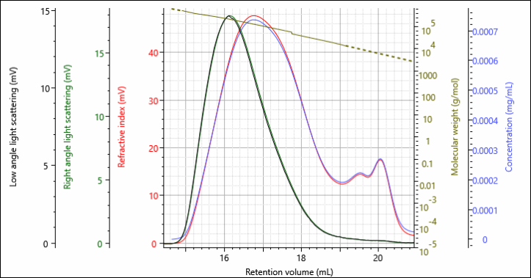
Figure S23. GPC elugram of polymer 1 (rxn010), showing a number-average molecular weight M_{n} = 24.5 kDa, weight-average molecular weight of M_{w} = 116.2 kDa and a dispersity Đ = 4.738.
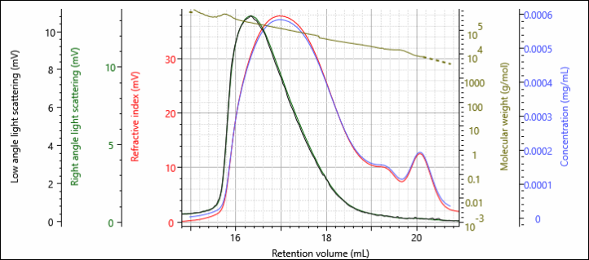
Figure S24. GPC elugram of poly(rotaxane) 3 (rxn014), showing a number-average molecular weight M_{n} = 38.5 kDa, weight-average molecular weight of M_{w} = 107.2 kDa and a dispersity of Đ = 2.78.

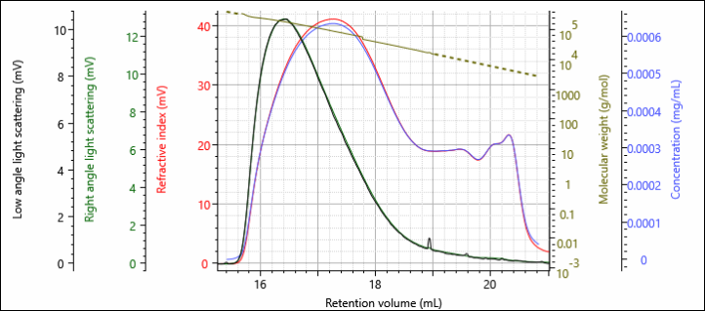
Figure S25. GPC elugram of polymer 1 (rxn015), showing a number-average molecular weight M_{n} = 21.0 kDa, weight-average molecular weight of M_{w} = 82.4 kDa and a dispersity Đ = 3.92.
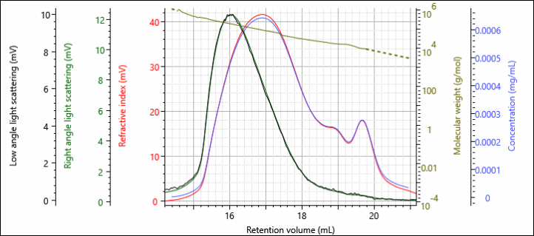
Figure S26. GPC elugram of poly(rotaxane) 3 (rxn018), showing a number-average molecular weight M_{n} = 31.7 kDa, weight-average molecular weight of M_{w} = 92.1 kDa and a dispersity Đ = 2.905.

Table S1. Comparison between molecular weight data of polymer 1 and polyrotaxane 3 coming from different batches.
Polymer (reaction) | M_{n,GPC}^{[a]} [kDa] (DP)^{[b]} | ΔM_{n,GPC} ^{[d]} [kDa] | N_{α-CD,GPC}^{[e]} | N_{α-CD,NMR}^{[f]} | GPC α-CD/azo ratio^{[g]} | ¹H NMR α-CD/azo ratio^{[h]}
1 (rxn010) | 24.5 (7)^{[c]} | - | - | - | - | -
3 (rxn014) | 38.5 (7) | 14.0 | 14 | 17 | 2.0 | 2.4
1 (rxn015) | 21.0 (6)^{[c]} | - | - | - | - | -
3 (rxn018) | 31.7 (6) | 10.7 | 11 | 11 | 1.8 | 1.8
[a] M_{n} obtained by GPC. [b] Degree of polymerizations were obtained from the unthreaded polymer and by using the molecular weight of a single repeating unit $MW_{RU}=3736$ Da. [c] The molecular weights of unthreaded polymers 1 were confirmed by MALDI-ToF measurements (Figure S27-S28). [d] difference in molecular weight of polymers 1 and polyrotaxanes 3. [e] Number of threaded α-CDs obtained by dividing ΔM_{n,GPC} by the MW of α-CD (973 Da). [f] DP × α-CD/azo ratio (obtained by ¹H NMR analysis). [g] N_{α-CD,GPC} / DP. [h] obtained from the ¹H NMR integral ratio of the glucose CH protons to the azobenzene CH protons (normalized by 8H and 6H, respectively).

MALDI-ToF spectrometry
Figure S27. MALDI-ToF spectrum of polymer 1 (rxn010, see Table S1). The number-average molecular weights are in line with the one measured by GPC (M_{n,GPC} = 24.5 kDa). The differences in molecular weight between the three peaks amount to Δm/z = 3672 and 3841 Da, which is in agreement with the molecular weight of the repeating unit MW_{RU} = 3736 Da.
Figure S28. MALDI-ToF spectrum of polymer 1 (rxn015, see Table S1). The number-average molecular weights are in line with the one measured by GPC (M_{n,GPC} = 21.0 kDa). The differences in molecular weight between the three peaks amount to Δm/z = 3672 and 3841 Da, which is in agreement with the molecular weight of the repeating unit MW_{RU} = 3736 Da.

Isothermal titration calorimetry
Titrations of azobenzene model compound were performed in a 15:85 solvent mixture of CH₃CN and H₂O. For the stepwise complex formation, each α-cyclodextrin host (20 mM) was initially titrated into the azobenzene model (8·10⁻⁴ M) through 18 × 2 µL injections. Every titration started with one injection of 0.4 µL followed by all other consecutive injections with 150 s intervals between injections. The first data point was removed from the data set before analysis. To assess whether heats of dilution must be considered during data treatment, reference measurements were performed by titrating solutions of azobenzene model compound into the solvent mixture. Every host−guest titration was carried out in triplicates and binding constants and enthalpies of binding were obtained by curve fitting of the titration data using the one-site binding model. In order to avoid bias or potentially arbitrary offsets caused by manual adjustment of baseline, all raw data (thermograms) of ITC were integrated by NITPIC (v.2.1.0),^{[1]} fitted in Sedphat (v.15.2b),^{[2]} and visualized through GUSSI (v.2.1.4).^{[3]}
Due to its limited solubility in water, 4 was dissolved in a 15:85 CH₃CN-water mixture (1 mM) prior to its titration with a solution of α-CD (20 mM) in the same solvent. The resulting titration curve showed a moderate slope indicative of a rather weak binding constant. Fitting the curve to a one site binding model gave a binding constant of K_{a} = 120 M⁻¹.
Polymer 1 was measured under analogous conditions. An apparent binding affinity of K_{a} = 454 M⁻¹ was calculated a curve fit to a one site binding model, which is on the same order of magnitude as the binding affinity of α-CD to 4.
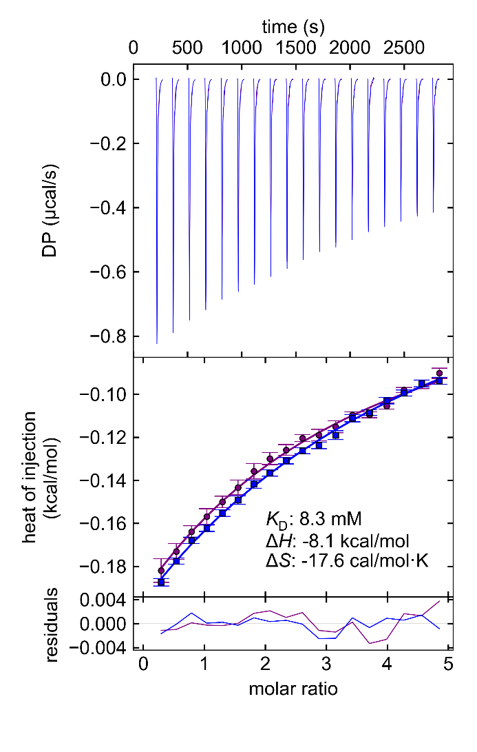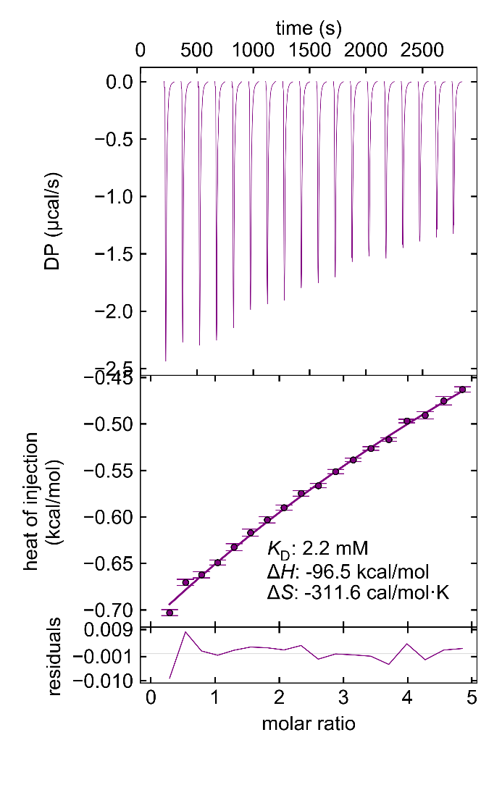
Figure S29. Isothermal titration thermogram (ITC) showing the titration of a solution of 4 (8·10⁻⁴ M) with α-CD (20 mM, left) and the titration of a solution containing 1 (1 mM) with α-CD (25 mM, right). Both titrations were performed in 15:85 CH₃CN/water mixture, using 18 × 2 μL injections with an interval time of 150 s at 298.15 K.

Photoisomerization studies
Due to solubility constraints, the irradiation of compound 4 was performed in DMSO, whereas all other compounds were characterized in a 15:85 CH₃CN-H₂O solvent mixture. For the irradiation experiment a solution of 4 in DMSO (4.92·10⁻⁵ M) was prepared. A volume of 3 mL of this stock solution was transferred into a quartz cuvette (1 cm pathlength) and a spectrum was recorded. The cuvette was then irradiated for increasing time intervals using a Hg lamp with a 365 nm cut-off filter (I₀=5.9·10⁻⁸ hν·min⁻¹). Same procedure was repeated for a solution of polymer 1 in 15:85 CH₃CN-H₂O mixture (0.13 mg/mL) irradiated with a Hg lamp with a 365 nm cut-off filter (I₀=4.4·10⁻⁷ hν·min⁻¹) and for a solution of poly(rotaxane) 3 in 15:85 CH₃CN-H₂O mixture (0.13 mg/mL) irradiated with a Hg lamp with a 365 nm cut-off filter (I₀=4.4·10⁻⁷ hν·min⁻¹). After each irradiation interval a spectrum was recorded (Figure S30A,C,E). A representative wavelength for the decrease of the π-π* band and for the increase of the n-π* band were plotted against the irradiation time to show the time required to reach the photostationary state (Figure S30B,D,F) . This finding suggested that with the surrounding PEG units, the azobenzene unit would retain its capacity to reversibly switch between E and Z configuration.
Figure S30. UV-Vis spectra and kinetic of a solution of 4 in DMSO (4.92·10⁻⁵ M) (A–B), of a solution of polymer 1 in 15:85 CH₃CN-H₂O mixture (0.13mg/mL) (C–D) and of a solution of poly(rotaxane) 3 in 15:85 CH₃CN-H₂O mixture (0.13 mg/mL) (E–F) during an irradiation with an Hg lamp with a 365 nm cut-off filter.
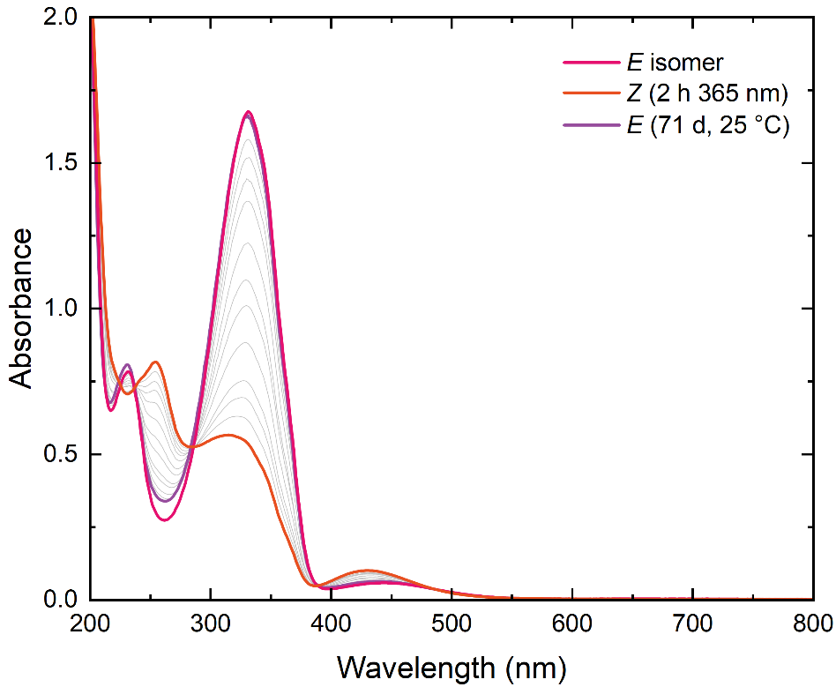
Figure S31 UV-Vis spectra of a solution of polymer 1 in a 15:85 CH₃CN–H₂O mixture (0.24 mg/mL) before irradiation (pink), after irradiation at 365 nm for 2 h to obtain the Z isomer (orange), and after 71 d of thermal back isomerization at 25 °C (purple).
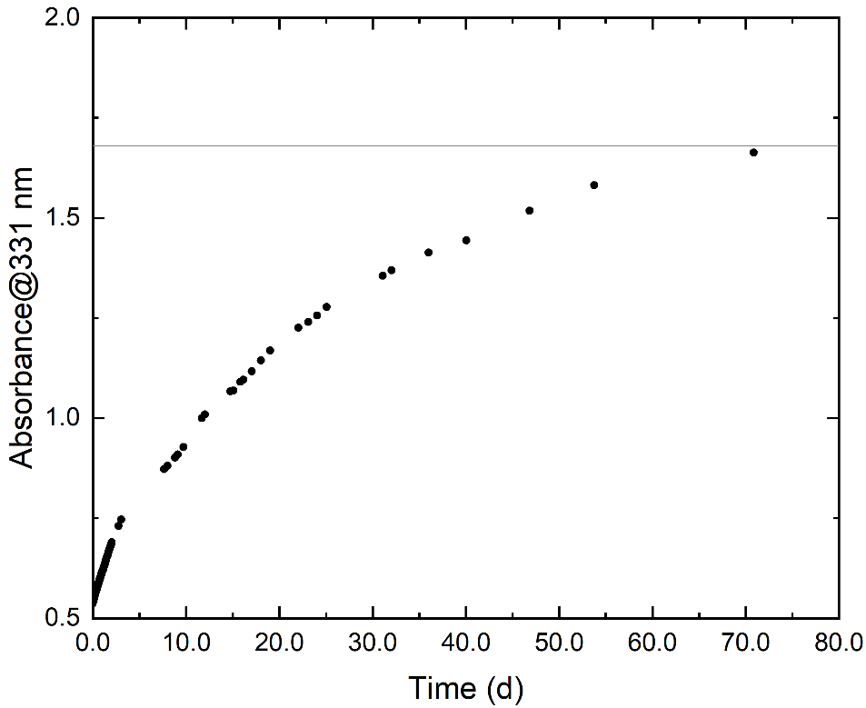
Figure S32. Absorption kinetics at 331 nm over time for the thermal back isomerization of a solution of polymer Z-1 in a 15:85 CH₃CN–H₂O mixture (0.24 mg/mL).

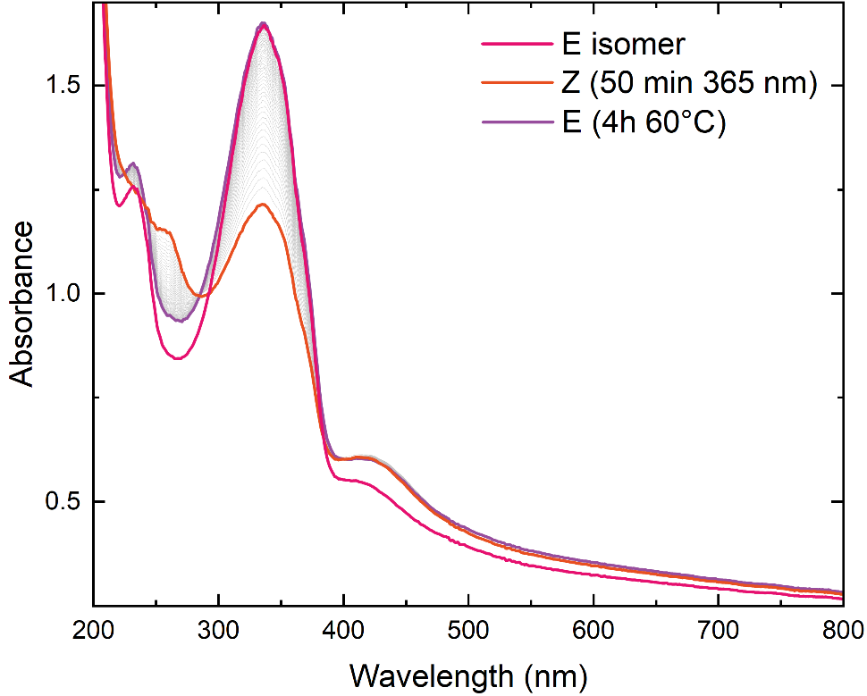
Figure S33. UV–Vis spectra of a thin hydrogel film before irradiation (pink), after irradiation at 365 nm for 50 min to obtain the Z isomer (orange), and after 4 h of thermal back isomerization at 60 °C (purple).

Rheological data
Sample preparation for the irradiation on the rheometer:
After pipetting the sample solution onto the rheometer plate (see Synthesis of a thin gel film on the rheometer in 1.3.4 paragraph) and monitoring its gelation via a time sweep for 1 hour, the sample was directly irradiated in situ on the rheometer. The standard rheometer plate was replaced with a quartz glass plate equipped with a dedicated port for an optical fiber enabling for direct irradiation of the sample from below the plate. The optical fiber was connected to an LED source that allowed us to select the desired wavelength. The light power was measured with an optical power meter prior to the start of the experiment.

A)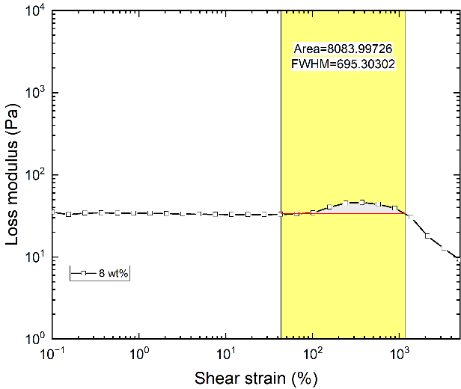 | B)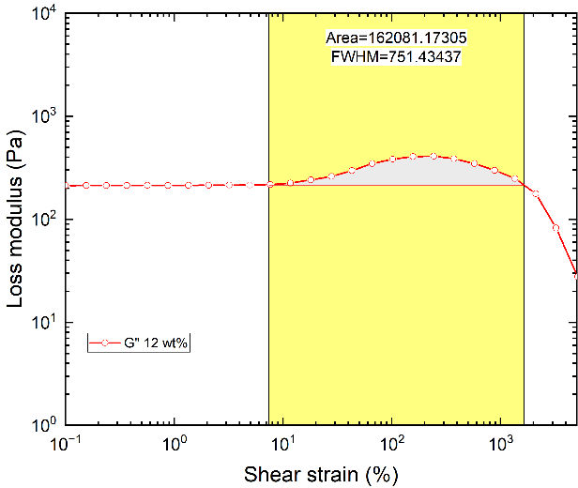
C)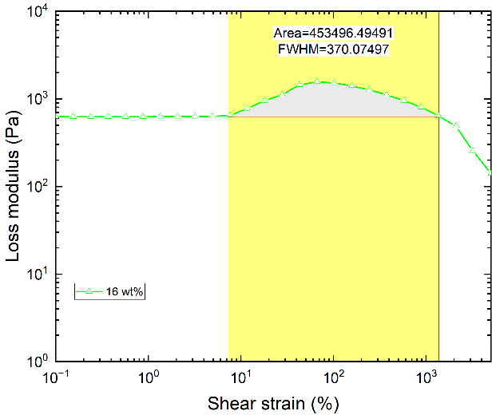 | D)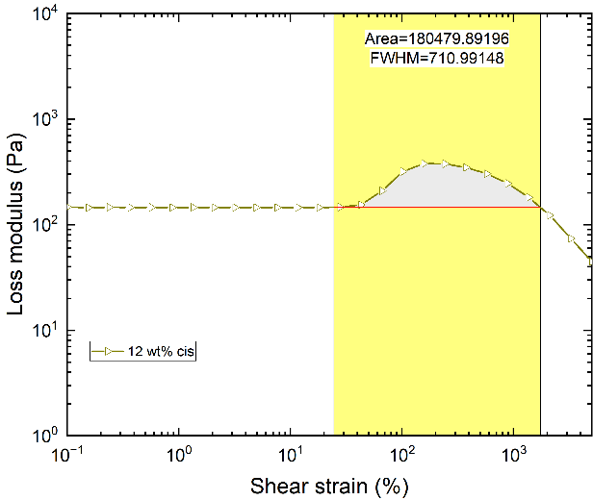
Figure S34. Strain sweeps (γ = 0.1-5000%, ω = 0.5 rad·s⁻¹) showing the overshoot in loss moduli and their respective integrals for SRG prepared from 3 (31.7 kDa) and 3% DVS in 0.1 M NaOH_{(aq)} at A) 8 wt%, B) 12 wt% all-E isomer, C) 16 wt% and D) 12 wt% all-Z isomer.
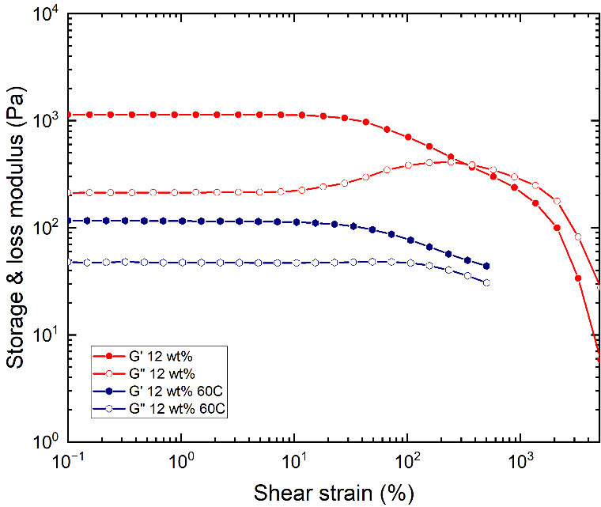
Figure S35. Strain sweeps (γ = 0.1-5000%, ω = 0.5 rad·s⁻¹) of SRG prepared from 3 (31.7 kDa) and 3% DVS in 0.1 M NaOH_{(aq)} (12 wt%) at room temperature (red) and 60 °C (blue).

A)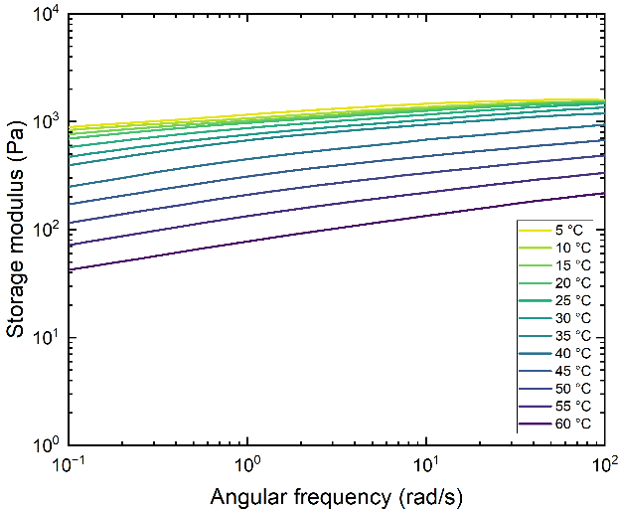 | B)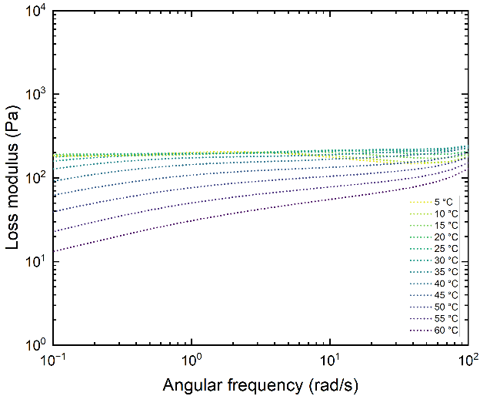
C)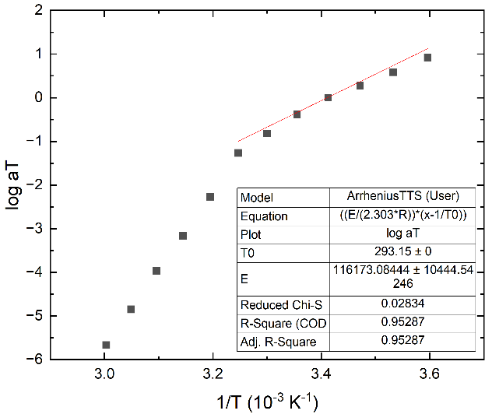 | D)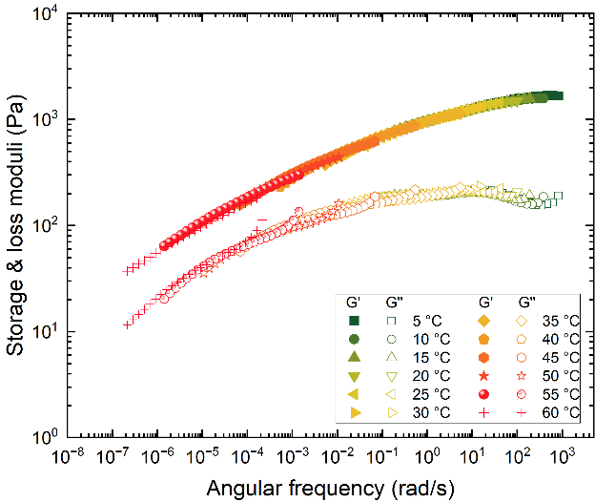
E)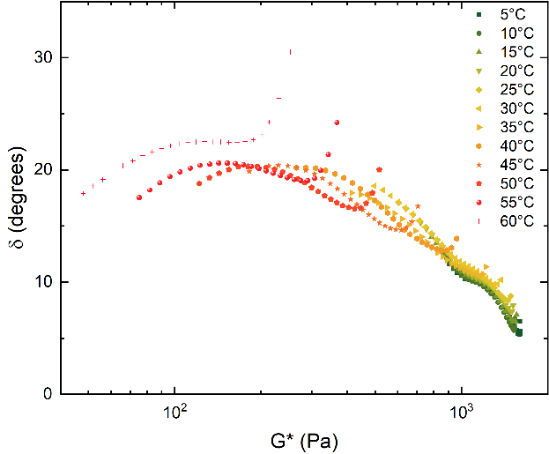 | F)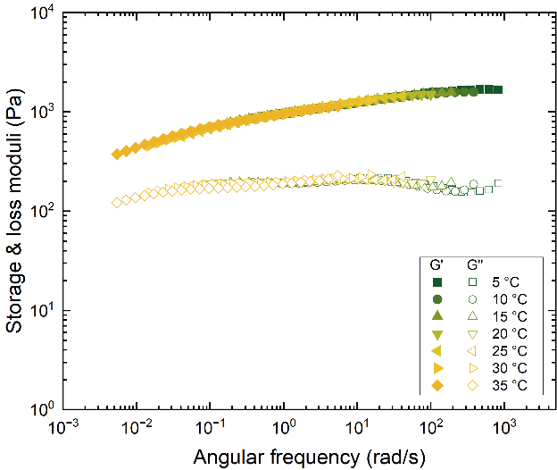
Figure S36. Frequency sweeps (γ = 0.5%, ω = 100-0.1 rad·s⁻¹) showing A) storage moduli, B) loss moduli at different temperatures (5–60°C), and C) the TTS master curve for an SRG made from 3 (31.7 kDa, 12 wt%) and 3% DVS in 0.1 M NaOH_{(aq)} (T_{ref} = 20 °C). D) Arrhenius plot, the activation energy was fitted to E_{a} = 116 kJ/mol up in a temperature range of T = 5–35 °C. E) Van Gurp–Palmen plot, showing that the temperature data only superimposed within 5–35 °C. Above this range (40–60 °C), rheologically more complex behavior sets in, rendering TTS inapplicable. F) Corrected TTS master curve (T_{ref} = 20 °C), showing only the curves recorded in a temperature range of T = 5–35 °C.

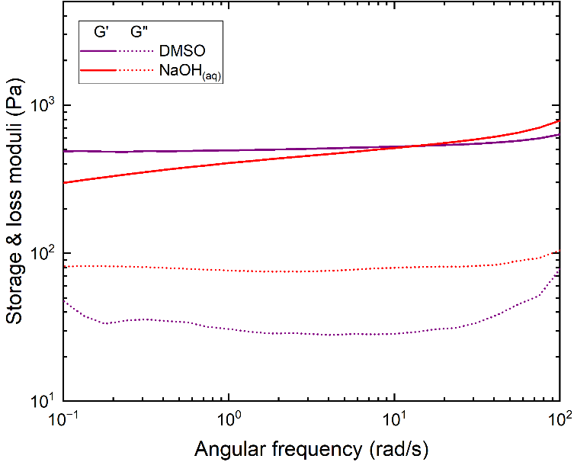
Figure S37. Frequency sweeps (γ = 0.5%, ω = 100-0.1 rad·s⁻¹) of SRG prepared from 3 (38.5 kDa) and 3% DVS in DMSO (purple) and 0.1 M NaOH_{(aq)} (red) at 10 wt%.
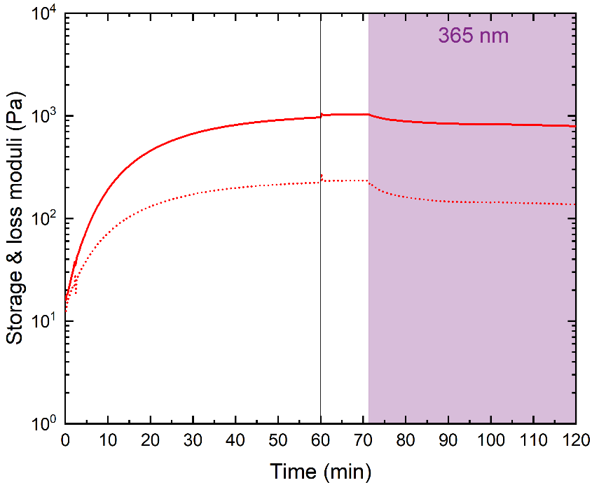
Figure S38. Time sweeps (γ = 0.5%, ω = 10 rad·s⁻¹) of a SRG made from 3 (31.7 kDa) and 3% DVS in 0.1 M NaOH_{(aq)} at 12 wt%. First time sweep: 1 h without irradiation. Second time sweep: 1 h, 10 min conditioning followed by 50 min irradiation at 365 nm light.
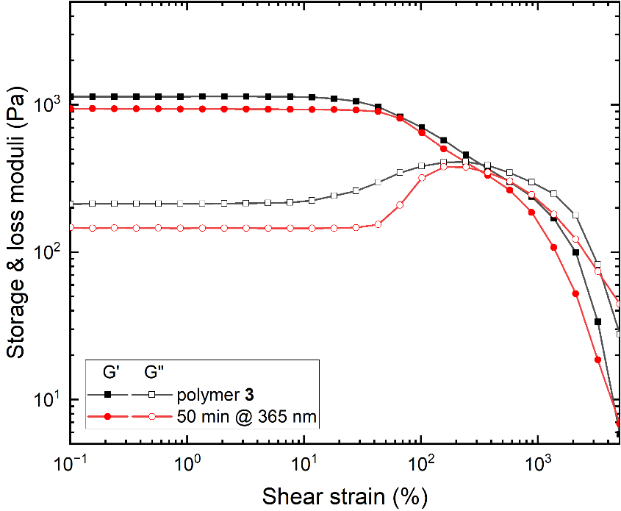
Figure S39. Strain sweeps (γ = 0.1-5000%, ω = 0.5 rad·s⁻¹) of a SRG made from 3 (31.7 kDa) and 3% DVS in 0.1 M NaOH_{(aq)} at 12 wt% before irradiation (black curve) and after 50 minutes irradiation at 365 nm (red curve).

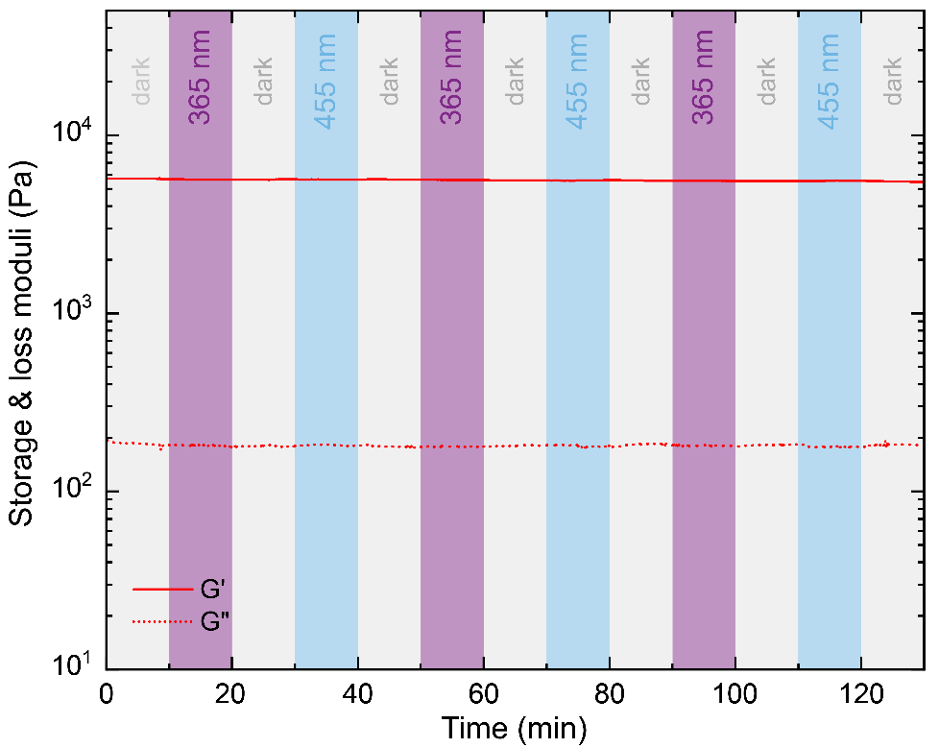
Figure S40. Time sweep (γ = 5%, ω = 10 rad·s⁻¹) of a SRG made from 3 (31.7 kDa) and 3% DVS in DMSO at 12 wt% subjected to 10 min irradiation intervals at λ = 365 nm and λ = 455 nm light.

Swelling experiments
For the swelling experiments gel specimen were prepared according to section 1.3.4 Synthesis of a bulk gel. Following gelation, two hydrogel specimens (dimensions: 1 mm × 1 cm × 1 cm) were fully immersed in excess water in separate Petri dishes at room temperature. One sample was kept in the dark, while the other sample was continuously exposed irradiation at 365 nm. The weights of each sample were monitored at regular time intervals to record relative differences. The degree of equilibrium swelling was calculated according to the following formular:
$$Q=\frac{W_{s}-W_{0}}{W_{0}}$$
with $W_{s}$ the weight of the swollen sample at time t and $W_{0}$ the weight of the as prepared hydrogel.
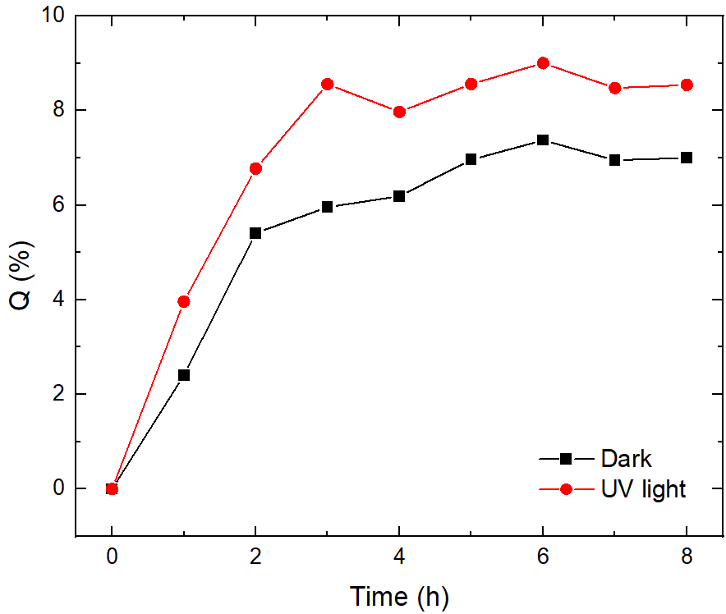
Figure S41. Equilibrium degree of swelling for two bulk hydrogel specimens after being immersed in an excess of water. One hydrogel specimen was kept in the dark (black), while the other was continuously irradiated with 365 nm light (red).

References
[1] M. Montalti, A. Credi, L. Prodi, M. T. Gandolfi, Handbook of Photochemistry, CRC Press, Boca Raton, 2006.
[2] S. Keller, C. Vargas, H. Zhao, G. Piszczek, C. A. Brautigam, P. Schuck, Anal. Chem. 2012, 84, 5066–5073.
[3] T. H. Scheuermann, C. A. Brautigam, Methods 2015, 76, 87–98.
[4] C. A. Brautigam, H. Zhao, C. Vargas, S. Keller, P. Schuck, Nat. Protoc. 2016, 11, 882–894.
[5] C. A. Brautigam, in Methods in Enzymology, Elsevier, 2015, 109–133.
[6] R. Meusinger, Anal. Bioanal. Chem. 2024, 416, 5217–5219.

Macromolecular Engineering Laboratory, Department of Mechanical and Process Engineering, ETH Zurich, Sonneggstrasse 3, 8092, Zurich, Switzerland. E-mail: smommer@ethz.ch.
Dipartimento di Chimica "Giacomo Ciamician", Università di Bologna, Via Selmi 2, Bologna, Italy. c Dipartimento di Chimica, Biologia e Biotecnologia, Università di Perugia, Via Elce di Sotto 8, Perugia, Italy.

