Manuscript Number: ANNSURG-D-23-01822 (First Revision)
SUPPLEMENTAL DATA FILES

SUPPLEMENTARY TABLES

Table S1: Details of free rupture patients

N | Gender, Age(years) | Location Rupture  SVS | Type of Symptoms | Blood pressure systolic/diastolic (mmHg)  amine support | Aneurysm type Diameter (mm) |  | Time to treatment (h) | Type of treatment (main graft) | Need for immediate evacuation | Alive or Death (days/months)
1 | F, 75 | 4 | Thoracic backpain + left haemothorax | 95/60  Amines support needed | TAAA type II  95 mm |  | 4 | T-branch | NO | Alive 23 months
2 | M, 73 | 9 | Abdominal pain | 100/65  Amines support needed | TAAA type II  77 mm |  | 2 | T-branch | NO | Alive at 13 months
3 | M, 62 | 5 | Back pain | 90/40  Amines support needed | TAAA type III  55 mm |  | 2 | PMEG | NO | Alive at 5 months
4 | M, 69 | 5 | Chest/back pain | 124/80  No need for amines | PAU  (type IV TAAA extension)  34 mm |  | 12 | T-branch | NO | Alive at 20 months
5 | M, 77 | 5 | Thoracic pain | 110/65  No amines support needed | TAAA type IV 75 mm |  | 20 | T-branch | NO | Died after 3 days
6 | F, 77 | 4 | Thoracic/chest pain | 120/80  No need for amines | TAAA type IV 140 mm |  | 24 | T-branch | YES | Died after 9 months
7 | M, 67 | 9 | Abdominal pain | 130/80  No amines support needed | TAAA type IV  80 mm |  | 12 | T-branch | NO | Died after 4 months
8 | F, 79 | 6 | Chest pain | 80/50  Amines support needed | TAAA type II  57 mm |  | 10 | T-branch | NO | Died after 5 days
9 | M, 64 | 9 | Abdominal pain | 110/80  No amines support needed | TAAA type II  75 mm |  | 6 | T-branch | NO | Intraoperative death
10 | F, 85 | 9 | Abdominal pain | 120/80  No amines support needed | TAAA Type IV 85 mm |  | 0 | T-branch | NO | Died after 46 days
11 | M, 70 | 5 | Chest Pain | 70/20  Amines support needed | TAAA Type III  70 mm |  | 1 | T-branch | YES | Died after 24 months
12 | M, 78 | 4 | Chest Pain | 105/60  No amines support needed | TAAA type II  95 mm |  | 2 | T-branch | YES | Died after 2 days
13 | M, 74 | 6 | Abdominal Pain | 117/90  No amines support needed | TAAA type IV  100 mm |  | 5 | T-branch | NO | Died after 30 days
14 | M, 85 | 8 | Abdominal and back pain | 100/60  No amines support needed | Endoleak IA prior EVAR  (type IV TAAA extension)  110 mm |  | 2 | T-branch | NO | Alive at 15 months
M=Male; F= Female; SVS = Society for Vascular Surgery; TAAA: Thoraco abdominal aortic aneurysm
Supplementary Table S2: Details of proximal and distal landing zones (SVS zone).
SVS Zone | N | Free Rupture  N (%) | Contained Rupture  N (%) | T-branch  N (%) | PMEG  N (%) | CMD  N (%) | Parallel Graft  N (%) | Adjunctive Procedure  N (patients) and details for landing zone
Location of Proximal Landing Zone
Zone 1 | 2 | 1 (50) | 1 (50) | 2 (100) | 0 | 0 | 0 | 3 (2)  - (1) Previous arch replacement  - (1) C-C-S bypass + TEVAR
Zone 2 | 6 | 2 (33) | 4 (67) | 5 (83) | 0 | 0 | 1 (17) | 12 (6)  - (1) Laser fenestration for LSA + TEVAR  - (4) C-S bypass + TEVAR  - (1) Chimney for LSA + TEVAR
Zone 3 | 32 | 10 (31) | 22 (69) | 31 (97) | 1 (3) | 0 | 0 | 35 (32):  - (32) Proximal TEVAR  - (1) Coil Embolization of rupture site  - (1) Embolization of renal branch
Zone 4 | 26 | 1 (4) | 25 (96) | 20 (77) | 5 (19) | 0 | 1 (96) | 24 (23)  - (23) proximal TEVAR  - (1) candy PLUG in the false lumen
Zone 5 | 34 | 0 | 34 (100) | 30 (88) | 2 (6) | 2 (6) | 0 | -
Location of Distal Landing Zone
Zone 9 | 35 | 5 (14) | 30 (86) | 27 (77) | 7 (20) | 0 | 1 (3) | 4 (3)  - CIA lithotripsy and stenting  - stenting of CIA for dissection  - iliac artery angioplasty
Zone 10 | 46 | 7 (15) | 39 (85) | 42 (92) | 1 (2) | 2 (4) | 1 (2) | 8 (7)  - CFA angioplasty and iliac paving and cracking  - (4) iliac artery angioplasty  - (2) Iliac – femoral bypass conduit
Zone 11 | 19 | 2 (10) | 17 (90) | 19 (100) | 0 | 0 | 0 | 20 (19)  - (15) IBD  - (1) IBD + Contralateral IIA embolization  - (3) cases of iliac rupture and landing zone into external iliac

Data are presented as numbers (percentage).
SVS; Society for Vascular Surgery; CCS: carotid to carotid subclavian bypass; LSA: Left subclavian artery; CS: carotid subclavian bypass. CMD: Custom Made Devices; PMEG: Physician-Modified Endograft; ; TEVAR: Thoracic Endovascular Repair; CIA: Common iliac artery; CFA: Common femoral artery; IIA: Internal Internal Artery; IBD Iliac Branch Devices;

Supplementary Table S3. Details of technical failures

N | Type of Rupture | Location Rupture  SVS | Aneurysm type  Diameter (mm) | Time to treatment (h) | Type of treatment (main graft) | Total operation time (minutes) | Reason for Technical Failure | Solved (Assisted TS)  Details | Clinical Evolution
1 | Contained | 4 | TAAA type II  72 mm | 2 | T-branch | 235 | Persisting perfusion of false lumen ruptured | YES  Coil Embolization of FL | Regular, Alive
2 | Contained | 9 | TAAA type IV  78 mm | 4 | T-branch | 186 | Intraoperative death | NO | Intraoperative death
3 | Contained | 5 | TAAA type IV  70 mm | 24 | T-branch | 456 | Impossible recanalization of left renal artery | NO  Plug embolization of dedicated branch | Death after 13 days for respiratory insufficiency
4 | Free | 4 | TAAA type IV  140 mm | 24 | T-branch | 840 | Impossible recanalization of celiac trunk | NO  Plug embolization of dedicated branch | Embolization of left renal artery + thoracotomy Died after 9 months
5 | Contained | 9 | TAAA type III  63 mm | 23 | T-branch | 555 | Endoleak type III | YES  Endovascular relining | Reinterventions for endoleak and hematoma.  Died after 13 months for pneumonia
6 | Contained | 5 | TAAA type III  103 mm | 5 | T-branch | 480 | Impossible recanalization of right renal artery | NO  Plug embolization of dedicated branch | Renal parenchymal rupture and retroperitoneal hematoma  Died after 3 days
7 | Free | 9 | TAAA type IV  80 mm | 12 | T-branch | 300 | Parenchymal bleeding from right kidney during the procedure | NO  Emergency right nephrectomy | Temporary dialysis  Death after 4 months
8 | Free | 6 | TAAA type II  57 mm | 10 | T-branch | 595 | Endoleak IA during postoperative CTA for instability | NO  Hemorrhagic shock | Pulmonary insufficiency due to hemothorax Died after 5 days
9 | Free | 9 | TAAA type II  75 mm | 6 | T-branch | 1035 | Intraoperative death | NO | Intraoperative death
10 | Free | 4 | TAAA type II  95 mm | 2 | T-branch | 525 | Endoleak type Ib | YES  Solved with extra relining | Died after 2 days for myocardial infarct
11 | Free | 6 | TAAA type IV  100 mm | 5 | T-branch | 415 | Endoleak type III and Ib + major axillary access bleeding | YES  Endovascular relining + axillary artery patching | Respiratory insufficiency due to pneumonia, permanent dialysis, paraplegia  Died after 30 days
SVS = Society for Vascular Surgery; TAAA: Thoraco abdominal aortic aneurysm
Supplementary Table 4: 30-day primary and secondary endpoints

Variable | N (%) or Mean (SD)
Overall cases | 100 (100%)
Primary endpoints
Technical Success | 89 (89)
Intraoperative mortality | 2 (2)
Other technical failures | 9 (9)
30-day+in-hospital mortality | 24 (24)
Clinical secondary endpoints
Need for ICU | 82 (84)
ICU more than 48 hours | 69 (70)
Mean days in ICU | 7 (6)
Patients with MAEs | 33 (34)
Stroke | 2
Myocardial infarction/failure | 9
Pulmonary complications | 19
Acute Kidney injury | 22
Need for temporary dialysis | 8
Need for permanent dialysis | 4
Permanent SCI (paralysis / paraparesis) | 8
Transient SCI (paralysis / paraparesis) | 12
Bowel ischemia | 5
Acute Limb ischemia | 4
Reinterventions | 24 (24)
Clinical Success* | 68 (69)
90-day mortality | 27 (27)

Data are presented as mean (standard deviation-SD) and categorical data as
numbers (percentage). Primary endpoints are calculated on 100 cases. Clinical secondary endpoints percentages are calculated on 98 cases, due to 2 intra-operative mortalities.90-day mortality was calculated on the overall cohort of patients.
ICU: Intensive Care Unit; MAE: Major Adverse Events; SCI: Spinal Cord Ischemia
*: as reported by Reporting Standards³⁰ presence of Technical Success and absence of important disabling permanent clinical sequelae.

Supplementary Table S5. Details of 30 day reinterventions

Reason for Reintervention | N (%) | Free rupture  N (%) | Contained  Rupture  N(%) | Type of rupture and complication | Type of reintervention | Clinical Evolution
Access related | 7 (30) | 2 (29) | 5 (71) | Contained Rupture; Occlusion of right femoral artery | - Surgical Thrombectomy and patching - Solved | Alive
 |  |  |  | Contained Rupture; Dissection of iliac artery | - Iliac artery relining via bare metal stent- Solved | Died  (10 days)
 |  |  |  | Contained Rupture; pseudoaneurysm of right groin | - Surgical repair - Solved | Alive
 |  |  |  | Contained Rupture; Dissection of right iliac artery | - Endovascular relining - Solved | Alive
 |  |  |  | Contained Rupture; Axillary artery bleeding | - Surgical revision - Solved | Alive
 |  |  |  | Free Rupture; Groin access dehiscence | - Multiple surgical revisions - Failure | Died  (46 days)
 |  |  |  | Free Rupture; Multiple Bleeding from axillary access and retroperitoneal bleeding | - Multiple surgical revisions - Solved | Died  (24 months)
TVV relining | 3 (12) | 1 (33) | 2 (67) | Free Rupture; Endoleak type IIIc from CT | - Endovascular Relining with stentgraft - Solved | Alive
 |  |  |  | Contained Rupture; Endoleak type Ic from CT branch | Endovascular Relining with stentgraft - Solved | Died  (5 days)
 |  |  |  | Contained Rupture; Endoleak type Icfrom SMA branch | Endovascular relining with stentgraft - Solved | Alive
Main endograft relining | 4 (17) | 2 (50) | 2 (50) | Contained Rupture; Persistent of flow in false lumen (type III) | TEVAR relining - Solved | Alive
 |  |  |  | Contained Rupture; Type 1B endoleak | Endovascular relining with IIA occlusion - Solved | Alive
 |  |  |  | Free Rupture; Endoleak1A proximal and new hemodynamic shock | Additional relining proximal TEVAR - Unsolved | Died  (5 days)
 |  |  |  | Free Rupture; Type III endoleak between thoracic and T-branch modules | Relining with extra-TEVAR module - Solved | Died  (30 days)
Active bleeding | 4 (17) | 2 (50) | 2 (50) | Contained Rupture; retroperitoneal bleeding | Surgical hemostasis and evacuation- Unsolved | Died  (36 days)
 |  |  |  | Contained Rupture; Bleeding from artero-venous fistula in iliac limb | Endovascular relining with extra iliac limb - Solved | Alive
 |  |  |  | Free Rupture; Left kidney parenchymal bleeding | Embolization of left renal artery - Solved | Died  (9 months)
 |  |  |  | Free Rupture; Right kidney parenchymal bleeding | Hemostasis evacuation and subsequent right kidney nefrectomy - Unsolved | Died  (4 months)
Unplanned hematoma evacuations | 3 (12) | 1 (33) | 2 (67) | Free Rupture; Hemothorax with lung atelectasis | Post-operative thoracoscopic evacuation - Solved | Alive
 |  |  |  | Contained Rupture;  Persistent pleural effusion | Surgical thoracotomy - Solved | Alive
 |  |  |  | Contained Rupture; Retroperitoneal hematoma | Evacuation of retroperitoneal abdominal hematoma- Solved | Died  (13 months)
Bowel ischemia | 2 (8) | 0 | 2 (100) | Contained Rupture;  Mesenteric Ischemia | Resection of ileum - Unsolved | Died  (18 days)
 |  |  |  | Contained Rupture;  Mesenteric Ischemia | Left hemicolectomy - Solved | Died  (56 days)
Graft thrombosis | 1 (4) | 0 | 1 (100) | Contained Rupture; Right iliac limb occlusion | Right femoral access thrombectomy and stentgrafft relining | Died  (27 days)
OVERALL | 24 (100) | 8 (33) | 16 (67)

Supplementary Table S6: Summary of main outcomes with recent Literature

Author  (year)  Journal | Overall  patients  N | Symptomatic  cases  N (%) | Ruptured  Cases  N (%) | Type of repair*  N (%) details | Type of main endograft*  N + details | TechnicSucces*  % | 30-day or  In-hospital mortality*  % | SCI*  % | Pulmonary  complication*  % | New onset  dialysis*  % | 30-day redo*  % | 1-year survival*  %
Spath  (2023) | 100 | 100  (100) | 100  (100) | 100  (100)  Endovascular | 88 t-branch  8 PMEG  2 PG  2 CMD | 89 | 24 | 20 | 19 | 12 | 24 | 65
Dias-Neto  (2023)  Ann Surg²⁵ | 2603 | 268  (16) | 148  (5.6) | 148  (100)  Endovascular | 133 t-branch  15 PMEG | 95 | 20 | 17 | 14 | 22** | - | 62
Gallitto²³  (2022)  EJCTS | 65 | 35  (54) | 27  (42) | 27 (100)  Endovascular | 27 t-branch | 93 | 22 | 30 | 33 | 15 | 33 | 56
Eleshra²⁴  (2022)  JVS | 100 | 70  (70) | 21  (21) | 100 (100)  Endovascular | 21 t-branch | 95 | 24 | 38 | 5 | 19 | - | 87
Kolbel²¹  (2021)  JVS | 542 | 213  (37) | 46  (9) | 46 (100)  Endovascular | 46 t-branch | 97 | 30 | - | - | - | - | -
Hongku²⁶  (2018)  EJVES | 12 | 12  (100) | 12  (100) | 12 (100)  Endovascular | 11 t-branch  1 CMD | 64 | 27 | 27 | - | 33 | 8 | 75
Gombert³⁵  (2022)  EJVES | 255 | 51  (20) | 51  (20) | 51 (100)  Open Surgical Repair | - | - | 35 | 12 | 45 | 35 | - | 55

* cases are calculated on ruptured patients; PMEG: Physician Modified Endograft; CMD; Custom Made Devices; PG: Parallel Graft.
** not reported if permanent/temporary dyalisis

SUPPLEMENTARY FIGURE
Supplementary Figure S1
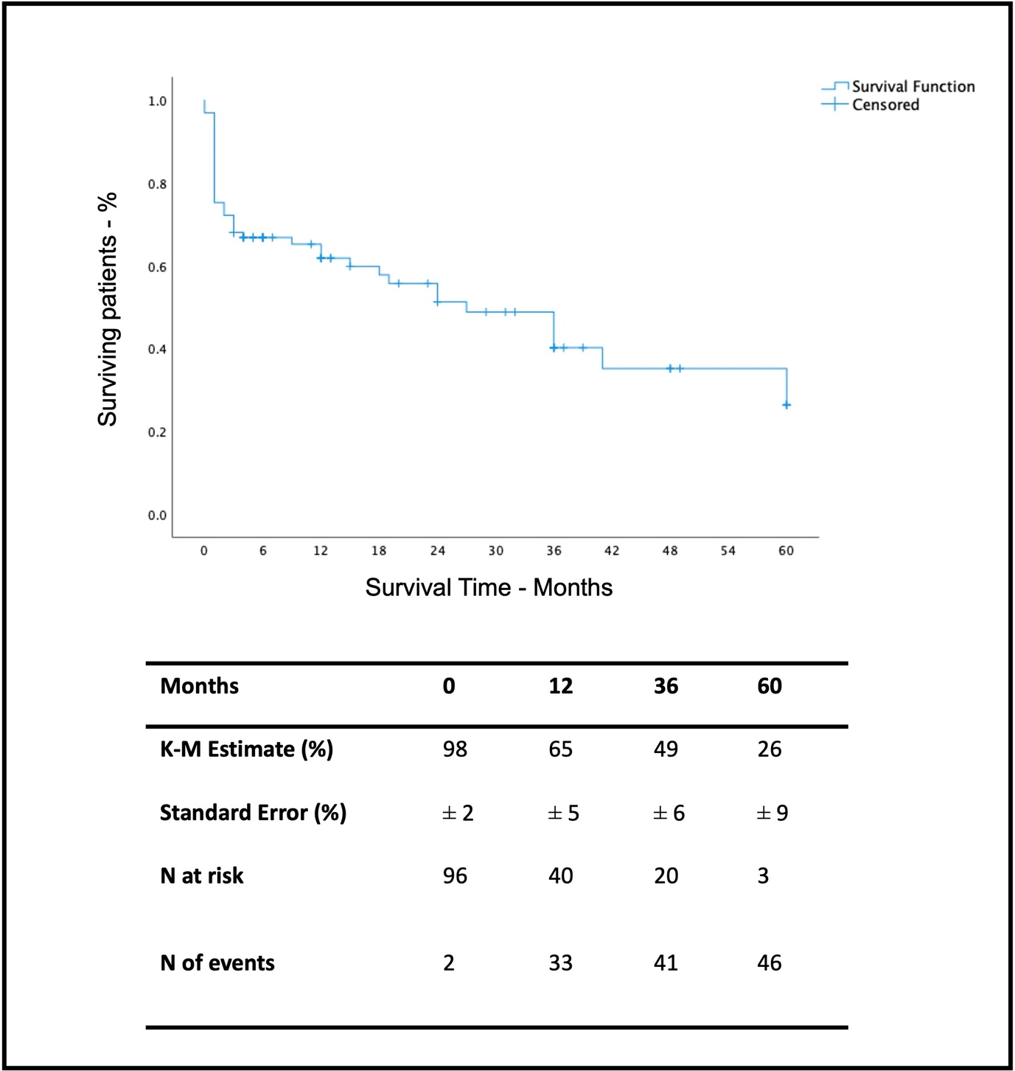

Supplementary Figure S1: Kaplan Meier’s Survival Analysis. Overall survival through follow-up time. In the table are reported estimates and standard errors (percentages-%) and numbers (N) of patients at risk and events at 1, 12, 36 and 60 months follow-up. The two intra-operative mortalities were excluded from analysis.

Supplementary Figure S2

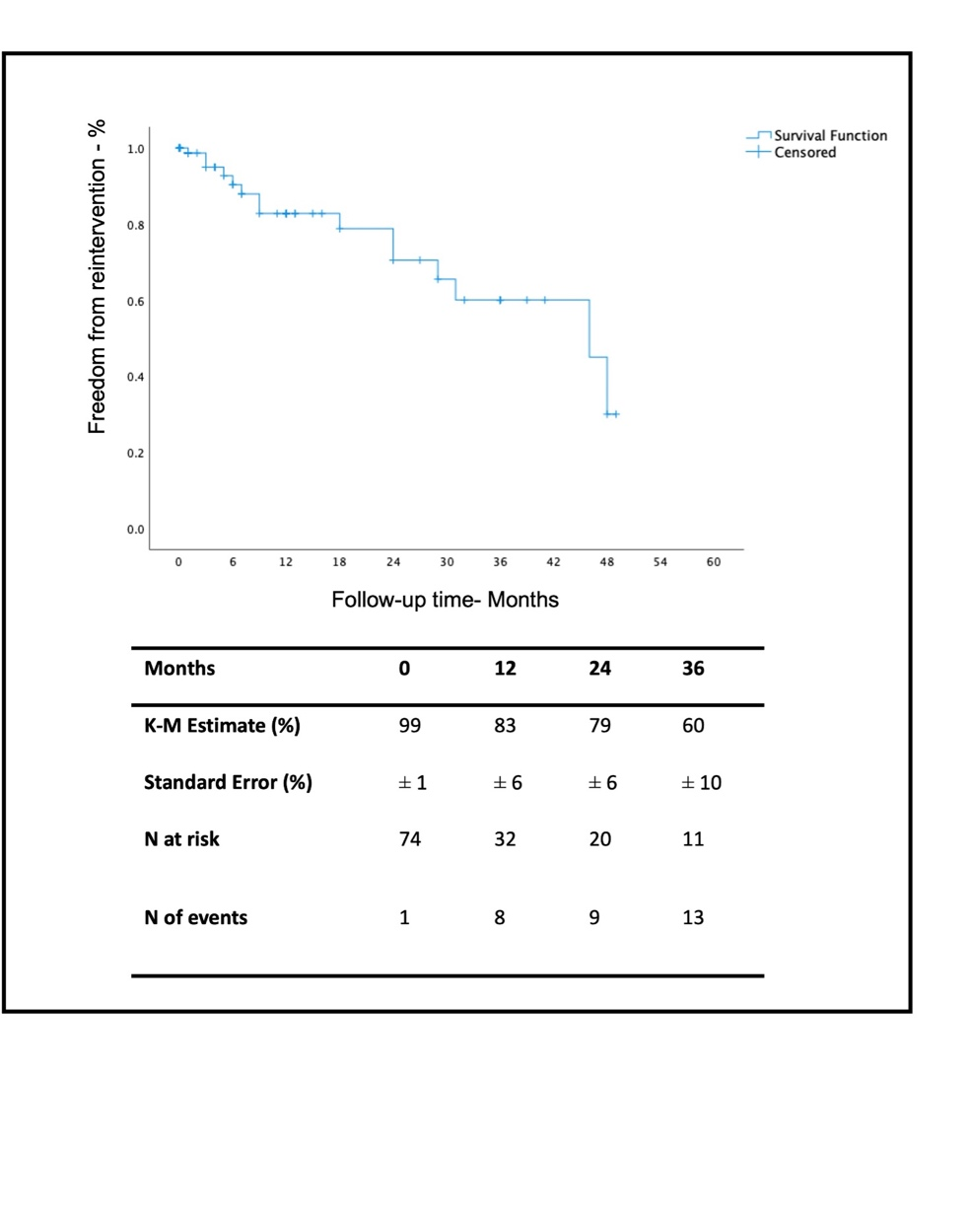
SUPPLEMENTARY FIGURE LEGENDS

Supplementary Figure S2: Kaplan Meier’s Freedom from reinterventions Analysis. Overall freedom from reintervention through follow-up time. In the table are reported estimates and standard errors (percentages-%) and numbers (N) of patients at risk and events at 0, 12, 36 and 60 months follow-up.

