Supplementary Table 1. The comparison of characteristics between the training cohort and validation cohort.
Characteristics | Training vs. Internal validation  P-value | Training vs. External validation  P-value
Age, years | 0.806 | 0.483
Sex (female, male) | 0.604 | 0.280
Hypertension (yes, no) | 0.674 | 0.673
Diabetes (yes, no) | 0.971 | 0.790
Cirrhosis (yes, no) | 0.980 | 0.829
Hepatitis (none, HBV, HCV) | 0.997 | 0.985
Antiviral treatment (yes, no) | 0.539 | 0.997
AFP, ng/mL (≤ 200, > 200) | 0.663 | 0.809
ALT, U/mL (≤ 50, > 50) | 0.815 | 0.796
AST, U/mL (≤ 40, > 40) | 0.421 | 0.509
ALB, g/L (≤ 36, > 36) | 0.114 | 0.130
TB, µmol/L (≤17.1, > 17.1) | 0.766 | 1.000
PT, seconds (≤13, > 13) | 0.838 | 0.792
ALBI grade (I, II) | 0.607 | 0.366
Child-Pugh (A, B) | 0.075 | 0.468
BCLC B subclassification  (B1, B2, B3, B4) | 0.273 | 0.468
Tumor number | 0.724 | 0.888
Tumor size, cm | 0.857 | 0.584
Tumor location  (right lobe, left lobe,  segment I, segment IV) | 0.888 | 0.339
Arterial hyperenhancement  [homogeneous, heterogeneous,  none (hypovascular)] | 0.969 | 0.869
Response to TACE  (CR, PR, SD, PD) | 0.901 | 0.811
Rounds of TACE | 0.860 | 0.808
Combined with other treatment (supportive care, sorafenib or PD1, ablation) | 0.538 | 0.461
HBV/HCV = hepatitis B/C virus, AFP = alpha-fetoprotein, ALT = alanine aminotransferase, AST = aspartate aminotransferase, ALB = albumin, TB = total bilirubin, PT = prothrombin time, ALBI = albumin-bilirubin, OR= objective response, NR= nonresponsive, CR = complete response, PR = partial response, SD = stable disease, PD = progressive disease, BCLC = Barcelona Clinic Liver Cancer System.

Supplementary Table 2. Radiomic feature analysis in the tumoral and peritumoral (10mm) signature with the LASSO method.
Label name | ROIs | CT phase | Details of important radiomic features | Coefficient
THA1 | Tumor | Hepatic arterial | Wavelet-HHL GSLZM Large Area Low Gray Level Emphasis | 4.1×10⁻³
THA2 | Tumor | Hepatic arterial | Wavelet-LHL GLSZM Zone Entropy | 3.5×10⁻³
THA3 | Tumor | Hepatic arterial | Wavelet-HHH GLSZM Low Gray Level Zone Emphasis | 3.7×10⁻³
THA4 | Tumor | Hepatic arterial | Wavelet-HHL GLSZM Gray Level Non-Uniformity Normalized | 2.3×10⁻³
THA5 | Tumor | Hepatic arterial | Original GLDM Dependence Variance | 1.4×10⁻³
THA6 | Tumor | Hepatic arterial | Shape Flatness | 1.1×10⁻³
THA7 | Tumor | Hepatic arterial | Wavelet-LLL GLCM MCC | 9.4×10⁻⁴
THA8 | Tumor | Hepatic arterial | Wavelet-HHL First order Median | 7.3×10⁻⁴
THA9 | Tumor | Hepatic arterial | Wavelet-HLH GLSZM Gray Level Non-Uniformity | 6.9×10⁻³
THA10 | Tumor | Hepatic arterial | Wavelet-LLL GLCM lmc2 | 8.3×10⁻⁴
THA11 | Tumor | Hepatic arterial | Wavelet-LLH GLRLM Long Run Low Gray Level Emphasis | 3.1×10⁻³
THA12 | Tumor | Hepatic arterial | Original NGTDM Busyness | 7.6×10⁻³
THA13 | Tumor | Hepatic arterial | Wavelet-HHL GLCM MCC | 2.3×10⁻⁴
THA14 | Tumor | Hepatic arterial | Wavelet-LHH NGTDM First Order Median | 1.3×10⁻³
TNC1 | Tumor | Non-contrast | Wavelet-HHL GLCM lmc1 | 4.5×10⁻³
TNC2 | Tumor | Non-contrast | Wavelet-HHL GLSZM Gray Level Non-Uniformity Normalized | 3.2×10⁻³
TNC3 | Tumor | Non-contrast | Original GLSZM Large Area Low Gray Level Emphasis | 1.8×10⁻³
PHA1 | Peritumor | Hepatic arterial | Original GLSZM Small Area Emphasis | 5.7×10⁻³
LASSO = least absolute shrinkage and selection operator; ROIs = regions of interest.

Supplementary Table 3. Univariate and multivariate analysis of treatment response in the training cohort.
Variables | No. of OR | Univariate analysis |  |  | Multivariate analysis
 |  |  | P-value | RR [95%CI] |  | P-value
Age, years (≤ 60, > 60) | 110/74 (54.5/48.4) |  | 0.255
Gender (female, male) | 19/165 (51.4/51.9) |  | 0.951
Hypertension (no, yes) | 115/69 (51.8/52.0) |  | 0.980
Diabetes (no, yes) | 119/65 (51.6/52.3) |  | 0.946
Cirrhosis (no, yes) | 105/79 (55.6/47.6) |  | 0.134
Hepatitis (no, yes) | 26/158 (41.9/53.9) |  | 0.086
Antiviral treatment (no, yes) | 79/95 (42.7/56.0) |  | 0.048 | 0.57 [0.29-1.15] |  | 0.118
AFP, ng/mL (≤ 200, > 200) | 128/40 (55.0/43.0) |  | < 0.001 | 2.48 [1.34-4.59] |  | 0.004
ALT, U/Ml (≤ 50, > 50) | 138/46 (51.5/52.9) |  | 0.823
AST, U/Ml (≤ 40, > 40) | 129/55 (51.8/51.9) |  | 0.990
ALB, g/L (≤ 36, > 36) | 29/155 (46.0/53.1) |  | 0.310
TB, µmol/L (≤ 17.1, > 17.1) | 111/73 (48.3/58.4) |  | 0.068
PT, seconds (≤ 13, > 13) | 65/119 (52.8/51.3) |  | 0.781
ALBI grade (I, II) | 104/80 (51.5/52.3) |  | 0.881
Child-Pugh (A, B) | 180/4 (52.5/33.3) |  | 0.192
BCLC B subclassification |  |  | 0.003 |  |  | 0.010
B1 | 146 (57.5) |  |  | Reference
B2 | 35 (38.9) |  |  | 3.68 [1.54-8.82] |  | 0.003
B3/4 | 3 (27.3) |  |  | 4.38 [0.89-10.8] |  | 0.070
Targeted tumor lesions
Tumor size, cm (≤ 5, > 5) | 125/59 (58.1/42.1) |  | 0.003 | 0.60 [0.25-1.45] |  | 0.254
Tumor location (I/IV, remaining) | 12/172 (22.6/57.0) |  | < 0.001 | 0.38 [0.15-0.95] |  | 0.039
Arterial hyperenhancement |  |  | < 0.001 |  |  | 0.050
Homogeneous | 33 (68.8) |  |  | Reference
Heterogeneous | 142 (54.2) |  |  | 0.94 [0.27-3.29] |  | 0.921
None (hypovascular) | 9 (20.0) |  |  | 2.34 [1.09-5.27] |  | 0.049
Non-targeted tumor lesions
Tumor number (≤ 2, > 2) | 89/95 (44.1/62.1) |  | 0.001 | 1.10 [0.49-2.46] |  | 0.823
Location (≤ 4, > 4 any segments) | 155/30 (52.7/47.6) |  | 0.330
Treatment and follow-up
From TACE to follow-up CT, days | NA |  | 0.524
Radiomics signature
TPS (10mm) (low, high) | NA |  | < 0.001 | 0.02 [0.01-0.04] |  | < 0.001
OR = objective response, AFP = alpha-fetoprotein, ALT = alanine aminotransferase, AST = aspartate aminotransferase, ALB = albumin, TB = total bilirubin, PT = prothrombin time, ALBI = albumin-bilirubin, BCLC = Barcelona Clinic Liver Cancer, TPS (10mm) = Tumoral and peritumoral (10mm) signature.

Supplementary Table 4. Univariate and multivariate analysis of overall survival in the external validation cohort.
 | Univariate analysis |  |  | Multivariate analysis
Variables | HR | P |  | HR | P
Age, years (≤ 60, > 60) | 0.57 [0.38-0.86] | 0.008 |  | 0.64 [0.40-1.03] | 0.063
Gender (female, male) | 0.78 [0.34-1.79] | 0.557
Hypertension (no, yes) | 0.84 [0.56-1.26] | 0.391
Diabetes (no, yes) | 1.17 [0.77-1.78] | 0.457
Cirrhosis (no, yes) | 1.71 [1.11-2.61] | 0.014 |  | 1.58 [0.98-2.54] | 0.061
Hepatitis (no, yes) | 0.74 [0.45-1.22] | 0.237
Antiviral treatment (no, yes) | 0.74 [0.50-1.10] | 0.147
AFP, ng/mL (≤ 200, > 200) | 1.87 [1.25-2.80] | 0.002 |  | 1.76 [1.12-2.77] | 0.014
ALT, U/mL (≤ 50, > 50) | 1.42 [0.91-2.22] | 0.125
AST, U/mL (≤ 40, > 40) | 1.24 [0.82-1.88] | 0.315
ALB, g/L (≤ 36, > 36) | 0.79 [0.50-1.25] | 0.319
TB, µmol/L (≤ 17.1, > 17.1) | 0.95 [0.62-1.44] | 0.806
PT, seconds (≤ 13, > 13) | 1.25 [0.82-1.91] | 0.298
ALBI grade (I, II) | 1.16 [0.79-1.73] | 0.467
Child-Pugh (A, B) | 1.31 [0.53-3.23] | 0.556
BCLC B subclassification |  | <0.001 |  |  | <0.001
B1 | Reference |  |  | Reference
B2 | 1.94 [1.24-3.03] | 0.003 |  | 1.97 [1.23-3.16] | 0.005
B3/4 | 5.15 [2.02-13.1] | 0.001 |  | 5.10 [1.92-13.5] | 0.011
Targeted tumor lesions
Tumor size, cm (≤ 5, > 5) | 1.18 [0.79-1.76] | 0.419
Tumor location (I/IV, remaining) | 0.80 [0.41-1.53] | 0.492
Arterial hyperenhancement |  | < 0.001 |  |  | 0.029
Homogeneous | Reference |  |  | Reference
Heterogeneous | 2.20 [1.09-4.42] | 0.027 |  | 1.73 [0.85-3.52] | 0.131
None (hypovascular) | 7.20 [2.99-17.4] | 0.001 |  | 1.76 [1.12-2.77] | 0.014
Non-targeted tumor lesions
Non-targeted tumor number  (≤ 2, > 2) | 0.73 [0.49-1.10] | 0.127
Non-targeted tumors location  (≤ 4, > 4 any segments) | 0.84 [0.67-1.05] | 0.131
From TACE to follow-up CT, days (≤ 45, > 45) | 1.19 [0.79-1.78] | 0.410
Predicted response to TACE (objective, no response) | 2.54 [1.69-3.81] | < 0.001 |  | 2.43 [1.60-3.69] | < 0.001
Rounds of TACE |  | 0.437
1 | Reference
2 | 0.84 [0.54-1.31] | 0.443
≥ 3 | 0.68 [0.36-1.28] | 0.232
Other treatment |  | 0.021 |  |  | 0.047
No | Reference |  |  | Reference
Yes (after failure of TACE) | 1.62 [1.12-2.34] | 0.010 |  | 1.36 [1.08-1.47] | 0.033
Yes (other) | 0.84 [0.57-1.24] | 0.378 |  | 0.78 [0.42-1.45] | 0.432
AFP = alpha-fetoprotein, ALB = albumin, TB = total bilirubin, ALT = alanine aminotransferase, AST = aminotransferase, PT = prothrombin time, ALBI = albumin-bilirubin, BCLC = Barcelona Clinic Liver Cancer, HR = hazard ratio.
Supplementary Figure 1. Identification of the significant radiomic features associated with treatment response using the least absolute shrinkage and selection operator (LASSO) method. (A) Identification of the optimal penalization coefficient lambda in the lasso model with 10-fold cross-validation and optimal lambda resulted in the tumoral and peritumoral (10 mm) signature. Label names of the tumoral radiomic features (TPA1-14 and TNC1-3) and peritumoral radiomic feature (PHA1). (B) The radiomic features selected using the LASSO logistic regression model.

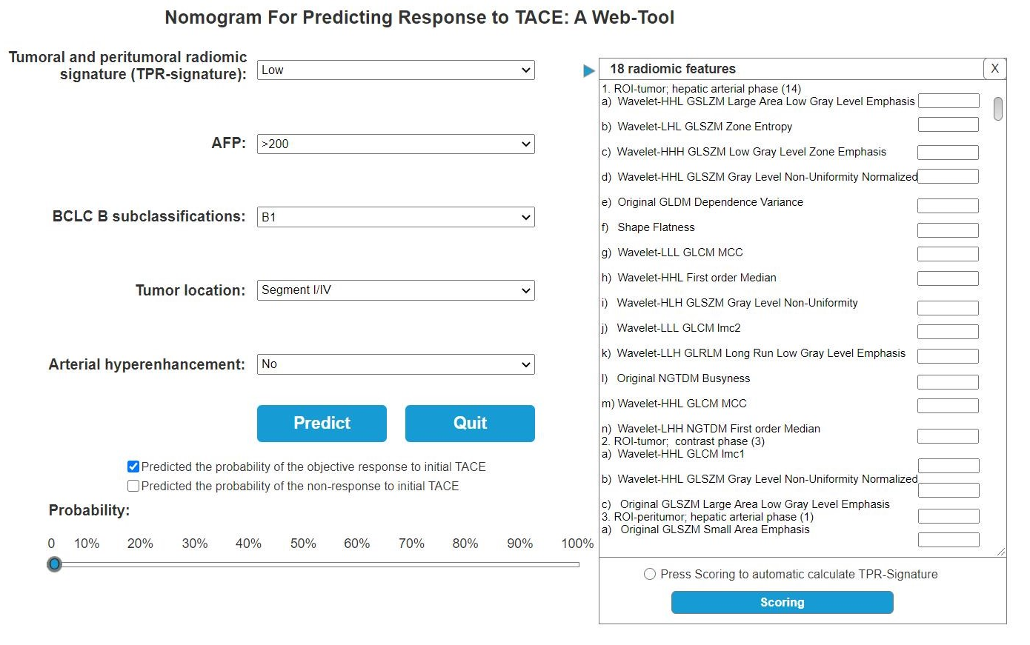
Supplementary Figure 2. A web-tool based on the clinical-radiomic nomogram.

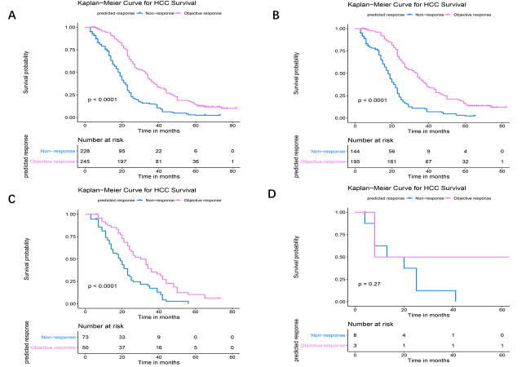
Supplementary Figure 3. Kaplan-Meier curves for OS within each BCLC B subclassification in the primary cohort. (A) Overall patients; (B) HCC patients with BCLC B1 stage; (C) HCC patients with BCLC B2 stage; and (D) HCC patients with BCLC B3/4 stage.

Supplementary Text 1
Clarifications of CT imaging techniques
All CT imaging examinations were performed with a 64/128-MDCT (Product type: Philips Brillance I/II CT scanner). The scanning parameters were as follows: 1) scan thickness of at least 5 mm, a layer spacing of at least 5 mm; 2) a pitch of 0.993; 3) a tube voltage of 120 kV with avertical dynamic dose used to modulate the electric current of the matching tube; 4) the width of the collimator was 128 × 0.625 mm. The process of CT scanning is summarized as follows: 1) The patient was placed, in a conventional supine position, to undergo a plain scan; 2) An enhanced scan was performed; 3) Non-ionic contrast agent (80 ml of Iohexol, 350 mg/mL) and 20 ml of normal saline were injected into the elbow vein with a double-cylinder high-pressure syringe at a speed of 3.0 ml/s. 4) The arterial phase of the CT-scan was performed 25-30 s after the start of the injection. 5) The portal venous phase of the CT-scan was performed 60-70 s after the start of the injection; 6) The delayed phase of the CT-scan was performed 160-180 s after the start of the injection.
Pre-judged criteria/scoring
All CT images were recorded on picture archiving and communication system (PACS) work-stations. Two radiologists independently scored the targeted lesions according to 10 primary imaging features (pre-judged criteria), which are summarized in the following table.
The 10 primary imaging features.
Imaging features | 0 | 1
Lobes with tumor involvement | Lobe involved | More than 1 lobe involved
Number of lesions detected | One lesion | More than one lesion
Mean tumor length | Max. length ≤ 3 cm | Max. length > 3 cm
Maximum tumor length | Max. length ≤ 5 cm | Max. length > 5 cm
Intra-tumoral vascularity | Hypo-/mild arterial  enhancement | Hyper-arterial enhancement
Intra-tumoral hemorrhage | Absent | Present
Intra-tumoral necrosis | Absent | Present
Peritumoral arterial enhancement | Absent | Present
Tumor margin | Smooth margin | Non-smooth margin
Peritumoral star lesion | absent | present

Supplementary Text 2
Radiomic data from tumoral and peritumoral tissue (analyzed HCC part and the expanded rim part) at two phases.
The radiomic data were extracted from four ROIs, including tumoral ROI (analyzed HCC part) at the hepatic arterial phase, tumoral ROI (analyzed HCC part) at the non-contrast phase, peritumoral ROI (expanded rim part) at the hepatic arterial phase, and peritumoral ROI (expanded rim part) at the non-contrast phase. Each ROIs included 851 radiomic features, which are listed in the following page. Finally, there were 3,404 radiomic features.
Details of the 851 radiomic features
The 851 radiomic features were automatically extracted from the ROIs using the 3D slicer software with an extended plug-in called “PyRadmoics package”. The “PyRadmoics package” integrated parts of function from PyRadmoics (Versions 2.2.0), Numpy (Versions 1.13.1), SimpleITK (Versions 1.1.0), PyWavelet (Versions 1.0.0), and Python (Versions 2.7.13). The 851 radiomic features could be divided into 8 subgroups, which are summarized in the table below. The features’ details were also uploaded onto a resource-sharing platform (https://pan.baidu.com/s/1wJ7MQwGoInQIfxKsBNQasg; code: 6y03).
The summary of the 851 radiomic features.
Feature subgroups | Number | Representative 3-4 feature details
Shape | 14 | Voxel Volume, Maximum 3D Diameter, Surface Area
GLDM | 14 | Gray Level Variance, High Gray Level Emphasis,  Dependence Entropy
GLCM | 24 | Joint Average, Sum Average, Joint Entropy
First order | 18 | Interquartile Range, Skewness, Uniformity
GLRLM | 16 | Short Run Low Gray Level Emphasis, Run Variance, Gray Level Variance, Low Gray Level Run Emphasis
GLSZM | 16 | Zone Variance, Size Zone Non-Uniformity, Zone Percentage, Small Area Emphasis
NGTDM | 5 | Coarseness, Complexity, Strength, Contrast
Wavelet | 744 | Wavelet-HLL-related features, Wavelet-LHL-related features, Wavelet-LHH-related features
Total | 851
In order to distinguish these clearly, the four radiomic features (“tumoral ROI at arterial phase”, “tumoral ROI at non-contrast phase”, “peritumoral ROI at arterial phase”, and “peritumoral ROI at non-contrast phase”) are respectively labeled as “THA”, “TNC”, “PHA” and “PNC” according to the corresponding tissue and CT phase.
Imaging/radiological data from HCC outside
The imaging data assessed by radiologists included number, lobes with tumor involvement, and radiological features (mean tumor length, maximum tumor length, intra-tumoral vascularity, intra-tumoral necrosis, peritumoral arterial enhancement, and tumor margin).

