Supplementary materials
Alginated-based separators for sustainable energy storage devices
Antonio De Marcoª, Giampaolo Lacarbonara^{a,b}, Mariangela Reaª, Serena Tombolesiª, Rossella Petruzzelliª, Chiara Gualandi^{a,b}, Maria Letizia Focarete^{a,b}, Catia Arbizzani^{a,b}
ª Alma Mater Studiorum - University of Bologna, Dept. of Chemistry “Giacomo Ciamician“, via P. Gobetti 85, 40129, Bologna, Italy
^{b} INSTM UdR of Bologna, University of Bologna, Via Gobetti 85, 40129 Bologna, Italy

Thermal characterization
TGA was firstly performed on the precursors of the synthesis, SA and PEO, on the scaffold PVDF/PEO and on a CA film obtained by immersing a Teflon mould containing a SA viscous solution in an EtOH bath for 15 minutes and the resulting film is then crosslinked with the CaCl₂ solution. This film was carefully washed with ethanol and Milli-Q water and freeze-dried for 6 hours at -60 °C. In Figure S1a, the dehydration of the powder is visible, showing that SA is moderately hygroscopic, then, the degradation of the main chain at 245 °C and other degradations of smaller entity. PEO (FigureS1b) shows only one degradation step at 390 °C that corresponds to the cleavage of the main chain. The polymeric scaffold (FigureS1c) shows two degradation steps at 365 °C and at 400°C, related to the PEO and PVDF degradation, respectively. CA (FigureS1d) has a hygroscopic character and the degradation is characterized by two main peaks, both around 250°C because the parts of the chains involved in the egg-box structures tend to have a degradation at higher temperatures, generating a second peak differently from SA [1].
Figure S1. TGA and dTGA curves of a) SA, b) PEO, c) PVDF/PEO, d) CA, e) SA/PEO, and f) CA/PEO.

Figure S2 presents the DSC scans of the starting materials used for preparing the separators. In Figure S2a, the DSC scan of SA is shown. SA is a hydrophilic material, as shown by a broad endothermic peak around 100 °C in the first heating scan (blue curve), corresponding to the evaporation of water from the polymer network. The absence of crystallization peaks in the cooling ramp (red curve) indicates that SA is completely amorphous. The second heating scan (light blue curve) reveals two endothermic events, one at -20 °C, corresponding to the glass transition temperature (T_{g}) and another at 67 °C. Figure S2b shows the DSC curves for PEO. In the first heating scan (blue curve), the T_{g} is observed at -54 °C, followed by a sharp melting peak at 68 °C. During controlled cooling (red curve), a crystallization peak appears with a crystallization temperature (T_{c}) of 45 °C. In the second heating (light blue curve), the T_{g} is identified at -51 °C, and the melting peak at 68 °C confirms the thermal behaviour. Figure S2c shows the thermogram of the polymeric scaffold. The first heating scan (blue curve) displays an endothermic melting peak at 57 °C, with an enthalpy of fusion (ΔH_{m}) of 6.9 J g⁻¹. Compared to pure PEO (ΔH_{m} = 139 J g⁻¹), this lower value suggests that the presence of PVDF hinders PEO crystallization. The cooling ramp (red curve) exhibits a weaker crystallization peak at 31 °C, consistent with the slower crystallization kinetics of the PVDF/PEO blend, with a ΔH_{c} of 4.5 J g⁻¹. The second heating scan (light blue curve) shows a T_{g} at -38 °C, higher than that of pure PEO, likely due to the stiffening effect of PVDF. The melting peak, now at a lower temperature of 55.5 °C (ΔH_{m} = 5.2 J g⁻¹), indicates that the crystals formed during cooling are smaller than those present initially. Figure S2d displays the DSC curves of CA, which are similar to those obtained for SA. Figure S2e presents the DSC analysis of the SA/PEO sample. In the first heating scan (blue curve), a T_{g} is observed at -47 °C (attributed to PEO) and another at -22°C (attributed to SA). Then, around 100 °C, a broad peak corresponding to water evaporation is registered. The controlled cooling scan (red curve) shows a crystallization peak of PEO at 45 °C, with a lower ΔH_{c} (16.3 J g⁻¹) compared to that of pure PEO (121.5 J g⁻¹), indicating that SA interferes with PEO crystallization. The second heating scan (light blue curve) reveals a melting peak at 63 °C, with ΔH_{m} = 17.5 J g⁻¹. Since this value closely matches the ΔH_{c}, the system can be considered nearly amorphous. Finally, Figure S2f shows the DSC thermogram of the CA/PEO system. The first heating scan (blue curve) highlights two T_{g} values: -44 °C (attributed to PEO) and -22 °C (attributed to CA), followed by an endothermic peak due to water evaporation. No crystallization is observed during the cooling scan (red curve). The second heating scan reveals T_{g} values at -40 °C (PEO) and -22 °C (CA). The slight increase in PEO's T_{g} compared to the pure polymer (-54 °C) suggests interactions with the other blend components. A thermal event at 48 °C likely corresponds to PEO melting, reflecting its reduced crystallinity in this system. Lastly, a transition at 67 °C may be associated with the melting of PEO/PVDF mixed domains, where PEO’s plasticizing effect likely reduces PVDF’s typical melting temperature (160–170 °C).
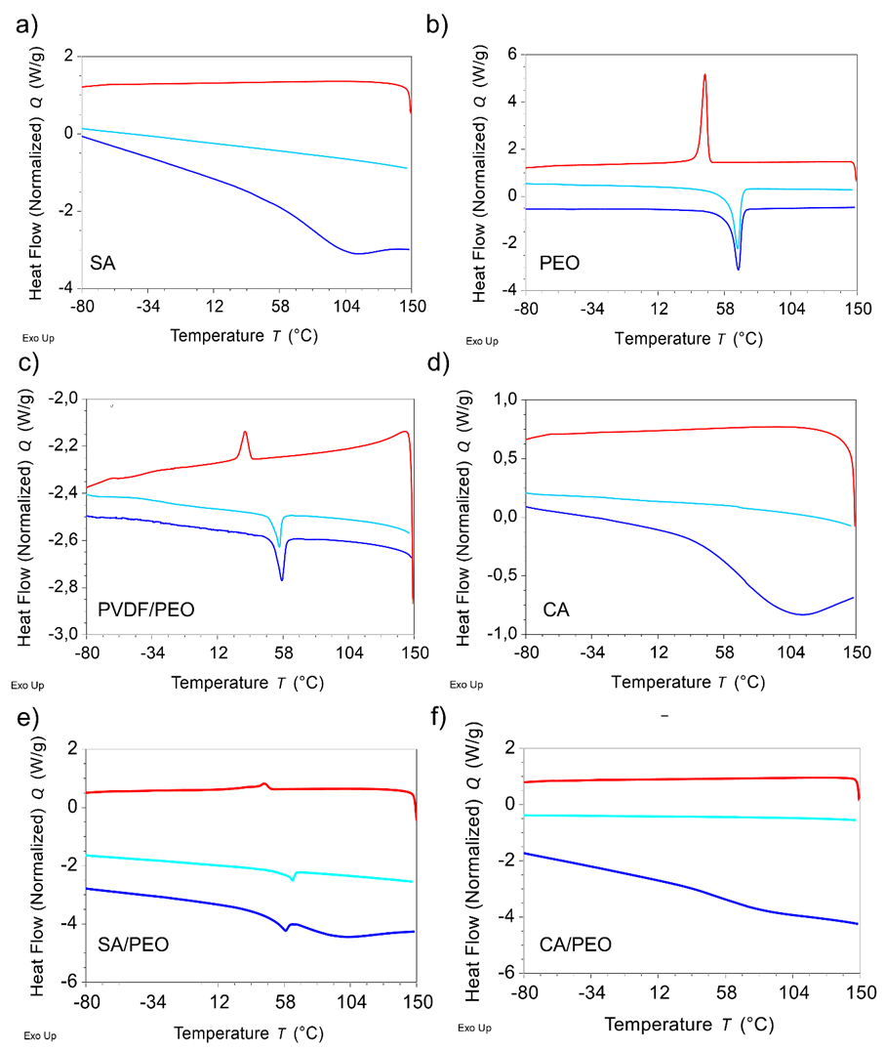
Figure S2. DSC analysis: first heating scan (blue curves), cooling scan (red curves) and second heating scan (light blue curves) of a) SA, b) PEO, c) PVDF/PEO, d) CA, (e) SA/PEO, (f) CA/PEO.

1st heating scan
Sample | T_{g} (°C) | T_{m} (°C) | ΔH_{m} (J g⁻¹)
SA | / | / | /
PEO | -54 | 68 | 139.0
SA/PEO | -47 (PEO), -25 (SA) | 60 | 17.4
CA | -22 | / | /
CA/PEO | -50 (PEO), -18 (CA) | / | /
PVDF/PEO | / | 57 | 6.9
Controlled cooling
 | T_{g} (°C) | T_{m} (°C) | ΔH_{m} (J g⁻¹)
SA | / | / | /
PEO | / | 45 | 121.5
SA/PEO | / | 45 | 16.3
CA | / | / | /
CA/PEO | / | / | /
PVDF/PEO | / | 31 | 4.5
2nd heating scan
 | T_{g} (°C) | T_{m} (°C) | ΔH_{m} (J g⁻¹)
SA | -20 | / | /
PEO | -51 | 68 | 130.8
SA/PEO | -47 (PEO), -25 (SA) | 63 | 17.5
CA | -22 | / | /
CA/PEO | -40 (PEO), -22 (CA) | 48 (PEO), 67 (PEO/PVDF) | /
PVDF/PEO | -38 | 55.5 | 5.2
Table S1. DSC results of SA, PEO, SA/PEO, CA, CA/PEO, PVDF/PEO samples.

Mechanical characterization
The PVDF/PEO blend (Figure S3) mat was subjected to tensile stress-strain test. It exhibits the high tensile strength (σ_{b}) and elongation at break (ε_{b}) indicating a tough and ductile material with a well-balanced combination of stiffness and flexibility.
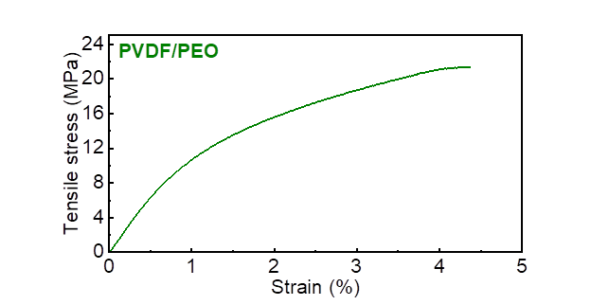
Figure S3. Mechanical characterization: (a) Tensile stress-strain test of PVDF/PEO scaffold

Morphological characterization
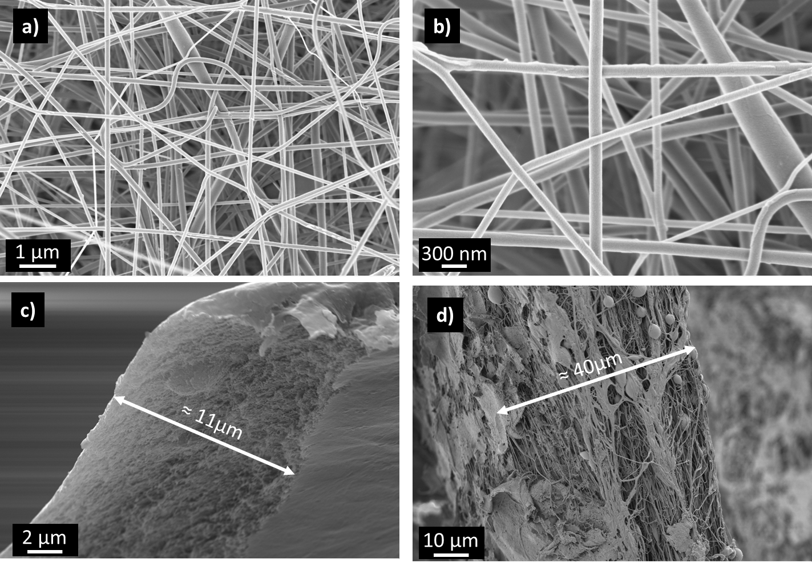
Figure S4. SEM images of PVDF scaffold (a,b); cross sectional SEM images of the SA/PEO separator (c), and of the CA/PEO separator (d).

Electrochemical characterization
Figure S5. PEIS spectra of different separators in LP30 (a) and in 5M NaNO₃ (b) in a sealed cell SS/separator/SS from 200 kHz to 20 kHz.

System | ρ (Ω cm) | N_{M}
LP30 | 85 [2] | /
NaNO₃ 5M | 5 | /
SA/PEO in LP30 | 1870 | 22
CA/PEO in LP30 | 1120 | 14
Celgard®2300 in LP30 | 1438 [2] | 17
CA/PEOaq in NaNO₃ 5M | 17 | 4
Celgard®aq in NaNO₃ 5M | 207 | 40
Table S2. ρ and N_{M} values for the different systems considered.

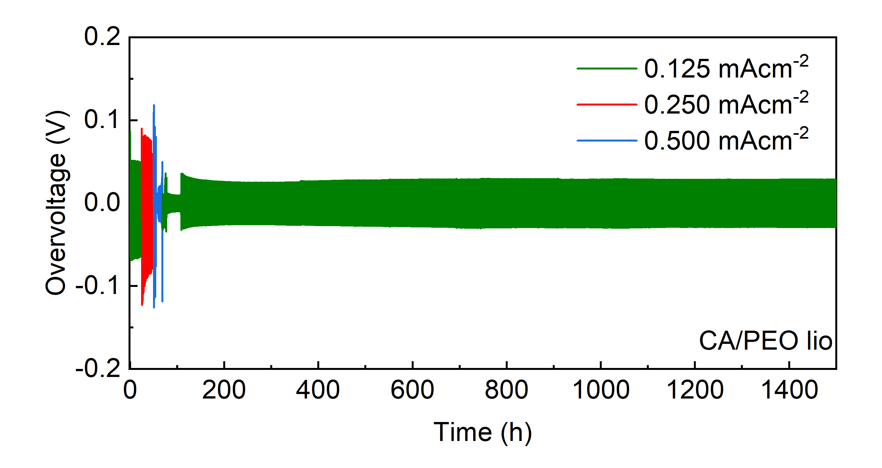
Figure S6. Li//Li symmetric cell voltage profiles in LP30 at 30°C using CA/PEO as separator.
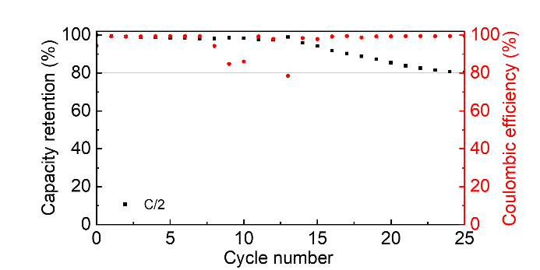
Figure S7. Capacity retention and coulombic efficiency in LP30 at 30°C of a Li//LFP cell using SA/PEO separator.

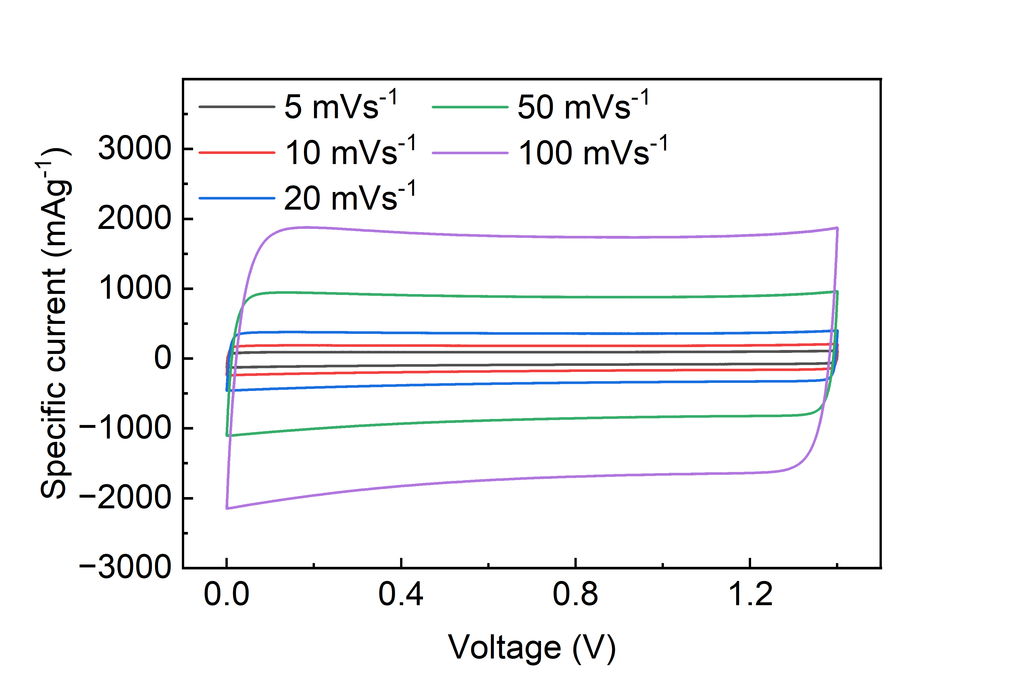
Figure S8. CVs of the AC symmetric cell with CA/PEOaq separator at different scan rates.
A constant current – constant voltage (CC–CV) test at low currents is carried out for the evaluation of the maximum supercapacitor discharge performance (RCT, reference capacity test). The test consists of a charge at ca. 5C constant current up to a cut-off voltage kept constant for 1 h. Then, the supercapacitor is discharged at the same current (Figure S9). The 5C current was determined based on the capacity measured at cycle 100000 of the charge/discharge test. The discharge capacitance (C_{RCT}) is evaluated by the RCT discharge curves reported in Figure S9 and resulted of ca. 88 F/g.

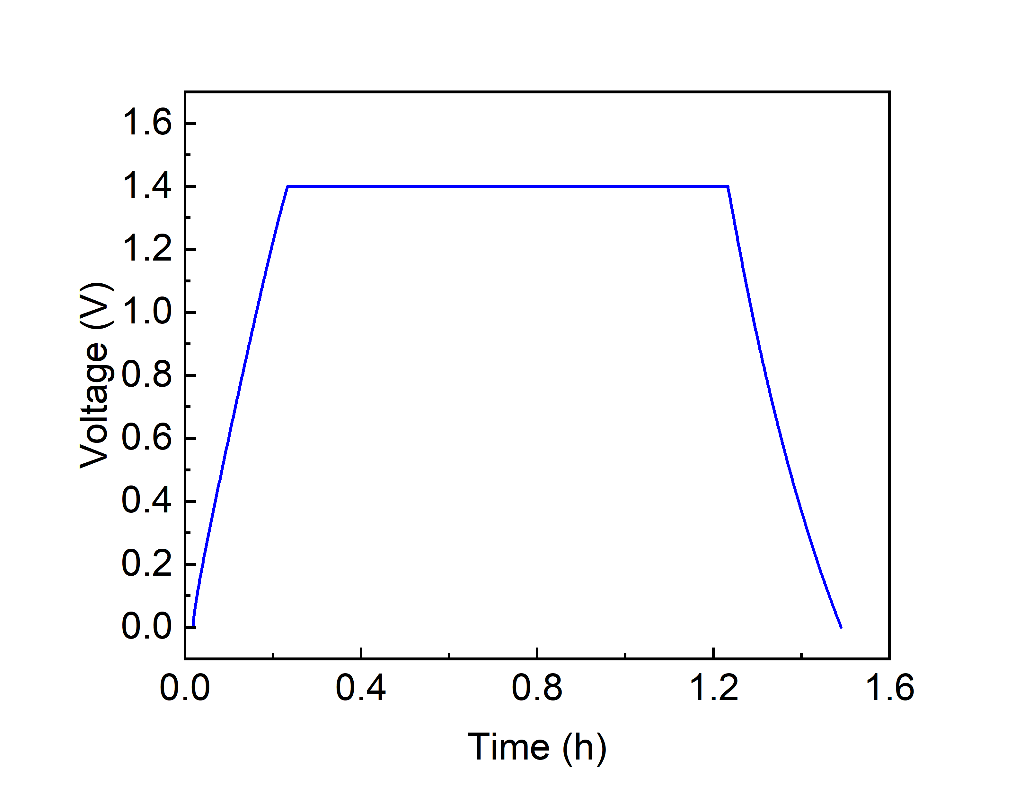
Figure S9. RCT curve of the AC//AC supercapacitor with CA/PEOaq and 5 M NaNO₃ electrolyte. Galvanostatic charge at 5C, rest at 1.4 V for 1 h and discharge at 5C.

References
[1] P. d. S. Araujo, G. B. Belini, G. P. Mambrini, F. M. Yamaji, W. R. Waldman, Thermal degradation of calcium and sodium alginate: A greener synthesis towards calcium oxide micro/nanoparticles, International Journal of Biological Macromolecules, 140 (2019) 749–760
[2] A. Terella, F. De Giorgio, M. Rahmanipour, L. Malavolta, E. Paolasini, D. Fabiani, M. L. Focarete, C. Arbizzani, Functional separators for the batteries of the future, J. Power Sources 449 (2020) 227556

