Supplementary material
SEARCH STRATEGY
A comprehensive search was conducted among the main database platforms, such as MEDLINE (PubMed platform), EMBASE, Cochrane platform and Web of Science Core Collection (Clarivate) up to June, 2024. Keywords such as “GOO”, “EUS”, “EUS-GJ”, “EUS-GEA,” “LAMS,” “peptic ulcer,” “pancreatitis” and “benign” were used in various strings, comprising their extended meanings.
Two among the used strings are:
First:
(("GOO"[All Fields] OR ("pyloric stenosis"[MeSH Terms] OR ("pyloric"[All Fields] AND "stenosis"[All Fields]) OR "pyloric stenosis"[All Fields] OR ("gastric"[All Fields] AND "outlet"[All Fields] AND "obstruction"[All Fields]) OR "gastric outlet obstruction"[All Fields] OR "gastric outlet obstruction"[MeSH Terms])) NOT ("malign"[All Fields] OR "malignance"[All Fields] OR "malignances"[All Fields] OR "malignant"[All Fields] OR "malignants"[All Fields] OR "malignities"[All Fields] OR "malignity"[All Fields] OR "malignization"[All Fields] OR "malignized"[All Fields] OR "maligns"[All Fields] OR "neoplasms"[MeSH Terms] OR "neoplasms"[All Fields] OR "malignancies"[All Fields] OR "malignancy"[All Fields])) AND ("endosc ultrasound"[Journal] OR "eus"[All Fields] OR ("endosonography"[MeSH Terms] OR "endosonography"[All Fields] OR ("endoscopic"[All Fields] AND "ultrasound"[All Fields]) OR "endoscopic ultrasound"[All Fields])) AND ("EUS-GJ"[All Fields] OR "EUS-GEA"[All Fields] OR "EUS-GE"[All Fields] OR ("gastric bypass"[MeSH Terms] OR ("gastric"[All Fields] AND "bypass"[All Fields]) OR "gastric bypass"[All Fields] OR "gastrojejunostomies"[All Fields] OR "gastrojejunostomy"[All Fields]) OR "gastroenteroanastomosis"[All Fields]) AND ("LAMS"[All Fields] OR (("lumen"[All Fields] OR "lumen s"[All Fields] OR "lumenal"[All Fields] OR "lumenally"[All Fields] OR "lumenization"[All Fields] OR "lumenized"[All Fields] OR "lumens"[All Fields]) AND ("appose"[All Fields] OR "apposed"[All Fields] OR "apposes"[All Fields] OR "apposing"[All Fields]) AND ("metal s"[All Fields] OR "metalate"[All Fields] OR "metalated"[All Fields] OR "metalates"[All Fields] OR "metalating"[All Fields] OR "metalation"[All Fields] OR "metalations"[All Fields] OR "metalative"[All Fields] OR "metalic"[All Fields] OR "metalization"[All Fields] OR "metalized"[All Fields] OR "metallate"[All Fields] OR "metallated"[All Fields] OR "metallates"[All Fields] OR "metallation"[All Fields] OR "metallations"[All Fields] OR "metallic"[All Fields] OR "metallically"[All Fields] OR "metallicities"[All Fields] OR "metallicity"[All Fields] OR "metallics"[All Fields] OR "metallization"[All Fields] OR "metallizations"[All Fields] OR "metallize"[All Fields] OR "metallized"[All Fields] OR "metals"[MeSH Terms] OR "metals"[All Fields] OR "metal"[All Fields]) AND ("stent s"[All Fields] OR "stentings"[All Fields] OR "stents"[MeSH Terms] OR "stents"[All Fields] OR "stent"[All Fields] OR "stented"[All Fields] OR "stenting"[All Fields])))
Second:
("GOO"[All Fields] OR ("pyloric stenosis"[MeSH Terms] OR ("pyloric"[All Fields] AND "stenosis"[All Fields]) OR "pyloric stenosis"[All Fields] OR ("gastric"[All Fields] AND "outlet"[All Fields] AND "obstruction"[All Fields]) OR "gastric outlet obstruction"[All Fields] OR "gastric outlet obstruction"[MeSH Terms])) AND ("benign"[All Fields] OR "benignancies"[All Fields] OR "benignancy"[All Fields] OR "benignant"[All Fields] OR "benigne"[All Fields] OR "benignity"[All Fields] OR "benigns"[All Fields]) AND ("endosc ultrasound"[Journal] OR "eus"[All Fields] OR ("endosonography"[MeSH Terms] OR "endosonography"[All Fields] OR ("endoscopic"[All Fields] AND "ultrasound"[All Fields]) OR "endoscopic ultrasound"[All Fields])) AND ("EUS-GJ"[All Fields] OR "EUS-GEA"[All Fields] OR "EUS-GE"[All Fields] OR ("gastric bypass"[MeSH Terms] OR ("gastric"[All Fields] AND "bypass"[All Fields]) OR "gastric bypass"[All Fields] OR "gastrojejunostomies"[All Fields] OR "gastrojejunostomy"[All Fields]) OR "gastroenteroanastomosis"[All Fields] OR ("gastroenterostomy"[MeSH Terms] OR "gastroenterostomy"[All Fields] OR ("gastro"[All Fields] AND "enterostomy"[All Fields]) OR "gastro enterostomy"[All Fields]) OR "gastro-entero-anastomosis"[All Fields] OR "gastro-enteral"[All Fields]) AND ("LAMS"[All Fields] OR (("lumen"[All Fields] OR "lumen s"[All Fields] OR "lumenal"[All Fields] OR "lumenally"[All Fields] OR "lumenization"[All Fields] OR "lumenized"[All Fields] OR "lumens"[All Fields]) AND ("appose"[All Fields] OR "apposed"[All Fields] OR "apposes"[All Fields] OR "apposing"[All Fields]) AND ("metal s"[All Fields] OR "metalate"[All Fields] OR "metalated"[All Fields] OR "metalates"[All Fields] OR "metalating"[All Fields] OR "metalation"[All Fields] OR "metalations"[All Fields] OR "metalative"[All Fields] OR "metalic"[All Fields] OR "metalization"[All Fields] OR "metalized"[All Fields] OR "metallate"[All Fields] OR "metallated"[All Fields] OR "metallates"[All Fields] OR "metallation"[All Fields] OR "metallations"[All Fields] OR "metallic"[All Fields] OR "metallically"[All Fields] OR "metallicities"[All Fields] OR "metallicity"[All Fields] OR "metallics"[All Fields] OR "metallization"[All Fields] OR "metallizations"[All Fields] OR "metallize"[All Fields] OR "metallized"[All Fields] OR "metals"[MeSH Terms] OR "metals"[All Fields] OR "metal"[All Fields]) AND ("stent s"[All Fields] OR "stentings"[All Fields] OR "stents"[MeSH Terms] OR "stents"[All Fields] OR "stent"[All Fields] OR "stented"[All Fields] OR "stenting"[All Fields])))

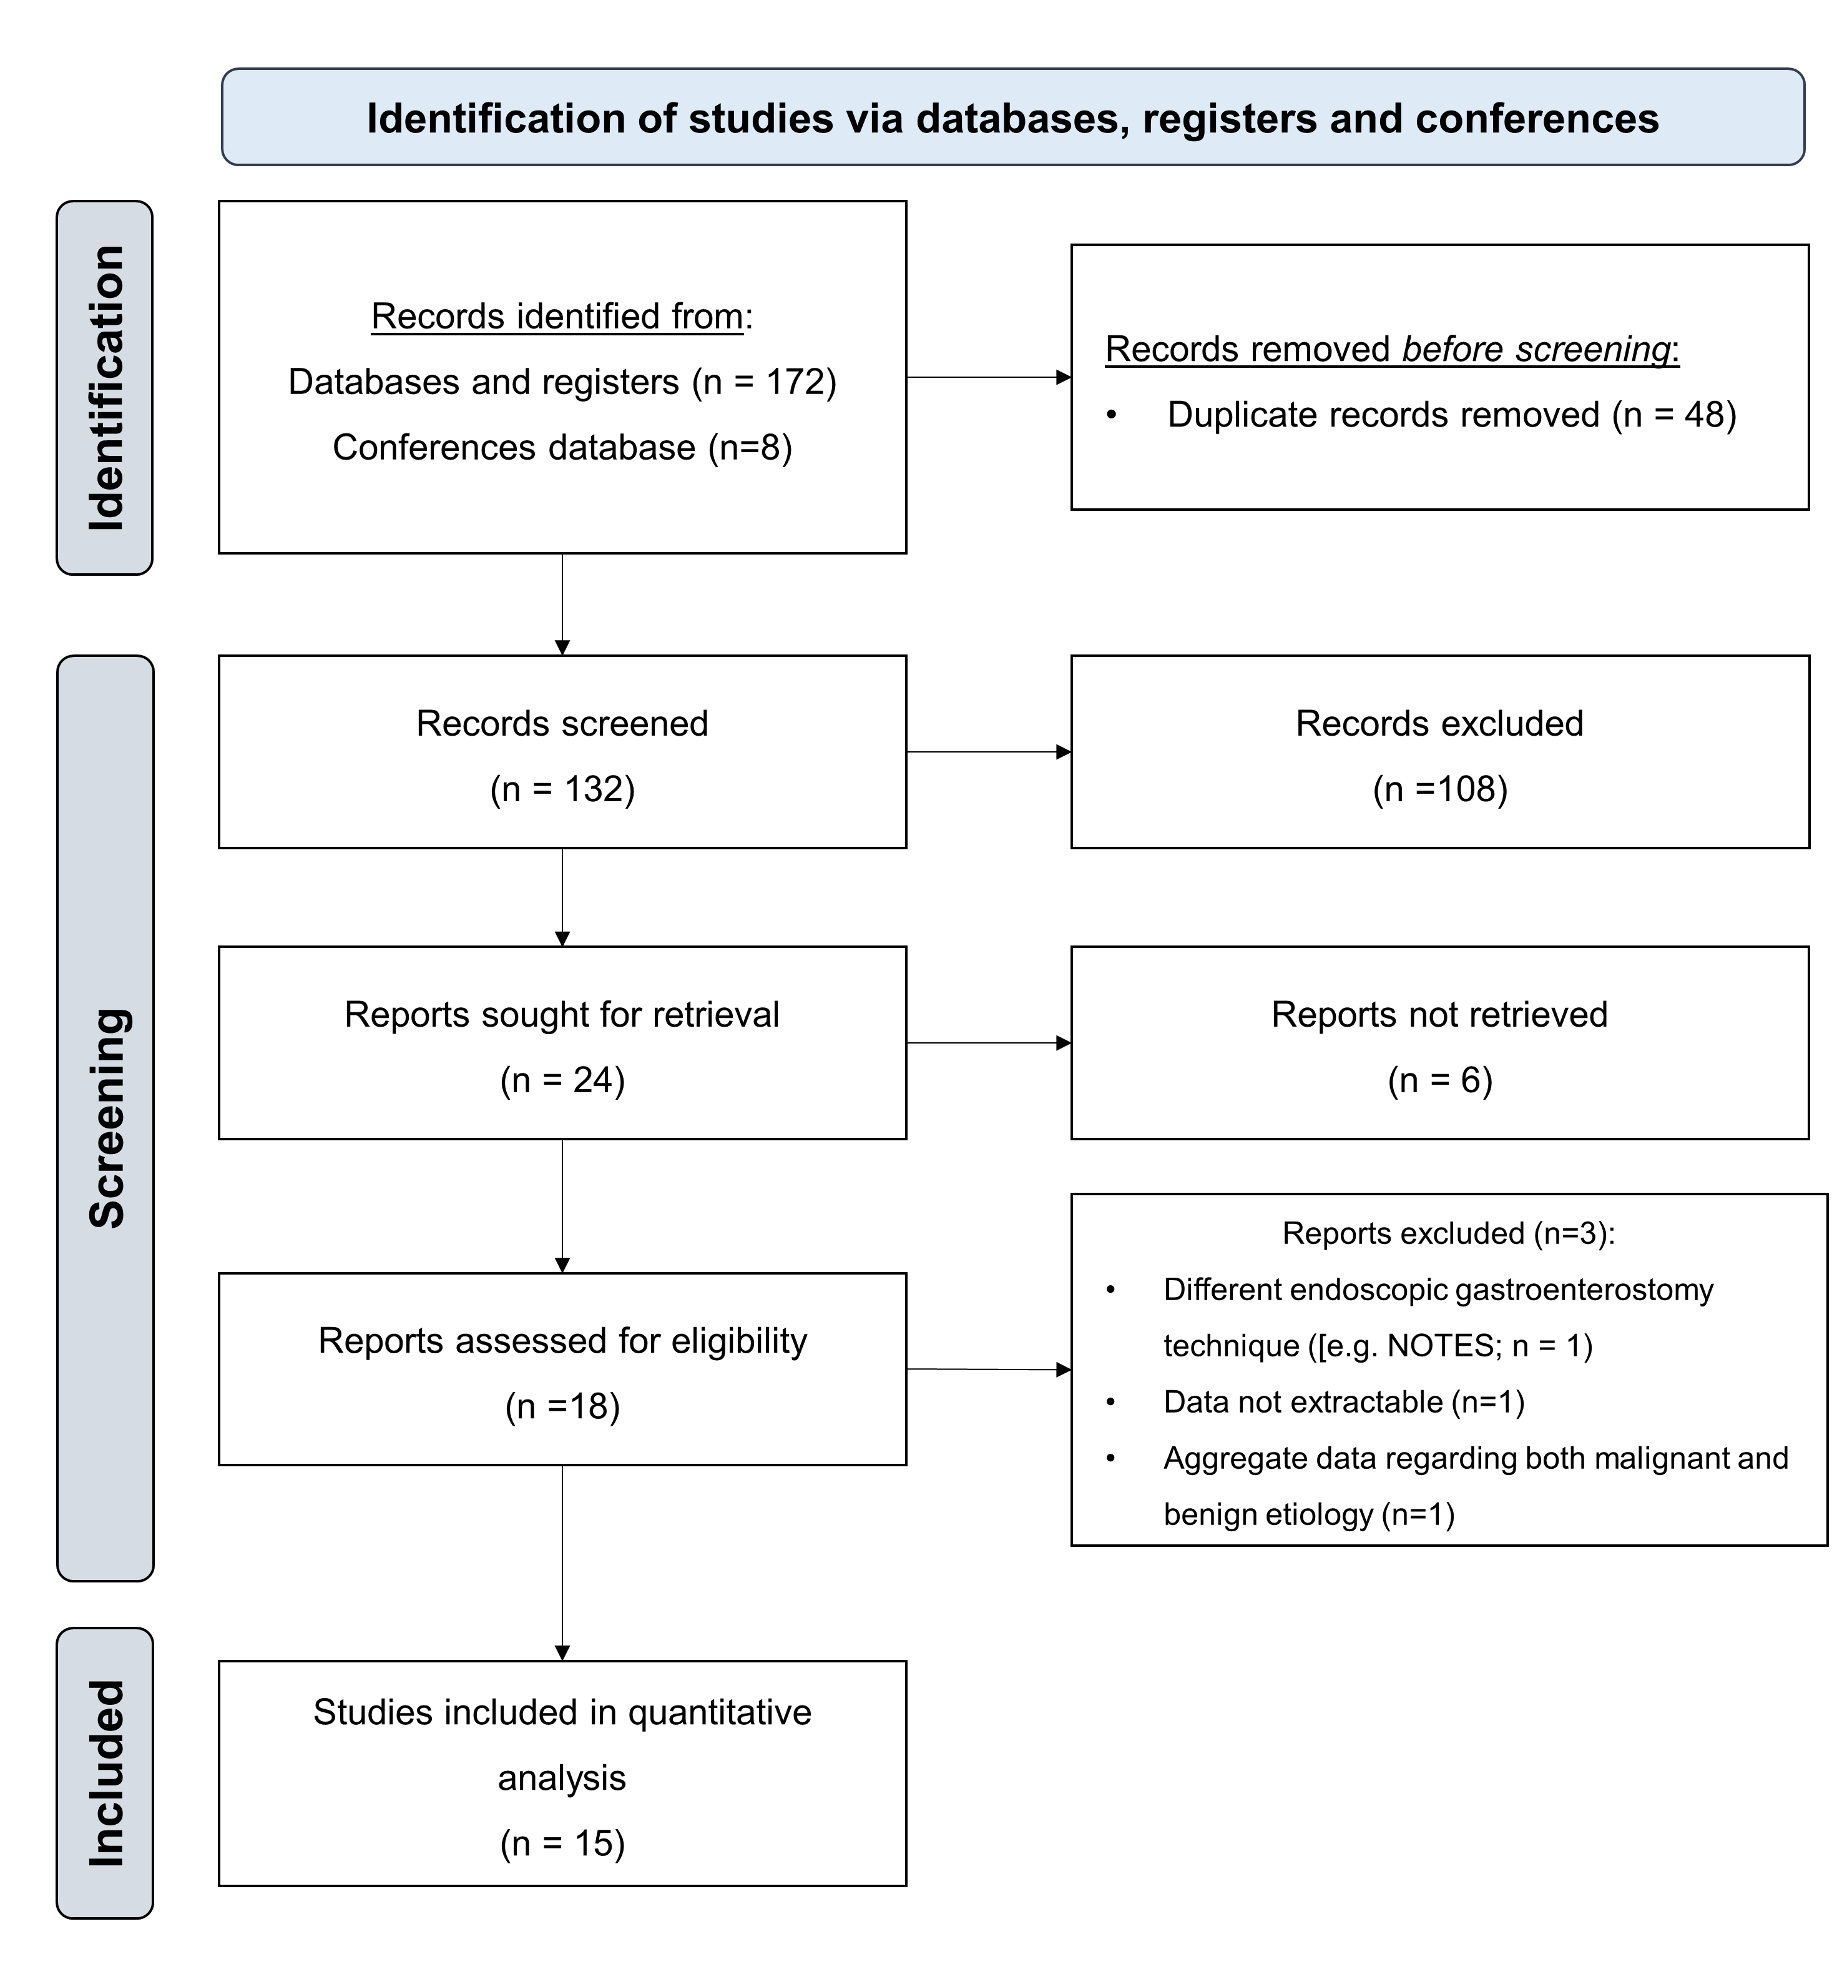
Supplementary Figure S1. Flowchart showing the results of the search and the review process. Twelve studies were included in the pooled analysis.
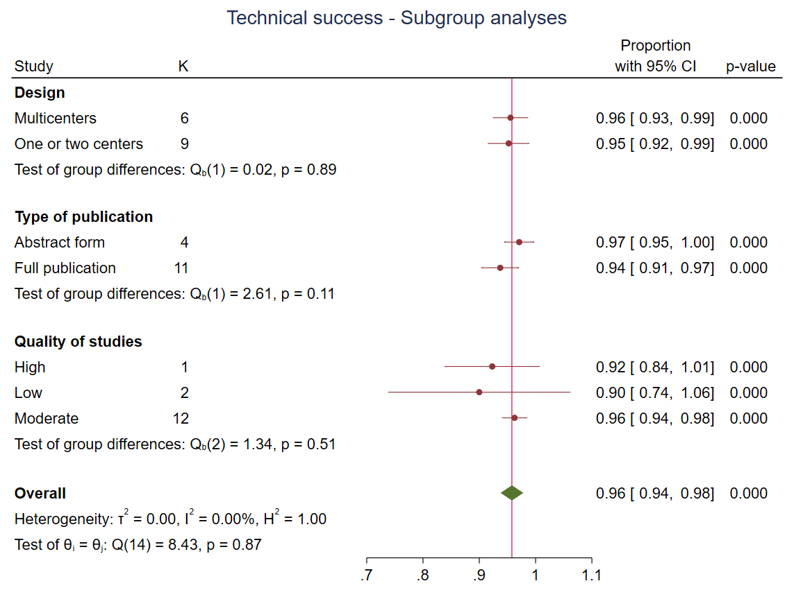
Supplementary Figure S2. Summary of subgroup analyses regarding technical success.
Supplementary Figure S3. Subgroups analysis according to the definition of clinical success.
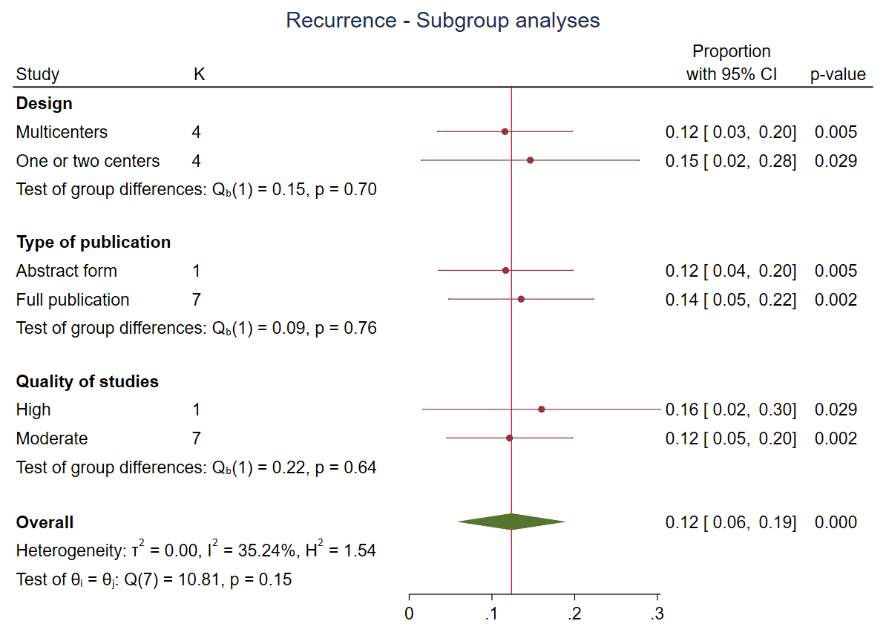
Supplementary Figure S4. Summary of subgroup analysis regarding recurrence.
A
B
Supplementary Figure S5. Subgroup analyses regarding safety: A) type of publication; B) design of studies.
Supplementary Figure S6. Subgroup analysis according to quality of studies regarding clinical success.

Supplementary Figure S7. Subgroup analysis according to quality of studies regarding safety.

A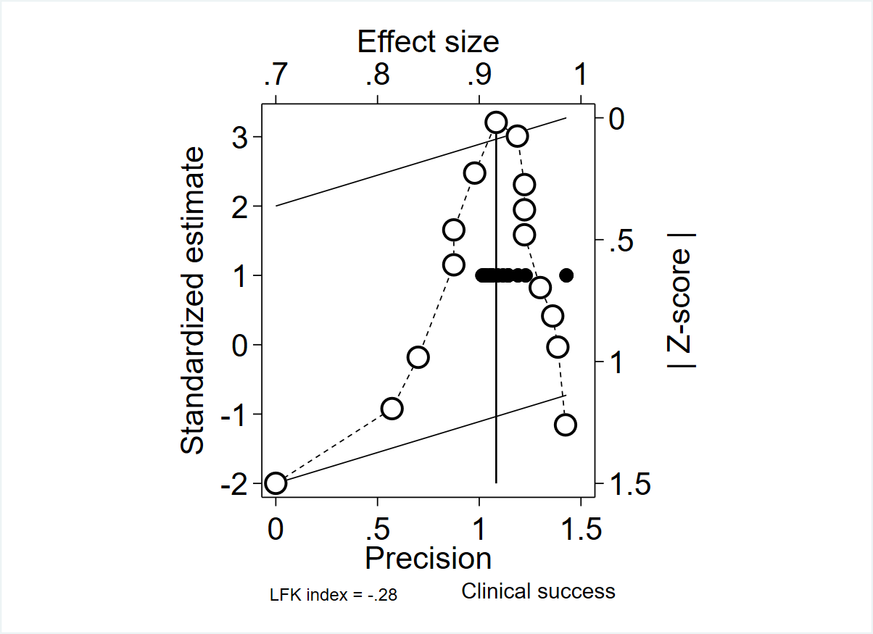 B 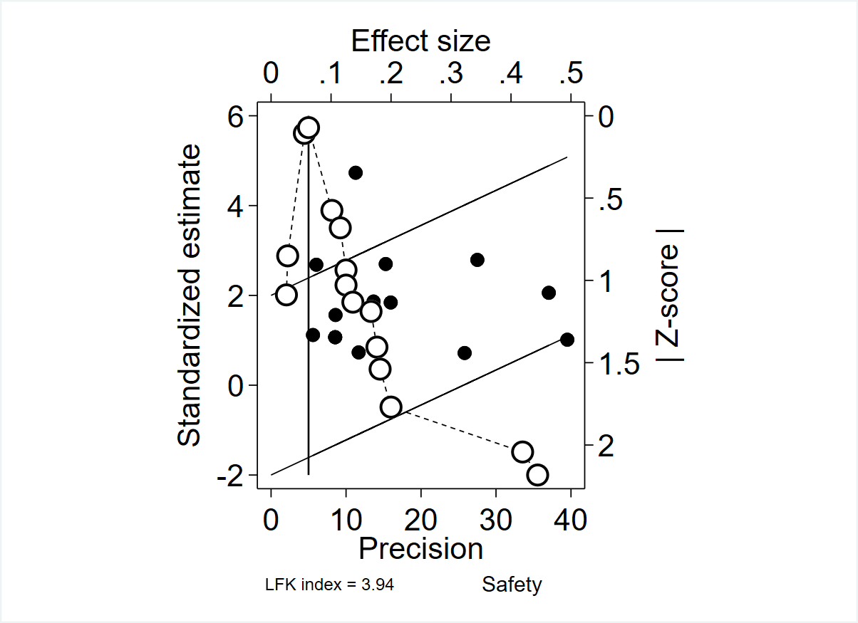
C

Supplementary Figure S8. Doi plots for identifying publication bias for A) clinical success, B) safety and C) recurrence.

Supplementary Table 1. Clinical e technical characteristics of procedures and patients.
 | Khashab, 2015° | Chen, 2018 | Kerdsirichairat, 2019 | Sameera, 2020* | James, 2020 | Sobani, 2021 | Havre, 2021 | Kahaleh, 2023 | Rizvi, 2023§ | Abel, 2024 | Fimiano. 2024* | Martinez-Ortega, 2024* | Gonzalez, 2024 | Wannhoff, 2024 | Rizzo, 2025
Procedural duration time, minutes | Mean 96 (range 45-152) | Mean 44.6 ± 26.1 | Median 39 minutes (IQR, 26 – 51.5) minutes | Median 42 minutes (range 22-110) | Mean 66 ± 33.5 | NR | NR | Mean 104 (20-270) | NR | NR | Mean 42 ± 10 | NR | NR | NR | Mean 52.7 ± 17.96
Dilation of the LAMS, n/N (%) | 7/7 (100%) | 13/25 (52%) | NR | NR | NR | 8/8 (100%) | NR | NR | 19/70 (27.14%) | 18/18, 100% | NR | NR | NR | NR | 1/11 (9.1%)
Previous dilation§, n/N (%) | NR | 7/26 (26.9%) | NR | NR | 3 (13.6%) | 5 (62.5%) | NR | NR | NR | 3/18 (16.7%) | NR | NR | NR | NR | 1 (9.1%)
Previous stenting§, n/N (%) | 1/7 (14.3%) | 4/26 (15.4%) | NR | NR | NR | 1 (12.5%) | NR | NR | NR | 3/18 (16.7%) | NR | NR | NR | NR | 1 (9.1%)
Previous dilation plus stenting§, n/N (%) | NR | NR | NR | NR | 2 (9.1%) | 1 (12.5%) | NR | NR | NR | 0 (0%) | NR | NR | NR | NR | NR
EUS-GE technique | Balloon assisted and direct puncture method (100%) | Direct gastroenterostomy (15 [57.7%]); Balloon assisted gastroenterostomy (7 [26.9%]); EUS-guided double-balloon-occluded gastrojejunostomy bypass (EPASS) (4 [15.4%]) | Direct gastroenterostomy 100% | Direct free hand puncture (n= 4); Balloon catheter over wire-assisted (n=4); Hybrid rendezvous with ultra slim scope (n=6) reverse enterogastrostomy (n=1); Naso-jejunal distention (n=2) | Orojejunal tube-assisted,  balloon-assisted,  fluid instillation followed by freehand direct approach | Modified direct puncture with tube-assisted fluid instillation | Balloon catheter over wire-assisted | NR | Free-hand puncture 76% (n=55) | Wire-assisted direct anterograde (n = 15);  Reverse enterogastrostomy (n = 3) | NR | Naso-biliary catheter technique: 100%  Free-hand (88.24%) | Direct technique and WEST | Direct free hand puncture (n = 26, 72.2%);  Other (n 10, 27.8%) | Direct EUS-GJ 100%
Timing of stent removal | NR | NR | NR | NR | Mean 270 ± 273 days | NR | NR | NR | NR | Median 286 days (range 88–1444 days) | NR | Median 7.34 (IQR 4.3-10.74) months | NR | Median 9 (1–44) months | Median 6 months
Adjusted$ timing of stent removal, days | NR | NR | NR | NR | Mean 270 ± 273 days | NR | NR | NR | NR | Mean 526 days | NR | Mean 222.9 days | NR | Mean 472.5 | Mean 180 days
*Abstract at ESGE Days 2024; § Abstract at DDW 2024; #Authors did not specify the benign etiologies; §In cases of gastrointestinal stricture. °Mixed etiologies (malignant and benign) were considered. ^Data for benign etiologies were not extractable. $Adjusted by Hozo method
LAMS: Lumen-apposing metal stent; EUS-GJ: Endoscopic ultrasound-guided gastrojejunostomy; GOO: Gastric outlet obstruction; NR: not reported.

Supplementary Table 2. Definitions of the outcomes.
First author, year | Definition of technical success | Definition of clinical success | AE classifications
Khashab, 2015 | The adequate positioning and deployment of the stent as determined endoscopically and confirmed radiologically. | The patient’s ability to tolerate oral intake without vomiting. | NR
Chen, 2018 | The adequate positioning and deployment of the stent as determined endoscopically and radiographically. | The ability to tolerate oral intake without vomiting. | ASGE Lexicon grading system
Kerdsirichairat, 2019 | The adequate positioning and deployment of the stent as determined endoscopically and radiographically | The ability to tolerate at least a full liquid diet during follow-up. | ASGE Lexicon grading system
Sameera, 2020* | Creation of a successful gastrojejunal fistulous tract. | The ability to tolerate a diet post-procedure. | NR
James, 2020 | The adequate positioning and deployment of the stent as determined by endoscopy and fluoroscopy. | The ability to tolerate at least a full liquid diet during follow-up. | ASGE Lexicon grading system
Sobani, 2021 | The successful transmural deployment and placement of LAMS between the stomach and the target loop of proximal small bowel distal to the site of obstruction, creating an endoscopic GE. | The ability to tolerate solid/regular consistency diet at 2 weeks after the procedure. | ASGE Lexicon grading system
Havre, 2021 | The ability under EUS guidance to place a cautery-enhanced LAMS between the stomach and the small bowel. | Assessed by the patient’s ability to resume oral intake of fluid or solid foods. | ASGE Lexicon grading system
Kahaleh, 2023 | NR | Measured by tolerating oral diet at 48 hours post-procedure. | Classification per Surgical Complications Grade Definition
Rizvi, 2023§ | NR | Solid food diet post-procedurally. | NR
Abel, 2024 | The successful connection of the stomach and post-obstruction small bowel with patent anastomosis as demonstrated by endoscopic visualization and fluoroscopic verification using contrast. | The ability to tolerate a diet, and improvement of obstructive symptoms, with no re-admissions to the hospital for symptoms related to obstruction within 30 days of the procedure. | ASGE Lexicon grading system
Fimiano, 2024* | NR | Resolution of symptoms and weight recovery. | NR
Martinez-Ortega, 2024* | NR | Recovery of oral tolerance without the need for surgery, enteral tubes or parenteral nutrition. | NR
Gonzalez, 2024 | Adequate completion of EUS-GJ on the first attempt. | In MGOO and benign organic GOO, the ability to resume an oral diet without vomiting, with a GOO score ≥2 within the weeks following the procedure and persisting at 3 months; in refractory gastroparesis, the decreasing of the GCSI score greater that 1 point from baseline at 3 months. | AGREE classification and classified between minor (grades I–II) and major (grades III–IV)
Wannhoff, 2024 | The successful creation of an anastomosis using a LAMS to bypass the obstruction. | Determined by a ≥1 point improvement in the Gastric Outlet Obstruction Scoring System (GOOSS). | AGREE classification for severity
Rizzo, 2025 | The proper placement of the LAMS between the two intended GI tracts, identified by EUS view and confirmed by both endoscopic and radiographic evaluation. | Improvement of at least 1 point in the Gastric Outlet Obstruction Scoring System (GOOSS)(12) after EUS-GE in the case of GOO. | ASGE Lexicon grading system and misdeployment classification system
*Abstract at ESGE Days 2024; § Abstract at DDW 2024; #Authors did not specify the benign etiologies.
NR: not reported.

Supplementary Table 3. Detailed adverse events reported among the included studies.
Author | AEs, n | Details on AEs and Management
Khashab, 2015 | 0
Chen, 2018 | 3 | Two mild AEs due to stent misdeployment, managed successfully with insertion of a bridging fully covered metal esophageal stent.  One severe AE following elective stent removal, resulting in a gastric leak needing emergency surgical management.
Kerdsirichairat, 2019 | 1 | One hemoperitoneum
Sameera, 2020* | 0
James, 2020 | 4 | - One mild abdominal pain resolving without intervention.  Three severe AEs (14.3%) occurred in the cohort.  - One patient developed bleeding from a gastric ulcer at the anastomotic site on post-procedure day 2 (managed with an ICU admission, endoscopy for treatment, epinephrine injection and argon plasma coagulation of the bleeding tissue with, ultimately, a favorable outcome without need for stent removal).  - The second severe AE occurred one year after the procedure in a patient whose LAMS spontaneously migrated to the level of the proximal ileum, leading to a small-bowel obstruction. Endoscopic removal was unsuccessful and ultimately required surgery, but the GOO had resolved at that point and surgical bypass was not required.  - The third severe AE occurred in a patient with necrotizing pancreatitis requiring multiple necrosectomies. The gastrojejunostomy stents were found to traverse from the stomach through the colon and into the jejunum. Despite this mispositioning, an upper GI series showed no evidence of contrast leaking around the stent proximally or distally, and he tolerated a regular diet with plans for surgical revision at a later date, once optimized nutritionally.
Sobani, 2021 | 1 | Clean-based jejunal ulcer noted on routine 3-month follow-up EGD.
Havre, 2021 | 1 | Late stent migration.
Kahaleh, 2023 | 13 | Four late AEs (not reported).  Nine short-term AEs= 2; release into peritoneal cavity, closure with OTSC clip; 1 infection; 1 abdominal pain; 1 GI bleeding; 1 bacterial peritonitis; 1 ascites infection; 1 abscess retroperitoneum; 1 LAMS-related jejunal ulcer with bleeding.
Rizvi, 2023§ | 12 | Two stent misdeployments; 2 stent migrations; one gastrocolonic fistula; three late migrations; one early migration; one late bleeding; two early bleedings;
Abel, 2024 | 3 | one intra-operative gastric bleeding resolved with epinephrine; one postoperative gastric bleeding resolved with clipping and epinephrine; one postoperative retroperitoneal hemorrhage resolved with IR embolization.
Fimiano, 2024* | 1 | one perforation after 48h leading to patient’s death.
Martinez-Ortega, 2024* | 7 | Three mild fever, one severe bleeding, one fatal bleeding.
Gonzalez, 2024 | 6 | Not specified for benign indication.
Wannhoff, 2024 | 1 | One gastrocolonic fistula treated endoscopically.
Rizzo, 2025 | 2 | One bleeding within 7 days of procedure successfully treated conservatively, and one intraprocedural type 1 misdeployment successfully treated endoscopically with a second attempt at EUS-GE.
*Abstract at ESGE Days 2024; § Abstract at DDW 2024
AEs= adverse events; OTSC= over-the-scope clip; LAMS: lumen-apposing metal stent; EUS-GE: EUS guided gastroenterostomy; NS: not specified; NR: not reported; IR= interventional radiology.

Supplementary Table 4. Modified Newcastle-Ottawa Quality Assessment Scale.
Study | Representativeness | Selection | Ascertainment of exposure | Demonstration that outcome of interest was not present at start of study | Assessment of outcome? | Follow-up | Adequacy of follow-up | Overall quality score  (Maximum = 9)
Khashab, 2015 | ★ | ★ | ★ | ★ | ★ | ★ | - | 6
Chen, 2018 | ★ | ★★ | ★ | ★ | ★ | ★ | - | 7
Kerdsirichairat, 2019 | ★ | ★ | ★ | ★ | ★ | ★ | ★ | 7
Sameera, 2020* | ★ | ★ | ★ | - | ★ | - | - | 4
James, 2020 | ★ | ★ | ★ | ★ | ★ | ★ | ★ | 7
Sobani, 2021 | ★ | ★ | ★ | ★ | ★ | ★ | ★ | 7
Havre, 2021 | ★ | ★ | ★ | ★ | ★ | ★ | ★ | 7
Kahaleh, 2023 | ★ | ★ | ★ | ★ | - | ★ | - | 5
Rizvi, 2023 | ★ | ★★ | ★ | ★ | - | ★ | ★ | 7
Abel, 2024 | ★ | ★★ | ★ | ★ | ★ | - | - | 6
Fimiano, 2024 | ★ | ★ | ★ | ★ | ★ | ★ | - | 6
Marcos-Carrasco, 2024 | ★ | ★ | ★ | - | ★ | ★ | ★ | 6
Gonzalez, 2024 | ★ | ★ | ★ | ★ | ★ | ★ | - | 6
Wannhoff, 2024 | ★ | ★★ | ★ | ★ | ★ | ★ | ★ | 8
Rizzo, 2025 | ★ | ★ | ★ | ★ | ★ | ★ | - | 6

Supplementary Text 1. Checklist of items for Preferred Reporting Items for Systematic Reviews and Meta-Analyses (PRISMA) - IPD (individual participant data).
PRISMA-IPD  Section/topic | Item No. | Checklist item | Reported on page
Title
Title | 1 | Identify the report as a systematic review and meta-analysis of individual participant data. | 1
Abstract
Structured summary | 2 | Provide a structured summary including as applicable: | 1
Structured summary | 2 | Background: State research question and main objectives, with information on participants, interventions, comparators and outcomes. | 1
Structured summary | 2 | Methods: Report eligibility criteria; data sources including dates of last bibliographic search or elicitation, noting that IPD were sought; methods of assessing risk of bias. | 1
Structured summary | 2 | Results: Provide number and type of studies and participants identified and number (%) obtained; summary effect estimates for main outcomes (benefits and harms) with confidence intervals and measures of statistical heterogeneity. Describe the direction and size of summary effects in terms meaningful to those who would put findings into practice. | 1
Structured summary | 2 | Discussion: State main strengths and limitations of the evidence, general interpretation of the results and any important implications. | 1
Structured summary | 2 | Other: Report primary funding source, registration number and registry name for the systematic review and IPD meta-analysis. | 1
Introduction
Rationale | 3 | Describe the rationale for the review in the context of what is already known. | 1
Objectives | 4 | Provide an explicit statement of the questions being addressed with reference, as applicable, to participants, interventions, comparisons, outcomes, and study design (PICOS). Include any hypotheses that relate to particular types of participant-level subgroups. | 1
Methods
Protocol and registration | 5 | Indicate if a protocol exists and where it can be accessed. If available, provide registration information including registration number and registry name. Provide publication details, if applicable. | NA
Eligibility criteria | 6 | Specify inclusion and exclusion criteria including those relating to participants, interventions, comparisons, outcomes, study design and characteristics (e.g., years when conducted, required minimum follow-up). Note whether these were applied at the study or individual level, i.e., whether eligible participants were included (and ineligible participants excluded) from a study that included a wider population than specified by the review inclusion criteria. The rationale for criteria should be stated. | 2
Identifying studies Information sources | 7 | Describe all methods of identifying published and unpublished studies including, as applicable: which bibliographic databases were searched with dates of coverage; details of any hand searching including of conference proceedings; use of study registers and agency or company databases; contact with the original research team and experts in the field; open adverts and surveys. Give the date of last search or elicitation.
Identifying studies - search | 8 | Present the full electronic search strategy for at least one database, including any limits used, such that it could be repeated. | Supplementary
Study selection processes | 9 | State the process for determining which studies were eligible for inclusion. | 2
Data collection processes | 10 | Describe how IPD were requested, collected and managed, including any processes for querying and confirming data with investigators. If IPD were not sought from any eligible study, the reason for this should be stated (for each such study). | 2-3
Data collection processes | 10 | If applicable, describe how any studies for which IPD were not available were dealt with. This should include whether, how and what aggregate data were sought or extracted from study reports and publications (such as extracting data independently in duplicate) and any processes for obtaining and confirming these data with investigators. | 2-3
Data items | 11 | Describe how the information and variables to be collected were chosen. List and define all study-level and participant-level data that were sought, including baseline and follow-up information. If applicable, describe methods of standardizing or translating variables within the IPD datasets to ensure common scales or measurements across studies. | 2-3
IPD integrity | A1 | Describe what aspects of IPD were subject to data checking (such as sequence generation, data consistency and completeness, baseline imbalance) and how this was done. | 2-3
Risk of bias assessment in individual studies | 12 | Describe methods used to assess risk of bias in the individual studies and whether this was applied separately for each outcome. If applicable, describe how findings of IPD checking were used to inform the assessment. Report if and how risk of bias assessment was used in any data synthesis. | 2-3
Specification of outcomes and effect measures | 13 | State all treatment comparisons of interests. State all outcomes addressed and define them in detail. State whether they were pre-specified for the review and, if applicable, whether they were primary/main or secondary/additional outcomes. Give the principal measures of effect (such as risk ratio, hazard ratio, difference in means) used for each outcome. | 2-3
Synthesis methods | 14 | Describe the meta-analysis methods used to synthesize IPD. Specify any statistical methods and models used. Issues should include (but are not restricted to):  - Use of a one-stage or two-stage approach.  - How effect estimates were generated separately within each study and combined across studies (where applicable).  - Specification of one-stage models (where applicable), including how clustering of patients within studies was accounted for.  - Use of fixed or random effects models and any other model assumptions, such as proportional hazards.  - How (summary) survival curves were generated (where applicable).  - Methods for quantifying statistical heterogeneity (such as I² and τ²).  - How studies providing IPD and not providing IPD were analyzed together (where applicable).  - How missing data within the IPD were dealt with (where applicable). | 2-3
Exploration of variation in effects | A2 | If applicable, describe any methods used to explore variation in effects by study or participant level characteristics (such as estimation of interactions between effect and covariates). State all participant-level characteristics that were analyzed as potential effect modifiers, and whether these were pre-specified. | 2-3
Risk of bias across studies | 15 | Specify any assessment of risk of bias relating to the accumulated body of evidence, including any pertaining to not obtaining IPD for particular studies, outcomes or other variables. | 2-3
Additional analyses | 16 | Describe methods of any additional analyses, including sensitivity analyses. State which of these were pre-specified. | 2-3
Results
Study selection and IPD obtained | 17 | Give numbers of studies screened, assessed for eligibility, and included in the systematic review with reasons for exclusions at each stage. Indicate the number of studies and participants for which IPD were sought and for which IPD were obtained. For those studies where IPD were not available, give the numbers of studies and participants for which aggregate data were available. Report reasons for non-availability of IPD. Include a flow diagram. | 4-6
Study characteristics | 18 | For each study, present information on key study and participant characteristics (such as description of interventions, numbers of participants, demographic data, unavailability of outcomes, funding source, and if applicable duration of follow-up). Provide (main) citations for each study. Where applicable, also report similar study characteristics for any studies not providing IPD. | 4-6
IPD integrity | A3 | Report any important issues identified in checking IPD or state that there were none. | 4-6
Risk of bias within studies | 19 | Present data on risk of bias assessments. If applicable, describe whether data checking led to the up-weighting or down-weighting of these assessments. Consider how any potential bias impacts on the robustness of meta-analysis conclusions. | 4-6
Results of individual studies | 20 | For each comparison and for each main outcome (benefit or harm), for each individual study report the number of eligible participants for which data were obtained and show simple summary data for each intervention group (including, where applicable, the number of events), effect estimates and confidence intervals. These may be tabulated or included on a forest plot. | 4-6
Results of syntheses | 21 | Present summary effects for each meta-analysis undertaken, including confidence intervals and measures of statistical heterogeneity. State whether the analysis was pre-specified, and report the numbers of studies and participants and, where applicable, the number of events on which it is based. | 4-6
Results of syntheses | 21 | When exploring variation in effects due to patient or study characteristics, present summary interaction estimates for each characteristic examined, including confidence intervals and measures of statistical heterogeneity. State whether the analysis was pre-specified. State whether any interaction is consistent across trials. | 4-6
Results of syntheses | 21 | Provide a description of the direction and size of effect in terms meaningful to those who would put findings into practice. | 4-6
Risk of bias across studies | 22 | Present results of any assessment of risk of bias relating to the accumulated body of evidence, including any pertaining to the availability and representativeness of available studies, outcomes or other variables. | 4-6
Additional analyses | 23 | Give results of any additional analyses (e.g., sensitivity analyses). If applicable, this should also include any analyses that incorporate aggregate data for studies that do not have IPD. If applicable, summarize the main meta-analysis results following the inclusion or exclusion of studies for which IPD were not available. | 6
Discussion
Summary of evidence | 24 | Summarize the main findings, including the strength of evidence for each main outcome. | 7-8
Strengths and limitations | 25 | Discuss any important strengths and limitations of the evidence including the benefits of access to IPD and any limitations arising from IPD that were not available. | 7-8
Conclusions | 26 | Provide a general interpretation of the findings in the context of other evidence. | 7-8
Implications | A4 | Consider relevance to key groups (such as policy makers, service providers and service users). Consider implications for future research. | 7-8
Funding
Funding | 27 | Describe sources of funding and other support (such as supply of IPD), and the role in the systematic review of those providing such support. | Title page

