Supplementary materials

Optimization of irrigation on walnut through the IRRIFRAME water balance model
Giulio Demetrio Perulli¹, Elena Baldi¹, Moreno Toselli¹, Salvatore Luca Gentile², Domenico Solimando², Stefano Anconelli², Alejandro Perez Pastor³, Alexandra Boini¹, Luigi Manfrini¹
¹Departement of Agricultural and Food Sciences (DISTAL) – University of Bologna
²Consorzio di bonifica di II grado per il Canale Emiliano Romagnolo – CER
³Technical University of Cartagena

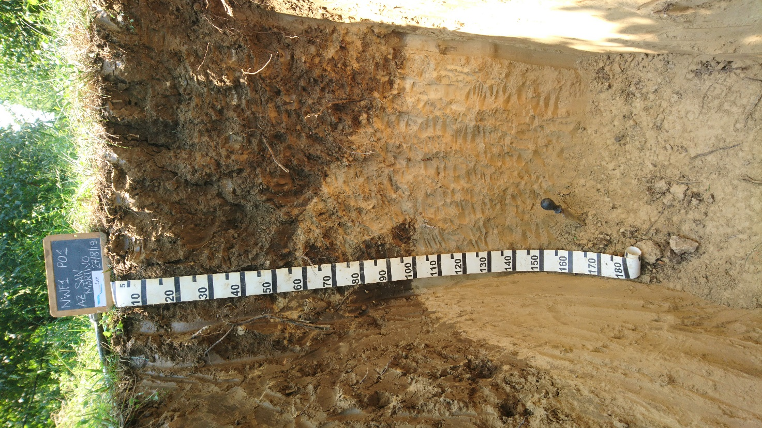
Figure S1. Soil profile in the middle of a walnut orchard row (27th August 2019). Roots are reaching 1m soil depth. Excavation and profile analysis was realized by I.TER (https://www.pedologia.net/).

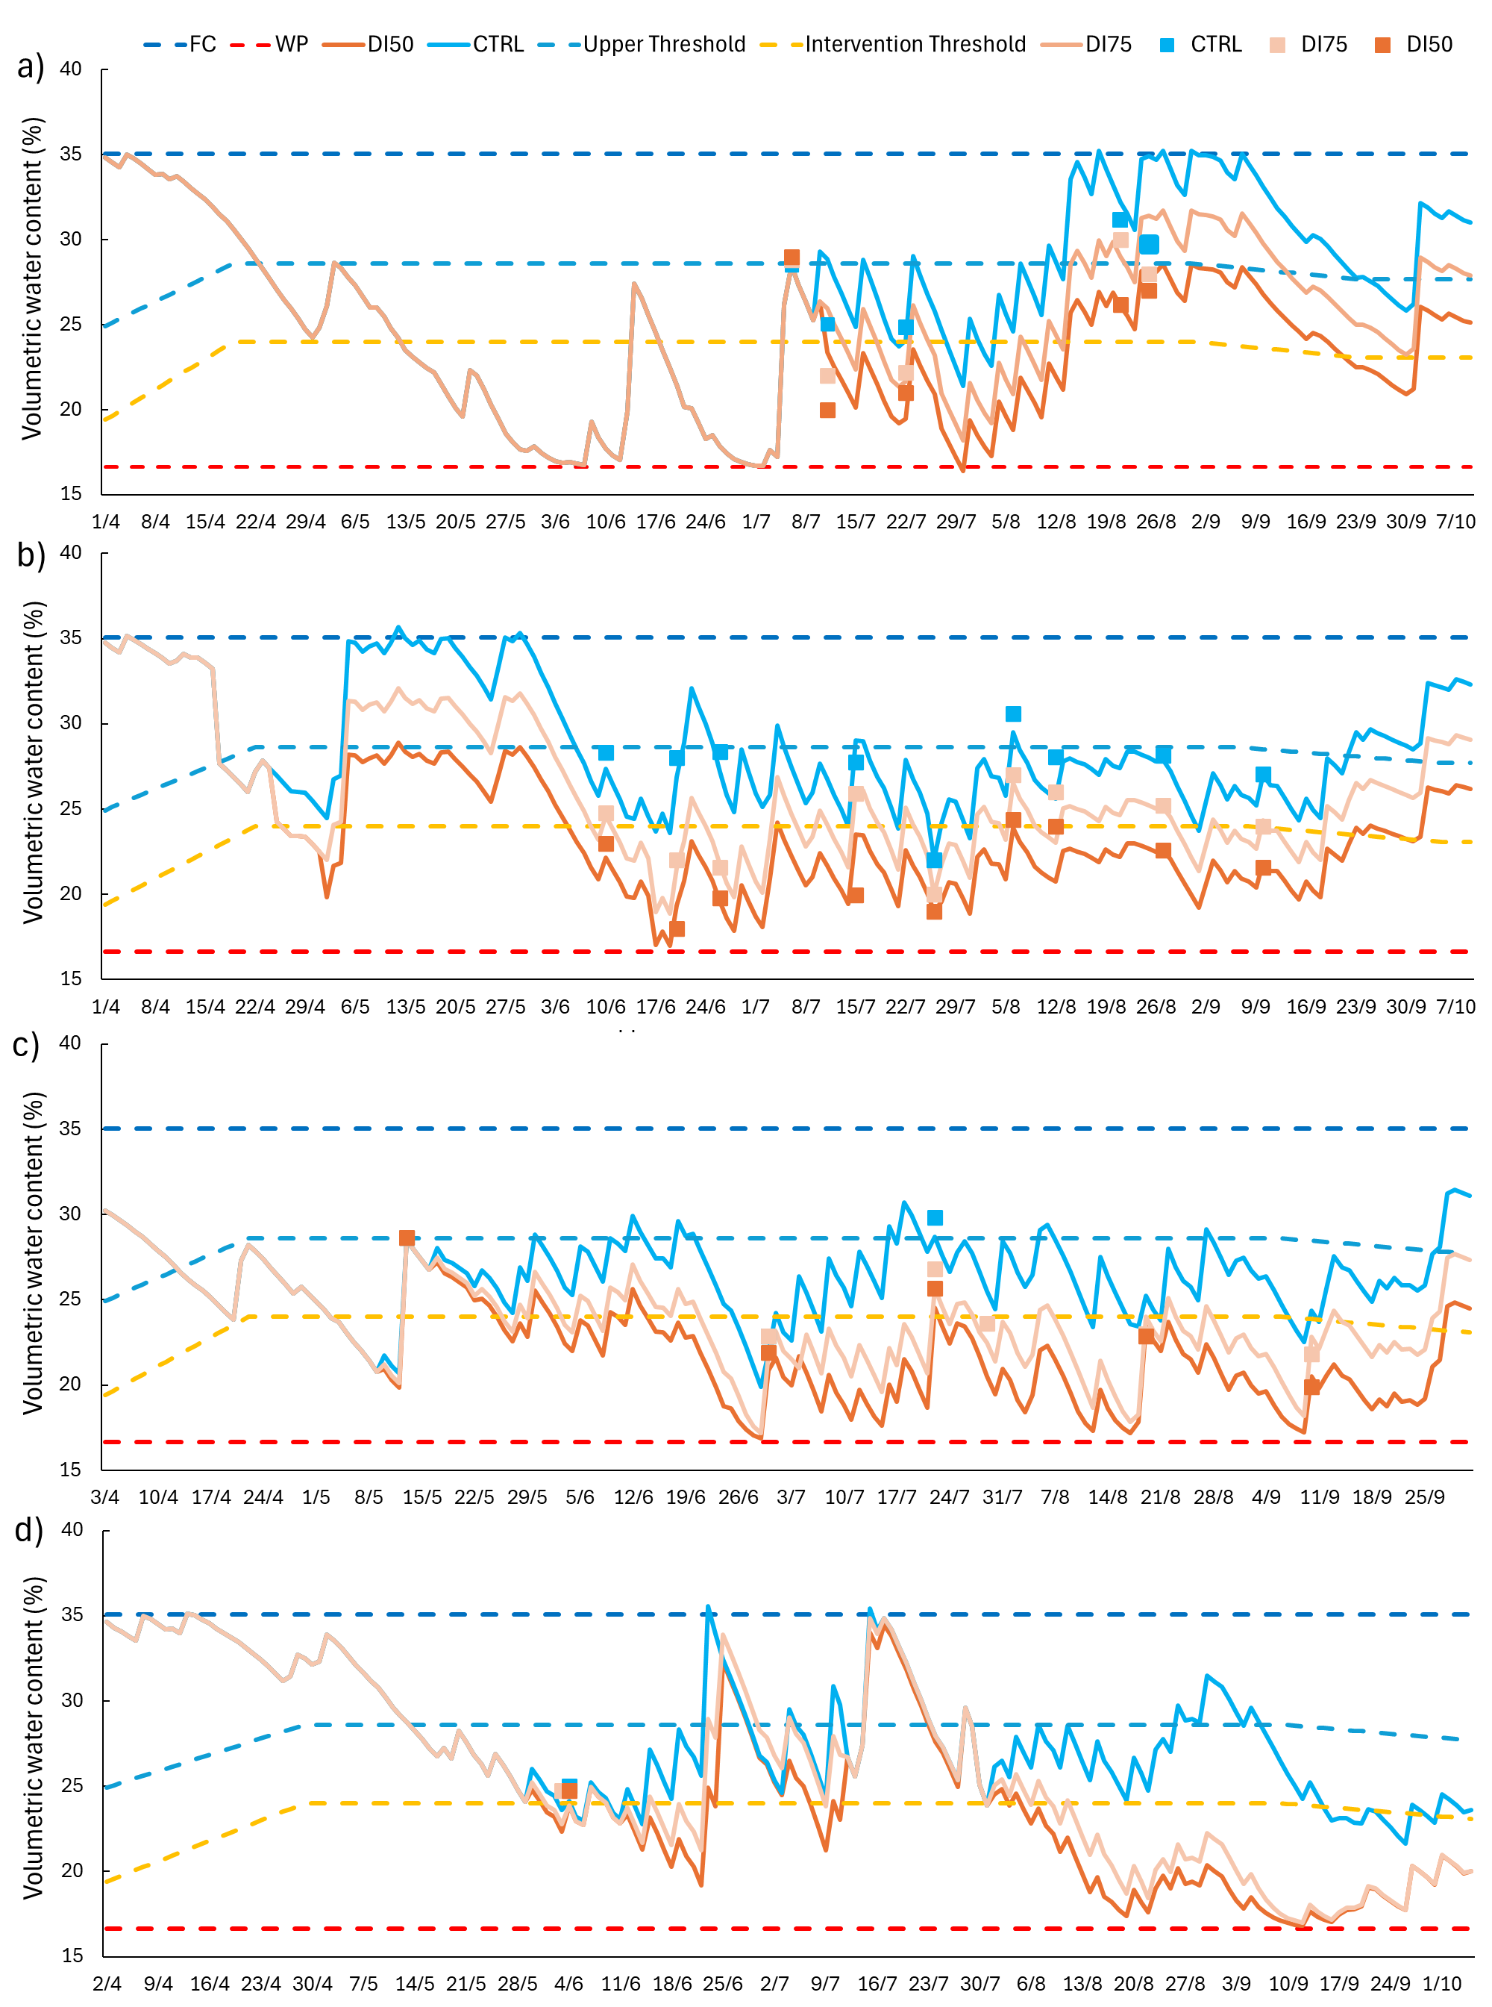
Figure S2. Estimated soil water content from the IRRIFRAME model in 2018 a); 2019 b); 2020 c); 2021 d). Continuous lines (orange, light-orange and light-blue) represent the estimated soil water content for each treatment. Squares (orange, light-orange and light-blue) are the real measured soil water content for each treatment. These punctiform soil moisture data measurements were utilized to perform an adjustment of the volumetric water content estimated by the IRRIFRAME model. Dashed lines (red, orange, blu and light-blue) represent respectively: Wilting Point (WP), Irrigation Intervention Threshold, Field Capacity (FC) and Upper Threshold.

