Table S1. Summary of studies included in the population pharmacokinetics analysis
Study | Dosing regimenª | PK sampling schedule | n^{b}
Study 12871: Phase I dose-escalation study of copanlisib in patients with solid tumors (NCT00962611)¹ | Copanlisib 0.1–1.2 mg/kg  (3 weeks on/1 week off) | Cycle 1, day 1: 0 hours (before dosing), 0.5, 1, 1.5, 2, 3, 5, 8, 11, 25, 49 hours after dosing; additional optional PK sample 72, 120 hours after dosing  Cycle 1, day 8: 0 hours (before dosing)  Cycle 1, day 15: 0 hours (before dosing), 0.5, 1, 1.5, 2, 3, 5, 8, 11, 25 hours after dosing  Cycle 3, day 15: 0 hours (before dosing), 0.5, 1, 1.5, 2, 3, 5, 8 hours after dosing | 56
Study 15205: Phase I dose-escalation study of copanlisib in Japanese patients with solid tumors (NCT01404390)² | Copanlisib 0.4 or 0.8 mg/kg (3 weeks on/1 week off) | Cycle 1, day 1: 0 hours (before dosing), 0.5, 1, 1.5, 2, 3, 5, 8, 11, 25, 49, 168 hours after dosing; additional optional PK samples 72, 96, 120 hours after dosing  Cycle 1, day 15: 0 hours (before dosing), 0.5, 1, 1.5, 2, 3, 5, 8, 11, 25 hours after dosing  Cycle 3, day 15: 0 hours (before dosing), 0.5, 1, 1.5, 2, 3, 5, 8 hours after dosing | 10
Study 16270: Phase I drug–drug interaction study of copanlisib in patients with advanced solid tumors (NCT02253420)³ | Copanlisib Arm A:  Cycle 1, part 1: single 12 mg doses on days 1 and 15; part 2: single 60 mg doses on days 1 and 15  Cycle 2 onwards: 60 mg  (3 weeks on/1 week off)  Copanlisib Arm B:  Cycle 1: single 60 mg doses on days 1 and 15  Cycle 2 onwards: 60 mg  (3 weeks on/1 week off)  Itraconazole (in Arm A):  Cycle 1, day 12: 200 mg  twice daily  Cycle 1, days 13–21: 200 mg once daily  Rifampin (in Arm B):  Cycle 1, days 10–21: 600 mg once daily | Cycle 1, day 1: 0.17, 1, 1.5, 2, 2.5, 3, 5, 8, 24, 48, 72, 96, 120, 168 hours after dosing  Cycle 1, day 15: 0.17, 1, 1.5, 2, 2.5, 3, 5, 8, 24, 48, 72, 96, 120, 168 hours after dosing  Cycle 3, day 1 (Arm B only): 0 hours (before dosing), 0.17, 1, 3 hours after dosing | 51
Study 16349: Phase II study of copanlisib in patients with aNHL or iNHL (NCT01660451;  CHRONOS-1)^{4,5} | Part A: copanlisib 0.8 mg/kg (3weeks on/1 week off)  Part B: copanlisib 60 mg  (3 weeks on/1 week off) | Cycle 1, day 8: 0 hours (before dosing), 1, 3 hours after dosing  Electrocardiogram sub-study  Cycle 1, day 1: 0 hours (before dosing), 1, 1.33, 2.5, 5, 8, 24 hours after dosing  Cycle 3, day 1: 0 hours (before dosing), 1 hour after dosing | Part A: 55  Part B: 122
Study 16790: Phase I pharmacodynamic study of copanlisib in patients with iNHL or solid tumors (NCT03711058)⁶ | Copanlisib 0.4 or 0.8 mg/kg  (3 weeks on/1 week off) | Cycle 1, day 1: 0.17, 1 hour (before end of infusion), 1.5, 2.5, 5, 8, 24 hours after dosing  Cycle 1, day 8: 0 hours (before dosing)  Cycle 2, day 1: 1.5 hours after dosing | 62
Study 16866: Phase I study of copanlisib in Chinese patients with relapsed iNHL (NCT03498430)⁷ | Copanlisib 60 mg  (3 weeks on/1 week off) | Cycle 1, day 8: 0 hours (before dosing), 0.17, 1, 1.5, 2, 3, 5, 8, 11, 24, 48, 72, 120, 168 hours after dosing  Cycle 1, day 15: 0 hours (before dosing), 0.17, 1, 1.5, 2, 3, 5, 8, 11, 24 hours after dosing | 12
Study 17067: Phase III study evaluating the efficacy and safety of copanlisib in combination with rituximab in patients with relapsed iNHL (NCT02367040; CHRONOS-3)⁸ | Copanlisib (n=307) 60 mg (3 weeks on/1 week off) or placebo (n=151) via 2:1 randomization:  Rituximab: 375 mg/m² given as an infusion for a duration influenced by precautions described in the drug label. Infusions were given on days 1, 8, 15, and 22 of cycle 1 and on day 1 of cycles 3, 5, 7, and 9 | Cycle 1, day 8: 0 hours (before dosing), 0.25, 0.92 hours after dosing  Cycle 1, day 15: 0 hours (before dosing), 5 minutes before end of rituximab infusion | 289
Study 17792: Phase Ib study in Japanese patients with iNHL relapsed after or refractory to standard therapy (NCT02342665)⁹ | Copanlisib 45 or 60 mg  (3 weeks on/1 week off) | Cycle 1, day 1: 0 hours (before dosing), 0.083, 1, 1.5, 2.5, 5, 8, 24, 48 hours after dosing  Cycle 1, day 8: 0 hours (before dosing)  Cycle 1, day 15: 0 hours (before dosing), 0.083, 1, 1.5 hours after dosing | 25
Study 18041: Phase I study of a single intravenous dose of copanlisib in patients with impaired hepatic or renal function compared with healthy participants (NCT03172884)¹⁰ | Single dose of copanlisib 12 mg | Day 1: 0 hours (before dosing), 0.17, 1, 1.5, 2, 2.5, 3, 5, 8, 24, 48, 72, 96, 120, 168 hours after dosing | Control group: 8  Group A: 8 (moderate hepatic impairment)  Group B: 8 (severe renal impairment)  Group C: 6 (severe hepatic impairment)
Abbreviations: aNHL, aggressive non-Hodgkin lymphoma; iNHL, indolent non-Hodgkin lymphoma; PK, pharmacokinetics.
ªAll copanlisib dose administrations were 1-hour intravenous infusions.
^{b}Number of patients with valid copanlisib PK observations.

REFERENCES
1. Patnaik, A. et al. First-in-human phase I study of copanlisib (BAY 80-6946), an intravenous pan-class I phosphatidylinositol 3-kinase inhibitor, in patients with advanced solid tumors and non-Hodgkin's lymphomas. Ann. Oncol. 27, 1928–1940 (2016).
2. Doi, T. et al. A Phase I study of intravenous PI3K inhibitor copanlisib in Japanese patients with advanced or refractory solid tumors. Cancer Chemother. Pharmacol. 79, 89–98 (2017).
3. Schlender, J.F. et al. Physiologically-based pharmacokinetic and clinical study to assess effects of CYP3A induction and inhibition on copanlisib PK in cancer patients. Clin. Pharmacol. Ther. 105 (Suppl 1), S5–S121 (2019).
4. Dreyling, M. et al. Phase II study of copanlisib, a PI3K inhibitor, in relapsed or refractory, indolent or aggressive lymphoma. Ann. Oncol. 28, 2169–2178 (2017).
5. Dreyling, M. et al. Phosphatidylinositol 3-kinase inhibition by copanlisib in relapsed or refractory indolent lymphoma. J. Clin. Oncol. 35, 3898–3905 (2017).
6. Morschhauser, F. et al. On-target pharmacodynamic activity of the PI3K inhibitor copanlisib in paired biopsies from patients with malignant lymphoma and advanced solid tumors. Mol. Cancer Ther. 19, 468–478 (2020).
7. Liu, W. et al. A phase I pharmacokinetic study of copanlisib in Chinese patients with relapsed indolent non-Hodgkin lymphoma. Cancer Chemother. Pharmacol. 89, 825–831 (2022).
8. Matasar, M.J. et al. Copanlisib plus rituximab versus placebo plus rituximab in patients with relapsed indolent non-Hodgkin lymphoma (CHRONOS-3): a double-blind, randomised, placebo-controlled, phase 3 trial. Lancet Oncol. 22, 678–689 (2021).
9. Maruyama, D. et al. Phase Ib/II study of copanlisib in Japanese patients with relapsed/refractory indolent B-cell NHL. Abstract OS1-7A-3 presented at: Japanese Society of Hematology Annual Meeting, Tokyo, Japan, October 11–13 (2019).
10. Granvil, C. et al. Effect of hepatic and renal impairment on the pharmacokinetics of copanlisib. Clin. Pharmacol. Ther. 109 (Suppl 1), S5–S88 (2021).

Table S2. Covariates tested for influence on the population pharmacokinetics base model
Covariate | Unit | Type | Description
Body weight | kg | Continuous | Body weight at baseline
Age | Years | Continuous | Age at baseline
Serum albumin | g/dL | Continuous | Serum albumin concentration at baseline
eGFRª | mL/min | Continuous | Estimated glomerular filtration rate at baseline
NCI^{b} | - | Categorical | Category of hepatic impairment at baseline
Sex | - | Dichotomous | Sex of patient as declared in study database
Region = Europe | - | Dichotomous | Geographic region of study is Europe
Region = North America | - | Dichotomous | Geographic region of study is North America
Region = Mainland China | - | Dichotomous | Geographic region of study is mainland China
Region = Japan | - | Dichotomous | Geographic region of study is Japan
Region = Others | - | Dichotomous | Geographic region of study is other than Europe, North America, mainland China, or Japan
Study group in study 18041 | - | Dichotomous | Patients not from study 18041 or healthy volunteers in study 18041 versus patients with moderate or severe hepatic impairment in study 18041 or patients with severe renal impairment in study 18041
Comedication with rifampin in study 16270 | - | Time-varying dichotomous | Covariate is set to 1 during periods of rifampin comedication in study 16270 and set to 0 at all other times for patients in study 16270, and set to 0 at all times for patients not in study 16270
Comedication with itraconazole in study 16270 | - | Time-varying dichotomous | Covariate is set to 1 during periods of itraconazole comedication in study 16270 and set to 0 at all other times for patients in study 16270, and set to 0 at all times for patients not in study 16270
Comedication with inhibitors of CYP450 3A sub-types | - | Time-varying dichotomous | Covariate is set to 1 during periods of comedication with inhibitors of CYP450 3A, and set to 0 at all other times
Comedication with inducers of CYP450 3A sub-types | - | Time-varying dichotomous | Covariate is set to 1 during periods of comedication with inducers of CYP450 3A, and set to 0 at all other times
Comedication with inhibitors of Pgp | - | Time-varying dichotomous | Covariate is set to 1 during periods of comedication with inhibitors of Pgp, and set to 0 at all other times
Comedication with inducers of Pgp | - | Time-varying dichotomous | Covariate is set to 1 during periods of comedication with inducers of Pgp, and set to 0 at all other times
Comedication with rituximab | - | Dichotomous | Rituximab was only co-administered in study 17067, so a test of the rituximab covariate is entirely confounded with a test of study 17067 versus all other studies
Abbreviations: CYP450 3A, cytochrome P450 3A; eGFR, estimated glomerular filtration rate; Pgp, permeability glycoprotein.
ªeGFR calculated using the equation of the Chronic Kidney Disease Epidemiology Collaboration¹ but with units converted from mL/min/1.73 m² to mL/min according to recent US Food and Drug Administration draft guidance.²
^{b}Category of hepatic impairment according to criteria of National Cancer Institute Organ Dysfunction Working Group.³
REFERENCES
1. Levey, A.S. et al. A new equation to estimate glomerular filtration rate. Ann. Intern. Med. 150, 604–612 (2009).
2. US Food and Drug Administration & Center for Drug Evaluation and Research. Draft Guidance for Industry. Pharmacokinetics in patients with impaired renal function: study design, data analysis, and impact on dosing and labeling. <https://www.fda.gov/regulatory-information/search-fda-guidance-documents/pharmacokinetics-patients-impaired-renal-function-study-design-data-analysis-and-impact-dosing-and> (2020). Accessed January 18, 2023.
3. Ramalingam, S.S. et al. Phase I study of vorinostat in patients with advanced solid tumors and hepatic dysfunction: a National Cancer Institute Organ Dysfunction Working Group study. J. Clin. Oncol. 28, 4507–4512 (2010).

Table S3. Clinical covariates investigated in the exposure–response models
Variable | Definition or categoriesª | ER model | Rationale
Treatment arm | 1 for the copanlisib plus rituximab treatment arm  0 for the placebo plus rituximab treatment arm | Exposure–efficacy and exposure–safety | Might influence safety and efficacy
Hypertension  (first infusion) | 1 for hypertension during first copanlisib infusion  0 for no hypertension during first copanlisib infusion | Exposure–efficacy | Question in ER (efficacy): is early hypertension a necessary intermediate pharmacodynamic effect?
Hyperglycemia  (first infusion) | 1 for hyperglycemia during first copanlisib infusion  0 for no hyperglycemia during first copanlisib infusion | Exposure–efficacy | Question in ER (efficacy): is early hyperglycemia a necessary intermediate pharmacodynamic effect?
Rituximab exposure | Individual rituximab pharmacokinetic samples taken on cycle 1, day 15 (third infusion): before infusion and at end of infusion; cycle 1, day 22 (fourth infusion): before infusion and at end of infusion  Tested as above or below median over all patients | Exposure–efficacy and exposure–safety | Might influence safety and efficacy
HbA_{1c} | 1 for HbA_{1c} ≥5.7%  0 for HbA_{1c} <5.7% | Exposure–efficacy and exposure–safety | Patients with borderline diabetes might be more prone to hyperglycemia
Bulky disease | 1 for bulky disease ≥7cm  0 for bulky disease <7 cm | Exposure–efficacy and exposure–safety | Tumors with additional development might be less likely to respond to treatment
Neutrophil count | 1 for absolute neutrophil count ≥3500/mm³  0 for absolute neutrophil count <3500/mm³ | Exposure–efficacy and exposure–safety | Possible influence on neutropenia and infections
Region = North America | 1 for North America  0 for rest of the world | Exposure–efficacy and exposure–safety | Regulatory interest
Region = Asia/Pacific: China | 1 for China  0 for rest of the world | Exposure–efficacy and exposure–safety | Regulatory interest
Region = Asia/Pacific: Japan | 1 for Japan  0 for rest of the world | Exposure–efficacy and exposure–safety | Regulatory interest
Region = Asia/Pacific: Other | 1 for Asia/Pacific (not China, Japan, or Australia)  0 for rest of the world | Exposure–efficacy and exposure–safety | Regulatory interest
Age | 1 for ≥65 years  0 for <65 years | Exposure–efficacy and exposure–safety | Age might influence response
Recent chemotherapy treatment | 1 for any recent treatment that included chemotherapy  0 for any recent treatment that did not include chemotherapy | Exposure–efficacy and exposure–safety | Increased tolerance of the tumor
Recent rituximab treatment | 1 for most recent treatment that included rituximab  0 for most recent treatment that did not include rituximab | Exposure–efficacy and exposure–safety | Increased tolerance of the tumor
Refractory disease | 1 for refractory to previous treatment  0 for not refractory to previous treatment | Exposure–efficacy and exposure–safety | Refractory tumors might be less likely to respond to treatment
Systemic cancer treatments | 1 for ≥4 previous systemic cancer treatments  0 for <4 previous systemic cancer treatments | Exposure–efficacy and exposure–safety | The more treatments a patient has received, the more susceptible they might be to adverse events and the more differentiated the tumor might be
ECOG score | 1 for ECOG score >0  0 for ECOG score 0 | Exposure–efficacy and exposure–safety | Patients with weaker scores might have a higher tendency to drop out
Hepatic function¹ | 1 for normal liver function  2 for mild liver dysfunction  3 for moderate liver dysfunction | Exposure–efficacy and exposure–safety | For considering ER in special populations
Renal function² | 1 for normal function (eGFR ≥90 mL/min)  2 for mild impairment (90 mL/min <eGFR ≥60 mL/min)  3 for moderate impairment (60 mL/min <eGFR ≥30 mL/min) | Exposure–efficacy and exposure–safety | For considering ER in special populations
Sex | 1 for male  0 for female | Exposure–efficacy and exposure–safety | For considering ER in special populations
Histology – SLL or LPL/WM | 1 for SLL or LPL/WM  0 for other histology | Exposure–efficacy and exposure–safety | Might influence safety and efficacy
Histology – MZL | 1 for MZL  0 for other histology | Exposure–efficacy and exposure–safety | Might influence safety and efficacy
Histology – FL | 1 for FL  0 for other histology | Exposure–efficacy and exposure–safety | Might influence safety and efficacy
Abbreviations: ER, exposure–response; FL, follicular lymphoma; HbA_{1c}, glycated hemoglobin; ECOG, Eastern Cooperative Oncology Group; eGFR, estimated glomerular filtration rate; LPL/WM, lymphoplasmacytic lymphoma/Waldenström macroglobulinemia; MZL, marginal zone lymphoma; SLL, small lymphocytic lymphoma.
ªValues taken at baseline (treatment day 1) unless otherwise stated.
REFERENCES
1. Reif, S., Ahsman, M., Jentsch, G., Wiegert, E., Grevel, J. & Granvil, C. Use of a population pharmacokinetic approach and time-to-event analysis to support the clinical recommendation of a flat dosing of copanlisib in cancer patients. Clin. Pharmacol. Ther. 99 (Suppl 1), S5–S107 (2016).
2. Dreyling, M. et al. Phase II study of copanlisib, a PI3K inhibitor, in relapsed or refractory, indolent or aggressive lymphoma. Ann. Oncol. 28, 2169–2178 (2017).

Figure S1. Structure of the copanlisib population pharmacokinetics covariate model. CL, clearance in an individual patient; CL_{pop}, clearance in a patient with the following covariate values: male in a non-Japanese Phase I or Phase II study without co-administration of rifampin or itraconazole and NCI −1 (normal liver function per the methodology of the National Cancer Institute Organ Dysfunction Working Group); ITRACON, time-varying covariate with a value of 1 when itraconazole is co-administered, else 0; JAPAN, covariate with a value of 1 for patients with region=4 (Japan), else 0; K₁₀, rate constant for elimination from central compartment; K₁₂ and K₂₁, rate constants for distribution between compartments 1 and 2; K₁₃ and K₃₁, rate constants for distribution between compartments 2 and 3; NCIGT1, covariate with a value of 1 for patients with NCI >1 (i.e., mild, moderate, or severely impaired liver function per the methodology of the National Cancer Institute Organ Dysfunction Working Group), else 0; Q2, inter-compartmental clearance for compartments 1 and 2; Q3, inter-compartmental clearance for compartments 1 and 3; SEXF, covariate with a value of 1 for female patients, else 0; STUD17067, covariate with a value of 1 for patients in study 17067, else 0; V1, volume of distribution for compartment 1 (central compartment) in an individual patient; V1_{pop}, volume of distribution for compartment 1 in a patient with the following covariate value: male without co-administration of rifampin; V2, volume of distribution for compartment 2; V3, volume of distribution for compartment 3; θ_{17607CL}, parameter describing the influence of STUD17067 on CL; θ_{ITRACL}, parameter describing the influence of ITRACON on CL; θ_{JAPCL}, parameter describing the influence of JAPAN on CL; θ_{NCICL}, parameter describing the influence of NCIGT1 on CL; θ_{RIFCL}, parameter describing the influence of RIFAMPIN on CL; θ_{RIFV1}, parameter describing the influence of RIFAMPIN on V1; θ_{SEXCL}, parameter describing the influence of SEXF on CL; θ_{SEXV1}, parameter describing the influence of SEXF on V1. Figure previously presented in a poster at the Third AACR International Meeting, Advances in Malignant Lymphoma: Maximizing the Basic-Translational Interface for Clinical Application, June 23-26, 2022, Boston, MA, USA, and reproduced with kind permission from Peter Morcos on behalf of all authors.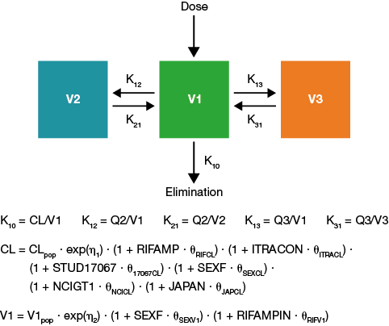

Figure S2. Goodness-of-fit plots from the final copanlisib population pharmacokinetics model. Bold horizontal lines show arithmetic mean CWRES within each bin of the independent variables (PRED and TAD). Each bin contains approximately 10% of the data and clearer bin limits are displayed as tick marks along the top of each plot. CWRES, conditional weighted residuals; DV, dependent variable; IPRED, individual prediction; PRED, prediction; TAD, time after dose.
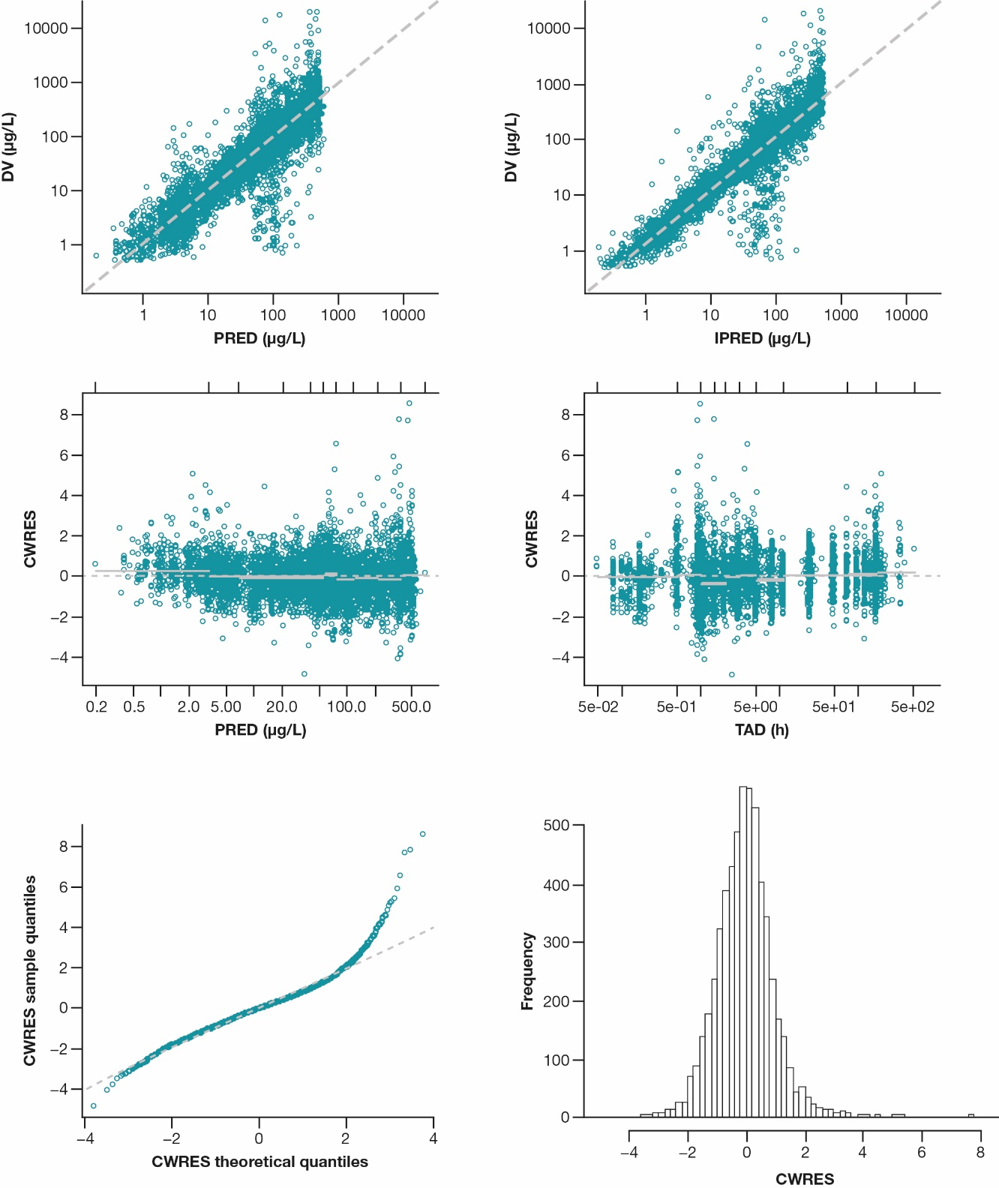
Figure S3. Univariate logistic regression of copanlisib AUC(0-168)_{nd} versus investigated safety endpoints. Copanlisib AUC(0-168)_{nd} is shown on the x-axis. Probability of the investigated safety event is shown on the y-axis. The solid lines represent the logistic regression fit with 95% CI. The blue points and vertical lines give the observed incidence rates and 95% CIs for each of the four quartiles of AUC(0-168)_{nd} and are located at the mean value for each quartile. Observed incidences for each quartile of AUC(0-168)_{nd} are given at the top of the plot. AUC(0-168)_{nd}, nominal area under the curve (0-168); CI, confidence interval.
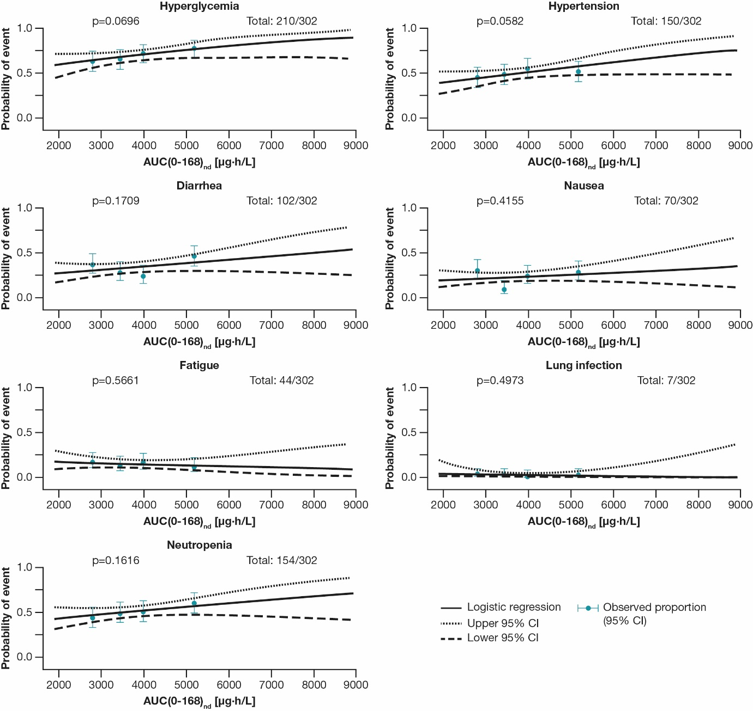
Figure S4. Graphical analysis of copanlisib relative dose intensity as a function of copanlisib AUC(0-168)_{nd}. Circles represent individual patient relative dose intensities in CHRONOS-3; AUC(0-168)_{nd} used as exposure metric for investigation of any relationship; orange line is loess trend line. AUC(0-168)_{nd}, nominal area under the curve (0-168).
