“Heal the sick": health status and caregiving during the 17th–18th century in Northern Italy (St. Biagio cemetery, Ravenna)

Supplementary Material 1

Tab. 1 SM1 Life table of St. Biagio church of Ravenna
x | dx | d'x | Ix | I'x | qx | px | Lx | Tx | ex
0-2 anni | 2 | 1.60 | 125.00 | 100.00 | 1.60 | 98.40 | 198.40 | 4037.60 | 40.38
3-11 | 3 | 2.40 | 123.00 | 98.40 | 2.44 | 97.56 | 874.80 | 3162.80 | 32.14
12-18 | 9 | 7.20 | 120.00 | 96.00 | 7.50 | 92.50 | 646.80 | 2516.00 | 26.21
19-29 | 10 | 8.00 | 111.00 | 88.80 | 9.01 | 90.99 | 848.00 | 1668.00 | 18.78
30-39 | 24 | 19.20 | 101.00 | 80.80 | 23.76 | 76.24 | 712.00 | 956.00 | 11.83
40-49 | 23 | 18.40 | 77.00 | 61.60 | 29.87 | 70.13 | 524.00 | 432.00 | 7.01
>50 | 54 | 43.20 | 54.00 | 43.20 | 100 | 0 | 216.00 | 216.00 | 5.00

Figure 1 SM1 Biomarkers frequencies in individuals from St. Biagio (Ravenna, Italy). Relative frequencies (in percentages) were calculated on the total number of individuals on which the biomarkers were detected (106 individuals).
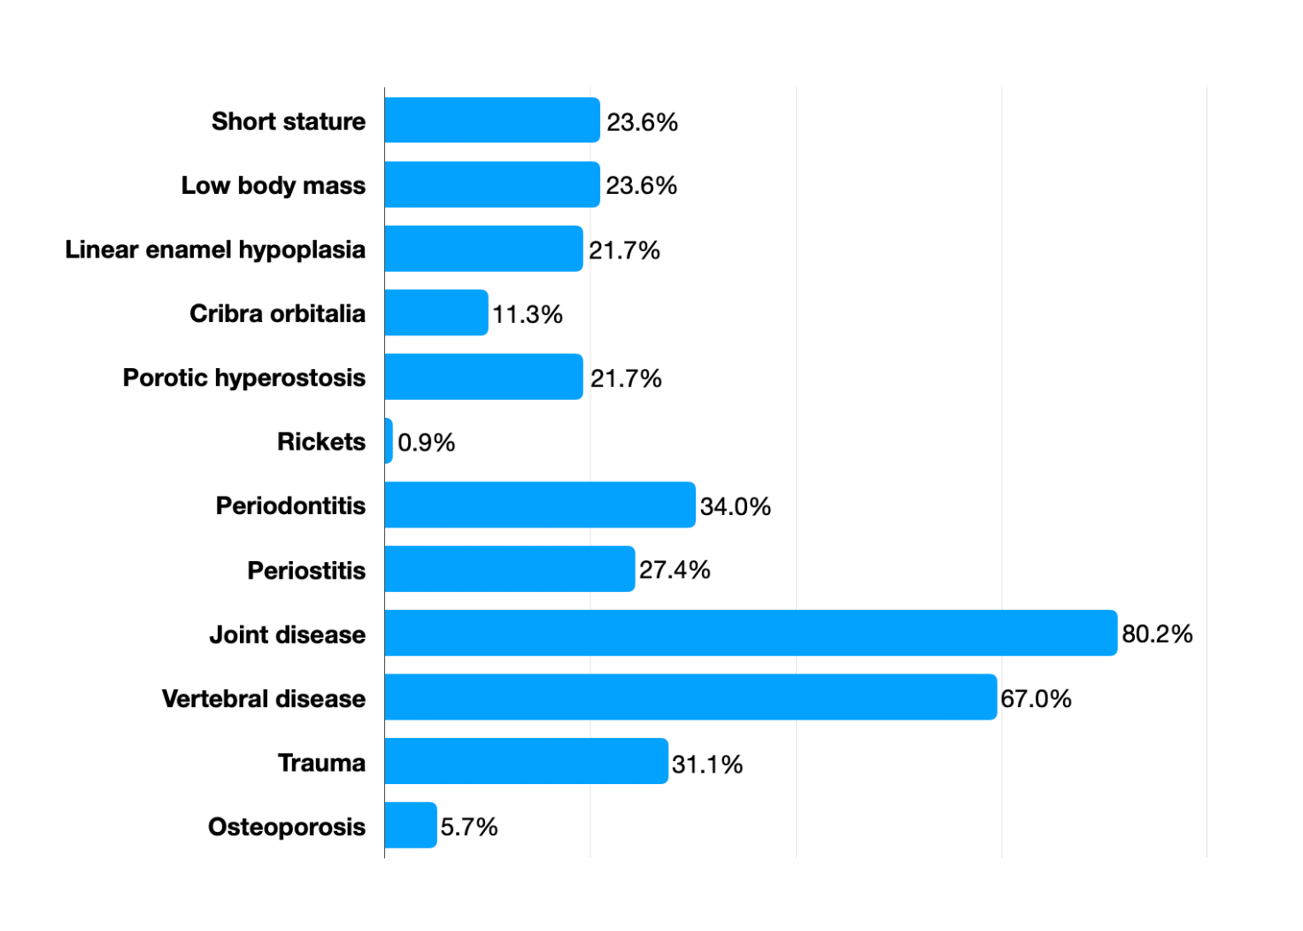

Figure 2 SM1. Bar graph representing the distribution of pathologies found in the total sample.

Figure 3 SM – Craniosynostosis cases at St. Biagio. A= Sk98a; B=Sk131.

