SUPPLEMENTAL APPENDIX

Supplemental Methods

Transition Performance Index (TPI)

The European Commission, Directorate-General for Research and Innovation evaluates the economic transition using the Transitions Performance Index (TPI). A successful Economic transition balances high performance in terms of wealth, education and ICT (information, communication and technology) use and skills, labor productivity and R&D (research and development intensity), and industrial base. The ranking and scores for Economic transition measure progress towards a sustainable and resilient prosperity model(1) . One EU country, Ireland, is a leader in economic transition, and eight countries are strong performers. Most of these combine strong or leader performances in education and wealth. Six countries are good performers in economic transition, with strengths in education and ICT skills. Twelve countries are in moderate or weak economic transition. For these moderate and weak performers, performances in wealth, labor productivity, R&D intensity, and industrial base are concerning.
Ranking and scores of the Economic transition
Country | 2020 Scores
Rank Name | Economic transition
Denmark | 73.4
Ireland | 76.1
Netherlands | 66.7
Germany | 70.7
Sweden | 73.0
Malta | 55.7
Slovenia | 62.5
Austria | 7.2
France | 58.9
Belgium | 67.9
Czechia | 60.4
Luxembourg | 69.3
Italy | 56.7
Finland | 68.2
Spain | 54.2
Portugal | 50.3
Estonia | 56.4
Slovakia | 50.1
Latvia | 47.9
Croatia | 45.6
Poland | 52.5
Hungary | 53.0
Lithuania | 52.3
Greece | 45.2
Romania | 42.2
Cyprus | 47.6
Bulgaria | 40.8

Supplemental Figure 1. Pearson correlation analyses: correlation between the ASMR-to-ASPR index and the TPI income levels

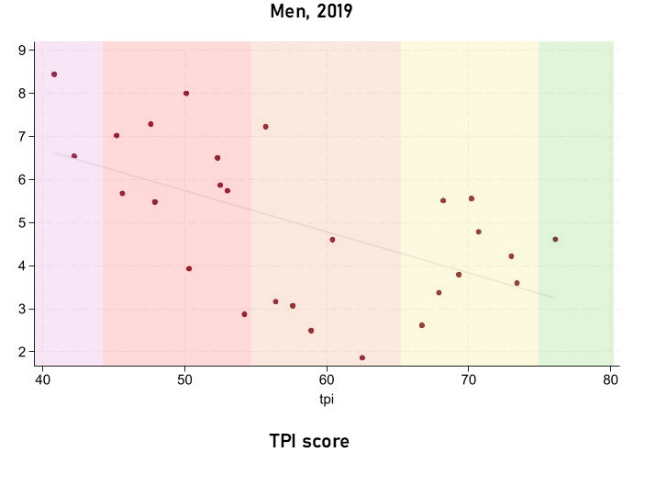
ASMR-to-ASPR index

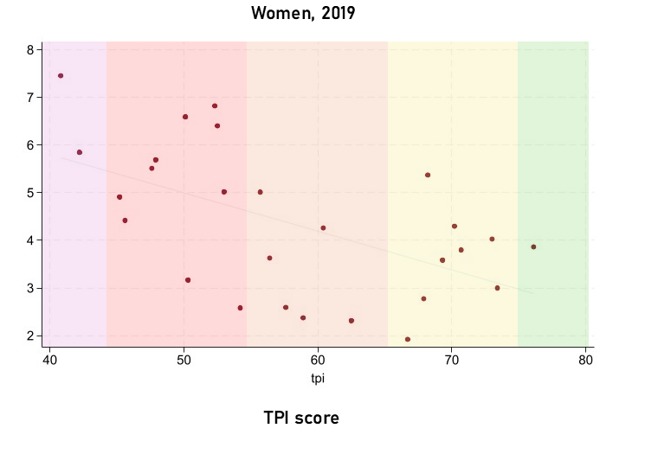
ASMR-to-ASPR index

Supplemental Figure 2. Pearson correlation analyses: correlation between the women-to-men ratios in ASMR-to-ASPR index and the TPI income levels
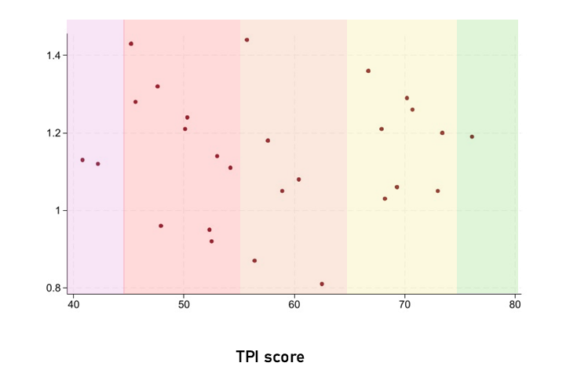
Women-to Men ratio in ASMR to ASPR index

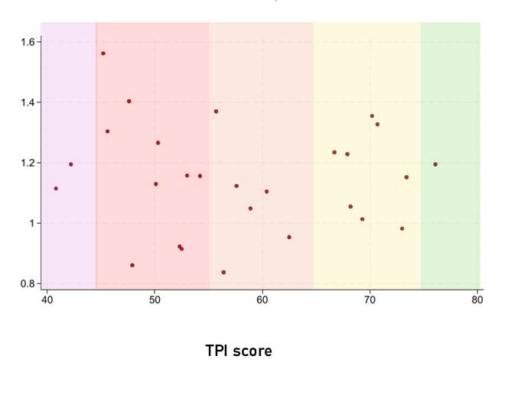
Women-to Men ratio in ASMR to ASPR index

Supplemental Figure 3. Pearson correlation analyses: correlation between the women-to-men ratios for elevated plasma glucose levels and the TPI income levels

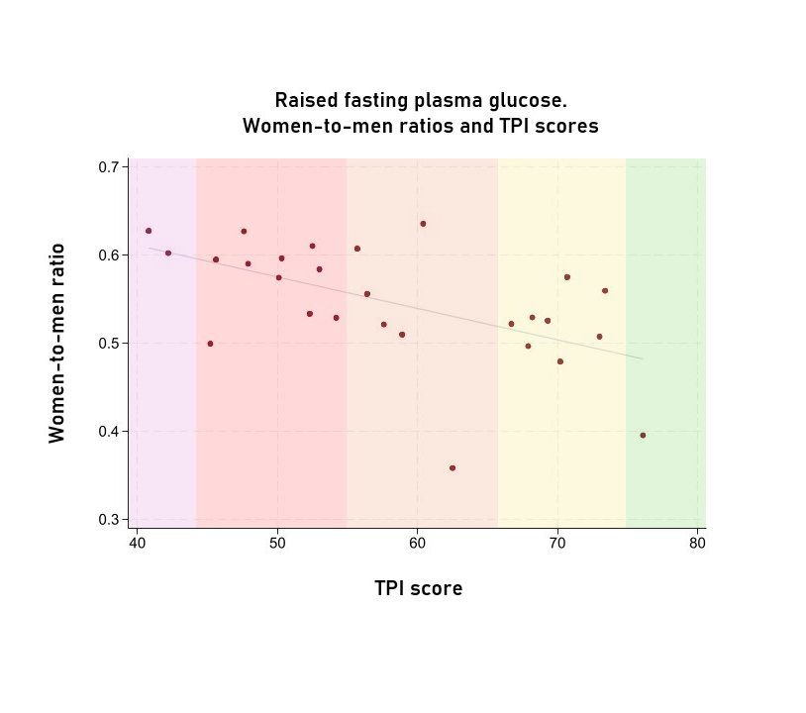

Supplemental Figure 4. Pearson correlation analyses: correlation between the women-to-men ratios for elevated LDL-c levels and the TPI income levels

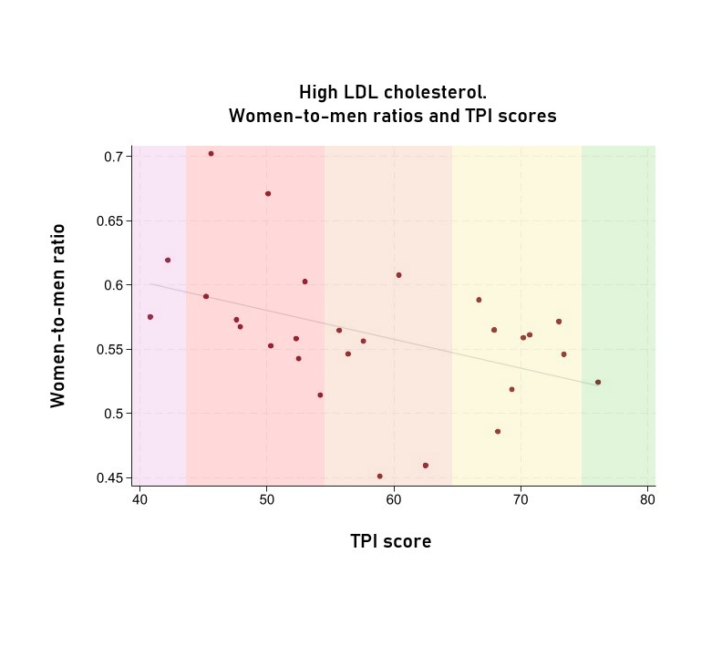

Supplemental Figure 5. Pearson correlation analyses: correlation between the women-to-men for elevated systolic blood pressure and the TPI income levels

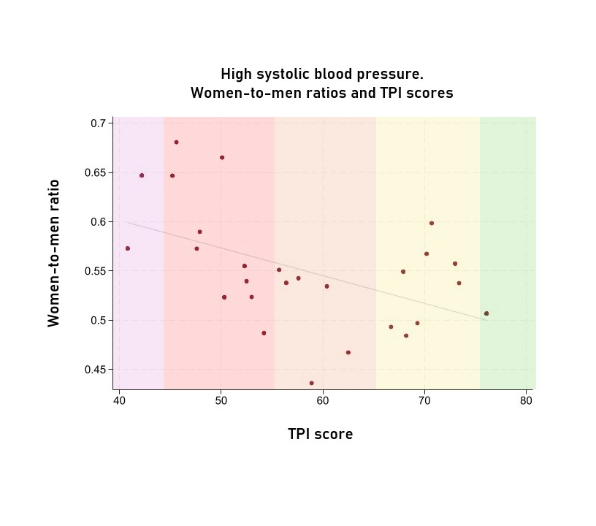

Supplemental Figure 6. Pearson correlation analyses: correlation between the women-to-men for low physical activity and the TPI income levels

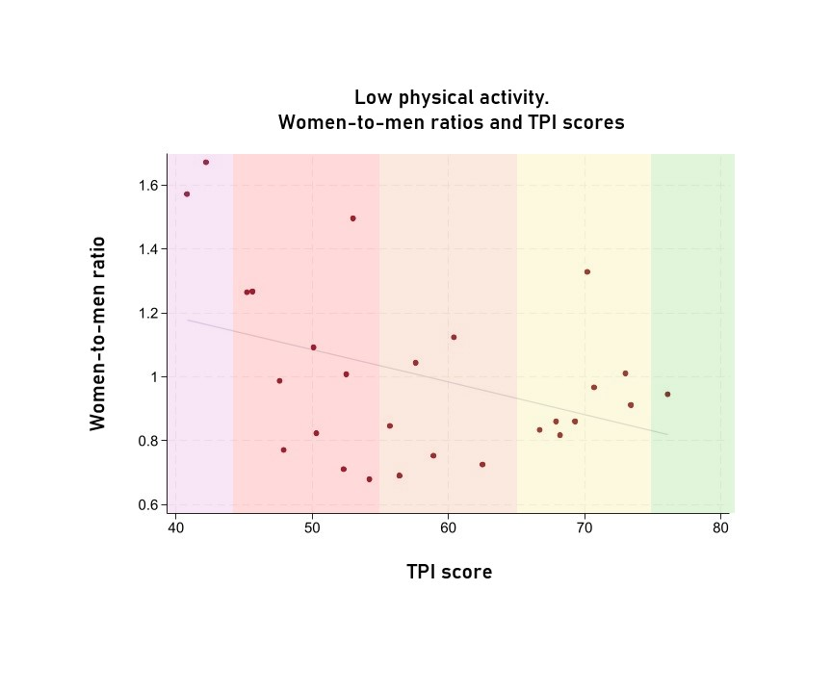

Supplemental Figure 7. Pearson correlation analyses: correlation between the women-to-men for exposure to air pollution and the TPI income levels

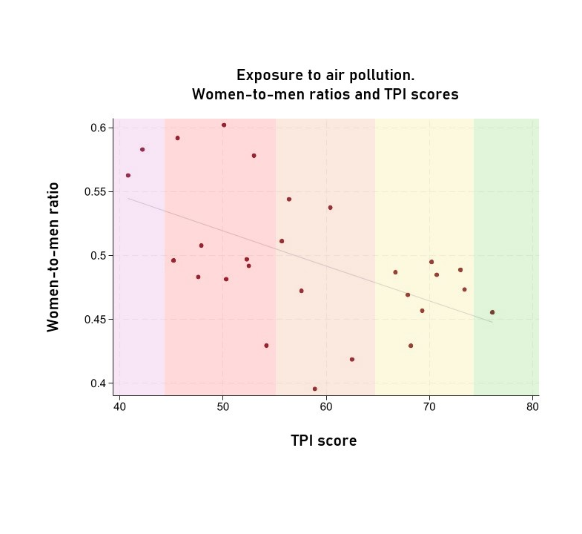

Supplemental Table 1. 2005-2019 age-standardised prevalence rate, mortality rate, ASMR-to-ASPR index, and risk ratio women to men in individuals of all ages, per 100,000 inhabitants. Data from GBD 2019
Country | Age-standardised prevalence rate of IHD  (100,000) |  |  |  | Age-standardized mortality rate for IHD per 100,000 inhabitants |  |  |  | ASMR-to-ASPR index  % |  |  |  | Women to men ratio
Country | 2005 |  | 2019 |  | 2005 |  | 2019 |  | 2005 |  | 2019 |  | 2005 | 2019
Country | Men | Women | Men | Women | Men | Women | Men | Women | Men | Women | Men | Women | 2005 | 2019
Transition leader
Ireland | 2902  (2674 - 3145) | 1297  (1164 - 1432) | 2578  (2357- 2823) | 1155  (1035 - 1282) | 163.08  (152.75 - 169.84) | 87.08  (76.15 - 93.05) | 99.6  (86.85 - 106.76) | 53.27  (44.39 - 59.12) | 5.62 (5.1 - 6.19) | 6.72 (5.83 - 7.74) | 3.86 (3.38 - 4.42) | 4.61 (3.87 - 5.49) | 1.19 (1.01 - 1.42) | 1.19 (0.96 - 1.49)
Strong transition
Austria | 2687  (2495 - 2898) | 1206  (1104 - 1313) | 2548  (2356 - 2758) | 1136  (1036 - 1243) | 159.41  (148.14 - 168.63) | 96.91  (84.85 - 104.94) | 109.48  (99.67 - 118.2) | 63.13  (53.31 - 70.88) | 5.93 (5.37 - 6.55) | 8.04 (7.02 - 9.2) | 4.3 (3.83 - 4.82) | 5.56 (4.71 - 6.57) | 1.35 (1.15 - 1.6) | 1.29 (1.06 - 1.59)
Belgium | 2939  (2736 - 3171) | 1274  (1163 - 1401) | 2676  (2476 - 2907) | 1175  (1062 - 1293) | 116.43  (109.16 - 121.53) | 62.01  (54.14 - 67.18) | 74.25  (67.85 - 78.75) | 39.61  (33.83 - 43.78) | 3.96 (3.62 - 4.34) | 4.87 (4.23 - 5.6) | 2.78 (2.49 - 3.09) | 3.37 (2.87 - 3.96) | 1.23 (1.04 - 1.45) | 1.22 (1 - 1.48)
Denmark | 2766  (2587 - 2967) | 1335  (1239 - 1438) | 2462  (2234 - 2692) | 1126  (1019 - 1240) | 126.67  (118.16 - 132.8) | 70.45  (61.65 - 75.74) | 73.88  (67.15 - 78.96) | 40.49  (34.2 - 44.91) | 4.58 (4.19 - 5.01) | 5.28 (4.66 - 5.98) | 3 (2.65 - 3.39) | 3.59 (3.05 - 4.24) | 1.15 (0.99 - 1.34) | 1.2 (0.97 - 1.47)
Finland | 2999  (2734 - 3279) | 1503  (1370 - 1649) | 2556  (2344 - 2782) | 1295  (1175 - 1431) | 195.02  (183.11 - 202.63) | 103.09  (89.74 - 110.26) | 137.34  (126.23 - 146) | 71.39  (59.84 - 79.14) | 6.5 (5.86 - 7.21) | 6.86 (5.99 - 7.86) | 5.37 (4.8 - 6.01) | 5.51 (4.66 - 6.52) | 1.05 (0.89 - 1.25) | 1.03 (0.84 - 1.26)
Germany | 3058  (2819 - 3291) | 1353  (1244 - 1465) | 2822  (2590 - 3064) | 1270  (1153 - 1386) | 142.62  (133.21 - 148.63) | 83.77  (73.44 - 89.51) | 107.22  (98.58 - 113.44) | 60.76  (52.6 - 66.38) | 4.66 (4.24 - 5.12) | 6.19 (5.46 - 7.02) | 3.8 (3.41 - 4.24) | 4.79 (4.14 - 5.54) | 1.33 (1.13 - 1.55) | 1.26 (1.05 - 1.51)
Luxembourg | 2053  (1873 - 2261) | 1075  (932 - 1237) | 2047  (1846 - 2261) | 1026  (905 - 1163) | 129.42  (120.59 - 137.21) | 68.64  (60.59 - 74.41) | 73.33  (63.53 - 82.44) | 38.91  (31.47 - 45.32) | 6.31 (5.63 - 7.07) | 6.39 (5.37 - 7.6) | 3.58 (3.04 - 4.22) | 3.79 (3.05 - 4.71) | 1.01 (0.82 - 1.25) | 1.06 (0.8 - 1.39)
Netherlands | 3631  (3367 - 3926) | 1476  (1341 - 1612) | 3275  (2993 - 3568) | 1327  (1205 - 1462) | 109.12  (101.47 - 114.46) | 54.77  (48 - 59.02) | 63  (57.05 - 67.53) | 34.74  (29.55 - 38.5) | 3.01 (2.73 - 3.31) | 3.71 (3.24 - 4.25) | 1.92 (1.7 - 2.17) | 2.62 (2.23 - 3.07) | 1.23 (1.04 - 1.46) | 1.36 (1.11 - 1.67)
Sweden | 2476  (2205 - 2787) | 1350  (1190 - 1533) | 2384  (2112 - 2695) | 1290  (1130 - 1466) | 148.75  (138.8 - 156.25) | 79.64  (69.21 - 86.51) | 96.04  (87.92 - 103.22) | 54.41  (45.64 - 62.8) | 6.01 (5.27 - 6.85) | 5.9 (4.99 - 6.97) | 4.03 (3.48 - 4.66) | 4.22 (3.44 - 5.18) | 0.98 (0.79 - 1.22) | 1.05 (0.81 - 1.35)
Good transition
Czech Republic | 4820  (4402 - 5296) | 2693  (2448 - 2980) | 4432  (4001 - 4953) | 2562  (2298 - 2861) | 272.62  (256.18 - 282.2) | 168.29  (152.1 - 177.75) | 188.86  (158.64 - 221.57) | 117.97  (95.3 - 138.33) | 5.66 (5.1 - 6.28) | 6.25 (5.52 - 7.08) | 4.26 (3.49 - 5.19) | 4.6 (3.72 - 5.7) | 1.1 (0.94 - 1.3) | 1.08 (0.81 - 1.45)
Estonia | 5557  (5141 - 6027) | 3475  (3189 - 3773) | 5388  (4900 - 5924) | 3567  (3247 - 3898) | 377.87  (352.47 - 406.03) | 197.88  (176.18 - 215.49) | 195.55  (155.95 - 253.77) | 112.91  (87.72 - 153.95) | 6.8 (6.11 - 7.57) | 5.69 (5 - 6.49) | 3.63 (2.78 - 4.74) | 3.17 (2.33 - 4.3) | 0.84 (0.71 - 0.99) | 0.87 (0.58 - 1.32)
France | 2440  (2244 - 2641) | 1088  (987 - 1201) | 2304  (2086 - 2528) | 1045  (938 - 1150) | 81.99  (75.67 - 87.34) | 38.34  (32.15 - 42.28) | 54.7  (49.58 - 58.87) | 26.07  (21.39 - 29.64) | 3.36 (3.02 - 3.74) | 3.52 (2.99 - 4.15) | 2.37 (2.09 - 2.7) | 2.49 (2.07 - 3.01) | 1.05 (0.86 - 1.28) | 1.05 (0.84 - 1.32)
Italy | 2960  (2676 - 3264) | 1434  (1282 - 1598) | 2838  (2550 - 3152) | 1339  (1196 - 1497) | 104  (95.45 - 111.46) | 56.58  (47.53 - 62.72) | 73.61  (65.37 - 79.3) | 41.07  (33.8 - 46.17) | 3.51 (3.1 - 3.98) | 3.95 (3.32 - 4.69) | 2.59 (2.25 - 2.99) | 3.07 (2.54 - 3.7) | 1.12 (0.91 - 1.39) | 1.18 (0.93 - 1.5)
Malta | 2229  (2039 - 2433) | 937  (813 - 1070) | 2357  (2149 - 2580) | 950  (840 - 1070) | 170.75  (159.12 - 180.24) | 98.35  (86.24 - 106.34) | 118.13  (106 - 129.71) | 68.64  (56.49 - 77.96) | 7.66 (6.88 - 8.53) | 10.49 (8.85 - 12.45) | 5.01 (4.38 - 5.74) | 7.22 (5.93 - 8.8) | 1.37 (1.12 - 1.68) | 1.44 (1.13 - 1.83)
Slovenia | 4138  (3713 - 4623) | 2345  (2065 - 2668) | 3661  (3275 - 4104) | 2191  (1923 - 2500) | 122.64  (111.41 - 141.64) | 66.26  (56.41 - 82.74) | 84.7  (67.04 - 107.01) | 40.81  (30.9 - 54.39) | 2.96 (2.51 - 3.5) | 2.83 (2.23 - 3.58) | 2.31 (1.78 - 3.01) | 1.86 (1.36 - 2.56) | 0.95 (0.71 - 1.28) | 0.81 (0.53 - 1.22)
Moderate transition
Croatia | 4439  (3962 - 4964) | 2224  (1967 - 2522) | 3932  (3472 - 4433) | 2109  (1852 - 2394) | 246.91  (230.74 - 261.03) | 161.28  (143.89 - 173.21) | 173.74  (142.52 - 207.96) | 119.72  (95.31 - 144.01) | 5.56 (4.89 - 6.33) | 7.25 (6.22 - 8.46) | 4.42 (3.53 - 5.53) | 5.68 (4.46 - 7.22) | 1.3 (1.07 - 1.6) | 1.28 (0.92 - 1.79)
Cyprus | 2084  (1897 - 2307) | 864  (748 - 988) | 2150  (1899 - 2456) | 998  (877 - 1143) | 206.36  (191.9 - 224.47) | 120.03  (106.1 - 134.75) | 118.5  (103.15 -140.65) | 72.71  (61.02 - 88.38) | 9.9 (8.73 - 11.23) | 13.9 (11.57 - 16.7) | 5.51 (4.49 - 6.76) | 7.29 (5.79 - 9.17) | 1.4 (1.12 - 1.76) | 1.32 (0.97 - 1.8)
Greece | 2320  (2132 - 2518) | 1038  (941 - 1148) | 2304  (2099- 2532) | 1039  (933 - 1153) | 143.12  (134.76 - 148.52) | 100  (89.4 - 105.65) | 113.14  (104.65 -119.46) | 72.94  (63.17 - 78.96) | 6.17 (5.6 - 6.79) | 9.64 (8.47 - 10.96) | 4.91 (4.38 - 5.51) | 7.02 (6.03 - 8.17) | 1.56 (1.33 - 1.83) | 1.43 (1.18 - 1.73)
Hungary | 5038  (4597 - 5538) | 2674  (2431 - 2971) | 4414  (3951 - 4966) | 2462  (2199 - 2743) | 302.06  (284.76 - 312.91) | 185.57  (167.6 - 195.39) | 221.55  (188.35 -258.48) | 141.31  (116.76 -165.39) | 6 (5.4 - 6.65) | 6.94 (6.12 - 7.87) | 5.02 (4.13 - 6.1) | 5.74 (4.68 - 7.04) | 1.16 (0.98 - 1.36) | 1.14 (0.86 - 1.52)
Latvia | 5014  (4593 - 5484) | 2843  (2565 - 3155) | 4763  (4314 - 5261) | 2873  (2553 - 3214) | 432.35  (409.78 - 457.83) | 211.01  (192.04 -222.97) | 270.95  (222.42 -330.45) | 157.4  (127.39 -195.02) | 8.62 (7.77 - 9.58) | 7.42 (6.54 - 8.43) | 5.69 (4.55 - 7.11) | 5.48 (4.29 - 6.99) | 0.86 (0.73 - 1.02) | 0.96 (0.69 - 1.34)
Lithuania | 4449  (4086 - 4872) | 2702  (2431 - 3020) | 4355  (3981- 4783) | 2710  (2437 - 3028) | 421.66  (399.08 - 439.7) | 236.39  (213.78 -249.09) | 297.18  (252.88 -348.59) | 176.14  (144.67 -206.21) | 9.48 (8.57 - 10.48) | 8.75 (7.66 - 9.98) | 6.82 (5.67 - 8.21) | 6.5 (5.29 - 7.99) | 0.92 (0.78 - 1.09) | 0.95 (0.72 - 1.26)
Poland | 3270  (2833 - 3775) | 2027  (1726 - 2388) | 2728  (2345 - 3162) | 1686  (1430 - 2001) | 252.43  (235.24 - 264.08) | 143.1  (126.7 - 151.3) | 174.68  (142.25 -211.15) | 98.91  (78.99 - 120.18) | 7.72 (6.61 - 9.01) | 7.06 (5.87 - 8.49) | 6.4 (5 - 8.2) | 5.87 (4.49 - 7.67) | 0.91 (0.72 - 1.16) | 0.92 (0.63 - 1.33)
Portugal | 1704  (1508 - 1931) | 856  (743 - 986) | 1864  (1636 - 2144) | 890  (777 - 1013) | 89.04  (83.07 - 93.33) | 56.62  (49.88 - 60.87) | 59  (54.09 - 63.31) | 34.97  (29.38 - 38.97) | 5.23 (4.56 - 5.99) | 6.61 (5.57 - 7.86) | 3.16 (2.71 - 3.7) | 3.93 (3.25 - 4.76) | 1.27 (1.02 - 1.58) | 1.24 (0.97 - 1.59)
Slovakia | 4175  (3748 - 4676) | 2317  (2068 - 2621) | 3664  (3261 - 4103) | 2085  (1856 - 2353) | 368.35  (346.06 - 381.28) | 230.97  (207.6 - 243.98) | 241.64  (196.24 -290.93) | 166.75  (134.09 -201.34) | 8.82 (7.82 - 9.96) | 9.97 (8.64 - 11.5) | 6.6 (5.26 - 8.28) | 8 (6.33 - 10.11) | 1.13 (0.94 - 1.36) | 1.21 (0.87 - 1.69)
Spain | 2459  (2266 - 2657) | 1124  (1027 - 1232) | 2351  (2145- 2588) | 1113  (1002 - 1236) | 94.12  (86.8 - 98.67) | 49.72  (41.74 - 55.33) | 60.71  (55.88 - 65.33) | 31.98  (26.69 - 36.87) | 3.83 (3.46 - 4.24) | 4.43 (3.75 - 5.22) | 2.58 (2.29 - 2.92) | 2.87 (2.37 - 3.48) | 1.16 (0.95 - 1.4) | 1.11 (0.89 - 1.4)
Weak transition
Bulgaria | 4341  (3861 - 4893) | 2423  (2163 - 2709) | 4036  (3615 - 4523) | 2254  (2002 - 2542) | 412.06  (388.1 - 434.84) | 256.36  (235.01 - 270.86) | 300.9  (250.37 - 353.62) | 190.23  (158.49 - 224.13) | 9.49 (8.32 - 10.83) | 10.58 (9.27 - 12.08) | 7.46 (6.07 - 9.15) | 8.44 (6.84 - 10.41) | 1.11 (0.92 - 1.34) | 1.13 (0.84 - 1.52)
Romania | 4090  (3651 - 4610) | 2379  (2114 - 2686) | 3760  (3339 - 4248) | 2196  (1962 - 2480) | 299.11  (282.64 - 314.08) | 207.85  (190.79- 219.46) | 219.87  (187.44 - 257.9) | 143.54  (119.71- 166.92) | 7.31 (6.43 - 8.32) | 8.74 (7.61 - 10.04) | 5.85 (4.78 - 7.15) | 6.54 (5.34 - 8) | 1.19 (0.99 - 1.44) | 1.12 (0.84 - 1.49)
Overall | 91036  (82841 - 100234) | 47311  (42455 - 52796) | 84649  (76331 - 93992) | 44872  (40041 - 50241) | 5687.95  (5328.62 - 5991.66) | 3290.96  (2932.92 - 3530.83) | 3801.55  (3257.65 - 4393.35) | 2270.78  (1866.09 - 2677.66) | 6.25 (5.59 - 6.99) | 6.96 (6.03 - 8.02) | 4.49 (3.74 - 5.39) | 5.06 (4.09 - 6.25) | 1.11 (0.93 - 1.33) | 1.13 (0.85 - 1.49)
European Union average | 3372 (3068 - 3712) | 1752 (1572 - 1955) | 3135 (2827 - 3481) | 1662 (1483 - 1861) | 210.66 (197.36 - 221.91) | 121.89 (108.63 - 130.77) | 140.8 (120.65 - 162.72) | 84.1 (69.11 - 99.17) | 6.25 (5.59 - 6.99) | 6.96 (6.03 - 8.02) | 4.49 (3.74 - 5.39) | 5.06 (4.09 - 6.25) | 1.11 (0.93 - 1.33) | 1.13 (0.85 - 1.49)
ASMR= age standardized mortality rate
ASPR= age standardized prevalence rate
IHD= ischemic heart disease. GBD 2019 definition describes IHD as International Classification of Disease (ICD) classes I20-25.9, namely: angina pectoris, acute myocardial infarction, subsequent ST elevation (STEMI) and non-ST elevation (NSTEMI) myocardial infarction, cxertain current complications following ST elevation (STEMI) and non-ST elevation (NSTEMI) myocardial infarction (within the 28 day period), other acute ischemic heart disease, and chronic ischemic heart disease.
Data and definitions from Global Burden of Disease Database, 2019

Supplemental Table 2. Age-standardised mortality rates for IHD attributable to high LDL cholesterol values.
Country | Men* | Women* | Women-to-Men ratio
Transition leader
Ireland | 42.32  (29.74 - 55.86) | 22.19  (14.04 - 31.06) | 0.52
Strong transition
Austria | 53.35  (38.5 - 70.28) | 29.83  (18.73 - 41.65) | 0.56
Belgium | 31.08  (22.34 - 40.77) | 17.57  (11.53 - 23.98) | 0.57
Denmark | 33.36  (23.8 - 43.59) | 18.22  (11.62 - 25.1) | 0.55
Finland | 60.53  (43.02 - 79) | 29.42  (17.85 - 42.13) | 0.49
Germany | 49.57  (35.58 - 64.64) | 27.82  (17.6 - 37.78) | 0.56
Luxembourg | 33.43  (23.22 - 44.23) | 17.34  (10.51 - 24.47) | 0.52
Netherlands | 28.38  (20.39 - 37.12) | 16.7  (11.14 - 22.47) | 0.59
Sweden | 42.2  (29.29 - 55.89) | 24.12  (15.11 - 33.97) | 0.57
Good transition
Czech Republic | 85.48  (57.52 - 115.31) | 51.95  (31.04 - 73.59) | 0.61
Estonia | 96.54  (63.41 - 140.84) | 52.76  (30.78 - 81.07) | 0.55
France | 26.54  (19.45 - 34.13) | 11.97  (7.51 - 16.6) | 0.45
Italy | 32.61  (23.34 - 43.39) | 18.14  (11.32 - 25.21) | 0.56
Malta | 56.16  (40.02 - 72.43) | 31.72  (20.34 - 43.19) | 0.56
Slovenia | 39.76  (26.76 - 55.68) | 18.27  (10.67 - 28.57) | 0.46
Moderate transition
Croatia | 75.44  (50.3 - 104.6) | 52.98  (31.54 - 76.54) | 0.70
Cyprus | 58.36  (41.91 - 76.99) | 33.44  (20.58 - 48.98) | 0.57
Greece | 53.87  (42.05 - 66.19) | 31.85  (20.82 - 43.15) | 0.59
Hungary | 99.71  (69.93 - 133.22) | 60.11  (37.57 - 83.82) | 0.60
Latvia | 127.73  (87.93 - 173.37) | 72.49  (46.24 - 105) | 0.57
Lithuania | 138.4  (96.68 - 186.45) | 77.27  (46.34 - 112.55) | 0.56
Poland | 74.07  (49.02 - 101.49) | 40.21  (24.27 - 58.69) | 0.54
Portugal | 29.31  (22.07 - 37.54) | 16.2  (10.47 - 22.62) | 0.55
Slovakia | 111.18  (75.45 - 151.98) | 74.62  (45.27 - 107.4) | 0.67
Spain | 26.69  (19.76 - 34.45) | 13.73  (8.69 - 19.62) | 0.51
Weak transition
Bulgaria | 141.67  (99.8 - 189.18) | 81.5  (52.08 - 114.53) | 0.58
Romania | 105.56  (74.85 - 140.25) | 65.39  (41.29 - 92.04) | 0.62
Data and definitions from Global Burden of Disease Database. 2019
*Each value corresponds to mortality rates per 100.000 inhabitants (95% Confidence Interval)

Supplemental Table 3. Age-standardised mortality rates for IHD attributable to high systolic blood pressure.
Country | Men* | Women* | Women-to-Men ratio
Transition leader
Ireland | 57.04  (43.47 - 69.7) | 28.91  (19.89 - 37.95) | 0.51
Strong transition
Austria | 59.84  (45.62 - 73.61) | 33.95  (22.49 - 44.82) | 0.57
Belgium | 40.69  (31.53 - 50.41) | 22.35  (15.77 - 28.49) | 0.55
Denmark | 42.5  (32.34 - 52.14) | 22.85  (15.8 - 29.79) | 0.54
Finland | 78.1  (59.25 - 94.44) | 37.82  (24.56 - 49.64) | 0.48
Germany | 59.21  (45.12 - 72.57) | 35.43  (24.9 - 45.4) | 0.60
Luxembourg | 42.32  (32 - 52.58) | 21.03  (13.62 - 28.25) | 0.50
Netherlands | 36.07  (27.8 - 44.3) | 17.79  (12.3 - 23.64) | 0.49
Sweden | 52.37  (39.27 - 64.97) | 29.19  (20.43 - 38.16) | 0.56
Good transition
Czech Republic | 98.27  (70.93 - 127.98) | 52.52  (32.39 - 74.72) | 0.53
Estonia | 111.94  (80.24 - 150.69) | 60.22  (38.23 - 86.5) | 0.54
France | 30.33  (22.8 - 37.29) | 13.23  (8.74 - 17.7) | 0.44
Italy | 34.62  (25.96 - 44.18) | 18.79  (12.22 - 25.19) | 0.54
Malta | 66.38  (51.1 - 81.71) | 36.59  (24.89 - 48.27) | 0.55
Slovenia | 50.52  (35.72 - 66.22) | 23.6  (14.85 - 33.59) | 0.47
Moderate transition
Croatia | 100.8  (71.77 - 129.88) | 68.61  (43.72 - 91.92) | 0.68
Cyprus | 66.04  (50.57 - 84.75) | 37.82  (24.53 - 51.02) | 0.57
Greece | 55.23  (43.55 - 67.82) | 35.72  (25.16 - 47.11) | 0.65
Hungary | 130.67  (96.52 - 164.33) | 68.41  (45.23 - 94.08) | 0.52
Latvia | 163.36  (121.71 - 208.99) | 96.34  (67.41 - 126.94) | 0.59
Lithuania | 184.02  (141.27 - 229.17) | 102.13  (70.51 - 134.29) | 0.56
Poland | 91.53  (67.23 - 117.58) | 49.39  (33.51 - 67.28) | 0.54
Portugal | 30.96  (24.31 - 38.1) | 16.2  (10.99 - 21.74) | 0.52
Slovakia | 141.75  (102.75 - 182.54) | 94.28  (61.7 - 126.32) | 0.67
Spain | 32.82  (26.14 - 39.9) | 15.98  (11.05 - 20.81) | 0.49
Weak transition
Bulgaria | 169.99  (123.76 - 217.36) | 97.39  (64.48 - 130.76) | 0.57
Romania | 136.73  (104.87 - 171.11) | 88.46  (62.44 - 112.76) | 0.65
Data and definitions from Global Burden of Disease Database. 2019
*Each value corresponds to mortality rates per 100.000 inhabitants (95% Confidence Interval)

Supplemental Table 4. Age-standardised mortality rates for IHD attributable to tobacco use.
Country | Men | Women | Women-to-Men ratio
Transition leader (High Income)
Ireland | 20.97  (18.45 - 22.99) | 9.83  (8.39 - 11.27) | 0.47
Strong transition
Austria | 26.18  (24.2 - 28.25) | 9.8  (8.62 - 11) | 0.37
Belgium | 17.92  (16.58 - 19.19) | 7.47  (6.62 - 8.25) | 0.42
Denmark | 18.51  (16.96 - 20.13) | 9.38  (8.13 - 10.62) | 0.51
Finland | 25.66  (23.36 - 28.02) | 8.06  (6.91 - 9.25) | 0.31
Germany | 23.03  (21.07 - 24.7) | 8.8  (7.73 - 9.94) | 0.38
Luxembourg | 15.8  (13.37 - 18.27) | 6.8  (5.37 - 8.36) | 0.43
Netherlands | 13.99  (12.77 - 15.28) | 6.75  (5.85 - 7.58) | 0.48
Sweden | 17.52  (15.89 - 19.17) | 10.16  (8.74 - 11.67) | 0.58
Good transition (High Income)
Czech Republic | 47.34  (38.41 - 56.98) | 18.51  (14.83 - 22.4) | 0.39
Estonia | 51.66  (39.57 - 68.38) | 14.43  (11.02 - 20.06) | 0.28
France | 11.79  (10.88 - 12.73) | 3.25  (2.82 - 3.7) | 0.28
Italy | 16.05  (14.68 - 17.33) | 5.24  (4.51 - 5.91) | 0.33
Malta | 25.78  (22.85 - 29.08) | 9.75  (8.15 - 11.46) | 0.38
Slovenia | 19.93  (15.68 - 25.56) | 6.62  (4.94 - 8.72) | 0.33
Moderate transition (Middle Income)
Croatia | 46.99  (37.35 - 58.21) | 21.33  (16.73 - 26.5) | 0.45
Cyprus | 36.32  (31.79 - 42.39) | 9.69  (8.13 - 11.83) | 0.27
Greece | 40.5  (37.69 - 43.27) | 13.86  (12.45 - 15.28) | 0.34
Hungary | 60.48  (49.75 - 72.62) | 26  (21.18 - 31.33) | 0.43
Latvia | 76.77  (60.79 - 96.3) | 18.75  (14.25 - 24.55) | 0.24
Lithuania | 76.18  (62.13 - 92.15) | 14.49  (11.63 - 17.83) | 0.19
Poland | 44.23  (34.68 - 55.32) | 16.16  (12.55 - 20.3) | 0.37
Portugal | 13.24  (12.21 - 14.39) | 2.96  (2.56 - 3.4) | 0.22
Slovakia | 57.54  (44.69 - 71.86) | 19.05  (14.63 - 23.97) | 0.33
Spain | 16.4  (15.13 - 17.63) | 3.63  (3.21 - 4.13) | 0.22
Weak transition (Middle Income)
Bulgaria | 89.06  (70.94 - 109.38) | 30.71  (24.16 - 38.43) | 0.34
Romania | 56.66  (46.56 - 67.93) | 19.19  (15.52 - 23.32) | 0.34
Data and definitions from Global Burden of Disease Database. 2019
*Each value corresponds to mortality rates per 100.000 inhabitants (95% Confidence Interval)

Supplemental Table 5. Age-standardised mortality rates for IHD attributable to elevated Body Mass Index.
Country | Men* | Women* | Women-to-Men ratio
Transition leader (High Income)
Ireland | 19.93  (10.79 - 30.89) | 9.61  (5.4 - 14.95) | 0.48
Strong transition (High Income)
Austria | 19.08  (9.77 - 30.15) | 10.69  (5.63 - 16.9) | 0.56
Belgium | 12.97  (6.93 - 20.25) | 6.99  (4.03 - 10.56) | 0.54
Denmark | 12.03  (6.18 - 18.95) | 6.42  (3.61 - 10.3) | 0.53
Finland | 23.98  (12.62 - 37.52) | 11.5  (6.02 - 18.47) | 0.48
Germany | 21.05  (11.31 - 32.25) | 11.26  (6.31 - 17.16) | 0.53
Luxembourg | 12.86  (6.85 - 20.19) | 6.57  (3.57 - 10.27) | 0.51
Netherlands | 10.37  (5.2 - 16.55) | 5.93  (3.25 - 9.42) | 0.57
Sweden | 16.29  (8.44 - 25.78) | 9.12  (5.01 - 14.28) | 0.56
Good transition (High Income)
Czech Republic | 47.77  (28.02 - 72.72) | 26.68  (14.61 - 41.17) | 0.56
Estonia | 47.26  (27.27 - 71.73) | 26.47  (14.49 - 41.37) | 0.56
France | 9.7  (5.19 - 15.14) | 4.37  (2.5 - 6.76) | 0.45
Italy | 12.18  (6.26 - 19.75) | 6.55  (3.6 - 10.4) | 0.54
Malta | 18.8  (9.56 - 30.2) | 11.56  (6.23 - 18.33) | 0.61
Slovenia | 21.74  (12.46 - 32.9) | 8.82  (4.82 - 14.01) | 0.41
Moderate transition (Middle Income)
Croatia | 42  (23.74 - 64.26) | 24.95  (13.28 - 39.05) | 0.59
Cyprus | 18.88  (9.8 - 30.07) | 9.66  (5.15 - 16.55) | 0.51
Greece | 24.51  (13.03 - 37.27) | 13.55  (7.39 - 20.75) | 0.55
Hungary | 58.15  (35.64 - 85.74) | 32.67  (19.06 - 48.67) | 0.56
Latvia | 64.86  (36.93 - 98.58) | 39.16  (22.31 - 59.64) | 0.60
Lithuania | 71  (39.41 - 106.75) | 41.01  (23.23 - 62.06) | 0.58
Poland | 43.04  (24.09 - 64.68) | 22.59  (12.83 - 34.03) | 0.52
Portugal | 10.65  (5.36 - 16.9) | 5.72  (3.1 - 9.07) | 0.54
Slovakia | 56.99  (31.46 - 89.19) | 37.94  (21.79 - 57.45) | 0.67
Spain | 12.68  (6.93 - 19.31) | 6.25  (3.52 - 9.84) | 0.49
Weak transition (Middle Income)
Bulgaria | 71.53  (40.36 - 109.03) | 38.97  (21.83 - 61.29) | 0.54
Romania | 55.23  (34.09 - 80.83) | 33.22  (20.86 - 48.46) | 0.60
Data and definitions from Global Burden of Disease Database. 2019
*Each value corresponds to mortality rates per 100.000 inhabitants (95% Confidence Interval)

Supplemental Table 6. Age-standardised mortality rates for IHD attributable to elevated fasting plasma glucose.
Country | Men* | Women* | Women-to-Men ratio
Transition leader
Ireland | 32.51  (15.61 - 58.25) | 12.85  (5.67 - 26.01) | 0.40
Strong transition
Austria | 32.52  (15.15 - 58.24) | 15.58  (6.89 - 31.7) | 0.48
Belgium | 20.44  (9.92 - 37.45) | 10.15  (4.61 - 20.34) | 0.50
Denmark | 15.87  (7.96 - 30.29) | 8.88  (3.67 - 18.82) | 0.56
Finland | 48.73  (24.39 - 85.7) | 25.79  (11.3 - 48.44) | 0.53
Germany | 38.9  (19.76 - 68.71) | 22.36  (9.75 - 41.76) | 0.57
Luxembourg | 27.79  (13.86 - 48.14) | 14.6  (6.25 - 27.45) | 0.53
Netherlands | 15.06  (7.27 - 27.72) | 7.86  (3.16 - 16.63) | 0.52
Sweden | 28.89  (14.25 - 52.81) | 14.66  (6.34 - 29.71) | 0.51
Good transition
Czech Republic | 70.35  (36.52 - 117.14) | 44.71  (20.38 - 79) | 0.64
Estonia | 34.34  (19.44 - 60.29) | 19.08  (9.26 - 35.32) | 0.56
France | 7.67  (4.29 - 12.15) | 3.91  (1.83 - 7) | 0.51
Italy | 25.43  (12.52 - 45.24) | 13.25  (5.75 - 26.13) | 0.52
Malta | 42.34  (21.03 - 70.69) | 25.72  (11.78 - 46.81) | 0.61
Slovenia | 23.74  (11.46 - 43.06) | 8.5  (4.04 - 15.76) | 0.36
Moderate transition
Croatia | 62.74  (31.09 - 110.06) | 37.32  (16.09 - 74.4) | 0.59
Cyprus | 42.02  (22.27 - 72.37) | 26.34  (11.25 - 53.41) | 0.63
Greece | 31.26  (16.7 - 53.95) | 15.61  (7.21 - 31.15) | 0.50
Hungary | 80.23  (41.81 - 134.74) | 46.85  (20.95 - 87.65) | 0.58
Latvia | 45.44  (26.46 - 72.08) | 26.82  (14.34 - 47.19) | 0.59
Lithuania | 41.68  (23.43 - 66.68) | 22.23  (11.15 - 38.21) | 0.53
Poland | 53.54  (28.02 - 90.44) | 32.68  (15.18 - 57.69) | 0.61
Portugal | 20.15  (10.91 - 33) | 12.02  (5.83 - 21.84) | 0.60
Slovakia | 59.64  (28.45 - 111.43) | 34.25  (17 - 61.1) | 0.57
Spain | 21.16  (10.88 - 35.84) | 11.19  (4.92 - 20.98) | 0.53
Weak transition
Bulgaria | 84.09  (41.62 - 145.86) | 52.77  (22.99 - 107.84) | 0.63
Romania | 41.26  (22.79 - 72.91) | 24.85  (12.67 - 43.83) | 0.60
Data and definitions from Global Burden of Disease Database. 2019
*Each value corresponds to mortality rates per 100.000 inhabitants (95% Confidence Interval)

Supplemental Table 7. Age-standardised mortality rates for IHD attributable to air pollution or physical inactivity
Country | Air Pollution |  | Women-to-Men ratio | Physical Inactivity |  | Women-to-Men ratio
Country | Men* | Women* | Women-to-Men ratio | Men* | Women* | Women-to-Men ratio
Transition leader (High Income)
Ireland | 3.74  (1.89 - 5.79) | 1.7  (0.85 - 2.69) | 0.46 | 7.73  (1.92 - 15.96) | 7.31  (3.46 - 11.4) | 0.95
Strong transition (High Income)
Austria | 7.73  (5.67 - 9.99) | 3.82  (2.71 - 5.11) | 0.49 | 5.16  (0.93 - 13.43) | 6.85  (2.58 - 11.93) | 1.33
Belgium | 5.77  (4.3 - 7.38) | 2.71  (1.95 - 3.54) | 0.47 | 4.92  (1.19 - 10.77) | 4.24  (1.69 - 7.32) | 0.86
Denmark | 3.92  (2.4 - 5.55) | 1.85  (1.14 - 2.69) | 0.47 | 4.1  (0.85 - 9.69) | 3.74  (1.31 - 6.89) | 0.91
Finland | 2.23  (0.45 - 4.66) | 0.96  (0.2 - 2.01) | 0.43 | 8.05  (1.7 - 18.71) | 6.58  (2.25 - 12.27) | 0.82
Germany | 7.46  (5.47 - 9.68) | 3.62  (2.58 - 4.81) | 0.48 | 4.96  (0.88 - 12.75) | 4.8  (1.46 - 9.73) | 0.97
Luxembourg | 4.1  (2.64 - 5.84) | 1.87  (1.17 - 2.71) | 0.46 | 4.16  (0.85 - 9.74) | 3.58  (1.17 - 6.71) | 0.86
Netherlands | 4.56  (3.34 - 5.89) | 2.22  (1.57 - 2.94) | 0.49 | 2.11  (0.35 - 5.94) | 1.76  (0.42 - 4.22) | 0.83
Sweden | 1.62  (0.43 - 3.25) | 0.79  (0.21 - 1.64) | 0.49 | 4.23  (0.75 - 11.2) | 4.28  (1.33 - 8.79) | 1.01
Good transition (High Income)
Czech Republic | 19.53  (14.53 - 25.45) | 10.5  (7.7 - 13.79) | 0.54 | 7.84  (2.3 - 18.88) | 8.82  (3.58 - 17.4) | 1.12
Estonia | 5.54  (1.7 - 10.58) | 3.01  (1 - 5.82) | 0.54 | 9.85  (3.1 - 21.75) | 6.81  (2.66 - 13.9) | 0.69
France | 3.73  (2.69 - 4.88) | 1.47  (1.02 - 2) | 0.40 | 4.2  (1.07 - 8.63) | 3.16  (1.37 - 5.28) | 0.75
Italy | 6.94  (5.44 - 8.59) | 3.28  (2.44 - 4.2) | 0.47 | 4.39  (0.95 - 10.17) | 4.58  (1.78 - 7.94) | 1.04
Malta | 9.53  (6.9 - 12.37) | 4.87  (3.42 - 6.48) | 0.51 | 12.15  (4.1 - 21.97) | 10.28  (5.38 - 15.7) | 0.85
Slovenia | 9.54  (6.8 - 13.1) | 3.99  (2.72 - 5.74) | 0.42 | 3.35  (0.92 - 8.26) | 2.43  (0.92 - 5.02) | 0.73
Moderate transition (Middle Income)
Croatia | 20.22  (15.1 - 26.5) | 11.97  (8.8 - 15.76) | 0.59 | 5.66  (1.52- 14.12) | 7.17  (2.7 - 14.68) | 1.27
Cyprus | 12.25  (9.1 - 16.15) | 5.92  (4.25 - 8.02) | 0.48 | 6.26  (1.3 - 15.58) | 6.18  (1.96 - 12.6) | 0.99
Greece | 11.43  (8.7 - 14.37) | 5.67  (4.23 - 7.28) | 0.50 | 4  (0.7 - 10.9) | 5.06  (1.46 - 10.7) | 1.27
Hungary | 26.91  (19.9 - 34.9) | 15.56  (11.2 - 20.5) | 0.58 | 5.12  (1.4 - 13.4) | 7.66  (2.9 - 15.9) | 1.50
Latvia | 21.96  (14.6 - 31.7) | 11.15  (7.27 - 16.6) | 0.51 | 17.59  (6.4 - 34.8) | 13.57  (5.7 - 25.8) | 0.77
Lithuania | 18.98  (12.2 - 27.1) | 9.43  (6.02 - 13.6) | 0.50 | 22.14  (8.5 - 42.6) | 15.75  (6.6 - 28.7) | 0.71
Poland | 25.87  (19.54 - 33.75) | 12.72  (9.61 - 16.5) | 0.49 | 7.24  (1.97 - 17.1) | 7.3  (2.87 - 14.5) | 1.01
Portugal | 2.6  (1.49 - 3.86) | 1.25  (0.72 - 1.91) | 0.48 | 4.6  (1.23 - 9.29) | 3.79  (1.5 - 6.59) | 0.82
Slovakia | 28.04  (20.6 - 36.9) | 16.88  (12.3 - 22.2) | 0.60 | 9.24  (2.54 - 22.3) | 10.09  (3.8 - 21.09) | 1.09
Spain | 3.47  (2.31 - 4.79) | 1.49  (0.98 - 2.11) | 0.43 | 4.31  (1.06 - 9.34) | 2.93  (0.99 - 5.55) | 0.68
Weak transition (Middle Income)
Bulgaria | 42.84  (32.09 - 54.8) | 24.1  (18.19 - 30.9) | 0.56 | 7.16  (1.85 - 18.95) | 11.26  (4.35 - 22.7) | 1.57
Romania | 25.11  (18.7 - 32.95) | 14.64  (10.75 - 19.4) | 0.58 | 6.9  (1.87 - 17.39) | 11.53  (4.66 - 21.81) | 1.67
Data and definitions from Global Burden of Disease Database. 2019
*Each value corresponds to mortality rates per 100.000 inhabitants (95% Confidence Interval)

Supplemental Table 8. Changes in intervention rates for 100.000 inhabitants for PCI and CABG, by country
Country | PCI rate per 100.000 inhabitants |  | CABG rate per 100.000 inhabitants |  | Total heart revascularization procedures rate per 100.000 inhabitants |  | Age-standardized IHD prevalence rates |  | PCI to IHD prevalence rate ratio  % |  | CABG to IHD prevalence rate ratio  % |  | Total heart revascularization procedures to IHD prevalence rate ratio  %
Country | 2005 | 2019 | 2005 | 2019 | 2005 | 2019 | 2005 | 2019 | 2005 | 2019 | 2005 | 2019 | 2005 | 2019
Transition leader
Ireland | 106.08 | 120.14 | 28.34 | 19.17 | 134.42 | 139.31 | 4.199 | 3.733 | 2.53 | 3.22 | 0.67 | 0.51 | 3.20 | 3.73
Strong transition
Austria | 210.55 | 325.66 | 52.29 | 36.32 | 262.84 | 361.98 | 3.893 | 3.684 | 5.41 | 8.84 | 1.34 | 0.99 | 6.75 | 9.83
Belgium | 241.4 | 283.17 | 82.29 | 59.92 | 323.69 | 343.09 | 4.213 | 3.851 | 5.73 | 7.35 | 1.95 | 1.56 | 7.68 | 8.91
Denmark | 209.78 | 189.17 | 92.45 | 51.54 | 302.23 | 240.71 | 4.101 | 3.588 | 5.12 | 5.27 | 2.25 | 1.44 | 7.37 | 6.71
Finland | 146.99 | 235.67 | 74.78 | 30.88 | 221.77 | 266.55 | 4.502 | 3.851 | 3.26 | 6.12 | 1.66 | 0.80 | 4.93 | 6.92
Germany | 279.34 | 419.48 | 79.94 | 54.64 | 359.28 | 474.12 | 4.411 | 4.092 | 6.33 | 10.25 | 1.81 | 1.34 | 8.15 | 11.59
Luxembourg | 176.71 | 120.81 | 61.05 | 16.13 | 237.76 | 136.94 | 3.128 | 3.074 | 5.65 | 3.93 | 1.95 | 0.52 | 7.60 | 4.45
Netherlands | 196.8 | 229.06 | 57.28 | 52.47 | 254.08 | 281.53 | 5.107 | 4.602 | 3.85 | 4.98 | 1.12 | 1.14 | 4.98 | 6.12
Sweden | 150.21 | 204.18 | 50.79 | 27.67 | 201 | 231.85 | 3.826 | 3.674 | 3.93 | 5.56 | 1.33 | 0.75 | 5.25 | 6.31
Good transition
Czech Republic | 205.3 | 219.3 | 76.01 | 43.48 | 281.31 | 262.78 | 7.513 | 6.995 | 2.73 | 3.14 | 1.01 | 0.62 | 3.74 | 3.76
Estonia | 116.62 | 219.99 | 51.52 | 36.1 | 168.14 | 256.09 | 9.032 | 8.955 | 1.29 | 2.46 | 0.57 | 0.40 | 1.86 | 2.86
France | 180.52 | 288.71 | 30.31 | 28.35 | 210.83 | 317.06 | 3.528 | 3.349 | 5.12 | 8.62 | 0.86 | 0.85 | 5.98 | 9.47
Italy | 173.28 | 229.1 | 53.15 | 34.13 | 226.43 | 263.23 | 4.394 | 4.177 | 3.94 | 5.48 | 1.21 | 0.82 | 5.15 | 6.30
Malta | no data | 187.87 | 108.71 | 31.15 | 108.71* | 219.02 | 3.166 | 3.307 | no data | 5.68 | 3.43 | 0.94 | 3.43** | 6.62
Slovenia | 85.28 | 224.38 | 34.29 | 38.4 | 119.57 | 262.78 | 6.483 | 5.852 | 1.32 | 3.83 | 0.53 | 0.66 | 1.84 | 4.49
Moderate transition
Croatia | no data | 410.26 | no data | 57.46 | no data | 467.72 | 6.663 | 6.041 | no data | 6.79 | no data | 0.95 | no data | 7.74
Cyprus | 2.3 | 154.77 | 67.29 | 54.65 | 69.59 | 209.42 | 2.948 | 3.148 | 0.08 | 4.92 | 2.28 | 1.74 | 2.36 | 6.65
Greece | no data | no data | no data | no data | no data | no data | 3.358 | 3.343 | no data | no data | no data | no data | no data | no data
Hungary | 143.31 | 242.38 | 46.87 | 28.25 | 190.18 | 270.63 | 7.712 | 6.876 | 1.86 | 3.53 | 0.61 | 0.41 | 2.47 | 3.94
Latvia | no data | no data | no data | no data | no data | no data | 7.857 | 7.636 | no data | no data | no data | no data | no data | no data
Lithuania | no data | 324.36 | no data | 56.58 | no data | 380.94 | 7.151 | 7.065 | no data | 4.59 | no data | 0.80 | no data | 5.39
Poland | 73.04 | 258.84 | 50.35 | 46.26 | 123.39 | 305.1 | 5.297 | 4.414 | 1.38 | 5.86 | 0.95 | 1.05 | 2.33 | 6.91
Portugal | 81.36 | 122.92 | 23.12 | 21.48 | 104.48 | 144.4 | 2.560 | 2.754 | 3.18 | 4.46 | 0.90 | 0.78 | 4.08 | 5.24
Slovakia | no data | no data | no data | 37.57 | no data | 37.57* | 6.492 | 5.749 | no data | no data | no data | 0.65 | no data | 0.65**
Spain | 91.72 | 128.59 | 18.07 | 16.35 | 109.79 | 144.94 | 3.583 | 3.465 | 2.56 | 3.71 | 0.50 | 0.47 | 3.06 | 4.18
Weak transition
Bulgaria | no data | 294.84 | no data | 38.12 | no data | 332.96 | 6.764 | 6.290 | no data | 4.69 | no data | 0.61 | no data | 5.29
Romania | no data | 139.38 | no data | 20.25 | no data | 159.63 | 6.469 | 5.956 | no data | 2.34 | no data | 0.34 | no data | 2.68
*= The value is the result of the sum of a known rate and an unknown one. because of missing data. It is reasonable to assume that the actual value is greater than what reported.
**= The value is the result of the ratio between the sum of a known rate and an unknown one. because of missing data. and a known rate. It is reasonable to assume that the actual value is greater than what reported.
All data were extrapolated by Eurostat and GBD 2019.
Abbreviations: CABG= coronary artery bypass graft. = bypass anastomosis for heart revascularization; IHD= ischemic heart disease; PCI= percutaneous coronary intervention.
PCI to IHD prevalence rate ratios. CABG to IHD prevalence rate ratios. and Total heart revascularization procedures to IHD prevalence rate ratios were obtained by dividing the rate of relevant procedures performed in the reference year by the IHD prevalence rate of that year. and multiplying by 100 to obtain a percentage.

Supplemental Table 9. Population* in European Union in 2005 and 2019, by sex, country, and TPI score. Data from World Bank
 | 2005 |  | 2019
 | Men | Women | Men | Women
Transition leader
Ireland | 2,075,615 | 2,084,299 | 2,444,120 | 2,490,220
Strong transition
Austria | 3,999,609 | 4,228,220 | 4,367,938 | 4,511,982
Belgium | 5,128,227 | 5,350,390 | 5,667,234 | 5,821,746
Denmark | 2,682,792 | 2,736,640 | 2,890,925 | 2,923,497
Finland | 2,567,217 | 2,678,879 | 2,725,793 | 2,795,813
Germany | 40,147,180 | 42,322,242 | 40,996,355 | 42,096,607
Luxembourg | 230,296 | 234,862 | 311,845 | 308,156
Netherlands | 8,076,039 | 8,243,829 | 8,615,130 | 8,729,744
Sweden | 4,477,573 | 4,551,999 | 5,168,880 | 5,110,007
Good transition
Czechia | 4,989,584 | 5,221,632 | 5,255,756 | 5,416,114
Estonia | 629,863 | 724,912 | 627,427 | 699,471
France | 30,619,950 | 32,568,445 | 32,586,251 | 34,801,750
Italy | 28,085,939 | 29,883,545 | 29,090,818 | 30,638,263
Malta | 200,402 | 203,432 | 259,855 | 244,207
Slovenia | 979,492 | 1,020,982 | 1,045,794 | 1,042,591
Moderate transition
Croatia | 2,068,224 | 2,241,921 | 1,976,147 | 2,089,106
Cyprus | 521,681 | 515,381 | 615,637 | 613,199
Greece | 5,461,842 | 5,525,472 | 5,254,476 | 5,467,106
Hungary | 4,789,543 | 5,297,522 | 4,678,279 | 5,092,862
Latvia | 1,019,762 | 1,219,037 | 883,240 | 1,030,582
Lithuania | 1,532,393 | 1,790,135 | 1,306,199 | 1,487,938
Poland | 18,518,319 | 19,647,126 | 18,370,296 | 19,595,179
Portugal | 5,051,464 | 5,451,866 | 4,855,992 | 5,430,271
Slovakia | 2,611,029 | 2,761,778 | 2,663,171 | 2,790,976
Spain | 21,516,423 | 22,136,732 | 23,104,636 | 24,030,201
Weak transition
Bulgaria | 3,691,351 | 3,967,621 | 3,383,676 | 3,592,085
Romania | 10,321,647 | 10,998,038 | 9,377,040 | 9,994,608
*Population is based on the de facto definition of population, which counts all residents regardless of legal status or citizenship. The values reported are midyear estimates.
World Bank staff estimates using the World Bank's total population and age/sex distributions of the United Nations Population Division's World Population Prospects: 2022 Revision.
Data and definition from World Bank (last accessed 6/08/2024)

Supplemental Table 10. Age-standardised prevalence rate (ASPR) in 2005, 2010, 2015, 2019 in individuals of all ages, per 100,000 inhabitants. Stratified for sex and country, and TPI scores. Data from GBD 2019
 | 2005 |  | 2010 |  | 2015 |  | 2019
 | Males | Females | Males | Females | Males | Females | Males | Females
Transition leader
Ireland | 2902  (2674 - 3145) | 1297  (1164 - 1432) | 2704  (2454 - 2966) | 1214  (1088 - 1356) | 2556  (2351 - 2780) | 1133  (1025 - 1253) | 2578  (2357- 2823) | 1155  (1035- 1282)
Strong transition
Austria | 2687  (2495 - 2898) | 1206  (1104 - 1313) | 2615  (2434 - 2824) | 1160  (1066 - 1269) | 2588  (2410 - 2782) | 1143  (1053 - 1240) | 2548  (2356- 2758) | 1136  (1036- 1243)
Belgium | 2939  (2736 - 3171) | 1274  (1163 - 1401) | 2910  (2704 - 3132) | 1260  (1145 - 1382) | 2814  (2627 - 3019) | 1215  (1112 - 1331) | 2676  (2476- 2907) | 1175  (1062- 1293)
Denmark | 2766  (2587 - 2967) | 1335  (1239 - 1438) | 2634  (2451 - 2833) | 1274  (1178 - 1386) | 2540  (2370 - 2741) | 1209  (1111 - 1311) | 2462  (2234- 2692) | 1126  (1019- 1240)
Finland | 2999  (2734 - 3279) | 1503  (1370 - 1649) | 2653  (2447 - 2897) | 1340  (1219 - 1472) | 2577  (2373 - 2780) | 1301  (1187 - 1427) | 2556  (2344- 2783) | 1295  (1175- 1431)
Germany | 3058  (2819 - 3291) | 1353  (1244 - 1465) | 2883  (2646 - 3132) | 1272  (1163 - 1389) | 2823  (2630 - 3036) | 1250  (1151 - 1358) | 2822  (2590- 3064) | 1270  (1153- 1386)
Luxembourg | 2053  (1873 - 2261) | 1075  (932 - 1237) | 2088  (1877 - 2322) | 1091  (951 - 1254) | 1975  (1804 - 2164) | 984  (869 - 1115) | 2047  (1846- 2261) | 1026  (905- 1163)
Netherlands | 3631  (3367 - 3926) | 1476  (1341 - 1612) | 3399  (3123 - 3699) | 1381  (1249 - 1522) | 3325  (3087 - 3571) | 1330  (1213 - 1446) | 3275  (2993- 3568) | 1327  (1205- 1462)
Sweden | 2476  (2205 - 2787) | 1350  (1190 - 1533) | 2396  (2117 - 2698) | 1316  (1159 - 1486) | 2361  (2100 - 2651) | 1281  (1131 - 1451) | 2384  (2113- 2695) | 1290  (1130- 1466)
Good transition
Czechia | 4820  (4402 - 5296) | 2693  (2448 - 2980) | 4553  (4116 - 5084) | 2619  (2336 - 2935) | 4471  (4068 - 4927) | 2551  (2306 - 2840) | 4433  (4001- 4953) | 2562  (2298- 2861)
Estonia | 5557  (5141 - 6027) | 3475  (3189 - 3773) | 5364  (4903 - 5862) | 3572  (3253 - 3912) | 5446  (5016 - 5907) | 3559  (3278 - 3868) | 5388  (4900- 5924) | 3567  (3247- 3898)
France | 2440  (2244 - 2641) | 1088  (987 - 1201) | 2379  (2161 - 2599) | 1082  (974 - 1197) | 2286  (2097 - 2488) | 1026  (926 - 1124) | 2304  (2086- 2528) | 1045  (938- 1150)
Italy | 2960  (2676 - 3264) | 1434  (1282 - 1598) | 2831  (2542 - 3154) | 1346  (1203 - 1505) | 2834  (2565 - 3132) | 1330  (1194 - 1478) | 2838  (2551- 3152) | 1339  (1196- 1497)
Malta | 2229  (2039 - 2433) | 937  (813 - 1070) | 2202  (1999 - 2416) | 955  (830 - 1093) | 2255  (2075 - 2456) | 913  (801 - 1034) | 2357  (2149- 2580) | 950  (840- 1070)
Slovenia | 4138  (3713 - 4623) | 2345  (2065 - 2668) | 3855  (3460 - 4318) | 2198  (1933 - 2515) | 3722  (3366 - 4144) | 2136  (1885 - 2428) | 3661  (3275- 4104) | 2191  (1923- 2500)
High income countries average | 3177  (2914 - 3467) | 1589  (1435 - 1758) | 3031  (2762 - 3329) | 1539  (1383 - 1711) | 2971  (2729 - 3239) | 1491  (1350 - 1647) | 2955  (2685 - 3253) | 1497  (1344 - 1663)
Moderate transition
Croatia | 4439  (3962 - 4964) | 2224  (1967 - 2522) | 4100  (3615 - 4644) | 2186  (1903 - 2520) | 3957  (3523 - 4478) | 2073  (1808 - 2379) | 3932  (3472- 4433) | 2109  (1852- 2394)
Cyprus | 2084  (1897 - 2307) | 864  (748 - 988) | 2147  (1913 - 2403) | 1010  (885 - 1165) | 2033  (1843 - 2251) | 846  (735 - 965) | 2150  (1899- 2456) | 998  (877- 1143)
Greece | 2320  (2132 - 2518) | 1038  (941 - 1148) | 2276  (2070 - 2497) | 1032  (930 - 1145) | 2273  (2083 - 2479) | 1017  (919 - 1126) | 2304  (2099- 2532) | 1039  (933- 1153)
Hungary | 5038  (4597 - 5538) | 2674  (2431 - 2971) | 4722  (4234 - 5296) | 2613  (2328 - 2951) | 4459  (4015 - 4971) | 2447  (2205 - 2730) | 4414  (3951- 4966) | 2462  (2199- 2743)
Latvia | 5014  (4593 - 5484) | 2843  (2565 - 3155) | 4851  (4413 - 5358) | 2894  (2585 - 3251) | 4813  (4413 - 5281) | 2796  (2520 - 3106) | 4763  (4314- 5261) | 2873  (2553- 3214)
Lithuania | 4449  (4086 - 4872) | 2702  (2431 - 3020) | 4430  (4044 - 4864) | 2721  (2446 - 3025) | 4391  (4039 - 4793) | 2645  (2384 - 2945) | 4355  (3981- 4783) | 2710  (2437- 3028)
Poland | 3270  (2833 - 3775) | 2027  (1726 - 2388) | 3005  (2581 - 3502) | 1874  (1587 - 2218) | 2758  (2380 - 3197) | 1668  (1414 - 1970) | 2728  (2345- 3162) | 1686  (1430- 2001)
Portugal | 1704  (1508 - 1931) | 856  (743 - 986) | 1885  (1653 - 2148) | 896  (780 - 1028) | 1533  (1362 - 1719) | 841  (727 - 968) | 1864  (1636- 2144) | 890  (777- 1013)
Slovakia | 4175  (3748 - 4676) | 2317  (2068 - 2621) | 3868  (3458 - 4336) | 2171  (1935 - 2446) | 3708  (3345 - 4135) | 2069  (1839 - 2322) | 3664  (3261- 4103) | 2085  (1856- 2353)
Spain | 2459  (2266 - 2657) | 1124  (1027 - 1232) | 2363  (2152 - 2593) | 1112  (998 - 1236) | 2324  (2138 - 2530) | 1086  (988 - 1202) | 2351  (2146- 2588) | 1113  (1002- 1236)
Weak transition
Bulgaria | 4341  (3861 - 4893) | 2423  (2163 - 2709) | 4115  (3690 - 4590) | 2290  (2044 - 2570) | 4033  (3637 - 4480) | 2221  (1994 - 2502) | 4036  (3615- 4523) | 2254  (2002- 2542)
Romania | 4090  (3651 - 4610) | 2379  (2114 - 2686) | 3907  (3469 - 4395) | 2255  (2000 - 2562) | 3773  (3376 - 4236) | 2168  (1930 - 2450) | 3760  (3339- 4248) | 2196  (1962- 2480)
Middle income countries average | 3615  (3261 - 4019) | 1956  (1744 - 2202) | 3472  (3108 - 3886) | 1921  (1702 - 2176) | 3338  (3013 - 3713) | 1823  (1622 - 2055) | 3360  (3005 - 3767) | 1868  (1657 - 2108)
EU average | 3372  (3068 - 3712) | 1752  (1572 - 1955) | 3227  (2916 - 3576) | 1709  (1525 - 1918) | 3134  (2855 - 3449) | 1639  (1471 - 1828) | 3135  (2827 - 3481) | 1662  (1483 - 1861)
ASPR= age standardized prevalence rate
IHD= ischemic heart disease. GBD 2019 definition describes IHD as International Classification of Disease (ICD) classes I20-25.9, namely: angina pectoris, acute myocardial infarction, subsequent ST elevation (STEMI) and non-ST elevation (NSTEMI) myocardial infarction, certain current complications following ST elevation (STEMI) and non-ST elevation (NSTEMI) myocardial infarction (within the 28 day period), other acute ischemic heart disease, and chronic ischemic heart disease.
Data and definitions from Global Burden of Disease Database, 2019

Supplemental Table 11. Age-standardised IHD mortality rate in 2005, 2010, 2015, 2019 in individuals of all ages, per 100,000 inhabitants. Stratified for sex and country, and TPI scores. Data from GBD 2019
 | 2005 |  | 2010 |  | 2015 |  | 2019
 | Males | Females | Males | Females | Males | Females | Males | Females
Transition leader
Ireland | 163.08  (152.75 - 169.84) | 87.08  (76.15 - 93.05) | 121.27  (112.2 - 127.65) | 63.32  (54.34 - 68.66) | 105.97  (97.33 - 111.88) | 56.52  (47.85 - 62.17) | 99.6  (86.85 - 106.76) | 53.27  (44.39 - 59.12)
Strong transition
Austria | 159.41  (148.14 - 168.63) | 96.91  (84.85 - 104.94) | 134.56  (123.64 - 143.7) | 77.75  (66.51 - 85.92) | 119.06  (109.13 - 128.12) | 67.24  (57.29 - 75.14) | 109.48  (99.67 - 118.2) | 63.13  (53.31 - 70.88)
Belgium | 116.43  (109.16 - 121.53) | 62.01  (54.14 - 67.18) | 92.49  (86.35 - 96.77) | 48.68  (42.56 - 53.24) | 76.39  (70.64 - 80.49) | 40.67  (35.12 - 44.63) | 74.25  (67.85 - 78.75) | 39.61  (33.83 - 43.78)
Denmark | 126.67  (118.16 - 132.8) | 70.45  (61.65 - 75.74) | 93.08  (86.28 - 98.04) | 51.6  (44.51 - 56.24) | 72.33  (66.21 - 77.15) | 39.65  (33.29 - 43.87) | 73.88  (67.15 - 78.96) | 40.49  (34.2 - 44.91)
Finland | 195.02  (183.11 - 202.63) | 103.09  (89.74 - 110.26) | 169.04  (157.33 - 176.2) | 86.46  (74.07 - 93.56) | 140.89  (129.62 - 148.59) | 72.82  (61.45 - 80.54) | 137.34  (126.23 - 146) | 71.39  (59.84 - 79.14)
Germany | 142.62  (133.21 - 148.63) | 83.77  (73.44 - 89.51) | 119.57  (111.44 - 125.55) | 67.7  (58.83 - 72.84) | 114.5  (105.85 - 120.18) | 62.25  (54.3 - 67.94) | 107.22  (98.58 - 113.44) | 60.76  (52.6 - 66.38)
Luxembourg | 129.42  (120.59 - 137.21) | 68.64  (60.59 - 74.41) | 99.98  (92.03 - 106.79) | 52.98  (45.92 - 58.17) | 77.99  (69.66 - 85.23) | 42.3  (35.68 - 47.79) | 73.33  (63.53 - 82.44) | 38.91  (31.47 - 45.32)
Netherlands | 109.12  (101.47 - 114.46) | 54.77  (48 - 59.02) | 77.37  (71.31 - 81.88) | 39.62  (33.87 - 43.69) | 63.92  (58.46 - 68.24) | 34.3  (29.06 - 38.15) | 63  (57.05 - 67.53) | 34.74  (29.55 - 38.5)
Sweden | 148.75  (138.8 - 156.25) | 79.64  (69.21 - 86.51) | 120.02  (110.89 - 127.36) | 67.36  (57.83 - 74.95) | 99.58  (91.78 - 107.01) | 55.81  (47.41 - 64.55) | 96.04  (87.92 - 103.22) | 54.41  (45.64 - 62.8)
Good transition
Czechia | 272.62  (256.18 - 282.2) | 168.29  (152.1 - 177.75) | 229.76  (215.46 - 238.63) | 140.99  (124.76 - 149.65) | 200.36  (185.09 - 209.79) | 123.94  (108.17 - 132.73) | 188.86  (158.64 - 221.57) | 117.97  (95.3 - 138.33)
Estonia | 377.87  (352.47 - 406.03) | 197.88  (176.18 - 215.49) | 271.36  (248.51 - 322.6) | 136.64  (116.14 - 172.3) | 208.58  (187.16 - 268.86) | 105.09  (86.75 - 149.67) | 195.55  (155.95 - 253.77) | 112.91  (87.72 - 153.95)
France | 81.99  (75.67 - 87.34) | 38.34  (32.15 - 42.28) | 68.37  (62.63 - 72.78) | 31.56  (26.4 - 35.07) | 58.16  (52.98 - 62.14) | 26.7  (21.75 - 30.02) | 54.7  (49.58 - 58.87) | 26.07  (21.39 - 29.64)
Italy | 104  (95.45 - 111.46) | 56.58  (47.53 - 62.72) | 87.24  (79.24 - 93.83) | 47.23  (39.42 - 52.81) | 78.15  (70.29 - 83.89) | 42.53  (35.37 - 47.66) | 73.61  (65.37 - 79.3) | 41.07  (33.8 - 46.17)
Malta | 170.75  (159.12 - 180.24) | 98.35  (86.24 - 106.34) | 149.93  (139.07 - 158.18) | 81.47  (70.14 - 89.34) | 124.66  (114.2 - 133.5) | 73.55  (62.27 - 81.54) | 118.13  (106 - 129.71) | 68.64  (56.49 - 77.96)
Slovenia | 122.64  (111.41 - 141.64) | 66.26  (56.41 - 82.74) | 103.68  (94.01 - 116.44) | 52.62  (44.25 - 66.84) | 90.86  (81.6 - 101.67) | 42.83  (34.85 - 54.53) | 84.7  (67.04 - 107.01) | 40.81  (30.9 - 54.39)
High income countries average | 161.36  (150.38 - 170.73) | 88.8  (77.89 - 96.53) | 129.18  (119.36 - 139.09) | 69.73  (59.97 - 78.22) | 108.76  (99.33 - 119.12) | 59.08  (50.04 - 68.06) | 103.31  (90.49 - 116.37) | 57.61  (47.36 - 67.42)
Moderate transition
Croatia | 246.91  (230.74 - 261.03) | 161.28  (143.89 - 173.21) | 212.01  (196.75 - 222.8) | 149.73  (133.33 - 161.08) | 190.52  (176.37 - 201.08) | 136.06  (120.6 - 147.31) | 173.74  (142.52 - 207.96) | 119.72  (95.31 - 144.01)
Cyprus | 206.36  (191.9 - 224.47) | 120.03  (106.1 - 134.75) | 179.4  (165.37 - 200.89) | 84.05  (73.34 - 98.01) | 142.23  (128.85 - 166.57) | 75.51  (64.97 - 93.05) | 118.5  (103.15 - 140.65) | 72.71  (61.02 - 88.38)
Greece | 143.12  (134.76 - 148.52) | 100  (89.4 - 105.65) | 127.99  (119.54 - 133.71) | 88.51  (77.66 - 95.04) | 110.75  (102.63 - 116.58) | 68.55  (59.37 - 74.17) | 113.14  (104.65 - 119.46) | 72.94  (63.17 - 78.96)
Hungary | 302.06  (284.76 - 312.91) | 185.57  (167.6 - 195.39) | 268  (250.74 - 278.31) | 166.15  (148.72 - 175.61) | 240.76  (224.28 - 252.15) | 152.78  (135.37 - 163.09) | 221.55  (188.35 - 258.48) | 141.31  (116.76 - 165.39)
Latvia | 432.35  (409.78 - 457.83) | 211.01  (192.04 - 222.97) | 356.71  (336.57 - 382.08) | 184.52  (166.41 - 199.88) | 307.25  (286.52 - 332.27) | 160.07  (141.29 - 175.11) | 270.95  (222.42 - 330.45) | 157.4  (127.39 - 195.02)
Lithuania | 421.66  (399.08 - 439.7) | 236.39  (213.78 - 249.09) | 384.29  (361.39 - 402.32) | 210.15  (187.56 - 222.32) | 347.81  (325.38 - 366.05) | 193.26  (171.26 - 205.53) | 297.18  (252.88 - 348.59) | 176.14  (144.67 - 206.21)
Poland | 252.43  (235.24 - 264.08) | 143.1  (126.7 - 151.3) | 211.39  (196.46 - 222.29) | 118.89  (103.64 - 127.44) | 185.48  (169.93 - 196.86) | 103.7  (89.49 - 111.87) | 174.68  (142.25 - 211.15) | 98.91  (78.99 - 120.18)
Portugal | 89.04  (83.07 - 93.33) | 56.62  (49.88 - 60.87) | 68.7  (64.02 - 72.68) | 42.3  (36.48 - 45.94) | 59.9  (55.23 - 63.99) | 34.92  (29.84 - 38.47) | 59  (54.09 - 63.31) | 34.97  (29.38 - 38.97)
Slovakia | 368.35  (346.06 - 381.28) | 230.97  (207.6 - 243.98) | 305.21  (284.32 - 319.15) | 197.16  (176.44 - 209.05) | 261.79  (241.02 - 280.66) | 172.42  (152.58 - 185.29) | 241.64  (196.24 - 290.93) | 166.75  (134.09 - 201.34)
Spain | 94.12  (86.8 - 98.67) | 49.72  (41.74 - 55.33) | 73.78  (67.7 - 77.87) | 37.08  (30.53 - 42.19) | 64.68  (59.62 - 69.24) | 32.47  (26.89 - 37.6) | 60.71  (55.88 - 65.33) | 31.98  (26.69 - 36.87)
Weak transition
Bulgaria | 412.06  (388.1 - 434.84) | 256.36  (235.01 - 270.86) | 332.33  (310.67 - 354.09) | 209.73  (192.32 - 226.2) | 300.24  (279.33 - 322.82) | 186.92  (169.14 - 202.36) | 300.9  (250.37 - 353.62) | 190.23  (158.49 - 224.13)
Romania | 299.11  (282.64 - 314.08) | 207.85  (190.79 - 219.46) | 264.69  (247.36 - 279.66) | 174.5  (158.96 - 185.33) | 228.66  (212.56 - 243.48) | 148.79  (132.9 - 158.25) | 219.87  (187.44 - 257.9) | 143.54  (119.71 - 166.92)
Middle income countries average | 272.3  (256.08 - 285.9) | 163.24  (147.04 - 173.57) | 232.04  (216.74 - 245.49) | 138.56  (123.78 - 149.01) | 203.34  (188.48 - 217.65) | 122.12  (107.81 - 132.68) | 187.66  (158.35 - 220.65) | 117.22  (96.31 - 138.86)
EU average | 210.66  (197.36 - 221.91) | 121.89  (108.63 - 130.77) | 174.9  (162.64 - 186.38) | 100.32  (88.33 - 109.68) | 150.8  (138.95 - 162.91) | 87.1  (75.72 - 96.78) | 140.8  (120.65 - 162.72) | 84.1  (69.11 - 99.17)
ASMR= age standardized mortality rate
IHD= ischemic heart disease. GBD 2019 definition describes IHD as International Classification of Disease (ICD) classes I20-25.9, namely: angina pectoris, acute myocardial infarction, subsequent ST elevation (STEMI) and non-ST elevation (NSTEMI) myocardial infarction, certain current complications following ST elevation (STEMI) and non-ST elevation (NSTEMI) myocardial infarction (within the 28 day period), other acute ischemic heart disease, and chronic ischemic heart disease.
Data and definitions from Global Burden of Disease Database, 2019

Supplemental Table 12. ASMR-to-ASPR index in 2005, 2010, 2015, 2019 in individuals of all ages, per 100,000 inhabitants. Stratified for sex and country, and TPI scores. Data from GBD 2019
 | 2005 |  | 2010 |  | 2015 |  | 2019
 | Males | Females | Males | Females | Males | Females | Males | Females
Transition leader
Ireland | 5.62  (5.1 - 6.19) | 6.72  (5.83 - 7.74) | 4.48  (4 - 5.03) | 5.22  (4.45 - 6.11) | 4.15  (3.72 - 4.62) | 4.99  (4.24 - 5.86) | 3.86  (3.38 - 4.42) | 4.61  (3.87 - 5.49)
Strong transition
Austria | 5.93  (5.37 - 6.55) | 8.04  (7.02 - 9.2) | 5.15  (4.63 - 5.72) | 6.7  (5.75 - 7.81) | 4.6  (4.13 - 5.12) | 5.88  (5.03 - 6.87) | 4.3  (3.83 - 4.82) | 5.56  (4.71 - 6.57)
Belgium | 3.96  (3.62 - 4.34) | 4.87  (4.23 - 5.6) | 3.18  (2.9 - 3.49) | 3.86  (3.34 - 4.46) | 2.71  (2.47 - 2.98) | 3.35  (2.89 - 3.88) | 2.78  (2.49 - 3.09) | 3.37  (2.87 - 3.96)
Denmark | 4.58  (4.19 - 5.01) | 5.28  (4.66 - 5.98) | 3.53  (3.21 - 3.89) | 4.05  (3.52 - 4.66) | 2.85  (2.56 - 3.16) | 3.28  (2.8 - 3.84) | 3  (2.65 - 3.39) | 3.59  (3.05 - 4.24)
Finland | 6.5  (5.86 - 7.21) | 6.86  (5.99 - 7.86) | 6.37  (5.76 - 7.05) | 6.45  (5.57 - 7.47) | 5.47  (4.93 - 6.07) | 5.6  (4.77 - 6.57) | 5.37  (4.8 - 6.01) | 5.51  (4.66 - 6.52)
Germany | 4.66  (4.24 - 5.12) | 6.19  (5.46 - 7.02) | 4.15  (3.74 - 4.6) | 5.32  (4.64 - 6.1) | 4.06  (3.69 - 4.46) | 4.98  (4.34 - 5.71) | 3.8  (3.41 - 4.24) | 4.79  (4.14 - 5.54)
Luxembourg | 6.31  (5.63 - 7.07) | 6.39  (5.37 - 7.6) | 4.79  (4.21 - 5.45) | 4.85  (4.05 - 5.82) | 3.95  (3.45 - 4.52) | 4.3  (3.56 - 5.2) | 3.58  (3.04 - 4.22) | 3.79  (3.05 - 4.71)
Netherlands | 3.01  (2.73 - 3.31) | 3.71  (3.24 - 4.25) | 2.28  (2.04 - 2.54) | 2.87  (2.45 - 3.36) | 1.92  (1.73 - 2.14) | 2.58  (2.2 - 3.02) | 1.92  (1.7 - 2.17) | 2.62  (2.23 - 3.07)
Sweden | 6.01  (5.27 - 6.85) | 5.9  (4.99 - 6.97) | 5.01  (4.36 - 5.76) | 5.12  (4.28 - 6.11) | 4.22  (3.67 - 4.85) | 4.36  (3.57 - 5.31) | 4.03  (3.48 - 4.66) | 4.22  (3.44 - 5.18)
Good transition
Czechia | 5.66  (5.1 - 6.28) | 6.25  (5.52 - 7.08) | 5.05  (4.49 - 5.68) | 5.38  (4.66 - 6.22) | 4.48  (4 - 5.02) | 4.86  (4.21 - 5.61) | 4.26  (3.49 - 5.19) | 4.6  (3.72 - 5.7)
Estonia | 6.8  (6.11 - 7.57) | 5.69  (5 - 6.49) | 5.06  (4.3 - 5.96) | 3.83  (3.05 - 4.79) | 3.83  (3.1 - 4.74) | 2.95  (2.16 - 4.03) | 3.63  (2.78 - 4.74) | 3.17  (2.33 - 4.3)
France | 3.36  (3.02 - 3.74) | 3.52  (2.99 - 4.15) | 2.87  (2.55 - 3.23) | 2.92  (2.46 - 3.46) | 2.54  (2.27 - 2.86) | 2.6  (2.17 - 3.12) | 2.37  (2.09 - 2.7) | 2.49  (2.07 - 3.01)
Italy | 3.51  (3.1 - 3.98) | 3.95  (3.32 - 4.69) | 3.08  (2.69 - 3.53) | 3.51  (2.93 - 4.2) | 2.76  (2.42 - 3.15) | 3.2  (2.67 - 3.83) | 2.59  (2.25 - 2.99) | 3.07  (2.54 - 3.7)
Malta | 7.66  (6.88 - 8.53) | 10.49  (8.85 - 12.45) | 6.81  (6.07 - 7.63) | 8.54  (7.12 - 10.23) | 5.53  (4.93 - 6.2) | 8.06  (6.71 - 9.68) | 5.01  (4.38 - 5.74) | 7.22  (5.93 - 8.8)
Slovenia | 2.96  (2.51 - 3.5) | 2.83  (2.23 - 3.58) | 2.69  (2.3 - 3.14) | 2.39  (1.86 - 3.08) | 2.44  (2.1 - 2.84) | 2  (1.54 - 2.61) | 2.31  (1.78 - 3.01) | 1.86  (1.36 - 2.56)
High income countries average | 5.1  (3.3 - 7.89) | 5.78  (3.74 - 8.92) | 4.3  (2.77 - 6.67) | 4.73  (3.04 - 7.38) | 3.7  (2.36 - 5.79) | 4.2  (2.66 - 6.62) | 3.52  (2.24 - 5.54) | 4.03  (2.54 - 6.39)
Moderate transition
Croatia | 5.56  (4.89 - 6.33) | 7.25  (6.22 - 8.46) | 5.17  (4.5 - 5.95) | 6.85  (5.79 - 8.11) | 4.81  (4.2 - 5.52) | 6.56  (5.54 - 7.77) | 4.42  (3.53 - 5.53) | 5.68  (4.46 - 7.22)
Cyprus | 9.9  (8.73 - 11.23) | 13.9  (11.57 - 16.7) | 8.36  (7.18 - 9.72) | 8.32  (6.8 - 10.19) | 7  (5.92 - 8.26) | 8.93  (7.09 - 11.24) | 5.51  (4.49 - 6.76) | 7.29  (5.79 - 9.17)
Greece | 6.17  (5.6 - 6.79) | 9.64  (8.47 - 10.96) | 5.62  (5.04 - 6.27) | 8.58  (7.44 - 9.9) | 4.87  (4.38 - 5.42) | 6.74  (5.81 - 7.82) | 4.91  (4.38 - 5.51) | 7.02  (6.03 - 8.17)
Hungary | 6  (5.4 - 6.65) | 6.94  (6.12 - 7.87) | 5.68  (5.01 - 6.42) | 6.36  (5.51 - 7.34) | 5.4  (4.78 - 6.1) | 6.24  (5.42 - 7.18) | 5.02  (4.13 - 6.1) | 5.74  (4.68 - 7.04)
Latvia | 8.62  (7.77 - 9.58) | 7.42  (6.54 - 8.43) | 7.35  (6.55 - 8.26) | 6.38  (5.51 - 7.38) | 6.38  (5.68 - 7.18) | 5.72  (4.93 - 6.64) | 5.69  (4.55 - 7.11) | 5.48  (4.29 - 6.99)
Lithuania | 9.48  (8.57 - 10.48) | 8.75  (7.66 - 9.98) | 8.67  (7.8 - 9.65) | 7.72  (6.75 - 8.84) | 7.92  (7.14 - 8.79) | 7.31  (6.36 - 8.39) | 6.82  (5.67 - 8.21) | 6.5  (5.29 - 7.99)
Poland | 7.72  (6.61 - 9.01) | 7.06  (5.87 - 8.49) | 7.04  (5.97 - 8.3) | 6.34  (5.21 - 7.71) | 6.72  (5.7 - 7.93) | 6.22  (5.1 - 7.58) | 6.4  (5 - 8.2) | 5.87  (4.49 - 7.67)
Portugal | 5.23  (4.56 - 5.99) | 6.61  (5.57 - 7.86) | 3.64  (3.15 - 4.22) | 4.72  (3.95 - 5.64) | 3.91  (3.41 - 4.48) | 4.15  (3.44 - 5.01) | 3.16  (2.71 - 3.7) | 3.93  (3.25 - 4.76)
Slovakia | 8.82  (7.82 - 9.96) | 9.97  (8.64 - 11.5) | 7.89  (6.95 - 8.96) | 9.08  (7.87 - 10.49) | 7.06  (6.19 - 8.05) | 8.33  (7.17 - 9.69) | 6.6  (5.26 - 8.28) | 8  (6.33 - 10.11)
Spain | 3.83  (3.46 - 4.24) | 4.43  (3.75 - 5.22) | 3.12  (2.78 - 3.51) | 3.33  (2.76 - 4.03) | 2.78  (2.49 - 3.11) | 2.99  (2.47 - 3.62) | 2.58  (2.29 - 2.92) | 2.87  (2.37 - 3.48)
Weak transition
Bulgaria | 9.49  (8.32 - 10.83) | 10.58  (9.27 - 12.08) | 8.08  (7.11 - 9.17) | 9.16  (7.96 - 10.54) | 7.45  (6.56 - 8.46) | 8.42  (7.28 - 9.73) | 7.46  (6.07 - 9.15) | 8.44  (6.84 - 10.41)
Romania | 7.31  (6.43 - 8.32) | 8.74  (7.61 - 10.04) | 6.78  (5.93 - 7.74) | 7.74  (6.69 - 8.95) | 6.06  (5.31 - 6.92) | 6.86  (5.92 - 7.95) | 5.85  (4.78 - 7.15) | 6.54  (5.34 - 8)
Middle income countries average | 7.34  (4.85 - 11.12) | 8.44  (5.6 - 12.71) | 6.45  (4.25 - 9.78) | 7.05  (4.66 - 10.67) | 5.86  (3.83 - 8.97) | 6.54  (4.29 - 9.96) | 5.37  (3.44 - 8.39) | 6.11  (3.92 - 9.54)
EU average | 6.1  (3.98 - 9.34) | 6.96  (4.57 - 10.61) | 5.26  (3.42 - 8.06) | 5.76  (3.76 - 8.84) | 4.66  (3.01 - 7.22) | 5.24  (3.39 - 8.1) | 4.34  (2.77 - 6.81) | 4.96  (3.15 - 7.8)
ASMR= age standardized mortality rate
ASPR= age standardized prevalence rate
IHD= ischemic heart disease. GBD 2019 definition describes IHD as International Classification of Disease (ICD) classes I20-25.9, namely: angina pectoris, acute myocardial infarction, subsequent ST elevation (STEMI) and non-ST elevation (NSTEMI) myocardial infarction, cxertain current complications following ST elevation (STEMI) and non-ST elevation (NSTEMI) myocardial infarction (within the 28 day period), other acute ischemic heart disease, and chronic ischemic heart disease.
Data and definitions from Global Burden of Disease Database, 2019

Supplemental Table 13. Women to men ratios of ASMR-to-ASPR index in 2005, 2010, 2015, 2019 in individuals of all ages, per 100,000 inhabitants. Stratified for sex and country, and TPI scores. Data from GBD 2019
 | 2005 | 2010 | 2015 | 2019
Transition leader
Ireland | 1.19  (1.01 - 1.42) | 1.16  (0.96 - 1.41) | 1.2  (0.99 - 1.46) | 1.19  (0.96 - 1.49)
Strong transition
Austria | 1.35  (1.15 - 1.6) | 1.3  (1.08 - 1.57) | 1.28  (1.06 - 1.55) | 1.29  (1.06 - 1.59)
Belgium | 1.23  (1.04 - 1.45) | 1.22  (1.02 - 1.44) | 1.23  (1.03 - 1.47) | 1.22  (1 - 1.48)
Denmark | 1.15  (0.99 - 1.34) | 1.15  (0.97 - 1.36) | 1.15  (0.95 - 1.39) | 1.2  (0.97 - 1.47)
Finland | 1.05  (0.89 - 1.25) | 1.01  (0.85 - 1.21) | 1.02  (0.85 - 1.24) | 1.03  (0.84 - 1.26)
Germany | 1.33  (1.13 - 1.55) | 1.28  (1.08 - 1.52) | 1.23  (1.04 - 1.45) | 1.26  (1.05 - 1.51)
Luxembourg | 1.01  (0.82 - 1.25) | 1.01  (0.81 - 1.27) | 1.09  (0.86 - 1.38) | 1.06  (0.8 - 1.39)
Netherlands | 1.23  (1.04 - 1.46) | 1.26  (1.04 - 1.53) | 1.34  (1.11 - 1.62) | 1.36  (1.11 - 1.67)
Sweden | 0.98  (0.79 - 1.22) | 1.02  (0.81 - 1.28) | 1.03  (0.81 - 1.32) | 1.05  (0.81 - 1.35)
Good transition
Czechia | 1.1  (0.94 - 1.3) | 1.07  (0.88 - 1.29) | 1.08  (0.9 - 1.3) | 1.08  (0.81 - 1.45)
Estonia | 0.84  (0.71 - 0.99) | 0.76  (0.57 - 1) | 0.77  (0.53 - 1.13) | 0.87  (0.58 - 1.32)
France | 1.05  (0.86 - 1.28) | 1.02  (0.82 - 1.25) | 1.02  (0.82 - 1.27) | 1.05  (0.84 - 1.32)
Italy | 1.12  (0.91 - 1.39) | 1.14  (0.91 - 1.43) | 1.16  (0.93 - 1.45) | 1.18  (0.93 - 1.5)
Malta | 1.37  (1.12 - 1.68) | 1.25  (1.01 - 1.55) | 1.46  (1.17 - 1.81) | 1.44  (1.13 - 1.83)
Slovenia | 0.95  (0.71 - 1.28) | 0.89  (0.66 - 1.2) | 0.82  (0.6 - 1.12) | 0.81  (0.53 - 1.22)
High income countries average | 1.13  (0.6 - 2.14) | 1.1  (0.62 - 1.97) | 1.13  (0.57 - 2.24) | 1.14  (0.55 - 2.39)
Moderate transition
Croatia | 1.3  (1.07 - 1.6) | 1.32  (1.06 - 1.65) | 1.36  (1.1 - 1.7) | 1.28  (0.92 - 1.79)
Cyprus | 1.4  (1.12 - 1.76) | 1  (0.77 - 1.28) | 1.28  (0.96 - 1.7) | 1.32  (0.97 - 1.8)
Greece | 1.56  (1.33 - 1.83) | 1.53  (1.27 - 1.83) | 1.38  (1.15 - 1.66) | 1.43  (1.18 - 1.73)
Hungary | 1.16  (0.98 - 1.36) | 1.12  (0.93 - 1.36) | 1.16  (0.96 - 1.39) | 1.14  (0.86 - 1.52)
Latvia | 0.86  (0.73 - 1.02) | 0.87  (0.72 - 1.05) | 0.9  (0.74 - 1.08) | 0.96  (0.69 - 1.34)
Lithuania | 0.92  (0.78 - 1.09) | 0.89  (0.75 - 1.06) | 0.92  (0.78 - 1.1) | 0.95  (0.72 - 1.26)
Poland | 0.91  (0.72 - 1.16) | 0.9  (0.7 - 1.17) | 0.92  (0.71 - 1.2) | 0.92  (0.63 - 1.33)
Portugal | 1.27  (1.02 - 1.58) | 1.29  (1.03 - 1.63) | 1.06  (0.84 - 1.34) | 1.24  (0.97 - 1.59)
Slovakia | 1.13  (0.94 - 1.36) | 1.15  (0.95 - 1.4) | 1.18  (0.97 - 1.44) | 1.21  (0.87 - 1.69)
Spain | 1.16  (0.95 - 1.4) | 1.07  (0.85 - 1.34) | 1.07  (0.86 - 1.34) | 1.11  (0.89 - 1.4)
Weak transition
Bulgaria | 1.11  (0.92 - 1.34) | 1.13  (0.94 - 1.37) | 1.13  (0.93 - 1.37) | 1.13  (0.84 - 1.52)
Romania | 1.19  (0.99 - 1.44) | 1.14  (0.94 - 1.39) | 1.13  (0.93 - 1.38) | 1.12  (0.84 - 1.49)
Middle income countries average | 1.15  (0.63 - 2.09) | 1.09  (0.6 - 2) | 1.12  (0.6 - 2.06) | 1.14  (0.59 - 2.18)
EU average | 1.14  (0.62 - 2.12) | 1.1  (0.59 - 2.05) | 1.12  (0.59 - 2.13) | 1.14  (0.59 - 2.21)
ASMR= age standardized mortality rate
ASPR= age standardized prevalence rate
IHD= ischemic heart disease. GBD 2019 definition describes IHD as International Classification of Disease (ICD) classes I20-25.9, namely: angina pectoris, acute myocardial infarction, subsequent ST elevation (STEMI) and non-ST elevation (NSTEMI) myocardial infarction, certain current complications following ST elevation (STEMI) and non-ST elevation (NSTEMI) myocardial infarction (within the 28 day period), other acute ischemic heart disease, and chronic ischemic heart disease.
Data and definitions from Global Burden of Disease Database, 2019

References

1. European C, Directorate-General for Research and I, Prevost S, Benavente D, Stevenson A, Caperna G, et al. Transitions performance index 2021 – Towards fair and prosperous sustainability: Publications Office of the European Union; 2022.

