Supplementary Materials 3

A rapid assessment tool of environmental and economic impacts of food waste in collective catering: an example from 8 European school canteens

Supplementary Information 3.1 - AI-prompt for automatic dish ingredients’ analysis.
Please process the following list of dishes using the following instructions:

1. The original list is in [SOURCE LANGUAGE]. Translate all text into English.
2. For each dish, list the **main ingredients** that make up **at least 5% of the total weight** of the dish.
- Exclude ingredients contributing less than 5% (e.g. salt, spices, wine, etc.).
3. Indicate the **approximate percentage** of each ingredient relative to the total weight of the dish.
4. Translate each ingredient into English.
5. Match each ingredient exactly to an item from the approved list below. If no perfect match is found, choose the **closest appropriate item** from the list. Ingredients must be spelled **exactly as in the list**.
6. Assign each matched ingredient to one of the following categories (in English):

- Beef
- Meat (excluding beef)
- Fish
- Vegetables
- Fruit
- Salad
- Soup
- Starch/satiating food
- Desserts
- Dairy products
- Other with beef
- Other with fish or meat (excluding beef)
- Other without meat

7. Export the output in CSV format. You may generate the CSV directly as a downloadable file, or display the table so the user can copy and save it manually.

**Output format (table):**

| Category | Dish Name | Ingredient (EN) | Percentage (e.g. 20%) |
|-----------|------------------|----------|------------------------|

**Input:**

[Paste your list of dishes here, one per line. For example:

Spaghetti Bolognese
Chicken Salad
Vegetable Soup
Chocolate Cake]

**Approved ingredient list (use only these items):**
Category | Ingredient
Beef | Beef; Beef sausage; Beef, without bone; Veal, without bone
Dairy products | Butter; Cheese, cheddar; Cheese, edam; Cheese, emmenthal; Cheese, hard; Cheese, mozzarella; Cheese, unspecified; Heavy cream; Milk; Cheese, parmesan; Yoghurt
Desserts | Dark chocolate 40%.; Dark chocolate 70%; Milk chocolate; Vanilla
Fish | Fish, anchovies; Fish, cod; Fish, salmon; Fish, sardine; Fish, tuna; Mussels
Fruit | Apple juice; Apples; Apricot; Avocado; Cherries; Chestnuts; Fruit juice, unspecified; Fruit puree; Grapefruit; Lemon; Mango puree; Orange juice; Oranges; Peach; Pears; Pineapple; Plums; Pomegranate; Raspberries; Strawberries; Table grapes
Meat (excluding beef) | Chicken, without bone; Cooked ham; Dry sausages; Duck; Duck fat; Lamb, without bone; Mutton, without bone; Pork; Pork fat; Pork sausage
Other | Almonds; Cashew; Coconut; Coconut milk or coconut cream; Eggs; Hazelnuts; Honey; Margarine, vegetable fat; Mayonnaise; Nuts; Oil, blend; Oil, coconut; Oil, olive; Oil, olive blend; Oil, palm; Oil, peanut; Oil, rapeseed; Oil, soybean; Oil, sunflower; Parsley; Peanuts; Vinegar
Plant-based protein | Bean, haricots; Bean, kidney; Chickpeas; Green peas; Lentils; Soybean; Plant-based mince; Seitan; Tofu; Vegetable steak.
Salad | Endive; Red chicory; Salad; Winter endive
Soup | Broth
Starch/satiating food | Bread, burger or hot-dog bun; Bread, white; Bread, whole grain; Brown sugar; Flour; Maize or corn; Oats; Pasta; Potatoes; Quinoa; Rice; Semolina; Sugar; Sweet potatoes
Vegetables | Asparagus; Bell pepper; Broccoli; Carrots; Cauliflower; Celeriac; Celery; Chicory; Chili pepper; Chives or spring onion; Courgettes or zucchini; Cucumber; Eggplants; Fennel; Garlic; Ginger; Green beans; Green cabbage; Green pepper; Leek; Mushrooms; Olives; Onions; Pumpkin; Shallot; Spinach; Sweet chili; Sweetcorn; Tomato puree; Tomatoes; Turnip; White cabbage

Supplementary Information 3.2 – Database entries for each ingredient modelled in the tool, for AGB, EI and EFF.
Ingredients | Country | Geography |  |  | Inventory name
Ingredients | Country | EFF | EI | AGB | EFF | EI | AGB
Apples | AT | AT | RoW | FR | Apples and similar- | apple production | Apple, pulp and peel, raw
Apples | IT | IT | IT | FR | Apples and similar- | apple production | Apple, pulp and peel, raw
Bean, kidney | IT | IT | RoW | FR | Beans (dry) and similar- | bean production, conventional, plain region | Red kidney bean, canned, drained
Beef | AT | AT | RoW | FR | Bovine fresh meat | beef cattle production on pasture | Burger, beef based, 15% fat, raw
Beef | IT | IT | RoW | FR | Bovine fresh meat | beef cattle production on pasture | Burger, beef based, 15% fat, raw
Bread, white | IT | IT | Not available | FR | Wheat bread and rolls | Not available | Bread, French bread (baguette or ball), with yeast
Broccoli | AT | AT | GLO | FR | Broccoli | broccoli production | Broccoli, raw
Broccoli | IT | IT | GLO | FR | Broccoli | broccoli production | Broccoli, raw
Broth | AT | Not available | Not available | FR |  | Not available | Broth, stock or bouillon, beef, reconstituted with water at consumer
Broth | IT | Not available | Not available | FR |  | Not available | Broth, stock or bouillon, beef, reconstituted with water at consumer
Butter | AT | AT | GLO | FR | Butter | butter production, from cow milk | Butter, 82% fat, unsalted
Butter | IT | IT | GLO | FR | Butter | butter production, from cow milk | Butter, 82% fat, unsalted
Carrots | AT | AT | RoW | FR | Carrots | carrot production | Carrot, raw
Carrots | IT | IT | RoW | FR | Carrots | carrot production | Carrot, raw
Cauliflower | AT | AT | GLO | FR | Cauliflowers | cauliflower production | Cauliflower, raw
Celery | IT | Not available | GLO | FR |  | celery production | Celery stalk, raw
Cheese, hard | IT | IT | Not available | FR | Extra hard cheese (parmesan, grana type) |  | Firm cheese, around 27% fat, Maasdam-type cheese
Cheese, mozzarella | IT | IT | GLO | FR | Cottage cheese | cheese production, soft, from cow milk | Mozzarella cheese, from cow's milk
Cheese, parmesan | AT | AT | Not available | FR | Extra hard cheese (parmesan, grana type) |  | Parmesan cheese, from cow's milk
Cheese, parmesan | IT | IT | Not available | FR | Extra hard cheese (parmesan, grana type) |  | Parmesan cheese, from cow's milk
Cheese, unspecified | AT | AT | GLO | FR | Firm/semi-hard cheese (gouda and edam type) | cheese production, soft, from cow milk | Hard cheese, emmental-type cheese, reduced fat
Cheese, unspecified | IT | IT | GLO | FR | Firm/semi-hard cheese (gouda and edam type) | cheese production, soft, from cow milk | Hard cheese, emmental-type cheese, reduced fat
Chicken, without bone | AT | AT | GLO | FR | Chicken fresh meat | chicken production | Chicken, leg, meat, raw
Chicken, without bone | IT | IT | GLO | FR | Chicken fresh meat | chicken production | Chicken, leg, meat, raw
Chives or spring onion | AT | Not available | Not available | FR |  |  | Chive or spring onion, fresh
Cooked ham | AT | Not available | Not available | FR |  |  | Cooked ham, choice
Courgettes or zucchini | AT | AT | GLO | FR | Courgettes and similar- | zucchini production | Courgette or zucchini, pulp and peel, raw
Courgettes or zucchini | IT | IT | GLO | FR | Courgettes and similar- | zucchini production | Courgette or zucchini, pulp and peel, raw
Dark chocolate 70% | IT | IT | Not available | FR | Bitter chocolate |  | Dark chocolate bar, more than 70% cocoa
Eggs | AT | AT | Not available | FR | Egg mixed whole |  | Egg white, raw
Eggs | IT | IT | Not available | FR | Egg mixed whole |  | Egg white, raw
Fennel | IT | Not available | GLO | FR |  | fennel production | Fennel, raw
Fish, anchovies | AT | AT | GLO | FR | Sardines and sardine-type fishes | landed anchovy to generic market for marine fish | Common anchovy, raw
Fish, cod | IT | IT | GLO | FR | Hairtails, scabbardfishes (generic) | demersal fish to generic market for marine fish | Cod, salted, dried
Flour | AT | AT | RoW | FR | Wheat flour | market for wheat flour | Wheat flour, type 80
Flour | IT | IT | RoW | FR | Wheat flour | market for wheat flour | Wheat flour, type 80
Green peas | IT | IT | CH | FR | Canned or jarred peas | market for pea | Garden peas, raw
Heavy cream | AT | AT | GLO | FR | Cream, plain | market for cream, from cow milk | Liquid cream, light, 15-20% fat, UHT
Heavy cream | IT | IT | GLO | FR | Cream, plain | market for cream, from cow milk | Liquid cream, light, 15-20% fat, UHT
Lemon | AT | AT | RoW | FR | Juice, lemon | lemon production | Lime, pulp, raw
Lentils | AT | AT | CH | FR | Lentils (dry) and similar- | bean production, conventional, plain region | Soy lecithin
Milk | AT | AT | RoW | FR | Cattle milk | milk production, from cow | Milk, whole, UHT
Milk | IT | IT | RoW | FR | Cattle milk | milk production, from cow | Milk, whole, UHT
Milk chocolate | AT | AT | Not available | FR | Milk chocolate |  | Milk chocolate bar
Nuts | AT | AT | Not available | FR | Walnuts and similar- |  | Walnut, fresh
Nuts | IT | IT | Not available | FR | Walnuts and similar- |  | Walnut, fresh
Oil, olive | IT | IT | Not available | FR | Olive oils |  | Olive oil, extra virgin
Oil, sunflower | AT | AT | Not available | FR | Sunflower seed oil, edible |  | Sunflower oil
Olives | IT | Not available | IT | FR |  | olive production | Olive, green, stuffed (anchovy, sweet peppers, etcâ€¦)
Onions | AT | AT | RoW | FR | Onions | onion production | Onion, raw
Onions | IT | IT | RoW | FR | Onions | onion production | Onion, raw
Oranges | IT | IT | GLO | FR | Oranges and similar- | orange production, fresh grade | Orange, pulp, raw
Parsley | AT | Not available | Not available | FR |  |  | Parsley, fresh
Pasta | AT | AT | Not available | FR | Pasta, plain (not stuffed) |  | Dried pasta (MODIFIED)
Pasta | IT | IT | Not available | FR | Pasta, plain (not stuffed) |  | Dried pasta (MODIFIED)
Pineapple | IT | IT | GLO | FR | Juice, pineapple | pineapple production | Pineapple, pulp, raw
Pork | AT | AT | RoW | FR | Pig fresh meat | swine production | Pork, chop, raw
Pork | IT | IT | RoW | FR | Pig fresh meat | swine production | Pork, chop, raw
Pork fat | IT | IT | Not available | FR | Pork lard |  | Pork fat, raw
Potatoes | AT | AT | RoW | FR | Potatoes | potato production | Potato, peeled, raw
Pumpkin | IT | IT | Not available | FR | Pumpkins and similar- |  | Pumpkin, raw
Raspberries | AT | Not available | Not available | FR |  |  | Raspberry, raw
Rice | AT | AT | RoW | FR | Rice and similar | rice production, non-basmati | Rice (MODIFIED)
Rice | IT | IT | RoW | FR | Rice and similar | rice production, non-basmati | Rice (MODIFIED)
Salad | AT | AT | GLO | FR | Lettuces and similar- | lettuce production | Curly endive, raw
Salad | IT | IT | GLO | FR | Lettuces and similar- | lettuce production | Curly endive, raw
Spinach | AT | AT | GLO | FR | Spinaches and similar- | spinach production | Spinach, raw
Spinach | IT | IT | GLO | FR | Spinaches and similar- | spinach production | Spinach, raw
Strawberries | AT | AT | GLO | FR | Strawberries and similar- | market for strawberry | Strawberry, raw
Sugar | AT | AT | GLO | FR | Sucrose (common sugar) | market for sugar, from sugar beet | Sugar, white
Sugar | IT | IT | GLO | FR | Sucrose (common sugar) | market for sugar, from sugar beet | Sugar, white
Tomato puree | IT | IT | Not available | FR | Tomato-containing cooked sauces |  | Tomato puree, canned
Tomatoes | AT | AT | RoW | FR | Tomatoes and similar- | tomato production, processing grade, open field | Tomato, in season, raw
Tomatoes | IT | IT | IT | FR | Tomatoes and similar- | tomato production, processing grade, open field | Tomato, in season, raw
Turnip | AT | Not available | Not available | FR |  |  | Turnip, peeled, raw
Vanilla | AT | Not available | RoW | FR |  | vanilla production | Vanilla, aqueous extract
White cabbage | AT | AT | RoW | FR | Head cabbages and similar- | white cabbage production | White cabbage, raw
Yoghurt | AT | AT | RoW | FR | Yoghurt | yogurt production, from cow milk | Yogurt, fermented milk or dairy specialty, plain

Supplementary Information 3.3 – Monetization factors tested in the sensitivity analysis.

Impact category | Low/Medium/High | Value (2019€) | Value (2025€) | Unit | Reference
Acidification | Low | 1.75E-01 | 2.19E-01 | €/mol H+ eq. | Trinomics - 50%
Acidification | Medium | 3.50E-01 | 4.38E-01 | €/mol H+ eq. | Trinomics (2020)
Acidification | High | 5.25E-01 | 6.57E-01 | €/mol H+ eq. | Trinomics + 50%
Climate change | Low | 2.95E-02 | 3.69E-02 | €/kg CO2 eq. | Bruyn et al. (2010) (damage cost)
Climate change | Medium | 1.04E-01 | 1.30E-01 | €/kg CO2 eq. | Trinomics (2020)
Climate change | High | 6.85E-01 | 8.57E-01 | €/kg CO2 eq. | Schneider-Marin and Lang (2020) (Low; High)
Ecotoxicity freshwater | Low | 1.95E-05 | 2.43E-05 | €/CTUe | De Nocker and Debacker (2018)
Ecotoxicity freshwater | Medium | 3.89E-05 | 4.87E-05 | €/CTUe | Trinomics (2020)
Ecotoxicity freshwater | High | 3.92E-05 | 4.90E-05 | €/CTUe
Eutrophication - Marine | Low | 1.94E+00 | 2.43E+00 | €/kg N eq. | Alberici et al. (2014)
Eutrophication - Marine | Medium | 3.27E+00 | 4.09E+00 | €/kg N eq. | Trinomics (2020)
Eutrophication - Marine | High | 1.28E+01 | 1.60E+01 | €/kg N eq. | Bruyn et al. (2010) (damage cost)
Eutrophication - Terrestrial | Low | Not available | n.a | n.a | n.a
Eutrophication - Terrestrial | Medium | Not available | n.a | n.a | n.a
Eutrophication - Terrestrial | High | Not available | n.a | n.a | n.a
Eutrophication - Freshwater | Low | 9.75E-01 | 1.22E+00 | €/kg P eq. | Trinomics - 50%
Eutrophication - Freshwater | Medium | 1.95E+00 | 2.44E+00 | €/kg P eq. | Trinomics (2020)
Eutrophication - Freshwater | High | 2.93E+00 | 3.67E+00 | €/kg P eq. | Trinomics + 50%
Human toxicity cancer | Low | 7.04E+05 | 8.81E+05 | €/CTUh | De Nocker and Debacker (2018)
Human toxicity cancer | Medium | 9.19E+05 | 1.15E+06 | €/CTUh | Trinomics (2020)
Human toxicity cancer | High | 1.38E+06 | 1.73E+06 | €/CTUh | Trinomics + 50%
Human toxicity non-cancer | Low | 1.53E+05 | 1.91E+05 | €/CTUh | De Nocker and Debacker (2018)
Human toxicity non-cancer | Medium | 1.66E+05 | 2.08E+05 | €/CTUh | Trinomics (2020)
Human toxicity non-cancer | High | 2.49E+05 | 3.11E+05 | €/CTUh | Trinomics + 50%
Ionizing radiation | Low | 6.10E-04 | 7.63E-04 | €/kBq U235 eq. | Trinomics - 50%
Ionizing radiation | Medium | 1.22E-03 | 1.53E-03 | €/kBq U235 eq. | Trinomics (2020)
Ionizing radiation | High | 1.83E-03 | 2.29E-03 | €/kBq U235 eq. | Trinomics + 50%
Land use | Low | 8.90E-05 | 1.11E-04 | €/pt | Trinomics - 50%
Land use | Medium | 1.78E-04 | 2.23E-04 | €/pt | Trinomics (2020)
Land use | High | 2.67E-04 | 3.34E-04 | €/pt | Trinomics + 50%
Ozone depletion | Low | 0 | 0.00E+00 | €/kg CFC-11 eq. | Schneider-Marin and Lang (2020) (Low; High)
Ozone depletion | Medium | 3.20E+01 | 4.00E+01 | €/kg CFC-11 eq. | Trinomics (2020)
Ozone depletion | High | 7.56E+02 | 9.46E+02 | €/kg CFC-11 eq. | Steen (2000)
Particulate matter | Low | 3.99E+05 | 4.99E+05 | €/disease incidences | Trinomics - 50%
Particulate matter | Medium | 7.98E+05 | 9.98E+05 | €/disease incidences | Trinomics (2020)
Particulate matter | High | 1.20E+06 | 1.50E+06 | €/disease incidences | Trinomics + 50%
Photochemical ozone formation | Low | 2.30E-03 | 2.88E-03 | €/kg NMVOC eq. | Alberici et al. (2014)
Photochemical ozone formation | Medium | 1.21E+00 | 1.51E+00 | €/kg NMVOC eq. | Trinomics (2020)
Photochemical ozone formation | High | 1.84E+01 | 2.30E+01 | €/kg NMVOC eq. | Steen (2000)
Resource use, Fossils | Low | 5.40E-03 | 6.76E-03 | €/MJ | Weidema et al. (2009)
Resource use, Fossils | Medium | 1.76E-02 | 2.20E-02 | €/MJ | Trinomics (2020)
Resource use, Fossils | High | 2.64E-02 | 3.30E-02 | €/MJ | Schneider-Marin and Lang (2020) (Low; High)
Resource use, minerals & metals | Low | 1.65E+00 | 2.06E+00 | €/kg Sb eq. | De Nocker and Debacker (2018)
Resource use, minerals & metals | Medium | 1.67E+00 | 2.09E+00 | €/kg Sb eq. | Trinomics (2020)
Resource use, minerals & metals | High | 1.92E+04 | 2.40E+04 | €/kg Sb eq. | Steen (2000)
Water use | Low | 2.54E-03 | 3.18E-03 | €/m3 eq. deprived water | Trinomics - 50%
Water use | Medium | 5.08E-03 | 6.35E-03 | €/m3 eq. deprived water | Trinomics (2020)
Water use | High | 7.62E-03 | 9.53E-03 | €/m3 eq. deprived water | Trinomics + 50%

Supplementary Information 3.4 – Scheme and equations of the different allocation strategies’ sensitivity analysis.
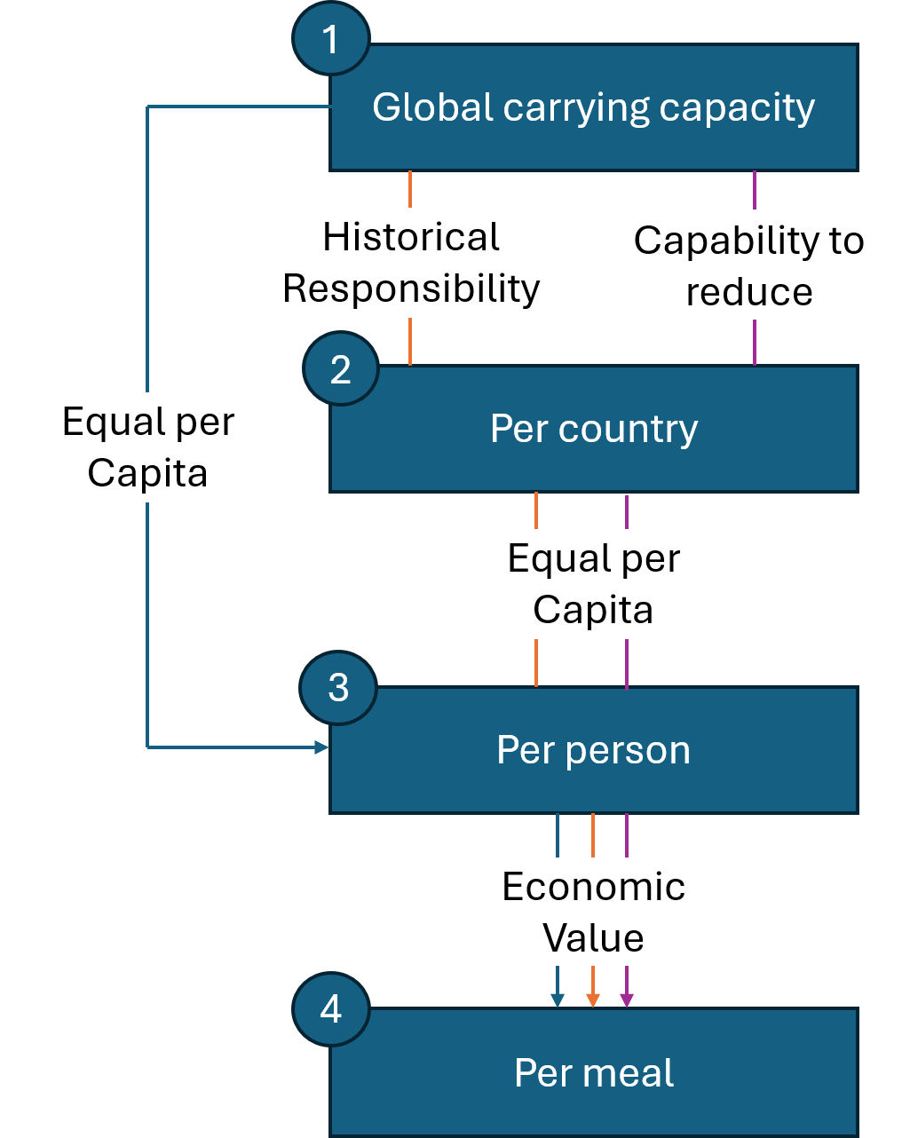
“Equal per Capita” approach – 1-3
(1-3) ${CAR.CAP}_{capita} = {{CAR.CAP}_{world}}/{{Pop}_{world}}$
“Capability to reduce” approach – 1-2-3
(1-2) ${CAR.CAP}_{country} = {CAR.CAP}_{world} *\left({{GDP}_{capita,world}}/{{GDP}_{capita,country}}\right)*\left({{Pop}_{country}}/{{Pop}_{world}}\right)*\left({{Pop}_{world}}/{{GDP}_{capita,world}*\sum_{country}{{{Pop}_{country}}/{{GDP}_{capita,country}}}}\right)$
(2-3) ${CAR.CAP}_{capita,country =}{{CAR.CAP}_{country}}/{{Pop}_{country}}$
“Historical Responsibility” approach – 1-2-3
(1-2) ${CAR.CAP}_{country} = {CAR.CAP}_{world} *\left({{NCE}_{capita,country}}/{{NCE}_{capita,world}}\right)*\left({{Pop}_{country}}/{{Pop}_{world}}\right)*\left({{NCE}_{capita,world}*{Pop}_{world}}/{\sum_{country}{{NCE}_{capita,country}*{Pop}_{country}}}\right)$
(2-3) ${CAR.CAP}_{capita,country =}{{CAR.CAP}_{country}}/{{Pop}_{country}}$
All approaches – 3-4
(3-4) ${CAR.CAP}_{meal,country}=\left({P_{meal,country}}/{{GDP}_{capita,country}}\right)* {CAR.CAP}_{capita}$
Where:
CAR.CAP_{world} is the world’s carrying capacity in all the Product Environmental Footprint’s (PEF) environmental impact categories, taken from Sala et al. (2021).
CAR.CAP_{country} is any given country’s carrying capacity in all the Product Environmental Footprint’s (PEF) environmental impact categories, taken from Sala et al. (2021).
CAR.CAP_{capita} is any given country’s per capita carrying capacity in all the Product Environmental Footprint’s (PEF) environmental impact categories, taken from Sala et al. (2021).
CAR.CAP_{meal} is the assigned share of a country’s per capita carrying capacity for 1 meal in all the Product Environmental Footprint’s (PEF) environmental impact categories, taken from Sala et al. (2021).
Pop_{world} is the world’s population as for 2024.
Pop_{country} is any given country’s population as for 2024.
GDP_{capita,world} is the world’s average gross domestic product per capita in 2024, taken from the World Bank (2025).
GDP_{capita,country} is any given country’s gross domestic product per capita in 2024, taken from the World Bank (2025).
NCE_{capita,world} is the cumulated carbon emission in the world, as for 2024, taken from OurWorldinData (2025).
NCE_{capita,country} is the cumulated carbon emission in any given country, as for 2024, taken from OurWorldinData (2025).
Supplementary Information 3.5 - Comparison of environmental results per meal, per impact category, in the Austrian and Italian sample.
Impact category | Austria | Italy
CC | 6.98E-01 | 4.07E-01
OD | 1.43E-08 | 1.56E-08
IR | 1.11E-01 | 5.82E-02
PO | 1.67E-03 | 1.99E-03
PM | 5.69E-08 | 4.13E-08
HTnc | 1.06E-08 | 1.11E-08
HTc | 5.59E-10 | 3.97E-10
AC | 7.97E-03 | 5.60E-03
Eufw | 1.13E-04 | 5.10E-05
Euma | 2.60E-03 | 1.90E-03
Eute | 3.34E-02 | 2.15E-02
EC | 1.27E+01 | 6.44E+00
LU | 3.31E+01 | 1.93E+01
WU | 2.16E-01 | 3.55E-01
EN | 6.02E+00 | 4.27E+00
RU | 2.10E-06 | 1.41E-06

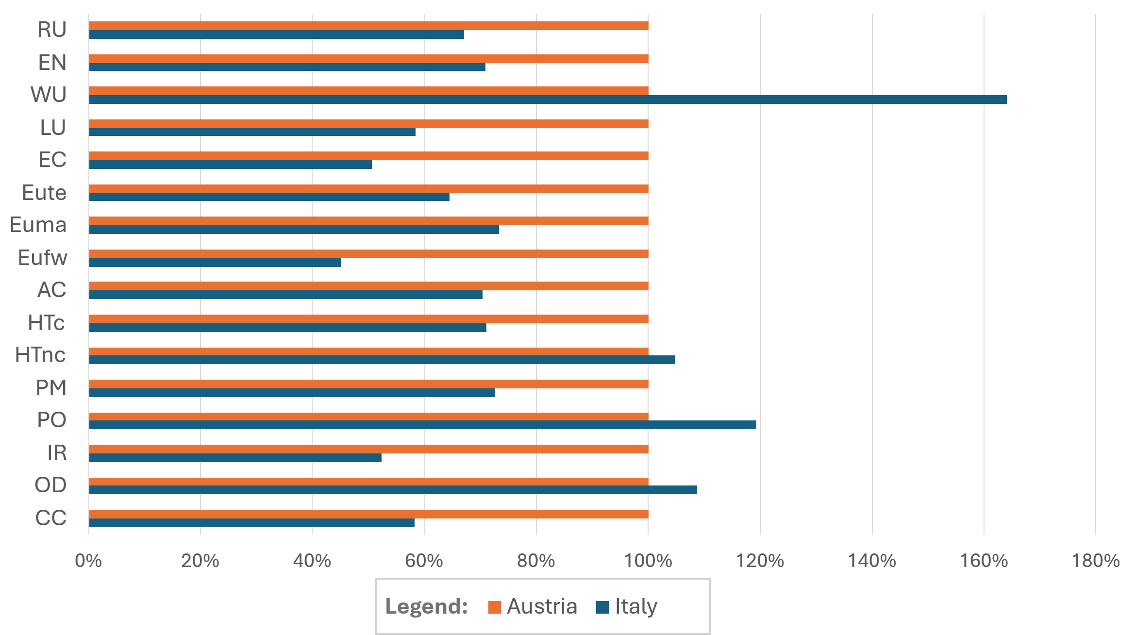

Supplementary Information 3.6 – Sensitivity analysis results for different databases.
Impact assessment results with the 3 different databases, in Austria.
IC | DB | Beef | Meat (excluding beef) | Dairy products | Fish | Plant-based protein | Starch/satiating food | Vegetables | Salad | Soup | Fruit | Desserts | Other
AC | AGB | 1.53E+00 | 1.22E+00 | 1.29E+00 | N/A | 1.15E-01 | 3.89E-01 | 2.82E-01 | 7.67E-03 | 1.01E-01 | 2.91E-02 | 1.34E-02 | 2.03E-01
AC | EI | 1.67E+00 | 1.33E+00 | 1.27E+00 | N/A | 2.89E-02 | 2.95E-01 | 3.04E-01 | 5.39E-03 | 1.01E-01 | 2.69E-02 | 7.44E-03 | 2.03E-01
AC | EFF | 3.68E+00 | 1.50E+00 | 1.99E+00 | N/A | 4.78E-02 | 2.21E-01 | 4.12E-01 | 8.84E-03 | 1.01E-01 | 2.98E-02 | 1.41E-02 | 4.25E-01
CC | AGB | 1.12E+02 | 8.33E+01 | 1.11E+02 | N/A | 3.02E+01 | 4.34E+01 | 3.82E+01 | 9.87E-01 | 1.28E+01 | 2.35E+00 | 3.02E+00 | 1.54E+01
CC | EI | 1.58E+02 | 9.23E+01 | 1.11E+02 | N/A | 2.96E+00 | 2.68E+01 | 2.52E+01 | 3.35E-01 | 1.28E+01 | 2.13E+00 | 7.40E+00 | 1.54E+01
CC | EFF | 4.46E+02 | 1.08E+02 | 1.52E+02 | N/A | 4.99E+00 | 2.10E+01 | 3.53E+01 | 4.91E-01 | 1.28E+01 | 2.10E+00 | 2.44E+00 | 3.03E+01
EC | AGB | 6.46E+02 | 2.28E+03 | 1.54E+03 | N/A | 1.31E+03 | 6.35E+02 | 9.70E+02 | 2.27E+01 | 3.06E+02 | 7.19E+01 | 2.31E+01 | 4.63E+02
EC | EI | 2.28E+03 | 9.09E+03 | 1.87E+03 | N/A | 8.78E+01 | 7.62E+02 | 7.89E+02 | 2.00E+01 | 3.06E+02 | 6.23E+02 | 1.01E+01 | 4.63E+02
EC | EFF | 2.37E+04 | 3.78E+04 | 1.74E+04 | N/A | 1.17E+03 | 1.63E+04 | 4.28E+04 | 1.60E+03 | 3.06E+02 | 5.75E+03 | 9.20E+01 | 1.06E+04
EN | AGB | 4.09E+02 | 8.02E+02 | 8.26E+02 | N/A | 2.37E+02 | 6.33E+02 | 5.51E+02 | 1.88E+01 | 2.09E+02 | 4.01E+01 | 3.00E+01 | 1.54E+02
EN | EI | 6.49E+01 | 7.45E+02 | 6.92E+02 | N/A | 4.87E+01 | 3.81E+02 | 3.41E+02 | 3.76E+00 | 2.09E+02 | 3.53E+01 | 1.14E+01 | 1.54E+02
EN | EFF | 1.08E+03 | 7.16E+02 | 6.07E+02 | N/A | 7.35E+01 | 3.50E+02 | 4.43E+02 | 4.34E+00 | 2.09E+02 | 3.55E+01 | 2.69E+01 | 1.50E+02
Eufw | AGB | 5.99E-03 | 1.45E-02 | 1.38E-02 | N/A | 3.46E-03 | 1.60E-02 | 9.44E-03 | 1.36E-04 | 3.07E-03 | 1.13E-03 | 1.07E-03 | 4.93E-03
Eufw | EI | 1.71E-02 | 2.51E-02 | 2.54E-02 | N/A | 1.75E-03 | 1.65E-02 | 8.31E-03 | 6.00E-05 | 3.07E-03 | 1.20E-03 | 8.10E-04 | 4.93E-03
Eufw | EFF | 1.16E-01 | 2.98E-02 | 3.78E-02 | N/A | 3.72E-03 | 1.17E-02 | 2.00E-02 | 2.60E-04 | 3.07E-03 | 1.27E-03 | 1.26E-03 | 8.38E-03
Euma | AGB | 3.42E-01 | 3.44E-01 | 3.34E-01 | N/A | 1.36E-01 | 2.05E-01 | 1.51E-01 | 2.47E-03 | 1.56E-02 | 1.03E-02 | 3.80E-02 | 1.10E-01
Euma | EI | 6.47E-01 | 3.90E-01 | 4.84E-01 | N/A | 4.50E-02 | 1.50E-01 | 1.35E-01 | 2.31E-03 | 1.56E-02 | 8.47E-03 | 2.64E-02 | 1.10E-01
Euma | EFF | 3.31E+00 | 5.38E-01 | 7.11E-01 | N/A | 1.88E-02 | 9.69E-02 | 1.88E-01 | 2.88E-03 | 1.56E-02 | 9.36E-03 | 3.72E-02 | 1.73E-01
Eute | AGB | 6.72E+00 | 5.19E+00 | 5.46E+00 | N/A | 3.77E-01 | 1.46E+00 | 1.05E+00 | 3.04E-02 | 3.97E-01 | 1.11E-01 | 3.95E-02 | 8.69E-01
Eute | EI | 7.42E+00 | 5.46E+00 | 5.23E+00 | N/A | 1.00E-01 | 1.12E+00 | 1.20E+00 | 2.19E-02 | 3.97E-01 | 1.01E-01 | 2.63E-02 | 8.69E-01
Eute | EFF | 7.61E+00 | 6.46E+00 | 9.76E+00 | N/A | 1.87E-01 | 9.07E-01 | 1.67E+00 | 3.79E-02 | 3.97E-01 | 1.10E-01 | 4.52E-02 | 1.93E+00
HTc | AGB | 4.95E-08 | 6.51E-08 | 7.09E-08 | N/A | 2.39E-08 | 5.10E-08 | 4.58E-08 | 1.40E-09 | 2.55E-08 | 3.85E-09 | 1.56E-09 | 2.46E-08
HTc | EI | 1.59E-06 | 4.08E-08 | 5.66E-08 | N/A | 5.15E-09 | 3.90E-08 | 3.80E-08 | 5.01E-10 | 2.55E-08 | 7.01E-09 | 1.16E-09 | 2.46E-08
HTc | EFF | 7.73E-07 | 4.93E-08 | 5.30E-08 | N/A | 7.11E-09 | 3.52E-08 | 4.69E-08 | 6.60E-10 | 2.55E-08 | 3.35E-09 | 1.19E-09 | 1.38E-08
HTnc | AGB | 1.62E-06 | 9.12E-07 | 1.33E-06 | N/A | 4.85E-07 | 1.18E-06 | 8.28E-07 | 5.71E-08 | 1.18E-07 | 4.95E-08 | 1.81E-08 | 2.81E-07
HTnc | EI | 3.51E-04 | 8.79E-07 | 8.62E-07 | N/A | 3.32E-07 | 6.03E-07 | 9.99E-07 | 7.89E-09 | 1.18E-07 | 8.94E-08 | 1.44E-09 | 2.81E-07
HTnc | EFF | 5.17E-06 | 3.20E-06 | 2.30E-06 | N/A | 2.24E-07 | 6.84E-07 | 1.94E-06 | 4.39E-08 | 1.18E-07 | 1.33E-07 | 3.08E-08 | 7.57E-07
IR | AGB | 8.51E+00 | 1.88E+01 | 1.79E+01 | N/A | 2.07E+00 | 8.73E+00 | 8.39E+00 | 3.79E-01 | 3.96E+00 | 8.37E-01 | 4.66E-01 | 2.08E+00
IR | EI | 2.78E-01 | 8.57E+00 | 6.04E+00 | N/A | 9.96E-01 | 6.30E+00 | 4.72E+00 | 7.15E-03 | 3.96E+00 | 6.95E-01 | 2.80E-01 | 2.08E+00
IR | EFF | 1.38E+00 | 6.74E+00 | 3.50E+00 | N/A | 9.60E-01 | 5.44E+00 | 4.54E+00 | 2.25E-03 | 3.96E+00 | 6.69E-01 | 4.10E-01 | 5.83E-01
LU | AGB | 7.15E+03 | 4.10E+03 | 4.66E+03 | N/A | 2.41E+02 | 2.33E+03 | 6.64E+02 | 1.16E+01 | 1.03E+02 | 1.30E+02 | 3.84E+02 | 1.74E+03
LU | EI | 6.23E+04 | 3.89E+03 | 4.60E+04 | N/A | -3.85E+02 | 1.64E+03 | 3.98E+02 | 7.52E+00 | 1.03E+02 | 8.30E+01 | 2.77E+02 | 1.74E+03
LU | EFF | 3.35E+04 | 9.97E+03 | 1.16E+04 | N/A | 5.25E+02 | 2.03E+03 | 2.47E+03 | 7.00E+01 | 1.03E+02 | 1.32E+02 | 4.43E+02 | 3.24E+03
OD | AGB | 6.53E-07 | 3.60E-06 | 1.62E-06 | N/A | 2.56E-07 | 7.84E-07 | 1.32E-06 | 3.80E-08 | 3.01E-07 | 7.63E-08 | 1.03E-07 | 5.62E-07
OD | EI | 8.17E-08 | 3.34E-06 | 2.77E-06 | N/A | 6.02E-08 | 7.40E-07 | 5.62E-07 | 1.93E-08 | 3.01E-07 | 1.81E-06 | 9.05E-09 | 5.62E-07
OD | EFF | 1.18E-06 | 2.66E-06 | 4.06E-07 | N/A | 2.97E-08 | 2.74E-07 | 4.45E-07 | 9.47E-10 | 3.01E-07 | 2.27E-08 | 9.75E-08 | 9.38E-08
PM | AGB | 1.04E-05 | 8.90E-06 | 9.21E-06 | N/A | 8.82E-07 | 2.82E-06 | 2.28E-06 | 7.18E-08 | 6.34E-07 | 1.99E-07 | 1.16E-07 | 1.47E-06
PM | EI | 1.15E-05 | 1.14E-05 | 9.89E-06 | N/A | 1.65E-07 | 1.87E-06 | 2.02E-06 | 3.29E-08 | 6.34E-07 | 1.88E-07 | 4.98E-08 | 1.47E-06
PM | EFF | 6.22E-05 | 1.30E-05 | 2.28E-05 | N/A | 2.98E-07 | 1.44E-06 | 3.47E-06 | 6.89E-08 | 6.34E-07 | 1.94E-07 | 1.28E-07 | 4.34E-06
PO | AGB | 1.78E-01 | 2.00E-01 | 2.22E-01 | N/A | 1.13E-01 | 1.42E-01 | 1.22E-01 | 3.36E-03 | 2.92E-02 | 8.96E-03 | 8.29E-03 | 5.53E-02
PO | EI | 9.30E-02 | 2.63E-01 | 2.72E-01 | N/A | 1.17E-02 | 8.50E-02 | 8.52E-02 | 1.60E-03 | 2.92E-02 | 8.84E-03 | 2.94E-03 | 5.53E-02
PO | EFF | 1.13E+00 | 3.28E-01 | 6.47E-01 | N/A | 1.73E-02 | 6.55E-02 | 1.46E-01 | 2.85E-03 | 2.92E-02 | 9.08E-03 | 7.54E-03 | 1.31E-01
RU | AGB | 1.64E-04 | 3.69E-04 | 2.94E-04 | N/A | 6.95E-05 | 1.53E-04 | 1.69E-04 | 7.15E-06 | 5.68E-05 | 9.64E-06 | 4.05E-06 | 7.06E-05
RU | EI | 1.09E-04 | 4.97E-04 | 5.58E-04 | N/A | 1.41E-05 | 1.03E-04 | 1.07E-04 | 2.50E-06 | 5.68E-05 | 1.25E-05 | 1.97E-06 | 7.06E-05
RU | EFF | 2.21E-05 | 1.24E-04 | 2.00E-05 | N/A | 4.25E-06 | 2.28E-05 | 4.81E-05 | 2.22E-07 | 5.68E-05 | 3.46E-06 | 2.56E-06 | 7.45E-06
WU | AGB | 1.11E+01 | 2.78E+01 | 1.63E+01 | N/A | 4.33E+00 | 2.94E+01 | 2.56E+01 | 7.73E-01 | 4.32E+00 | 9.37E+00 | 4.79E-01 | 1.11E+01
WU | EI | 1.12E+01 | 1.11E+02 | 1.11E+02 | N/A | 1.12E+00 | 1.10E+02 | 6.01E+01 | 9.89E-01 | 4.32E+00 | 1.07E+01 | 2.52E-01 | 1.11E+01
WU | EFF | 3.20E+01 | 6.92E+01 | 1.38E+02 | N/A | 8.53E+02 | 9.03E+00 | 2.22E+02 | 7.67E+00 | 4.32E+00 | 1.67E+01 | 4.49E-01 | 8.25E+01

Impact assessment results with the 3 different databases, in Italy.
IC | DB | Beef | Meat (excluding beef) | Dairy products | Fish | Plant-based protein | Starch/satiating food | Vegetables | Salad | Soup | Fruit | Desserts | Other
AC | AGB | 5.59E-01 | 4.01E-01 | 3.75E-01 | 6.82E-01 | 2.14E-02 | 4.85E-01 | 1.25E-01 | 2.76E-03 | 4.19E-03 | 9.70E-02 | 5.32E-03 | 1.57E-01
AC | EI | 4.29E-01 | 1.61E-01 | 6.81E-01 | 6.70E-02 | 2.38E-02 | 4.47E-01 | 1.08E-01 | 1.94E-03 | 3.89E-03 | 6.95E-02 | 5.32E-03 | 1.52E-01
AC | EFF | 1.35E+00 | 2.76E-01 | 4.32E-01 | 1.08E-01 | 2.75E-02 | 2.59E-01 | 1.53E-01 | 3.18E-03 | 4.19E-03 | 8.74E-02 | 8.28E-03 | 1.54E-01
CC | AGB | 4.13E+01 | 1.86E+01 | 3.17E+01 | 2.58E+01 | 3.88E+00 | 4.97E+01 | 1.82E+01 | 3.56E-01 | 5.49E-01 | 1.05E+01 | 3.29E+00 | 7.80E+00
CC | EI | 4.07E+01 | 8.55E+00 | 6.24E+01 | 3.69E+00 | 2.68E+00 | 5.58E+01 | 1.07E+01 | 1.22E-01 | 4.90E-01 | 3.53E+00 | 3.29E+00 | 7.52E+00
CC | EFF | 1.64E+02 | 1.61E+01 | 5.38E+01 | 1.59E+01 | 2.75E+00 | 2.98E+01 | 1.60E+01 | 1.78E-01 | 5.49E-01 | 5.68E+00 | 1.74E+00 | 1.42E+01
EC | AGB | 2.37E+02 | 5.22E+02 | 4.11E+02 | 1.61E+02 | 7.44E+01 | 8.39E+02 | 4.07E+02 | 8.17E+00 | 1.21E+01 | 3.85E+02 | 8.91E+00 | 2.84E+02
EC | EI | 5.88E+02 | 5.50E+02 | 6.14E+02 | 1.87E+01 | 7.98E+01 | 7.16E+02 | 3.48E+02 | 7.20E+00 | 1.17E+01 | 3.48E+02 | 8.91E+00 | 2.74E+02
EC | EFF | 8.69E+03 | 7.07E+03 | 7.04E+03 | 6.57E+01 | 2.07E+02 | 5.76E+03 | 1.98E+04 | 5.78E+02 | 1.21E+01 | 6.36E+04 | 9.49E+01 | 1.76E+05
EN | AGB | 1.51E+02 | 1.81E+02 | 1.78E+02 | 3.43E+02 | 5.62E+01 | 7.53E+02 | 2.94E+02 | 6.80E+00 | 8.96E+00 | 1.23E+02 | 1.05E+01 | 1.13E+02
EN | EI | 1.91E+01 | 6.73E+01 | 3.86E+02 | 3.66E+01 | 3.37E+01 | 6.99E+02 | 1.71E+02 | 1.37E+00 | 7.74E+00 | 3.21E+01 | 1.05E+01 | 1.10E+02
EN | EFF | 3.98E+02 | 1.13E+02 | 2.09E+02 | 2.23E+02 | 4.42E+01 | 3.61E+02 | 1.96E+02 | 1.58E+00 | 8.96E+00 | 6.46E+01 | 4.00E+00 | 8.78E+01
Eufw | AGB | 2.10E-03 | 3.03E-03 | 3.18E-03 | 1.08E-03 | 7.87E-04 | 9.37E-03 | 2.61E-03 | 4.78E-05 | 8.01E-05 | 1.46E-03 | 4.25E-04 | 2.35E-03
Eufw | EI | 4.34E-03 | 2.14E-03 | 1.23E-02 | 1.60E-04 | 4.91E-04 | 1.16E-02 | 2.00E-03 | 2.06E-05 | 6.51E-05 | 1.14E-03 | 4.25E-04 | 2.27E-03
Eufw | EFF | 4.24E-02 | 4.99E-03 | 1.23E-02 | 1.67E-04 | 8.66E-04 | 7.51E-03 | 5.12E-03 | 9.28E-05 | 8.01E-05 | 1.89E-03 | 1.31E-03 | 2.41E-03
Euma | AGB | 1.25E-01 | 9.33E-02 | 1.03E-01 | 1.68E-01 | 1.85E-02 | 3.10E-01 | 6.58E-02 | 8.91E-04 | 6.32E-04 | 3.19E-02 | 7.86E-03 | 6.58E-02
Euma | EI | 1.66E-01 | 5.13E-02 | 2.72E-01 | 1.60E-02 | 4.12E-02 | 3.26E-01 | 5.76E-02 | 8.34E-04 | 5.20E-04 | 2.82E-02 | 7.86E-03 | 6.39E-02
Euma | EFF | 1.21E+00 | 8.34E-02 | 2.28E-01 | 4.37E-02 | 8.36E-03 | 1.44E-01 | 7.30E-02 | 1.04E-03 | 6.32E-04 | 3.82E-02 | 3.62E-03 | 6.56E-02
Eute | AGB | 2.46E+00 | 1.73E+00 | 1.61E+00 | 1.84E+00 | 7.88E-02 | 1.93E+00 | 4.66E-01 | 1.09E-02 | 1.60E-02 | 3.87E-01 | 1.90E-02 | 6.48E-01
Eute | EI | 1.91E+00 | 6.73E-01 | 2.79E+00 | 1.89E-01 | 9.07E-02 | 1.76E+00 | 4.28E-01 | 7.88E-03 | 1.51E-02 | 2.90E-01 | 1.90E-02 | 6.29E-01
Eute | EFF | 2.79E+00 | 1.22E+00 | 3.77E+00 | 4.90E-01 | 1.14E-01 | 1.43E+00 | 6.51E-01 | 1.37E-02 | 1.60E-02 | 4.25E-01 | 3.53E-02 | 7.41E-01
HTc | AGB | 1.83E-08 | 1.92E-08 | 1.69E-08 | 1.65E-08 | 1.33E-08 | 6.59E-08 | 2.85E-08 | 5.05E-10 | 1.08E-09 | 1.38E-08 | 1.85E-09 | 1.08E-08
HTc | EI | 4.07E-07 | 4.92E-09 | 2.07E-08 | 2.03E-09 | 5.03E-09 | 6.25E-08 | 2.17E-08 | 1.82E-10 | 1.03E-09 | 1.67E-08 | 1.85E-09 | 1.05E-08
HTc | EFF | 2.84E-07 | 8.67E-09 | 1.47E-08 | 2.11E-09 | 5.03E-09 | 4.74E-08 | 1.76E-08 | 2.40E-10 | 1.08E-09 | 7.17E-09 | 1.50E-09 | 1.17E-08
HTnc | AGB | 5.92E-07 | 2.53E-07 | 3.64E-07 | 1.21E-07 | 2.54E-07 | 2.68E-06 | 3.41E-07 | 2.06E-08 | 4.71E-09 | 5.65E-07 | 7.89E-09 | 5.51E-07
HTnc | EI | 9.00E-05 | 6.73E-08 | 4.02E-07 | 1.37E-08 | 3.03E-07 | 8.66E-07 | 2.81E-07 | 2.84E-09 | 3.75E-09 | 6.42E-08 | 7.89E-09 | 5.46E-07
HTnc | EFF | 1.89E-06 | 5.44E-07 | 8.03E-07 | 2.55E-08 | 6.99E-08 | 9.57E-07 | 7.11E-07 | 1.58E-08 | 4.71E-09 | 1.04E-06 | 6.49E-08 | 2.82E-06
IR | AGB | 3.09E+00 | 2.34E+00 | 3.29E+00 | 6.49E-01 | 6.26E-01 | 1.31E+01 | 4.71E+00 | 1.36E-01 | 1.54E-01 | 1.06E+00 | 8.01E-02 | 1.06E+00
IR | EI | 5.58E-02 | 4.27E-01 | 1.71E+00 | 3.95E-02 | 1.13E-01 | 1.08E+01 | 2.73E+00 | 2.49E-03 | 1.12E-01 | 9.04E-02 | 8.01E-02 | 1.03E+00
IR | EFF | 4.75E-01 | 1.92E-01 | 1.99E-01 | 6.06E-02 | 7.83E-02 | 7.19E-01 | 6.14E-01 | 7.24E-04 | 1.54E-01 | 2.27E-02 | 4.19E-03 | 6.29E-02
LU | AGB | 2.62E+03 | 9.87E+02 | 1.40E+03 | 3.58E+01 | -2.59E+02 | 2.79E+03 | 2.95E+02 | 4.18E+00 | 4.07E+00 | 3.55E+02 | 1.22E+02 | 1.68E+03
LU | EI | 1.60E+04 | 4.41E+02 | 2.67E+04 | 6.39E+00 | -3.57E+02 | 3.31E+03 | 4.31E+02 | 2.71E+00 | 3.16E+00 | 4.88E+02 | 1.22E+02 | 1.66E+03
LU | EFF | 1.23E+04 | 1.84E+03 | 4.21E+03 | 8.06E+00 | 2.32E+02 | 3.57E+03 | 9.58E+02 | 2.52E+01 | 4.07E+00 | 8.63E+02 | 3.77E+02 | 8.76E+03
OD | AGB | 2.44E-07 | 3.93E-07 | 8.35E-07 | 3.71E-06 | 1.10E-07 | 1.35E-06 | 6.45E-07 | 1.37E-08 | 1.27E-08 | 4.57E-07 | 1.27E-08 | 3.15E-07
OD | EI | 2.91E-08 | 1.44E-07 | 1.99E-06 | 1.45E-05 | 8.46E-08 | 1.43E-06 | 2.97E-07 | 6.97E-09 | 1.19E-08 | 3.75E-08 | 1.27E-08 | 3.10E-07
OD | EFF | 4.36E-07 | 6.30E-08 | 1.27E-07 | 3.87E-08 | 5.52E-08 | 7.05E-07 | 2.46E-07 | 3.59E-10 | 1.27E-08 | 1.06E-08 | 4.93E-09 | 4.43E-08
PM | AGB | 3.81E-06 | 2.96E-06 | 2.68E-06 | 5.25E-06 | 1.82E-07 | 3.45E-06 | 1.08E-06 | 2.59E-08 | 2.61E-08 | 7.83E-07 | 4.99E-08 | 1.16E-06
PM | EI | 2.96E-06 | 1.26E-06 | 5.52E-06 | 5.23E-07 | 1.51E-07 | 3.28E-06 | 7.75E-07 | 1.19E-08 | 2.33E-08 | 4.97E-07 | 4.99E-08 | 1.12E-06
PM | EFF | 2.28E-05 | 2.65E-06 | 9.48E-06 | 1.54E-06 | 1.65E-07 | 2.68E-06 | 1.30E-06 | 2.48E-08 | 2.61E-08 | 7.12E-07 | 5.46E-08 | 1.72E-06
PO | AGB | 6.55E-02 | 6.18E-02 | 6.04E-02 | 5.05E-01 | 1.26E-02 | 1.65E-01 | 6.58E-02 | 1.22E-03 | 1.32E-03 | 4.57E-02 | 5.56E-03 | 4.49E-02
PO | EI | 2.43E-02 | 2.48E-02 | 1.63E-01 | 4.86E-02 | 1.06E-02 | 1.56E-01 | 4.05E-02 | 5.83E-04 | 1.15E-03 | 1.86E-02 | 5.56E-03 | 4.39E-02
PO | EFF | 4.14E-01 | 6.55E-02 | 2.72E-01 | 1.32E-01 | 7.03E-03 | 9.61E-02 | 6.52E-02 | 1.03E-03 | 1.32E-03 | 3.16E-02 | 1.63E-03 | 6.08E-02
RU | AGB | 6.04E-05 | 7.42E-05 | 8.14E-05 | 1.36E-04 | 1.20E-05 | 1.71E-04 | 8.62E-05 | 2.58E-06 | 2.26E-06 | 5.02E-05 | 2.40E-06 | 5.56E-05
RU | EI | 2.82E-05 | 3.45E-05 | 3.14E-04 | 6.22E-06 | 1.30E-05 | 1.79E-04 | 5.53E-05 | 9.00E-07 | 1.74E-06 | 2.74E-05 | 2.40E-06 | 5.46E-05
RU | EFF | 8.21E-06 | 4.75E-06 | 4.07E-06 | 1.67E-06 | 3.34E-06 | 3.12E-05 | 2.52E-05 | 8.14E-08 | 2.26E-06 | 2.51E-06 | 4.24E-07 | 3.87E-06
WU | AGB | 4.05E+00 | 7.29E+00 | 4.00E+00 | 1.13E+00 | 7.82E-01 | 5.32E+01 | 1.41E+01 | 2.78E-01 | 1.71E-01 | 5.05E+01 | 1.56E-01 | 4.89E+01
WU | EI | 2.91E+00 | 1.68E+01 | 6.00E+01 | 2.20E-01 | 6.35E-01 | 2.61E+02 | 1.98E+01 | 3.56E-01 | 1.43E-01 | 9.61E+01 | 1.56E-01 | 4.88E+01
WU | EFF | 1.17E+01 | 1.30E+01 | 3.29E+01 | -1.13E+00 | 7.36E+02 | 3.62E+01 | 3.89E+02 | 2.76E+00 | 1.71E-01 | 4.97E+01 | 1.36E-01 | 1.40E+02

Graphical comparison of the impact assessment results with the 3 different databases, in Italy and Austria.
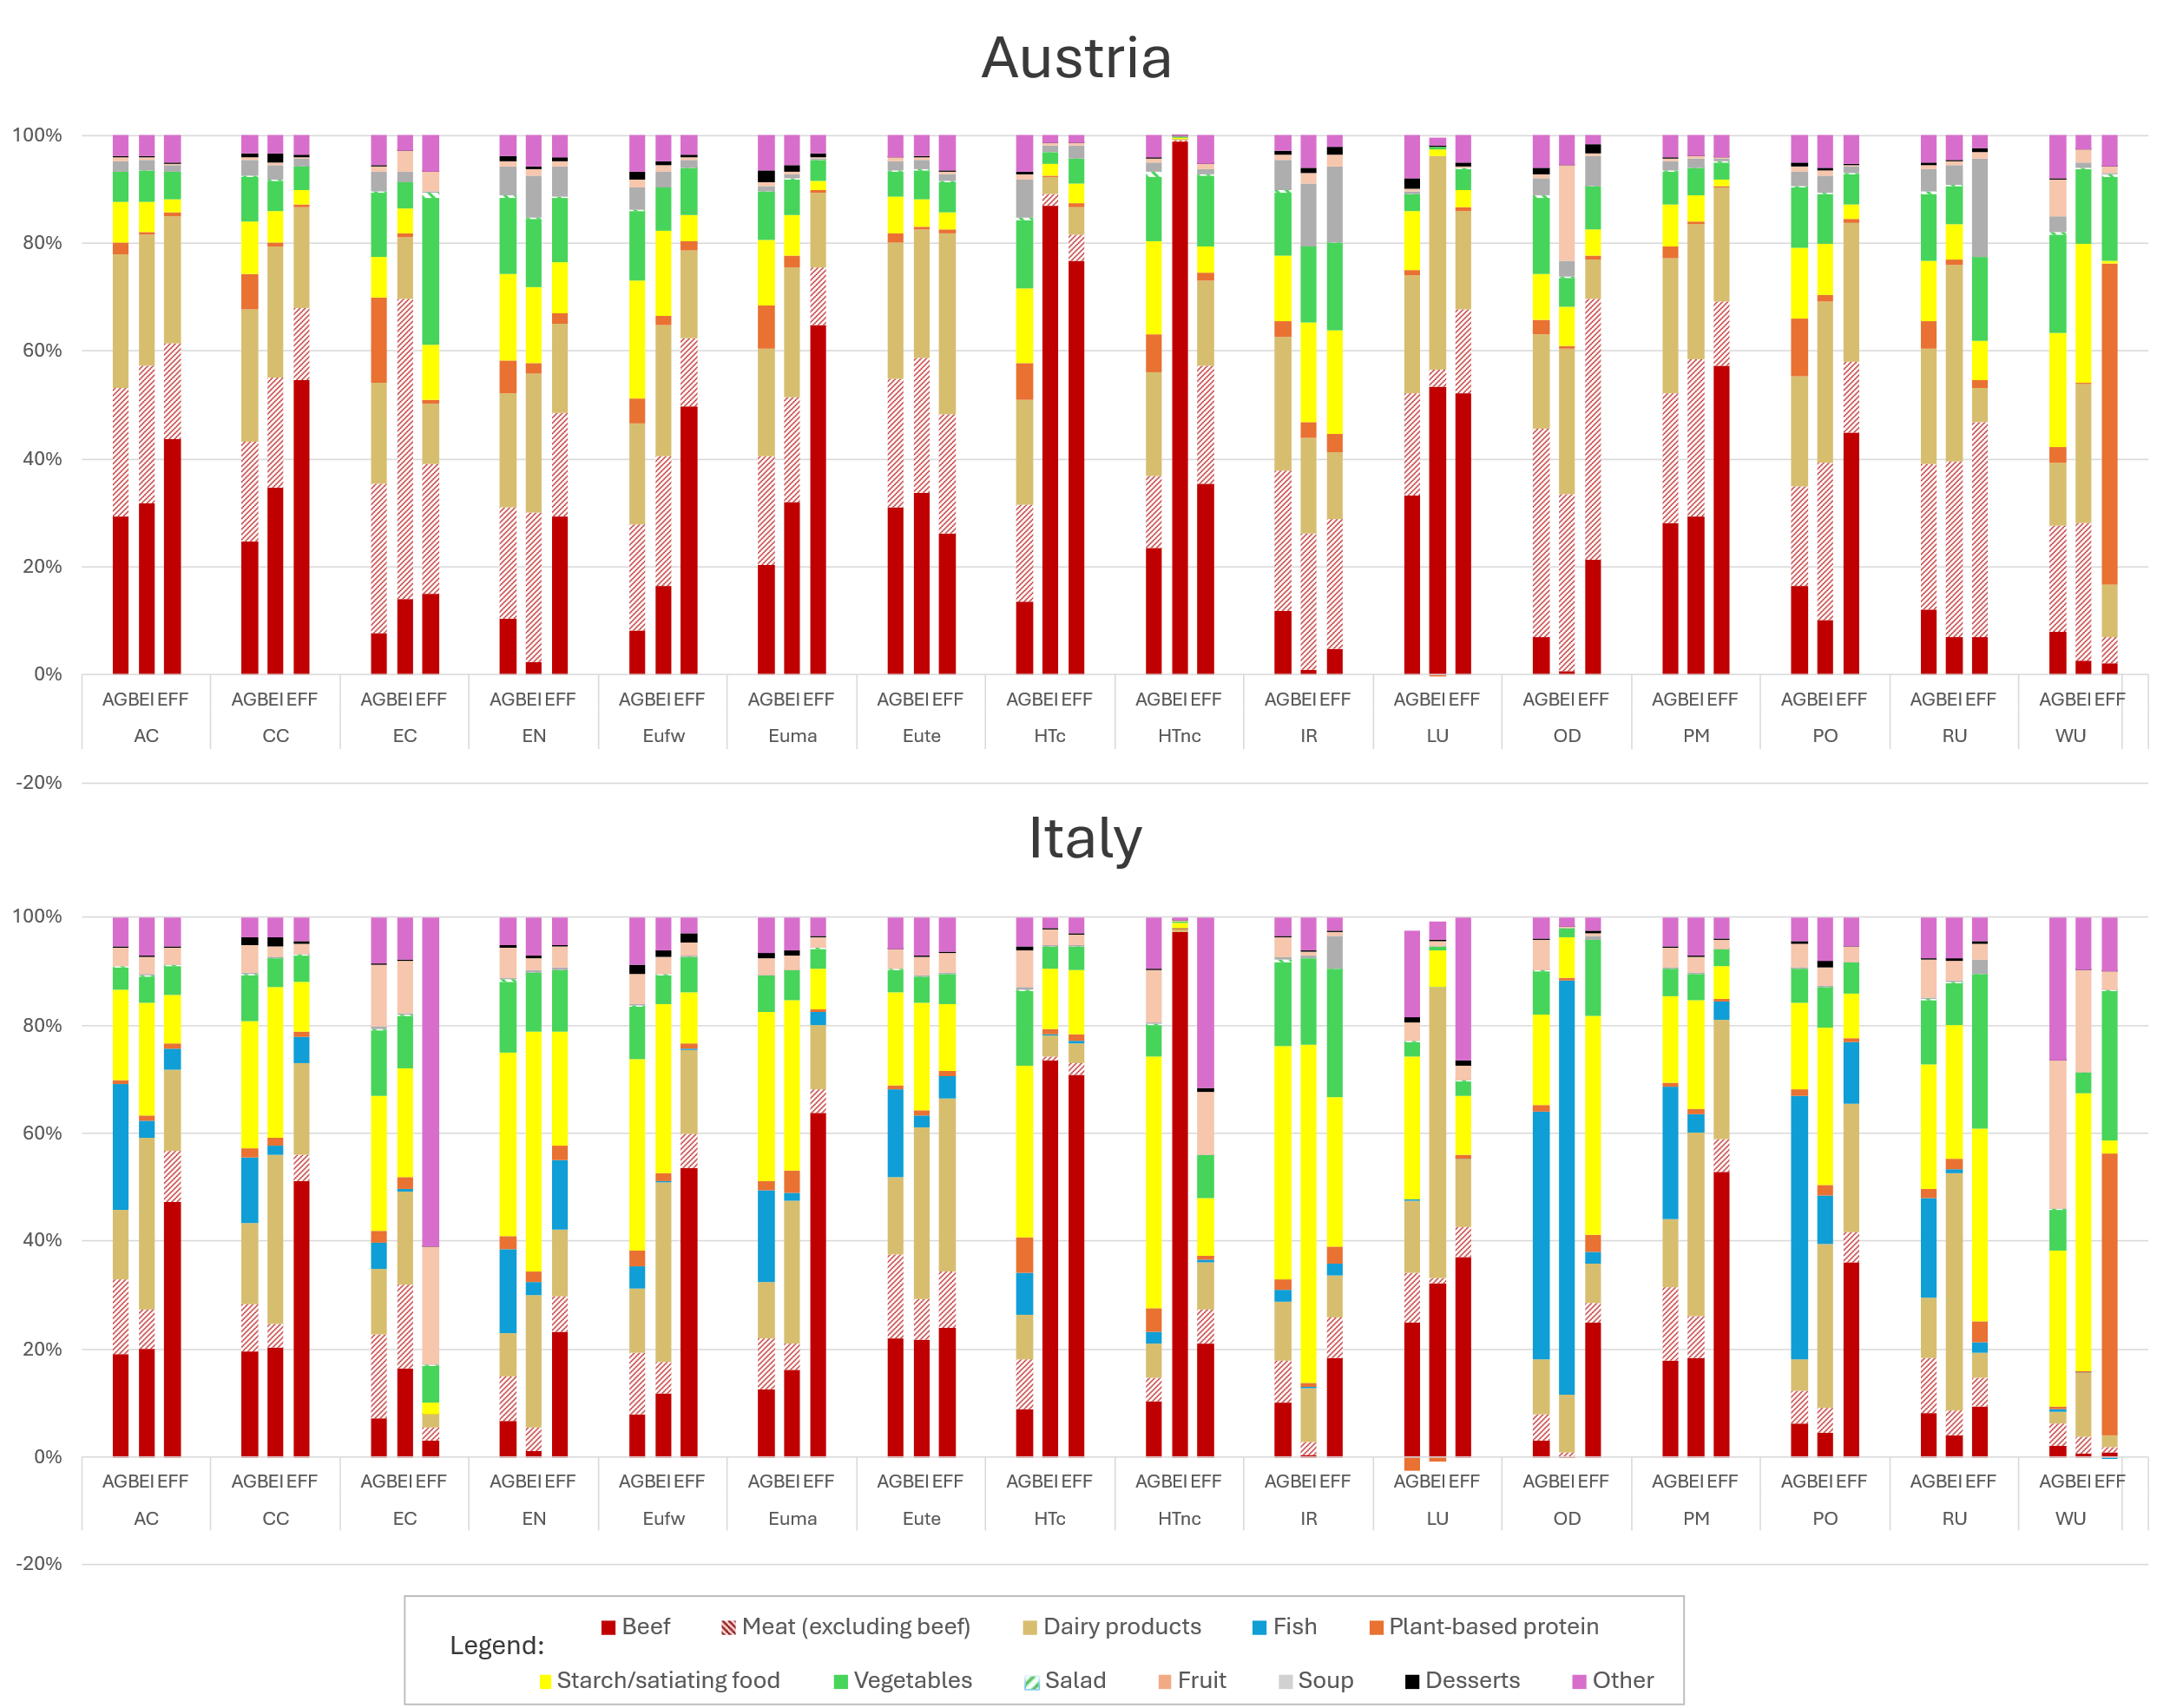
Supplementary Information 3.7 – Sensitivity analysis for different monetization coefficients.

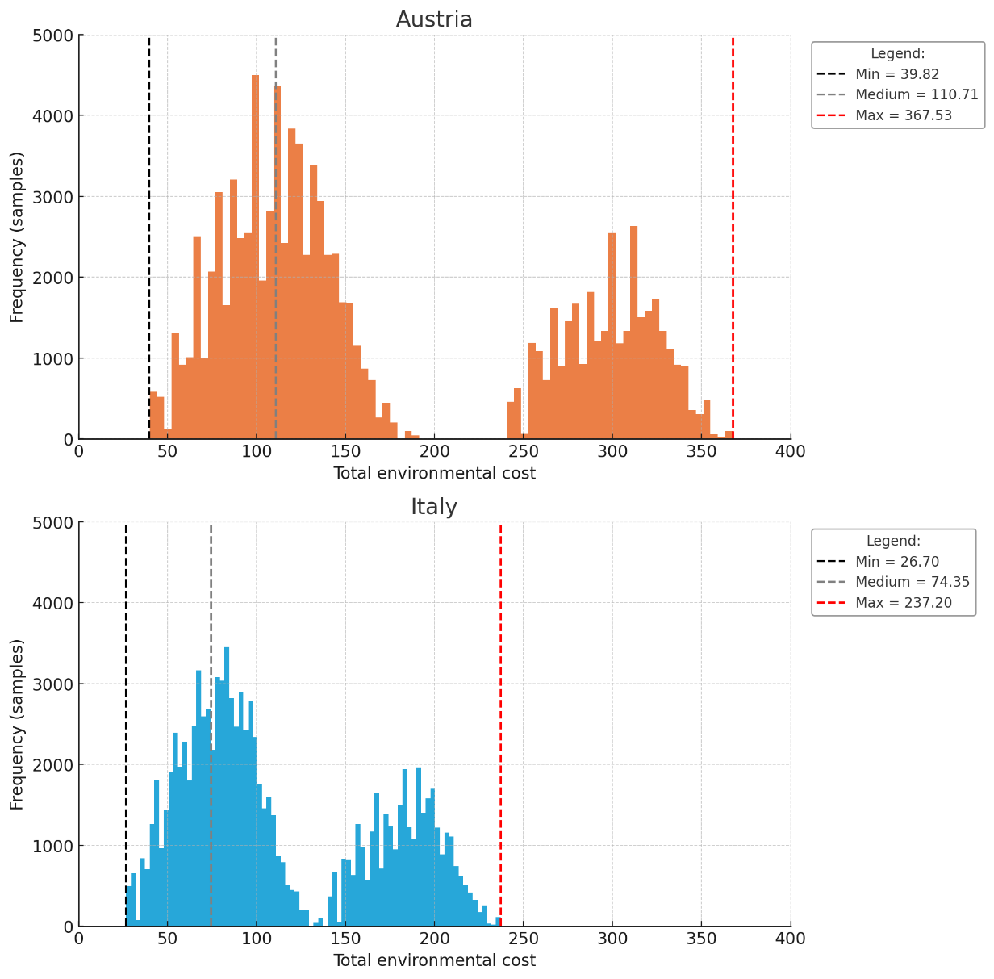
Supplementary Information 3.8 - Sensitivity analysis for different allocation methods for AESA.
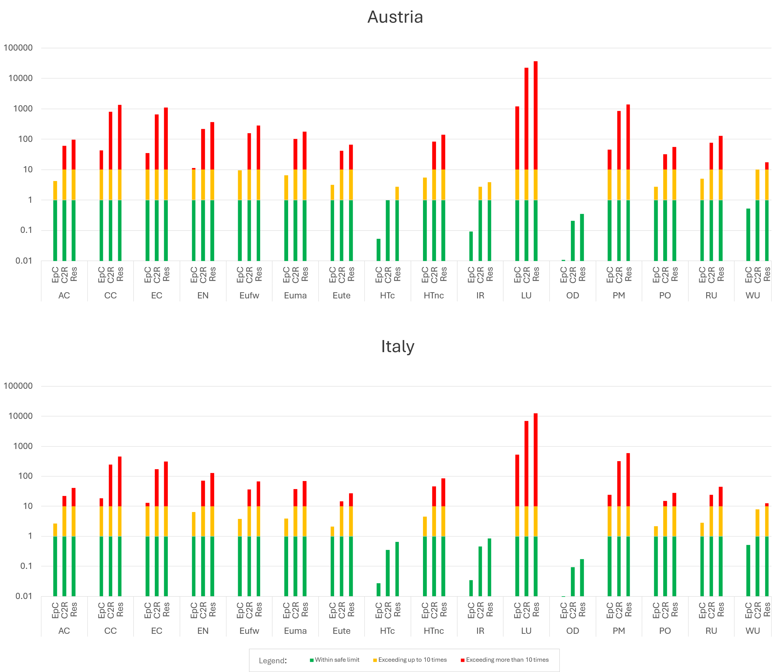
Supplementary Information 3.9 - Sensitivity analysis for different meal prices.
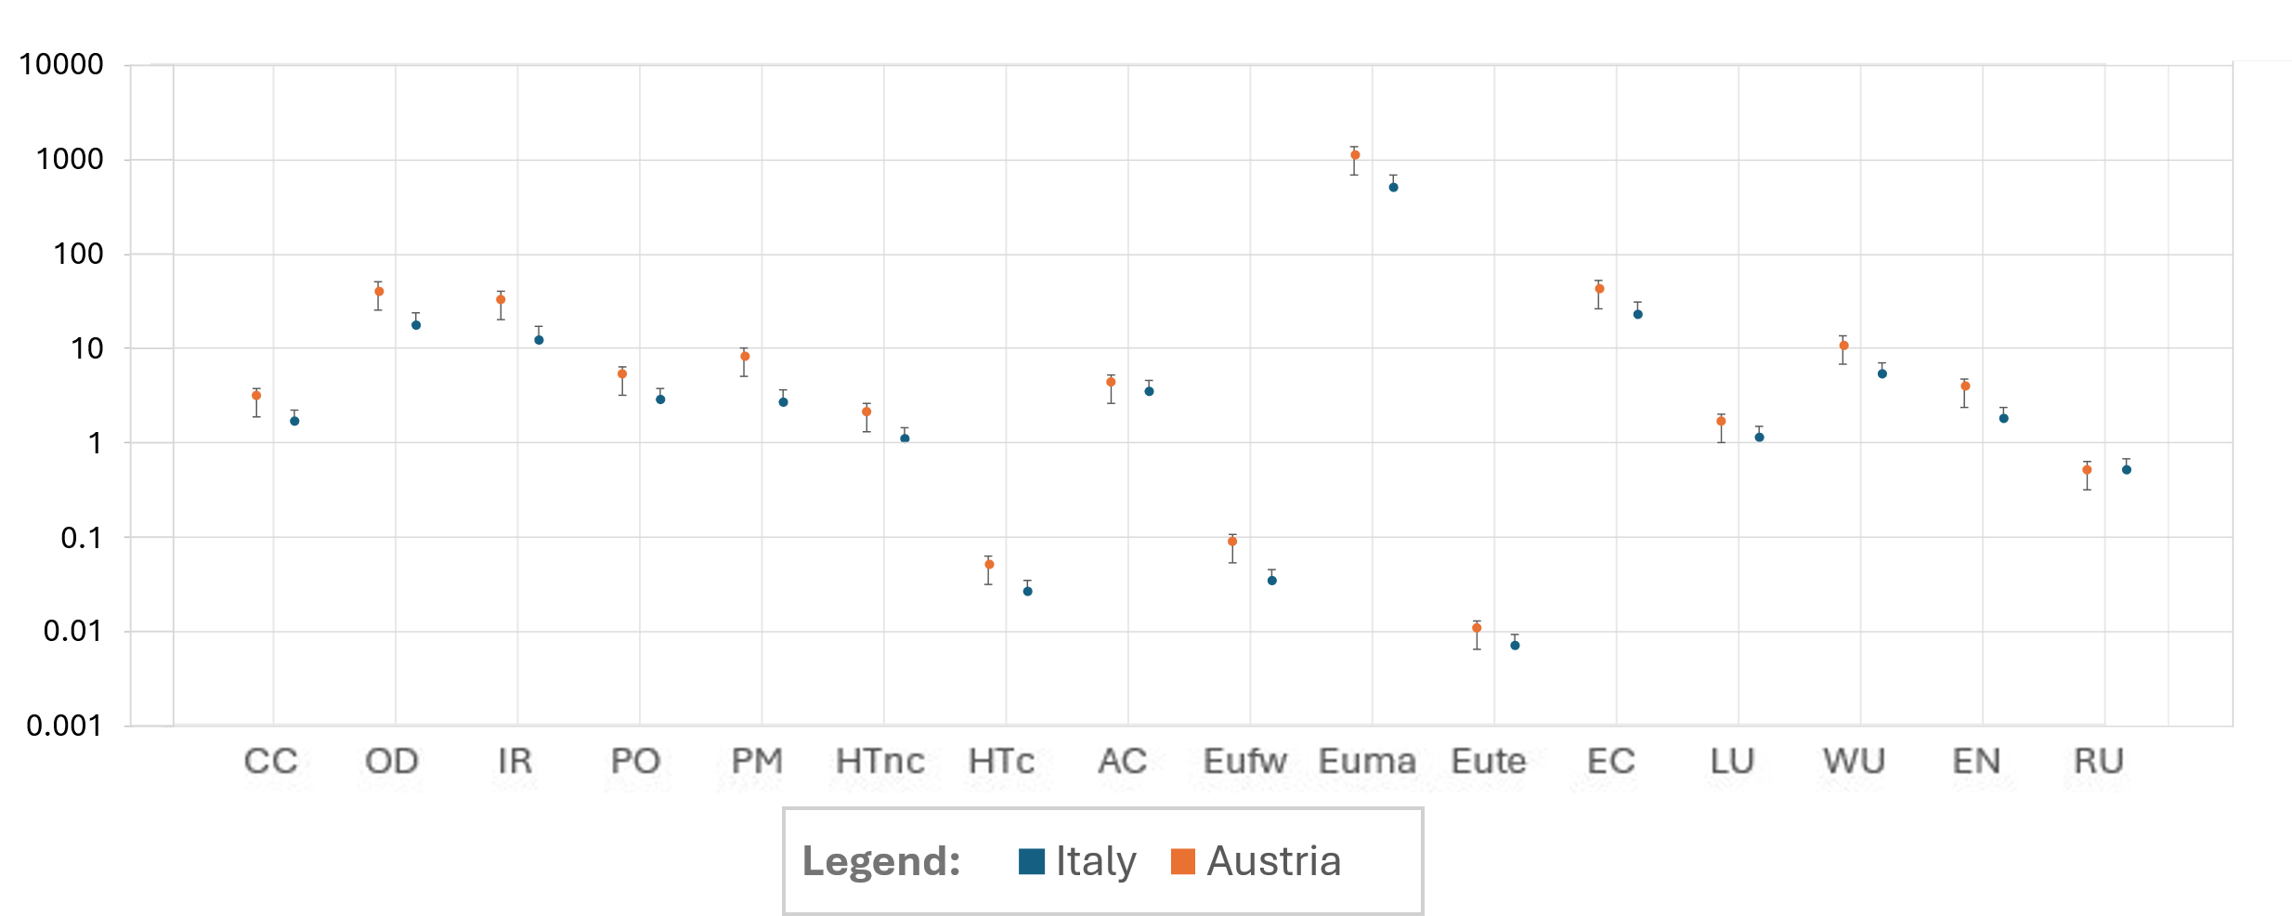

Supplementary Information 3.10 – Analysis on the contribution of packaging and distribution on total impact.
