Supplementary figures and legends
Figure S1. Academic genomic HRD test and RAD51 are feasible in ovarian cancer samples. A) Summary of the evaluable cases for genomic HRD test and/or RAD51 test and/or miR-506 expression in MITO16a concordance analyses. B) Causes of failure rate for RAD51 assay in MITO16a concordance analyses.

Figure S2. High relative expression of miR-506 correlates with HRD status and favorable prognosis. A) Preliminary analysis correlating the relative expression of miR-506 with the HRR status as defined by the academic genomic test (n=72 - Unpaired t test). B) Kaplan–Meier curves for Progression Free Survival (PFS) of 140 OC patients stratified for miR-506 relative expression (upper quartile vs. others). In the inset relative expression of miR-506 n all cases. C and D) Relative expression of miR-506 in MITO16A cases with evaluable HRR status as defined by the academic genomic (C) test and by RAD51 assay (D); only cases with relative miR-506 expression above median expression were considered. HRP: homologous recombination proficient; HRD: homologous recombination deficient.

Figure S3. Genomic and functional HRD, and miR-506 expression in BRCA1/2 WT population. A) HRD status in BRCA1/2 WT population according to genomic and functional testing. B) Percentage of HRD and Neg-HRD tumors by genomic testing among RAD51 assay HRD and HRP samples. C) miR-506 distribution in HRD and Neg-HRD samples by genomic assay. D) miR-506 distribution in HRD and HRP samples by RAD51 assay.
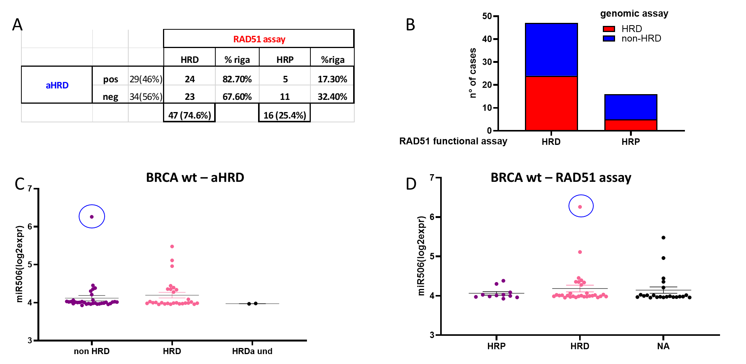

Supplementary Tables

Table S1. Clinical-pathological characteristic of the population in analysis compared to the MITO16A enrolled patients

Table S2. Comparison between Genomic and Functional HRD in MITO16A concordance analyses.
A) Functional HRD by RAD51 and Genomic HRD classified in to two groups (HRD vs Neg-HRD). B) Functional HRD by RAD51 and Genomic HRD classified in to three groups (High-HRD, Medium-HRD vs Neg-HRD).
Table S3. Comparison between Genomic and Functional HRD in MITO16A concordance analyses within samples in upper quartile of miR-506 relative expression.
Functional HRD by RAD51 assay and Genomic HRD classified into two groups (HRD vs Neg-HRD).

